2023 Dashboard On-Demand Session: Academic Indicators Notetaking Guide
California Department of Education | January 2024

Welcome

Agenda
- Overview of the California School Dashboard (Dashboard)
- Academic Indicators
- Participation Rate
- Frequently Asked Questions (FAQs)
- General Rules About the Dashboard
- Contact Us

Overview of the Dashboard

Dashboard
The Dashboard is an online tool designed to help communities across the state access important information about students in kindergarten through grade twelve. The Dashboard reports how districts and schools are performing on multiple state and local measures that make up California’s accountability system.

What Can I Expect from the 2023 Dashboard?
The Dashboard will still report local indicators and state indicators. The big change will be in the state indicators returning to colors.

Dashboard State Measures
- Academic Indicators
  - English language arts/literacy (ELA)
  - Mathematics
- English Learner Progress Indicator (ELPI)
- Chronic Absenteeism Indicator
- Graduation Rate Indicator
- Suspension Rate Indicator
- College/Career Indicator (CCI)
*The CCI is reported as a Status Only indicator on the 2023 Dashboard.

Academic Indicators

Measurement of Performance

Status and Change
- The measurement of performance for local educational agencies (LEAs), schools, and student groups on the Dashboard is done by looking at two years of data.
  - Current year data equals Status.
  - A comparison between the current and prior years’ data equals Change.
- It is the combination of Status and Change that determines color performance on the Dashboard and is designated by receiving a color, ranging from Red at the lowest Performance Level to Blue at the highest Performance Level.

Performance Levels
There are five Performance Levels (colors) that can be reported on the Dashboard.
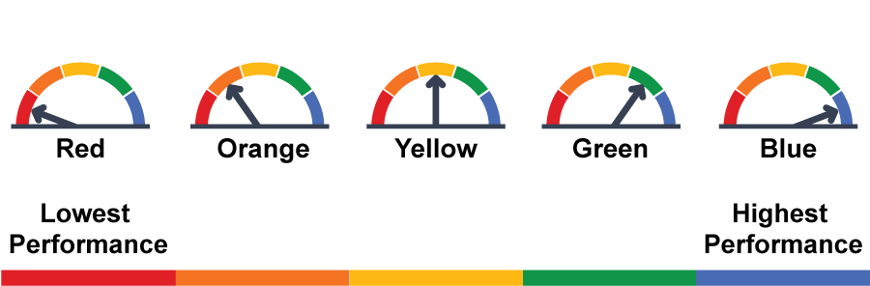

What Are the Academic Indicators?
The Academic Indicators are based on performance on the Smarter Balanced Summative Assessments and the California Alternate Assessments (CAAs). The Academic Indicators contain two measures:
- ELA
- Mathematics
Testing occurs in grades three through eight and grade eleven. The results show how well students are meeting grade-level standards.
Test scores are only included in the indicator if the student is continuously enrolled.

What Is Continuous Enrollment?
Continuous enrollment is defined as enrollment from Fall Census Day (the first Wednesday in October) to testing without a gap in enrollment of more than 30 consecutive calendar days.

Where Does the Data Come From?
- The Smarter Balanced Summative Assessments and CAAs results are received from the testing vendor.
- California Longitudinal Pupil Achievement Data Systems (CALPADS) data—specifically
  - demographic data (to make student group determinations);
  - enrollment data (to determine which students are included in the participation rate); and
  - enrollment data (to determine continuous enrollment to calculate the Distance from Standard [DFS]).

Academic Indicators on the Dashboard
A baseball card will be the first level of information available to schools and LEAs related to the Academic Indicators. It shows Performance Levels (colors), Status, Change, and the equity report.
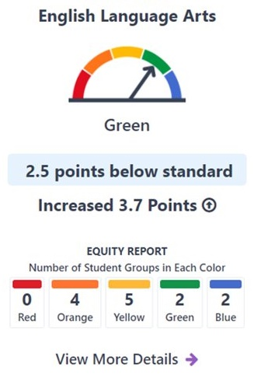

Description of the Academic Baseball Cards
For the ELA baseball card, the Performance Level is green, with the gauge pointed to the green section. Then it shows the reporting for Status and Change. In this example, they scored 2.5 points below standard and had an increase of 3.7 points from the prior year. Next, the equity report reports the number of student groups in each color. In this example, there are zero student groups in Red, 4 student groups in Orange, 5 student groups in Yellow, 2 student groups in Green, and 2 student groups in Blue. Finally, there is a link to view more details, which provides more specific student group information.

Additional Student Group Reports
The Academic Indicators provide DFS and Status level overall as well as for each of the 13 student groups when the school or district has met the minimum N-size to show results.
DFS and Change are provided on the Dashboard for additional student groups for informational purposes only. No Performance Levels or colors are shown for these groups.
These student groups include the following groups:
- Current English Learners
- Recently Reclassified English Learners
- English Only
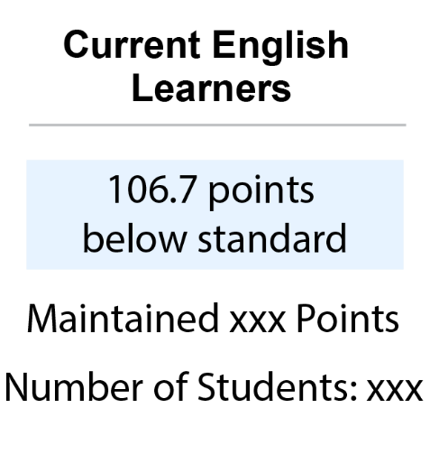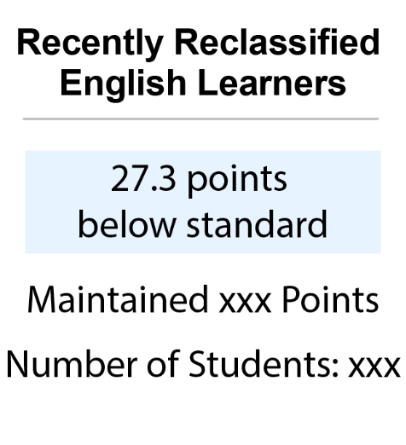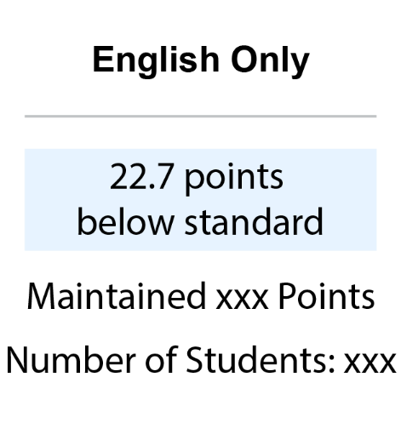

What Is the DFS?
The DFS is used to determine the Status level for ELA and mathematics.
It is the distance between a student’s score on the Smarter Balanced Summative Assessments and the Standard Met Achievement Level threshold (i.e., the lowest threshold scale score for Level Three).
The scale score ranges for the Smarter Balanced Summative Assessments vary by content area—ELA and mathematics—and by grade level.
The scale score levels and ranges can be found on the California Assessment of Student Performance and Progress (CAASPP) Smarter Balanced ELA and Mathematics Scale Score Ranges web page at
https://caaspp-elpac.ets.org/caaspp/scalescorerangesSB.

Calculating the Smarter Balanced DFS
- Calculate the DFS for each student.
- Calculate the Average DFS for a school or district using all students’ DFS values. The Average DFS will be used to determine the Status level if a school, district, or student group meets the minimum N-size.
- Calculate change based on the difference in DFS from the year prior.
The average DFS and the change from the prior year for each assessment are used to determine the Performance Level (color).

CAA DFS
For the CAA scores, a crosswalk was created to convert levels of the CAAs to correspond with levels on the Smarter Balanced Summative Assessments using a "Top of the Scale Range" Approach.

Top of the Scale Range
For levels one to three on the CAA, a student's CAA score would be substituted with the top score point of the same Smarter Balanced achievement level. All CAA assessment results will be converted to one of three scale scores in each content area. For example, grade three CAA scores will be converted to the following Smarter Balanced scores:

Table 1. Scale Score Ranges for the CAA
ELA | Mathematics
Level one is converted to 2366 | Level one is converted to 2380
Level two is converted to 2431 | Level two is converted to 2435
Level three is converted to 2489 | Level three is converted to 2500
Scale score ranges for the CAA can be found on the CAASPP/ELPAC CAAs for ELA and Mathematics Scale Score Ranges web page at
https://caaspp-elpac.ets.org/caaspp/ScaleScoreRangesCAA.
This newly converted Smarter Balanced Summative Assessments score will be used to calculate the DFS for those students taking the CAA.

Academic Five-by-Five
An LEA, school, or student group’s Performance Level (color) is determined through the use of a five-by-five table that utilizes the Status and Change levels. The Academic Indicators five-by-five is a little different than the other indicators. but still uses the intersection of Status and Change to determine the final Performance Level or color.
Table 2. Five-by-Five Colored Table
Performance Level | Declined Significantly | Declined | Maintained | Increased | Increased Significantly
Very High | Green | Green | Blue | Blue | Blue
High | Green | Green | Green | Green | Blue
Medium | Yellow | Yellow | Yellow | Green | Green
Low | Orange | Orange | Orange | Yellow | Yellow
Very Low | Red | Red | Red | Orange | Orange
The Academic Indicators do not have a three-by-five methodology applied.

Different Cut Scores
The Academic Indicators have two sets of cut scores: one applies to high school and high school districts while the other applies to all other school and district types (elementary school, middle school, kindergarten through grade twelve, etc.).
Dashboard Alternative School Status (DASS)-specific cut scores are no longer being applied to the Dashboard. DASS schools will have the same cut scores applied as the other schools with their school type.
Cut scores can be accessed on the California Department of Education (CDE) Cut Scores Five-by-Five Colored Tables for the 2023 Dashboard web page at https://www.cde.ca.gov/ta/ac/cm/fivebyfivecolortables23.asp

Pair and Share Schools
Schools that serve only kindergarten, grade one, and/or grade two (non-testing grades) are required to receive a Performance Level on the Academic Indicators even though students in these grades are not administered the ELA and mathematics assessments.

Pair and Share Methodology
- Pair and Share schools are specifically assigned grade three DFS (which includes results from both the Smarter Balanced Summative Assessments and the CAAs) from the District, County, or up to three schools to which their students matriculate.
- Only reported for the "All Student" level, no student groups.

Academic Measures for Future Consideration

California Science Test (CAST)
The CAST is administered for all students in grades five and eight and once in high school (i.e., once in grade ten, eleven, or twelve).
The CAST is not a state indicator on the 2023 Dashboard, however, a link to the CAST results will be available. Elevating measures to a state indicator require both State Board approval and multiple years of results to reliably select cut scores.

California Growth Model
Since 2015, California has invested significant time and effort in developing a student-level growth model that is valid, reliable, and fair.
The growth model is currently not included as a part of the Academic Indicators or the Dashboard. Results of the growth model are projected to be released for the 2023–24 academic year in 2024.

Participation Rate
Under the Every Student Succeeds Act (ESSA), all states must test at least 95 percent of their students. This requirement is applied to all schools, LEAs, and student groups and is calculated separately for each group.
If they fail to meet this target, California is required to assign a Lowest Obtainable Scale Score (LOSS) to each student needed to bring the participation rate of the school, district, and/or student group to 95 percent.
The LOSS assigned to each of these students who did not test will be used in calculating the DFS.
For more information about the participation rate and penalty applied, refer to the Changes to Academic Indicator Participation Rate Calculation for the Dashboard on the CDE Dashboard Flyers web page at https://www.cde.ca.gov/ta/ac/cm/dashboardflyers.asp.

Participation Rate Formula
Numerator: Number of tested students
Denominator: Number of students enrolled during the Accountability testing window
Numerator Tested: For student to count as "tested,” the following must be true:
- Must log on to both the Computer Adaptive Test and the Performance Task portions of the assessment
  - Does not need to complete the entire assessment, however, their score will be included in the average DFS calculations
  - If there is no score generated, a LOSS for their grade level will be applied
Denominator Enrolled: Many rules are applied to determine if the student is enrolled at the school or LEA.
- Few exemptions for special cases (medical emergency, newly enrolled English learner students.)
- Grace periods for students entering or exiting the school during the testing window.

Exemptions for Participation Rate
There are a few students who are excluded from the participation rate. These students are not expected to take the test and are not included in either the numerator or the denominator of the participation rate.
Students excluded from Participation Rate
- Medical Exemption Flag
- EL students enrolled in a US school for less than one year (for ELA only)
There are other students who did not take the test for a variety of possible reasons who are not excluded from the participation rate. These students are still expected to take the test and are included in the denominator of the participation rate. If they did not test, they will not be included as testing in the numerator.
Students not excluded from Participation Rate:
- Parent opt-outs
- Chronically Absent
- Sick without medical emergency exemption

Completion Status Reports Versus Participation Rate
- The Test Operations Management System (TOMS) completion reports are not the same as the participation rate.
- TOMS reports can provide insight in "real-time."
  - Dashboard does not use the same inclusion/exclusion rules.
  - CDE does not receive testing data until the Fall.
  - May not reflect the final Dashboard participation rate.

Testing Windows and Grace Periods

Testing Windows
Determining a school’s accountability testing window is one of the first steps to finalize the participation rate denominator.
Although LEAs set their own testing window for the Smarter Balanced Summative Assessments and CAAs in the TOMS Test Administration Setup module, for Dashboard accountability purposes, CDE determines what is called an Accountability testing window for each school and LEA.
The Accountability testing window for the Dashboard starts when the first student at the school takes the test. Depending on the length of the LEA-selected testing window, grace periods may be applied as well.

Grace Period Defined
- Developed for students who transfer in or out during a school's determined testing window
- Apply only to certain students who transfer in and/or out within the testing start and end dates (not the entire testing window)
- Hold schools harmless when there is inadequate time to administer the assessments

Grace Period Applied
If the LEA selected testing window is:
- 14 days or less
  - No grace periods applied
- Between 15–30 days
  - One grace period applied at the end of the window
    - For students entering the school at the end of the testing window
- 31 or more days
  - One grace period applied at the beginning of the window
    - For students exiting the school at the beginning of the testing window
  - One grace period applied at the end of the window
    - For students entering the school at the end of the testing window

Participation Rate Simplified
Students who transfer in or out of a school are expected to test if they are enrolled for at least one day during the Accountability testing window.

District of Special Education Accountability (DSEA)
- At the LEA level only, Students with Disabilities may be included in the denominator of a district other than their tested district if they have a DSEA in the CALPADS Special Education file.
- Students are expected to take the test at the school they are attending.

FAQs

Will we be resetting DFS cut scores for the 2023 Dashboard?
No. The State Board of Education is committed to continuous improvement of the Dashboard and did not want to lower the standards in 2023.

Will the California Growth Model replace Status for the Academic Indicators?
Action would need to be taken by the State Board of Education to add growth scores to the Academic Indicators on the Dashboard, or to replace DFS with any other measurement such as growth scores.

Why do the CAASPP reports not match the results of the Dashboard?
The CAASPP reporting web page and the Dashboard are reporting results from the Spring Summative CAASPP testing, however, they do have a number of differences and will often not match. Table 3 simplifies these differences below.
Table 3. Dashboard and CAASPP Results
CAASPP Results | Dashboard Results
Most student demographics based on data at the close of testing | Student demographics based on CALPADS EOY submissions
Results based on achievement levels and included all tested students | Results based on a combination of participation rate and DFS
Reports Alternative tests separate from Smarter Balanced tests | Reports Alternative tests together with Smarter Balanced tests through DFS
Reports the total number of students tested | Student scores are included only for continuously enrolled
No District of Residence rules applied | District of Residence rules applied

If my newcomer English learner student took the ELA test by accident, will it still be used in my DFS calculation?
English learner students who have been enrolled in a US school for less than one year are exempt from taking the ELA portion of the Smarter Balanced Summative Assessments and the CAA. For accountability purposes, any English learner newcomer who enrolled in a US school after April 15, 2022, will automatically be removed from the calculation of the ELA participation rate even if the student opted to take one or both parts of the ELA assessment. These students will not be included in the participation rate or DFS calculations.

A student left my school before the testing window opened but they are still showing up in TOMS—will this affect my participation rate?
TOMS is a great tool for looking at real-time testing rates within a school or LEA. Completion rates, however, are a similar but different metric than the participation rate. Additionally, students remain in TOMS at their last known CALPADS school. Therefore, if a student never enrolled in another California school, they would appear as needing to test in TOMS. Since these students left before the testing window opened, they will not be included in the numerator or the denominator of the participation rate.

A student left in the middle of testing but did not start any of the assessments. Will I be held accountable for their test?
If the student is expected to test and did not test the school and LEA will be held accountable for their student not testing. If the student falls under any of the exemptions including grace periods and is not expected to test, the school and LEA will not be held accountable for the student not testing.

A student left my school during the LEA-selected testing window but before we tested any students. Will they affect my participation rate?
No. Students who exit the school before testing has begun are not expected to test and will not be included in either the numerator or the denominator of the participation rate.

My school did not reach 95 percent participation in the CAST. What will happen?
At this time, the Science test is not included as a measure on the Academic Indicators. While we encourage participation in the test, reaching less than 95 percent for the Science test has no impact on Accountability.

General Rules About the Dashboard

Additional 2023 Academic Indicator Resources
- CDE Academic Indicators web page:
https://www.cde.ca.gov/ta/ac/cm/dashboardacad.asp
- CDE Academic Mini-Guide web page (coming soon): https://www.cde.ca.gov/ta/ac/cm/dashboardguide23.asp
- CDE School Dashboard Additional Reports web page: https://www6.cde.ca.gov/californiamodel/
- Participation Report
- ELA Report
- Mathematics Report

Reporting for At Least 30 Students
- Performance Level (color) gauge graphic displayed
- Status and Change reported
- Held accountable for support determinations

Reporting for 11 to 29 Students
- Performance Level (color) graphic greyed out
- Status and Change reported
- Not held accountable for support determinations

Reporting for Fewer than 11 Students
- Performance Level (color) graphic greyed out
- Status and Change not reported
- Not held accountable for support determinations

Reporting for At Least 30 Students: Exception
LEAs with at least 15 students in the current and prior year will receive a Performance Level (color) for Homeless and Foster Youth only.
Charter schools are treated as schools and still require the 30 students to receive a Performance Level (color).

DSEA
The DSEA rule is applied to all available state indicators for students with disabilities who receive special education services at another district or county office of education. These students will be “sent back” to the district of residence or DSEA and included in the DSEA’s Dashboard.
For example, the district where the student geographically resides is held accountable for the student’s graduation outcomes, and that data is included in the district of residence’s Graduation Rate Indicator.
Please note that this rule applies to LEAs only. All schools, including charter schools, are held accountable for all students with disabilities.
For more information about DSEA rules, refer to the DSEA flyer under the Additional Flyers and Information section on the CDE Dashboard Communications Toolkit web page at https://www.cde.ca.gov/ta/ac/cm/dashboardtoolkit.asp.

A Rule About Charter Schools
Since charter schools are treated as LEAs under the Local Control Funding Formula, or LCFF, their data are not included in their authorizer’s Dashboard report. This includes both direct and locally funded charters.
DataQuest reports have the toggle option to either include or exclude charters from the district reports.

Contact Us
- Email: Dashboard@cde.ca.gov
- Follow us on X (formerly Twitter): @cdedashboard

