California Department of Education
Executive Office
SBE-003 (REV. 11/2017)
oab-sftsd-jul23item01

California State Board of Education
July 2023 Agenda
Item #13

Subject
Appeal from an Action of the Santa Clara County Committee on School District Organization to Disapprove a Petition to Transfer Territory from the San José Unified School District to the Oak Grove Elementary School District and the East Side Union High School District.

Type of Action
Action, Information, Public Hearing

Summary of the Issue(s)
The Santa Clara County Committee on School District Organization (County Committee) disapproved a petition to transfer two homes from the San José Unified School District (USD) to the Oak Grove Elementary School District (ESD) and the East Side Union High School District (UHSD). The chief petitioners for the proposed transfer submitted an appeal to the California State Board of Education (SBE) from this County Committee action pursuant to California Education Code (EC) Section 35710.5.
The SBE may affirm or reverse the County Committee’s decision to approve the territory transfer proposal. If the SBE reverses the County Committee’s action, thus approving the territory transfer, it must establish the election area for final voter approval of the proposal (EC Section 35756).

Recommendation
The California Department of Education (CDE) recommends that the SBE affirm the decision of the County Committee to disapprove the proposal to transfer territory from the San José USD to the Oak Grove ESD and the East Side UHSD.

Brief History of Key Issues
The Santa Clara County Superintendent of Schools (County Superintendent) received a petition signed by the owners of two homes located in the city of San José and within the boundaries of the San José USD. One student resided in the area at the time of the appeal—the student attended another school district on an interdistrict transfer. Petitioners request transfer of these parcels to the Oak Grove ESD and the East Side UHSD for the following reasons:
- Schools in the Oak Grove ESD and the East Side UHSD are closer to the petitioners’ homes than are the San José USD schools.
- Travel to the Oak Grove ESD and the East Side UHSD schools is on residential streets, which is not the case for San José USD schools. Students could walk or ride bikes to the Oak Grove ESD and the East Side UHSD schools.
- Schools in the Oak Grove ESD and the East Side UHSD are closer to the petitioner’s daily commute patterns.
- Petitioners have a greater sense of community identify with the Oak Grove ESD and the East Side UHSD.
All three affected school districts oppose the transfer. They note that transferring two homes does nothing to address the general issues raised by the petitioners—there still will be a boundary and the same issues will remain on each side of that boundary. Moreover, the affected students always have had interdistrict attendance agreements approved, which allow them to attend their desired district. The affected districts believe that such agreements are the most appropriate way to address the preferences expressed by the petitioners.
After conducting public hearings in the affected school district, the County Committee determined that all of the nine minimum threshold conditions of EC Section 35753(a) are substantially met. These conditions are minimum standards, but the County Committee is not required to approve a transfer simply because those standards are substantially met.
Approval of a territory transfer is a discretionary action, and it is the intent of the California state legislature that local educational needs and concerns shall serve as the basis for any school district reorganization (EC Section 35500). The County Committee identified no local educational need or concern as a compelling reason to approve the transfer, with members noting that interdistrict attendance agreements are the more appropriate option. On a four-to-five vote, the County Committee failed to approved the territory transfer proposal.
Pursuant to EC Section 35710.5, the chief petitioners submitted an appeal from this County Committee action. They identified the following reasons for the appeal:
- The chief petitioners claim that they were not afforded their right to due process.
- Chief petitioners claim that County Committee members used their own opinions and personal experiences as fact when acting on the territory transfer proposal.
The CDE reviewed the entire administrative record provided by the County Superintendent—as well as new information requested and received from the County Superintendent and the affected school districts (pursuant to EC Section 35751). After this review, the CDE completed an analysis of the proposed territory transfer and the subsequent appeal. The complete analysis and resultant recommendations are contained in attachment 1.

CDE Findings and Recommendations
Below is a summary of the CDE’s findings and recommendations from attachment 1:
- All minimum threshold standards of EC Section 35753 are substantially met. In general, it is the determination of the CDE that the loss of one or two students from a school district would not have significant negative effects on any of these standards.
- It is the opinion of the CDE that the reasons provided by the chief petitioners in their appeal are not reasons that are subject to CDE analysis and SBE review.
- The CDE finds no local educational reason compelling enough to justify reversal of the local action to disapprove the transfer.
- The CDE does find local educational concerns compelling enough to justify affirmation of the local action to disapprove the transfer.
Based on these findings, the CDE recommends that the SBE affirm the decision of the County Committee to disapprove the proposal to transfer territory from the San José USD to the Oak Grove ESD and the East Side UHSD.

Summary of Previous State Board of Education Discussion and Action
The SBE has not addressed a reorganization matter involving the San José USD and the Oak Grove ESD/East Side UHSD for at least 29 years (the entirety of CDE records). The SBE has considered 18 appeals of Santa Clara County Committee decisions over this time period—affirming all but two of them.

Fiscal Analysis (as appropriate)
Affirming the action of the County Committee results in no fiscal effects on any local or state agency. Reversal of the County Committee’s action could result in an election (depending on the election area established by the SBE). Costs for this election would depend upon the timing of the election, the type of election, and the size of the election area established by the SBE—election costs would be borne by the county.

Attachments
Attachment 1: Analysis of Administrative Record (19 pages)
Attachment 2: Supplementary Maps and Tables (4 pages)

ATTACHMENT 1
Analysis of Administrative Record
Appeal from an Action of the
Santa Clara County Committee on School District Organization
to Disapprove a Petition to Transfer Territory from the
San José Unified School District to the
Oak Grove Elementary School District and the
East Side Union High School District

1.0 Recommendation
The California Department of Education (CDE) recommends that the California State Board of Education (SBE) affirm the decision of the Santa Clara County Committee on School District Organization (County Committee) to disapprove the proposal to transfer territory from the San José Unified School District (USD) to the Oak Grove Elementary School District (ESD) and the East Side Union High School District (UHSD).

2.0 Background

2.1 Affected Districts
Both the San José USD and the East Side UHSD are geographically large districts in Santa Clara County. According to 2021–22 data from the California Longitudinal Pupil Achievement Data System (CALPADS), the San José USD serves almost 27,000 kindergarten through twelfth grade (K-12) students, while the East Side UHSD has over 25,000 students at the high school level (grades 9-12).
With almost 9,000 K-8 students, the Oak Grove ESD is the third largest of the seven elementary component districts of the East Side UHSD. Five of these component districts share a common boundary with the San José USD. Figure 1 in attachment 2 contains a map depicting the geographic relationship of the districts. All affected school districts are in the City of San José.
The percentages of students in select CALPADS categories are displayed in the following table 1.

Table 1: Percent Race/Ethnicity in Affected Districts (2021–22 CALPADS)
District* | Asian | Hispanic or Latino | White | Other**
San José USD  (K-12 enrollment: 26,901) | 13.5% | 53.8% | 21.7% | 10.9%
Oak Grove ESD  (K-8 enrollment: 8,860) | 22.1% | 49.4% | 13.9% | 14.6%
East Side UHSD  (9-12 enrollment: 25,174) | 32.4% | 52.3% | 4.7% | 10.7%
* Students in the “Not Reported” CALPADS category are excluded from
the enrollment figures and are omitted from all calculations for this table.
** The “Other” category includes “African American,” “American Indian or
Alaska Native,” “Filipino,” “Pacific Islander,” and “Two or More.”
Select 2021–22 CALPADS socio-economic data (English Learner [EL] and Free or Reduced-Price Meal [FRPM]) for each affected district is shown in table 2 below. Also contained in this table is each district’s percentage of socioeconomically disadvantaged (SED) students that is displayed on the 2022 California School Dashboard.

Table 2: Percent of Students in Select Programs
District | EL | FRPM | SED
San José USD  (K-12 enrollment: 26,901) | 22.3% | 37.5% | 39.3%
Oak Grove ESD  (K-8 enrollment: 8,860) | 23.9% | 25.1% | 16.7%
East Side UHSD  (9-12 enrollment: 25,174) | 21.1% | 41.9% | 45.4%

2.2 Territory Transfer Proposal
The proposed transfer area consists of two homes in the city of San José, and within the boundaries of the San José USD. One public school student resided in one of the homes at the time the petition to transfer these two homes to the Oak Grove ESD and the East Side UHSD was considered. There were no children residing in the second home.
A map of the proposed transfer area is below:

Figure 1: Map Showing Location of Proposed Transfer Area
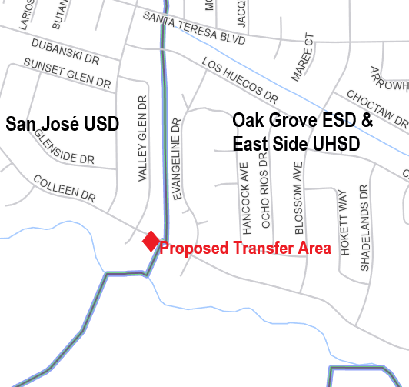
Source map: US Census Bureau

2.3 Petitioner Reasons for Transfer
In the petition submitted to the Santa Clara County Superintendent of Schools (County Superintendent), the following reasons for the proposed transfer of territory were included:
- Schools in the Oak Grove ESD and the East Side UHSD are closer to the petitioners’ homes than are the San José USD schools.
- Travel to the Oak Grove ESD and the East Side UHSD schools is on residential streets, which is not the case for San José USD schools. Students could walk or ride bikes to the Oak Grove ESD and the East Side UHSD schools.
- Schools in the Oak Grove ESD and the East Side UHSD are closer to the petitioner’s daily commute patterns.
- Petitioners have a greater sense of community identify with the Oak Grove ESD and the East Side UHSD.

3.0 Action of the County Committee
The County Committee held two public hearings for the proposed transfer of territory—one within the boundaries of the San José USD and one within the boundaries of the Oak Grove ESD (which also was within the East Side UHSD). Following these hearings, the County Committee had the following options pursuant to the California Education Code (EC):
- If the County Committee determined that all nine minimum threshold standards of EC Section 35753(a) are substantially met, it could approve the petition (though not required to do so). It is the intent of the California state legislature that local educational needs and concerns shall serve as the basis for any school district reorganization (EC Section 35500).
- The County Committee could disapprove the petition to transfer territory for other concerns even if it finds that all nine conditions of EC Section 35753(a) have been substantially met.
- If the County Committee determined that all nine minimum threshold standards of EC Section 35753(a) are not substantially met, it would be required to disapprove the petition.
An analysis of the proposed territory transfer was prepared by the County Superintendent and presented to the County Committee in a public meeting. This analysis contained recommendations that all nine conditions of EC Section 35753(a) are substantially met. However, no local educational needs or concerns were identified to either support or oppose the proposed transfer; and no recommendation to the County Committee regarding approval or disapproval is contained in the analysis.
The County Committee determined that that all nine minimum threshold standards of EC Section 35753(a) are substantially met. However, a motion to approve the transfer failed on a four-to-five vote—thus, the territory transfer proposal was disapproved by the County Committee.
Pursuant to EC Section 35710.5, chief petitioners or affected school districts may appeal County Committee actions to approve territory transfers for issues of noncompliance with the provisions of EC sections 35705, 35706, 35709, 35710, and 35753(a). Chief petitioners submitted such an appeal to the County Superintendent, who subsequently transmitted the appeal, along with the complete administrative record of the County Committee action, to the SBE.

4.0 Positions of Affected School Districts

4.1 San José USD
The San José USD is opposed to the transfer of territory proposal for the following reasons:
- Inconsistencies and anomalies with boundary lines often exist.
- Changing the boundary line between the school districts will not address the issues raised by the petitioners. There still will be a border and the same issues will remain on each side of that border.
- The numbers and needs of students in any home changes over a relatively short time period. The interdistrict attendance agreement process is the more appropriate option.
- The San José USD grants almost 1,000 interdistrict attendance requests each year. The district rarely denies such requests—typically only when disciplinary reasons exist.
- The district is concerned that approval of this territory transfer will lead to future boundary change requests.

4.2 Oak Grove ESD
The Oak Grove ESD is opposed to the transfer of territory proposal for the following reasons:
- Consistency in school district boundaries helps maintain stability for the districts and its students.
- The elementary school and the intermediate school serving the area adjacent to the proposed transfer area currently are at capacity. There are no guarantees that students in the proposed transfer area could attend these schools.

4.3 East Side UHSD
The East Side UHSD opposes the transfer and shares the concerns expressed by the Oak Grove ESD. Specifically, the district notes:
- East Side UHSD has concerns about piecemeal territory transfers. Future families in the two homes proposed for transfer may want San José USD schools and propose to change the boundary again.
- The current boundary has been in place for a long time. The district wants to protect the integrity of that boundary.
- The concerns of the family involved in the transfer can be addressed through an interdistrict attendance transfer.

5.0 Reasons for the Appeal
The chief petitioners are appealing the County Committee disapproval of the transfer based on claims that (1) petitioners were denied due process and (2) County Committee members substituted their own opinions and personal experiences for fact.

5.1 Right to Due Process
The chief petitioners claim that they were not afforded their right to due process because:
- The County Committee did not abide by local and state (Education Code) definitions and guidelines for processing territory transfer requests.
- The County Committee did not determine that any of the required EC Section 35753 conditions are unmet.
- The County Committee did not come to any consensus on the criteria or facts by which the territory transfer petition was denied.
- Petitioners did not receive a written justification of the Country Committee’s decision when notified of the petition’s disapproval.
- Petitioners were not provided an opportunity to challenge the unsubstantiated opinions made by County Committee members.

5.2 Unsubstantiated/Incompetent Evidence
Chief petitioners claim that County Committee members used their own opinions and personal experiences as fact when acting on the territory transfer proposal—and argue that such personal experiences/opinions, philosophical leanings, hypothetical scenarios, or conjecture should not be used as the basis (facts) for decision-making.

5.3 CDE Response to Chief Petitioner Appeal Claims
The Education Code states that an “appeal shall be limited to issues of noncompliance with Section 35705, 35706, or 35710, or subdivision (a) or (b) of Section 35709.” (EC Section 35710.5[a][1]. It is CDE’s opinion that the two issues raised in the chief petitioners’ appeal (Right to Due Process and Unsubstantiated/Incompetent Evidence) are not included within those limitations. Regardless, the CDE makes the following observations regarding the two issues:

Right to Due Process
Appellants “right to due process” does not appear to have been violated because:
- The appellants have not demonstrated that the decision of the County Committee would have been different had the alleged violations not occurred.
- The school district reorganization process is a quasi-legislative proceeding (Fullerton Joint Union High School District v. State Board of Education [1982] 32 Cal. 3d 779 [Fullerton]) and does not involve a trial-type process in which witnesses are called and cross-examined, findings made, etc.
- There is no requirement that the County Committee (or the SBE for that matter) provide a written explanation for its decision (Fullerton).
- The appeal before the SBE is de novo and appellants are free to reargue their case and submit additional information for the SBE’s consideration (San Rafael Elementary School District v. State Board of Education [1999] 73 Cal.App.2d 1018).

Unsubstantiated/Incompetent Evidence
The courts have established that the EC Section 35753 conditions are “minimal threshold requirements for consideration of the petition.” (Hamilton v. State Board of Education [1981] 117 Cal.App.3d 132) [Hamilton]). Hamilton further states that there is nothing to compel approval of “a petition which at least substantially complies with the conditions” of Section 35753.
It is the CDE’s opinion that the County Committee, once it determined that all nine EC Section 35753 conditions were substantially met, had discretion to approve the petition if it found a compelling reason to do so. The CDE notes that it is the California Legislature’s intent that reorganizations of school districts should address “local educational needs and concerns” (EC Section 35500). It is clear to the CDE, after reviewing the county administrative record, that the County Committee made no finding that the proposed territory transfer addresses “local educational needs and concerns.” That lack of a compelling reason to approve is sufficient to disapprove a territory transfer petition—and any concerns regarding the petition that were expressed by County Committee members (factual or not) are inconsequential given the lack of an identified compelling reason. Again, there is no requirement that the County Committee provide a written explanation for its decision (Fullerton).

6.0 Education Code Section 35753 Conditions
As stated previously, the courts (Hamilton) have established that the EC Section 35753 conditions are minimum threshold requirements for a school district reorganization. The County Committee (and the SBE) are required to determine if these minimum standards are substantially met before taking any discretionary action to approve a reorganization (EC sections 35709, 35710, and 35753). Regarding this territory transfer petition, the County Committee determined that all nine EC Section 35753 conditions are substantially met.
This is not an unexpected finding. Barring some exceptional situation, it is highly unlikely that the transfer of two homes from (or into) a school district the size of the affected districts would fail to substantially meet the minimum threshold requirements of EC Section 35753. Moreover, neither the chief petitioners nor any affected school district expressed any concerns regarding the County Committee’s finding that all Section 35753 minimum threshold standards are substantially met in this territory transfer proposal. Given these circumstances, the CDE will not address the conditions in Section 35753, other than to express concurrence with the local findings.

7.0 Compelling Reasons and Concerns
An action by the SBE to either affirm or reverse the County Committee is a discretionary action—whether the SBE finds that all EC Section 35753 conditions are substantially met or if it finds all the conditions are not met. As part of this discretionary authority, the SBE may consider compelling reasons and concerns offered by affected districts, petitioners and appellants, community members, and the CDE in making its determination to either affirm or reverse the County Committee’s action.
Similarly, County Committee approval of a territory transfer proposal is a discretionary action. EC sections 35709 and 35710 govern the approval processes for territory transfers that the County Committee is required to follow. Both processes recognize the discretionary nature of an action to approve a territory transfer by stating that a County Committee may approve a petition if it finds that the minimum threshold standards in EC Section 35753 are substantially met.
As stated in sections 5.0 and 6.0 of this attachment, EC Section 35753 conditions are established as minimum threshold requirements for a school district reorganization and, as such, substantially meeting these standards is not intended to serve as the reason that compels approval of a reorganization proposal (Hamilton). Through review of the minutes of County Committee meetings, it appears clear to the CDE that the County Committee found no compelling reason to approve the territory transfer petition. As noted previously, the County Committee took no formal action to identify reasons for its disapproval of the proposal—however, as stated by the chief petitioners in their appeal, County Committee members did discuss concerns they had with the petition.
That local disapproval action is what has been appealed to the SBE. The SBE may consider any concerns with the proposed transfer in consideration of an action to affirm County Committee disapproval of the transfer. Conversely, the SBE may consider compelling reasons that support the transfer in any decision it might make to reverse the County Committee decision.
The chief petitioners, as the appellants, offer reasons they believe compel approval. The affected school districts provide a number of concerns with the proposal that they believe compel disapproval. Those that the CDE considers most relevant (in addition to the CDE’s own reasons and concerns) are presented in the following sections.

7.1 Potential Reasons for Supporting the Transfer
As stated previously, the CDE finds that the proposed territory transfer substantially meets all nine minimum threshold standards provided in EC Section 35753. Again, the fact that a proposed territory transfer substantially meets these standards is not intended as a compelling reason for approval (Hamilton).
The SBE may consider any issue it finds appropriate, including the following offered by chief petitioners, to determine if a compelling reason for approval exists:
- Distances and safety of commutes to schools in affected districts.
- Greater sense of community identity with the Oak Grove ESD and the East Side UHSD.
These reasons are examined in greater detail in the following paragraphs.

Distance to Schools
Petitioners claim that, for all grade levels, commutes to San José USD schools are significantly longer than are commutes to schools in the Oak Grove ESD and the East Side UHSD. The County Superintendent analysis identified these commute times for County Committee members. CDE provides its own analysis in table 3.

Table 3: Distances to School from Proposed Transfer Area
School (District) | Distance (miles) | Walk Time  (minutes) | Bike Time  (minutes) | Drive Time  (minutes)
Allen at Steinbeck ES (San José USD) | 1.6 | 29 | 9 | 5
Sakamoto ES  (Oak Grove ESD) | 0.6 | 11 | 3 | 2
Castillero Middle  (San José USD) | 4.1 | 75 | 24 | 12
Herman Intermediate (Oak Grove ESD) | 0.9 | 18 | 6 | 3
Gunderson High  (San José USD) | 3.4 | 53 | 14 | 10
Santa Teresa High  (East Side UHSD) | 1.4 | 29 | 8 | 5
Source: Google Maps ©
The map provided in figure 2 shows the proximity of the affected schools to the proposed transfer area.

Figure 2: Map Showing Schools in Relation to Proposed Transfer Area
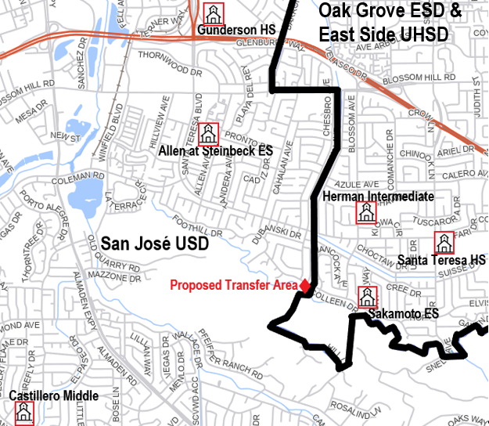
Source map: US Census Bureau
The County Committee has a long history of territory transfer requests where a primary rationale by petitioners is that schools of the district desired are closer to their homes than are the schools of the district in which they are residents. As a result, the County Committee, after considerable study of the issues countywide, adopted a “Geographic Isolation” policy. This policy outlines the criteria by which the County Committee determines if an extreme hardship exists regarding the duration and safety of home-to-school commutes. The County Superintendent stated, in the analysis prepared for the County Committee, that the proposed territory transfer did not meet those extreme hardship criteria. No County Committee member concerns regarding the home-to-school commute were noted in the minutes of any County Committee meeting.
The CDE agrees with the County Superintendent. Although the commutes to San José USD schools are longer than are commutes to schools in the Oak Grove ESD and the East Side UHSD, it does not appear to the CDE that the differences represent a significant hardship, especially given the availability of district-provided home-to-school transportation services in the San José USD.
Regardless, approval of the transfer does little to address any local concern regarding commute duration, since many neighboring homes would remain under the existing conditions even if the transfer is approved (see figure 2 in attachment 2).
In addition to the differences in commute distances, petitioners note that the commutes to San José USD schools involve travel on busier streets with higher speed limits, more lanes, and greater traffic volume than commutes to Oak Grove ESD and East Side UHSD schools, which are along residential streets. Although the petitioners described commute conditions that they believe would cause safety concerns, they provided no data regarding any specific safety issues related to those conditions.
As with the commute duration issue, the County Superintendent recommended that the safety concerns noted by the chief petitioners did not meet the County Committee’s “Extreme Hardship” criteria. Again, no County Committee member concerns regarding safety issues with the home-to-school commute were noted in the minutes of any County Committee meeting.
The CDE agrees with the County Superintendent. It does not appear to the CDE that the safety concerns raised by the petitioners represent a significant hardship, especially given the availability of district-provided home-to-school transportation services. Again, approval of the transfer does little to address any local concern regarding potential commute safety since many neighboring homes would remain under the existing conditions.

Community Identity
Petitioners claim that they identify more strongly with the communities within the Oak Grove ESD and the East Side UHSD. They further note that (1) the proximity of schools in these two districts makes it easier for parents to participate in extracurricular and school-centric activities; and (2) the schools in these districts are in proximity to their daily commute patterns.
It is CDE’s position that community identity is not measured by the individual circumstances and the personal convenience of a small handful of current residents in a neighborhood. Instead, it must be based on the circumstances of the entire neighborhood and surrounding neighborhoods. The CDE sees no support for the petitioners’ claims of stronger community identity with homes and neighborhoods immediately east of their homes compared with homes and neighborhoods immediately west and directly across the street (see figure 2 of attachment 2).
Similarly, schools in proximity to daily commute patterns are, in the opinion of CDE, circumstances specific to the current residents of a home. If daily commute patterns of subsequent residents involved transit to the job-rich city center of San José (and nearby “Silicone Valley” businesses), it is likely that commute patterns would differ significantly (see figure 3 of attachment 2).
Regardless, approval of the transfer would do little to address any local concern regarding alignment with individual commute patterns in the neighborhood since many neighboring homes would remain under the existing conditions.
The CDE agrees with the affected school districts and observations of County Committee members that such individual circumstances are best addressed through other processes (i.e., interdistrict transfer agreements) rather than through the territory transfer process.

7.2 Potential Concerns Regarding the Proposed Transfer
The SBE, even if it determines the transfer substantially meets EC Section 35753 conditions, may consider any concerns that warrant reversing the County Committee’s action to approve the proposal. Concerns raised by the affected districts include:
- Availability of other processes, especially interdistrict transfer agreements, are more appropriate to address issues raised by the petitioners.
- Precedent for future territory transfer petitions.
These concerns, along with an additional CDE concern, are examined in greater detail in the following paragraphs.

Availability of Interdistrict Attendance Agreements
The purpose of interdistrict attendance agreements (EC Section 46600) is to provide parents the ability to address individual circumstances by allowing their students to attend schools in another district. The affected districts state that interdistrict attendance agreements are readily available for parents in this area. Petitioners note that such agreements must be renewed annually and does not provide certainty that the desired districts will approve transfer and, if they do approve them, that the desired schools will be available.
No current student from the proposed transfer area has attended a school in the San José USD. The students have attended other elementary school districts (including the Oak Grove ESD) under approved interdistrict attendance agreements. The CDE agrees with the affected districts that the issues raised by petitioners are best addressed through the interdistrict attendance agreement process and not through a territory transfer.
The CDE further notes that district disapproval of an interdistrict attendance agreement may be appealed to the County Board of Education. Reasons for appeal, which are established by the Board of Education in its policies, include: substantial danger to the student's health or safety; severe and demonstrated hardship to parents/guardians; and other exceptional or extraordinary circumstances. The policies clearly state that hardship excludes inconvenience to the parents/guardians or matters of preference.

Socio-economic Differences between Schools
Although the three affected school districts are relatively equivalent on socio-economic measures (see table 2 of this attachment), similar comparisons between schools (the San José USD schools to which the neighborhood containing the proposed transfer area currently are assigned and the Oak Grove ESD/East Side UHSD schools that students would attend if the transfer was approved) produce a different result.

Table 4: Socio-economic Comparisons in Affected Schools
District | School | EL | FRPM | SED
San José USD | Allen @ Steinbeck Elementary | 26.8% | 57.8% | 60.3%
Oak Grove ESD | Sakamoto Elementary | 14.7% | 10.6% | 11.4%
San José USD | Castillero Middle | 11.7% | 25.9% | 28.0%
Oak Grove ESD | Herman Intermediate | 7.1% | 13.2% | 14.9%
San José USD | Gunderson High | 17.1% | 48.5% | 54.3%
East Side UHSD | Santa Teresa High | 5.6% | 17.2% | 19.5%
Table 4 depicts the percentages of students who are EL, in the FRPM program, and are SED in these schools. As can be seen, the percentages of students in these categories are significantly higher in the San José USD schools compared to the students in the Oak Grove ESD/East Side UHSD schools. The differences are particularly pronounced at the elementary school level, with almost 58 percent of students eligible for the FRPM program and over 60 percent labelled as SED at the San José USD elementary school—while approximately 11 percent of students at the Oak Grove ESD elementary school are in each of those categories.
The CDE also provides the racial/ethnic composition of the affected schools in table 1 of attachment 2.

Precedent for Future Transfer Petitions
In the past, the CDE has been reluctant to make recommendations that, in its opinion, could promote similar, and significant, additional transfers. In past cases, the CDE had identified the following factors that could establish a precedent for future transfer attempts.
- The territory in the transfer petition is part of, or adjacent to, previous transfer efforts.
- Similarities exist between the territory in the transfer proposal and the territory in previous transfer attempts.
- Petitioners’ reasons for the transfer (as provided in their petition), and other circumstances specific to the transfer proposal, could apply to future attempts to transfer the territory of these surrounding areas.
Existence of the above factors has led to long-term efforts in the state (and especially in Santa Clara County) to move territory from a district (or districts) perceived to be less desirable to a district (or districts) perceived to be more desirable:
- There have been multiple efforts to transfer portions of the city of Menlo Park (San Mateo County) from the Ravenswood City Elementary School District (CESD) to the Menlo Park CESD. These efforts began with an approval of a territory transfer in 1983 and are ongoing. The SBE last heard an appeal of a local disapproval of a petition to transfer territory from the Ravenswood CESD to the Menlo Park CESD at its September 2018 meeting—at which time it affirmed the decision of the San Mateo County Committee to disapprove the transfer. Similar efforts currently are under local consideration.
- There have been long-term efforts to transfer portions of the city of Saratoga and the town of Los Gatos (Santa Clara County) from the Campbell Union High SD (and its components) to the Los Gatos-Saratoga Union High SD (and its components).Those efforts began with approvals of territory transfers in 1994 and 1996 and, as with the Ravenswood CESD, continue. The SBE most recently heard appeals from three separate actions of the Santa Clara County Committee to disapprove such transfers at its January 2019 meeting—the SBE affirmed the local action in each appeal.
The current territory transfer proposal does not meet the first two factors described above, since the CDE is unaware of previous efforts to transfer territory involving the affected districts. However, the CDE believes that other circumstances specific to the current proposal could provide an impetus for future territory transfer attempts, including:
- Proximity of schools; and
- Differences in student socio-economic status at the affected schools.
The CDE agrees with the affected districts that, given these conditions, approval of this transfer proposal could establish a precedent for future territory transfer efforts.

7.3 CDE Recommendation Regarding Reasons and Concerns
The chief petitioners have provided reasons that they believe justify reversal of the County Committee action (and approval of the transfer), while all three affected school districts provide rationale for why the SBE should affirm the action of the County Committee to disapprove transfer of the two homes currently in the San José USD.
The CDE does not find that any of the reasons offered by the petitioners make a compelling enough case to reverse the local action to disapprove the proposed transfer of territory (see section 7.1 of this attachment). The CDE also notes that the County Committee did not identify any local educational need or concern that would be addressed by approval of the transfer.
The County Committee also did not identify any specific reason to disapprove the transfer. However, the CDE does find concerns that are sufficient to disapprove the transfer (see section 7.2 of this attachment).
It is the CDE’s recommendation that the action of the County Committee should be affirmed by the SBE. Both the CDE and the SBE give considerable weight to local decisions regarding territory transfer proposals. In this case, the County Committee found no local educational need or concern sufficient to approve the transfer proposal and, subsequently, disapproved it. The CDE believes that the County Committee is the best position to understand the local educational needs and concerns of the affected districts and communities.

8.0 Amendments to the Territory Transfer Proposal: Area of Election
The SBE has authority to amend or add certain provisions to any petition for reorganization. Pursuant to EC Section 35756, the SBE is required to establish the election area if its action results in approval of a district reorganization. The following information details the CDE recommendation regarding this provision.
District opposition to a territory transfer approved by a County Committee is one of the factors that triggers a local election (see EC sections 35709 and 35710). All three affected school districts are on record opposing the territory transfer—thus, final approval of the transfer must be through approval at a local election. The County Committee disapproved the territory transfer—therefore, it had no obligation to establish an election area as the next step in the approval process. If the SBE reverses the action of the County Committee, it must determine the territory in which this election will be held (pursuant to EC Section 35756).
The “default” election area in EC Section 35732 is the territory proposed for reorganization (i.e., the proposed transfer area). The SBE may expand the election area if it determines that conditions warrant such expansion.

8.1 Area of Election Principles
In establishing the area of election, the CDE and SBE follow the legal precedent set by the California Supreme Court in Board of Supervisors of Sacramento County, et al. v. Local Agency Formation Commission (1992) 3 Cal. 4th 903 (the “LAFCO” decision). LAFCO holds that elections may be confined to within the boundaries of the territory proposed for reorganization (the “default” area), provided there is a rational basis for doing so. LAFCO requires we examine: (1) the public policy reasons for holding a reorganization election within the boundaries specified; and (2) whether there is a genuine difference in the relevant interests of the groups that the election plan creates.
A reduced voting area has a fair relationship to a legitimate public purpose. State policy favors procedures that promote orderly school district reorganization statewide in a manner that allows for planned, orderly, community-based school systems that adequately address transportation, curriculum, faculty, and administration.
Discussion of other judicial activity in this area is warranted. In a case that preceded LAFCO, the California Supreme Court invalidated an SBE reorganization decision that approved an area of election that was limited to the newly unified district. As a result, electors in the entire high school district were entitled to vote (Fullerton). The Fullerton court applied strict scrutiny and required demonstration of a compelling state interest to justify the exclusion of those portions of the district from which the newly unified district would be formed.

8.2 Recommended Area of Election
The Fullerton case does not require that the SBE conduct a different analysis than that described above. The LAFCO decision disapproved the Fullerton case, and held that absent invidious discrimination, the rational basis approach to defining the election area applied. In this matter of the proposed transfer of territory from the San José USD to the Oak Grove ESD and the East Side UHSD, no discrimination, segregation, or racial impacts are identified. Accordingly, the LAFCO standard and analysis applies.
The CDE finds no reason to believe that the proposed transfer would have a significant effect on the present or future racial composition of any affected district, or have any significant negative fiscal effect. Therefore, the CDE recommends that the election area only be the territory proposed for transfer if the SBE acts to reverse the County Committee’s disapproval of the territory transfer proposal. Since the County Committee disapproved the territory transfer petition, it took no action to establish an election area.
The CDE notes, however, that the above-recommended election area is uninhabited territory pursuant to EC Section 35517. If the SBE acts to reverse the County Committee disapproval of the transfer, and assuming the SBE does not expand the election area, no election would be held since elections cannot be conducted in uninhabited territory (EC Section 35710.1).

9.0 State Board of Education Action
Subdivision (c) of EC Section 35710.5 provides that the SBE, upon receiving an appeal from an action of a County Committee, may review the appeal (either in conjunction with a public hearing or based solely on the administrative record) or ratify the County Committee’s decision by summarily denying review of the appeal. Past practice of the SBE has been to hear all appeals in conjunction with a public hearing—thus, the assumption in this section is that the SBE will conduct a public hearing as part of its review.

9.1 State Board of Education Options
The SBE has the following three options for this territory transfer appeal:
- The SBE may review the appeal in conjunction with a public hearing.
- Following review of the appeal, the SBE must affirm or reverse the action of the County Committee.
- If the proposal will be sent to election, the SBE must determine the territory in which the election is to be held.
- The SBE may reverse or modify the action of the County Committee in any manner consistent with law.
- The SBE may request additional information regarding the appeal or the territory transfer—and choose not to act until a later meeting.
- The SBE, pursuant to EC Section 35720, may direct the County Committee to formulate plans and recommendations for an alternative reorganization. The County Committee then would report back to the SBE regarding its actions.

9.2 California Department of Education Findings
The CDE makes the following findings regarding the territory transfer proposal:
- All minimum threshold standards of EC Section 35753 are substantially met. This finding corresponds to the County Committee’s determination that all such conditions are substantially met.
- The appellants provided, in their appeal, no valid reasons to reverse the action of the County Committee.
- There is no compelling local educational reason to transfer the two homes from the San José USD to the Oak Grove ESD and the East Side UHSD.
- There are compelling local educational concerns to justify affirming the County Committee decision to disapprove the proposed territory transfer.

9.3 Recommended Action
The CDE recommends that the SBE affirm the action of the County Committee to disapprove the proposal to transfer territory from the San José USD to the Oak Grove ESD and the East Side UHSD.
If the SBE acts to reverse the local decision (thus approving the transfer), it must establish an election area. Under this circumstance, the CDE recommends that the SBE not expand the area for the election beyond the territory proposed for transfer. Note however, that such action would result in no election being conducted since the territory proposed for transfer is defined in statute as uninhabited—elections cannot be held in uninhabited territory.

ATTACHMENT 2
Supplementary Maps and Tables

Figure 1: Map of Affected Districts including all Components of East Side UHSD
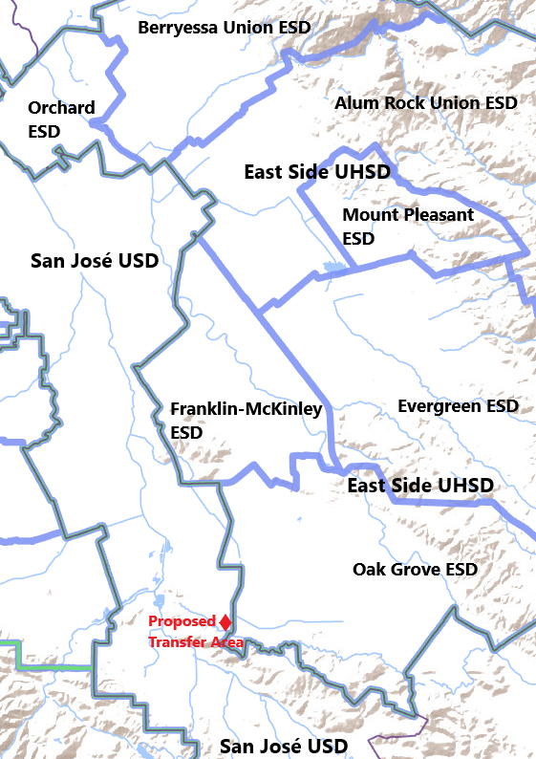
Source map: US Census Bureau

Figure 2: Map of Transfer Area Showing Surrounding Residential Areas
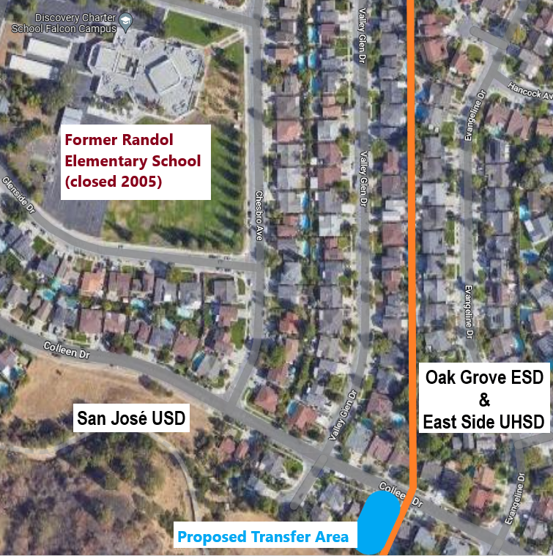
Source map: Google Maps ©

Figure 3: Map Depicting Transfer Area and Downtown San José
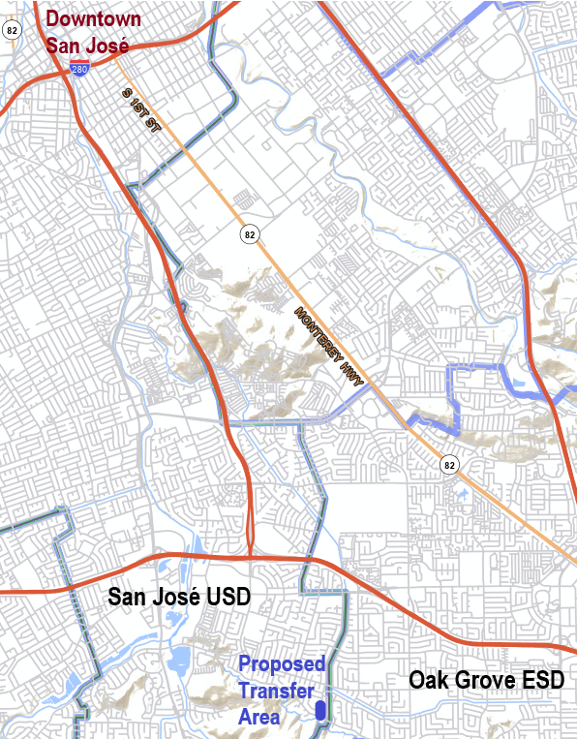
Source map: US Census Bureau

Table 1: Percent Race/Ethnicity in Affected Schools (2021–22 CALPADS)
District* | Asian | Hispanic or Latino | White | Other**
Allen @ Steinbeck Elementary (San José USD) | 4.7% | 66.8% | 17.3% | 11.3%
Sakamoto Elementary  (Oak Grove ESD) | 26.7% | 28.2% | 28.7% | 16.4%
Castillero Middle  (San José USD) | 14.2% | 41.2% | 33.7% | 10.9%
Herman Intermediate  (Oak Grove ESD) | 26.0% | 35.9% | 21.4% | 16.7%
Gunderson High  (San José USD) | 12.0% | 63.0% | 12.1% | 13.0%
Santa Teresa High  (East Side UHSD) | 24.6% | 40.6% | 21.0% | 13.7%
* Students in the “Not Reported” CALPADS category are excluded from
the enrollment figures and are omitted from all calculations for this table.
** The “Other” category includes “African American,” “American Indian or
Alaska Native,” “Filipino,” “Pacific Islander,” and “Two or More.”

Pursuant to EC sections 35709 and 35710, a county committee may approve a territory transfer only if it finds all conditions in EC Section 35753 substantially met.
The California School Dashboard is California’s accountability and continuous improvement system for local educational agencies, schools, and student groups: California School Dashboard - California School Dashboard and System of Support (CA Dept of Education).
Two public school students currently reside at the first home. The owners of the second home reported (during local consideration of the petition) that their children were beyond school-age, and had attended San José USD schools. These owners have since sold the home (August 2022). The new owners indicate that they support the transfer—it is unknown if they have school-age students.
Recent legislation (Statutes of 2020, chapter 24 [Senate Bill 98]) revised EC Section 35710.5 so that appeals may be submitted only in response to a county committee action to approve a territory transfer. This current appeal from an action to disapprove is allowed because it was filed prior to July 1, 2020, the date at which the change was effective (see EC Section 35710.5[a][2]).
No video-recording or transcripts of the meeting at which the County Committee disapproved the proposed territory transfer exist. Thus, CDE staff bases its findings on the approved minutes of this meeting, as well as minutes of the two pubic hearings held by the County Committee.
The San José USD transportation policy may be viewed at: Transportation Information | Transportation | Your Resources | San José Unified School District (sjusd.org).
The County Committee is not required to find a compelling reason to disapprove a proposal—the lack of a compelling reason to approve is sufficient to disapprove a territory transfer petition (see section 5.3 of this attachment).

