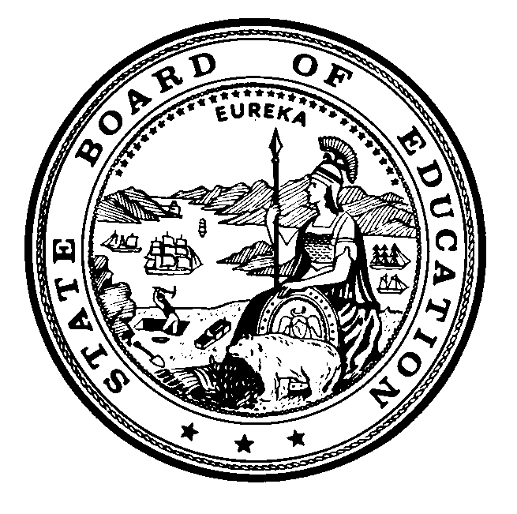
Instructional Quality Commission
An Advisory Body to the California State Board of Education

Instructional Quality Commission Meeting Dates
Commission will consider for approval on September 20, 2023

2024 Dates
Revised - Wednesday–Thursday, January 24–25, 2024
Wednesday–Thursday, March 20–21, 2024
Wednesday–Thursday, May 15–16, 2024
Wednesday–Thursday, July 17–18, 2024
Wednesday–Thursday, September 18–19, 2024
Wednesday–Thursday, November 20–21, 2024
All meetings, unless otherwise indicated, will be held at the
California Department of Education Building
1430 N Street
Sacramento, CA 95814

California Department of Education, September 2023.

