Elementary and Secondary Education Act
Title II, Part A

Teacher Equity Plan

Submitted by the California State Board of Education in association with the State Superintendent of Public Instruction
September 16, 2010
Background:
Level A: Required Data Table

State Fiscal Stabilization Fund (SFSF) Indicator (a)(2) requires the state to,

…confirm whether the State’s Teacher Equity Plan fully reflects the steps the State is currently taking to ensure that students from low-income families and minority students are not taught at higher rates than other students by inexperienced, unqualified, or out-of-field teachers.

California’s Teacher Equity Plan (TEP) was originally addressed as Requirement Six of the State’s Plan for Highly Qualified Teachers (HQT), written and approved by the State Board of Education (SBE) in 2006. The TEP is organized around five guiding questions from the U.S. Department of Education (ED). This updated plan satisfies the requirements for SFSF Indicator (a)(2).

Response Area One: Does the Revised Plan include a Written Equity Plan?

The SBE and the California Department of Education (CDE) believe that teachers are important component of academic success and, therefore, key to closing the achievement gap between our poor and minority students and their more affluent peers. A teacher, who is appropriately credentialed, has a deep understanding of the content he or she teaches, and has been trained in a variety of instructional strategies, is in the best position to aid California students in reaching academic proficiency. The SBE and the CDE are committed to ensuring that highly qualified, experienced, and effective teachers are accessible to all students, regardless of ethnicity or socioeconomic status.

In order to meet this commitment, local educational agencies (LEAs) that do not provide all students’ access to highly qualified teachers (HQT) are required to create and implement a written Equitable Distribution Plan (EDP) for teachers and administrators.

The EDP is one element of an overall program designed to assist LEAs in their efforts to reach the goal of 100 percent HQT and the equitable distribution of those teachers. This program, called Compliance, Monitoring, Intervention, and Sanctions (CMIS), was authorized and funded by the California Legislature in 2006. The table below provides an overview of the CMIS levels, criteria for entry, and requirements.

Table 1: CMIS Overview
 | Criteria for Entry | Requirements
Level A | Failed to meet 100% HQT for 1 year | LEA must submit Teacher Action Plan (TAP)
Level B | Failed to meet 100% HQT for 2 consecutive years | LEA must create and implement an Equitable Distribution Plan (EDP)
Level C | Failed to meet 100% HQT and Adequate Yearly Progress (AYP) for 3 consecutive years | LEA must enter into a fiscal agreement with CDE regarding the expenditure of Title II, Part A funds

Those LEAs that meet the criteria for entry into CMIS Level B are required to write an EDP in order to address the following the Elementary and Secondary Education Act (ESEA) statutes:

Sections 2141(a) and 2141(b) require that each LEA that has not met their annual measurable objective (AMO) for HQT for two consecutive years has an improvement plan in place.

Section 1112(c)(1)(L) requires that LEA plans include an assurance that through the implementation of various strategies, poor and minority students are not taught at higher rates than other students by inexperienced, unqualified, or out-of-field teachers.

Sections 2123(a)(4)(A) and 2123(a)(4)(B) require that LEAs develop and implement initiatives to promote the retention of highly qualified teachers and principals, particularly within elementary schools and secondary schools with a high percentage of low-achieving students, including programs that provide: (A) teacher mentoring from exemplary teachers, principals, or superintendents;(B) induction and support for teachers and principals during their first 3 years of employment as teachers or principals, respectively.

For purposes of ensuring equitable distribution relative to these ESEA requirements, LEAs use the following criteria:

ESEA language | EDP Definition
“poor and minority students” 1112(c)(1)(L) | Schools in which 40% or more of the student population are eligible for Free or Reduced Price Lunch (FRPL)
“schools with a high percentage of low-achieving students”  2123(a)(4)(A) and 2123(a)(4)(B) | Schools that are in Program Improvement status (PI)

The EDP has four requirements, shown in Table 2, that assist LEAs in creating EDP that address the ESEA regulations.

Table 2: EDP Requirements and Legal Citations
 | 1 | 2 |  | 3 |  | 4
Requirement Overview | Teacher Qualifications |  | Teacher Experience and Support |  | Principal Experience and Support |  | Recruitment and Retention
Requirement Goals | a. 100% HQT and fully-trained teachers |  | - No under-qualified teachers at high-poverty or low-performing schools |  | a. Equitable distribution of experienced principals |  | a. Equitable retention rates at high-poverty or low-performing schools
Requirement Goals | b. Needs-based professional development provided |  | - Interns equitably distributed  c. Support/ induction for new teachers provided |  | - Needs-based professional development and demonstrated support for new principals provided |  | b. Effective recruitment policies district-wide
ESEA Sections and Citation | 2141(a)  2141(b) |  | 1112(c)(1)(L)2123(a)(4)(A) 2123(a)(4)(B) |  | 2123(a)(4)(A) 2123(a)(4)(B) |  | 2123(a)(4)(A) 2123(a)(4)(B)

In order to demonstrate that each of the four requirements have been addressed, the LEA must submit its EDP for approval to CDE staff. Each requirement has associated data tables, guiding questions, and documentation that are submitted as part of the review process.
3
4
Response Area Two: Does the prevised plan identify where inequities in teacher assignments exist?

California’s TEP requires LEAs to develop and implement a detailed and coherent set of specific activities to ensure that poor and minority children are not taught by inexperienced, under-qualified, or out-of-field teachers at higher rates than are other children in the district [ESEA 1111(b)(8)(C)].

Requirements One and Two of the EDP are specific to the issue of teacher assignment, and direct LEAs to pay close attention to how qualified and experienced teachers and administrators are assigned and supported.

LEAs must conduct a thorough teacher equity analysis using site-level data. Further analysis is facilitated by answering the following guiding questions as part of the EDP submission.

Table 3: Guiding Questions Relevant to Teacher Assignments
- Within the last three years, have teachers with Provisional Intern Permits (PIPs) been placed in high-poverty, high-minority, or program improvement schools?*
- Within the last three years, have teachers with Short Term Staff Permits (STSPs) been placed in high-poverty, high-minority, or program improvement schools?
- Are more interns placed at high-poverty, high-minority, or program improvement schools? If all schools are high-poverty, are there more interns at schools that have been in program improvement (PI) status for extended periods of time (i.e.,, schools that have entered corrective action)?
- In what ways do district administrators work to achieve equitable distribution of fully prepared, experienced teachers among district schools?
- What evidence is there that the LEA Human Resources Department takes into consideration the HQT and experience staffing needs of program improvement schools when placing newly hired teachers?
- What evidence is there that the district supports PIPs, STSPs, and Interns?

The EDP requires LEAs to address concerns raised by the teacher equity analysis. For example, if the analysis identifies the use of PIPs and STSPs, the plan must include board-approved policy or contract language ensuring that non-credentialed teachers holding PIPs and STSPs are not assigned to high poverty or PI schools. Additionally, local board-approved policy or contract language is required ensuring that interns are not placed in high poverty or PI schools in greater numbers than in schools with low-poverty or higher levels of achievement.

Response Area Three: does the revised plan deliniate specific strategies for addressing inequity in teacher assignments?

LEAs are required to submit documentation of specific strategies addressing inequities in teacher and principal assignment as part of their EDP. The review and approval process of the EDP by CDE staff is designed to ensure that the LEA’s strategies are relevant and actionable. EDPs submitted to the CDE are reviewed for content and specificity. Two trained reviewers then score each plan compared to a rubric that has been prepared for this purpose. If there is disagreement between readers, a third reader is then used to either approve the plan, or to return it to the LEA to ask for further completeness on specific items or strategies to address issues of equitable distribution.

In order for an EDP to be approved, it must contain the following required documents, each of which are centered around specific strategies related to the equitable distribution of teachers and principals.

Table 4: EDP Required Documentation
1. Submit Requirement One Data Tables, Guidance Documents, and
a. Non-Compliant Teacher Action Plan
b. Professional Development Needs Assessment
c. Professional Development Action Plan
2. Submit Requirement Two Data Table, Guidance Documents, and
a. Local board-approved policy or contract language guiding STSP and PIP placement and the equitable distribution of interns
b. Documentation of new teacher support system
3. Submit Requirement Three Data Table, Guidance Documents, and
a. Documentation of principal support system
4. Submit Requirement Four Data Table, Guidance Documents, and
a. District Recruitment Plan
b. District Retention Plan

Response Area Four: does the revised plan provide evidence for the probable success of the strategies it includes?

LEAs enter into CMIS monitoring the year after their EDP has been approved. In
August 2009, a new online monitoring system was created, allowing quantitative data regarding the implementation of LEAs’ EDP to be collected. This data was used to conduct an analysis of EDP implementation for 206 LEAs.

Overall Summary of Data Collected:

A total of 206 LEAs reported data for 3,877 schools.

- 1206 schools were reported for LEAs that wrote an EDP in 08–09.
- 2670 schools were reported for LEAs that wrote an EDP in 07–08.

Of the 3,877, a total of 843 schools were not in PI or high-poverty schools. A total of 3,035 schools were high poverty (40 percent or more students receiving Free and Reduced Price Lunch [FRPL]) or were schools in PI. Of the 3,035 schools:

- 3,000 schools had 40 percent or more students participating in FRPL.

- 1,545 schools were in PI.

- 1,510 schools were in PI and had 40 percent or more students participating in FRPL.

Figure 1: Characteristics of schools reported in CMIS Monitoring
Not in PI or high poverty:
843 schools

Program Improvement
High Poverty

1,510
Schools

1,490 Schools

35 Schools

One hundred and fourteen (55.34 percent) LEAs that submitted data had at least one school that is either a high-poverty site or is in PI status and at least one school that is not a high poverty site and is not in PI status. Data from these LEAs were used to conduct an analysis of the success of the current CMIS program with regards to the equitable distribution of teachers and administrators between high poverty, PI sites and those with lower rates of poverty or higher levels of student achievement. Four areas of analysis were conducted:

    - The use of under-qualified teachers
    - The distribution of interns
    - Teacher resignation rates
    - Principal experience levels

Analysis Area One: What is the pattern of PIPs and STSPs usage (i.e., under-qualified teachers) at high poverty or PI schools and how has it changed since EDP implementation?

Table 5 shows the use of PIPs and STSPs by LEAs in CMIS Monitoring over a three year period.

Table 5: Percentage of LEAs using PIPs and STSPs
 | 07–08  School Year | 08–09  School Year | 09–10  School Year
Percent of LEAs that used no PIPs or STSPs | 65% | 75% | 89%
Percent of LEAs that used 1 or more PIP or STSP | 35% | 25% | 11%

This data suggests that for LEAs in CMIS monitoring, the use of under-qualified teachers has declined over time. Upon entry into the CMIS program, 35 percent of participating LEAs used PIPs or STSPs, while after EDP implementation only 11 percent continued to use under-qualified teachers.

Figure 2 shows a frequency distribution of the average number of interns across the
07–08, 08–09, and 09–10 school years.

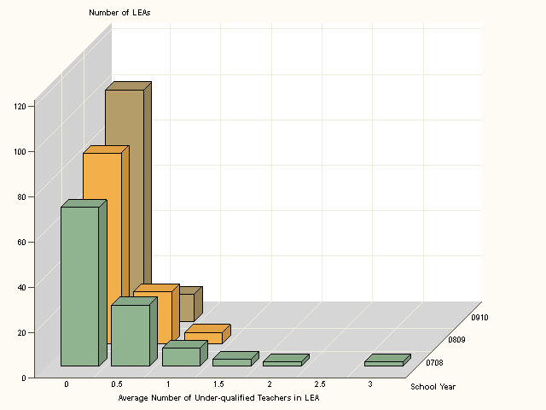

Figure 3 displays the average number of under-qualified teachers for each school type within the LEAs in CMIS monitoring.

There are no statistically significant differences in LEA under-qualified teacher usage between schools that are high-poverty or in PI and schools that are not high-poverty and not in PI. However, there are statistically significant differences in average LEA under-qualified teacher usage from the 2007–08 school year to the 2008–09 school year and from the 2008–09 school year to the 2009–10 school year.

Analysis Area Two: What is the pattern of distribution of interns in LEAs in CMIS monitoring and how has it changed since EDP implementation?

Figure 4 is a frequency distribution of the average number of interns across the 07–08, 08–09, and 09–10 school years.

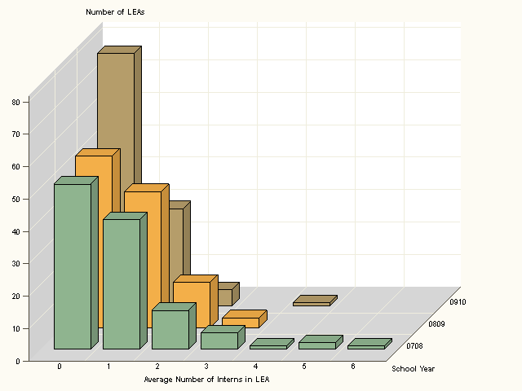

Figure 5 displays the average number of interns for each school type within the LEAs in CMIS monitoring.

There is a statistically significant difference (p=.0498) between the average number of interns in schools that are high-poverty or in PI and schools that are not high-poverty and not in PI for the 2007–08 school year. There are also statistically significant differences in average LEA intern usage from the 2007–08 school year and the
2009–10 school year. This data suggests that for these LEAs in the CMIS program, interns (teachers with less experience) are placed in significantly higher proportions at schools that are high poverty or in PI. Since implementation of EDP the use of interns has declined.

Table 6 provides more information about intern distribution by school type (i.e., high poverty or in PI verses not high poverty and not in PI):

Intern Distribution
 | 2007–08  School Year |  | 2008–09  School Year |  | 2009–10  School Year
 | Mean | Standard Deviation | Mean | Standard Deviation | Mean | Standard Deviation
High Poverty or in PI | 0.85 | 1.00 | 0.75 | 0.76 | 0.46 | 0.56
Not High Poverty, Not in PI | 0.74 | 1.36 | 0.60 | 1.05 | 0.35 | 0.68
LEA Average (weighted by number of schools) ( n = 114) | 0.89 | 1.08 | 0.73 | 0.70 | 0.45 | 0.52

Area of Analysis Three: What are the patterns of resignation in high-poverty or PI schools for LEAs in the CMIS program and how have they changed since EDP implementation?

Figure Six shows a frequency distribution of the average number of teacher resignations across the 07–08, 08–09, and 09–10 school years.

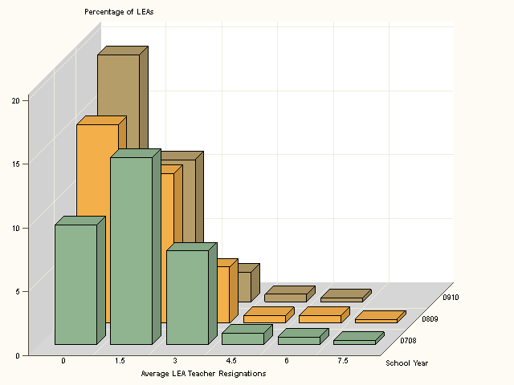

Figure Seven is a chart displaying the average number of resignations for each school type within LEAs in CMIS Monitoring.

There is a statistically significant difference (p < .0001) between the average number of teacher resignations between schools that are high-poverty or in PI and schools that are not high-poverty and not in PI for the 2007–08 school year. However, there is not a statistically significant difference in average teacher resignations between school types for the 2008–09 and the 2009–10 school years. This data indicates that for LEAs in the CMIS program, resignations were significantly higher at PI or high poverty sites. Two years after EDP implementation, there is no significant difference between the number of resignations at high poverty, PI sites and other sites in the district.

Table Seven provides additional information about the teacher resignations by school type (i.e., high poverty or in PI verses not high poverty and not in PI):

Teacher Resignations
 | 2007–08  School Year |  | 2008–09  School Year |  | 2009–10  School Year
 | Mean | Standard Deviation | Mean | Standard Deviation | Mean | Standard Deviation
High poverty or In PI | 1.64 | 1.5 | 1.30 | 1.4 | 0.93 | 1.03
Not high poverty, not in PI | 1.28 | 1.64 | 1.13 | 1.81 | 0.86 | 1.28
LEA average (weighted by number of schools) | 1.60 | 1.34 | 1.31 | 1.37 | 0.94 | 1.03

Area of Analysis Four: What are the patterns of principal experience levels in high-poverty or PI schools for LEAs in the CMIS program and how have they changed since EDP implementation?

Figure Eight shows the distribution of average principle experience in years across LEAs with high poverty and PI schools and not high poverty and not in PI schools.

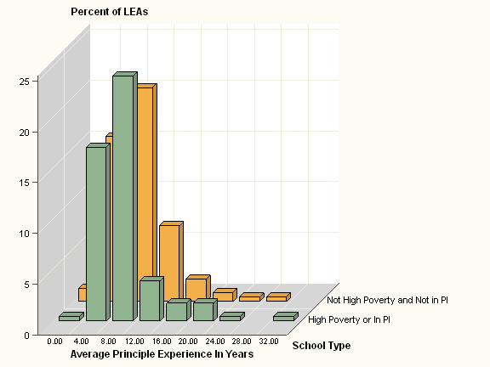

The difference in average principle experience across the school types (i.e., high poverty or PI schools and not high-poverty and not PI schools) is not statistically significant.

- 61 (53.50 percent) of LEAs in CMIS Monitoring have on average more experienced principles in schools that are high-poverty or in PI status verses schools that are not high-poverty and not in PI.

- 53 (46.49 percent) of LEAs in CMIS Monitoring have on average more experienced principles in schools that are not high-poverty and not in PI verses schools that are high-poverty or in PI status.
Response Area Five: does the revised plan indicate that the SEA will examine the issue of equitable teacher assignments when it monitors leas, and how will this be done?

After the submission and approval of an EDP, there are four methods of monitoring conducted by the Title II Office in relation to the equitable distribution of HQT in each LEA. Between each of the four processes, a minimum of 250 LEAs are monitored each year

Categorical Program Monitoring (CPM): Through the CPM process and instrument, staff reviews LEAs’ EDP in comparison to placement of teachers at school sites.

Title Alignment: Through the alignment of Titles I, II, and III, those districts that are in sanctions for all three Titles are identified. That identification leads the Title II Office to offer intense support in the area of HQT and to monitor the execution of the LEA’s approved EDP.

Commission on Teacher Credentialing (CTC) web portal: The CTC has recently launched a web portal where district information can be reviewed. Title II staff randomly select 10 percent of the LEAs once a year that have submitted EDPs or EDP monitoring documents to ensure the data submitted aligns with CTC reports.

Equitable Distribution Monitoring: Monitoring tables are submitted y, in June, by LEAs that have previously submitted an EDP. LEAs submit quantitative data relative to the four requirements of the EDP to show progress towards implementation. LEAs must meet the release criteria for two years in order to qualify for release from CMIS. After two years of not meeting release criteria, LEAs must revise their EDP the following school year.
Release Criteria 1:
Fully certificated teachers in equity schools

Quantitative Benchmark: No PIPs/STSPs in high poverty or PI schools

Release Criteria 2: Interns equitably distributed

Quantitative Benchmark: Average n of interns at high poverty or PI sites is ≤ average n at all other sites

Quantitative Benchmark: Average years of experience at high poverty or PI sites is ≥ average at other sites

Release Criteria 3: Equitable levels of principal experience

Release Criteria 4a: Equitable retention of teachers in equity schools

Quantitative Benchmark: Teacher resignation and transfer rate at high poverty or PI sites is ≤ average at all other sites

Release Criteria 4b: Equitable retention of principals in equity schools

Quantitative Benchmark: Total n of out-of district transfers or resignations at high poverty or program improvement sites

