California department of education
Nutrition Services Division — 2010

Child Nutrition Information and Payment System

Food Distribution Program

User Manual

For Recipient Agency Users
Table of Contents
User Manual 1
Introduction 5
System Benefits and Features 5
User Manual 5
Getting Started 6
Accessing the System 6
Logging On 7
Content Overview 8
Programs Home Page 10
Food Distribution Program Home Page 10
Error Processing 12
Input Edits 12
Business Rule Edits 13
Selecting a Year 13
Agencies 14
Agencies Menu 14
Orders 14
Open Orders 15
Order Inquiry 18
Extended Storage Request 21
Shipping Inquiry 23
Shipment Overages, Shortages, & Damages Reporting 25
Surveys 27
Commodity Allocations 30
Allocation Inquiry 31
Decline Allocation 32
Invoices 34
Contract 35
Contract Packet 36
Contract Entitlement 40
Reports 43
About Reports 43
Report Parameters 44
Report 45
Security 46
Security menu 46
Change Password 46

Table of Figures
Figure 1: CNIPS Home Page 6
Figure 2: System Log On area 7
Figure 3: CNIPS Content Overview 8
Figure 4: Common Application Components–Screen Options (highlighted) 9
Figure 5: CNIPS Programs Page 10
Figure 6: Food Distribution Program Home Page 11
Figure 7: Input Error (Partial) 12
Figure 8: Warning Code and Description 13
Figure 9: Agencies Menu 14
Figure 10: Orders menu screen 14
Figure 11: Open Orders screen 15
Figure 12: Open Orders - SNP screen 15
Figure 13: New Order - SNP screen 15
Figure 14: Allocation Order Form - SNP screen 16
Figure 15: Agency Order - SNP screen (Order Number link) 17
Figure 16: Order Inquiry screen 18
Figure 17: Order Inquiry SNP screen 19
Figure 18: Agency Order - SNP screen (Order Number link) 20
Figure 19: Agency Order Inquiry - SNP screen (Activity link) 21
Figure 20: Extended Storage Request screen 21
Figure 21: Extended Storage Request - SNP screen 22
Figure 22: Extended Storage Request - SNP screen (New) 22
Figure 23: Shipping Inquiry screen 23
Figure 24: Shipping Inquiry screen 24
Figure 25: Shipping Inquiry screen 24
Figure 26: Overages, Shortages & Damages (OS&D) Reporting screen 25
Figure 27: Overages, Shortages & Damages (OS&D) Reporting screen 25
Figure 28: Overages, Shortages & Damages (OS&D) Report - SNP screen 26
Figure 29: Overages, Shortages & Damages (OS&D) Resolution - SNP screen 27
Figure 30: Survey Entry – Survey Search screen 28
Figure 31: Survey Entry – Available Surveys screen 28
Figure 32: Survey Form – Annual screen 29
Figure 33: Survey Form – Periodic screen 29
Figure 34: Survey Form - Processing screen 30
Figure 35: Commodity Allocations menu 30
Figure 36: Allocation Inquiry – Allocation Search screen 31
Figure 37: Allocation Inquiry – SNP screen 31
Figure 38: Commodity Allocation Report screen 32
Figure 39: Allocation Inquiry – Allocation Details screen 32
Figure 40: Decline Allocation screen 32
Figure 41: Decline Allocation - SNP screen 33
Figure 42: Decline Allocation - SNP screen 33
Figure 43: Invoices screen 34
Figure 44: FDP Invoices – SNP screen 34
Figure 45: FDP Invoices – SNP screen 35
Figure 46: Contract menu 36
Figure 47: Food Distribution (FDP) Contracts (selection) screen 36
Figure 48: Food Distribution Program Contract Packet– FDP screen 37
Figure 49: Agency Information Update/Annual Inventory Certification screen 38
Figure 50: Commodity Contact Profile screen 39
Figure 51: Contract Entitlement – SNP screen 40
Figure 52: Entitlement Distribution Detail – SNP screen 40
Figure 53: Contract Entitlement – SNP screen 41
Figure 54: Entitlement Distribution Adjustment – SNP screen 41
Figure 55: Entitlement Usage – SNP screen 42
Figure 56: Food Distribution Program Reports (Partial) 44
Figure 57: Report Parameter – Recipient Customer Contracts Report 44
Figure 58: Sample Report 45
Figure 59: Security Menu screen 46
Figure 60: Change Password screen 47

Introduction
1
Welcome to the California Department of Education (CDE) Child Nutrition Information and Payment System (CNIPS) user manual for the system’s Food Distribution Program (FDP) module. The CNIPS is a software solution for Nutrition Program management. This system utilizes the Internet to provide FDP users with efficient and immediate access to agency contracts, commodity ordering, entitlement, inventory and all other FDP functions.

System Benefits and Features
The CNIPS is a user-friendly Web application that allows State agency personnel and agency users to submit and approve documents via the Internet. Key system features include:
- A single software system, which manages information regarding agency contracts, entitlement, inventory, orders and many other Food Distribution Program (FDP) functions.
- A single database, which works behind the scenes to combine configuration information that can be utilized across the Child Nutrition Programs.
- The ability to save partially completed documentation on-line, allowing the user to complete the process at a later time.
- Individual User IDs and passwords for secure login to program functions and accurate tracking of user behavior.

User Manual
This user manual is intended for use by the CDE FDP Agency users. It is designed to provide a general understanding of how to use the system to perform FDP Module functions effectively and efficiently. To achieve this objective this manual will provide you with:
- A general explanation of each feature available
- Screen examples of system pages and forms
- Step-by-step instructions for utilizing the system features
- Tips and Notes to enhance your understanding of the system
2

Getting Started
Before you can begin using the CNIPS, you must be assigned a user ID and password by an administrator and granted access to the FDP Module. Once this is complete, you may use the Internet and your assigned user ID and password to access and log into the CNIPS. (System Setup is not covered in this manual.)

Accessing the System
You can access the CNIPS from any computer connected to the Internet by opening your Internet browser and entering the URL (shown below) in the address line:
-- https://www.cnips.ca.gov --
TIP: You can add this URL to your browser’s FAVORITES list or create a shortcut on your desktop for quicker access to the site. Refer to your browser or operating system help files for further information.
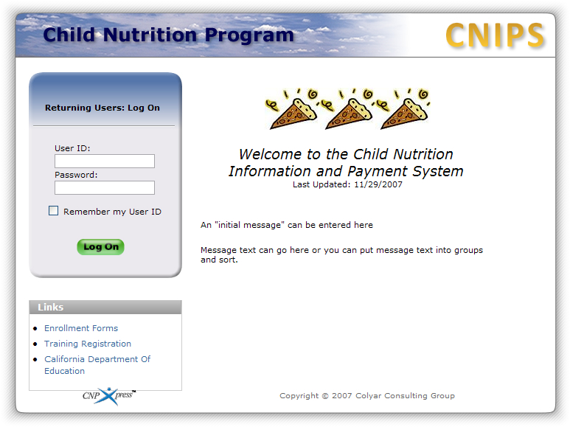
Figure 1: CNIPS Home Page

Logging On
To Log on
- Access the CNIPS by typing the URL into the address line of your Web browser of choice
-OR-
Open the CNIPS from your Desktop or Internet Favorites.
- In the Log On box, enter your User ID.
- Enter your Password.
The Password field is case-sensitive, so be sure to use upper and lower-case letters if necessary.
- Select Log On.
Note: If you do not have a User ID and Password, contact your Security Administrator.
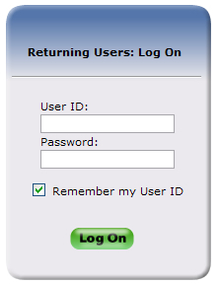
Figure 2: System Log On area
If this is your first time logging on, you will be required to change your password.
To change your password
- Select a new password and type it into the box provided.
Note: Default settings require a password from between six to twelve characters in length, one or more numbers and one or more symbols. However, these settings can be changed by state administrators within the Configuration module.
- Re-enter your new password for confirmation.
- Select Save to continue to the CNIPS programs page.
TIP: Strong, secure passwords contain between 6 and 15 characters, including numbers, upper-case, and lower-case letters.

Content Overview
The CNIPS contains key elements that provide basic information about your location within the system or that simplify basic tasks, such as system navigation. (A School Nutrition Program screen displays as an example. For general purposes, functions described here are identical for FDP screens.)
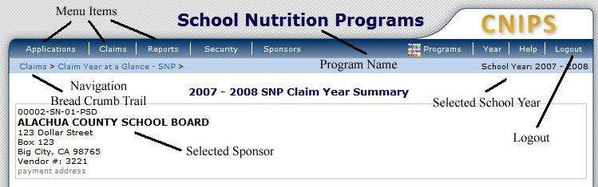
Figure 3: CNIPS Content Overview

Item | Description
Program Name | The selected program name appears in the gray area at the top of the page.
Menu Items | Menu items display on the blue menu bar at the top of the page. Selecting a menu item will take you to its menu page.
Note: Some users do not have access to all menu items. If you are unable to select on a particular menu item, you do not have the necessary security rights. Contact your administrator if you need additional help.
Navigation / Breadcrumb Trail | The navigation, or breadcrumb trail, shows your location within the system at all times. Selecting on a specific portion of the trail will bring you back to that particular screen.
Selected School Year | The selected school year displays on the right beneath the menu bar. Upon logging in, the newest program year will be the default selected school year.
Selected Agency | Your selected organization name and information displays as you perform tasks within the system.
Logout | The logout button displays in the menu bar. Logout before exiting the system.
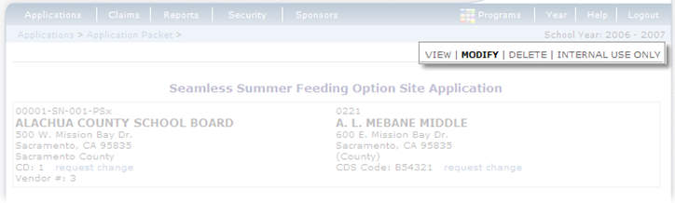
Figure 4: Common Application Components–Screen Options (highlighted)
Some screens in the application offer the user some or all of the following options: View, Add, Modify, Delete, and Internal Use Only. The Screen Options area is located on the right side of the screen directly beneath the colored bar. (A School Nutrition Program screen displays as an example. Functions are identical for FDP screens.)
The following table describes each of the possible screen options:
Item | Description
View | Presents the screen information in ‘view-only’ mode. In this mode, the user cannot modify any data.
Modify | Presents the screen in ‘modify’ mode. In this mode, the user can modify field data and save the data after pressing the save button at the bottom of the screen.
Add | Presents the screen in ‘add’ mode. In this mode, fields on the screen are empty and field data is enterable by the user. After selecting the save button, a new record is added with the information that was entered. (The screen example does not show this option.)
Delete | Deletes the current record displayed on the screen. The user will typically be presented with a confirmation screen to validate that they intend to delete the record.
Internal Use Only | (State users only) This is available for screens that have an Internal Use Only section which is typically at the bottom portion of the forms on the Application Menu. Selecting on this screen option will result in the internal use fields being editable. This option is only available to state users and as with all screen options, only those options for which users have security access will be available to that user.

Programs Home Page
Once you successfully log on, the Programs home page provides access to all of the Programs and Modules that comprise the CNIPS.
Actual access to specific programs and modules depends on a user’s security rights. Program tiles only display if the logged-in user has been granted access to the program. For example, agency users will not have access to the Accounting, Configuration, and Security tiles, because these programs are for State users only.
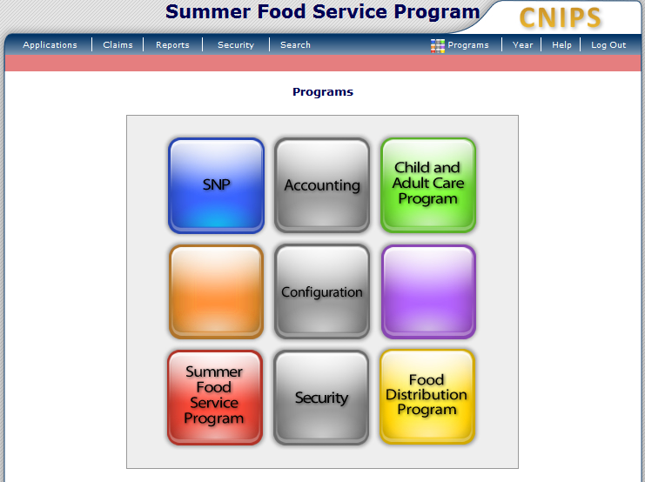
Figure 5: CNIPS Programs Page
Select this button | To
SNP | Display the School Nutrition Programs home page
Accounting | Display the Accounting Module home page
Child and Adult Care Program | Display the Child and Adult Care Food Program home page
Configuration | Display the Configuration Module home page
Summer Food Service Program | Display the Summer Food Service Program home page
Security | Display the Security Module home page
Food Distribution Program | Display the Food Distribution Program home page

Food Distribution Program Home Page
After logging on using your assigned user name and chosen password and selecting the Food Distribution Program button, you will be taken to the Food Distribution Program Home Page. All FDP menu functions are accessible from this screen within the blue menu bar.
To access the Food Distribution Program home page
- Log on to the CNIPS.
- On the Programs screen, select Food Distribution Program.
The FDP Module Home Page displays.
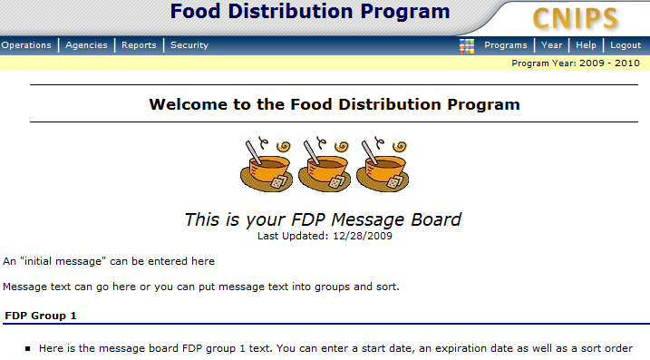
Figure 6: Food Distribution Program Home Page
From the FDP home page, you can select a menu item from the blue menu bar at the top of the page. The menu bar contains only menu items specific to the Food Distribution Program. The table below describes the features available for each menu option, which the remainder of this manual will discuss in detail:
Menu Item | Menu Features
Operations | Contracts – Manage FDP Contracts  Entitlement – Manage FDP Entitlement  Allocations – Create and Manage Commodity Allocations  Agency Orders – Manage Agency Orders  Shipping – Manage Agency Shipments  Surveys – Create and Manage Commodity Surveys  Inventory – Manage Inventory  Food Orders – Create and Manage Food Orders  Processors – Processors Applications and Activity Reports and Maintenance  Invoicing – Process Invoices  FDP Maintenance – FDP Maintenance
Agencies | Orders – Submit and Track Commodity Orders  Surveys - Survey Entry Forms  Commodity Allocations – View or Decline Commodity Allocations  Invoices – View/Print FDP Invoices  Contract - Submit and Maintain Annual Commodity Contract Packet and View Contract Entitlement
Reports | Report List—Contains all reports available in the FDP Module.
Security | Change Password – Access to Change Password for Logged-In User  User Manager - Displays User Manager for selected agency (if no agency has been selected, the agency Search screen will first display.)  Note: This menu item should be used when creating agency User IDs. The Security module (selected from the Programs screen) should be used when creating State User IDs.

Error Processing
All information entered and saved on the site is checked to ensure it conforms to data entry guidelines and system rules. The site performs two types of checks on information entered: Input Edits and Business Rule Edits.

Input Edits
Whenever you save information or proceed to a new screen, the system checks for Input Errors. These errors are generally typographical mistakes, such as entering a 4-digit Zip Code or entering characters in a numeric field. If a form contains an input error, the screen re-displays with the error code and description in red at the top of the page. These errors must be corrected before you can proceed.
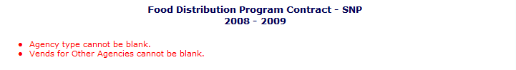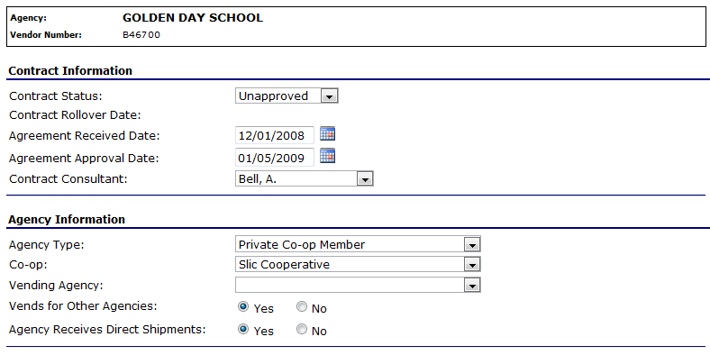
Figure 7: Input Error (Partial)

Business Rule Edits
Business rule edits are used to ensure that all required data on a form does not conflict with system guidelines or information entered on the system. For example, if you enter a Reduced Meal Price greater than the Full Price Meal price, you will receive a business rule error.
The system runs business rule edits when a form is saved on the system. Business rule errors display on a save confirmation screen. The errors will also display with a code description and severity at the bottom of the form containing the errors. The description briefly describes and indicates which field contains the error. In addition, the error severity indicates whether an error is considered a Warning or an Error. Errors appear in red and must be corrected before the agreement or form can be submitted Warnings appear in blue and indicate something out of the ordinary, but not crucial to the approval of the agreement or form.
Figure 8: Warning Code and Description

Selecting a Year
Information displays for the selected school year only. Upon logging onto the system, the current school year is the default selection and displays in the top-right corner in the light blue bar. In order to view information from a different year, you will need to change the school year.
Note: Some users may be unable to select a new year if they have not been granted the security right. Contact your administrator and request that you be given the Select Year security right if you feel this is in error.
To select a year
- Select Year on the blue menu bar at the top of the page.
The Year Select screen displays.
- Select the year you wish to select.
Note: The selected year is indicated by the <Selected to the right of the year.
- Use the menu bar to return to your task in the program.

Agencies
3
The Agencies menu is the agency user’s gateway to many of the important Food Distribution Program functions. See the menu below and the following sections for more information on orders, surveys, commodity allocations, invoices, and contract functions.

Agencies Menu
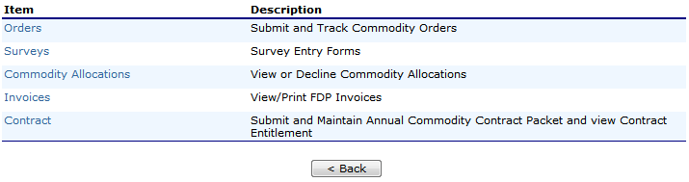
Figure 9: Agencies Menu

Orders
The Orders menu is your access point to order commodities, view commodity orders, and request extended storage. You can also view shipments and report overages, shortages, and damages.
To access orders
- On the blue menu bar, select Agencies.
- Select Orders.
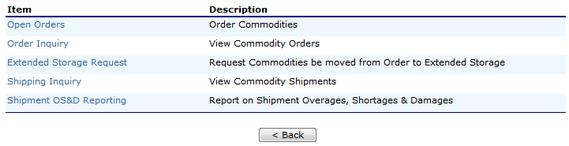
Figure 10: Orders menu screen

Open Orders
To create a new order
- Select Orders from the Agencies menu.
- Select Open Orders.
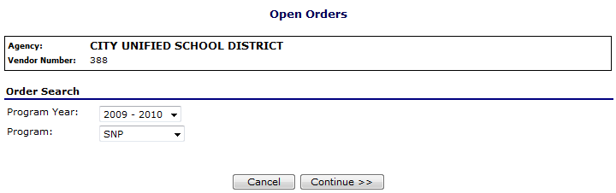
Figure 11: Open Orders screen
- Select the Program Year from the dropdown.
- Select the Program from the dropdown.
- Select Continue >>.
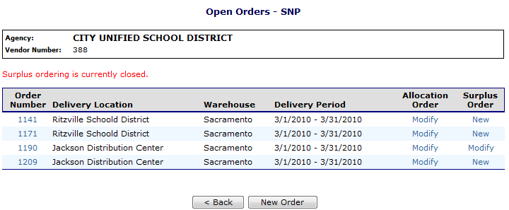
Figure 12: Open Orders - SNP screen
- Select New Order.
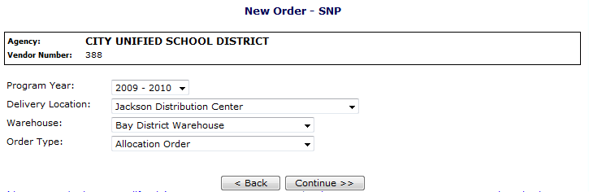
Figure 13: New Order - SNP screen
- Select the Program Year from the dropdown.
- Select the Delivery Location from the dropdown.
- Select the Warehouse from the dropdown.
- Select the Order Type from the dropdown, if applicable.
- Select Continue >>.
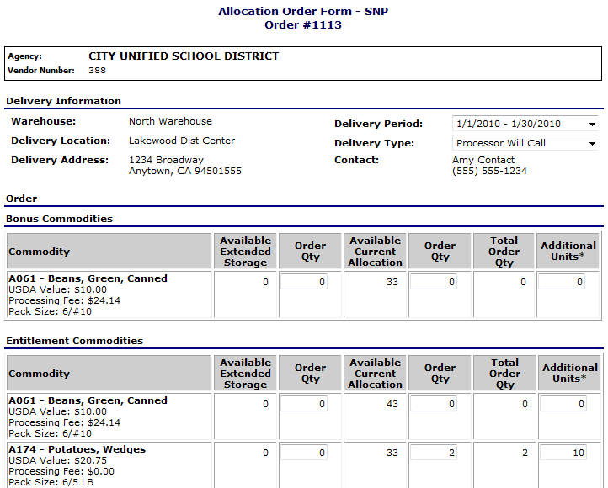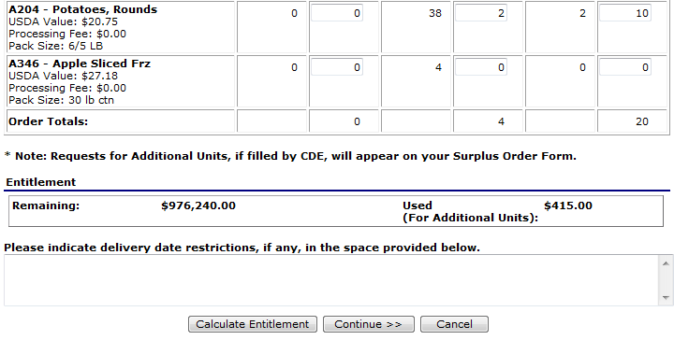
Figure 14: Allocation Order Form - SNP screen
- Select the Delivery Period from the dropdown.
Note: For Agency users, the Delivery Type field is display only.
- Select the Delivery Type from the dropdown, if applicable.
- Enter order quantities in the textboxes.
- Select Calculate Entitlement to display entitlement values
-OR-
Select Continue >>.
- Review order and select Submit Order.
To view or modify an order
- Select Orders from the Agencies menu.
- Select Open Orders.
- Select the desired criteria (selection of an Agency or Vendor Number is required).
- Select Continue >>.
- Select the Order Number link to View.
-OR-
Select the Modify link to modify.
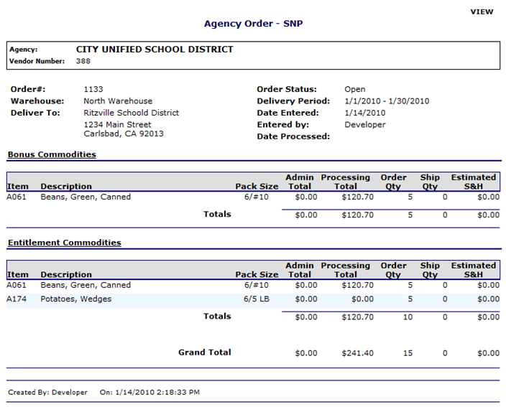
Figure 15: Agency Order - SNP screen (Order Number link)
- If modifying, make any desired changes.
- Select Calculate Entitlement to display entitlement values
-OR-
Select Continue >>.
- Review order and select Submit Order.
To delete an order
- Select Orders from the Agencies menu.
- Select Open Orders.
- Select the desired criteria (selection of an Agency or Vendor Number is required).
- Select Continue >>.
- Select the Order Number link to View.
- Select Delete Order.

Order Inquiry
The Order Inquiry function enables you to view order details and activity.
To search for an order
- Select Orders from the Agencies menu.
- Select Order Inquiry.
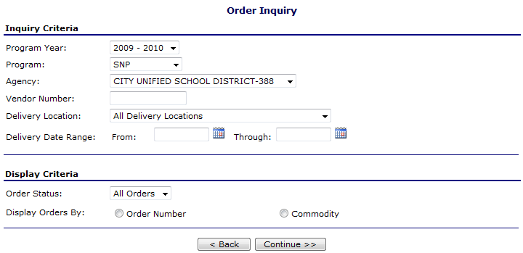
Figure 16: Order Inquiry screen
- Enter Inquiry Criteria in the respective fields.
Note: An agency or vendor number is required.
- Select the Order Status from the dropdown.
- Select a Display Orders By radio button.
- Select Continue >>.
A list of orders displays from the selected criteria.

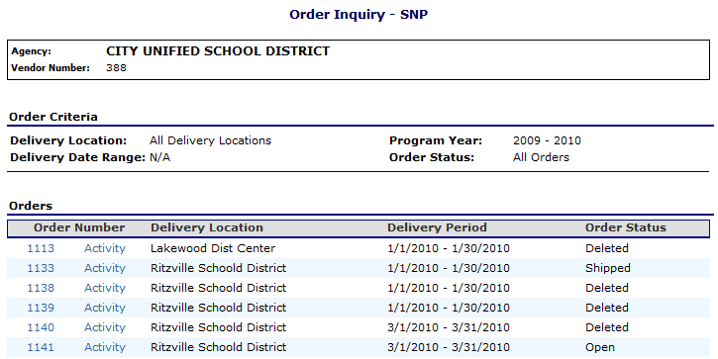
Figure 17: Order Inquiry SNP screen
To view order details
- Select Orders from the Agencies menu.
- Select Order Inquiry.
- Search for an order (see preceding topic).
- Select the Order Number link to view that order.
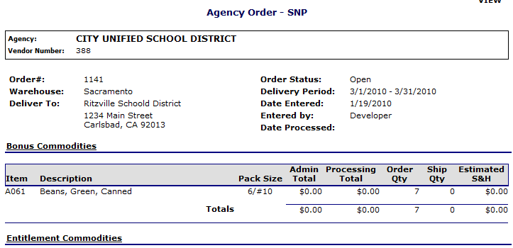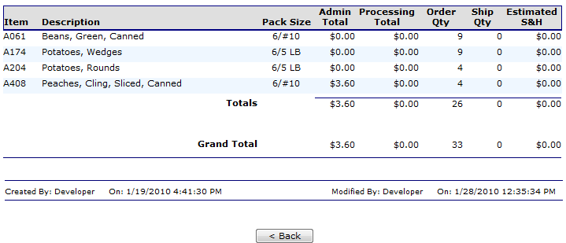
Figure 18: Agency Order - SNP screen (Order Number link)
To view order activity
- Select Orders from the Agencies menu.
- Select Order Inquiry.
- Search for an order (see preceding topic).
- Select the Activity link for an order.
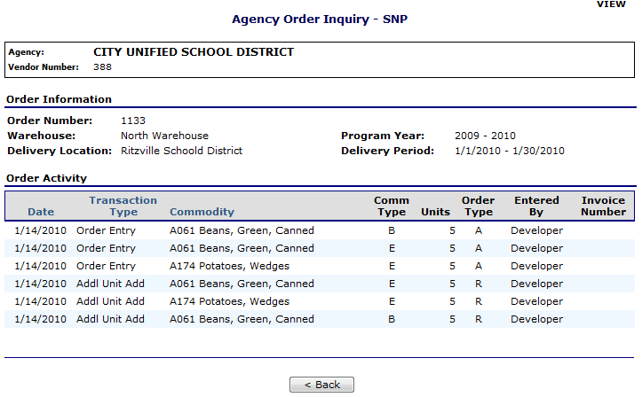
Figure 19: Agency Order Inquiry - SNP screen (Activity link)

Extended Storage Request
The Extended Storage Request function enables you to transfer commodities from an order into extended storage.
Note: An extended storage agreement is required to transfer commodities (The agency’s contract states if this agreement is on file with the state).
To create a new extended storage request
- Select Orders from the Agencies menu.
- Select Extended Storage Request.
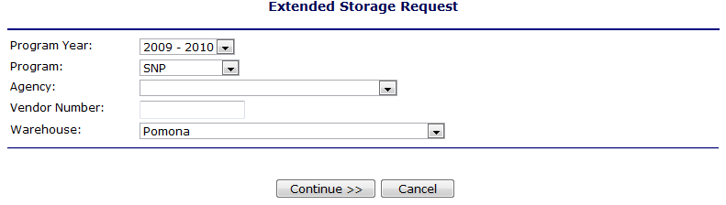
Figure 20: Extended Storage Request screen
- Use the criteria to select the following:
  - Program Year
  - Program
  - Agency or Vendor Number
  - Warehouse
- Select Continue >>.
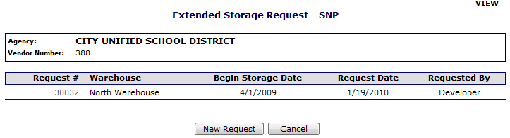
Figure 21: Extended Storage Request - SNP screen
- Select New Request.
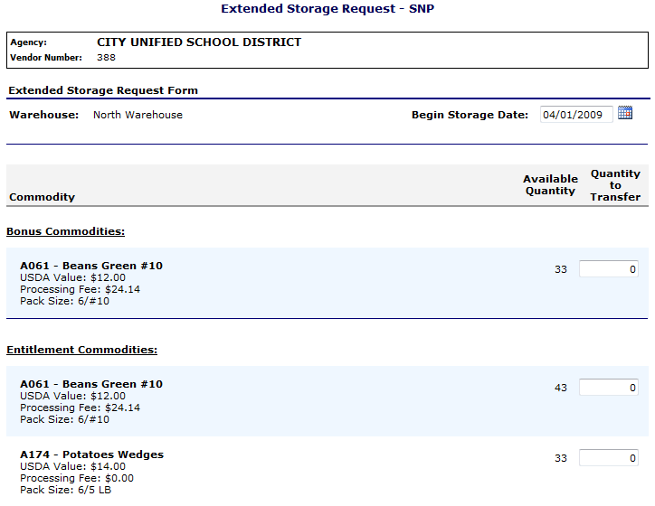
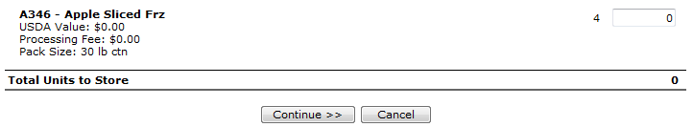
Figure 22: Extended Storage Request - SNP screen (New)
Note: The Begin Storage Date is defaulted to the first day of the agency's current open distribution period. This field is display only.
- Enter the Quantity to Transfer in the textbox for each desired commodity.
- Select Continue >>.
- Review and select Submit Request.
To view extended storage request details
- Select Orders from the Agencies menu.
- Select Extended Storage Request.
- Use the criteria to select the following:
  - Program Year
  - Program
  - Agency or Vendor Number
  - Warehouse
- Select Continue >>.
- Select the Request # link from the list.
The Extended Storage Request details display.

Shipping Inquiry
The Shipping Inquiry screen enables the user to search for shipments to a specified agency based upon selected criteria.
To view a shipment detail
- Select Orders from the Agencies menu.
- Select Shipping Inquiry.
- Search for a Shipment using the search criteria.
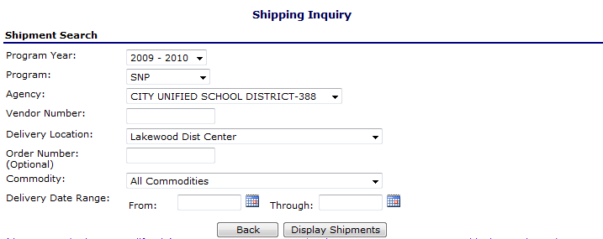
Figure 23: Shipping Inquiry screen
- Select Display Shipments.
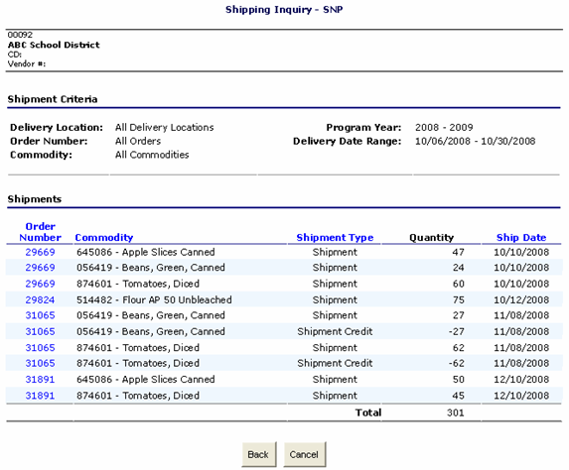
Figure 24: Shipping Inquiry screen
- Select an Order Number link.
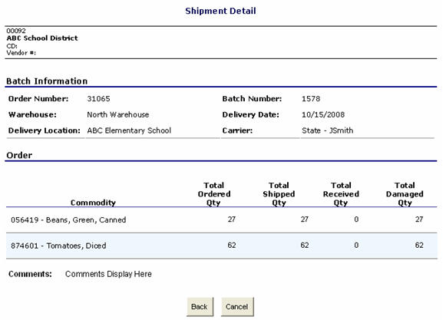
Figure 25: Shipping Inquiry screen
- Select Back or Cancel when finished.

Shipment Overages, Shortages, & Damages Reporting
The Shipment OS&D Reporting function allows agency users to report Overages, Shortage, and Damages issues with their deliveries. The Shipping OS&D Reporting – Shipment Search screen enables users to search for shipments based upon selected criteria.
To report overages, shortages, & damages
- Select Orders from the Agencies menu.
- Select Shipment OS&D Reporting.
- Search for a Shipment using the search criteria.
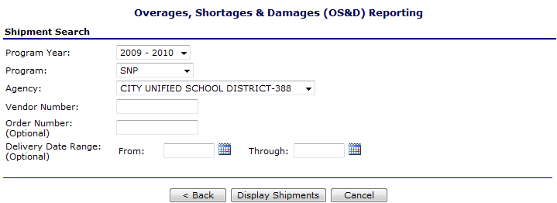
Figure 26: Overages, Shortages & Damages (OS&D) Reporting screen
- Select Display Shipments.
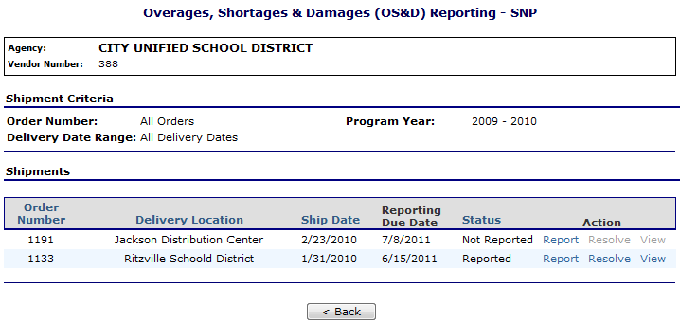
Figure 27: Overages, Shortages & Damages (OS&D) Reporting screen
- Select Report.
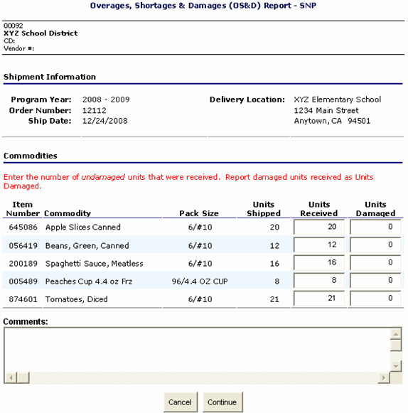
Figure 28: Overages, Shortages & Damages (OS&D) Report - SNP screen
- Enter the number of Units Received in the respective textboxes.
- Enter the number of Units Damaged in the respective textboxes.
- Enter any comments.
- Select Continue >>.
- Review information and select Submit Report.

To resolve overages, shortages, & damages
- Select Orders from the Agencies menu.
- Select Shipment OS&D Reporting.
- Search for a Shipment using the search criteria.
- Select Resolve.
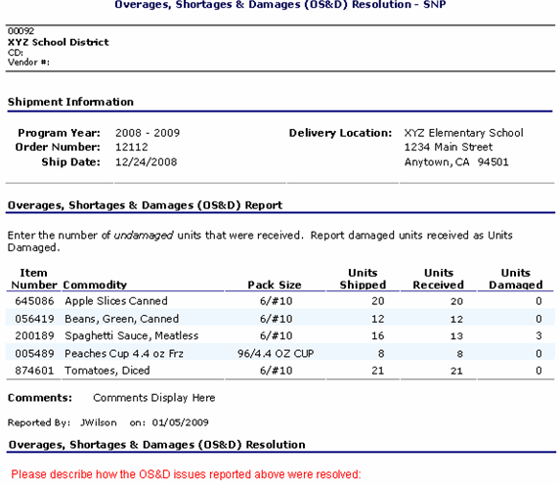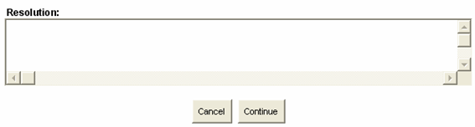
Figure 29: Overages, Shortages & Damages (OS&D) Resolution - SNP screen
- Describe how the OS&D issues were resolved in the Resolution textbox.
- Select Continue >>.
- Select Submit Resolution.
To view overages, shortages, & damages
- Select Orders from the Agencies menu.
- Select Shipment OS&D Reporting.
- Search for a Shipment using the search criteria.
- Select View.
- View desired information.
- Select < Back or Cancel when finished.

Surveys
The Surveys function enables agency users to view and complete surveys.
To search for a surveys
- On the blue menu bar, select Agencies.
- Select Surveys.
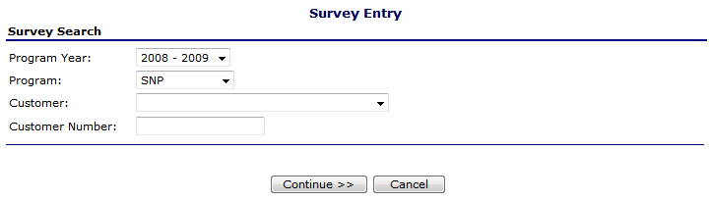
Figure 30: Survey Entry – Survey Search screen
- Select Program Year from dropdown list.
- Select Program from dropdown list.
- Select Customer from dropdown list
-OR-
Enter Customer Number in textbox.
- Select Continue >>.
A list of Available Surveys displays for the agency.
- Select the Survey # link to display survey details.
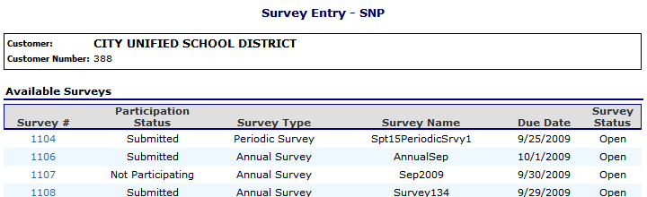
Figure 31: Survey Entry – Available Surveys screen
To complete a survey
- Select a Survey # (link) from the list of available surveys.
- Select Open Orders.
- Complete the survey form.
-OR-
Select the checkbox to indicate that “you will not participate in this survey.”
- For annual surveys, select Submit Survey.
For periodic surveys or processing surveys, select Continue >>.
Note: You can select the Calculate Entitlement button to calculate the Estimated Entitlement Used, Estimated Fees, and Estimated S&H values before selecting Continue >>. This information also displays on the Survey Entry – Submit screen.
- Select Continue >>.
- Review information and select Submit.
Note: For periodic and processing surveys, the number of units that an agency can request may or may not be limited.
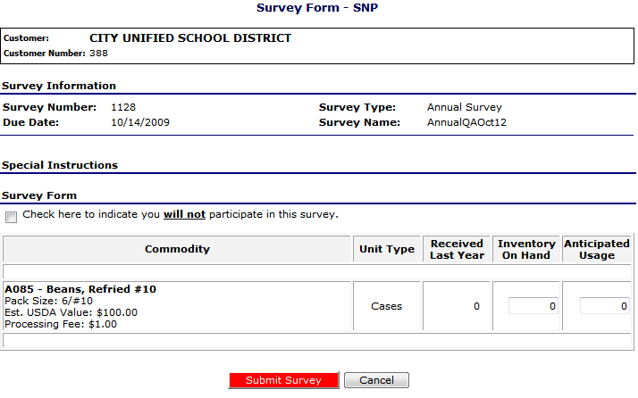
Figure 32: Survey Form – Annual screen
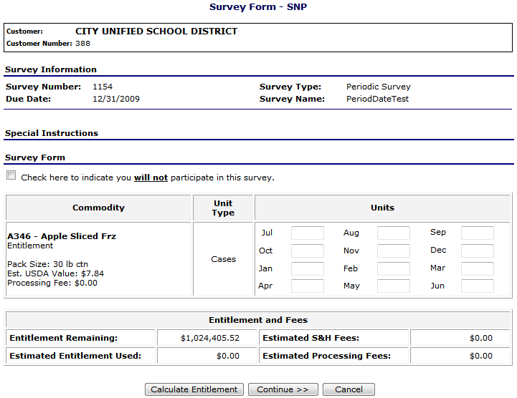
Figure 33: Survey Form – Periodic screen

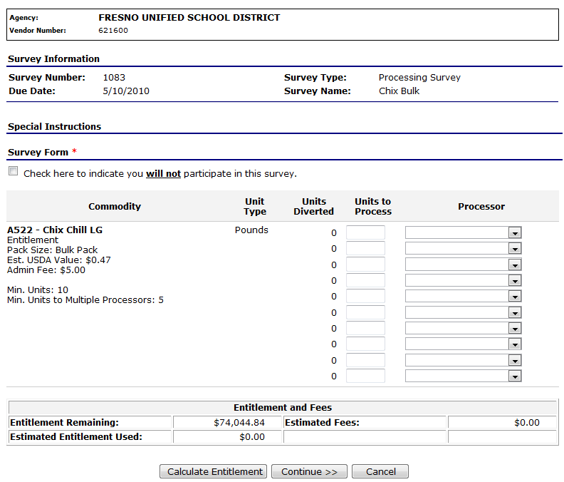
Figure 34: Survey Form - Processing screen

Commodity Allocations
Users can access the Allocation Inquiry and Decline Allocation functions from the Commodity Allocations.
To access Commodity Allocations
- On the blue menu bar, select Agencies.
- Select Commodity Allocations.
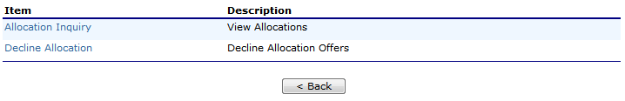
Figure 35: Commodity Allocations menu

Allocation Inquiry
The Allocation Inquiry screen enables an agency to search for an allocation and view allocation details.
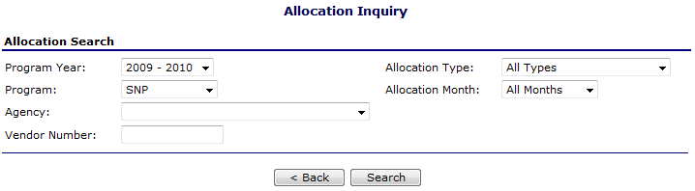
Figure 36: Allocation Inquiry – Allocation Search screen
To view allocation details
- On the blue menu bar, select Agencies.
- Select Commodity Allocations.
- Select Allocation Inquiry.
- Enter any desired search criteria.
Note: An Agency Name or Vendor Number is required.
- Select Search.
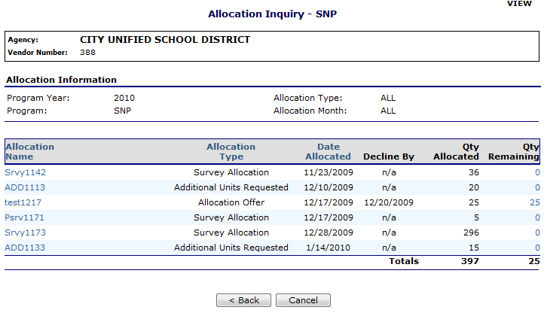
Figure 37: Allocation Inquiry – SNP screen
- Select an Allocation Name link to view the Commodity Allocation Report
-OR-
Select a Qty Remaining link to view the Allocation Detail.
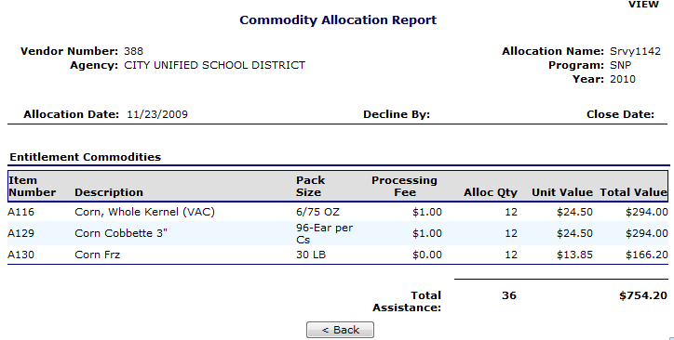
Figure 38: Commodity Allocation Report screen
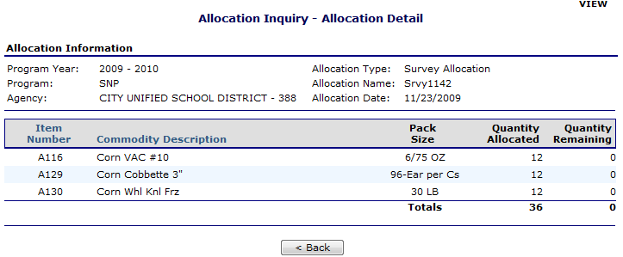
Figure 39: Allocation Inquiry – Allocation Details screen

Decline Allocation
The Decline Allocation screen provides agencies with the ability to refuse regular allocations of a commodity. An agency’s entitlement is charged for commodities at the time the allocation is made, declining allocations allows the agency to return their entitlement for commodities they have no intention of ordering. Allocations must be refused prior to the allocation ‘Refuse By’ date set for the allocation and only remaining quantities can be refused.
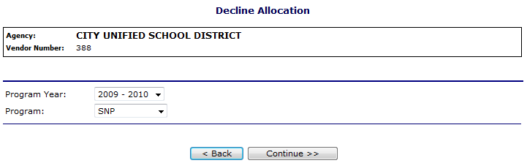
Figure 40: Decline Allocation screen
To decline an allocation
- On the blue menu bar, select Agencies.
- Select Commodity Allocations.
- Select the Program Year from the dropdown.
- Select the Program from the dropdown.
- Select Continue >>.
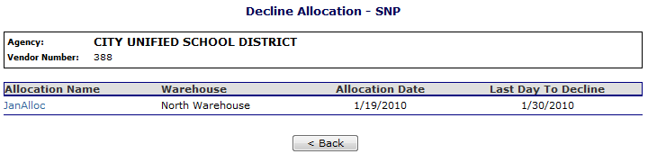
Figure 41: Decline Allocation - SNP screen
- Select the Allocation Name link.
- Enter the Quantity Declined in the textbox(es).
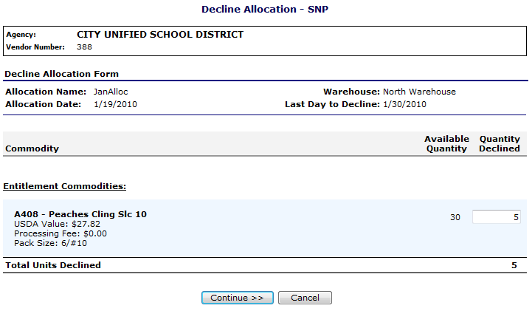
Figure 42: Decline Allocation - SNP screen
- Select Continue >>.
- Select Decline Allocations.
Note: Refusing an allocation of a commodity will adjust the agency’s entitlement accordingly and result in the commodity being moved to Surplus Inventory.

Invoices
The Invoices function allows Agency users to view and print their invoices for remittance. The Invoices screen enables the user to search for invoices.
To
- On the blue menu bar, select Agencies.
- Select Invoices.
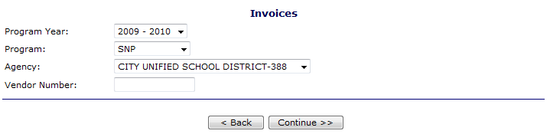
Figure 43: Invoices screen
- Select a Program Year from the dropdown.
- Select a Program from the dropdown.
- Select an Agency from the dropdown.
-OR-
Enter a Vendor Number.
- Select Continue >>.
- Select an Invoice Number link.
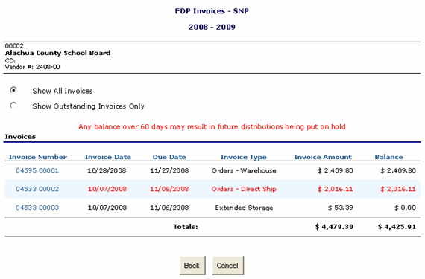
Figure 44: FDP Invoices – SNP screen
- Select an Invoice Number link.
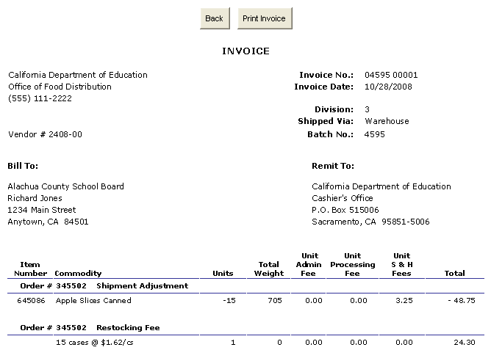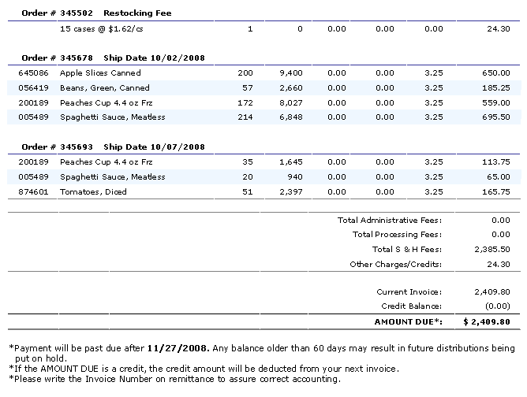
Figure 45: FDP Invoices – SNP screen
- Select Print Invoice to print.

Contract
The Contract menu option enables agency users to submit and maintain their annual commodity contract packet and view contract entitlement information.
To access Contract
- On the blue menu bar, select Agencies.
- Select Contract.
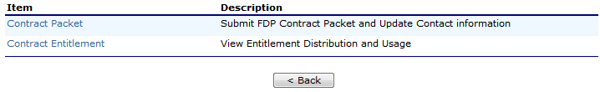
Figure 46: Contract menu

Contract Packet
The Food Distribution Program Contract Packet is the starting point for all tasks related to the agency’s annual commodities contract. This screen contains all contract and forms for an agency’s contract packet, including the Agency Information Update / Certification, Contacts information, and Delivery Location information.
An agency information header displays in a box at the top of the screen and contains the Agency name and Vendor Number. In addition, it displays the Packet Status, Packet Approved Date (if applicable) and Contract Status.
An Annual Contract can only be deleted if there are no records associated with the contract (i.e., Allocations, Orders, etc.).
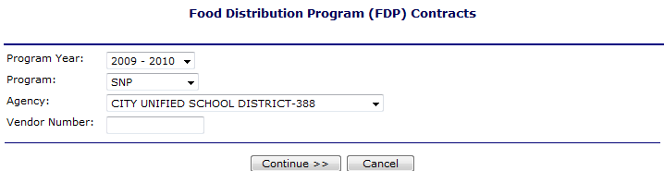
Figure 47: Food Distribution (FDP) Contracts (selection) screen
To access the contract packet
- On the blue menu bar, select Agencies.
- Select Contract.
- Select Program Year from the dropdown.
- Select Program from the dropdown.
- Select Continue >>.
The agency’s Contract Packet displays.
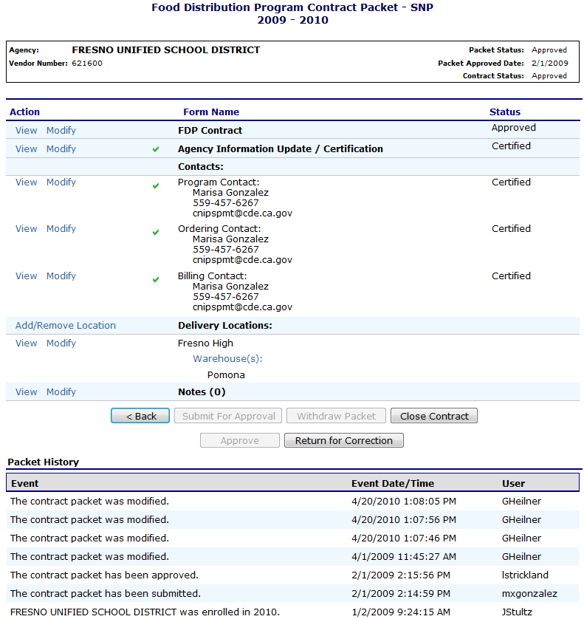
Figure 48: Food Distribution Program Contract Packet– FDP screen
To view a Contract
- Access the Food Distribution Program Contract screen.
- Select View for FDP Contract.
- Select Cancel when finished.
To update Customer Information and Certify Inventory
Agencies must update this information once a year after their contract packet has been rolled over from the previous year. Once the contract packet is approved, the form is view-only.
- Access the Food Distribution Program Contract screen.
- Select View or Modify for Agency Information Update/Certification.
- View or revise any desired information.
- If viewing, select Cancel.
-OR-
If modifying, select Save.
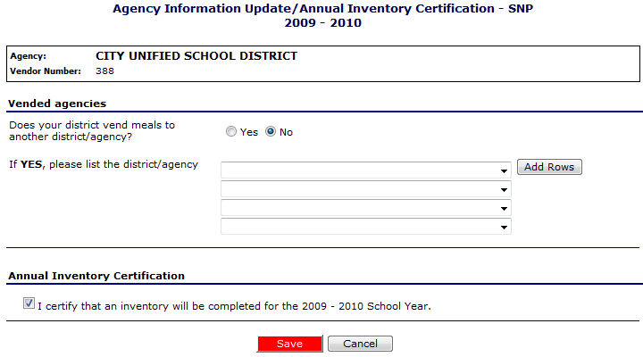
Figure 49: Agency Information Update/Annual Inventory Certification screen
To view or modify Contact information
The following section pertains to Program, Ordering, and Billing Contact information. Contact Information for each contact type must be created for each agency, as this contact information will appear on various documents printed using the Reports functionality.
- Access the Food Distribution Program Contract screen.
- Select View or Modify for the Program, Ordering, or Billing Contact.
- View or revise any desired information.
- Select the checkbox for the Contact Information Certification, if applicable.
- If viewing, select Cancel.
-OR-
If modifying, select Save.
TIP: You can copy information from a saved Contact by selecting the “Copy contact information from” checkbox at the top of the form. For example:
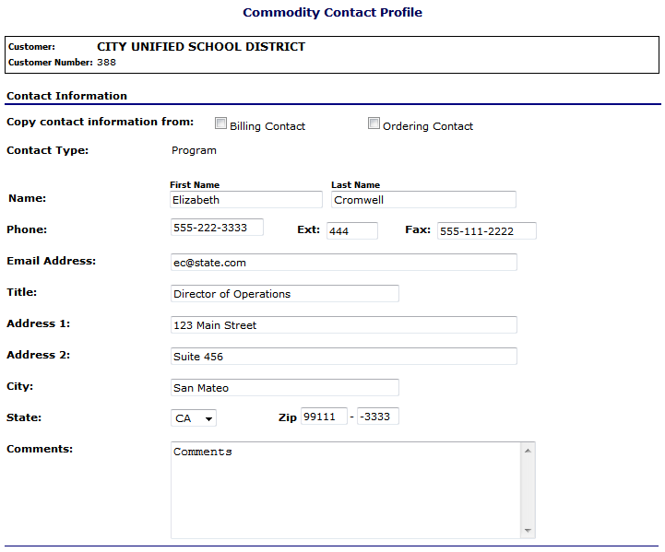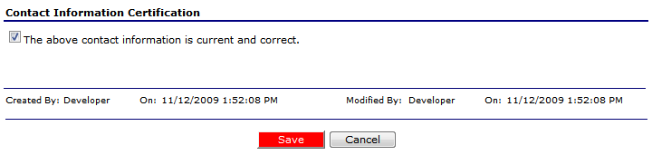
Figure 50: Commodity Contact Profile screen
To view or modify a Delivery Location Profile
- Access the Food Distribution Program Contract screen.
- Select View for the desired Delivery Location.
- Select < Back when finished.
To submit a contract packet for approval
All components of the contract packet must be complete before an agency can submit the packet for approval.
- Access the Food Distribution Program Contract screen.
- Select Submit for Approval.
The screen re-displays and displays that the packet has been submitted for approval in the Packet history section.
To withdraw a contract packet
Agencies may choose to withdraw a contract packet after it has been submitted for approval. Withdrawing only removes the contract packet from its Submitted state. All contract packet information is retained by the system. Once the agency is ready, the packet can be re-submitted.
- Access the Food Distribution Program Contract screen.
- Select Withdraw Packet.
The screen re-displays and displays that the packet has been withdrawn in the Packet history section.

Contract Entitlement
The Contract Entitlement function enables you to view entitlement distribution, entitlement used, and remaining entitlement amounts for your agency.
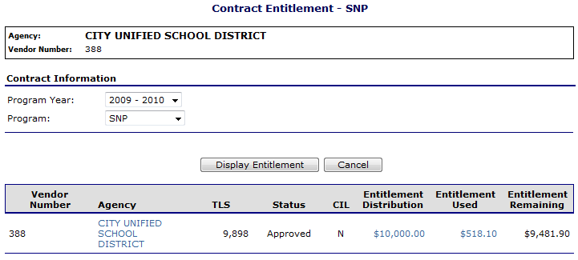
Figure 51: Contract Entitlement – SNP screen
To view entitlement distribution detail
- On the blue menu bar, select Agencies.
- Select Contract.
- Select Contract Entitlement.
- Select the link under the Agency column.
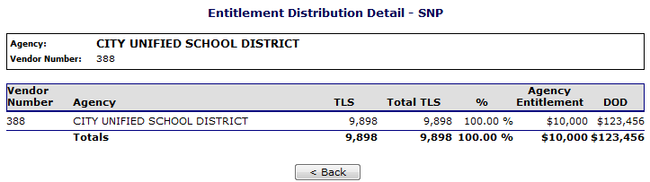
Figure 52: Entitlement Distribution Detail – SNP screen

To view entitlement distribution history
- On the blue menu bar, select Agencies.
- Select Contract.
- Select Contract Entitlement.
- Select the link under the Entitlement Distribution column.
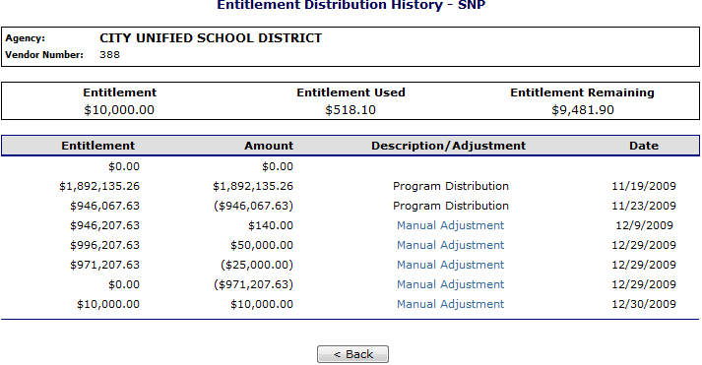
Figure 53: Contract Entitlement – SNP screen
- Select the Manual Adjustment link to view the adjustment details.
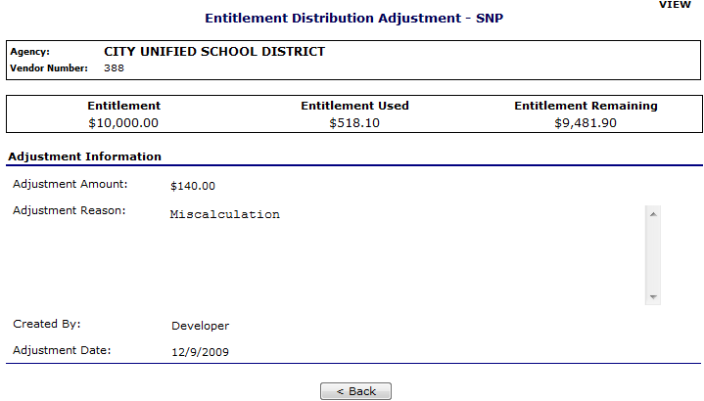
Figure 54: Entitlement Distribution Adjustment – SNP screen
To view entitlement distribution usage
- On the blue menu bar, select Agencies.
- Select Contract.
- Select Contract Entitlement.
- Select the link under the Entitlement Used column.
Note: Selecting a link in the Description column displays the Commodity Allocation Report.
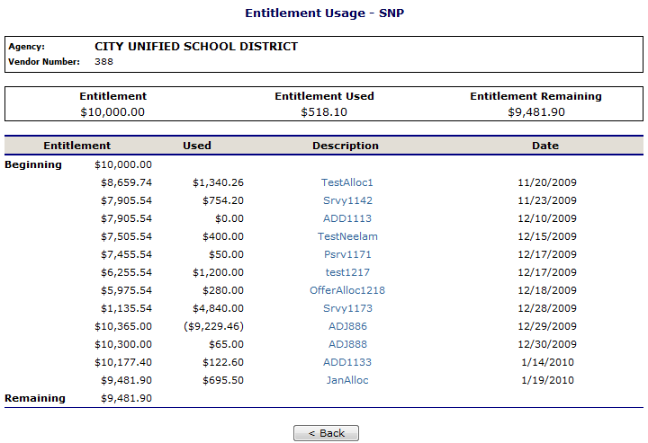
Figure 55: Entitlement Usage – SNP screen

Reports
Reports for the Food Distribution Program are available to users through the CNIPS Reports component.
4

About Reports
The Reports component of the FDP module enables users to run, view and print reports by utilizing information gathered and logged by the application. The Report List contains all reports available within the module and is divided into groups. Each report is categorized and listed alphabetically under these groups. As new reports are added to the CNIPS, this menu will expand to show those new reports.
Once a user selects a particular report, the CNIPS may prompt the user for additional information needed before building the report, such as a particular Fiscal Year, Claim Month, Agency, and/or Sort Order.
While all reports are available to state users, agencies users have access to only certain reports. Therefore, the Reports menu will only display categories containing reports to which the user has access.
To view report
- On the blue menu bar at the top of the page, select Reports.
The Report List displays.
TIP: Use the Report Filter to filter Report list by Report Group. For example, to display only USDA Reports, select USDA Reports from the drop-down list and select Apply Filter. The Report List automatically refreshes.
- Select the report you wish to view from the Report List.
The report parameters screen may display.
- If required, use the drop-down lists and/or text fields to enter parameters.
- Select Create Report.
The report displays in a new window.
Note: The report will not open in a new window if you have a pop-up blocker running on your system. If this occurs, hold down the CTRL key and select Create Report again.
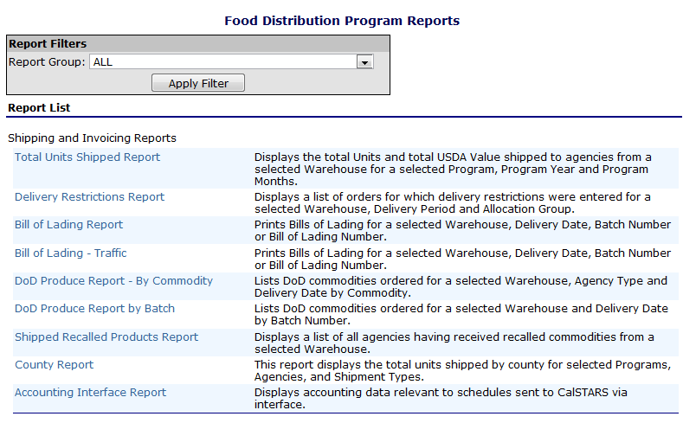
Figure 56: Food Distribution Program Reports (Partial)

Report Parameters
Most reports require one or more parameters to be entered in order to customize the report to the user’s specific needs. Report parameters may limit data contained in the report or control how the information is sorted or grouped. Below is an example of types of report parameters that may be used for running a report.
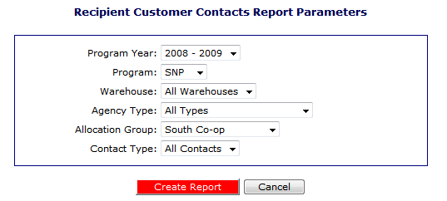
Figure 57: Report Parameter – Recipient Customer Contracts Report

Report
Below is an example of a report displayed in SQL Report Services.
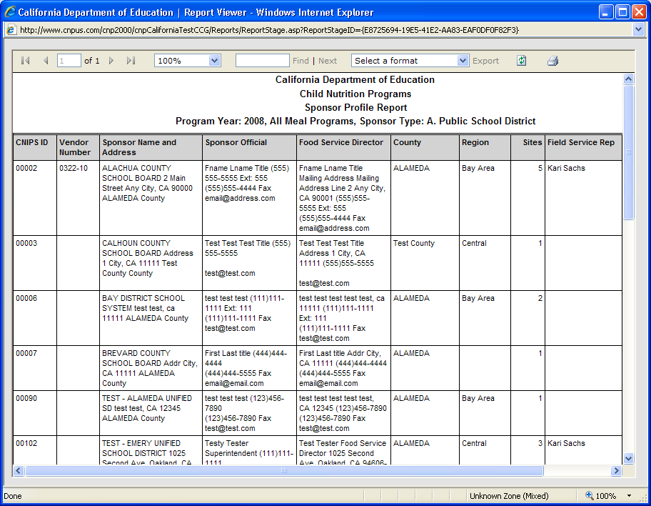
Figure 58: Sample Report
The report displays in the right-hand pane. Use the scroll bar to scroll through the report or the right and left arrows ◄ ► to navigate through the report one page at a time.
To print the report, select on the printer icon then use the printer setup dialogue box to indicate what you wish to print.
Reports displayed as Web pages are printed using the Web browser ‘Print’ button.
To export report
- On the blue menu bar at the top of the page, select Reports.
The Report List displays.
TIP: Use the Report Filter to filter Report list by Report Group. For example, to display only USDA Reports, select USDA Reports from the drop-down list and select Apply Filter. The Report List automatically refreshes.
- Select the report you wish to view from the Report List.
The report parameters screen may display.
- If required, use the drop-down lists and/or text fields to enter parameters.
- Select Create Report.
The report displays in a new window.
- Select the format to export from the dropdown list (shown in the following figure).
- Select Export.
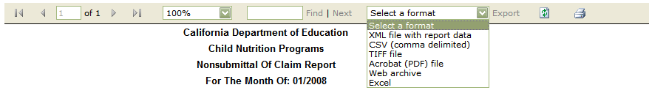

Security
Security is an important part of the integrity of the CNIPS. The Security component of the FDP module is the access point to user-level security settings. Individuals may change their password through the Change Password feature, while administrators and State users can manage other user-level security settings through the User Manager. In addition, State and agency users with security clearance can manage individual user settings within the User Manager.
5
Note: The Security component of the FDP module is primarily intended for agency users and administrators. State users may prefer to access the Security module through the CNIPS programs menu.

Security menu
The Security menu is the access point to the Change Password function.

Change Password
System security is greatly enhanced by regularly modifying your password.
Note: Default security settings require that a password must be at least six characters and contain one number.
TIP: Strong, secure passwords contain between 6 and 15 characters, including numbers, upper-case, and lower-case letters.
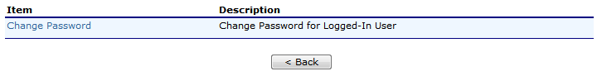
Figure 59: Security Menu screen
To access Change Password
- On the blue menu bar, select Security.
- On the Security menu, select Change Password.
The Change Password screen displays.
- Enter your New Password.
- Re-Enter your New Password.
- Select Save.
A confirmation message displays.
- Select <Edit to return to the Change Password screen you just modified.
-OR-
Select Finish to return to the Security menu.
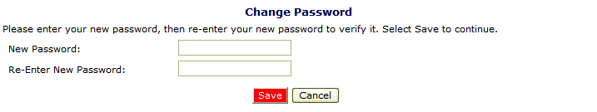
Figure 60: Change Password screen

Index

Accessing the Web Site 6
Agencies 14
Agencies Menu 14
Allocation Inquiry 31
View allocation 31
Certify Inventory 37
Change your password See Reset User's Password
CNIPS Programs Page 10
Commodity Allocations 30
Contact Information
View/modify 38
Contract 35
View 37
Contract Entitlement 40
View entitlement distribution detail 40
View entitlement distribution history 41
View entitlement distribution usage 41
Contract Packet 36
Submit 39
Update Customer Information and Certify Inventory 37
View a delivery location profile 39
View or modify contact information 38
Withdraw 40
Crystal Viewer®. 45
Decline Allocation 32
Delivery Location Profile 39
Error Processing 12
Extended Storage Request 21
Create new 21
View details 23
Food Distribution Program Home Page 10
Invoices 34
Log on 7
Open Orders 15
Create new 15
Delete 18
View/modify 17
Order Inquiry 18
Search 18
View order activity 20
View order details 19
Orders 14
Password
To change 46
Report Parameters 44
Reports 43
To view 43, 45
Security 46
Security menu 46
Selecting a School Year 13
Shipment OS&D Reporting 25
Shipping Inquiry 23
View shipment detail 23
Submit contract packet 39
Surveys 27
Complete 28
Search for 27
Update Customer Information 37
Withdraw contract packet 40

