California Department of Education

Report to the Governor and the Legislature:
Foster Youth Services Program



Prepared by:

Coordinated Student Support Division
Student Support and Special Services Branch

October 2014

Description: This report contains recommendations regarding the continuation of foster youth services (FYS), effectiveness of services, and broadening of services; data on foster youth academic achievement, expulsion and truancy rates; and a discussion of the data. The report also includes: (1) summary of services provided; (2) challenges reported by FYS Programs; (3) significant accomplishments; and (4) 2014–15 goals.

Authority: California Education Code Section 42923(b)

Recipient: The Governor and the Legislature

Due Date: February 15 of each even-numbered year per California Education Code Section 42923(b)

California Department of Education

Report to the Governor and the Legislature

Foster Youth Services Program

Table of Contents

Executive Summary ii

Report to the Governor and the Legislature: Foster Youth Services Program 1

Appendix A: California Education Code sections 42920–42925 46

Appendix B: 1998 Budget Bill Section 6110–121–0001 Foster Youth
Programs (Proposition 98) Program 20.40.060 50

Appendix C: Assembly Bill 1808, Chapter 75, Statutes of 2006 Amending
California Education Code Section 42921 51

Appendix D: Key Educational Concepts of Senate Bill 933 (Thompson,
Chapter 311, Statutes of 1998) 53

Appendix E: Assembly Bill 490 Overview 57

Appendix F: California Department of Education Foster Youth Services
List of Coordinators and Program Sites 59

California Department of Education

Report to the Governor and the Legislature:
Foster Youth Services Program

Executive Summary

This report is required by California Education Code (EC) Section 42923(b).

In 1981, the Legislature recognized that a high percentage of foster youth were working substantially below grade level, were being retained at least one year at the same grade level, and were becoming school dropouts. In response, the Legislature declared that the instruction, counseling, tutoring, and provision of related services for foster youth be a state priority and mandated the Foster Youth Services (FYS) Core Programs through EC sections 42920–42925, establishing six FYS Core Programs that provide services to all foster youth attending schools in each of the Core Program districts. The Budget Act of 1998 expanded services statewide to foster youth living in licensed children’s institutions by enabling county offices of education to apply to a grant program administered by the California Department of Education (CDE). The Budget Act of 2006 expanded the statewide services to include foster youth residing in Foster Homes, Foster Family Agencies, Court Specified Placements, and Juvenile Detention Facilities.

The goals of the FYS Programs are to (1) identify the educational, physical, social, and emotional needs of foster youth; (2) determine gaps in service provision and provide educational and social support services, either through direct service provision or referral to collaborative partners; (3) identify inadequacies in the completion and timely transfer of health and education records to facilitate appropriate and stable care and educational placements; (4) improve student academic achievement, reduce incidence of juvenile delinquency, and reduce rates of student truancy/dropouts; and (5) provide advocacy to promote the education-related best interests of foster youth throughout California.

Outcome data for the FYS Programs for the 2012–13 school year show that 72 percent of foster youth served gained more than one month of academic growth per month of tutoring received, surpassing the target population objective by 12 percent. The high school completion data collected indicates that 62 percent of eligible twelfth graders completed a high school program. In addition, only 0.19 percent of foster youth served were expelled, surpassing the target rate of less than 5 percent, and the foster youth exceeded their attendance target rate of 90 percent.

In their 2012 year-end reports to the State Superintendent of Public Instruction, all of the FYS Programs reported substantial progress in establishing effective collaborative networks for service provision. The data show that the FYS Programs have had an impact on the educational achievement and success of foster youth in their communities. Recommendations from FYS providers include: (1) continue the existing FYS Programs and provide adequate funding to support the programs; (2) develop a statewide database for collecting and sharing health and education information and outcome data on foster youth; and (3) expand the FYS Countywide Programs to provide services to all foster youth and provide additional funding to support an expansion of services.

If you have any questions regarding this report or would like a copy of this report, please contact Lisa Guillen, Education Programs Consultant, Coordinated Student Support Division, by phone at 916-327-5930 or by e-mail at lguillen@cde.ca.gov. You will find this report on the CDE FYS Web page at http://www.cde.ca.gov/ls/pf/fy/index.asp.

Report to the Governor and the Legislature:
Foster Youth Services Program

Introduction

This report is submitted in accordance with the provisions of California Education Code (EC) Section 42923(b) which requires the State Superintendent of Public Instruction to report to the Legislature and the Governor on services provided by school districts for students in foster care by February 15 of each even-numbered year. This EC section further stipulates that the report is to be prepared with input from the providers of the Foster Youth Services (FYS) Program and that it shall include recommendations regarding the continuation of services, effectiveness of services, and broadening of services; data on the academic achievement, expulsion, and truancy rates of foster youth; and a discussion of the data.

Program History and Purpose

Children and youth in foster care face significant barriers to positive educational experiences and academic achievement. A large percentage of children and youth placed in foster care experience physical and emotional trauma as a result of abuse, neglect, separation from family, and impermanence. Although youth are placed in foster care for their safety, foster youth often do not find the security and stability they need through the foster care system. Most children who enter foster care have been exposed to many conditions that have undermined their chances for healthy development. On average, children who enter the foster care system have experienced more than 14 different environmental, social, biological, and psychological risk factors before coming into care. These factors often include abuse and neglect, exposure to illicit drugs, and poverty. Once in foster care, they often experience other challenges to their well-being.
They may be separated from their brothers and sisters, moved from one foster care placement to another, and experience frequent changes in caseworkers who may lack the skills and resources to effectively advocate and plan for their “best interests.”

Foster youth commonly experience multiple placements in foster homes (FHs) and licensed children’s institutions (LCIs). Youth in foster care change placements an average of 1–2 times a year. Though the average stay in foster care is 13.4 months, approximately 27 percent of children in care stay for more than two years. Many foster care youth are unable to remain in their schools of origin when it is clearly in their best interest to do so. A recent study conducted of students in foster care examining the impact of educational school stability on school behavior issues discovered that students reported a mean of 7.35 placement changes and 8.26 school transfers over the average of 6.6 years spent in foster care. This study also concluded that there was significant correlation between school changes and negative behaviors. The Institute for Higher Education Policy estimates that a change in placement occurs about once every six months and, due to this movement, foster youth lose an average of four to six months of educational attainment. The educational impact of every school change is significant. Foster youth must adjust to different curricula, different expectations, new friends, and new teachers. They must withstand disruptions in education services, including special education support, counseling, enrichment programs, and extracurricular opportunities.

In addition to these studies, a recent Chapin Hall study discovered that students in foster care were more than twice as likely to experience school changes compared to students who had no history with child welfare services. This was especially true with students who entered foster care during the academic year, with over two-thirds experiencing a school change. The same study discovered that over 50 percent of students in foster care ages six to ten and approximately two-thirds of students in foster care ages eleven to seventeen transferred schools at least once within the last two years, in addition to normal changes in school due to matriculation schedules.
According to data retrieved from the University of California at Berkeley Center for Social Services Research Web site, on January 16, 2014, the following table represents the percentage of students in care and the number of residential placements within that time period. The data indicates that the more time a student remains in foster care, the greater likelihood that the student will change residential placement more than three times.

Table 1: Residential Placements

Minimum Length of Time in Care | Number of Placements
Minimum Length of Time in Care | 1 | 2 | 3+
3 months | 33.5% | 35.8% | 30.7%
6 months | 31.9% | 35.9% | 32.3%
12 months | 29.6% | 34.7% | 35.8%
October 1, 2011 to March 31, 2012

Table 1 illustrates how the length of time spent in foster care can impact the number of times a student changes residential placement.

These frequent changes in residential placement impact the changes in school placement, which have a negative impact on academic student performance. A study by the John W. Gardner Center for Youth and Their Communities that focused on the academic achievement of students in foster care living in San Mateo County, California, discovered that students who had contact with the child welfare system were more than twice as likely to not be proficient in their English and Math California Standards Test (CST) scores. By grade eleven, only 1 in 5 foster youth is proficient in English and only 1 in 20 is proficient in math. In addition, 48 percent of high school students who had contact with the child welfare system passed the California High School Exit Examination (CAHSEE) for English Language Arts (ELA) and 50 percent passed the CAHSEE for Math compared to a 74 percent ELA pass rate and a 75 percent Math pass rate experienced by their peers. This study also noted that foster students were earning approximately 50 percent fewer University of California/California State University College Admissions (A-G) required high school credits than their peers who had no history with the child welfare system.

A report titled California Connected by 25: Efforts to Address the K–12 Needs of Transitioning Foster Youth by Heidi Sommer, Lynn Wu, and Jane Mauldon (January 9, 2009) made the following literature review findings:

Three-quarters [of foster youth] perform below their grade level and over half are held back in school at least one year. Foster youth earn lower grades and achieve lower scores on standardized achievement tests in reading and mathematics, they have lower levels of engagement in school (39 percent versus 20 percent), high levels of behavioral and emotional problems (27 percent versus 7 percent), and are half as likely to be involved in extracurricular activities. Many foster youth have mental health problems, which may be associated with behavioral problems and special-education placement. Foster youth are placed in special education at a much higher rate (30 to 52 percent) than their peers (10 to 12 percent), and one study found foster youth were twice as likely to be suspended and four times as likely to be expelled as non-foster youth. Nearly a third suffers from at least one affective or substance use disorder and nearly a quarter use prescription drugs to treat a psychological or psychiatric condition. When mental and physical health needs are not addressed, they can lead to or compound pre-existing academic difficulties.

The long-term consequences of poor academic experiences are significant. Foster youth are twice as likely as other students to drop out of school before graduation. Only 58 percent of foster youth in the twelfth grade have graduated from high school at the time of emancipation, in comparison to an estimated public school graduation in California of 84 percent in 2009. Courtney and Dworsky (2006) found that 32 percent of current and former foster youth ages eighteen to twenty were neither employed nor in school (compared with 12 percent of nineteen year olds in the general population), and 37 percent of females (11 percent of males) were receiving one or more government benefits. Another study found that two to four years after leaving the foster care system, only half of the young adults were regularly employed, nearly half had been arrested, a quarter had experienced homelessness, and more than half of the young women had given birth. It is estimated that among youth who emancipated from the foster care system, only 10 to 30 percent have attended at least some college (versus 60 percent of American youth in general) and only 1 to 5 percent of foster youth earn a bachelor’s degree (compared with roughly 25 percent of all youth nationwide). Former foster youth also earn significantly less than their same-age peers with over 75 percent earning less than $5,000 a year and 90 percent earning less than $10,000 a year, a gap that is surely due in part to their limited education.

Frequent changes in home and school placements can also have a detrimental effect on foster youth academic performance and future success in life. According to a report by the Child Welfare League of America, the number of changes in youth FH placements is associated with students having at least one severe academic skill delay.

Some of the barriers that foster youth face as a result of frequent changes in placement include:

- Loss of education records, resulting in potential loss of academic credits and time spent in school and increased risk of dropping out of school

- Loss in their continuity of education, which further exacerbates the learning gaps that these students face

- Loss of health records, resulting in possible duplication of immunizations and a potential break in continuity of essential health care and medication

- Difficulties adjusting to changing care and school environments, resulting in stress and behavioral problems

- Loss of contact with persons familiar with their health, education, and welfare needs, resulting in inadequate care and inappropriate school placements

- Lack of permanent family or family-like support systems upon emancipation from the foster care system

- Lack of pro-social bonding with peers, which can lead to higher risk of delinquency

The Chapin Hall study discovered that one-fifth of students ages eleven to seventeen who were removed from their homes were not enrolled in school or were kept out of school so long that the extended delay in enrollment had the same effect as never being enrolled in school. This factor negatively impacted school engagement for the duration of their time in school for many of these students. The California Legislature recognized that a high percentage of foster youth were working substantially below grade level, were being retained at least one year at the same grade level, and were dropping out of school. Studies conducted in connection with legislation to support the expansion of the FYS Program show that 75 percent of foster youth students are working below grade level, 83 percent are being held back by the third grade, and 46 percent become high school dropouts. Other studies indicate that 44 percent of foster youth entering the system in grades three through eight are in the bottom quartile in reading, and on statewide achievement scores, foster youth perform 15 to 20 percentile points below their peers. Approximately 75 percent of foster youth perform below grade level standards, and by third grade, 80 percent have had to repeat a grade in school. This results in significant numbers of foster youth who continue to struggle academically throughout their kindergarten through grade twelve (K–12) career and ultimately fail to graduate. Chapter 721, Statutes of 1981, declares that the instruction, counseling, tutoring, and related services for foster children that provide program effectiveness and potential cost savings shall be a state priority and mandated the FYS Program through EC sections 42920–42925 (Appendix A).
The 1981 legislative mandate also provided funding for these services to the following school districts that had successfully operated FYS Program sites since 1973: (1) San Juan Unified School District (USD), (2) Mount Diablo USD, (3) Sacramento City USD, and (4) Elk Grove USD. In 1988, the Legislature established uniform data collection for these four FYS Core Programs, requiring biennial reports on their progress and effectiveness. In 1992, the Legislature funded two additional FYS Core Programs administered by the Paramount USD and the Placer/Nevada Counties Consortium. The primary purpose of the six FYS Core Programs is to provide advocacy and direct services to support the educational success of all foster youth attending school in their districts.

The demonstrated success of the six FYS Core Programs resulted in renewed annual funding for the existing FYS Core Programs and the creation of the FYS Countywide (CW) Programs through the Budget Act of 1998 (Appendix B). The intent of the FYS CW Programs is to provide academic and social support services to all youth, ages four to twenty-one, living in LCIs (also referred to as group homes) in California. Foster youth residing in LCIs represent approximately 16 percent of the total foster youth population in California. The Budget Act of 1998 provided $3 million in half-year funding to initiate the FYS CW Programs, with annual full-year funding provided in each Budget Act thereafter. The California Department of Education (CDE) released an initial Request for Applications (RFA) in 1999 to all county offices of education (COEs) to solicit applications for FYS funding. Through this initial noncompetitive process, the CDE funded 24 FYS CW Programs in fiscal year (FY) 1998–99. In FY 2005–06, 55 COEs were operating FYS CW Programs, serving approximately 11,200 students residing in LCIs.

The Budget Act of 2006 provided $18.3 million to expand services originally only targeting foster youth living in LCIs to include foster youth residing in FHs, Foster Family Agencies (FFAs), Court Specified Placements (CSPs), and Juvenile Detention (JD) facilities. With this budget augmentation, the CDE invited the remaining three counties to apply for CW funding. This process resulted in expanding CW Programs to 57 COEs in FY 2007–08, which funded programs to serve approximately 29,100 students.

A significant change to FYS programming was the inclusion of funding to serve foster youth in JD facilities. These foster youth are often referred to as “crossover youth” because they have contact with child welfare and the juvenile justice systems. They are also referred to as “dual jurisdiction” or “dual status” youth. There are three main ways in which a youth becomes a dual status youth. The most frequent manner is when a current foster youth commits a crime and enters the juvenile justice system. The second pathway is when a youth who had prior contact with the child welfare system commits a crime and enters the juvenile justice system. The third pathway is when a crime is committed by a youth who has never had contact with the child welfare system but has been referred by juvenile justice for an investigation of neglect and/or abuse.

Early child abuse and neglect increases the risk for juvenile arrests by 55 percent and the risk of violent crime arrests by 96 percent. Various studies indicate that foster youth are involved with the juvenile justice system at higher rates than youth in the general population. One study found that, on average, youth who were involved with the child welfare system had a 47 percent greater rate of delinquency. In addition, several research studies have examined the negative impact of out-of-home placements and have concluded that youth in these settings are approximately two times more likely than their in-home peers to engage in delinquency.,

The number of changes in placement has also been shown to increase the risk of delinquency in foster youth. One study indicates that males who have had three placements are 1.54 times more likely to enter the juvenile justice system than males who have had only one placement. In addition, males who have experienced four or more placements are 2.13 times more likely to enter the juvenile justice system.

The assumption is that these youth have had a long history of delinquency and therefore the likelihood of higher rates of involvement in the juvenile justice system is to be expected, but a Los Angeles study of crossover youth indicated that 79 percent of these youth were first-time offenders. It is also important to note that a study of foster youth indicates that 61 percent of boys and 41 percent of girls have been arrested by the age of seventeen. It is also noted that 20 percent of foster youth become incarcerated within two years of emancipating from the child welfare system.
The research report written by Dr. Denise Herz and Dr. Joseph Ryan, Building Multisystem Approaches in Child Welfare and Juvenile Justice (2008), provides a great framework for increasing collaboration among systems, which include educational systems, to ensure that crossover youth are afforded the same opportunities as their peers. There is strong evidence that often when youth are released from juvenile hall (JH), their transition back to school is difficult—likely due to a lack of a well-understood or well-articulated case management system between schools, child welfare, or probation as to how enrollment should occur, how supports are to be delivered, or how educational outcomes are to be monitored.

In addition, a first-ever study, “Young Adult Outcomes of Youth Exiting Dependent or Delinquent Care in Los Angeles County,” conducted by Dennis P. Culhane, Ph.D., from the University of Pennsylvania, examined young adult outcomes of crossover youth. This study discovered that crossover youth had significantly greater negative outcomes compared to youth who were only involved in the child welfare systems. Some of the outcomes experienced by crossover youth as compared to their peers who were only involved in foster care are highlighted below:

- Crossover youth were more likely to exit care from a group home rather than with relatives or a foster family.

- Crossover youth were more than twice as likely to be heavy users of public systems, three times as likely to experience a jail stay, 1½ times more likely to receive General Relief, and 50 percent less likely to be consistently employed.

- The average cumulative earnings for former foster youth over the first four years after exit was $30,000 and less than $14,000 for crossover youth.

- The average per-person cost of crossover youth who access public services was more than double that of youth who were only involved in the foster care system or youth who were only involved in the probation system.

The Culhane study concludes that targeting resources to the relatively small number of crossover youth will have greater positive impact for this population as they exit the system.

Recognizing that a correlation existed between the foster care system and juvenile justice system, as well as a strong need to support educational services for foster youth, the Legislature included $643,000 in the budget augmentation in the Budget Act of 2006 to expand services to foster youth in JD facilities with a strong emphasis on educational transition services. In accordance with the expansion, the CDE released an initial 2006–07 RFA for the FYS JD Program and another RFA in 2007–08. This has resulted in the establishment of 28 FYS JD Programs throughout California in FY 2007–08.

The FYS JD Programs are intended to provide foster youth placed in county-operated JD facilities the same access to comprehensive educational and support services available to students who are not in the juvenile justice system. In addition, the primary focus of the program is to assist foster youth in the smooth transition from juvenile court school to an appropriate school placement within their community of residence.

Due to California’s fiscal climate, the Budget Act of 2008 provided $15.1 million for all FYS Programs in FY 2009–10. This included a 0.32 percent reduction for a decline in average daily attendance and a 19.84 percent reduction due to the Categorical Program Tier II classification. The Budget Act of 2011, 2012, and 2013 continued to provide $15.1 million for FYS Programs.

In response to the Legislature, the primary goal of the CDE is to establish effective, sustainable, and results-oriented FYS Programs in California with a strong focus on ensuring that the educational needs of students in foster care are appropriately met.
The FYS Programs reflect the mandates of EC sections 42920–42925, which were amended by Assembly Bill (AB) 1808, Chapter 75, Statutes of 2006 (Appendix C) and key educational mandates of Senate Bill (SB) 933, Chapter 311, Statutes of 1998 (Appendix D), which were enacted to effect group home reform. The mandates of SB 933 are intended to ensure collaboration among local agencies in counties receiving FYS Program funding to facilitate appropriate placements and provide comprehensive services for foster youth living in LCIs.

Although the FYS Core, CW, and the JD Programs differ in the structure and location of the foster youth populations they serve, the overarching goals of the FYS Programs are similar. The following items summarize the goals common to all programs:

- Identify the educational, physical, social, and emotional needs of foster youth.

- Determine gaps in the provision of educational and social support services and provide those services (either directly or through referral to collaborative partners).

- Identify inadequacies in the completion and timely transfer of health and education records to facilitate appropriate and stable care and educational placement.

- Improve student academic achievement and reduce student truancy, dropout rates, and delinquent behavior.

- Provide advocacy to promote the best interests of foster youth throughout California.
Due to overlap in services provided to students in the CW and JD Program, the CDE released an RFA for the FY 2011–14 that integrated the CW and JD FYS Programs in an effort to provide a more streamlined continuum of services. Program implementation and subsequent year-end reporting of these integrated programs began in FY 2011–12 and continued in FY 2012–13.

Organization of the 2014 Report to the Governor and the Legislature for the Foster Youth Services Program

This report includes four parts: Part I—FYS Core Programs Report, Part II—FYS Programs Report, Part III—Recommendations of the Foster Youth Programs, and Part IV—Conclusion.

Part I displays quantitative outcome data for the six FYS Core Programs, including improvement in pupil academic achievement, incidence of pupil discipline problems, and pupil dropout rates or truancy rates, as mandated in EC Section 42923(b) for FY 2011–12 and 2012–13.

Part II provides documentation of the progress and success of the FYS Programs (including the Core, CW, and JD Programs) in providing services to foster youth residing in LCIs, FHs, FFAs, and CSPs during FY 2011–12 and 2012–13. These services are provided through effective collaborations among local government, nonprofit, and private-sector agencies.

Part III provides recommendations from the coordinators for the 55 FYS Programs regarding the continuation of services, effectiveness of the services, and broadening of the application of services provided to foster youth.

Part IV provides a conclusion and a summary of the FYS Programs discussed throughout this report.

Part I—Foster Youth Services Core Programs Report

This section includes information generated by the six FYS Core Programs on program effectiveness during the 2011–12 and 2012–13 school year. The outcome data reported in this section are for all students served by the six FYS Core Programs. The outcome data represent the degree to which three objectives for student performance have been achieved. The data have been compiled from the six FYS Core Programs and aggregated to form one report to the Legislature. The evaluation design was approved by the State Superintendent of Public Instruction and the Department of Finance and was codified in EC Section 42923. Student performance objectives were established to measure program impact of the FYS Core Programs on pupil academic achievement, incidence of pupil discipline problems or juvenile delinquency, and pupil dropout or truancy rates.

Objective One: Impact on Pupil Academic Achievement

Rationale: A majority of foster youth students are academically deficient; therefore, the FYS Core Programs measured program impact on academic achievement. Seventy-five percent of foster youth are working below grade level, as reported in Child Welfare in California, Facts at a Glance. For the period July–September 2013 just over half (58 percent) of foster youth completed high school or equivalency statewide. Because of the academic similarity between foster youth and Title I low-achieving students, the measure for success was designed to be comparable to the standard of growth for the Title I population. The adopted measure of academic achievement is one month of growth for every month tutored.

Target objective: Sixty percent of foster youth students will gain one month of academic growth for every month of tutoring received.

Findings: The target objective of 60 percent was surpassed in 2010–11 with 69 percent, in 2011–12 with 66 percent, and in 2012–13 with 72 percent of the students having gained at least one month of academic growth per month of tutoring received. In 2010–11, 591 students were both pre- and post-tested; in 2011–12, 496 students were pre- and post-tested; and in 2012–13, 385 students were both pre- and post-tested. The results for 2010–11 were 409 (69 percent) achieved the goal; for 2011–12, 329 (66 percent) achieved the goal; and for 2012–13, 277 (72 percent) achieved the goal. Results from the Student Achievement Test Data Form indicate that the average rate of academic growth was 3.08 months for each month of tutoring. In 2010–11 some programs serving students in grades two, four, and six did not meet the target objective for those grade levels, but they were able to increase the percentage in both 2011–12 and 2012–13. The FYS Core Programs used the STAR Enterprise reading and math assessments from Renaissance Learning and the Wide Range Achievement Test. The STAR assessments are norm-referenced pre-tests and post-tests that are research-based and computer-adaptive.

Table 2: Data for Pupil Academic Achievement

Students Achieving Academic Growth Objectiveª
During School Years 2010–11, 2011–12, and 2012–13

 | 2010–11 |  |  | 2011–12 |  |  | 2012–13
 | Number of Students Tested | Number of Students Who Achieved Desired Outcomes^{b} | Percent Achieving Desired Outcome | Number of Students Tested | Number of Students Who Achieved Desired Outcomes^{b} | Percent Achieving Desired Outcome | Number of Students Tested | Number of Students Who Achieved Desired Outcomes^{b} | Percent Achieving Desired Outcome
K | 22 | 20 | 91% | 20 | 17 | 85% | 29 | 8 | 28%^{c}
1 | 47 | 33 | 70% | 45 | 29 | 64% | 29 | 25 | 86%
2 | 61 | 35 | 57% | 37 | 22 | 59% | 33 | 23 | 70%
3 | 44 | 27 | 61% | 34 | 31 | 91% | 43 | 34 | 79%
4 | 50 | 27 | 54% | 33 | 24 | 73% | 38 | 22 | 58%
5 | 50 | 30 | 60% | 43 | 32 | 74% | 38 | 30 | 79%
6 | 53 | 30 | 57% | 36 | 27 | 75% | 43 | 30 | 70%
7 | 40 | 30 | 75% | 23 | 11 | 48% | 19 | 17 | 89%
8 | 54 | 42 | 78% | 27 | 16 | 59% | 16 | 11 | 69%
9 | 40 | 32 | 80% | 38 | 25 | 66% | 19 | 14 | 74%
10 | 46 | 37 | 80% | 45 | 23 | 51% | 26 | 22 | 85%
11 | 42 | 38 | 73% | 75 | 47 | 63% | 21 | 14 | 67%
12 | 32 | 28 | 88% | 40 | 25 | 63% | 31 | 27 | 87%
Total | 591 | 409 | 69% | 496 | 329 | 66% | 385 | 277 | 72%

ª Academic growth objective is one month of growth per one month of tutoring.
^{b} K–12 students received at least three months of tutoring and were pre-tested and post-tested.
^{c} Decrease due to one program changing assessment tool and new tool is not geared to assess kindergarten students.

The chart below indicates the percentage achieving desired outcomes for FY 2010–11, 2011–12, and 2012–13.

Chart 2: Students Achieving Academic Growth Objective
During School Years 2010–11, 2011–12, and 2012–13

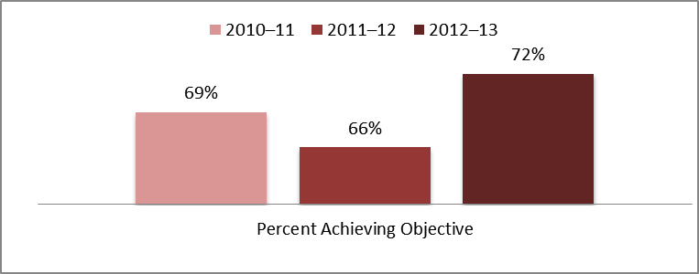

Data for High School Completion

In addition to pre- and post-testing students who received tutoring services, Core Programs were asked to track the high school completion data for twelfth grade students who received services from FYS.

Table 3 outlines the High School Completion Data. The data reflects a 70 percent high school completion rate in 2010–11, a 77 percent high school completion rate in 2011–12, and a 62 percent completion rate in 2012–13, all of which are above the 58 percent research graduation data rate for students in foster care.

Table 3: Data for High School Completion in 2010–11, 2011–12, and 2012–13

 | Number of Grade Twelve Foster Youth Eligible to Complete High School Program | Number of Eligible Foster Youth Completing High School Program | Percentage of Eligible Foster Youth Completing High School Program
2010–11 | 256 | 180 | 70%
2011–12 | 174 | 134 | 77%
2012–13 | 225 | 140 | 62%

Table 4 further explains the completion rates for each year into types of certificates received. For 2010–11, 89 percent of the eligible foster youth completing a high school program earned a high school diploma, 2 percent passed the General Educational Development Test (GED®), 9 percent received a certificate of completion, and no students took the California High School Proficiency Examination (CHSPE). For 2011–12, 94 percent earned a high school diploma, 3 percent passed the GED®, 3 percent received a certificate of completion, and no students took the CHSPE. For 2012–13, 96 percent earned a high school diploma, 2 percent passed the GED®, 2 percent received a certificate of completion, and no students took the CHSPE.

On September 23, 2013, Governor Edmund G. Brown Jr. signed into law AB 216, Chapter 324, Statutes of 2013, which amends the EC regarding high school graduation requirements for students in foster care. AB 216 adds Section 51225.1 to the EC with respect to a foster student who transfers school after the second year of high school. Under the new section, each school district must exempt the student from the school district's graduation requirements that exceed state graduation requirements unless the school district makes a finding that the student is "reasonably able" to complete the school district's graduation requirements in time to graduate from high school by the end of the student's fourth year. AB 216 authorizes each school district to allow a student in foster care to stay in high school for a fifth year so the student can complete the school district's graduation requirements. If the school district makes this determination, the school district must provide notice to the student and others involved in the student’s education planning of this option and related details.

The intent of AB 216 is to help continue the trend of increasing the number of students in foster care who are receiving high school diplomas compared to other methods of high school completion (similar to AB 167, Chapter 224, Statutes of 2009). AB 167 allowed students in foster care who change schools in their eleventh or twelfth grade year to receive high school diplomas by meeting the California State minimum graduation requirements. This includes passing the CAHSEE unless otherwise exempted.

Table 4: Types of High School Completion in 2010–11, 2011–12, and 2012–13

 | Number Completing High School Diploma |  | Number Completing GED® |  | Number Completing Certificate of Completion |  | Number Completing CA High School Proficiency Exam
 | Number | Percent | Number | Percent | Number | Percent | Number | Percent
2010–11 | 160 | 89% | 3 | 2% | 17 | 9% | 0 | 0%
2011–12 | 126 | 94% | 4 | 3% | 4 | 3% | 0 | 0%
2012–13 | 134 | 96% | 3 | 2% | 3 | 2% | 0 | 0%

Objective Two: Impact on Incidence of Pupil Discipline

Rationale: Foster children and youth often exhibit maladaptive behaviors that interfere with their school success. Such problem behaviors include excessive truancy, assault, and substance abuse, all of which constitute grounds for expulsion. The FYS Core Programs measured program impact on the incidence of student discipline referrals, expulsions, and involvement in the juvenile justice system.

Target objective: Fewer than 5 percent of the foster youth population will be expelled during the school year.

Findings: Of the 3,785 students served in 2010–11, 0.26 percent (10 students) were expelled; of the 2,089 students served in 2011–12, 0.24 percent (5 students) were expelled; and of the 2,568 students served in 2012–13, 0.19 percent (5 students) were expelled. These numbers significantly surpassed the target objective of fewer than 5 percent of students expelled.

Table 5: Data for Pupil Expulsions for Discipline Problems

For School Years 2010–11, 2011–12, and 2012–13

 | Total Number of FYS Students | Number  of FYS Students Expelled | Percentage  of FYS Students Expelled
2010–11 | 3,785 | 10 | 0.26%
2011–12 | 2,089 | 5 | 0.24%
2012–13 | 2,568 | 5 | 0.19%

Objective Three: Impact on Pupil Truancy Rates

Rationale: Truancy has been identified as one of the barriers to academic success for foster youth which significantly impacts the youth’s opportunities to access the curriculum. Studies show that 70 percent of non-foster youth complete high school, while only 50 percent of foster youth complete high school.

Target objective: Foster youth students will achieve an average attendance rate of 90 percent during the school year.

Findings: Table 6 illustrates that for 2010–11, 2011–12, and 2012–13, foster youth enrolled in a comprehensive program exceeded the target rate of 90 percent.

Table 6: Data for Pupil Truancy in Foster Youth Services Core Programs

For Program Year 2010–11, 2011–12, and 2012–13

Grade Level | 2010–11 |  | 2011–12 |  | 2012–13
 | Number of Students | Attendance Rate | Number of Students | Attendance Rate | Number of Students | Attendance Rate
K | 81 | 96% | 151 | 97% | 72 | 95%
1 | 132 | 97% | 216 | 97% | 101 | 97%
2 | 125 | 96% | 180 | 98% | 97 | 97%
3 | 115 | 96% | 187 | 97% | 94 | 97%
4 | 114 | 96% | 180 | 97% | 90 | 96%
5 | 109 | 96% | 180 | 97% | 85 | 96%
6 | 129 | 97% | 165 | 96% | 104 | 95%
7 | 129 | 95% | 174 | 95% | 86 | 93%
8 | 160 | 96% | 187 | 91% | 108 | 93%
9 | 161 | 94% | 294 | 94% | 130 | 95%
10 | 233 | 95% | 355 | 92% | 149 | 93%
11 | 195 | 94% | 404 | 92% | 140 | 91%
12 | 180 | 94% | 422 | 89% | 163 | 90%
Total | 1863 | 95% | 3095 | 94% | 1419 | 94%

Table 7 explains that foster youth students attending alternative education programs such as Court and Community School, Opportunity Program, or a school within a juvenile detention facility achieved an attendance rate of 92 percent in 2010–11, 88 percent in 2011–12, and 91 percent in 2012–13. These rates exceeded the target in two of the three years (2010–11 and 2012–13).

Table 7: Alternative Education Student Attendance
For Program Years 2010–11, 2011–12, and 2012–13

2010–11 |  | 2011–12 |  | 2012–13
Number of Students | Attendance Rate | Number of Students | Attendance Rate | Number of Students | Attendance Rate
295 | 92% | 224 | 88% | 156 | 91%

Core Programs’ Response to the Legislative Analyst’s Office Report

In May 2009, the California Legislative Analyst’s Office (LAO) released a report titled Education of Foster Youth in California. One recommendation included the elimination of Core Programs in an effort to streamline FYS implementation efforts. The following is the Programs’ response to the LAO report.

Foster youth benefit from the services and support provided by FYS Core Programs in the following ways: (1) increased school attendance; (2) improved grades; (3) reduced emotional and behavioral difficulties at school; (4) increased graduation rates; and (5) reduced rates of homelessness and unemployment after exiting the foster care system, all due to the individualized attention to each student’s particular needs. This information is well documented in the annual FYS Program Year-End Reports (YERs) submitted to the CDE.

The FYS Core Programs are able to identify their foster youth students and address individual issues that would be challenging to the larger FYS Programs, collaborate with one another to problem-solve systems-related and service delivery concerns, and provide a leadership role to the FYS Programs. The FYS Core Programs are in a unique position to base services and support at schools. The inherent relationships that school districts have with the local community provide a platform for grants and partnerships that would be more challenging for a large FYS Program. This makes it more feasible for FYS Core Programs to leverage outside funding and resources.

If FYS Core Programs were eliminated, as recommended in the 2009 LAO Report, there would be no platform on which to expand appropriate FYS strategies and best practices in the future. Dismantling these programs would eradicate some of the most effective support and services that meet the particular needs of foster youth in California. Large COEs are not in a position to replicate the individualized services provided by FYS Core Programs. The FYS Core Programs recommend that FYS Programs expand district-level programs for better identification and assessment of individual needs and supportive services for foster students in California.

Part II—Foster Youth Services Programs Report (Countywide/Juvenile Detention)

This section reports on progress made by the FYS Programs in meeting the goals established in the guiding legislation, SB 933, Chapter 311, Statutes of 1998 (Appendix D). It also describes program challenges, accomplishments, and goals and objectives for 2012–13.

Part II of this report contains the following:

- Evidence of progress in the establishment of advisory groups of collaborative partners in participating counties to plan the FYS Programs

- Evidence of progress in the establishment of collaborative partners to provide services to foster youth residing in county boundaries (services include, but are not limited to, educational assessments, tutoring, mentoring, counseling, transitional services, vocational education, training for LCI staff and partner agencies, and emancipation/independent living services)

- Evidence of progress in the development of a mechanism for the efficient and timely transfer of health and education records

- Description of services provided by FYS Programs

- Description of the challenges reported by the 55 participating COEs in the implementation of various aspects of the FYS Programs

- Description of significant accomplishments reported by the FYS Programs

Establishment of Local Advisory Group

Evidence of progress made in the establishment of a local advisory group (LAG) of collaborative partners in each participating county to plan the FYS Programs, to advise on the direction of program services, and to collaborate on providing those services:

All of the FYS Programs operating in 2012–13 reported the existence of a LAG that serves as a steering committee and/or service provider for foster youth living within county boundaries. In 2010–11, the majority of counties (62 percent) reported having established the LAG from scratch rather than adopting an existing interagency committee to serve as the LAG. The FYS Programs have continued this practice and have been able to expand the number and types of agencies participating. The counties that have adopted an existing interagency committee to satisfy the LAG function are primarily small, rural counties that lack a large government and social-services infrastructure. The adoption of existing interagency committees is an efficient utilization of existing staff and resources in these counties.

In addition, as FYS Programs evolve, they are increasingly integrating into the local collaborative frameworks that include more collaborative partnerships with the courts, social services, and probation and other social service related agencies. This ensures that the FYS Program is sustainable over time and can leverage resources effectively to benefit the educational achievement of foster youth in their local communities.

The FYS LAGs are composed of a wide array of agency representatives to address the comprehensive needs of foster youth. The LAGs represent a multidisciplinary approach to meeting the unique educational, social, emotional, physical, and legal needs of foster youth. The FYS Programs have succeeded in establishing comprehensive LAGs that meet the holistic needs of foster youth.

Table 8 illustrates a breakdown of LAG representatives for the FYS Programs and the percentages of counties that include these representatives in their LAGs.

Table 8: Percent of Foster Youth Services Programs

Agency Representative | 2008–09 | 2010–11 | 2011–12 | 2012–13
Alcohol/Drug Programs | 61% | 67% | 77% | 74%
Colleges/Universities | 82% | 80% | 84% | 87%
Community-Based Organizations | 84% | 80% | 82% | 85%
County Mental Health | 88% | 95% | 95% | 96%
County Employment Development Offices | 54% | 55% | 63% | 63%
County Probation | 96% | 100% | 96% | 100%
County Public Health | 71% | 73% | 70% | 69%
County Department of Social Services | 99% | 100% | 96% | 100%
Courts | 75% | 75% | 79% | 72%
Faith-Based Organizations | 27% | 38% | 44% | 43%
Former and Current Foster Youth | 79% | 78% | 86% | 94%
Foster Youth Advocacy Groups | 59% | 62% | 70% | 72%
Group Home Providers | 80% | 84% | 88% | 91%
Independent Living Skills Programs | 91% | 93% | 88% | 94%
Private Industry | 27% | 20% | 21% | 28%
Schools and District Offices | 98% | 100% | 100% | 96%
Tribal Organizations | 21% | 29% | 33% | 43%

The variance of agency representation on LAGs for the FYS Programs ranged from 4 to 30 representatives. Predictably, the larger counties had the greatest number of representatives from various agencies. The smaller counties with only four or five representatives in their LAGs included representatives from county social services, county mental health, county probation, and local educational agencies (LEAs). Overall, counties reported an increase in the number of advisory group representatives. As noted in the 2012 FYS Program Report to the Legislature and the Governor (FYS Report), advisory group representation has continued to increase among faith-based organizations by 5 percent, tribal organizations by 14 percent, and alcohol and other drug programs by 7 percent. There was an increase in former and current foster youth by 16 percent, group home providers by 7 percent, and private industry by 8 percent. The overall data indicates increased involvement of local agencies evidenced by an increased number of formal Memorandums of Understanding (MOUs) resulting in more leveraged resources in 2012.

Chart 3 shows that in 2011–12, 89 percent and in 2012–13, 93 percent of programs indicate that the LAG has or is in the process of finalizing MOUs to share local resources and/or data. This is up from 80 percent reported in 2010–11.

Chart 3: Percent of Foster Youth Services Program
With or Developing A Memorandum of Understanding

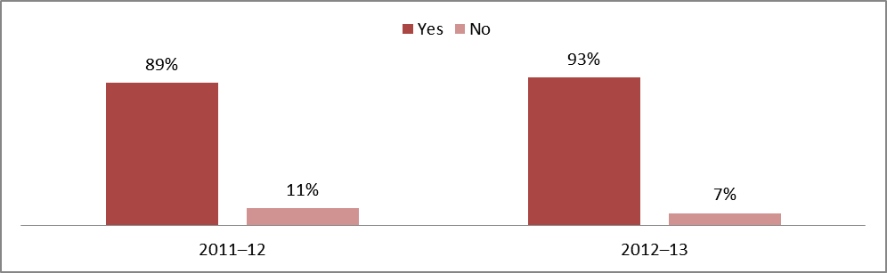

Establishment of Collaborative Partners

Evidence shows progress was made in the establishment of collaborative partners to provide services to foster youth residing in county boundaries. (Services to be provided through collaborative partners include, but are not limited to, educational assessments, tutoring, mentoring, counseling, transition services, vocational education, emancipation/independent living services, transfer of health and education records, and training for LCI staff and partner agencies.) Further progress is evidenced by the increase in the number of partners engaging in data sharing practices.

Chart 4 illustrates that the percent of FYS Programs sharing data with collaborative partners has increased from 61 percent in 2011–12 to 69 percent in 2012–13.

Chart 4: Data Sharing with Other Agencies and/or School Districts

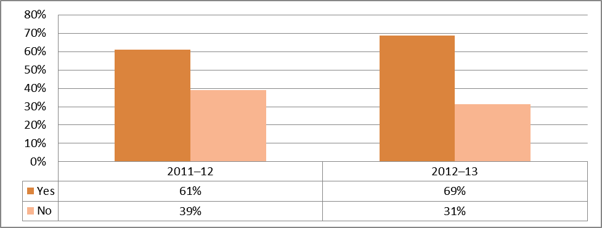

One of the vital aspects of the FYS Programs is the development of collaborative relationships among social workers, probation officers, group home staff, school staff, and community service agencies to influence foster care placement and to enhance the academic success of foster youth. Specifically, AB 490, Chapter 862, Statutes of 2003, requires collaboration between placing agencies, educators, care providers, and juvenile courts to ensure that foster youth: (1) have a meaningful opportunity to meet state academic achievement standards; (2) are able to maintain stable school placements; (3) are placed in the least restrictive care and educational environments; and (4) have access to the academic resources, services, and enrichment activities available to all other students. In addition, AB 490 places a limit on the amount of time allowed for the transfer of health and education records and requires that foster youth be enrolled in school immediately, even without the requisite health and education records. To ensure accountability, AB 490 requires LEAs to designate a staff person as a foster youth education liaison to ensure proper educational placement and timely transfer and enrollment.

In addition to AB 490, on October 7, 2008, the federal government also recognized the importance of education for foster youth and passed Public Law 110–351, Fostering Connections to Success and Increasing Adoptions Act of 2008 (Fostering Connections), which included provisions very similar to AB 490. An important change in federal law is the requirement for Child Welfare Agencies (CWAs) to work with their LEAs to develop case plans that support the educational stability of a child while in foster care. This new mandate for CWAs has created a new opportunity to further strengthen existing collaboratives focused on supporting positive educational outcomes for foster youth.

On November 3–4, 2011, The Children’s Bureau, in partnership with the CDE, hosted a conference entitled Child Welfare, Education, and the Courts: A Collaboration to Strengthen Educational Successes of Children and Youth in Foster Care in Washington, D.C. This event brought together national, state, and local child welfare, education, and court leaders from across the nation to work together to develop workable solutions to improve education outcomes for all students in foster care. This meeting highlighted several of the positive outcomes of California’s FYS Programs as well as California’s landmark legislation which supports the educational needs and achievements of students in foster care.

While the concept of collaboration is readily accepted as necessary in addressing the comprehensive needs of foster youth, the actual attainment of effective collaboratives has proven to be a challenge. Collaboratives are built and maintained through ongoing communication and interaction among collaborating agencies. Many agency directors and staff do not have adequate time to develop new collaborative relationships and responsibilities. As noted in a study by the American Institutes for Research, “even among agencies with a history of successful interagency collaboration, no one reported it is an easy accomplishment.” The FYS Programs have difficulty establishing and maintaining effective collaborations with partner agencies.

Despite the difficulties of collaboration, the FYS Programs provided strong evidence of the development of effective collaborations throughout the state in service to foster youth. Common strategies used to facilitate the development of collaborative relationships with partner agencies are described as follows:

Co-location: Several counties, varying in size and demographic composition, reported the establishment of the FYS Program service site at a location other than the COE. The most common co-location sites reported were school campuses, school district offices, and county health and human services offices. A primary benefit of co-location, as reported by FYS Program staff, is the increased interaction of FYS staff with their collaborative partners. The ability to interface on a daily basis helps build working relationships among collaborative partners. Co-location also makes the sharing of information more efficient, enhances the effectiveness of staff development training, maximizes the coordination of services, and results in overall cost savings. Several counties reported having co-located in order to collect and transfer the health and education records of foster youth more efficiently.

Interface with existing services: In addition to developing new collaboratives, FYS Programs also interface with existing programs to supplement support services provided to foster youth. These existing programs include Title I Neglected and Delinquent Youth, Title VII American Indian Education, Healthy Start, Systems of Care, Special Education, Workforce Investment Act’s School to Career Program, McKinney-Vento Homeless Education, and Independent Living Skills. In many instances the coordinators for the FYS Programs also manage the aforementioned programs for the COEs, further maximizing the coordination of services and leveraged resources.

Participation in county multidisciplinary team meetings and other interagency group meetings: As in the 2012 FYS Report, a majority of the FYS Programs reported that their FYS Program coordinators or other FYS Program staff are members of multiple children’s interagency councils or county multidisciplinary teams. Examples of councils and interagency groups include the Juvenile Justice Commission, the Juvenile Justice Coordinating Council, Court Appointed Special Advocates, Children’s Services Coordinating Council, Superintendents’ Council, Schools Advisory Group, Health Advisory Council, Providers’ Network, Transition Coalition, foster parents’ associations, and tribal councils. A key role of the FYS representative is to alleviate the division between programs and systems by serving as a bridge between education, social services, law enforcement/courts, placing agencies, and care providers. The FYS representative acts as a liaison and provides a voice for foster youth in the team decision-making process to ensure that their holistic needs are addressed. In addition to these collaboratives, in its Final Report and Action Plan dated May 2009, the California Blue Ribbon Commission on Foster Care recommended that all agencies and the courts make access to education and all of its related services a top priority when working with foster children and youth. This is a unique collaborative because it is spearheaded by the courts and judiciary.
Table 9 describes how each agency participates with the FYS programs.

Table 9: Local Advisory Group Information for 2011–12 and 2012–13

 | Participates in FYS Advisory Activities |  | Co-located with FYS Staff |  | Involved in Health and Education Passport |  | Provides Student Referrals to FYS |  | FYS Participates in Multidisciplinary Team Case Planning |  | Party to Formal Interagency Agreement with FYS
 | 2011–12 | 2012–13 | 2011–12 | 2012–13 | 2011–12 | 2012–13 | 2011–12 | 2012–13 | 2011–12 | 2012–13 | 2011–12 | 2012–13
Alcohol and Other Drug Programs | 47% | 39% | 19% | 19% | 11% | 5% | 42% | 42% | 28% | 23% | 9% | 9%
Colleges and Universities | 79% | 77% | 5% | 5% | 5% | 11% | 40% | 39% | 9% | 12% | 19% | 19%
Community- Based Organizations | 74% | 68% | 7% | 9% | 4% | 7% | 53% | 51% | 33% | 25% | 25% | 21%
County Mental Health | 82% | 79% | 16% | 14% | 12% | 11% | 60% | 61% | 60% | 53% | 30% | 23%
County Employment | 49% | 42% | 5% | 7% | 0% | 2% | 35% | 25% | 9% | 11% | 7% | 11%
County Probation | 96% | 82% | 16% | 21% | 44% | 40% | 79% | 75% | 72% | 63% | 58% | 49%
County Public Health | 51% | 46% | 16% | 14% | 47% | 35% | 39% | 39% | 37% | 33% | 30% | 25%
County Social Services | 93% | 88% | 30% | 33% | 63% | 68% | 82% | 79% | 77% | 74% | 74% | 68%
Courts | 56% | 51% | 5% | 9% | 18% | 18% | 53% | 44% | 19% | 19% | 28% | 23%
Faith-Based Organizations | 30% | 25% | 0% | 0% | 0% | 0% | 19% | 19% | 5% | 2% | 4% | 5%
Former and Current Foster Youth | 81% | 12% | 16% | 9% | 5% | 39% | 49% | 21% | 23% | 9% | 14% | 61%
Foster Youth Advocacy Groups | 68% | 61% | 5% | 5% | 5% | 7% | 47% | 42% | 14% | 21% | 16% | 16%
Group Home Providers | 70% | 68% | 4% | 7% | 28% | 23% | 74% | 61% | 33% | 35% | 21% | 18%
Independent Living Skills Programs | 82% | 79% | 18% | 23% | 25% | 25% | 63% | 58% | 42% | 46% | 25% | 23%
Private Industry | 18% | 16% | 4% | 2% | 0% | 0% | 5% | 9% | 4% | 5% | 5% | 7%
School and District Offices | 89% | 82% | 30% | 32% | 40% | 40% | 82% | 75% | 51% | 47% | 49% | 39%
Tribal Organizations | 25% | 32% | 4% | 4% | 0% | 5% | 19% | 23% | 14% | 16% | 12% | 12%
Other | 46% | 46% | 7% | 9% | 12% | 11% | 39% | 42% | 28% | 23% | 19% | 16%

Table 10 lists the agencies and their respective services reported by a majority of FYS Programs to be commonly found in collaborative partnerships.

Table 10: Collaborative Agencies and Services Provided

Collaborative Agencies | Services Provided
County Courts/  Local Blue Ribbon Commissions | Judicial guidance and leadership regarding to the case management challenges associated with supporting the health and well-being of youth in care, which include, but are not limited to, education services
County Departments of Mental Health | Counseling, psychological evaluations, medication consultation, behavior management techniques, and assistance in completing health and education records
County Departments of Social Services/Probation | Case management, counseling, monitoring, appropriate behavioral reinforcement, and assistance in completing health and education records
County Departments of Employment and Human Services | Employment training and assistance
County Public Health Departments | Health and education records, provision of public health services at schools, workshops for foster youth and group home staff, and funding for eyeglasses
County Probation Departments | Monitoring and reinforcement of appropriate behavior, meetings with family and school personnel, and information regarding placement changes for foster youth
Local Educational Agencies | Educational assessment to determine appropriate special education services and school placement, assistance through the School Attendance Review Board, tutoring services, and school attendance monitoring/truancy intervention
Colleges and Universities | Tutoring and mentoring services, counseling, financial aid information, and outside evaluations of FYS Programs
Family Resource Centers and Other Community-Based Organizations | Case management, training for group home providers, employment services (work experience, job skills, career assessments, and Regional Occupation Program credits, etc.), and funding for school clothes
Tribal Organizations | Leisure/recreational activities, family therapy, development of social skills, problem solving, team building, and cultural awareness
Independent Living Skills Programs | Career development services, life skills classes, transition and emancipation services, and vocational education
Churches and Private- Sector Organizations | Funding for extracurricular activities, toys, gift certificates for basic needs, and mentoring
Caregivers | Address the needs of foster youth in their care
Other Foster Youth Service Countywide Programs | Technical assistance, sharing of best practices, data collection procedures, and operational databases

The collaborative relationships developed by the FYS Programs have resulted in a substantive base of comprehensive services provided to foster youth. Services are

provided primarily through referrals to partner agencies with some instances of direct service provision.

Table 11 summarizes the FYS services provided statewide in 2010–11, 2011–12, and 2012–13, either directly through FYS Programs or through referral to partner agencies.

Table 11: Services Provided Through the Foster Youth Services Programs
For Program Years 2010–11, 2011–12, and 2012–13

Services Provided | Direct Service |  |  | Indirect Service |  |  | Referral Service
Services Provided | 2010–11 | 2011–12 | 2012–13 | 2010–11 | 2011–12 | 2012–13 | 2010–11 | 2011–12 | 2012–13
Academic Counseling | 2,968 | 5,229 | 7,268 | 3,064 | 3,340 | 3,288 | 1,748 | 2,137 | 2,732
Academic Tutoring | 3,314 | 3,718 | 4,343 | 931 | 1,943 | 1,644 | 1,426 | 2,404 | 2,078
Advocacy and Consultation | 5,513 | 6,163 | 6,589 | 7,150 | 6,225 | 5,382 | 2,187 | 2,950 | 2,350
Education Assessment | 5,258 | 5,859 | 5,372 | 3,001 | 2,908 | 1,105 | 1,208 | 1,794 | 907
Link to Community Services | 2,659 | 2,938 | 2,601 | 2,410 | 3,141 | 1,801 | 1,395 | 3,402 | 3,499
Mentoring | 2,724 | 2,552 | 3,053 | 1,924 | 1,429 | 1,979 | 1,736 | 544 | 463
School-based Behavior Support Services | 1,102 | 1,476 | 1,082 | 567 | 719 | 625 | 133 | 349 | 215
Other | 6,617 | 7,650 | 6,949 | 1,993 | 5,900 | 7,996 | 255 | 737 | 685

- Direct Services—indicates the number of students who received services provided by the FYS Program directly. Example: FYS staff or contractors were directly involved in tutoring, advocating, or doing educational case management.

- Indirect Services—indicates the number of students who received services provided by the FYS Program in collaboration with local partners. Example: FYS staff provided a transfer of record.

- Referred Services—indicates the number of students who were referred to other agencies or departments for services. For example, FYS staff has referred students for tutoring at a local school site. The indirect and referral services are often provided to foster youth in Family Maintenance, those youth in the child welfare system that remain with parents, as well as those youth in Guardian placement who are youth in the child welfare system placed with family members.

Family Maintenance and Guardian placements represent 36 percent of the foster care population.

Chart 5 illustrates that tutoring services remain the most prevalent service provided by the FYS Programs with 54 of the 55 (98 percent) FYS Programs offering tutoring programs in 2011–12 and all 55 (100 percent) FYS Programs offering tutoring services in 2012–13. The next most prevalent service provided is transition service. In an effort to improve outcomes for youth exiting foster care, the federal Fostering Connections to Success and Increasing Adoptions Act of 2008 included planning provisions to help youth better transition to independent living and adulthood. A Transition Plan is required for each youth exiting foster care. Specific elements such as housing, education, employment, mentoring, and continued support services must be included. AB 12, Chapter 559, Statutes of 2010, known as the California Fostering Connections to Success Act, allows California to take advantage of several components of the federal Fostering Connections to Success and Increasing Adoptions Act of 2008.

Chart 5: Services Provided Through Foster Youth Services Programs

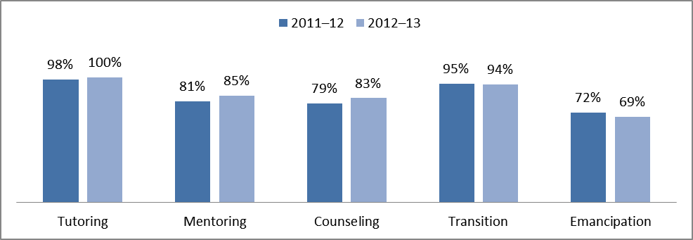

In 2011–12 and in 2012–13, FYS Programs provided appropriate placement services to 8,913 and 7,654 foster youth respectively.

Chart 6 provides the types of services categories in the FYS Programs and indicates that the service most utilized is special education support. A high percentage of foster students qualify for special education services; however, their high mobility rate interferes with timely and appropriate placement. For this reason it is important for the FYS Programs to participate in appropriate educational placement decisions. As a result of the successful FYS Program collaborations, the team decision-making services increased from 29.2 percent in 2011–12 to 38.9 percent in 2012–13, an increase of 9.7 percent. This data also reveals an opportunity to increase the use of other intervention strategies, such as 504 plans and Student Study Teams, to strengthen overall case

management for foster youth, thereby increasing access to more supports with the overall goal of improving educational outcomes.

Chart 6: Percent of Appropriate Placement Services

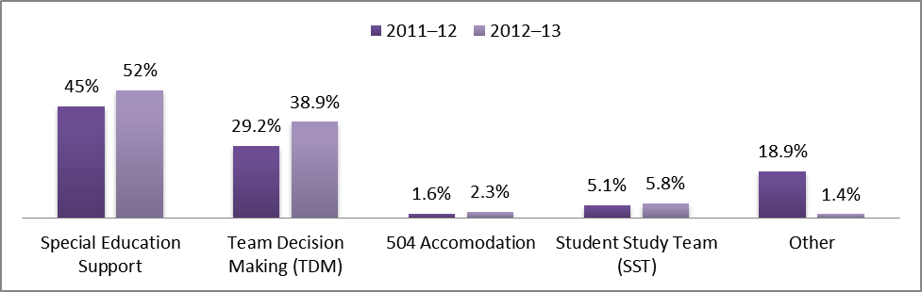

One of the challenges of transitioning between adolescence and young adulthood is developing the ability to become a self-advocate to pursue a purpose in life, to meet one’s own needs and interact effectively with other people, and to contribute to the welfare of society. When foster youth turn eighteen they are often left on their own with little to no support to address their changing needs. Thus, it is important that they learn self-advocacy skills, and it is a task of the FYS Programs to provide such training.

Chart 7 indicates that in 2011–12, FYS Programs provided self-advocacy material or training to 17,012 foster youth. Of these, 42 percent were direct services, 39 percent were indirect services, and 19 percent were referral services. In 2012–13, FYS Programs provided self-advocacy services to 16,108 foster youth. Of these, 53 percent were direct services, 33 percent were indirect services, and 14 percent were referral services. It is significant to note the increase (11 percent) in the provision of direct services. This supports a self-advocacy study conducted with more than 1,500 successful people from business, science, sports, and the arts which revealed that "successful people in any field excel at making decisions, self-managing their behavior, and adapting to changing circumstances."
Chart 7: Foster Youth Receiving Self-Advocacy Material or Training

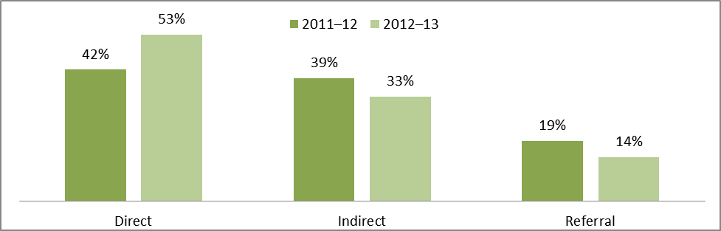

In order for youth to be prepared to work in partnership with adults, they need to develop and/or enhance their leadership skills. Leadership training prepares youth to manage time, work as a team, set goals, start conversations, facilitate meetings, and make effective presentations.

Research on resilient youth and the process of growing into adulthood indicates that youth participation (a broader category that encompasses youth leadership) is a critical component that supports positive youth development. It creates a sense of belonging, a sense of autonomy and power, helps youth develop needed social and decision-making skills, builds their sense of competence, and also motivates them to persist.

Studies show that youth who have meaningful involvement in decision-making about their lives early in high school are substantially more likely than other youth to meet key developmental milestones by the end of high school.

Youth leadership builds skills that employers are looking for. A survey conducted by the National Association of Colleges and Employers (2011) found that when it comes to the importance of candidate skills/qualities, employers are looking for team players and candidates who have strong verbal communication skills. These skills are developed in strong Youth Leadership programs.

Chart 8 explains that in 2011–12 FYS Programs provided leadership/youth development services to 11,492 foster youth. Of these, 42 percent were direct services, 32 percent were indirect services, and 25 percent were referral services. In 2012–13, FYS Programs provided leadership/youth development services to 9,764 foster youth. Of these, 44 percent were direct services, 30 percent were indirect services, and 26 percent were referral services.
Chart 8: Foster Youth Participating in Leadership/Youth Development Activities

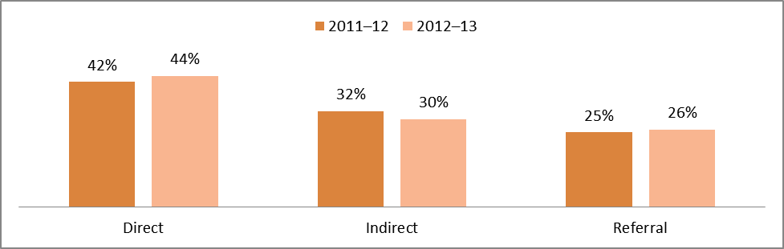

FYS Programs also provide services and support to help youth develop skills and knowledge, make connections with resources, and access transitional living arrangements. Services provided for youth include individualized assessment and service planning based on the needs, strengths, and goals of the individual. For younger students the focus is on age and developmentally appropriate skills provided primarily through group process with a focus on communication, self-identity, peer pressure, and decision-making. For older students, services are provided in individual and group sessions. The focus is on skills that include assisting the youth with obtaining a high school diploma; career exploration; vocational training; job placement and retention; budgeting and financial management skills; substance abuse prevention; preventive health activities; and making connections with community resources such as employment programs, Department of Health Services, housing, and financial assistance.

- In 2010–11, FYS Programs provided independent living services to 15,127 foster youth.

- In 2011–12, FYS Programs provided independent living services to 16,034 foster youth.

- In 2012–13, FYS Programs provided independent living services to 11,883 foster youth.

Chart 9 illustrates the breakdown of these services in 2012–13 as 52 percent direct, 23 percent indirect, and 25 percent referral.

The data indicate that although the total number of youth served in 2012−13 is reduced from 2010–11, the FYS Programs are providing more direct services in independent living services (up 18 percent from 2010–11 to 2012–13).

Chart 9: Independent Living Services

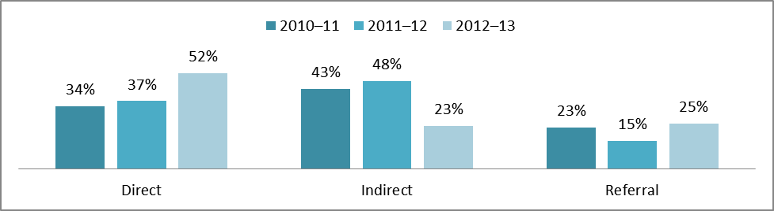

Chart 10 illustrates the breakdown of these services in 2012–13 as 59 percent direct, 27 percent indirect, and 14 percent referral. The data indicate that although the total number of youth served in 2012–13 is only slightly higher than in 2010–11 in Vocational/Career Technical Education Support Services, the FYS Programs are providing more direct services (up 20 percent from 2010–11 to 2012–13).

- In 2010–11, FYS Programs provided Vocational/Career Technical Education Support Services to 8,274 foster youth.

- In 2011–12, FYS Programs provided Vocational/Career Technical Education Support Services to 11,219 foster youth.

- In 2012–13, FYS Programs provided Vocational/Career Technical Education Support Services to 8,510 foster youth.

Chart 10: Vocational/Career Technical Educational Support Services

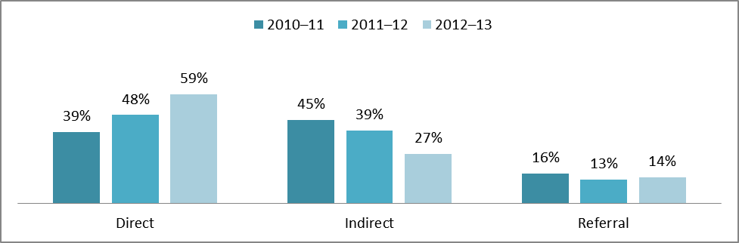

Chart 11 illustrates the breakdown of these services in 2012–13 as 56 percent direct, 28 percent indirect, and 16 percent referral. The data indicate that although the overall number of foster youth served is only slightly increased from 2010–11 in Post–Secondary Preparation and Support Services, the FYS Programs are providing more direct services (up 11 percent from 2010–11 to 2012–13).

- In 2010–11, FYS Programs provided Post–Secondary Preparation and Support Services to 10,017 foster youth.

- In 2011–12, FYS Programs provided Post-Secondary Preparation and Support Services to 13,128 foster youth.

- In 2012–13, FYS Programs provided Post-Secondary Preparation and Support Services to 11,659 foster youth.

Chart 11: Post-Secondary Preparation and Support Services

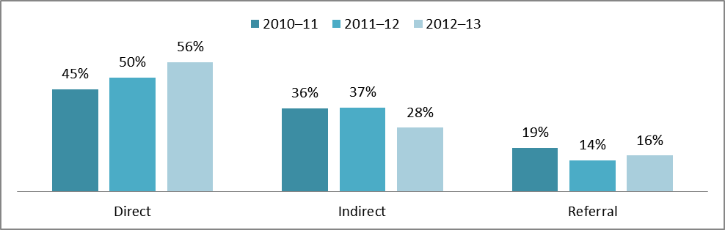

Transfer of Health and Education Records

Evidence of progress made in developing a mechanism for the efficient and timely transfer of health and education records.

AB 490 requires LEAs to transfer education information and other records to a foster student’s next educational placement within two business days of receiving a transfer request. The information to be transferred includes determination of seat time, full or partial credits earned, classes, grades, immunizations, and individualized education programs (IEPs) for special education services. In addition, AB 490 stipulates that LEAs must designate a staff person to serve as the foster youth educational liaison to ensure the timely transfer of complete health and education records.

The Health and Education Passport (HEP) is the essential instrument used to ensure that the health and education records of FYS students are current. County placing agencies have the primary responsibility for completing the HEP. The health information for the HEP is often completed by public health nurses, while the education information is completed by social workers for foster youth. Counties report that HEPs frequently are incomplete and that the length of time necessary to locate prior school records remains a common barrier.

Facilitation of the timely transfer of complete health and education records has been a principal goal of the FYS Programs since its inception. Over the past 11 years, FYS coordinators have worked diligently to improve record transfers through collaboration with placing agencies, evaluation of administrative systems, and the bridging of communication and operational gaps between various agencies involved in the placement and education of foster youth. Several FYS coordinators report that their programs have recently dedicated staff, co-located, or entered into an MOU to advance a more expeditious, accurate, and efficient record transfer process.

Chart 12 explains that in FY 2011–12, FYS Programs reported having facilitated the transfer of 22,157 records and in 2012–13, 20,580 records were transferred to school districts throughout California to enroll foster youth in school.

Chart 12: Number of Foster Youth Records Transferred

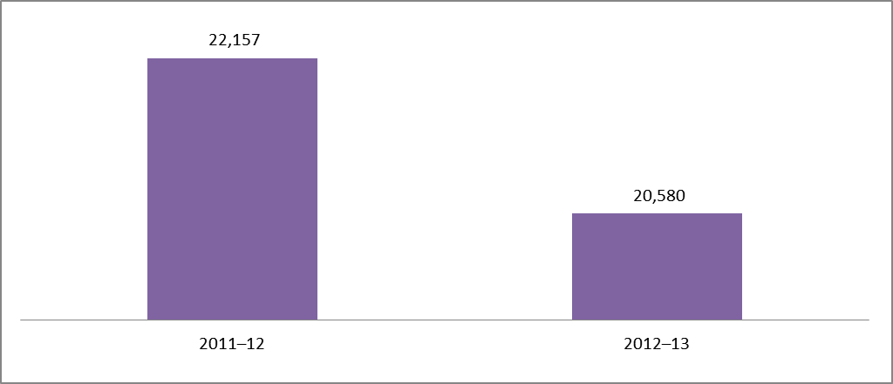

Chart 13 indicates the number of records transferred has decreased over the past two years. In addition, the majority of FYS Programs (95 percent) reported the range of days taken to transfer records was 1 to 3 days, with the average number of days to transfer records for 2011–12 being 1.81 days and for 2012–13 being 1.79 days, a decrease from the 2.63 average days reported in the 2010 FYS Report.

Chart 13: Average Number of Days for Transfer of Records

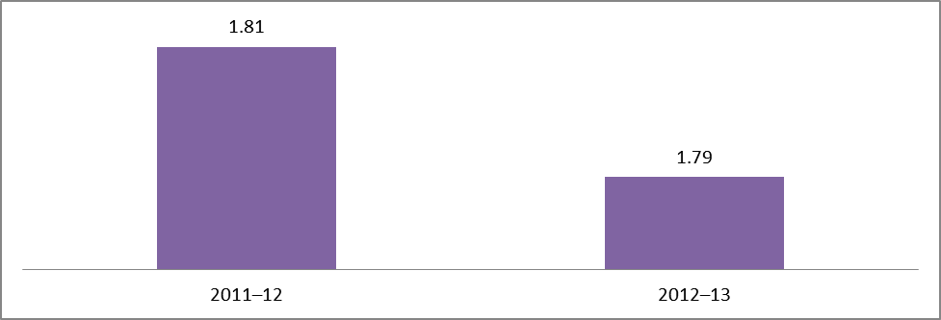

Chart 14 indicates the method of record transfers for 2011–12 and 2012–13. The transfer of health and education records within a two-day period, as stipulated by AB 490, remains a top priority for the FYS Programs to ensure that students have appropriate placements in the absence of school stability. High student mobility rates have continued to impact the school placement stability of foster youth in California.

Chart 14: Types of Record Transfer

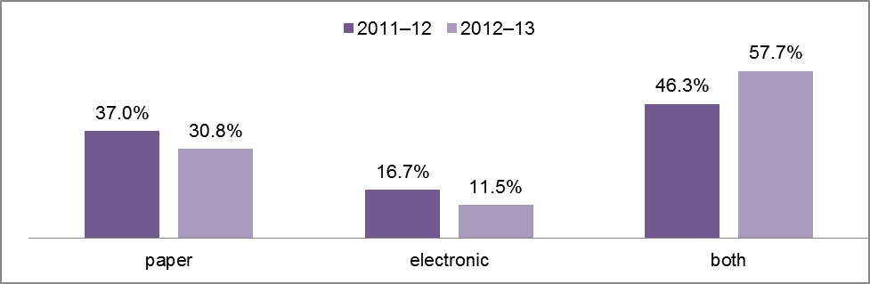

Challenges

Many of the FYS Programs reported common challenges in implementing effective FYS Programs. The challenges listed in Table 12 were reported most frequently by the 55 participating COEs in the implementation of various aspects of the FYS Program.

Table 12: Challenges in Implementing Effective Foster Youth Services Program

- Funding/Budget Cuts
- Education Records Tracking/Collection
- Foster Youth Transiency
- Collaboration with Partner Agencies
- Enrollment Challenges
- Transportation to School of Origin
- Identifying Person with Education Rights

Some of these challenges are described as follows:

Budget Cuts/Funding Decrease: The fiscal challenges reported in the 2012 FYS Report continue to be an issue. The funding level for the FYS Programs has remained constant for the past three years, despite an increase in eligible foster youth in California over the past three years. The consistent increases in eligible foster youth, coupled with a flat funding structure have created a widening gap in resources that makes it challenging to close.

Record Sharing: Issues of confidentiality related to the Health Insurance Portability and Accountability Act (HIPAA) of 1996 and the Family Educational Rights and Privacy Act (FERPA) of 2000 have resulted in difficulty sharing foster youth records. Although the majority of counties have employed collaborative agreements, developed MOUs, or utilized standing court orders to address confidentiality issues related to the sharing of health and education records of foster youth among schools, social services, and probation, some counties continue to report barriers in this area. These counties reported difficulties in acquiring health and, in some cases, education records for foster youth transferring into their districts. While both HIPAA and FERPA contain clauses that allow the sharing of health and education records with appropriate agencies, some agencies that possess health and education information have a conservative interpretation in regard to sharing this information with schools and other agencies because of the potential legal ramifications of breaching compliance. The U.S. Department of Education’s Family Policy Compliance Office recognized these challenges and released new FERPA regulations on December 2, 2011, which provided more clarity on how records may be shared, with specific discussion in regards to child welfare agencies. These regulations became effective on January 3, 2012, and can be found on the U.S. Department of Education’s Family Policy Compliance Office web page.

Data Collection: A challenge for all FYS Programs is the high mobility rate of foster youth. Fostering Connections and AB 490 are designed to reduce the mobility rate of foster youth by requiring placing agencies to consider placements that promote educational stability. Although much progress has been made to reduce the number of school placements for youth, many programs still indicate that there are significant numbers of youth who experience multiple moves within a school year. The high mobility of foster students makes tracking the success of services provided and data collection difficult.

Implementation of AB 490: Immediate enrollment, transportation to school of origin, and appropriate educational placement have been increasing challenges as school districts have inconsistent interpretations of immediate enrollment, and the funding for transportation to a student’s school of origin is largely undefined in state statute. However, federal statute under the Individuals with Disabilities Education Act and Fostering Connections provides some guidance and access to federal funds for transportation to the school of origin. In addition, the identification of educational rights holders has been inconsistent in education records for students in foster care who have special education needs. This lack of identification has prevented some students from immediate access to the special education services that they are entitled to in their IEPs.

Accomplishments Reported by the Foster Youth Services Programs

FYS Outcomes: The FYS Programs have worked diligently to establish measurable outcomes that demonstrate the significant impact of the services they provide to foster youth. The data in this report indicates that the FYS Programs are striving to meet the outcomes collaboratively developed by the FYS Program Coordinators. These outcomes state Foster Youth will:

- Experience successful transition to independent living or higher education
- Advocate for their own needs
- Experience timely and appropriate school placement
- Successfully complete their educational programs

The increased provision of direct services was a CDE objective for 2011–12 and 2012–13. The FYS Programs strived to meet this outcome and did so in many of the service categories as seen in Chart 15.
Chart 15: Increase in the Provision of Direct Services

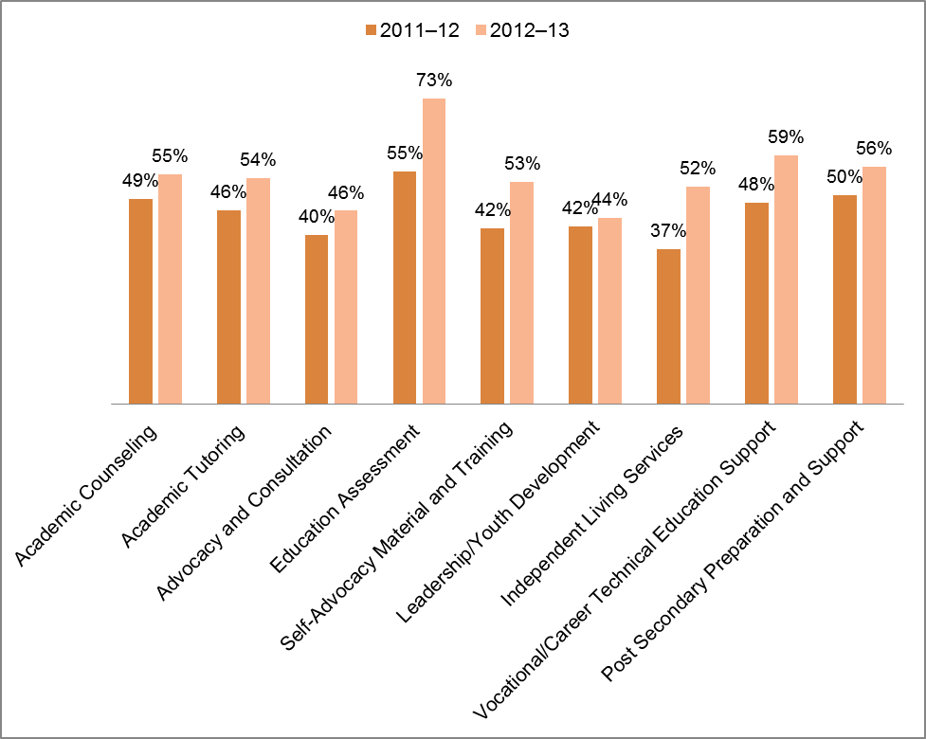

Reported Goals and Objectives

The FYS Programs have made significant progress on the goals and objectives identified in the 2012 FYS Report. Despite this progress, the five goals identified in the 2012 FYS Report continue to be priorities for the FYS Programs. The following list includes the primary goals and objectives:

- FYS Outcomes: Determine appropriate performance measures and collect outcome data for the four FYS outcomes described above.

- Health and Education Records: Improve the accuracy, efficiency, and timely transfer of health and education records for foster youth who experience a change in school placement.

- Collaboration with Partner Agencies: Further develop collaborative relationships with partner agencies to facilitate the sharing of records, ensure appropriate school placements, and more effectively meet the holistic needs of foster youth.
- Provision of Services: Increase the provision of services (tutoring, counseling, mentoring, transition, and emancipation services) to ensure that foster youth receive comprehensive support services.

- Data Collection: Expand automated foster youth data collection systems to track service delivery and to document program outcomes.

Part III—Recommendations Regarding Foster Youth Services Programs

Recommendations Regarding the Continuation of Services

- FYS Programs unanimously recommend a continuation of the FYS Program.

- FYS Programs further recommend allocation of an adequate level of funding to support continuation of those programs.

The FYS Program Coordinators report that FYS Programs are successfully addressing the educational and psychosocial needs of foster youth. A significant cause of the stress foster youth face is the lack of stability in their lives. These programs have been instrumental in providing services that improve educational stability. When foster youth in out-of-home care receive support, their educational, employment, and social outcomes are improved. Funding constraints, at both the county and state levels, have made the expansion and continued development of the FYS Programs challenging. The FYS Programs report that the existing funding model, wherein allocations fluctuate on the basis of a point-in-time count of foster youth placed in specified placements, makes long-term program planning difficult. In addition to this, with the statewide movement to focus more on Family Maintenance and Guardian placement and permanency, the funding structure for FYS will be greatly impacted because FYS Programs are not currently funded to provide services to foster youth in Family Maintenance and Guardian placements. Given that many of the issues faced by foster youth do not end once they are reunited with family members or find permanent placement, FYS Program Coordinators continue to recommend the exploration of a more stable funding structure.

CDE Response: The CDE recommends a continuation of the FYS Programs. The CDE recognizes the inequity and instability in a per pupil funding formula that is based on a dynamic data system that is controlled by the California Department of Social Services (CDSS). The CDE also acknowledges the high mobility of students across county lines, which has contributed to a funding formula that supports a system where some counties are significantly underfunded compared to others. The CDE has attempted to address the discrepancies in funding in the 2011–14 grant with a more static funding formula that was developed by reviewing all of the submitted FYS YERs. In 2013–14, the CDE will explore the feasibility of using the California Longitudinal Pupil Achievement Data System (CALPADS) data when allocating FYS funds. The FYS Program will consider the process used in implementing the Local Control Funding Formula (LCFF) to obtain foster student counts. The LCFF process will utilize data submitted by LEAs through routine CALPADS reporting and data matching. For the first year of implementation, however, it will only be based on one year of data (2013–14 school year), and for the second year, it will be based on two years of data as enumerated by state statute (paragraph [1] of subdivision [b] of Section 2574 and paragraph [5] of subdivision [b] of Section 42238.02 of the EC).

Recommendation Regarding Data Sharing to Improve Effectiveness of Services

- The FYS Program Coordinators recommend that a statewide database for sharing foster youth health and education records and collecting outcome data be developed.

The FYS Programs, particularly those in operation over a number of years, report substantial progress in the establishment of database systems to manage health and education records for foster youth. Despite this progress, a large number of FYS Programs must rely on data systems developed and maintained by collaborative agencies. These programs report ongoing difficulties with importing and consolidating information from multiple data systems that often are incompatible with FYS Program needs. The FYS Programs report that the mobility of foster youth is too great to be tracked by counties that cannot share data in a timely manner, and they recommend the creation of a statewide database capable of linking all school districts and placement agencies with the same data for foster youth. In addition, the FYS Programs report a lack of a well-developed infrastructure and case management system in schools for the purpose of ensuring timely enrollment, the delivery of meaningful supports for foster youth or for ensuring adequate monitoring of educational outcomes for foster youth. The implementation of LCFF and the Local Control and Accountability Plans (LCAP) can provide the foundation for the creation of such a robust system of student support for foster youth in California.

CDE Response: The CDE recognizes the need for FYS Programs to have tools to assist schools and school personnel in the development of a well understood and well- articulated case management process and mechanism for accounting for educational outcomes under LCFF for foster youth. The CDE is working to ensure such tools and technical support is available for districts. In addition, the CDE acknowledges the need for FYS Programs to have access to a uniform database containing up-to-date health and education records on foster youth. Such a statewide system is not currently available, nor is there funding for one. In addition, the creation of such a state system will require a number of years given the state’s process for building and implementing such systems. The Child Welfare Services/Case Management System (CWS/CMS), the system currently utilized for foster youth health and education information, is currently in the process of being replaced. The CDSS is developing a Feasibility Study Report (FSR) for the new system, and the requirements for this new system should reflect the need for a comprehensive database for foster youth.
One requirement may include access to the system by FYS Coordinators in COEs and foster liaisons in LEAs. Currently, FYS Program staff does not have access to CWS/CMS. Allowing FYS Program staff or other appropriately designated school personnel access to the health and education portions of the current CWS/CMS would be a cost-efficient means of addressing this challenge in the short term.

Another requirement could be the sharing of educational data at the state level. Currently, the state’s student education system, CALPADS, does not collect and maintain student attendance data, and it does not collect course enrollment on an ongoing basis. Therefore, sharing data at the state level will not meet the data sharing needs of foster students. However, CALPADS will be providing LEAs with information of who their foster students are based on a weekly match with CDSS foster data. This will greatly enhance the ability for LEAs to share timely educational data locally with their county welfare departments.

Status of Identifying Foster Youth: The CDE and CDSS have developed an MOU to enable the CDE to access, match, and share data for funding and service delivery purposes and to provide the information on identified foster youth to LEAs through CALPADS. Assuming execution of the MOU, the CDE is conducting the activities necessary to implement, by fall of 2014, a new functionality in CALPADS that will enable LEAs to view the status of foster youth on a weekly basis. Knowing who their foster youth are will enable LEAs to provide timely and current education information to their COEs, which will facilitate data sharing to the benefit of foster youth.

Recommendations Regarding Broadening the Application of Services

- FYS Programs strongly recommend that FYS Programs be expanded to include all foster youth, including youth in Family Maintenance and Guardian placement.

- FYS Programs further recommend that additional funding be provided to support an expansion of services.

With the implementation of LCFF in 2013–14, the definition of foster youth was broadened under EC Section 48853.5 to include all youth under the Welfare and Institutions Code (WIC) 300 petition (abused and neglected), some youth under the WIC 602 petition (on probation), and whether or not the child is in a court-ordered out-of-home placement . The CDE continues to work with the Legislature and CDSS to refine this definition for purposes of LCFF implementation at the local level.

Data from the CWS/CMS database from 2010–13 show the following:

- In FY 2010–11, 55,271 children and youth were in the foster care system in California

- In FY 2011–12, 55,756 children and youth were in the foster care system in CaliforniaError: Reference source not found

- In FY 2012–13, 60,381 children and youth were in the foster care system in CaliforniaError: Reference source not found

Of those children and youth in the foster care system the following data indicate the number living in out-of-home foster care: FHs, with FFAs, in GHs, or Court Specified placements:

- In FY 2010–11, 17,236 or 31 percent of children and youth were in the foster care system in California

- In FY 2011–12, 16,662 or 30 percent of children and youth were in the foster care system in California

- In FY 2012–13, 17,206 or 28 percent of children and youth were in the foster care system in California

The CDSS has not defined youth under court supervision in Family Maintenance and Guardian placement as foster youth, though these youth are in the foster care system. The CWS/CMS database does not track foster youth in JD facilities. On average, only 30 percent of foster youth are identified in placement facilities, which represent only a portion of the eligible foster youth according to the definition under the LCFF.

- In FY 2010–11, 7,701 foster children were under the age of four
- In FY 2011–12, 7,507 foster children were under the age of four
- In FY 2012–13, 8,132 foster children were under the age of four

- In FY 2010–11, 3,919 foster children were considered preschool (age two to four)
- In FY 2011–12, 3,747 foster children were considered preschool (age two to four)
- In FY 2012–13, 4,078 foster children were considered preschool (age two to four)

The FYS Programs identified approximately 37,800 foster youth in 2010–11, 40,421 foster youth in 2011–12, and 40,270 foster youth in 2012–13 eligible for services living in their county boundaries.

Even with the expansion of funding in 2010–11, 2011–12, and 2012–13, 17,466 or 31.6 percent, 15,333 or 27.5 percent, and 20,107 or 33.3 percent of foster youth, respectively, are currently not receiving the counseling, tutoring, mentoring, and other vital services provided through the FYS Programs. These foster youth are often placed in Family Maintenance and Guardian placement. The FYS Programs are limited by EC Section 42921(a) to operate an education-based FYS Program to provide educational and support services for foster youth who reside in a licensed FH or county-operated JD facility to serve these foster youth students.

Chart 16: Eligible Children and Youth in Foster Care System

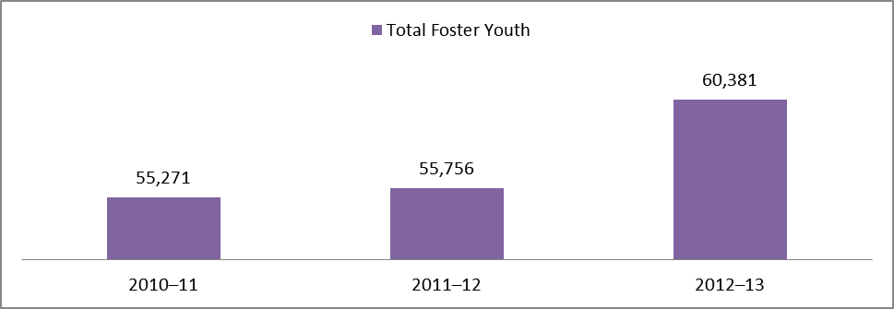

Chart 17: Foster Youth Served by Foster Youth Services Programs

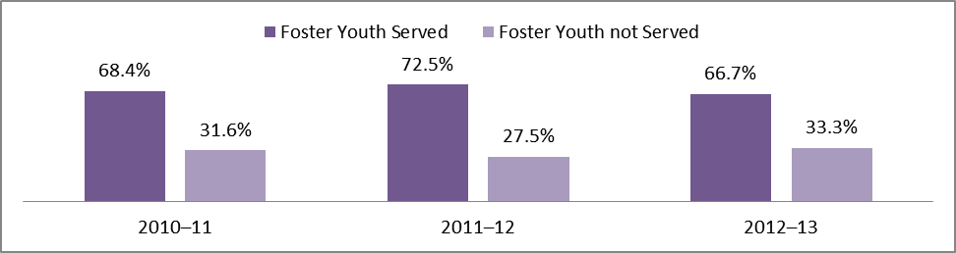

CDE Response: The CDE recognizes that a significant percent of California’s students in foster care are not directly receiving FYS Program services at this time and supports the recommendation for an expansion of services. The CDE also acknowledges that with statewide support for permanency and family settings, more support for transition to Family Maintenance and Guardian placements must be provided to help promote the academic success of foster youth. The CDE also recognizes that a portion of the foster youth not currently participating in a FYS Program do receive services through Title I Neglected or Delinquent programs, special education, remedial education, and other programs provided by their local schools. Therefore, the CDE recommends increasing foster youth access to existing services through their local school districts.

The CDE recognizes that there has been a reduction of students served in foster care. The CDE further recommends that the Legislature and Governor consider increasing funding to support foster youth in all placement types and/or expand the FYS Program services to support all students in foster care to ensure that there is a streamlined continuum of support services focused on academic success from cradle to college and career.

Part IV—Conclusion

Education has the potential to provide foster youth the necessary academic, vocational, and life skills to counterbalance the separation and impermanence experienced by youth in out-of-home care. Positive school experiences: (1) enhance foster youth attitudes toward school, their confidence about learning, and their educational aspirations; and (2) increase foster youth opportunities for economic self-sufficiency. The FYS Programs are designed to provide support services that help reduce the trauma of transition and displacement from family and schools.

Specifically, FYS Programs help to:

- Obtain health and education records to determine appropriate school placements and coordinate instruction.

- Provide direct service and referrals for counseling, tutoring, mentoring, vocational training, emancipation services, and training for independent living.

- Facilitate education advocacy, training, and collaboration among partner agencies and systems.

While many foster youth are at increased risk of failure in school, the services provided through the FYS Programs offset this risk and increase foster youth opportunities for success in school. Evidence of the positive impact of these services is found in the outcome data on academic gains, expulsion rates, and attendance rates, all of which surpassed the identified targets reflected in Part I of this report.

The number of counties currently participating in FYS Programs has grown to 55, all of which have provided YERs for 2011–12 and 2012–13. These FYS Programs have demonstrated substantial progress in building collaborative relationships between various agencies and systems that interface with the lives of foster youth. Interagency agreements and MOUs have been used with increasing frequency to formalize and document agreements between partner agencies. The collaborative relationships developed by the FYS Programs have resulted in some gains in comprehensive services being provided to foster youth. In addition, the ability of FYS Programs to transfer more than 22,157 student records in an average of 1.81 days during 2011–12 and 20,580 student records on an average of 1.79 days during 2012–13 is, in part, is a result of cooperation with partner agencies.

However, the FYS Programs continue to face many challenges, including:

- Under-identification of foster youth due to inadequacies in information sharing systems

- Inadequate funding

- Transportation to remain in school of origin

- Mobility of foster youth and subsequent enrollment delays

- Low academic progress for foster youth due to a lack of coordinated case management and information sharing

Despite these challenges, FYS Programs have made significant accomplishments and contributions to ensure that students in foster care have the opportunity to meet state academic achievement standards and have access to the academic resources, services, and enrichment activities available to other students. The use of FYS Program outcomes is an important accomplishment that will lead to performance measures that will demonstrate the impact of the services provided to foster youth in the future. These outcomes must address the transition to independent living and higher education, self-advocacy, timely and appropriate school placements, and completion of the students’ educational programs. The programs are continuing to increase the delivery of services in academic counseling, academic tutoring, education advocacy and training, education assessment, self-advocacy material and training, leadership/youth development, independent living, vocational/career technical education and post-secondary preparation, and support services to meet the growing needs of California’s foster youth population.

It is evident that the FYS Programs provide essential academic and support services that significantly enhance the ability of foster youth to achieve academic standards and to access resources, support services, and enrichment activities. One of the most important services that FYS Programs offer is helping foster youth feel a sense of connectedness that helps support successful transitions.

Despite significant legislative changes in recent years, there is still much work ahead to close the gap in services for California’s foster youth. The current funding for the FYS Program is tied to a narrow statutory definition of foster youth; the implementation of LCFF creates a significant opportunity to increase access to meaningful support services, to build a comprehensive infrastructure to increase collaboration among support providers, and to improve educational outcomes for California’s foster youth.

Due to some of the systematic deficiencies in the identification of foster youth, some youth who could benefit from services are not being identified. As the data indicates in Chart 17 (page 42), over 33 percent of students in foster care, the majority of whom are living in Family Maintenance and Guardian placements, do not receive the appropriate support services.

There is an understanding among those who directly serve foster youth in homes, schools, and in the court system that for youth in foster care to make progress, specific steps must be taken to identify individual needs and/or obstacles to success. Ensuring that all foster children have the same access to educational resources and future economic opportunities as other children is one of the greatest challenges. A support structure should be available for each child and enhanced at crucial junctions in the pursuit of educational success.

A key to this success is through the partnerships and collaborations the FYS Programs have made, increased access for students, and a well-developed delivery infrastructure, including increased funding. Research shows that foster children are more likely to be at risk of poor life outcomes such as increased poverty, unemployment, homelessness, incarceration, and welfare dependency. That’s why it is crucial for California to meet its obligation to care for and nurture all foster children by investing the resources necessary to promote success.

California Education Code sections 42920–42925

42920. (a) The Legislature finds as follows:
(1) It is essential to recognize, identify and plan for the critical and unique needs of children residing in licensed community care facilities.
(2) A high percentage of these foster children are working substantially below grade level, are being retained at least one year in the same grade level, and become school dropouts.
(3) Without programs specifically designed to meet their individual needs, foster children are frequently dysfunctional human beings at great penal and welfare costs.
(b) The Legislature further finds and declares that the instruction, counseling, tutoring, and related services for foster children that provide program effectiveness and potential cost savings shall be a state priority. Funding for that purpose is hereby provided to the following unified school districts and consortia that have successfully operated foster children services program sites: Elk Grove, Mount Diablo, Sacramento City, San Juan, and Paramount, and the Placer–Nevada consortium.

42920.5. (a) Commencing with fiscal year 1982–83, and each fiscal year thereafter, each of the six program sites specified in subdivision (b) of Section 42920 shall receive, in addition to the base revenue limit, an allowance from the amount annually transferred
to Section A of the State School Fund equal to the amount the district spent on foster children service programs in fiscal year 1981–82, adjusted to reflect cost–of–living increases by the total percentage increase received by all categorical education programs. In no event shall this cost–of–living adjustment exceed the inflation adjustment provided pursuant to Section 42238.
This allowance shall be used exclusively for foster children services.
The six program sites may continue to record revenue received pursuant to this subdivision in the same manner used to record revenue received for foster children services in the 1981–82 fiscal year.
The six program sites shall maintain their foster children services programs in fiscal year 1995–96 and each subsequent fiscal year at a program level comparable to that at which they administered those programs in fiscal year 1994–95.
(b) Commencing with fiscal year 1982–83, the base revenue of each of the six school districts specified in subdivision (b) of Section 42920 shall be permanently reduced in an amount equal to the amount spent on foster children services in fiscal year 1981–82.

42921. (a) In addition to the six program sites specified in Section 42920, any county office of education, or consortium of county offices of education, may elect to apply to the Superintendent of Public Instruction for grant funding, to the extent funds are available, to operate an education–based foster youth services program to provide educational and support services for foster children who reside in a licensed foster home or county–operated juvenile detention facility. The provision of educational and support services to foster youth in licensed foster homes shall also apply to foster youth services programs in operation as of July 1, 2006, and receiving grant funding.
(b) Each foster youth services program operated pursuant to this chapter, if sufficient funds are available, shall have at least one person identified as the foster youth educational services coordinator. The foster youth educational services coordinator shall facilitate the provision of educational services pursuant to subdivision (d) to any foster child in the county who is either under the jurisdiction of the juvenile court pursuant to Section 300 of the Welfare and Institutions Code or under the jurisdiction of the juvenile court pursuant to Section 601 or 602 of the Welfare and Institutions Code who is placed in a licensed foster home or county–operated juvenile detention facility. A program operated pursuant to this chapter may prescribe the methodology for determining which children may be served. Applicable methodologies may include, but are not limited to, serving specific age groups, serving children in specific geographic areas with the highest concentration of foster children or serving the children with the greatest academic need. It is the intent of the Legislature that children with the greatest need for services be identified as the first priority for foster youth services.
(c) The responsibilities of the foster youth educational services coordinator shall include, but shall not be limited to, all of the following:
(1) Working with the child welfare agency to minimize changes in school placement.
(2) Facilitating the prompt transfer of educational records, including the health and education passport, between educational institutions when placement changes are necessary.
(3) Providing education–related information to the child welfare agency to assist the child welfare agency to deliver services to foster children, including, but not limited to, educational status and progress information required for inclusion in court reports by Section 16010 of the Welfare and Institutions Code.
(4) Responding to requests from the juvenile court for information and working with the court to ensure the delivery or coordination of necessary educational services.
(5) Working to obtain and identify, and link children to, mentoring, tutoring, vocational training, and other services designed to enhance the educational prospects of foster children.
(6) Facilitating communication between the foster care provider, the teacher, and any other school staff or education service providers for the child.
(7) Sharing information with the foster care provider regarding available training programs that address education issues for children in foster care.
(8) Referring caregivers of foster youth who have special education needs to special education programs and services.
(d) Each foster youth services program operated pursuant to this chapter shall include guiding principles that establish a hierarchy of services, in accordance with the following order:
(1) Provide, or arrange for the referral to, tutoring services for foster youth.
(2) Provide, or arrange for the referral to, services that meet local needs identified through collaborative relationships and local advisory groups, which may include, but shall not be limited to, all of the following:
(A) Mentoring.
(B) Counseling.
(C) Transitioning services

(D) Emancipation services
(3) Facilitation of timely individualized education programs, in accordance with the Individuals with Disabilities Education Act (20 U.S.C. Sec. 1400 et seq.), and of all special education services.
(4) Establishing collaborative relationships and local advisory groups.
(5) Establishing a mechanism for the efficient and expeditious transfer of health and education records and the health and education passport.
(e) For purposes of this section, "licensed foster home" means a licensed foster family home, certified foster family agency home, court–specified home, or licensed care institution (group home).

42922. Any school district which provides educational services for foster children pursuant to Section 42921 shall receive funding in any fiscal year for those services only by such sums as may be specifically appropriated by the annual Budget Act of the Legislature for that fiscal year for support of those school–centered foster children services which provide program effectiveness and potential cost savings to the state.
The Legislature may appropriate moneys from the General Fund for this purpose, or, if sufficient funds are available, from the Foster Children and Parent Training Fund pursuant to the provisions of Section 903.7 of the Welfare and Institutions Code.

42923. (a) Each school district providing foster children services pursuant to this chapter shall, by January 1 of each even–numbered year, report to the Superintendent of Public Instruction any information as may be required by the Superintendent of Public Instruction for the purpose of subdivision (b).
(b) The Superintendent of Public Instruction shall, by February 15 of each even–numbered year, report to the Legislature and the Governor on the foster children services provided by school districts. The report shall be prepared with the advice and assistance of providers of foster children services and shall include, but not be limited to, the following:
(1) Recommendations regarding the continuation of services.
(2) Recommendations regarding the effectiveness of the services, unless program effectiveness is assessed in any other report covering the same time period.
(3) Recommendations regarding the broadening of the application of those services.
(4) Information which shall be sufficient to determine, at a minimum, whether these services have resulted in a major quantitative improvement or deterioration in any of the following indicators:
(A) Pupil academic achievement.
(B) The incidence of pupil discipline problems or juvenile delinquency.
(C) Pupil dropout rates or truancy rates.
(5) A discussion of the meaning and implications of the indicators contained in paragraph (4).

42924. Any funds allocated to school districts for foster children services pursuant to subdivision (c) of Section 42920 or Section 42922 shall be used only for foster children services and any funds not used by districts for those services shall revert to the state
General Fund.

42925. (a) The Superintendent of Public Instruction shall form an advisory committee to make recommendations regarding the allocation of available funds to school districts applying to receive funding for foster children programs pursuant to subdivision (b). The advisory committee shall include, but not be limited to, representatives from the Department of the Youth Authority, from the State Department of Social Services, and from foster children services programs. Members of the advisory committee shall serve without compensation, including travel and per diem.
(b) Any school district which chooses to provide foster children services programs pursuant to Section 42921 may apply to the Superintendent of Public Instruction and to the advisory committee for funding for those programs.
(c) On or before November 1 of each year, the Superintendent of Public Instruction shall provide the Governor with a proposed sum to be included in the Governor's budget for the ensuing fiscal year for allocation to school districts wishing to provide foster children services programs pursuant to Section 42921. Recommendations regarding the specific programs to be funded and the amount to be allocated to each shall be included with the proposed sum.

1998 Budget Act Item 6110–121–0001
Foster Youth Programs (Proposition 98)
Program 20.40.060

Provisions

The funds appropriated in this item are provided to annualize funding for the Foster Youth Services Program to children residing in licensed children’s institutions (LCIs), pursuant to Chapter 11 (commencing with Section 42920) of part 24 of the California Education Code and guidelines developed by the State Department of Education. These funds shall be allocated on the basis of the number of pupils residing in LCIs in each county, and shall be used to supplement, and not supplant services currently provided to students residing in LCIs through this program.

Assembly Bill 1808, Chapter 75, Statutes of 2006
Amending California Education Code Section 42921

SEC. 4. Section 42921 of the California Education Code is amended to read:

42921. (a) In addition to the six program sites specified in Section 42920, any county office of education, or consortium of county offices of education, may elect to apply to the Superintendent of Public Instruction for grant funding, to the extent funds are available, to operate an education–based foster youth services program to provide educational and support services for foster children who reside in a licensed foster home or county–operated juvenile detention facility. The provision of educational and support services to foster youth in licensed foster homes shall also apply to foster youth services programs in operation as of July 1, 2006, and receiving grant funding.
(b) Each foster youth services program operated pursuant to this chapter, if sufficient funds are available, shall have at least one person identified as the foster youth educational services coordinator. The foster youth educational services coordinator shall facilitate the provision of educational services pursuant to subdivision (d) to any foster child in the county who is either under the jurisdiction of the juvenile court pursuant to Section 300 of the Welfare and Institutions Code or under the jurisdiction of the juvenile court pursuant to Section 601 or 602 of the Welfare and Institutions Code who is placed in a licensed foster home or county–operated juvenile detention facility.

A program operated pursuant to this chapter may prescribe the methodology for determining which children may be served. Applicable methodologies may include, but are not limited to, serving specific age groups, serving children in specific geographic areas with the highest concentration of foster children or serving the children with the greatest academic need. It is the intent of the Legislature that children with the greatest need for services be identified as the first priority for foster youth services.
(c) The responsibilities of the foster youth educational services coordinator shall include, but shall not be limited to, all of the following:
(1) Working with the child welfare agency to minimize changes in school placement.
(2) Facilitating the prompt transfer of educational records, including the health and education passport, between educational institutions when placement changes are necessary.
(3) Providing education–related information to the child welfare agency to assist the child welfare agency to deliver services to foster children, including, but not limited to, educational status and progress information required for inclusion in court reports by
Section 16010 of the Welfare and Institutions Code.
(4) Responding to requests from the juvenile court for information and working with the court to ensure the delivery or coordination of necessary educational services.
(5) Working to obtain and identify, and link children to, mentoring, tutoring, vocational training, and other services designed to enhance the educational prospects of foster children.

(6) Facilitating communication between the foster care provider, the teacher, and any other school staff or education service providers for the child.
(7) Sharing information with the foster care provider regarding available training programs that address education issues for children in foster care.
(8) Referring caregivers of foster youth who have special education needs to special education programs and services.
(d) Each foster youth services program operated pursuant to this chapter shall include guiding principles that establish a hierarchy of services, in accordance with the following order:
(1) Provide, or arrange for the referral to, tutoring services for foster youth.
(2) Provide, or arrange for the referral to, services that meet local needs identified through collaborative relationships and local advisory groups, which may include, but shall not be limited to, all of the following:
(A) Mentoring.
(B) Counseling.
(C) Transitioning services.
(D) Emancipation services.
(3) Facilitation of timely individualized education programs, in accordance with the Individuals with Disabilities Education Act (20 U.S.C. Sec. 1400 et seq.), and of all special education services.
(4) Establishing collaborative relationships and local advisory groups.
(5) Establishing a mechanism for the efficient and expeditious transfer of health and education records and the health and education passport.
(e) For purposes of this section, "licensed foster home" means “ licensed foster family home, certified foster family agency home, court–specified home, or licensed care institution (group home)."

Key Educational Concepts of Senate Bill 933
(Thompson, Chapter 311, Statutes of 1998)

Senate Bill 933 set into motion a number of activities and concepts at the state and local levels that directly involve participants in the Foster Youth Services (FYS) Countywide (CW) Program. Many of these legal mandates are intended to ensure a coordinated effort to protect foster youth and secure appropriate, stable placements. A number of California code sections reinforce the importance of this collaborative effort and provide an avenue for service delivery and coordination for foster youth in group home care.

Educational Options for Foster Youth

California Welfare and Institution Code (WIC) Section 48850 mandates that every county office of education shall make available to agencies that place children in LCIs information on educational options for children residing in LCIs within the jurisdiction of the county office of education for use by the placing agencies in assisting parents and foster children to choose educational placements.

Placement Notification of Local Educational Agency

The WIC Section 48852 mandates that every agency that places a child in an LCI shall notify the local educational agency at the time a pupil is placed in an LCI. As part of that notification, the placing agency shall provide any available information on immediate past educational placements to facilitate prompt transfer of records and appropriate educational placement. Nothing in this section shall be construed to prohibit prompt educational placement prior to notification.

County Multidisciplinary Teams

California Family Code Section 7911.1 mandates that the State Department of Social Services or its designee shall investigate any threat to the health and safety of children placed by a California county social services agency or probation department in an out-of-state group home pursuant to the provisions of the Interstate Compact on the Placement of Children. This shall include the authority to interview children or staff in private or review their file at the out-of-state facility or wherever the child or files may be at the time of the investigation. Notwithstanding any other provisions of law, the State Department of Social Services or its designee shall require certified out-of-state group homes to comply with the reporting requirements applicable to group homes licensed in California pursuant to the California Code of Regulations Title 22 for each child in care, regardless of whether he or she is a California placement, by submitting a copy of the required reports to the Compact Administrator within regulatory timeframes. The Compact Administrator, within one business day of receiving a serious events report, shall verbally notify the appropriate placement agencies and, within five working days of receiving a written report from the out-of-state group home, forward a copy of the written report to the appropriate placement agencies.

Mental Health Services

The WIC Section 5867.5 mandates that county mental health departments that receive full system of care funding, as determined by the State Department of Mental Health in consultation with counties, shall provide to children served by county social services and probation departments mental health screening, assessment, participation in multidisciplinary placement teams, and specialty mental health treatment services for children placed out of home in group care, for those children who meet the definition of medical necessity, to the extent resources are available. These counties shall give first priority to children currently receiving psychoactive medication.

Collaborative Efforts

The WIC Section 18987.6 (a) permits all counties to provide children with service alternatives to group home care through the development of expanded family-based services programs and to expand the capacity of group homes to provide services appropriate to the changing needs of children in their care; (b) encourages collaboration among persons and entities including, but not limited to, parents, county welfare departments, county mental health departments, county probation departments, county health departments, special education local planning agencies, school districts, and private service providers for the purpose of planning and providing individualized services for children and their birth or substitute families; (c) ensures local community participation in the development of innovative delivery of services by county placing agencies and service providers and the use of the service resources and expertise of nonprofit providers to develop family-based and community-based service alternatives.

Statewide Collaboration

Section 72 of Senate Bill 933 also mandates that:

- The State Department of Social Services shall convene a working group of representatives of County Welfare Directors, the Chief Probation Officers, foster and former foster youth, group home providers, and other interested parties convene a working group to develop protocols outlining the roles and responsibilities of placing agencies and group homes regarding emergency and nonemergency placements of foster children in group homes . . .
(c) The model protocols shall at a minimum address all of the following:
(1) Relevant information regarding the child and family that placement workers shall provide to group homes, including health, mental health, and education information pursuant to Section 16010 of the Welfare and Institutions Code.
(2) Appropriate orientations to be provided by group homes for foster children and, if appropriate, their family, after a decision to place has been made.
(3) County and provider responsibilities in ensuring the child receives timely access to treatment and services to the extent they are available identified in the child's case plan and treatment plan, including multidisciplinary assessments provided in counties involved in the Systems of Care Program under Part 4 (commencing with Section 5850) of Division 5 of the Welfare and Institutions Code.
(4) County and provider responsibilities in the periodic monitoring of foster children to ensure the continued appropriateness of the placements and the continued progress toward achieving the case plan and treatment plan goals.
(5) Appropriate mechanisms, timelines, and information sharing regarding discharge planning.

Health and Education Passport

California Education Code Section 49069.5 responds to the disruption of the educational experience for pupils in foster care that results from a high level of mobility. Whenever a local educational agency (LEA) in which a pupil in foster care has most recently been enrolled is informed of the pupil’s next educational placement, that LEA must cooperate with the county social services or probation department to ensure that educational background information for the pupil’s health and education record is transferred to the receiving LEA in a timely manner.

This information must include, at a minimum, the following:

- Location of the pupil’s records

- Pupil’s last school and teacher

- Pupil’s current grade level

- Any information deemed necessary to enable enrollment at the receiving school, to the extent allowable under state and federal law

Notice of a new education placement of a pupil in foster care must be made within five working days, and information must be transferred within five working days of receipt of the notification.

Recommendations to the Judicial Council

SB 933 recommends that the Judicial Council adopt appropriate rules, standards, and forms regarding the education placement of children in foster care. The purpose of the recommendation is to ensure that state courts routinely indicate the party that is to maintain or assume the education rights of a child placed in foster care to facilitate the child's prompt education placement. When the parent maintains educational authority for the child, the parent also has the right to designate another person or entity to maintain educational authority. The Judicial Council is also encouraged to ensure that state courts consistently authorize the agencies that place children in foster care to receive the children's records.

Assembly Bill 490 Overview

Effective January 1, 2004, Assembly Bill 490 (Steinberg), Chapter 862, Statutes of 2004, imposed new duties and rights related to the education of youth in foster care (wards and dependents). The key provisions of the legislation are as follows:

  - Established legislative intent that foster youth shall be ensured the same opportunities as those provided to other students to meet the academic achievement standards to which all students are held

  - Established that stable school placements shall be maintained

  - Established that foster youth shall be placed in the least restrictive education placement

  - Established that foster youth shall have access to the same academic resources, services, and extracurricular and enrichment activities as all other students

  - Established that education and school placement decisions shall be dictated by the best interest of the child

  - Created school stability for foster children by allowing them to remain in their school of origin for the duration of the school year when their placement changes and when remaining in the same school is in the child’s best interest

  - Required county placing agencies to promote educational stability by considering the child’s school attendance area in placement decisions

  - Required local educational agencies (LEA) to designate a staff person as a foster care education liaison to ensure proper placement, transfer, and enrollment in school for foster youth

  - Made LEAs and county social workers or probation officers jointly responsible for the timely transfer of students and their records when a change of schools is in the child’s best interest

  - Required that a comprehensive public school be considered the first school placement option for foster youth

  - Provided a foster child the right to remain enrolled in and attend his or her school of origin pending resolution of school placement disputes

  - Required a foster child to be immediately enrolled in school even if all typically required school records, immunizations, or school uniforms are not available

  - Required school districts to calculate and accept credit for full or partial coursework satisfactorily completed by the student and earned during attendance at a public school, juvenile court school, or nonpublic, nonsectarian school

  - Authorized the release of education records of foster youth to county placing agency, for the purposes of compliance with California Welfare and Institution Code Section 16010, case management responsibilities required by the juvenile court or law, or assistance with the transfer or enrollment of a pupil, without the consent of a parent or a court order

  - Ensured that foster youth will not be penalized for absences caused by placement changes, court appearances, or related court-ordered activities

California Department of Education

Foster Youth Services

List of Coordinators and Sites

Statewide Coordinator

Lisa Guillen, Education Programs Consultant
Coordinated School Health and Safety Office
California Department of Education
1430 N Street, Suite 6408
Sacramento, CA 95814-5901
Phone: 916-319-0506; Fax: 916-323-6061
lguillen@cde.ca.gov
http://www.cde.ca.gov/ls/pf/fy

Foster Youth Services Core District Program Coordinators and Sites

Elk Grove Unified School District
Kim Parker
Elk Grove Unified School District
9510 Elk Grove–Florin Road, Room 110
Elk Grove, CA 95624
Phone: 916-686-7797
Fax: 916-686-7596
kparker@egusd.net

Mount Diablo Unified School District
James Wogan
Ben O’Meara
Mount Diablo Unified School District
2730 Salvio Street
Concord, CA 94519
Phone: 925-682-8000
Fax: 925-566-6692
woganj@mdusd.k12.ca.us

Nevada County
Melissa A. Marcum
Nevada County Superintendent of Schools
117 New Mohawk Road, Suite F
Nevada City, CA 95959
Phone: 530-470-8510
Fax: 530-470-8545
mmarcum@nevco.k12.ca.us

Paramount Unified School District
James Monico
Paramount Unified School District
15110 California Avenue
Paramount, CA 90723
Phone: 562-602-6035
Fax: 562-602-8121
jmonico@paramount.k12.ca.us

Placer/Nevada County
Craig Gibbs
Placer County Office of Education
360 Nevada Street
Auburn, CA 95603
Phone: 530-745-1301
Fax: 530-745-1441
cgibbs@placercoe.k12.ca.us
San Juan Unified School District
Dominic Covello
San Juan Unified School District
3738 Walnut Avenue
Carmichael, CA 95608
Phone: 916-971-7391
Fax: 916-971-7147
dcovello@sanjuan.edu

Sacramento City Unified School District
Aliya Holmes
Sacramento City Unified School District
5735 47th Avenue
Sacramento, CA 95824
Phone: 916-643-7991
Fax: 916-643-9469
Aliya-Holmes@sac-city.k12.ca.us

Foster Youth Services Countywide Program Coordinators

Alameda County
Elizabeth Tarango
Alameda County Office of Education
313 West Winton Avenue, Room 244
Hayward, CA 94544
Phone: 510-670-7750
Fax: 510-670-4536
lizt@acoe.org

Butte County
Meagan Meloy
Butte County Office of Education
1870 Bird Street
Oroville, CA 95965
Phone: 530-879-3781
Fax: 530-879-2341
mmeloy@bcoe.org

Calaveras County
Barbara Bernstein
Calaveras County Office of Education
509 East Saint Charles
San Andreas, CA 95249
Phone: 209-754-6862
Fax: 209-754-3293
bbernstein@co.calaveras.ca.us

Contra Costa County
Catherine Giacalone
Contra Costa County Office of
Education
77 Santa Barbara Road
Pleasant Hill, CA 94523
Phone: 925-942-3308
Fax: 925-942-3490
cgiacalone@cccoe.k12.ca.us
Del Norte County
Martha de la Mare
Del Norte County Office of Education
301 West Washington Boulevard
Crescent City, CA 95531
Phone: 707-464-0721
Fax: 707-464-0238
mdelamare@delnorte.k12.us.ca

El Dorado/Alpine County
Sheila Silan
El Dorado County Office of Education
6767 Green Valley Road
Placerville, CA 95667
Phone: 530-295-2412
Fax: 530-295-1506
ssilan@edcoe.org

Fresno County
Pamela Hancock
Fresno County Office of Education
2011 Fresno Street, Suite 102
Fresno, CA 93721
Phone: 559-265-4003
Fax: 559-265-4005
phancock@fcoe.org

Glenn County
Robin Smith
Glenn County Office of Education
311 South Villa Street
Willows, CA 95988
Phone: 530-934-6575
Fax: 530-934-6576
rmsmith@glenncoe.org

Humboldt County
Roger Golec
Humboldt County Office of Education
901 Myrtle Avenue
Eureka, CA 95501
Phone: 707-445-7187
Fax: 707-445-7071
rgolec@humboldt.k12.ca.us

Imperial County
Carmen Zamora
Imperial County Office of Education
1398 Sperber Road
El Centro, CA 92243
Phone: 760-312-5500
Fax: 760-312-5580
carmenz@icoe.org

Inyo County
Kellie Bell
Inyo County Office of Education
166 Grandview Lane
Bishop, CA 93514
Phone: 760-873-3262
Fax: 760-873-3324
kellie_bell@inyo.k12.ca.us

Kern County
Tom Corson
Carrie Bloxom
Kern County Superintendent of Schools
1300 17th Street
Bakersfield, CA 93301
Phone: 661-636-4488
Fax: 661-636-4501
tocorson@kern.org
cabloxom@kern.org

Kings County
Susan Brewer
Kings County Office of Education
1144 West Lacey Boulevard
Hanford, CA 93230
Phone: 559-589-7076
Fax: 559-589-7006
susan.brewer@kingscoe.org

Lake County
Doreen Gilmore
Lake County Office of Education
1152 Main Street
Lakeport, CA 95453
Phone: 707-994-0669
Fax: 707-994-9637
dgilmore@lake–coe.k12.ca.us

Lassen County
Lester Ruda
Lassen County Office of Education
107 South Roop Street
Susanville, CA 96130
Phone: 530-251-8173
Fax: 530-257-9160
lruda@co.lassen.ca.us

Los Angeles County
John Phillip Keane
Foster Youth Services Coordinator
Los Angeles County Office of Education
9300 Imperial Highway
Downey, CA 90242
Phone: 626-253-6142 (cell)
Keane_John@lacoe.edu

Madera County
Elizabeth Rodriguez
Madera County Office of Education
28123 Avenue 14
Madera, CA 93638
Phone: 559-662-3842 or 559-662-3876
Fax: 559-661-3551
erodriguez@maderacoe.k12.ca.us
Marin County
Lisa Schwartz
Marin County Office of Education
1111 Las Gallinas Avenue
P.O. Box 4925
San Rafael, CA 94913
Phone: 415-491-0581
Fax: 415-491-0981
lisas@marin.k12.ca.us

Mariposa County
Chris Busch
Mariposa County Unified School District
P.O. Box 8
Mariposa, CA 95338
Phone: 209-742-0215
Fax: 209-966-3674
cbusch@mariposa.k12.ca.us

Mendocino County
Abbey Kaufman
Mendocino County Office of Education
2240 Old River Road
Ukiah, CA 95482
Phone: 707-467-5104
Fax: 707-468-3364
ab@mcoe.us

Merced County
Derrek Dean
Merced County Office of Education
632 West 13th Street
Merced, CA 95341
Phone: 209-381-4506
Fax: 209-381-4511
ddean@mcoe.org

Modoc County
Carole McCulley
Modoc County Office of Education
802 North East Street
Alturas, CA 96101
Phone: 530-233-7115
Fax: 530-233-7133
cmcculley@modoccoe.k12.ca.us
Monterey County
Denise Lange
Monterey County Office of Education
901 Blanco Circle, Salinas CA 93901
P.O. Box 90951, Salinas CA 93912 Phone: 831-784-4227
Fax: 831-758-9410
dlang@monterey.k12.ca.us

Napa County
Jeannie Puhger
Napa County Office of Education
2121 Imola Avenue
Napa, CA 94559
Phone: 707-259-5949
Fax: 707-251-1050
jpuhger@ncoe.k12.ca.us

Orange County
Betsy DeGarmoe
Orange County Office of Education
Building 112
P.O. Box 14100
Orange, CA 92863-1500
Phone: 714-835-4909
Fax: 714-939-6312
bdegarmoe@ocde.us

Plumas County
Cathy Rahmeyer
Plumas County Office of Education
50 Church Street
Quincy, CA 95971
Phone: 530-283-6500
Fax: 530-283-3155
crahmeyer@pcoe.k12.ca.us

Riverside County
Bruce Petersen
Riverside County Office of Education
2300 Market Street
Riverside, CA 92501
Phone: 951-826-4700
Fax: 951-826-4793
bpetersen@rcoe.us
Sacramento County
Trish Kennedy
Sacramento County Office of Education
P.O. Box 269003
Sacramento, CA 95826–9003
Phone: 916-228-2730
Fax: 916-228-2216
tkennedy@scoe.net

San Benito County
Frank Beitz
San Benito County Office of Education
460 Fifth Street
Hollister, CA 95023
Phone: 831-655-0405
Fax: 831-655-3845
frank@startbuildingfutures.com

San Bernardino County
Bernadette Pinchback
San Bernardino County Superintendent
of Schools
601 North E Street
San Bernardino, CA 92410-3093
Phone: 909-252-4501
Fax: 909-386-2940
bernadette_pinchback@sbcss.k12.ca.us

Santa Barbara County
Bonnie Beedles
Santa Barbara County Education Office
3970 La Colina Road, Suite 9
Santa Barbara, CA 93110
Phone: 805-946-4710
Fax: 805-563-1103
beedles@sbceo.org

Santa Clara County
Sonja House
Santa Clara County Office of Education
1290 Ridder Park Drive–MC 213
San Jose, CA 95131-2398
Phone: 408-453-6956
Fax: 408-441-7824
sonja_house@sccoe.org
Santa Cruz County
Michael Paynter
Santa Cruz County Office of Education
400 Encinal Street
Santa Cruz, CA 95060
Phone: 831-466-5729
Fax: 831-466-5730
mpaynter@santacruz.k12.ca.us

San Diego County
Michelle Lustig
San Diego County Office of Education
8333 Clairmont Mesa Boulevard,
Suite 212
San Diego, CA 92111
Phone: 858-503-2628
Fax: 858-503-2636
mlustig@sdcoe.net

San Francisco County
Maya Webb
San Francisco Unified School District
1515 Quintara Street
San Francisco, CA 94116
Phone: 415-242-2615
Fax: 415-242-2618
webbm1@sfusd.edu

San Joaquin County
Mark Yost
San Joaquin County Office of Education
P.O. Box 213030
Stockton, CA 95213
Phone: 209-468-5954
Fax: 209-468-4984
myost@sjcoe.net
San Luis Obispo County
John Elfers
San Luis Obispo County Office of
Education
3350 Education Drive
San Luis Obispo, CA 93405
Phone: 805-782-7209
Fax: 805-594-0739
jelfers@slocoe.org

San Mateo County
Theresa Anderberg
San Mateo County Office of Education
31 Tower Road
San Mateo, CA 94402
Phone: 650-802-5461
Fax: 650-802-5470
tanderberg@smcoe.k12.ca.us

Shasta County
Heidi Brahms
Karen Cross
Shasta County Office of Education
1644 Magnolia Street
Redding, CA 96001
Phone: 530-229-8076
Fax: 530-229-3897
hbrahms@shastacoe.org

Siskiyou County
Colette Bradley
Siskiyou County Office of Education
609 South Gold Street
Yreka, CA 96097
Phone: 530-842-8461
Fax: 530-842-8436
cbradley@siskiyoucoe.net
Solano County
Becky Cruz
Solano County Office of Education
2460 Clay Bank Road
Fairfield, CA 94533
Phone: 707-399-4855
Fax: 707-421-2745
bcruz@solanocoe.net

Sonoma County
Debra Sanders
Sonoma County Office of Education
5340 Skylane Boulevard
Santa Rosa, CA 95403
Phone: 707-524-2661
Fax: 707-524-2709
dsanders@scoe.org

Stanislaus County
Victor Serranto
Stanislaus County Office of Education
1100 H Street
Modesto, CA 95354
Phone: 209-238-1506
Fax: 209-238-4216
vserrato@stancoe.org

Sutter County
Graciela Espindola
Sutter Superintendent of Schools
970 Klamath Lane
Yuba City, CA 95993
Phone: 530-822-2969
Fax: 530-822-3074
gracee@sutter.k12.ca.us

Tehama County
Jo Kee
Tehama County Department of
Education
1135 Lincoln Street
Red Bluff, CA 96080
Phone: 530-528-7394
Fax: 530-529-4120
jkee@tehamaschools.org

Trinity County
Alan Sanger
Trinity County Office of Education
P.O. Box 1256
Weaverville, CA 96093
Phone: 530-623-2861
Fax: 530-623-4489
asanger@tcoek12.org

Ventura County
Laura Welbourn
Ventura County Office of Education
5189 Verdugo Way
Camarillo, CA 93012
Phone: 805-437-1525
Fax: 805-437-1535
lwelbourn@vcoe.org
Yolo County
Jessica Larsen
Yolo County Office of Education
1280 Santa Anita Court, Suite 100
Woodland, CA 95776
Phone: 530-668-3791
Fax: 530-668-3850
larsen@ycoe.org

Yuba County
Chris Reyna
Yuba County Office of Education
1104 E Street
Marysville, CA 95901
Phone: 530-749-4005
Fax: 530-741-6500
chris.reyna@yubacoe.k12.ca.us

Sandra Bass, Margie K. Shields, and Richard E. Behrman, “Children, families, and foster care: Analysis and recommendations,” The Future of Children 14, no. 1 (Winter 2004): 5–31.
Sandra Stukes Chipungu and Tricia B. Bent-Goodley, “Meeting the challenges of contemporary foster care,” The Future of Children 14, no. 1 (Winter 2004): 75–93.
Child Welfare Information Gateway. 2013 https://www.childwelfare.gov/pubs/factsheets/foster.cfm.
M. Sullivan, L. Jones, & S. Mathiesen, “School Change, Academic Progress, and Behavior Problems in a Sample of Foster Youth.” Children and Youth Services Review 32 (2010): 164–170.
T. R. Wolanin, Higher Education Opportunities for Foster Youth: A Primer for Policy Makers. The Institute for Higher Education Policy, December 2005, 29 http://www.ihep.org/research/publications (accessed December 20, 2011).
C. Smithgall, E. Jarpe–Ratner, & L. Walker, Looking Back, Moving Forward: Using Integrated Assessments to Examine the Educational Experiences of Children Entering Foster Care (Chicago, IL: Chapin Hall at the University of Chicago, 2010) http://www.chapinhall.org/research/report/looking–back–moving–forward–using–integrated–assessments–examine–educational–experie (accessed December 27, 2011).
Needell, B., Webster, D., Armijo, M., Lee, S., Dawson, W., Magruder, J., Exel, M., Cuccaro-Alamin, S., Putnam-Hornstein, E., Williams, D., Yee, H., Hightower, L., Mason, F., Lou, C., Peng, C., King, B., & Lawson, J (2013). Child Welfare Services Reports for California. University of California at Berkeley Center for Social Services Research Web site http://cssr.berkeley.edu/ucb_childwelfare (accessed January 16, 2014).
Frerer, K., Sosenko, L., Pellegrin, N., Zakharenkov, A., Horowitz, J., & Patton, M. (2011). Ready to Succeed: An exploration of secondary and postsecondary educational outcomes for foster children in California. (Four County Study)
S. Castechini, Educational outcomes in court-dependent youth in San Mateo County. Issue Brief: Court Dependent Youth (Stanford, CA: John W. Gardner Center for Youth and Their Communities, 2009) http://gardnercenter.stanford.edu/resources/publications/JGC_IB_CourtDependentYouth2009.pdf (accessed September 6, 2012).
C. Smithgall, E. Jarpe-Ratner, and L. Walker, Looking back, moving forward: Using integrated assessments to examine the educational experiences of children entering foster care. (Chicago, IL: Chapin Hall at the University of Chicago, 2010) http://www.chapinhall.org/research/report/looking–back–moving–forward–using–integrated–assessments–examine–educational–experie (accessed December 27, 2011).
An overview of AB 490 (Steinberg, Helping Foster Children Make the Grade) developed by the California Youth Connection, Children’s Advocacy Institute, and Children’s Law Center of Los Angeles (2004), appears at the end of this report in Appendix E. The complete law can be viewed at the Official California Legislative Information Web site at http://leginfo.legislature.ca.gov/ (accessed October 1, 2011).
C. Smithgall, and others. Educational Experiences of Children in Out-of-Home Care (Chicago, IL: Chapin Hall Center for Children, 2004).
M. Burley and M. Halpern, Educational Attainment Of Foster Youth: Achievement And Graduation Outcomes For Children In State Care (Olympia, Washington: State Institute for Public Policy, 2001).
California Legislative Analyst’s Office (2009). Education of Foster Youth in California Report.
L.A. Loman, and G.L. Siegel, A Review of the Literature on Independent Living of Youth in Foster and Residential Care (St. Louis, MO: Institute of Applied Research, 2000).
Needell, B., and others. (2009). Child Welfare Services Reports for California. Retrieved October 23, 2009, from University of California at Berkeley Center for Social Services Research Web site http://cssr.berkeley.edu/ucb_childwelfare (accessed October 1, 2012).
Tuolumne was unsuccessful in the application for FYS Countywide funding process.
Needell, B., Webster, D., Armijo, M., Lee, S., Dawson, W., Magruder, J., Exel, M., Cuccaro-Alamin, S., Putnam-Hornstein, E., Williams, D., Yee, H., Hightower, L., Mason, F., Lou, C., Peng, C., King, B., Lawson, J (2009). Child Welfare Services Reports for California. Retrieved October 23, 2009, from University of California at Berkeley Center for Social Services Research Web site http://cssr.berkeley.edu/ucb_childwelfare (accessed October 1, 2012).
G.J. Halemba, and others, Arizona dual jurisdiction study: Final report (Pittsburg, PA: National Center for Juvenile Justice, November 30, 2004).
Ibid
C.S. Widom, “Child abuse, neglect, and violent criminal behavior.” Criminology 27 (1989): 251–271.
T. Festinger, No One Ever Asked Us… A Postscript to Foster Care (New York: Columbia University Press, 1983).
D. English, C. Widom, and C. Branford, Childhood victimization and delinquency, adult criminality, and violent criminal behavior: A replication and extension. (Grant #97–IJ–CX–0017) (Washington, D.C.: National Institute of Justice, 2000).
J.P. Ryan, and M.K. Testa, “Child maltreatment and juvenile delinquency: Investigating the role of placement and placement instability.” Children and Youth Services Review 27 (2005): 227–249.
Ibid
J.P. Ryan, and others, “Juvenile delinquency in child welfare: Investigating group home effects.” Children and Youth Services Review (2008).
“Mental Health Issues in the Child Welfare System, Best Practice Next Practice: Family–Center Child Welfare.” (Washington, D.C.: National Child Welfare Resource Center for Family–Centered Practice, Children’s Bureau, Summer 2003), 2.
Mark E. Courtney and Irving Pilianvin, Foster Youth Transitions to Adulthood: Outcomes 12 to 18 Months After Leaving Out-Of-Home Care (Madison, Wisconsin: University of Wisconsin, 1998).
Dennis P. Culhane, and others, Young Adult Outcomes of Youth Exiting Dependent or Delinquent Care in Los Angeles County (Los Angeles, CA: University of Pennsylvania, 2011) https://hilton-production.s3.amazonaws.com/documents/97/attachments/Hilton_Foundation_Report_Final.pdf?1440966405 (accessed December 27, 2011).
Categorical Program Flexibility provisions that were granted to LEAs with the enactment of SBX3 4 (2009) exclude FYS funding from being redirected for other educational purposes but applied an across-the-board budget reduction.
Child Welfare in California, Facts at a Glance. California Department of Social Services, August 26, 2004.
California Department of Social Services (2013). Exit Outcomes for Youth Aging Out of Foster Care Quarterly Statistically Report, July–September 2013. (Statewide Data)
Ibid.
Certificates of Completion are often issued to Special Education students who may have completed core coursework as determined by the LEA but may have not been able to complete all of the requirements for a high school diploma.
Thomas R. Wolanin, Higher Education Opportunities for Foster Youth: A Primer for Policy Makers. (Washington, D.C.: The Institute for Higher Education Policy, December 2005): Executive Summary
Education of Foster Youth in California (California Legislative Analyst’s Office, May 2009) http://www.lao.ca.gov/2009/edu/foster_children/foster_ed_052809.pdf (accessed December 27, 2011).
AB 490, Chapter 862, Statutes of 2003.
Education of Foster Group Home Children, Whose Responsibility is it Anyway? Study of the Educational Placement of Children Residing in Group Homes. (American Institute for Research, SRA Associates, and the University of California at Berkeley Child Welfare Research Center, January 2001).
Fostering a New Future for California’s Children and Action Plan Ensuring Every Child a Safe, Secure, and Permanent Home. California Blue Ribbon Commission on Children in Foster Care, Judicial Council of California/Administrative Office of the Courts, Final Report May 2009.
CWS/CMS Dynamic Report System, October 2013 http://cssr.berkeley.edu/ucb_childwelfare/PIT.aspx (accessed January 28, 2014).
Charles A Garfield, Peak Performers: The New Heroes of American Business (New York: Avon, 1986).
Benard, B. Resiliency: What we have learned. San Francisco: WestEd, 2004.
Gambone, M.A., Klem, A.M. & Connell, J.P. Finding Out What Matters for Youth: Testing Key Links in a Community Action Framework for Youth Development. Philadelphia: Youth Development Strategies, Inc., and Institute: Institute for Research and Reform in Education, November 2002.
CWS/CMS does not track the number of foster youth in JD. Some research indicates that 20 percent of the JD populations are foster youth.
Some of the numbers may be duplicate cases because many foster youth are often moved between county lines and served by multiple county FYS Programs.

