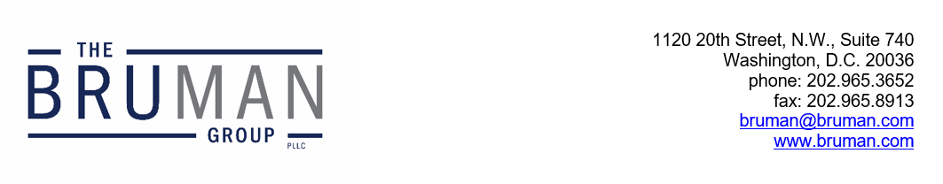

The Federal Update for November 1, 2024

From: Michael Brustein, Julia Martin, Steven Spillan, Kelly Christiansen
Re: Federal Update
Date: November 1, 2024
Legislation and Guidance 1
ED Issues New AI Toolkit for Schools 1
News 2
Colleges Failed to Act on Antisemitism, House Report Alleges 2

Congress is currently in recess due to the upcoming election and will return to session on November 12th.

Legislation and Guidance

ED Issues New AI Toolkit for Schools
The U.S. Department of Education (ED) has published guidance on how schools can manage the rise of artificial intelligence (AI). The document focuses on ways to mitigate risk and ensure data security in the use of technology, how and when to use it in instruction, and building AI literacy among users. It was created following listening sessions with teachers and other school staff.
For example, AI might be used to help translate materials into students’ home languages, identify instructional approaches or needs for students, project outcomes, and monitor students’ online activity to detect potential issues like cheating or inappropriate material. Notably, the guidance suggests that districts and schools consider how the AI tools can be used to reduce administrative burden and assist instruction, but that feeding data into those tools comes with some risk about data privacy and conflicts with existing student privacy laws. ED also noted the potential risk for errors and algorithmic discrimination that comes along with AI tools, and emphasized the need for “humans in the loop” to help mitigate bias, flag misinformation, and halt harmful content or malicious use and suggested that schools come up with plans to address civil rights concerns. The agency also noted that lack of access to digital tools like AI or AI-assisted instruction, especially for low-income students and those with disabilities, can create equity concerns.
Additionally, the document talks about the importance of creating a “clear and coherent strategy” around the use of AI, including how and whether to integrate those tools into classroom instruction. There are three critical steps that the guidance says came from teachers consulted: developing AI literacy for educators, creating and revising responsible use policies, and building a system-wide plan. The guidance document contains suggestions for public comment and discussion questions, as well as items to consider including evidence for AI, capacity, and levels of adoption including areas where use of AI is encouraged, allowed, limited, or prohibited.
The document also defines and describes a number of terms surrounding concerns about AI, including algorithmic discrimination, deepfakes, and impersonation with examples of ways these effects could impact students to help educators understand the implications of certain uses.
This is the first document ED has issued on the use of AI in schools. While it is largely classroom facing, there is an emphasis on using tools in ways that reduce administrative burden and paperwork handled by administrative staff.
The guidance on AI is available here.
Author: JCM

News

Colleges Failed to Act on Antisemitism, House Report Alleges
A report released Thursday by the House Committee on Education and the Workforce, championed by Chair Virginia Foxx (R-NC), argues that colleges failed to take sufficient action to quash antiwar protests. The report includes information gleaned from letters, emails, texts, and other documents provided to the Committee as a result of subpoenas issued to individual colleges, which the authors say reveal “systemic failure” at institutions to enforce their own policies and campus norms.
The report’s authors argue that the information in the document shows colleges failed to protect Jewish students, creating a hostile environment for those students in violation of Title VI of the Civil Rights Act, which bars discrimination based on shared ancestry, ethnic characteristics, or national origin. It provides examples of what it calls “troubling concessions” made by universities not only at the colleges and universities that were part of hearings held by the Committee earlier this year, but at other schools across the country where it says students replicated the strategy from university encampments and institutions like Columbia.
In a statement, Foxx suggested that the U.S. Department of Education should pull funding from colleges that are in violation of Title VI. “Our investigation has shown that these ‘leaders’ bear the responsibility for the chaos likely violating Title VI and threatening public safety,” Foxx said in a statement. “It is time for the executive branch to enforce the laws and ensure colleges and universities restore order and guarantee that all students have a safe learning environment.”
The text messages and meeting minutes included in the subpoenas show some university leaders dismissed the potential impact of Congressional inquiries, declining to meet with Republican leadership and staff and calling the hearings “capital [sic] hill nonsense.”
The full report is available here.
Author: JCM
The Federal Update has been prepared to inform The Bruman Group, PLLC’s legislative clients of recent events in federal education legislation and/or administrative law. It is not intended as legal advice, should not serve as the basis for decision-making in specific situations, and does not create an attorney-client relationship between The Bruman Group, PLLC and the reader.
© The Bruman Group, PLLC 2024
Contributors: Julia Martin
Posted by the California Department of Education, November 2024

