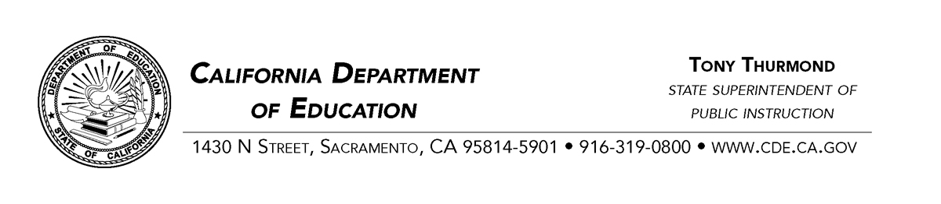
March 1, 2022

Public Comment Period for California's Proposed General Waiver for Dashboard Alternative School Status Program

The California Department of Education (CDE) is holding a public comment period for all stakeholders and local education agencies who would like to comment on the proposed General Waiver for Dashboard Alternative School Status (DASS) Program. On March 9, 2022, the CDE will bring this issue before the California State Board of Education and ask for approval to submit a waiver to the U.S. Department of Education (ED) in order to ensure the integrity of the DASS program in our state.

This waiver will focus on the reasons why California’s current DASS program is the most effective way to fairly evaluate the success or progress of alternative schools that serve high-risk students. Also, the proposed General Waiver will detail the rationale for developing modified methods for the Graduation Rate Indicator and Academic Indicator. The proposal will also demonstrate that the modified measures do not impact California’s ability to meaningfully differentiate among schools and that changing these measures would lead to providing fewer resources to schools who have the greatest need. Lastly, the waiver will also communicate why the ED’s suggested considerations in the January 2022 denial would not be effective for proper accountability determinations in California.

The CDE will hold a public comment period for all stakeholders and LEAs through March 30, 2022. Any comments or questions should be e-mailed to ESSA@cde.ca.gov.
More detail on this proposed waiver and related documents are posted on CDE’s Every Student Succeeds Act webpage at: https://www.cde.ca.gov/re/es/.

