Header: The BruMan Group, PLLC. Attorneys At Law. 1023 15th Street NW, Suite 500. Washington, DC 20005. Phone (202) 965-3652. Fax (202) 965-8913. bruman@bruman.com. www.bruman.com

# The Federal Update for April 28, 2023

From: Michael Brustein, Julia Martin, Steven Spillan, Kelly Christiansen

Re: Federal Update

Date: April 28, 2023

Legislation and Guidance 1

House Passes Debt Limit Bill 1

News 2

SCOTUS Agrees to Hear School Board Social Media Case 2

ED Plans to Restart Systemic Civil Rights Reviews 4

*Due to The Bruman Group’s Spring Forum May 1-4, the next issue of the Federal Update will publish on May 12.*

## Legislation and Guidance

### House Passes Debt Limit Bill

On Wednesday night, the House of Representatives passed a debt limit bill which would modify requirements for some social programs and drastically cut spending for others in exchange for raising the debt limit through March of 2024.

The bill passed by a vote of 217-215 but Senate Majority Leader Chuck Schumer (D-NY) has said that he will not move it forward in the Senate. House Speaker Kevin McCarthy (R-CA) must still work to find a compromise with Schumer, as well as President Joe Biden.

McCarthy says his bill would save about $4.5 trillion over the next decade by capping spending at fiscal year 2022 levels, rolling back environmental tax credits passed through the Inflation Reduction Act, rescinding new funding provided to the Internal Revenue Service under the bill, and imposing new work requirements for Medicaid and the Supplemental Nutrition Assistance Program (SNAP). The bill would expand the age range for the application of work requirements in SNAP and institute new requirements in Medicaid. In addition, the legislation would immediately rescind all unobligated stimulus funds designed to assist with pandemic-related relief. Finally, it would block the administration from forgiving federal student loans, a move which budget experts estimate would cost the government $400 billion.

Capping spending for education at fiscal year (FY) 2022 levels would result in cuts to most major federal education programs in FY 2024 compared to current fiscal year spending, as demonstrated in the chart below.

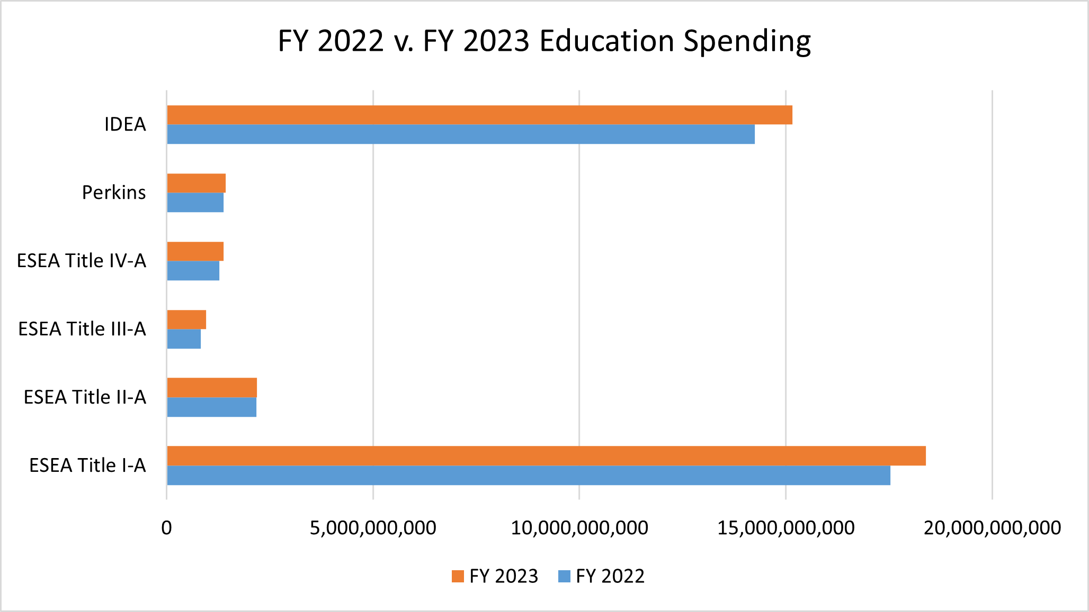

If Congress fails to approve additional spending and the U.S. breaches the debt limit, the country would default on a number of debts. This would impact the nation’s credit rating and drastically lower the value of the dollar, potentially setting off a global economic downturn.

Author: JCM

## News

### SCOTUS Agrees to Hear School Board Social Media Case

On Monday, the U.S. Supreme Court (SCOTUS) agreed to consider whether public officials, including school board members, are acting as government officials when they use personal social media accounts to interact with the public and, if so, whether they violate the First Amendment when blocking certain people.

The question surrounding school board members comes from *O’Connor-Ratliff v. Garnier*. The Garniers, parents of three students in California’s Poway Unified School District, filed suit against two Poway school board members. The school board members, Michelle O’Connor-Ratcliff and T.J. Zane, were elected to the board in 2014 and converted their campaign Facebook and Twitter accounts to personal accounts, which discussed board and district updates. On those pages, both O’Connor-Ratcliff and Zane identified themselves as board members, listed their official district emails, and discussed upcoming board meetings and other status reports.

The Garniers began to post critical responses to O’Connor-Ratcliff and Zane’s Facebook and Twitter posts. According to court documents and trial testimony, the Garniers acknowledged that some of the posts were repetitive, but they believed that their emails were not being responded to adequately and wanted more audience members to see their comments. The two board members blocked the Garniers on their Facebook and Twitter accounts, and O’Connor-Ratcliff, who is continuing in a second term, still has them blocked.

The Garniers filed suit in federal court, arguing that the board members violated their First Amendment rights of free speech and petitioning the government by blocking them on the social media accounts. The district court ruled for the Garniers and held that the social media pages were used as public forums and “tools of governance,” and that blocking the parents for over three years was regulating their speech more broadly than was necessary. The court found that the initial blocking was permissible, since the comments were “unreasonable.”

The 9th Circuit Court of Appeals upheld the lower court’s decision, finding that social media pages were treated as public forums, since O’Connor-Ratcliff and Zane used the pages as “channels of communication with the public.” O’Connor-Ratcliff and Zane’s petition to SCOTUS noted that the lower court’s ruling has the unintended consequence of creating less speech, since social media pages would be “overrun with harassment, trolling, and hate speech.”

SCOTUS will now weigh in on the case, along with the companion case, *Lindke v. Freed*. In that case, Lindke, a resident of Port Huron, Michigan filed suit against the city manager for violating his First Amendment rights. Lindke was also blocked on the city manager’s social media page after leaving critical comments regarding the handling of the COVID-19 pandemic. Unlike the 9th Circuit, the 6th Circuit found that the city manager did not operate the page as a public forum and, therefore, did not violate the First Amendment. The different rulings create a circuit split, where the courts are divided in their approaches to these questions.

This is not the first time that the Court has considered hearing First Amendment cases related to social media accounts. In 2017, then President Donald Trump was sued for blocking seven people on his Twitter account. The lower court held that blocking was a government action and SCOTUS was considering whether to hear the case when Trump lost reelection in 2020. SCOTUS dismissed the case as moot and threw out the lower court’s holding.

SCOTUS will hear *O’Connor-Ratliff v. Garnier* and *Lindke v. Freed* in its next term. The Court will likely hear oral arguments in the fall and make a decision next year.

Resources:

Mark Walsh, “Can School Board Members Block Parents on Social Media? Supreme Court to Decide,” *Education Week*, April 24, 2023.

Author: BNT

### ED Plans to Restart Systemic Civil Rights Reviews

The U.S. Department of Education’s Office for Civil Rights (OCR) says it will restart reviews of system-wide compliance with civil rights laws. In these reviews, an investigation can be triggered by a complaint of disparate impact, or by instances of alleged discrimination arising from the enforcement of policies in specific instances. This comes after similar investigations were paused under the Trump administration, which rescinded 2014 school disciplinary guidance that detailed how OCR reviewed and investigated cases of disparate impact.

Assistant Secretary Catherine Lhamon told reporters that “it’s unusual for a school to act because they have particular animus about a particular kid.”

“It’s more common for a harm to have taken place for a complainant who comes to us because the school community was unaware of their legal obligations.”

Resources:  
Naaz Modan, “Ed Dept revives system racial discrimination reviews of school districts,” *K-12 Dive,* April 26, 2023.  
Author: JCM

***The Federal Update has been prepared to inform The Bruman Group, PLLC’s legislative clients of recent events in federal education legislation and/or administrative law. It is not intended as legal advice, should not serve as the basis for decision-making in specific situations, and does not create an attorney-client relationship between The Bruman Group, PLLC and the reader.***

© The Bruman Group, PLLC 2023

Contributors: Julia Martin, Brandi Tennant

Posted by the California Department of Education, April 2023  
[www.bruman.com](http://www.bruman.com)