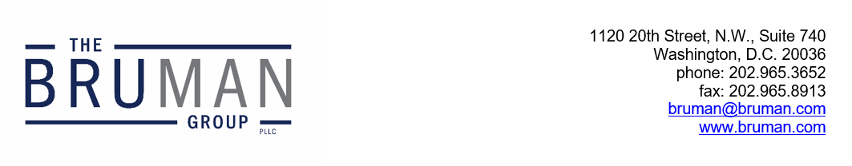

The Federal Update for August 16, 2024

From: Michael Brustein, Julia Martin, Steven Spillan, Kelly Christiansen
Re: Federal Update
Date: August 16, 2024
Legislation and Guidance 1
House Conservatives Push for Full Appropriations Bills in September 1
Reports 2
GAO Issues Report on Resumption of Student Loan Payments 2

Legislation and Guidance

House Conservatives Push for Full Appropriations Bills in September
In a statement released this week, the House Freedom Caucus urged the House of Representatives and Republican leadership to pass all 12 fiscal year 2025 appropriations bills, including proposed spending cuts, when Congress returns from recess on September 9th. Expressing concern about the contents of an omnibus appropriations bill that might be passed in December, the group said that if the passage of individual appropriations bills fails, Congress should pass a short-term continuing resolution (CR) that extends into early 2025.
The letter also urges Congress to append legislation known as the SAVE Act to a CR. The SAVE Act would establish both a private right of action and criminal penalties for officials or other individuals who register voters without “documentary proof” of U.S. citizenship. Given the internal divisions in the House over passing even simple spending bills without these kinds of policy riders, adding this condition would make it even more difficult to get a short-term spending bill in place.
Congress is widely expected to pass a CR when lawmakers return from the August recess, but there is not yet agreement about how long it will extend or whether it will include additional policy changes.
Author: JCM

Reports

GAO Issues Report on Resumption of Student Loan Payments
The Government Accountability Office (GAO) recently released a report examining the number of borrowers who were current on student loan payments and the number of borrowers enrolled in the SAVE plan after student loan payments resumed last year. The report was requested by Chair of the House Committee on Education and the Workforce, Virginia Foxx (R-NC), and Ranking Member of the Senate Committee on Health, Education, Labor, and Pensions, Bill Cassidy (R-LA).
According to the report, as of January 2024, 53 percent of borrowers were current on their payments. This percentage includes borrowers whose monthly payments are at $0 due to income-driven repayment plans. In addition, 29 percent of borrowers were late on their payments, while a total of 17 percent were in forbearance of deferment status. Further, as of the end of January, 22 percent of borrowers were enrolled in the administration’s Saving on a Valuable Education, or SAVE, program, which is a new income-driven repayment program for borrowers. In addition, 17 percent were enrolled in other income-drive repayment programs and 61 percent were not enrolled in any income-driven repayment programs. In total, the U.S. Department of Education has $1.5 trillion in student loan debt spread over 43 million borrowers.
The full GAO report is available here.
Author: KSC
The Federal Update has been prepared to inform The Bruman Group, PLLC’s legislative clients of recent events in federal education legislation and/or administrative law. It is not intended as legal advice, should not serve as the basis for decision-making in specific situations, and does not create an attorney-client relationship between The Bruman Group, PLLC and the reader.
© The Bruman Group, PLLC 2024
Contributors: Julia Martin, Kelly Christiansen

