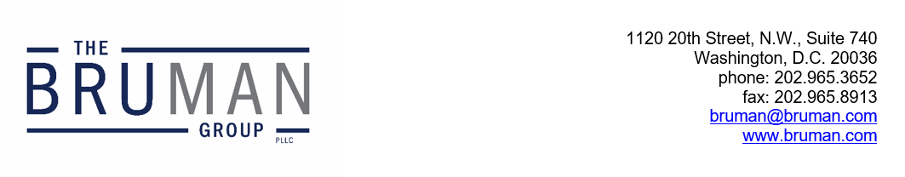

The Federal Update for August 23, 2024

From: Michael Brustein, Julia Martin, Steven Spillan, Kelly Christiansen
Re: Federal Update
Date: August 23, 2024
Legislation and Guidance 1
Supreme Court Says Title IX Injunctions Will Stay 1

Legislation and Guidance

Supreme Court Says Title IX Injunctions Will Stay
In a decision issued last Friday night, the U.S. Supreme Court rejected a request from the Biden administration to allow the U.S. Department of Education (ED) to enforce some portions of the final Title IX rule.
The rule, which took effect in many States on August 1, offers new instructions on how to implement the antidiscrimination provisions of Title IX of the Education Amendments of 1972. In this updated version, ED expands the definition of “sex” to include gender identity and sexual orientation and argues that schools should allow students to use the bathrooms and locker rooms that align with their identity. The rule has been temporarily enjoined from taking effect in 26 States while lawsuits saying that the rule represents administrative overreach proceed.
In its request, the administration asked the Court to allow the enforcement of other provisions of the rule that were not part of the litigation at issue, including new protections for pregnant and parenting students and employees, modifications to the formal grievance process, and expansion of protections to cover program admissions and online conduct. In a 5-4 decision, the Court said that the administration’s request had “not provided… a sufficient basis to disturb the lower courts” and that the modified definitions are “intertwined with and affect other provisions of the rule,” and thus those other provisions could not be enforced.
An opinion from the dissenting Justices said there was no reason to block the entire rule. “By blocking the Government from enforcing scores of regulations that respondents never challenged and that bear no apparent relationship to respondents’ alleged injuries, the lower courts went beyond their authority to remedy the discrete harms alleged here,” wrote Justice Sonia Sotomayor for the dissent.
With the 2024 rule still blocked in the plaintiff States, ED will be enforcing the prior rule that was finalized in 2020 in those States, while implementing the new regulations in States that have not been part of the litigation. ED has not yet issued guidance about the court decisions, nor has it instructed States or districts on how to manage implementation for schools and districts that were named as plaintiffs in lawsuits but are located in States where the new rule applies.
Author: JCM
The Federal Update has been prepared to inform The Bruman Group, PLLC’s legislative clients of recent events in federal education legislation and/or administrative law. It is not intended as legal advice, should not serve as the basis for decision-making in specific situations, and does not create an attorney-client relationship between The Bruman Group, PLLC and the reader.
© The Bruman Group, PLLC 2024
Contributors: Julia Martin
Posted by the California Department of Education, August 2024

