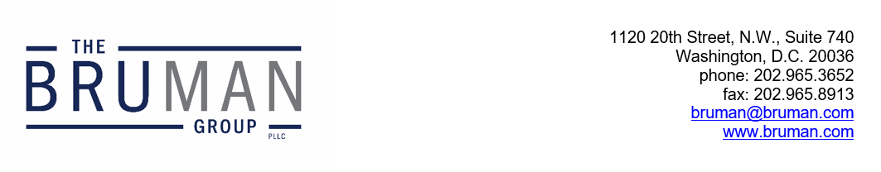

The Federal Update for September 20, 2024

From: Michael Brustein, Julia Martin, Steven Spillan, Kelly Christiansen
Re: Federal Update
Date: September 20, 2024
Legislation and Guidance 1
CR Fails on House Floor as Spending Deadline Looms 1
ED Delays Gainful Employment Reporting Again 2
Online Safety Bills Pass House Committee 2

Legislation and Guidance

CR Fails on House Floor as Spending Deadline Looms
House Republicans’ attempt to pass a continuing resolution (CR) which would extend federal funding through March of 2025 and avoid a government shutdown on October 1st failed on the House floor Wednesday. Fourteen Republicans, alongside all but three Democrats, voted against the bill, which also included policy legislation to require proof of citizenship to register to vote.
Speaker of the House Mike Johnson (R-LA) originally planned a vote on the CR last week but abandoned plans last minute as it became clear there would not be enough support within the Republican conference to pass the bill. Some Republicans voting against the legislation raised concerns that a six-month CR, without any funding increases, would lead to funding challenges for the military.
Democrats have been pushing for a shorter-term CR that would extend funding at current levels until December as an alternative to the House Republican proposal. But some Democrats are also urging the inclusion of additional funding for certain federal programs and agencies, including for Veterans Affairs to cover recent increases in veterans’ health costs.
The path forward is currently unclear as House Republicans have not outlined their next steps in the wake of the failed vote Wednesday, but a shorter-term CR with no additional funding or policy provisions is the most likely path forward to avoid a government shutdown at the end of the month.
Resources:
David Lerman, “Johnson’s stopgap funding package goes down to defeat,” Roll Call, September 18, 2024.
Author: KSC

ED Delays Gainful Employment Reporting Again
After pressure last week from lawmakers and industry experts, the U.S. Department of Education (ED) announced that it was extending the Financial Value Transparency and Gainful Employment reporting deadline to January 15th, 2025.
ED released the new rules last September with an original reporting deadline of July 31st. However, due to the flawed rollout of the Free Application for Federal Student Aid (FAFSA), ED initially delayed the deadline until October 1st. But FAFSA errors continued to pile up and financial aid offices are still correcting student financial aid awards.
Letters from industry groups requested that ED again delay the deadline so that institutions could have the time to collect and report the required data. A group of bipartisan senators also sent a letter to ED last week, arguing that the reporting requirements are burdensome and considering the FAFSA errors, institutions would not be able to provide quality data by the deadline.
Some groups are still advocating for a later deadline. Groups such as the National Association of Student Aid Administrators and the Association of Public and Land-grant Universities have asked for a deadline of July 1st, 2025 to provide the data. They say that institutions still need more to time address the 2024-2025 FAFSA errors and prepare for the already delayed 2025-2026 FAFSA. Since the new rules do not apply until 2026, the groups argue that the later deadline still offers ED enough time to review the data that institutions provide.
Resources:
Rebecca Carballo, “Education Department Extends college financial disclosure timeline after industry, lawmaker pleas,” Politico, September 13, 2024.
Author: BTW

Online Safety Bills Pass House Committee
The House Committee on Energy and Commerce passed two bills this week aimed at protecting students and children on the internet.
The first, the Kids Online Safety Act (KOSA) was similar to a bill passed by the Senate earlier this year but contains weaker language around the “duty of care” regarding what social media companies and others must do to protect underage users. The bill would still require platforms to design features to make platforms less addictive for minors, including limiting or eliminating push notifications and content surrounding topics like suicide, eating disorders, drugs, alcohol, and other types of self-harm.
Republicans objected to the bill as overly broad and were concerned with the authority that would be provided to the Federal Trade Commission to regulate content, with backing by some trade organizations who called it an “unconstitutional censorship bill.” There was also pushback regarding how, exactly, the age of users would be determined and who would perform information verification and storage.
The second bill passed by the Committee is a reauthorization of the Children’s Online Privacy Protection Act, known as “COPPA 2.0.” This bill would update the original 1998 law to raise the age of enforcement and add new rules prohibiting targeted advertising (and the associated data collection) to children.
The bills will now go to the House floor. If they pass, the differences between these versions and the Senate proposals will need to be reconciled before final passage. The President has indicated he will sign both pieces of legislation.
Author: JCM
The Federal Update has been prepared to inform The Bruman Group, PLLC’s legislative clients of recent events in federal education legislation and/or administrative law. It is not intended as legal advice, should not serve as the basis for decision-making in specific situations, and does not create an attorney-client relationship between The Bruman Group, PLLC and the reader.
© The Bruman Group, PLLC 2024
Contributors: Julia Martin, Kelly Christiansen, Brandi Tennant Wills
Posted by the California Department of Education, September 2024

