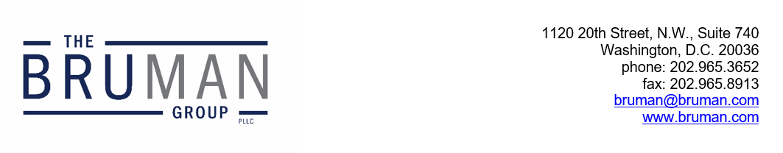

The Federal Update for October 4, 2024

From: Michael Brustein, Julia Martin, Steven Spillan, Kelly Christiansen
Re: Federal Update
Date: October 4, 2024
Legislation and Guidance 1
Congress in Recess until November 1
News 2
ED Launches 2025-26 FAFSA Beta Testing Period 2

Legislation and Guidance

Congress in Recess until November
After passing a six-month stopgap appropriations bill (known as a “continuing resolution” or “CR”) Congress left Washington for campaign season. Lawmakers are scheduled to be back in session on November 12th, the day after Veterans’ Day. They will then have approximately five weeks of Congressional session to draft and pass a full-year appropriations bill before the CR expires on December 20th. Also on the docket are an extension of the Farm Bill, potential reauthorization of the Workforce Innovation and Opportunity Act, and online safety legislation focused on students and their use of social media applications.
It is likely Congress will also vote on a supplemental disaster relief package for areas of Florida, Georgia, North Carolina, Tennessee, and Virginia that saw widespread wind and flood damage after Hurricane Helene. President Joe Biden and Vice President Kamala Harris have promised federal recovery funds and have weighed asking Congress to come back to Washington for a vote on the hypothetical package, but given the timing, it is more likely that this vote would happen after the November election.
Author: JCM

News

ED Launches 2025-26 FAFSA Beta Testing Period
On Tuesday, the U.S. Department of Education (ED) began testing the new Free Application for Federal Student Aid (FAFSA). The four-part beta testing process will evaluate the application’s functionality and identify issues before launching it to the general public.
For the first round, ED is working with six community-based organizations, including CollegeAIM and Education is Freedom. Applications from students in those organizations will go through the entire FAFSA process – from submission to ED, then transmission to colleges, and finally making any necessary corrections. In the following rounds, ED has chosen 20 community-based organizations, 10 high schools, and 48 colleges and universities to participate in the testing. The four phases of testing will take place over the next two months before the planned release of the final application on December 1st. ED usually releases the FAFSA on October 1st, but this is the second year the Department has missed that deadline.
The beta testing period comes after the Government Accountability Office (GAO) released two reports on ED’s “troubled rollout” of the 2024-25 FAFSA last week. The GAO found that ED did not have adequate systems and leadership in place to address and correct errors in the application. Additionally, the report notes that ED did not provide timely information to students, and that 4 million calls (or 76% of the total) to the Department in the early part of 2024 went unanswered. Institutions and students are still feeling the impacts of the issues with the 2024-25 FAFSA.
A day before the GAO reports were released, ED released its own plan to improve the rollout of the 2025-26 FAFSA, stating that it hired additional staff, consulted with experts, and would be implementing the beta-testing period.
The two GAO reports can be found here and here. ED’s plan for the 2025-26 FAFSA can be found here.
Resources:
Mackenzie Wilkes, “The Soft Launch,” Politico, October 1, 2024.
Author: BTW

The Federal Update has been prepared to inform The Bruman Group, PLLC’s legislative clients of recent events in federal education legislation and/or administrative law. It is not intended as legal advice, should not serve as the basis for decision-making in specific situations, and does not create an attorney-client relationship between The Bruman Group, PLLC and the reader.
© The Bruman Group, PLLC 2024
Contributors: Julia Martin, Brandi Tennant Wills
Posted by the California Department of Education, October 2024

