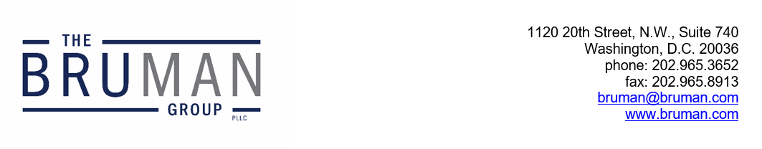

The Federal Update for October 11, 2024

From: Michael Brustein, Julia Martin, Steven Spillan, Kelly Christiansen
Re: Federal Update
Date: October 11, 2024
News 1
Group Asks Supreme Court to Take Up Religious Charters Question 1
EPA Rule Would Require Lead Testing for Schools 2

News

Group Asks Supreme Court to Take Up Religious Charters Question
The conservative group Alliance Defending Freedom (ADF) has asked the U.S. Supreme Court to take up an Oklahoma case regarding religious charter schools.
Oklahoma approved a religious virtual charter school to open this fall, over the objections of the State’s own attorney general. A State court invalidated the charter, noting that the school, St. Isidore of Seville, refused to sign on to charter assurances that it would not teach religious doctrine. The state court also noted that Oklahoma law prohibits the State from spending funds “for the benefit and support” of religious organizations like the catholic church and says that the state may not sponsor “a charter school program that is affiliated with a nonpublic sectarian school or religious institution.”
ADF has argued that denying the school a charter was an unconstitutional violation of State and federal law and prevented the school’s leadership and parents from exercising their religious beliefs. It has asked the justices to weigh in on a question they have previously declined to answer – whether charter schools are public entities and thus do not have first amendment rights. Instead, they seek to build on prior decisions of the Court in cases like a school voucher case Carson v. Makin, arguing that charter schools are not an arm of the State, but rather a contract with the State to offer a free educational option for students.
In fact, the petition seeks in some ways to redefine the term “public school.” In the case of Oklahoma, it argues, “[t]he relevant statute calls a charter school a “public school established by contract” – a phrase that contemplates the private delivery of publicly funded education.… In other words, labeling a school ‘public’ is just another way to say, ‘the state funds it.’”
A ruling in favor of the school would have significant implications for federal funding of religious schools – and the requirements that charter schools meet federal standards for civil rights and students with disabilities. Oklahoma Attorney General Gentner Drummond, who opposed the creation of the school, said in a statement that “[t]his unconstitutional scheme to create the nation’s first state-sponsored religious charter school will open the floodgates and force taxpayers to fund all manner of religious indoctrination, including radical Islam or even the Church of Satan.”
If the Court chooses to grant a writ of certiorari and hear the case, it could be decided as soon as spring of 2025.
Author: JCM

EPA Rule Would Require Lead Testing for Schools
New final regulations from the Environmental Protection Agency (EPA) issued Tuesday would require that all elementary schools and childcare facilities that get their water from public utilities test it for lead content. Those public utilities, which EPA refers to as “community water systems,” would have to track what schools and childcare facilities they serve, notify the community of testing, and conduct outreach on the dangers of lead exposure. The EPA will create a national inventory of lead service lines to help ensure that those pipes are removed.
Utilities would need to conduct lead sampling at no less than 20 percent of elementary schools and 20 percent of licensed childcare facilities each year for the first five years after the regulations take effect, with the goal of eliminating all lead pipes from drinking water within the next decade. Tests would also need to be offered to middle and high school facilities.
While utilities would be required to pay for improvements, critics of the regulation say consumers will ultimately see increases in their bills to cover the costs.
Author: JCM
The Federal Update has been prepared to inform The Bruman Group, PLLC’s legislative clients of recent events in federal education legislation and/or administrative law. It is not intended as legal advice, should not serve as the basis for decision-making in specific situations, and does not create an attorney-client relationship between The Bruman Group, PLLC and the reader.
© The Bruman Group, PLLC 2024
Contributors: Julia Martin
Posted by the California Department of Education, October 2024

