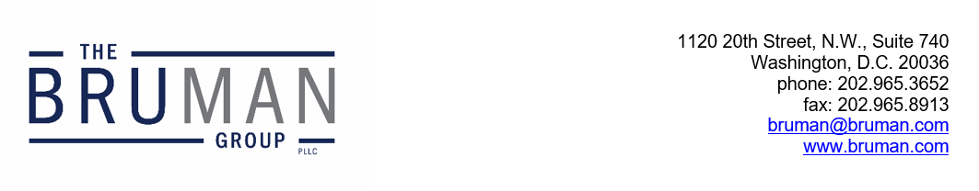

The Federal Update for October 18, 2024

From: Michael Brustein, Julia Martin, Steven Spillan, Kelly Christiansen
Re: Federal Update
Date: October 18, 2024
News 1
House Republicans Oppose Proposed Changes to Perkins State Plan 1
ED Proposes Revisions to Civil Rights Data Collection 2

News

House Republicans Oppose Proposed Changes to Perkins State Plan
Chair of the House Committee on Education and the Workforce Virginia Foxx (R-NC) and Chair of the Subcommittee on Early Childhood, Elementary, and Secondary Education Aaron Bean (R-FL) sent a letter to Secretary of Education Miguel Cardona this week that takes issue with proposed revisions to the Perkins Career and Technical Education (CTE) program State plans and Consolidated Annual Reports.
The U.S. Department of Education (ED) issued notices last month in the Federal Register proposing changes to information collections under the Perkins V program, which would include new reporting requirements on CTE students in the middle grades and the education and employment outcomes of CTE concentrators who have exited secondary education or who have completed a postsecondary program, disaggregated by placement type. In addition, the proposal would require States to describe how they define certain terms that are not defined in the Perkins statute and how they identify industry-recognized credentials. ED is also proposing to provide data specifications for calculating performance indicators to ensure the indicators “are measured in a manner that is consistent with the statute” and give States more time to report education and employment outcomes.
The letter sent by House Republicans this week argues that the “proposed revisions make substantive policy changes that exceed the Department’s authority under the law and will pose a significant and unjustified burden” on recipients and subrecipients. The lawmakers cite to provisions in the Perkins V law that limit the Secretary of Education’s authority to issue regulations only to “the extent necessary to administer and ensure compliance with the specific requirements” of Perkins V and that require ED to provide Congress with notice and opportunity to comment prior to issuing a proposed regulation. The notices issued last month are not proposed regulations, but ED indicated in its semi-annual regulatory agenda that it plans to issue a notice of proposed rulemaking (NPRM) for the Perkins program in the coming months. The lawmakers state that “it is our understanding that the proposed revisions to the State Plan Guide and Consolidated Annual Report are in lieu of the NPRM that was expected this fall” and that ED is “circumventing the law” given the possible impact of the information collection proposed revisions.
The lawmakers say that the proposed revisions go beyond the baseline requirements in the Perkins V statute, adding new State plan components and modifying the performance indicator calculations in a manner contrary to the Congressional intent of the law. The lawmakers address the potential administrative burden on recipients and subrecipients from the proposed revisions as well, noting that the revisions will require States to submit a new State plan shortly after completing their four-year State plan revisions earlier this year. In addition, the letter highlights how the current Perkins State plan cycle is aligned with the Workforce Innovation and Opportunity Act State plan process but that changes in the timeline would alter that alignment.
The lawmakers request that ED withdraw the proposed State plan and Consolidated Annual Report revisions, and they request copies of any communications between ED staff that discuss ED’s Perkins V policy agenda.
The full letter is available here.
Author: KSC

ED Proposes Revisions to Civil Rights Data Collection
The U.S. Department of Education’s (ED’s) Office for Civil Rights issued a notice in the Federal Register on Thursday that proposes revisions to the Civil Rights Data Collection (CRDC) for the 2025-2026 and 2027-2028 school years. Local educational agencies (LEAs) are required to submit certain data biennially under the CRDC.
The proposed changes for future CRDC submissions include new data elements, elimination of some data points, and revisions to current data elements. ED proposes adding a data collection on the type of instruction provided in schools (remote or in-person) but removing the COVID-19 related tie with regard to remote instruction, which was added to the collection after the onset of the pandemic. In addition, ED proposes including school-level counts of students who received at least one informal removal, disaggregated by subgroup classifications. “Informal removal” would be defined as “any action by a school staff member to remove a student (regardless of age, grade level, or disability status) from an education program or activity for a period of time without the incident being entered into a student’s record or without providing written notification about the incident to the student’s guardian.” Other new data elements include LEA-level data on the number of students enrolled in an LEA and who are being served in a non-LEA facility only, as well as the number of students enrolled in an LEA and who are being served in a non-LEA facility only that are subjected to mechanical restraint, physical restraint, and seclusion. The final new proposal is a data collection on threat assessments, including what types of threat assessment processes a school has in place.
Other proposed revisions include changing the snapshot date for reporting on a school’s Title IX, Title VI, and Section 504 civil rights coordinators to ensure the public gets access to the most accurate information and removing some COVID-19 related data elements.
Stakeholders can submit public comments on the proposed changes until December 16, 2024 through the Federal Register here. ED asks for specific feedback from stakeholders on the proposed definition of “informal removal” and the proposed data element related to threat assessments.
Author: KSC
The Federal Update has been prepared to inform The Bruman Group, PLLC’s legislative clients of recent events in federal education legislation and/or administrative law. It is not intended as legal advice, should not serve as the basis for decision-making in specific situations, and does not create an attorney-client relationship between The Bruman Group, PLLC and the reader.
© The Bruman Group, PLLC 2024
Contributors: Kelly Christiansen
Posted by the California Department of Education, October 2024

