# **California Preschool Data Collection (CAPSDAC)** **Setting Up Multi-Factor Authentication and Password Reset**

**Version 1.0**

**January 2025**



Early Education Division

California Department of Education

1430 N Street, Suite 3410

Sacramento, CA 95814-5901

Email Support: [CAPSDAC@cde.ca.gov](mailto:CAPSDAC@cde.ca.gov)

[EED Contractor Information](https://www.cde.ca.gov/sp/cd/ci/)

## Overview

This guide is intended for California State Preschool Program (CSPP) contractors who are responsible for submitting and certifying the monthly CAPSDAC submission on behalf of their agency. For more information, users can navigate to the CAPSDAC Support web page at <https://www.cde.ca.gov/sp/cd/ci/capsdacsupportlanding.asp>.

## Login Instructions

This section provides users with instructions on how to set up multi-factor authentication (MFA) and Self-Service Password Reset in the CAPSDAC Online Portal.

### **Accessing the CAPSDAC Website**

1. Open your web browser and navigate to the CAPSDAC Online Portal.
2. This is the website’s URL: <https://www.capsdac.org>
3. You will be navigated to the CAPSDAC login page and will be asked to input your CAPSDAC Account Username and Password.

### **Setting up MFA in CAPSDAC**

1. After inputting your CAPSDAC username and password, you will be prompted with a screen that reads “More information required. Your organization needs more information to keep your account secure.” When this screen appears, select the Next button.

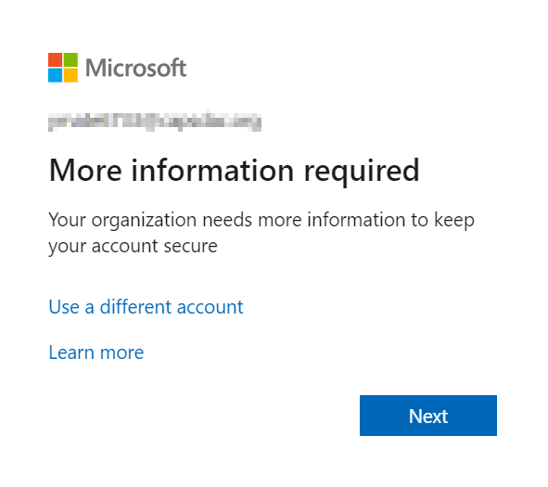

1. After selecting Next, a new screen will appear that says, “Keep your account secure. Start by getting the app. On your phone, install the Microsoft Authenticator app. Download now. After you install the Microsoft Authenticator app on your device, choose “Next”, and enables a choice between the following options:
   1. Using Microsoft Authenticator to establish the MFA
   2. Setting up a different method for MFA

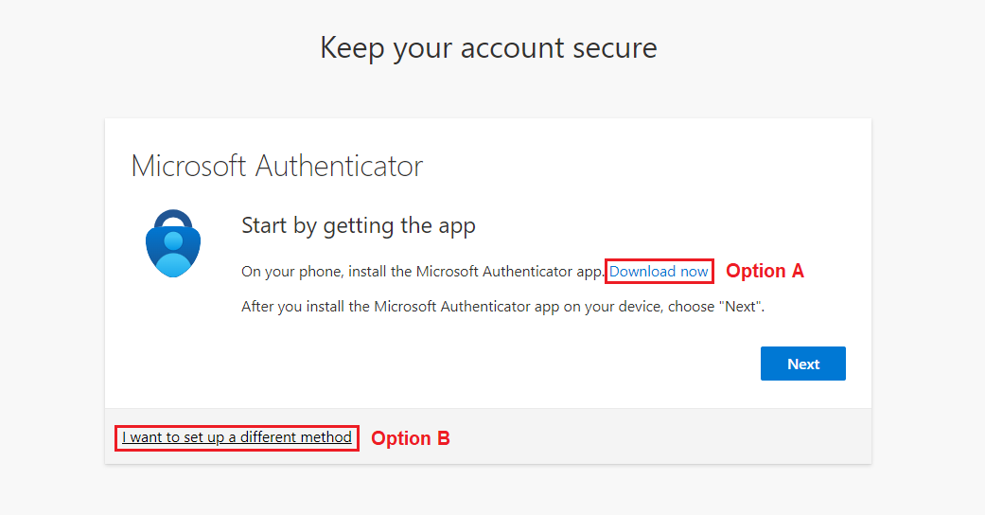

## MFA Methods

The following information provides a detailed walkthrough of all available methods for establishing MFA in the CAPSDAC. These methods include:

* Microsoft Authenticator
* Phone Authentication – Phone Call
* Mobile Phone Authentication – Short Message Service (SMS)

#### Microsoft Authenticator

1. The CAPSDAC will utilize Microsoft Authenticator as the default MFA method.

This method requires users to download the Microsoft Authenticator application, which is linked for download. However, if you navigate to your mobile phone’s application store, and search “Microsoft Authenticator” it should appear as one of the first options as shown below. The creator is the Microsoft Corporation, and the description “Protects your online identity”. Please note that this is a free application, so there are no associated costs to download or use it.

For your reference, we have included two screenshots showing how the app appears in both the Apple App Store and the Google Play Store. These images below will guide you in recognizing the correct app in your respective store, ensuring a smooth and secure setup process.

**Apple App Store (iPhone Users)**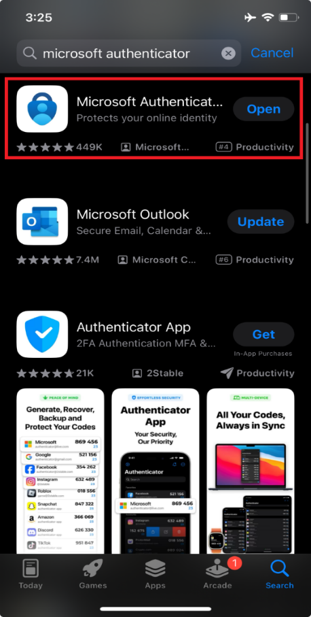

**Google Play Store (Android Users)**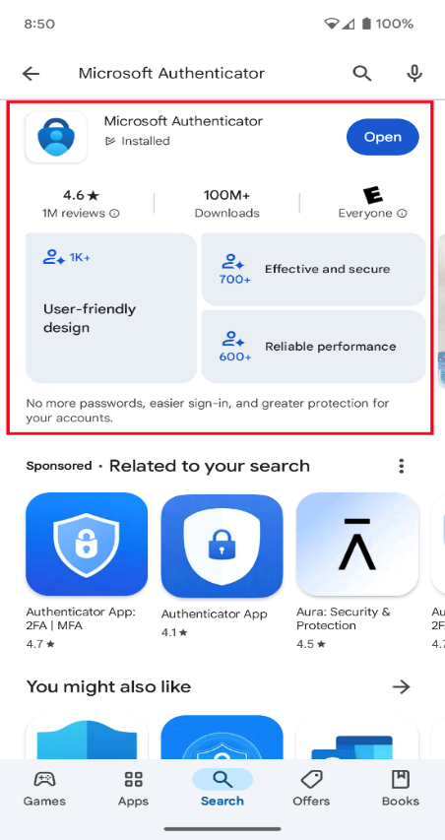

1. Once the application is successfully downloaded onto your mobile phone, select the Next button on the CAPSDAC MFA setup screen.

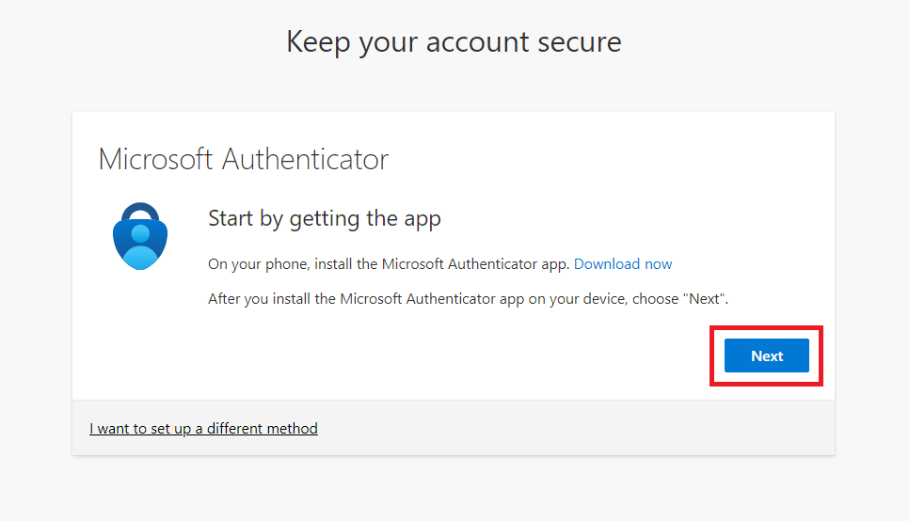

1. Now, you will be prompted to a screen will appear that says, “Set up your account. If prompted, allow notifications. Then add an account, and select “Work or school.” This window will prompt the user to allow notifications from the Microsoft Authenticator mobile application on their smart phone. Once you have reviewed the text in this screen, select Next.

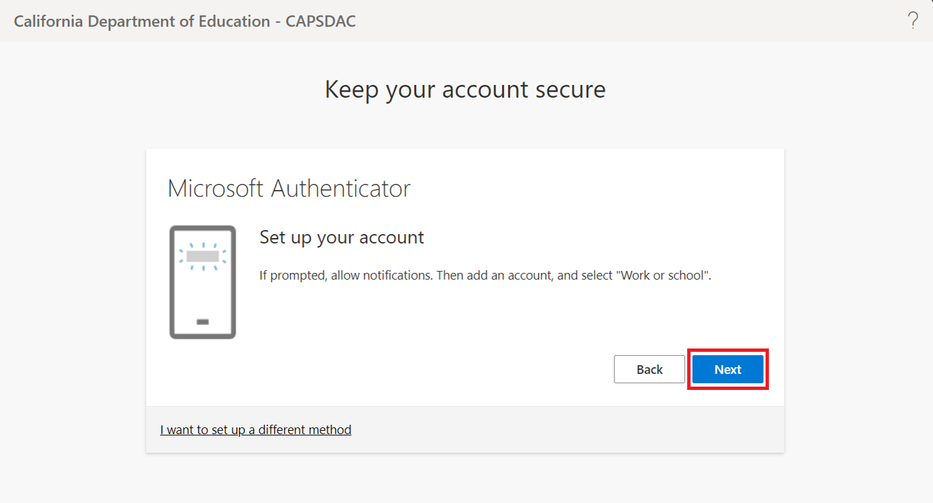

1. The next screen displays a QR Code and says, “Use the Microsoft Authenticator app to scan the QR code. This will connect the Microsoft Authenticator app with your account. After you scan the QR code, choose “Next.”

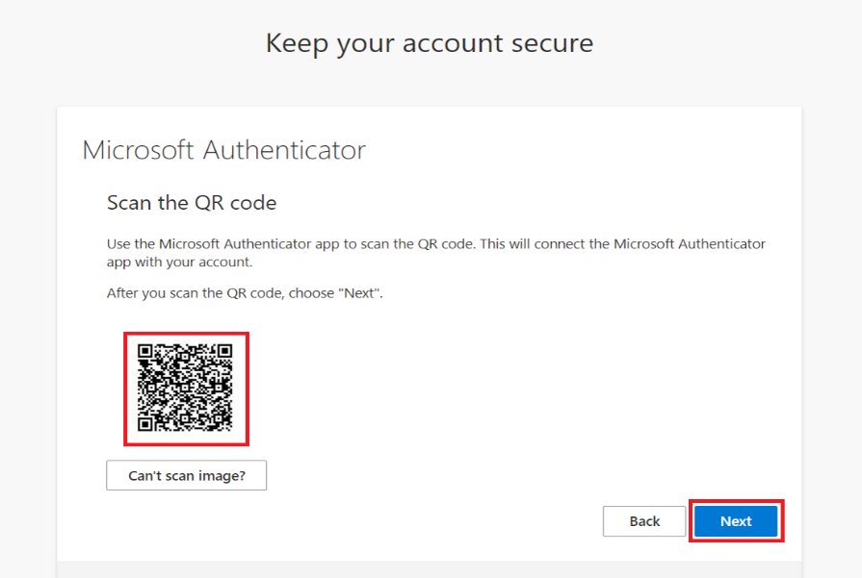

1. Now, using your mobile phone that has the Microsoft Authenticator application downloaded to it, open the Microsoft Authenticator application. From there, navigate to the Verified IDs tab at the bottom right of the screen. Then, select the blue button that says “Scan QR Code”.

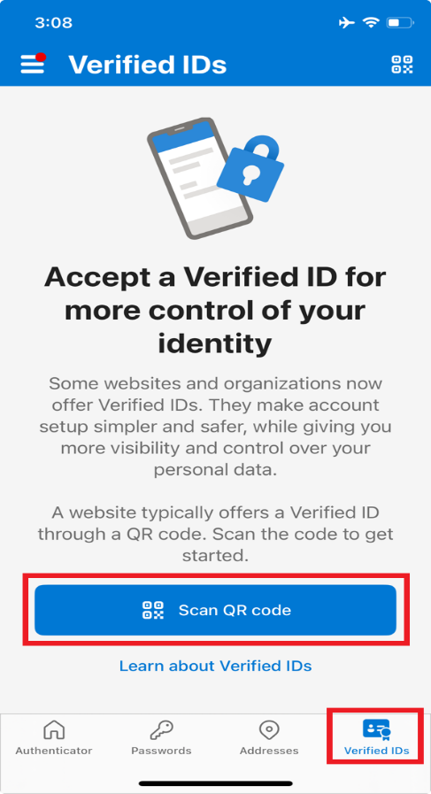

1. Using your mobile phone’s camera, point the QR reader in the Microsoft Authenticator application to the QR Code on your web browser’s screen.

When prompted to scan a QR code, users must align their phone’s camera with the QR code displayed on their computer screen. Ensure that the QR code fits neatly within the four blue corners visible in the app’s QR Reader interface.

1. Once your phone’s QR Reader successfully scans the QR code displayed on your computer screen, select the Next button on the web browser. At this stage, a numeric code will appear on your browser screen. This code is used to verify that the setup process is secure and corresponds to your account.

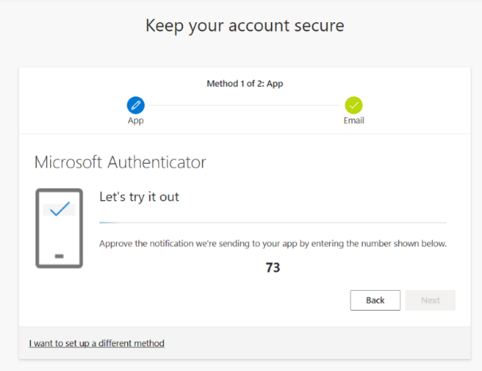

1. After you receive the code in your web browser, open the Microsoft Authenticator application on your mobile phone. You should see a prompt to enter the numeric code from the browser into a pop-up window within the Authenticator app. In the box that states, “Enter the number shown to sign in”, type the number from the browser and select “Yes.”

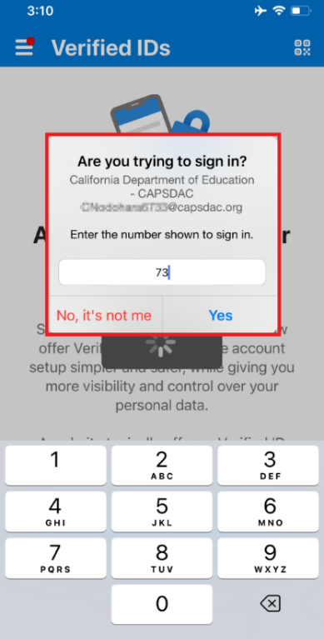

1. If the numeric code matches, a web browser screen will display “Notification approved”. Once you see this message, be sure to select the Next button on the browser screen to proceed to the next step of the setup process.

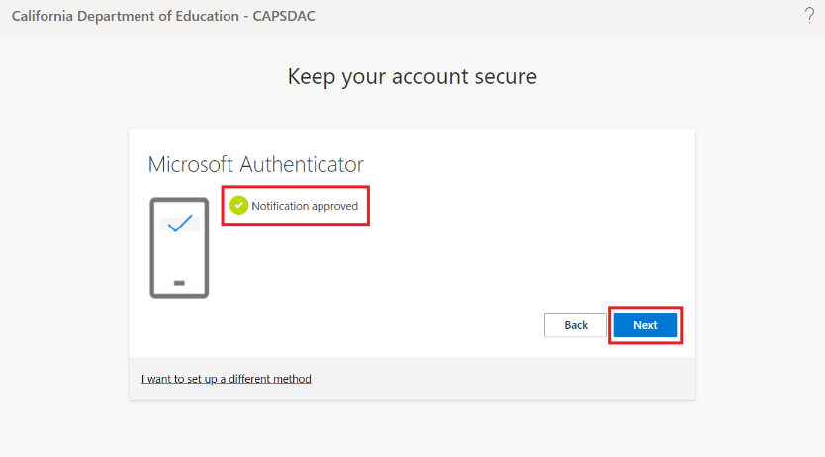

1. Your Multi-Factor Authentication has been successfully set up for your CAPSDAC account, ensuring enhanced security for future logins. This window says, “Great job! You have successfully set up your security info. Choose “Done” to continue signing in.” To continue to the CAPSDAC Online Portal, select "Done" on the success page, where your default sign-in method is confirmed as Microsoft Authenticator.

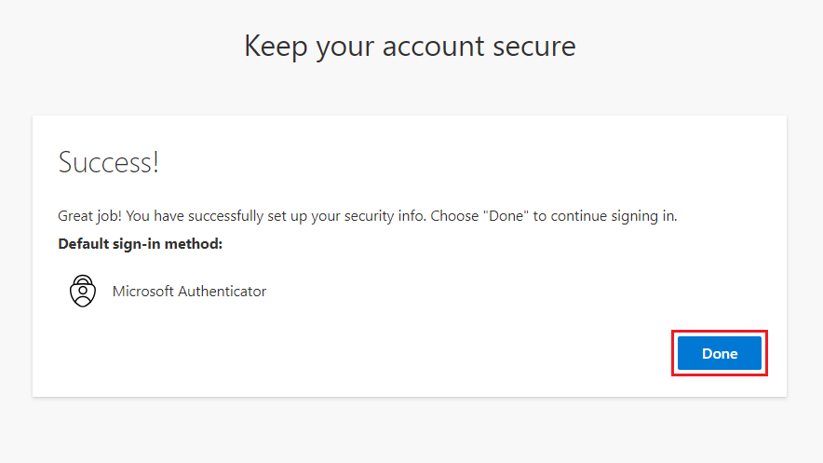

#### Multi-Factor Authentication — Phone Call

1. Users who prefer an alternative method for MFA instead of the Microsoft Authenticator can choose Phone Call-Based Two-Factor Authentication, which works on mobile or landline phones. To enable this option, navigate to the first MFA setup screen and select the text “I want to set up a different method.”

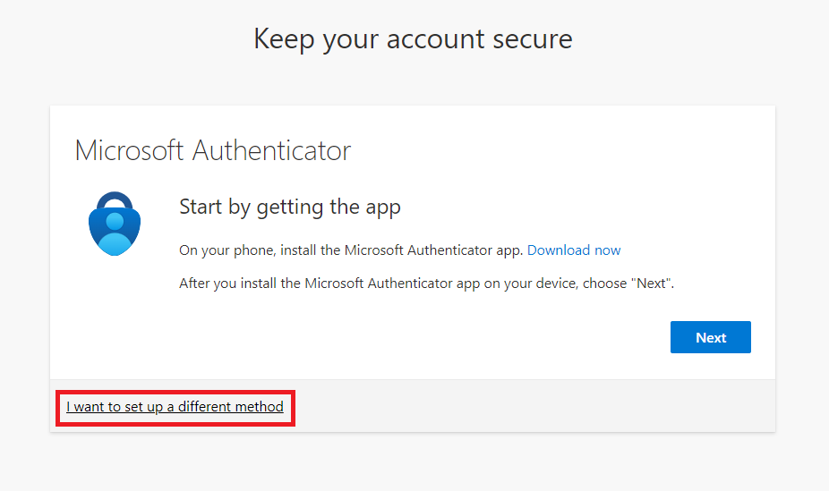

1. After selecting the “I want to set up a different method” option, a pop-up menu will present the two options: Microsoft Authenticator and Phone. From these two options, select the “Phone” option.

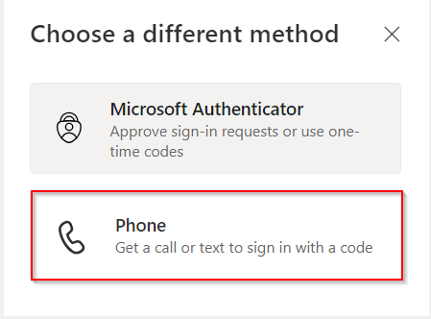

1. After selecting the Phone method, you will be prompted to enter the phone number of the phone you wish to link to your CAPSDAC account for MFA. Select the country code, then enter your 10-digit phone number in the provided field and review it for accuracy.

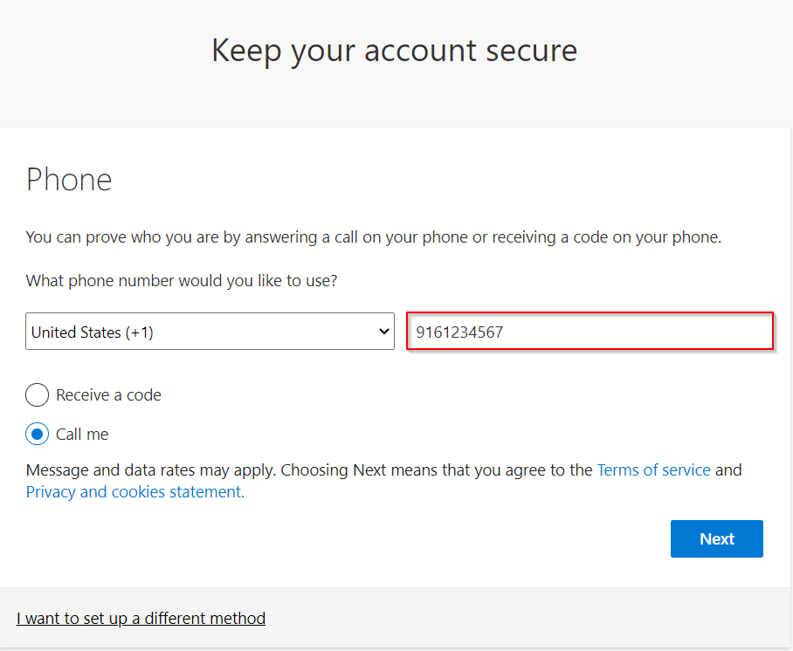

1. After inputting the phone number used for authentication, choose the Call Me option. Then, select Next.

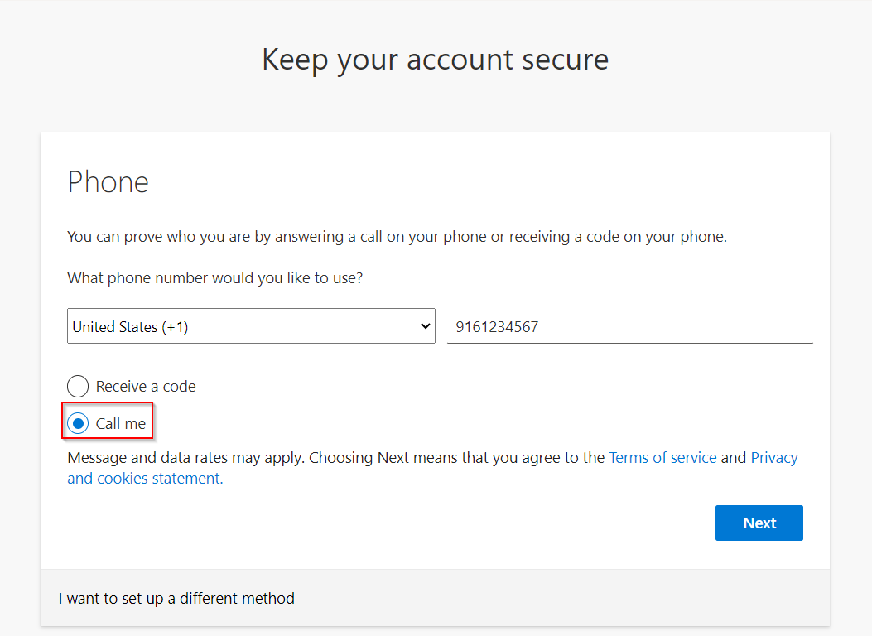

1. You will be navigated to a screen on your computer that says, “We’re calling [your phone number] now.” Shortly after, you should receive a phone call as part of the MFA process. When you receive the call, please answer and follow the instructions to complete the verification.

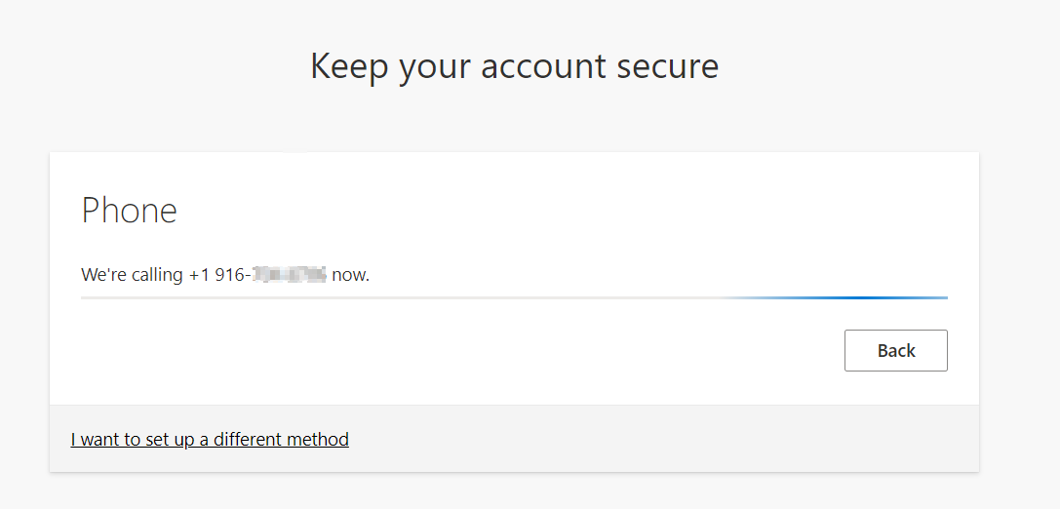

1. During the phone call, an automated message will say, 'This is Microsoft. If you are trying to sign in, press the POUND (#) key to finish signing in.' At this point, press the # key on your phone's keypad. Once you press the # key, the automated message will confirm, 'Your sign-in was successful.' The call will then end."
2. After the phone call ends, the CAPSDAC MFA screen will refresh to a new screen that says, “Call answered. Your phone was registered successfully.” Select the Next button.

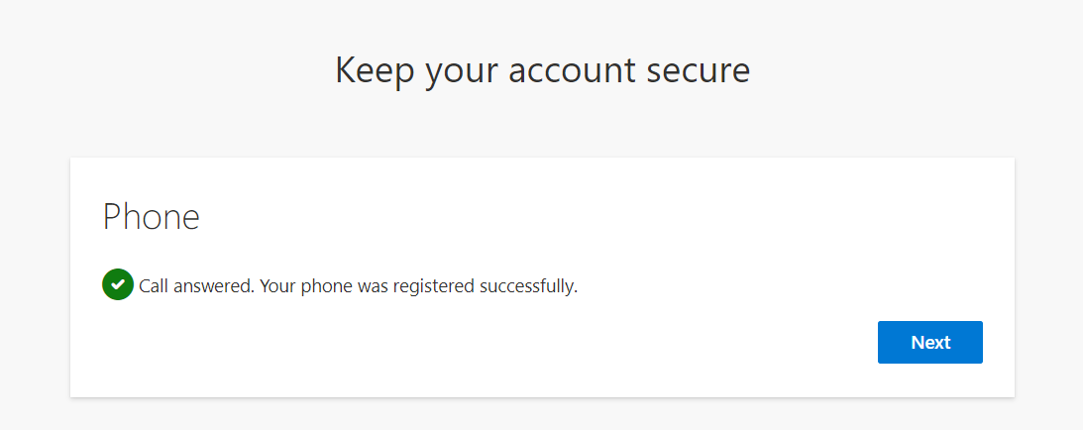

1. You have now successfully established the Phone Call MFA Method to your CAPSDAC account. Select “Done” to finish logging in to the CAPSDAC.

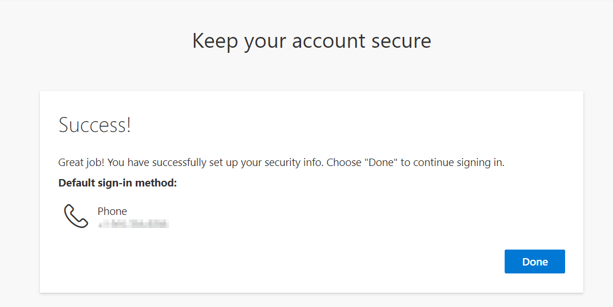

#### Multi-Factor Authentication — Short Message Service (SMS)

1. For users who prefer an alternative method for MFA instead of the Microsoft Authenticator, SMS-Based Two-Factor Authentication is available on their mobile phone to access their CAPSDAC account. To select this option, go to the first MFA setup screen and select on the text "I want to set up a different method."



1. After selecting the “I want to set up a different method” option, a pop-up menu will present the two options: Microsoft Authenticator and Phone. From these two options, select the “Phone” option.



1. After selecting the Phone method, you will be prompted to enter the phone number of the mobile device you wish to link to your CAPSDAC account for MFA. Select the country code, then enter your 10-digit phone number in the provided field and review it for accuracy. Before proceeding, select the "Receive a code" radio button. Once you have confirmed that the phone number is correct, select the Next button to proceed.

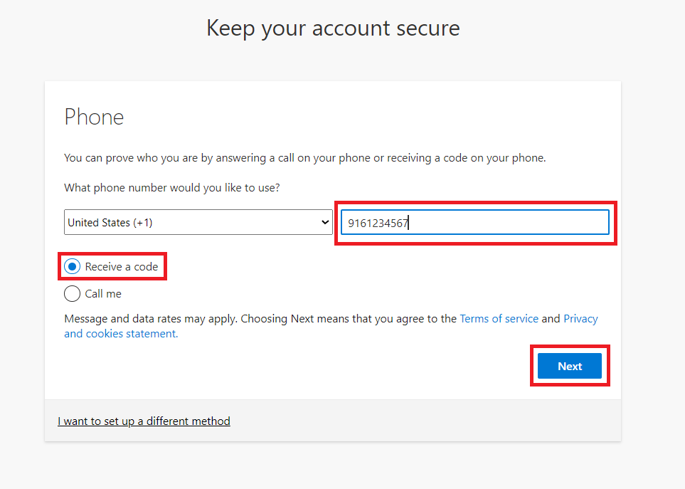

1. After entering your phone number on the previous screen, you will receive a text message containing a verification code on your mobile device. Enter the six-digit code into the designated field on the Microsoft authentication screen. Once the code is entered, select the Next button to continue.

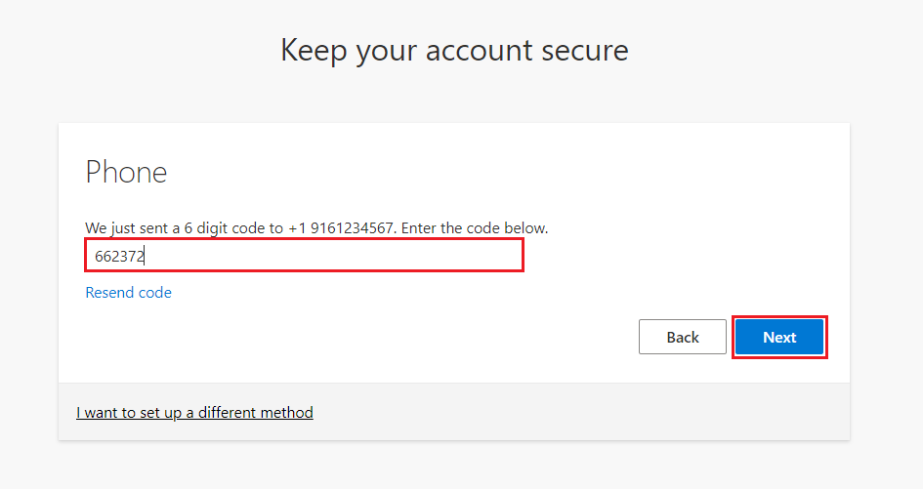

1. After successfully registering your phone number and validating it with the code, you will see a confirmation screen indicating that your phone verification is complete. You can now use your phone for MFA when logging into CAPSDAC. Select the Next button to proceed.

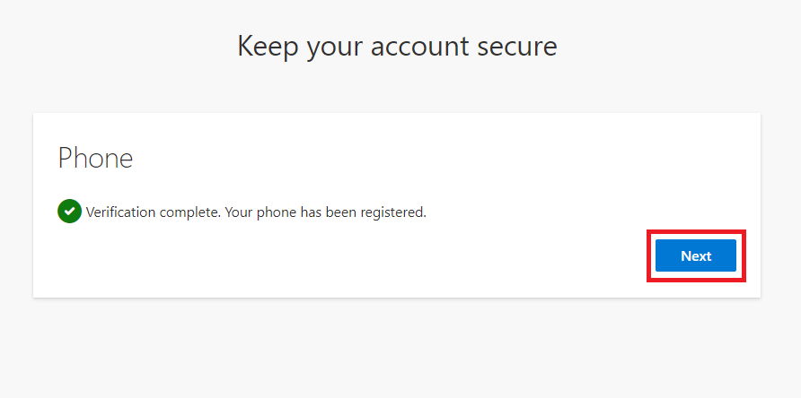

#### Managing Authentication Methods

1. After setting up an authentication method, users can review and manage sign-ins and authentication settings on the Microsoft My Sign-Ins webpage at <https://mysignins.microsoft.com/security-info>.
2. Users must log in to Microsoft My Sign-Ins using their CAPSDAC credentials. After logging in, they will be directed to a screen displaying all authentication methods associated with their CAPSDAC account.
3. To delete a previously established method, select the delete button next to the method you would like to remove.

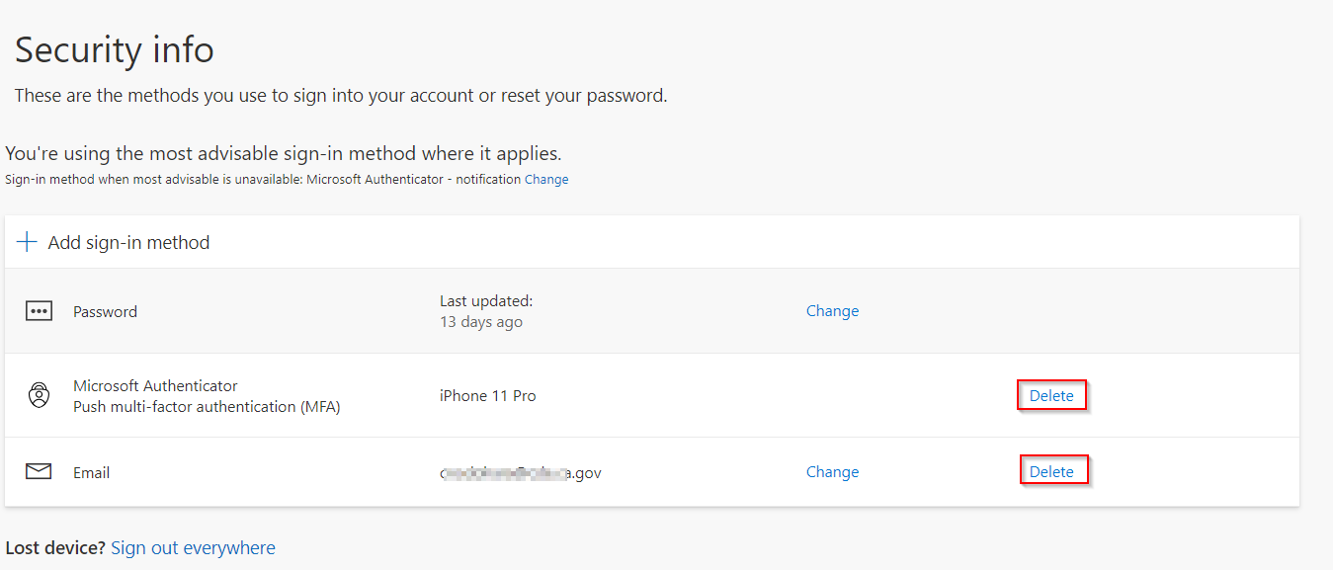

1. Once deleted, you will no longer be able to use that method for MFA into CAPSDAC.
   1. **Note**: If you remove all MFA methods, your account will be temporarily locked, and you will not be able to access the CAPSDAC Online Portal until you add a new MFA method (Authenticator, Phone Call, or SMS).

## Self-Service Password Reset (SSPR)

The following information outlines the step-by-step process for resetting the password for CAPSDAC accounts. Users can reset their passwords through multiple methods, including SMS Text, Phone Call, Microsoft Authenticator Notification, or Microsoft Authenticator Code. These options ensure that users can easily access the CAPSDAC Online Portal, regardless of their preferred method.

#### Password Reset Instructions

This section provides directions for resetting your CAPSDAC password. This function should be utilized if you cannot remember your password, or if you would like to change your existing password.

1. To begin the password reset process, navigate to the CAPSDAC Online Portal at [https://www.capsdac.org](https://www.capsdac.org/). Once there, select your account from the Microsoft login screen, or choose the "Use another account" option to enter your username. Both options will direct you to a screen where you'll be prompted for your CAPSDAC user account password. Beneath the password input field, select on the blue "Forgot my password" hyperlink to initiate the password reset process.

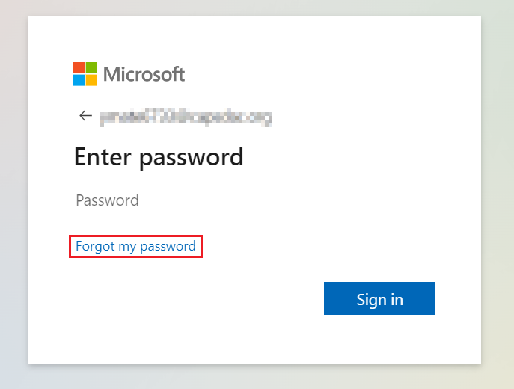

1. After selecting “Forgot my password,” you will be directed to a screen titled “Get back into your account.” To begin the account recovery process, enter the email address or username associated with your CAPSDAC account, followed by the characters displayed in the CAPTCHA image or audio. This step ensures that the account recovery request is being made by a legitimate user. Once you have confirmed that the email or username is correct and the CAPTCHA has been accurately completed, select the "Next" button to proceed with the next steps of the password reset process.

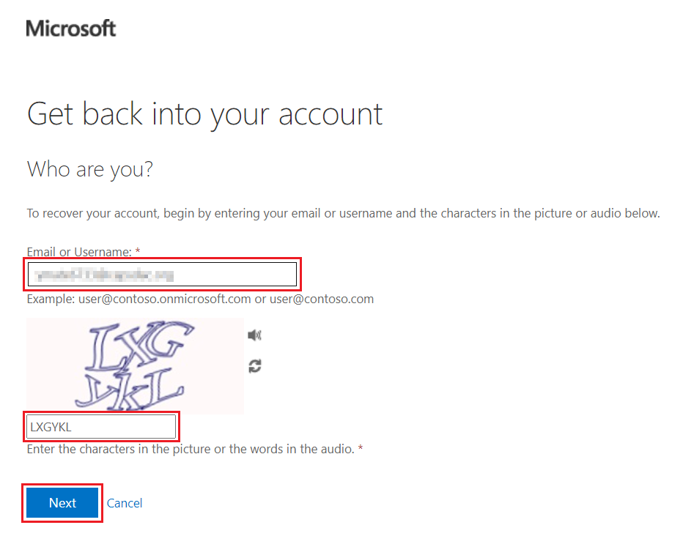

1. After selecting "Next," you will be directed to a screen that asks you to choose a contact method for verification. You will have several options, including “Email my alternate email”, "Text my mobile phone number," "Call my mobile phone," "Approve a notification on my authenticator app," or "Enter a code from my authenticator app." Select the contact method that works best for you to receive a verification code or notification. Once you’ve chosen your preferred method, follow the on-screen instructions to complete the verification process.

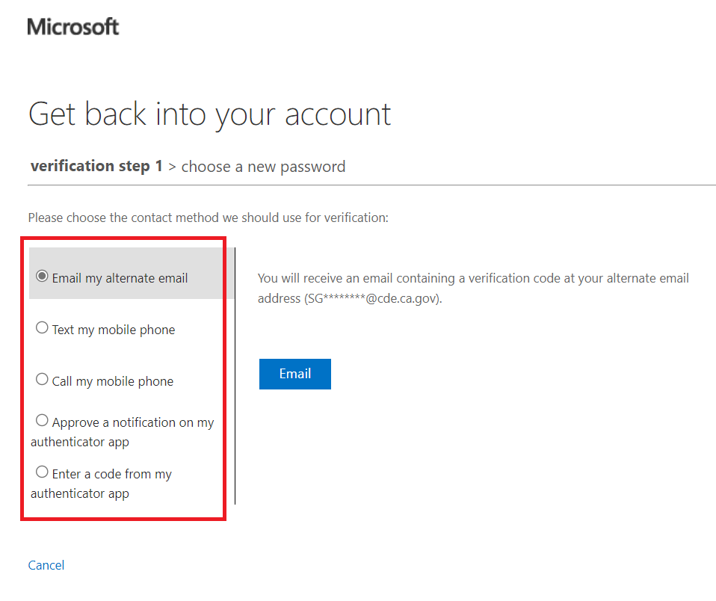

1. After selecting your contact method and completing the verification, you will be directed to a screen where you can set a new password. Enter the new password in the first field and confirm it by re-entering it in the second field. Once you have verified that both password entries are correct, select the "Finish" button to complete the password reset process.

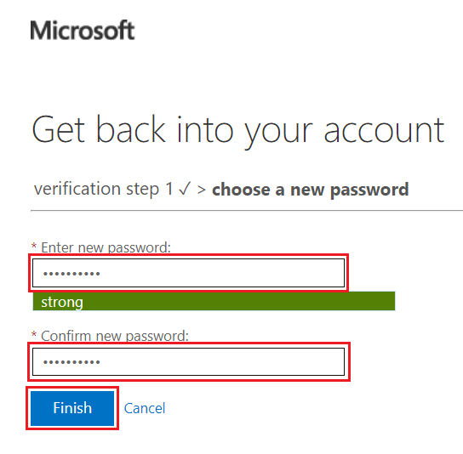

1. You will be directed to a screen confirming that your password has been reset with a message stating, "Get back into your account." To sign in using your new password, select the "click here" hyperlink to return to the CAPSDAC Online Portal login screen and access the system with your updated credentials.

