CA Early Childhood Inclusion Support
Spring 2024 Newsletter
Early Education Division

Inspirational Video
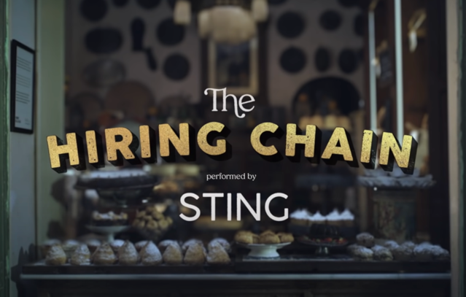
The Hiring Chain performed by Sting
— Video compliments of California Early Childhood Special Education (CalECSE)

Inclusive Early Education Expansion Program
Request for Applications: Inclusive Early Education Expansion Program 2023–27

Serving Children with Disabilities Frequently Asked Questions
Frequently asked questions (FAQs) regarding California state law relating to serving children with disabilities in California State Preschool Programs (CSPP)
Serving Children with Disabilities FAQs

Early Learning and
Care Inclusion News

Updated Policy Statement from the U.S. Dept of Education and Dept. of Health and Human Services
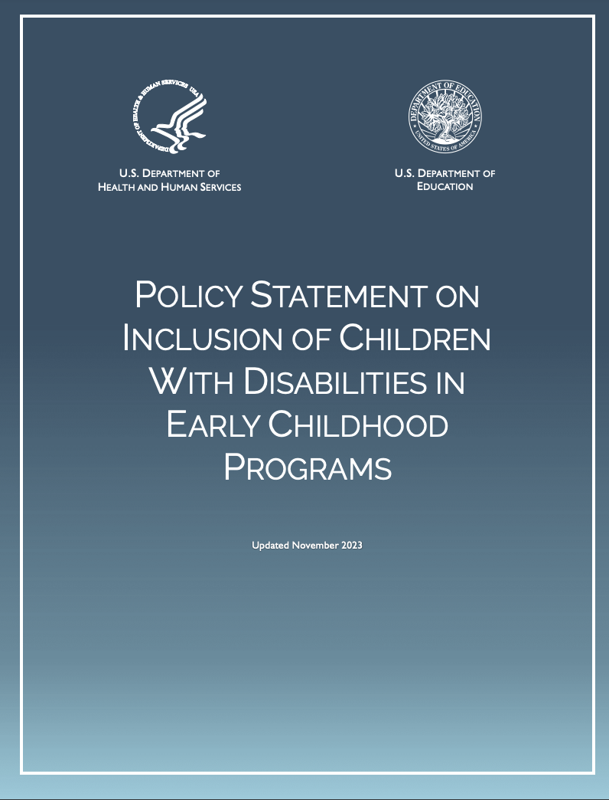
In late November 2023, the U.S. Department of Education and U.S. Department of Health and Human Services released an updated Policy Statement reaffirming their focus on the inclusion of children with disabilities in early childhood programs.
POLICY STATEMENT: Inclusion of Children with Disabilities in Early Childhood Programs (Nov. 28, 2023) (Individuals with Disabilities Education Act)

Inclusion Spotlight
Marysville Joint Unified School District Values Inclusive Early Childhood Professional Development
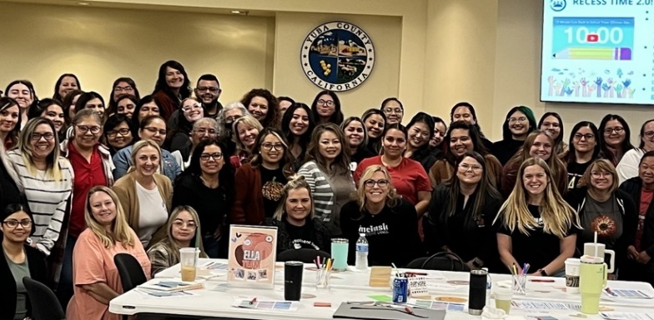

Early Education
Program Demographics:
Marysville Joint Unified School District (MJUSD) Child Development Programs operates 23 CSPPs at four school sites and five special day classes (SDC). MJUSD recently took over responsibility of directly serving children with disabilities as of July 2023. After this change the district intentionally placed their SDC classrooms next to their CSPP classrooms to provide opportunities for children with disabilities to mainstream with children enrolled in CSPP classrooms. Because of these changes, the CSPP program now has 40 children with Individualized Education Programs enrolled in and receiving the majority of their special education services and supports in a CSPP classroom. The district is serving 110 children with disabilities between the CSPP and SDC classrooms.

Highlight:
This year MJUSD Child Development Programs has nine (9) days in their calendar for professional development as it is essential for having a high-quality inclusive preschool program. MJUSD has worked closely with Supporting Inclusive Practices (SIP), funded through the California Department of Education (CDE), to provide professional development trainings on topics such as: Universal Design for Learning, inclusive classroom modifications, and co-teaching strategies. Their staff have developed a Conscious Discipline Action Team that meets monthly to help guide their program and also provide learning communities using Conscious Discipline strategies, a social emotional learning program. They also partnered with Yuba County Office of Education to ensure their classrooms are organized and designed as the optimum learning environment for inclusion using the Early Childhood Environment Rating Scale.
Through these professional development opportunities, their staff has gained a deeper understanding of the importance of inclusive practices and how to implement them effectively. They have learned strategies for modifying the classroom environment to meet the needs of all children, as well as techniques for co-teaching and collaborating with other professionals.
By continuously engaging in professional development, their staff members have become more confident and skilled in their ability to provide a high-quality inclusive preschool program. They are better able to identify and address the individual needs of each child and create a supportive and inclusive learning environment for all.
Overall, professional development has been instrumental in helping them achieve and maintain a high-quality inclusive preschool program. It has allowed them to enhance our knowledge and skills, collaborate with experts in the field, and continuously improve practices. As a result, they are better equipped to provide a positive and inclusive educational experience for all children in their program.
Content credit given to MJUSD’s Gold Gazette.

Parent’s Perspective
“My daughter has what I wish I had growing up, classes that included special needs children. Since we were separated, I was always afraid to approach special needs children because I didn't know what to say or do. Now I see my daughter making friends, especially a best friend with a special needs child. Always too excited to see him. I have witnessed one of their interactions and it melted my heart. She often talks about him at home which creates opportunities to talk about how wonderful we all are with our differences.”
— MJUSD Linda Preschool parent

Transitions

CalECSE- Interagency Collaboration Part C to B Transitions
In California, the Department of Developmental Services, through Regional Centers, serves as the primary agency for serving infants/toddlers under Part C of the Individuals with Disabilities Education Act (IDEA). For students approaching the age of three, a transition to school district/local educational agency (LEA) services under Part B of the IDEA requires extensive collaboration amongst Regional Centers, Special Education Local Plan Areas, County Offices of Education, and LEAs. Recognizing the need for collaboration, CalECSE has provided resources and support to agencies throughout California. CalECSE’s Developing and Sustaining Successful Interagency Collaborations and Agreements and the related webinars/recordings, supports agencies in ensuring Memorandums of Understanding are developed with the focus on the child and a smooth transition to Part B services.

Supporting Inclusive Practices
SIP is a technical assistance project, funded as a contractor by the CDE, with the focus on increasing inclusive practices for students with disabilities. Specifically, SIP supports LEAs in improving performance toward Indicator 5 (Least Restrictive Environment) and Indicator 6 (Preschool Least Restrictive Environment) on the Annual Performance Plan. SIP has developed comprehensive resources and recorded webinars from experts throughout the country that are all available at no cost on the SIP website. Additionally, SIP supports dozens of LEAs and offers grants for LEAs seeking to increase inclusive practices.
For more information about SIP, please visit:
SIP Universal Prekindergarten (UPK) Inclusion Resources
SIP Events: Innovate. Include. Impact
SIP and Sam Inclusion Coffee Talk Podcast - SIP

Social Emotional Resource Highlight

Supporting Children who have Experienced Trauma
The videos in this series explain how traumatic experiences can affect young children's behaviors, how educators can respond to trauma-related behaviors, and how educators can create classroom environments that build children's resilience. Credit given to Eastern Connecticut State University.
Supporting Children Affected by Trauma (Eastern Connecticut State University)

Children with Disabilities Office Hours
To be announced - Be on the lookout in future newsletters for new CWD Office Hours

Upcoming Events & Learning Opportunities

Summer 2024 Professional Development
- Multi-Tiered System of Supports (MTSS) conference July 16-18, 2024: Orange County Department of Education California MTSS Professional Learning Institute
- WestEd Summer Educator Professional Learning (multiple dates)

Fall 2024 Professional Development
- National Division for Early Childhood
- CAL-ECSE Symposium - October
- Every Child California – Fall Technical Assistance
- Inclusion Collaborative Annual Conference October 22-24, 2024
- National Association for the Education of Young Children Annual Conference Nov. 6-9, 2024

Winter 2024 Professional Development

Online Modules/Trainings:
- California Early Childhood Online
- IRIS modules for early childhood/early intervention

In Case You Missed It
SIP: Archived Virtual Events - SIP
Early Childhood Technical Assistance Center: Indicators of High-Quality Inclusion (revised 12/15)
Commission on Teacher Credentialing (CTC):
- Prekindergarten to Third Grade ECE Specialist Instruction Credential
- Becoming a Teacher in California
CDE: Become a Teacher

Other Newsletters to Highlight or Join:
- CDE - P-3 Alignment Newsletter - Email “subscribe” to subscribe-cdep3updates@mlist.cde.ca.gov for access to the P-3 listserv and ensure you receive the latest in P-3 news.
- CalECSE newsletter
- MAP Newsletters: California MAP to Inclusion & Belonging
- CTC ECE News List

Contact Us
Impact Inclusion Workgroup
ImpactInclusionWorkgroup@cde.ca.gov Or InclusionSupport@cde.ca.gov

