MIGRATORY STUDENT PROFILE 2017
California Department of Education
Migrant Education Office
Sacramento, CA
This Migratory Student Profile will assist stakeholders in developing the statewide Comprehensive Needs Assessment (CNA) during the CNA Stakeholder Meeting Series in February 2017.

Table of Contents
List of Appendices ii
List of Figures iii
List of Tables v
Background 1
Purpose 1
Guiding Research Questions 1
Demographics 1
Academic Achievement 2
Out-of-School Youth 2
School Readiness 2
Parent Involvement 2
Health Needs 2
Student Engagement 2
Methodology 3
Methods of Analysis 3
Data Limitations 3
Migratory Children: Demographics 4
Population Size and Trends 4
English Learners 6
Home Language 8
Grade-Level Distribution 8
Students with Disabilities 9
Academic Achievement 11
California Assessment of Student Performance and Progress Results 11
Achievement Levels 11
English Language Arts 11
2015–16 California Assessment of Student Performance and Progress Results 12
Mathematics 16
2015–16 California Assessment of Student Performance and Progress Results 16
California English Language Development Test Results 19
Out-of-School Youth 27
Population Size and Trends 27
Sample Out-of-School-Youth Demographics 30
Here-to-Work versus Credit Recovery Status 31
Access to Transportation 31
Service Referrals 32
School Readiness 34
Migrant Education School Readiness Participation 34
Parent Involvement 36
Migrant Education School Readiness Students’ Parent Participation 36
State Parent Advisory Council Participation 37
Health Needs 38
Health Services and Activities 38
General Trends 39
Distribution of Referral and Support Services 41
Five-Year Trends in Referral and Support Services 43
Health Services by Age Group 47
Student Engagement 48
High School Graduation and Dropout Rates 48
School Environment, School Connectedness, and Academic Motivation 50
Conclusion 53

List of Figures
Figure 1. Trend in the Number of Migratory Children in California, Ages 3 to 21 years 2010–11 to 2014–15 5
Figure 2. Trend in the Number of Migratory Children in California, by Age Group,
2010–11 to 2014–15 6
Figure 3. Percent of Students Who Are English Learners, by Grade, Migratory, and All Students, 2014–15 8
Figure 4. Number of English Learner and Migratory English Learner Students Statewide…………………….…………………………………………………………..8
Figure 5. Trends in the Percent Distributions of Migratory Children in California, by Grade Group, 2010–11 to 2014–15 10
Figure 6. Percent of Students with Disabilities, by Grade, Migratory, and All Students, 2014–15 11
Figure 7. Percent Distribution of 2015–16 CAASPP ELA Achievement Levels for Migratory Students, Migratory PFS Students, All Students, and SED Students, Grades 3–8 and Grade 11 14
Figure 8. Percent Distribution of 2015–16 CAASPP ELA Claim 1 - Reading Achievement Levels for Migratory Students, Migratory PFS Students, All Students, and SED Students, Grades 3–8 and Grade 11 15
Figure 9. Percent Distribution of 2015–16 CAASPP ELA Claim 2 - Writing Achievement Levels for Migratory Students, Migratory PFS Students, All Students, and SED Students, Grades 3–8 and Grade 11 15
Figure 10. Percent Distribution of 2015–16 CAASPP ELA Claim 3 - Listening Achievement Levels for Migratory Students, Migratory PFS Students, All Students, and SED Students, Grades 3–8 and Grade 11 16
Figure 11. Percent Distribution of 2015– 16 CAASPP ELA Claim 4 - Research/Inquiry Achievement Levels for Migratory Students, Migratory PFS Students, All Students, and SED Students, Grades 3–8 and Grade 11 16
Figure 12. Percent Distribution of 2015–16 CAASPP Math Achievement Levels for Migratory Students, Migratory PFS Students, All Students, and SED Students, Grades 3–8 and Grade 11 18
Figure 13. Percent Distribution of 2015–16 CAASPP Math Claim 1 - Concepts and Procedures Achievement Levels for Migratory Students, Migratory PFS Students, All Students, and SED Students, Grades 3–8 and Grade 11 19
Figure 14. Percent Distribution of 2015–16 CAASPP Math Claim 2 - Problem Solving and Modeling Achievement Levels for Migratory Students, Migratory PFS Students, All Students, and SED Students, Grades 3–8 and Grade 11 19
Figure 15. Percent Distribution of 2015-16 CAASPP Math Claim 3 - Communicating Reasoning Achievement Levels for Migratory Students, Migratory PFS Students, All Students, and SED Students, Grades 3–8 and Grade 11 20
Figure 16. Percent Distribution of 2013–14 and 2014–15 Overall CELDT Scores for Migratory and Non-migratory Students, All Grades 21
Figure 17. Percent Distribution of 2014–15 Overall CELDT Scores for Migratory and Non-migratory Students, by Grade Span 22
Figure 18. Percent Distribution of 2014–15 CELDT Listening Scores for Migratory and Non-migratory Students, by Grade Span 23
Figure 19. Percent Distribution of 2014–15 CELDT Speaking Scores for Migratory and Non-migratory Students, by Grade Span 24
Figure 20. Percent Distribution of 2014–15 CELDT Reading Scores for Migratory and Non-migratory Students, by Grade Span 25
Figure 21. Percent Distribution of 2014–15 CELDT Writing Scores for Migratory and Non-migratory Students, by Grade Span 26
Figure 22. Trend in the Number of Migratory OSY in California, 2010–11 to 2014–15 28
Figure 23. Trend in the Number of Migratory OSY in California, by Age, 2010–11 to 2014–15 29
Figure 24. 2015–16 OSY Sample Access to Transportation (N=92) 32
Figure 25. Number of Referrals Received per OSY, 2015–16 Sample (N=100) 32
Figure 26. Trend in the Number of Migratory Students and Parents Served by School Readiness Services, 2010–11 to 2014–15 35
Figure 27. Percent Distribution of Migratory Students, by Number of Parents Attending School Readiness Services and Activities, 2010–11 to 2014–15 37
Figure 28. Distribution of Health Services Provided, 2010–11 to 2014–15¹ 41
Figure 29. Referral Services by Activity Type, 2014–15 42
Figure 30. Trend in the Number of Referral Service Activities, 2010–11 to 2014–15 44
Figure 31. Trends in the Number of Growing Support Service Activities, 2010–11 to 2014–15 45
Figure 32. Trends in the Number of Declining Support Service Activities, 2010–11 to 2014–15 46
Figure 33. Distribution of MEP Health Services by Service Type and Age Group,
2014–15¹ 47
Figure 34. Trend in Graduation Rates for Migratory Students and All Students, 2010–11 to 2014–15 49
Figure 35. Trend in Dropout Rates for Migratory Students and All Students, 2010–11 to 2014–15 49

List of Tables
Table 1. Number of Migratory Children in California, by Age, 2010–11 to 2014–15 7
Table 2. Home Languages for California’s Migratory Students, 2010–11 to 2014–15 9
Table 3. Distribution of 2015–16 Migratory OSY Sample, by Age 30
Table 4. Distribution of 2015–16 Migratory OSY Sample, by Home Language 31
Table 5. 2015–16 Migratory OSY Sample Here-to-Work and Credit Recovery Status 31
Table 6. Distribution of OSY Referrals, by Service Type, 2015–16 OSY Sample 33
Table 7. Breakdown of High School Graduation/GED/ HEP Service Referrals, 33
Table 8. Breakdown of Medical/Vision/Dental Service Referrals, 2015–16 OSY Sample 33
Table 9. Number of Migrant School Readiness Participants in California and Percent Change over Time, 2010–11 to 2014–15 35
Table 10. Number of Migratory Parents who Participated in the SPAC Conference by Program Year, 2011–12 to 2015–16 38
Table 11. MEP Health Service Types and Activities 39
Table 12. Frequency of MEP Health Services Provided to Migratory Children, 2010–11 to 2014–15 40
Table 13. Frequency and Percent Distribution of MEP Health Services Provided to Migratory Children, 2010–11 to 2014–15 40
Table 14. Support Services by Activity Type, 2014–15 43
Table 15. Response of Middle School Migratory Students on School Environment, School Connectedness and Academic Motivation 51
Table 16. Response of Middle School Non-migratory Students on School Environment, School Connectedness and Academic Motivation 51
Table 17. Response of High School Migratory Students on School Environment, School Connectedness and Academic Motivation 52
Table 18. Response of High School Non-migratory Students on School Environment, School Connectedness and Academic Motivation 52

Background
With the reauthorization of the Elementary and Secondary Education Act, through the passage of the Every Student Succeeds Act, the U.S. Department of Education requires that each state educational agency grantee of Title I, Part C, Migrant Education, periodically review and revise its state plan to provide services. As the state plan is based on a statewide Comprehensive Needs Assessment (CNA) of the Migrant Education Program (MEP), developing a current CNA is the first step in the process to revise the state plan. The California Department of Education (CDE), Migrant Education Office (MEO) prepared the following Migrant Student Profile (student profile) as part of its 2017 CNA process. This student profile provides a descriptive analysis of California’s MEP-eligible migratory student population, and serves as a foundation for the development of the 2017 statewide CNA and State Service Delivery Plan (SSDP).

Purpose
This profile is designed to assist stakeholders in understanding the demographic characteristics and unique educational needs of California’s MEP-eligible children. It provides a snapshot of migratory children’s population size, age, home language, and educational outcomes. It also explores characteristics of California’s migratory Out-of-School Youth (OSY) population, and migratory children’s school readiness, parent involvement, health service needs, and engagement in school. Stakeholders will refer to this profile as they work to identify migratory student needs in a series of stakeholder engagement sessions to be held in February 2017.

Guiding Research Questions
The CDE identified a series of research questions to guide the development of this profile. These research questions align to federal, state, and MEP-specific accountability requirements, and fall under seven domains:

Demographics
- What are the demographic characteristics of migratory children¹, based on their age, grade level, and home languages?
- What percent of migratory students are English learners (ELs)?
- What percent of migratory students receive special education services?

Academic Achievement
- How did migratory students perform on the California Assessment of Student Performance and Progress (CAASPP) for English Language Arts (ELA) and Mathematics?
  - How did their performance compare to that of all students and socio-economically disadvantaged (SED) students?
- How did migratory students perform on the California Standards Test (CST) for ELA and Mathematics?
  - How did their performance compare to that of non-migratory students?
- How did migratory students perform on the California English Language Development Test (CELDT)?
  - How did their performance compare to that of non-migratory EL students?

Out-of-School Youth
- What are the characteristics of California’s migratory OSY, based on their age, home language, service referral history, access to transportation, and here-to-work versus credit recovery status?

School Readiness
- Are Pre-K migratory children ready for kindergarten when they enter school?

Parent Involvement
- Are parents engaged in their students’ education?

Health Needs
- What health services are provided to migratory children?

Student Engagement
- What percent of migratory students graduate from high school each year?
- What percent of migratory students drop out of school each year?
- How do these percentages compare to those of all students in California?
What percent of migratory middle and high school students feel positively about their school environment, school connectedness, and academic motivation compared with their non-migratory middle and high school peers?

Methodology
The CDE conducted an extensive review of available statewide data for the purposes of this profile. Taking into account data availability, timelines, and resources, the CDE relied on the following data sources to answer the guiding research questions:
- Migrant Student Information Network (MSIN) Databases for the MEP, 2010–11 to 2014–15
- 2014–15 list of MEP children enrolled in special education programs
- 2014–15 and 2015–16 CAASPP P2 data file
- 2009–10 to 2012–13 CST research files
- 2013–14 and 2014–15 CELDT research files
- TROMIK’s Migrant Education School Readiness Reports, 2010–11 to 2014–15
- DataQuest Reports, 2010–11 to 2014–15
- A sample of 100 2015–16 OSY Initial Needs Assessments (INAs) and Migrant Learning Action Plans (MLAPs) from five of California’s twenty MEP subgrantees
- 2015–16 California Healthy Kids Survey results

Methods of Analysis
The CDE used basic descriptive statistics to develop this profile, including frequencies and cross-tabs. When applicable, t-tests were used to test the significance of differences between migratory students and comparison groups. For all academic assessment scores included in this profile, the differences between student groups were significant, with a p-value of less than 0.05.

Data Limitations
The CDE’s INA/MLAP review provides a limited view of OSY’s home languages, referral needs, access to transportation, and whether the youth were here-to-work or in credit recovery status. Although this review provides context to the needs of California’s migratory OSY, these findings should not be extrapolated to the overall OSY population in California, as the sample size was small and the CDE is not aware of local sampling practices used to select the INAs.
Other focus areas, such as Parent Involvement, Student Engagement, and Health Needs, also had data limitations as minimal data are currently available for migratory students statewide. The CDE is in the process of developing data collection tools and procedures to ensure that this information is available for the next cycle of the CNA. More information on these limitations are discussed within the specific sections.

Migratory Children: Demographics

Population Size and Trends
In 2014–15, California served 102,348 migratory children, a decrease of nearly 36 percent compared to the numbers served in 2010–11. This downward trend is consistent across all age groups of migratory children, with the largest population declines among OSY ages 19 to 21 years.
Figure 1 shows the downward trend in migratory children population size between 2010–11 and 2014–15, and Figure 2 tracks these trends by age group. Table 1 details changes in the migratory child population size by age over the five-year period.

Figure 1. Trend in the Number of Migratory Children in California, Ages 3 to 21 years 2010–11 to 2014–15
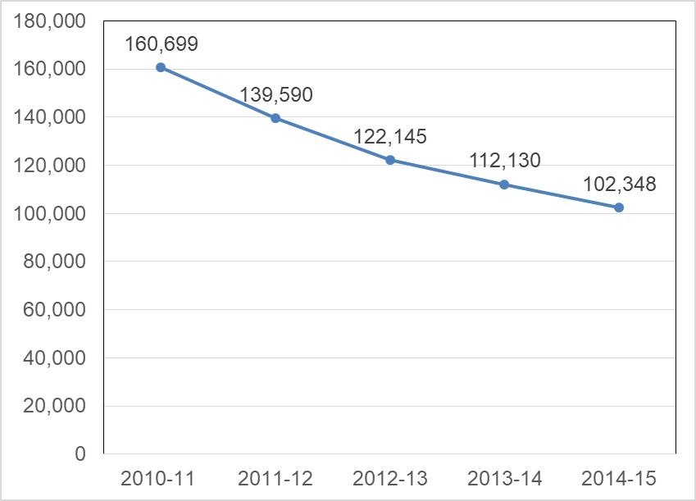
Trend in the number of migratory children in California, ages 3 to 21 years,160,699 in 2010-11, 139,590 in 2011-12, 122,145 in 2012-13, 112,130 in 2013-14, 102,348 in 2014-15. The complete data table of Figure 1 is located on Table 1. The complete data table of Figure 1 is located on Table 1.
Source: Consolidated State Performance Report, 2010–11 to 2014–15.

Figure 2. Trend in the Number of Migratory Children in California, by Age Group, 2010–11 to 2014–15
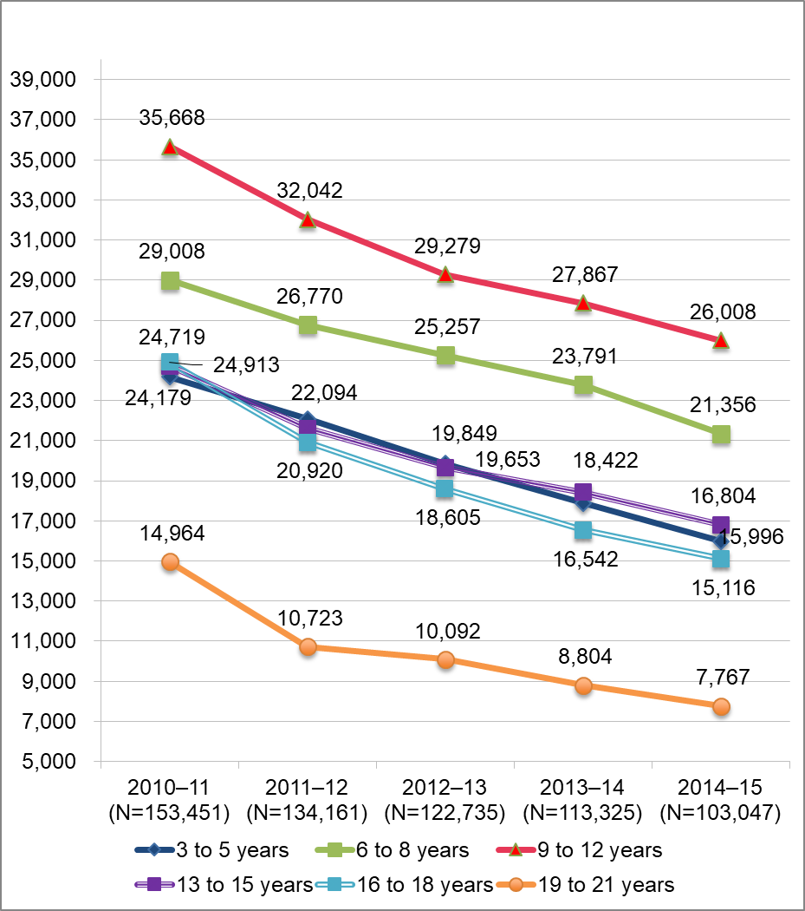
Number of migratory students in California by age group from 2010-11 through 2014-15. For 2010-11, 3-5 years old 24,179, 6-8 years old 29,008, 9-12 years old 35,668, 13-15 years old 24,719, 16-18 years old 24,913, and 19-21 years old 14,964. For 2011-12, 3-5 years old 22,094, 6-8 years old 26,770, 9-12 years old 32,042, 13-15 years old 21,612, 16-18 years old 20,920, and 19-21 years old 10,723. For 2012-13, 3-5 years old 19,849, 6-8 years old 25,257, 9-12 years old 29,279, 13-15 years old 19,653, 16-18 years old 18,605, and 19-21 years old 10,092. For 2013-14, 3-5 years old 17,899, 6-8 years old 23,791, 9-12 years old 27,867, 13-15 years old 18,422, 16-18 years old 16,542, and 19-21 years old 8,804. For 2014-15, 3-5 years old 15,996, 6-8 years old 21,356, 9-12 years old 26,008, 13-15 years old 16,804, 16-18 years old 15,116, and 19-21 years old 7,767. The complete data table of Figure 2 is located on Table 1.
Source: MSIN Databases for the MEP, 2010–11 to 2014–15.

Table 1. Number of Migratory Children in California, by Age, and by Program Year 2010–11 to 2014–15
Age | Program Year 2010–11 | Program Year 2011–12 | Program Year 2012–13 | Program Year 2013–14 | Program Year 2014–15 | Percent Change Over 5 Years
3 years | 6,497 | 5,749 | 5,126 | 4,833 | 4,230 | -35%
4 years | 8,309 | 7,568 | 6,699 | 5,977 | 5,513 | -34%
5 years | 9,373 | 8,777 | 8,024 | 7,089 | 6,253 | -33%
6 years | 9,925 | 8,957 | 8,569 | 7,891 | 6,885 | -31%
7 years | 9,650 | 9,176 | 8,387 | 8,107 | 7,212 | -25%
8 years | 9,433 | 8,637 | 8,301 | 7,793 | 7,259 | -23%
9 years | 9,006 | 8,183 | 7,658 | 7,557 | 6,922 | -23%
10 years | 9,213 | 7,950 | 7,435 | 7,029 | 6,801 | -26%
11 years | 8,979 | 8,076 | 7,122 | 6,838 | 6,204 | -31%
12 years | 8,470 | 7,833 | 7,064 | 6,443 | 6,081 | -28%
13 years | 8,364 | 7,244 | 6,904 | 6,320 | 5,743 | -31%
14 years | 8,464 | 7,197 | 6,520 | 6,319 | 5,610 | -34%
15 years | 7,891 | 7,171 | 6,229 | 5,783 | 5,451 | -31%
16 years | 8,390 | 7,034 | 6,433 | 5,756 | 5,295 | -37%
17 years | 8,703 | 7,353 | 6,378 | 5,786 | 5,257 | -40%
18 years | 7,820 | 6,533 | 5,794 | 5,000 | 4,564 | -42%
19 years | 5,140 | 3,869 | 3,384 | 3,077 | 2,543 | -51%
20 years | 4,732 | 3,597 | 3,269 | 2,813 | 2,562 | -46%
21 years | 5,092 | 3,257 | 3,439 | 2,914 | 2,662 | -48%
Total | 153,451 | 134,161 | 122,735 | 113,325 | 103,047 | -33%
Source: MSIN Databases for the MEP, 2010–11 to 2014–15.

English Learners
Statewide, approximately a quarter of all students are ELs, yet among migratory students there are far greater concentrations of ELs. In grades kindergarten through five, migratory students are at least twice as likely as all students to be classified as an English learner student, and those in grades six through twelve are at least three times as likely. Approximately half of all migratory students are classified as ELs, with a higher concentration in early elementary grades (74 to 81 percent).

Figure 3. Percent of Students Who Are English Learners, by Grade, Migratory and All Students, 2014–15
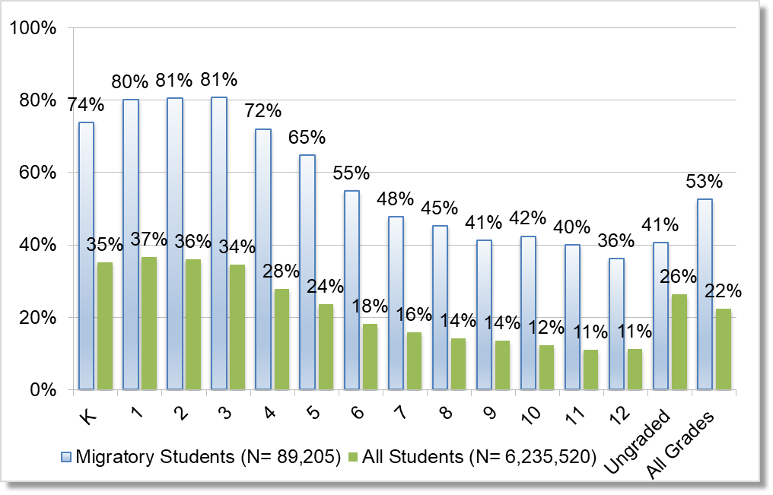
Percent of students who are English Learners for migratory and all student by grade for 2014-15. Kindergarten 74% migratory students and 35% all students, Grade 1 80% migratory students and 37% all students, Grade 2 81% migratory students and 36% all students, Grade 3 81% migratory students and 34% all students, Grade 4 72% migratory students and 28% all students, Grade 5 65% migratory students and 24% all students, Grade 6 55% migratory students and 18% all students, Grade 7 48% migratory students and 16% all students, Grade 8 45% migratory students and 14% all students, Grade 9 41% migratory students and 14% all students, Grade 10 42% migratory students and 12% all students, Grade 11 40% migratory students and 11% all students, Grade 12 36% migratory students and 11% all students, Ungraded 41% migratory students and 26% all students, All Grades 53% migratory students and 22% all students.
Sources: Migrant Students – CDE CELDT Data Files, 2013–14 to 2014–15. All Students - Dataquest, Enrollment by Grade for 2014–15 and English Learner Students by Language by Grade: http://data1.cde.ca.gov/dataquest/.
Figure 4 shows the number of Migratory EL students and the overall number of ELs statewide over the past four years.
Figure 4. Total Number of English Learner and Migratory English Learner Students Statewide
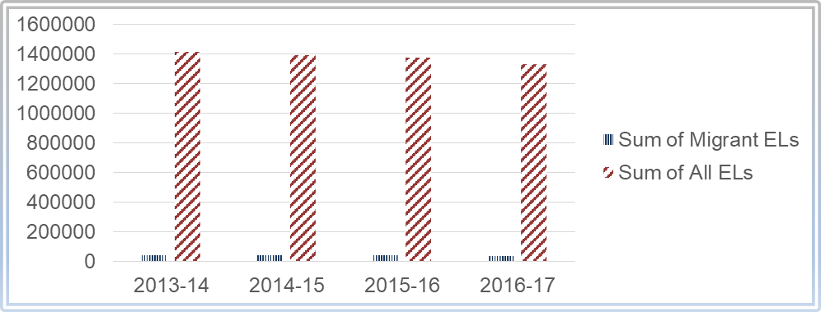
Number of English Learner and Migratory English Learner Students Statewide by year. Sum of All ELs in 2013–14 – 1,413,549; in 2014–15 – 1,392,263; in 2015–16 the number declined slightly again; and in 2016–17 the number declined slightly further. Sum of Migrant ELs has stayed fairly constant across the four school years.
Source: CDE DataQuest - English Learner

Home Language
The distribution of home languages among California’s migratory students has remained consistent during the past five years. Between 2010–11 and 2014–15, California’s migratory parents reported at least 31 different home languages. For the 2014–15 program year, Spanish was the most prevalent home language (97 percent), followed by Mixteco (2 percent), then Punjabi (less than 1 percent). Table 2 details the prevalence of the most common home languages reported for California’s migratory children over the past five program years.
Table 2. Home Languages for California’s Migratory Students, in Program Year 2010–11 to 2014–15
Home Language¹ | 2010–11  (N=75,115) | 2011–12  (N=67,231) | 2012–13  (N=55,391) | 2013–14  (N=45,217) | 2014–15  (N=35,915)
Spanish | 95.85% | 96.42% | 96.90% | 96.76% | 96.98%
Mixteco | 1.66% | 1.55% | 1.60% | 1.77% | 1.61%
Punjabi | 0.02% | 0.59% | 0.59% | 0.58% | 0.60%
Hmong | 1.50% | 0.98% | 0.43% | 0.38% | 0.34%
Cantonese | 0.08% | 0.08% | 0.09% | 0.08% | 0.06%
English | 0.03% | 0.04% | 0.03% | 0.04% | 0.04%
Vietnamese | 0.03% | 0.03% | 0.04% | 0.03% | 0.03%
Korean | 0.02% | 0.02% | 0.02% | 0.02% | 0.02%
Urdu | 0.01% | 0.02% | 0.02% | 0.02% | 0.02%
Filipino (Pilipino or Tagalog) | 0.01% | 0.02% | 0.02% | 0.02% | 0.01%
Portuguese | 0.53% | 0.01% | 0.01% | 0.00% | 0.01%
Other non–English languages | 0.22% | 0.20% | 0.22% | 0.26% | 0.26%
Source: CDE CELDT Data Files, 2010–11 to 2014–15.
¹This table includes home languages that represented at least 0.01 percent of migratory students in program year 2014–15. Reported languages with percent distributions less than 0.01 percent in that program year include: Arabic, Armenian, Burmese, Cebuano (Visayan), Chaozhou (Chiuchow), French, German, Hindi, Ilocano, Khmer (Cambodian), Lahu, Lao, Marshallese, Mien (Yao), Pashto, Polish, Samoan, Somali, and Thai.

Grade-Level Distribution
Between 2010–11 and 2014–15, the grade-level distribution of California’s migratory students remained consistent, with the exception of non-attending, or OSY, migratory youth. During that five-year period, the percent of migratory OSY decreased from 16 percent to 12 percent.
In program year 2014–15, children in Grades 1–3 made up the largest percentage of migratory students (23 percent), followed closely by those in Grades 4–6 (21 percent), and Grades 7–9 (19 percent). Preschool students comprised the smallest percentage (under 2 percent), while those in adult education and ungraded schools represented less than 1 percent of all migratory children.
Figure 5 shows the trend in the percent distributions of migratory children by most prevalent grade span classifications.

Figure 5. Trends in the Percent Distributions of Migratory Children in California, by Grade Group, 2010–11 to 2014–15
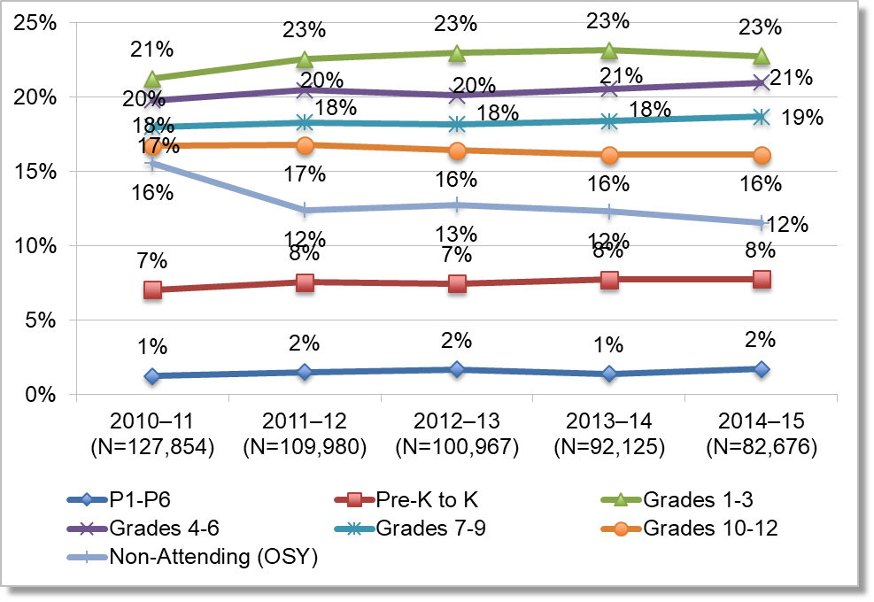
Trends in the Percent Distributions of Migratory Children in California by Grade Group for school years 2010–11 through 2014–15. For 2010–11, P1-P6 1%, Pre-K to K 7%, Grades 1-3 21%, Grades 4-6 20%, Grades 7-9 18%, Grades 10-12 17%, and Not-Attending (OSY) 16%. For 2011–12, P1-P6 2%, Pre-K to K 8%, Grades 1-3 23%, Grades 4-6 20%, Grades 7-9 18%, Grades 10-12 17%, and Not-Attending (OSY) 12%. For 2012–13, P1-P6 2%, Pre-K to K 7%, Grades 1-3 23%, Grades 4-6 20%, Grades 7-9 18%, Grades 10-12 16%, and Not-Attending (OSY) 13%. For 2013–14, P1-P6 1%, Pre-K to K 8%, Grades 1-3 23%, Grades 4-6 21%, Grades 7-9 18%, Grades 10-12 16%, and Not-Attending (OSY) 12%. For 2014–15, P1-P6 2%, Pre-K to K 8%, Grades 1-3 23%, Grades 4-6 21%, Grades 7-9 19%, Grades 10-12 16%, and Not-Attending (OSY) 12%.
Source: MSIN Databases for the MEP, 2010–11 to 2014–15. The complete data table of Figure 5 is located on Table 1.

Students with Disabilities
In 2014–15, approximately seven percent of all migratory students also received special education program services, which is below the statewide average incidence rate of approximately 10 percent. This percentage varied by grade, ranging from 0.2 percent of migratory preschoolers to nearly 10 percent of migratory 6th graders. Across all grades, migratory students are less likely than all students to be receiving special education services. Figure 6 compares the grade-level percentage of migratory students with disabilities to that of all students.

Figure 6. Percent of Students with Disabilities, by Grade, Migratory and All Students, 2014–15
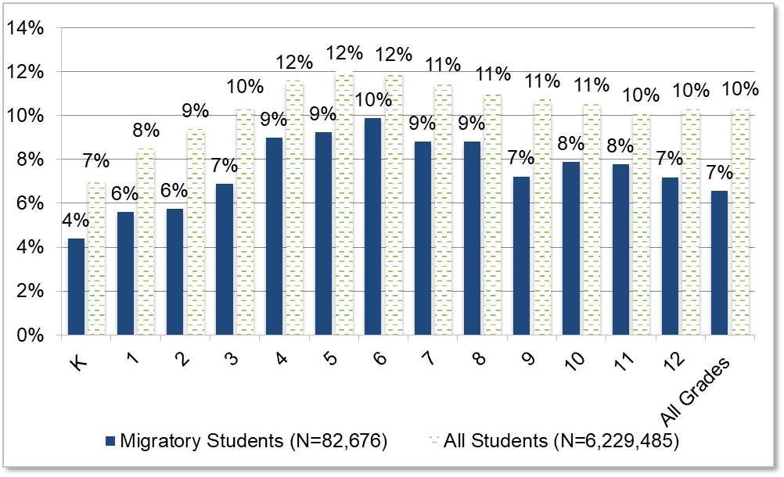
Percent of students with disabilities for migratory and all student by grade for 2014-15. Kindergarten 4% migratory students and 7% all students, Grade 1 6% migratory students and 8% all students, Grade 2 6% migratory students and 9% all students, Grade 3 7% migratory students and 10% all students, Grade 4 9% migratory students and 12% all students, Grade 5 9% migratory students and 12% all students, Grade 6 10% migratory students and 12% all students, Grade 7 9% migratory students and 11% all students, Grade 8 9% migratory students and 11% all students, Grade 9 7% migratory students and 11% all students, Grade 10 8% migratory students and 11% all students, Grade 11 8% migratory students and 10% all students, Grade 12 7% migratory students and 10% all students, and All Grades 7% migratory students and 10% all students.
Sources: Migrant Students - CDE list of MEP children enrolled in special education programs, 2014–15. All Students - Dataquest, Enrollment by Grade for 2014–15 and Special Education Enrollment by Grade and Disability, 2014–15: http://data1.cde.ca.gov/dataquest/.

Academic Achievement
To explore migratory students’ academic needs, the CDE compared Migratory Students’ CAASPP scores to that of All Students and SED Students. The CDE also examined Migratory EL Students’ performance on the CELDT and compared it to that of Non-migratory EL Students.
The following section details several key findings:
- On the 2014–15 and 2015–16 CAASPP, Migratory Students’ were more likely to perform below All Students and SED Students across all grade levels in English language arts (ELA) measures. Migratory Students were consistently less likely than All Students and SED Students to perform near or above the standard, and consistently more likely to perform below the standard.
- In 2015–16, Migratory Students are 21 percent less likely to meet or exceed the overall math standards than the All Students group. When comparing Migratory PFS and All Students, the gap widens to 32 percent.
- In 2014–15, Migratory EL Students are less likely than Non-migratory EL Students to score Advanced or Early Advanced on CELDT measures, and more likely to score Beginning or Early Intermediate. These gaps are more pronounced for students in grade levels one through three.

California Assessment of Student Performance and Progress Results
Beginning with the 2013–14 school year, CAASPP replaced the Standardized Testing and Reporting (STAR) system which had been in place since 1998. The CAASPP ELA and Mathematics assessments assess California’s state-adopted academic standards. The CAASPP allows students to demonstrate analytical writing, critical thinking, and problem-solving skills along with their knowledge of content knowledge in ELA and Mathematics.

Achievement Levels
Student scores are reported on overall achievement and by claims that focus on specific knowledge and skills. Overall ELA or Math Achievement levels consist of Level 1 – Standard Not Met, Level 2 – Standard Nearly Met, Level 3 – Standard Met and Level 4 – Standard Exceeded. Data on specific domains are also collected to identify specific areas of strengths and weaknesses within both ELA and math.

English Language Arts
In addition to identifying students’ overall ELA Achievement, students’ CAASPP ELA scores are also categorized by claims, which are broad, evidence-based statements about what students know and can do, as demonstrated by their performance on the assessment. The claims for ELA are:
- Claim 1 - Reading
- Claim 2 - Writing
- Claim 3 - Speaking and Listening
- Claim 4 - Research and Inquiry
Based on their assessment performance, students are assigned one of three claim achievement levels: Below Standard, Near Standard, or Above Standard.
On the 2014–15 Smarter Balanced ELA Assessment, Migratory Students were approximately 24 percentage points more likely to perform below standard, and 23 percentage points less likely to meet or exceed the standard when compared to All Students. They were also 14 percentage points more likely to perform Below Standard, and 11 percentage points less likely to perform at or Above Standard when compared to SED Students. Across the four ELA claims on the 2014–15 CAASPP, Migratory Students were consistently less likely than All Students and SED Students to perform Near or Above Standard, and consistently more likely to perform Below Standard. The performance gaps between Migratory Students and the comparison groups were largest for Claims 1 and 2 - Reading and Writing. For detailed distributions of Migratory Students’ 2014–15 ELA claim achievement levels by grade, as well as gaps between migratory students and their comparison groups, please see Appendix A.
2015–16 California Assessment of Student Performance and Progress Results
In 2015–16, there were 96,750 migratory students enrolled in the Migrant Education Program. Of these students, 80,402 students attend Grades K–12. Since the CAASPP only tests students in Grades 3–8 and 11th grade, between 33,000 and 35,000 students took the CAASPP test.
Based on the 2015–16 CAASPP, Migratory Students performed below All Students and SED Students on overall ELA achievement with Migratory PFS Students performing at lower levels than all populations with one exception—Migratory PFS Students were one percent more likely than the whole migratory student population to score at Standard Nearly Met. Additionally, half of the Migratory Students scored at Standard Not Met compared to 28 percent of All Students. Similarly, 60 percent of Migratory PFS Students’ overall ELA achievement was identified as Standard Not Met. Although approximately 49 percent of All Students met or exceeded the standard, only about 24 percent of Migratory Students and 11 percent of Migratory PFS Students did so. Therefore, Migratory Students, especially Migratory PFS Students, are consistently less likely to meet ELA achievement standards. Figure 7 shows the percent distribution of ELA achievement for Migratory, Migratory PFS, All Students, and SED Students on the 2015–16 CAASPP.

Figure 7. Percent Distribution of 2015–16 CAASPP ELA Achievement Levels for Migratory Students, Migratory PFS Students, All Students, and SED Students, Grades 3–8 and Grade 11
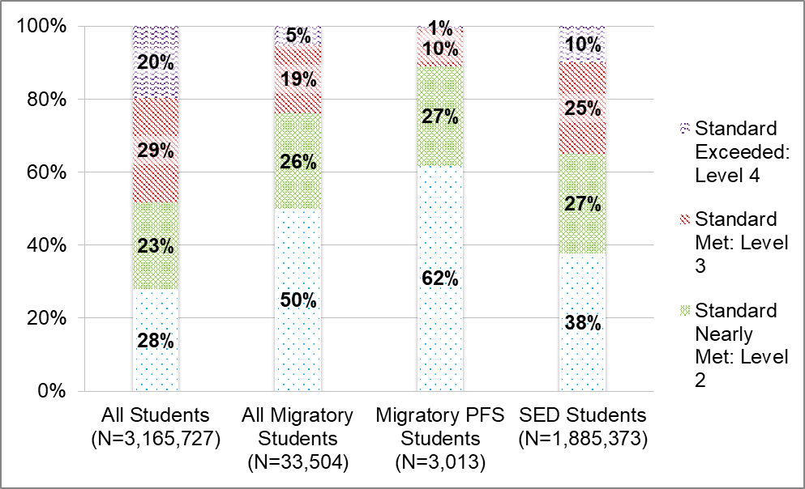
Percent Distribution of 2015–16 CAASPP ELA Achievement Levels for Migratory Students, Migratory PFS Students, All Students, and SED Students, Grades 3–8 and Grade 11. All Students – 20% Standard Exceeded: Level 4, 29% Standard Met: Level 3, 23% Standard Nearly Met: Level 2, 28% Standard Not Met. All Migratory Students – 5% Standard Exceeded: Level 4, 19% Standard Met: Level 3, 26% Standard Nearly Met: Level 2, 50% Standard Not Met. Migratory PFS Students – 1% Standard Exceeded: Level 4, 10% Standard Met: Level 3, 27% Standard Nearly Met: Level 2, 62% Standard Not Met. SED Students – 10% Standard Exceeded: Level 4, 25% Standard Met: Level 3, 27% Standard Nearly Met: Level 2, 38% Standard Not Met.
Sources: CDE CAASPP P2 Data File, 2015–16; MSIN Data Files, 2015–16.
Across the four ELA claims, Migratory Students were consistently less likely than All Students and SED Students to perform Near or Above Standard, and consistently more likely to perform Below Standard. While there were a handful of instances in which Migratory Students were more likely than All Students to perform at Near Standard on the claim data at specific grade levels, the gap was relatively small and the trend of Migratory Students being less likely to outperform All Students when reviewing grade level claim scores at Above Standard remained consistent. Figures 8 through 11 illustrate ELA achievement on all four claims for Migratory, Migratory PFS, All Students, and SED Students.

Figure 8. Percent Distribution of 2015–16 CAASPP ELA Claim 1 - Reading Achievement Levels for Migratory Students, Migratory PFS Students, All Students, and SED Students, Grades 3–8 and Grade 11
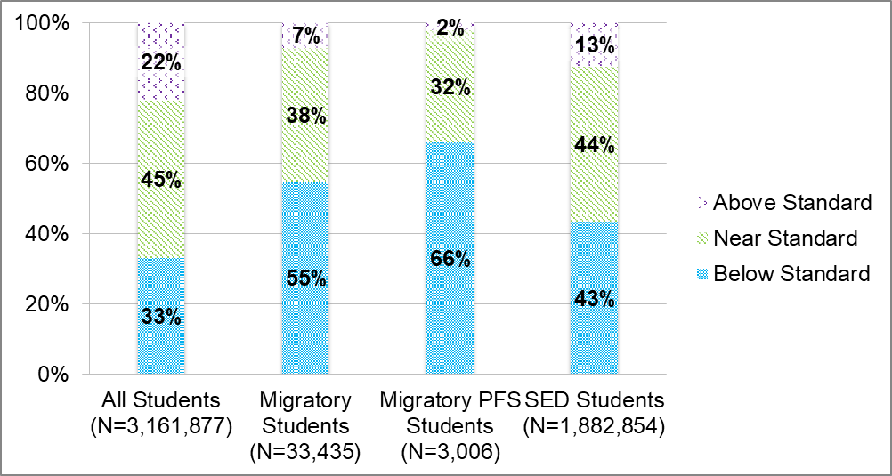
Percent Distribution of 2015–16 CAASPP ELA Claim 1 - Reading Achievement Levels for Migratory Students, Migratory PFS Students, All Students, and SED Students, Grades 3–8 and Grade 11. All Students – 22% Above Standard, 45% Near Standard, 33% Below Standard. Migratory Students – 7% Above Standard, 38% Near Standard, 55% Below Standard. Migratory PFS Students – 2% Above Standard, 32% Near Standard, 66% Below Standard. SED Students – 13% Above Standard, 44% Near Standard, 43% Below Standard.
Sources: CDE CAASPP P2 Data File, 2015–16; MSIN Data Files, 2015–16.

Figure 9. Percent Distribution of 2015–16 CAASPP ELA Claim 2 - Writing Achievement Levels for Migratory Students, Migratory PFS Students, All Students, and SED Students, Grades 3–8 and Grade 11
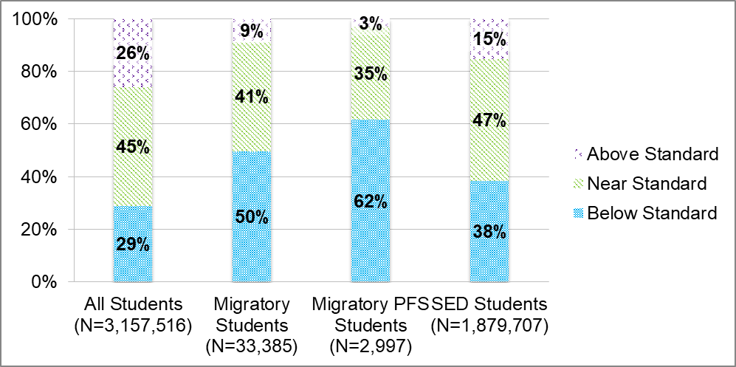
Percent Distribution of 2015–16 CAASPP ELA Claim 2 - Writing Achievement Levels for Migratory Students, Migratory PFS Students, All Students, and SED Students, Grades 3–8 and Grade 11. All Students – 26% Above Standard, 45% Near Standard, 29% Below Standard. Migratory Students – 9% Above Standard, 41% Near Standard, 50% Below Standard. Migratory PFS Students – 3% Above Standard, 35% Near Standard, 62% Below Standard. SED Students – 15% Above Standard, 47% Near Standard, 38% Below Standard.
Sources: CDE CAASPP P2 Data File, 2015–16; MSIN Data Files, 2015–16.

Figure 10. Percent Distribution of 2015–16 CAASPP ELA Claim 3 - Listening Achievement Levels for Migratory Students, Migratory PFS Students, All Students, and SED Students, Grades 3–8 and Grade 11
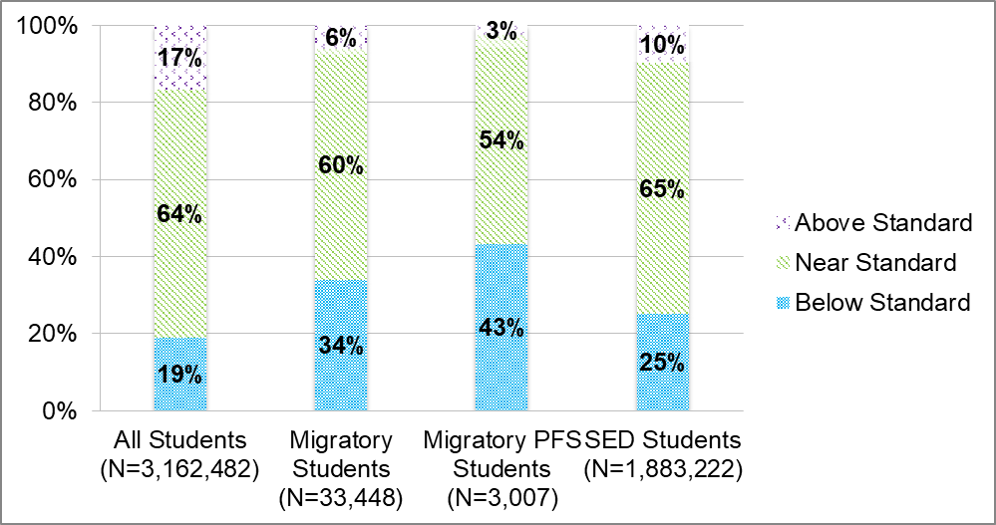
Percent Distribution of 2015–16 CAASPP ELA Claim 3 - Listening Achievement Levels for Migratory Students, Migratory PFS Students, All Students, and SED Students, Grades 3–8 and Grade 11. All Students – 17% Above Standard, 64% Near Standard, 19% Below Standard. Migratory Students – 6% Above Standard, 60% Near Standard, 34% Below Standard. Migratory PFS Students – 3% Above Standard, 54% Near Standard, 43% Below Standard. SED Students – 10% Above Standard, 65% Near Standard, 25% Below Standard.
Sources: CDE CAASPP P2 Data File, 2015–16; MSIN Data Files, 2015–16.

Figure 11. Percent Distribution of 2015–16 CAASPP ELA Claim 4 - Research/Inquiry Achievement Levels for Migratory Students, Migratory PFS Students, All Students, and SED Students, Grades 3–8 and Grade 11
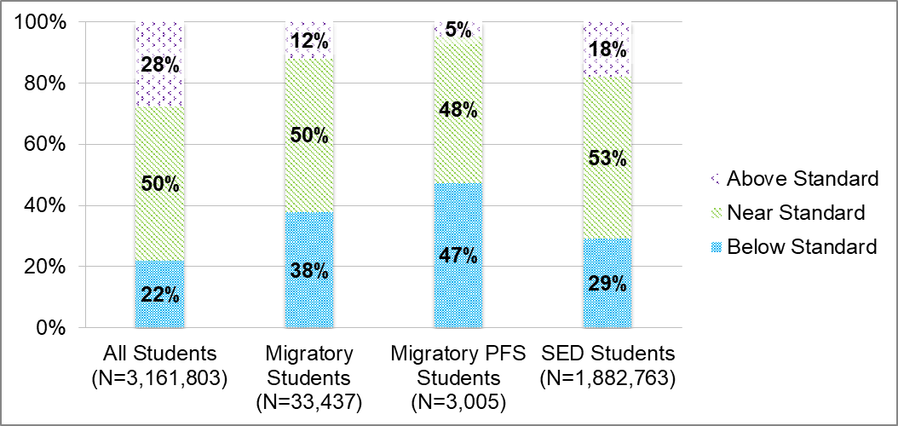
Percent Distribution of 2015–16 CAASPP ELA Claim 4 – Research/Inquiry Achievement Levels for Migratory Students, Migratory PFS Students, All Students, and SED Students, Grades 3–8 and Grade 11. All Students – 28% Above Standard, 50% Near Standard, 22% Below Standard. Migratory Students – 12% Above Standard, 50% Near Standard, 38% Below Standard. Migratory PFS Students – 5% Above Standard, 48% Near Standard, 47% Below Standard. SED Students – 18% Above Standard, 53% Near Standard, 29% Below Standard.
Sources: CDE CAASPP P2 Data File, 2015–16; MSIN Data Files, 2015–16.

Mathematics
Students’ CAASPP mathematics scores are also categorized by overall achievement and mathematical claims. Overall math achievement is scored similar to ELA. Based on overall performance, students are assigned one of four achievement levels: 1) Standard Not Met, 2) Standard Nearly Met, 3) Standard Met, and 4) Standard Exceeded
Students’ CAASPP mathematics scores are also categorized by claims. The claims for mathematics are:
- Claim 1 - Concepts and Procedures
- Claim 2 - Problem Solving
- Claim 3 - Communicating Reasoning
Based on performance, students are assigned one of three claim achievement levels: Below Standard, Near Standard, or Above Standard.
Identical to ELA, the data for 2015–16 CAASPP Math achievement compared math achievement for All Students, Migratory Students, Migratory PFS Students, and SED Students.

2015–16 California Assessment of Student Performance and Progress Results
Similar to the results on the 2015–16 ELA Achievement results, Migratory Students were more likely to perform below All Students and SED Students on math achievement with Migratory PFS Students performing at lower levels than all populations on the 2015–16 CAASPP Math achievement. Thirty-seven percent of All Students met or exceeded the standard for overall math achievement compared with only 16 percent of Migratory Students who met or exceeded the standard; only five percent of Migratory PFS Students met the standard and none of them exceeded the standard. Moreover, Migratory and Migratory PFS Students were more likely to score at Below Standard when compared to All and SED Students at all grade levels on Claims 1–3.
Figure 12 shows the percent distribution of 2015–16 CAASPP math achievement levels for Migratory Students, Migratory PFS Students, All Students, and SED Students.

Figure 12. Percent Distribution of 2015–16 CAASPP Math Achievement Levels for Migratory Students, Migratory PFS Students, All Students, and SED Students, Grades 3–8 and Grade 11
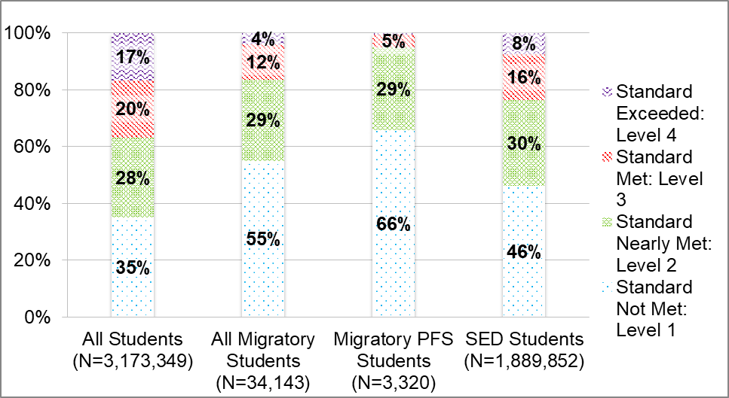
Percent Distribution of 2015–16 CAASPP Math Achievement Levels for Migratory Students, Migratory PFS Students, All Students, and SED Students, Grades 3–8 and Grade 11. All Students – 17% Standard Exceeded: Level 4, 20% Standard Met: Level 3, 28% Standard Nearly Met: Level 2, 35% Standard Not Met: Level 1. All Migratory Students – 4% Standard Exceeded: Level 4, 12% Standard Met: Level 3, 29% Standard Nearly Met: Level 2, 55% Standard Not Met. Migratory PFS Students – 5% Standard Met: Level 3, 29% Standard Nearly Met: Level 2, 66% Standard Not Met. SED Students – 8% Standard Exceeded: Level 4, 25% Standard Met: Level 3, 27% Standard Nearly Met: Level 2, 38% Standard Not Met.
Sources: CDE CAASPP P2 Data File, 2015–16; MSIN Data Files, 2015–16.
Across the three mathematics claims, Migratory Students were consistently less likely than All Students to perform Near or Above Standard, and consistently more likely to perform Below Standard. The performance gap between Migratory and All Students for Claim 1 - Concepts and Procedures and Claim 2 - Problem Solving was relatively close with Migratory Students being approximately 20 percentage points less likely to perform Near or Above Standard on both of these claims. The performance gap between Migratory and SED Students was largest for Claim 2 - Problem Solving and Modeling Data. Migratory Students were 9 percentage points less likely to perform Near and Above Standard.
Figures 13 through 15 illustrates the percent distribution of 2015–16 CAASPP data for each of the three mathematics claims.

Figure 13. Percent Distribution of 2015–16 CAASPP Math Claim 1 - Concepts and Procedures Achievement Levels for Migratory Students, Migratory PFS Students, All Students, and SED Students, Grades 3–8 and Grade 11
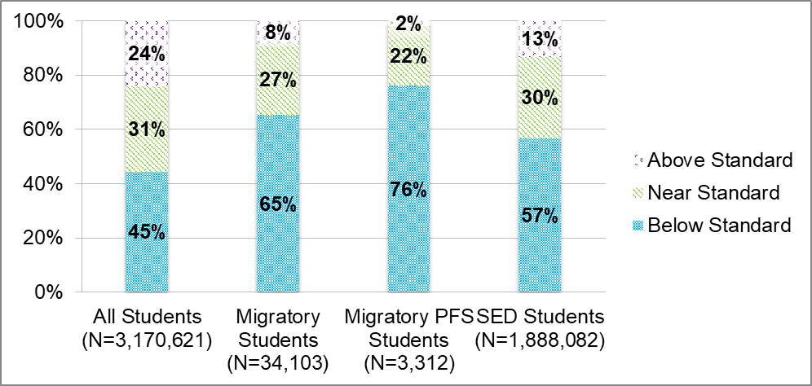
Percent Distribution of 2015–16 CAASPP Math Claim 1 – Concepts and Procedures Achievement Levels for Migratory Students, Migratory PFS Students, All Students, and SED Students, Grades 3–8 and Grade 11. All Students – 24% Above Standard, 31% Near Standard, 45% Below Standard. Migratory Students – 8% Above Standard, 27% Near Standard, 65% Below Standard. Migratory PFS Students – 2% Above Standard, 22% Near Standard, 76% Below Standard. SED Students – 13% Above Standard, 30% Near Standard, 57% Below Standard.
Sources: CDE CAASPP P2 Data File, 2015–16; MSIN Data Files, 2015–16.

Figure 14. Percent Distribution of 2015–16 CAASPP Math Claim 2 - Problem Solving and Modeling Achievement Levels for Migratory Students, Migratory PFS Students, All Students, and SED Students, Grades 3–8 and Grade 11
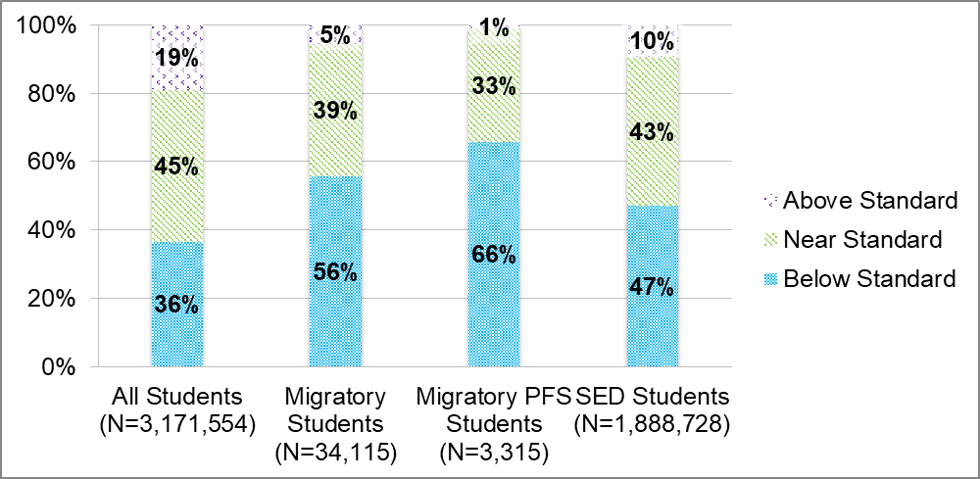
Percent Distribution of 2015–16 CAASPP Math Claim 2 – Problem Solving and Modeling Achievement Levels for Migratory Students, Migratory PFS Students, All Students, and SED Students, Grades 3–8 and Grade 11. All Students – 19% Above Standard, 45% Near Standard, 36% Below Standard. Migratory Students – 5% Above Standard, 39% Near Standard, 56% Below Standard. Migratory PFS Students – 1% Above Standard, 33% Near Standard, 66% Below Standard. SED Students – 10% Above Standard, 43% Near Standard, 47% Below Standard.
Sources: CDE CAASPP P2 Data File, 2015–16; MSIN Data Files, 2015–16.

Figure 15. Percent Distribution of 2015-16 CAASPP Math Claim 3 - Communicating Reasoning Achievement Levels for Migratory Students, Migratory PFS Students, All Students, and SED Students, Grades 3–8 and Grade 11
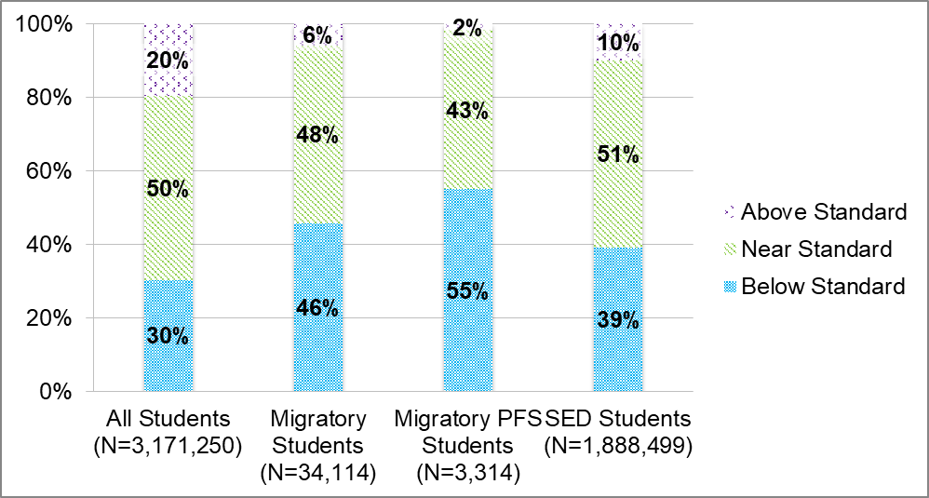
Percent Distribution of 2015–16 CAASPP Math Claim 3 – Communicating Reasoning Achievement Levels for Migratory Students, Migratory PFS Students, All Students, and SED Students, Grades 3–8 and Grade 11. All Students – 20% Above Standard, 50% Near Standard, 30% Below Standard. Migratory Students – 6% Above Standard, 48% Near Standard, 46% Below Standard. Migratory PFS Students – 2% Above Standard, 43% Near Standard, 55% Below Standard. SED Students – 10% Above Standard, 51% Near Standard, 39% Below Standard.
Sources: CDE CAASPP P2 Data File, 2015–16; MSIN Data Files, 2015–16.

California English Language Development Test Results
In California, students in grades kindergarten through twelve whose home language is not English are required by law to have their English language proficiency (ELP) assessed. California currently uses the CELDT as the ELP assessment. The CELDT measures a student's ELP in listening, speaking, reading, and writing, and scores students on a five-point scale, ranging from Beginning (1) to Advanced (5).
To identify migratory student gaps in ELP, the CDE analyzed differences in the annual CELDT assessment scores for Migratory and Non-migratory Students assessed in 2013–14 and 2014–15. The annual assessment is administered in the fall of each academic year, and differs from the student’s initial assessment, which is administered to students who are new to public education or who are new to a district and have no previous CELDT results.
In both 2013–14 and 2014–15, Migratory Students were 10 percentage points less likely than Non-migratory Students to score at the Advanced or Early Advanced levels overall on the CELDT measure, and 10 percentage points more likely to score at the Beginning or Early Intermediate levels overall. Similar gaps are found across all grade spans. Figure 16 shows the percent distribution of Migratory and Non-migratory Students’ overall ELP on the 2013–14 and 2014–15 CELDT. For detailed exploration of Migratory and Non-migratory Students’ CELDT performance by grade in both 2013–14 and 2014–15, see Appendix D.

Figure 16. Percent Distribution of 2013–14 and 2014–15 Overall CELDT Scores for Migratory and Non-migratory Students, All Grades
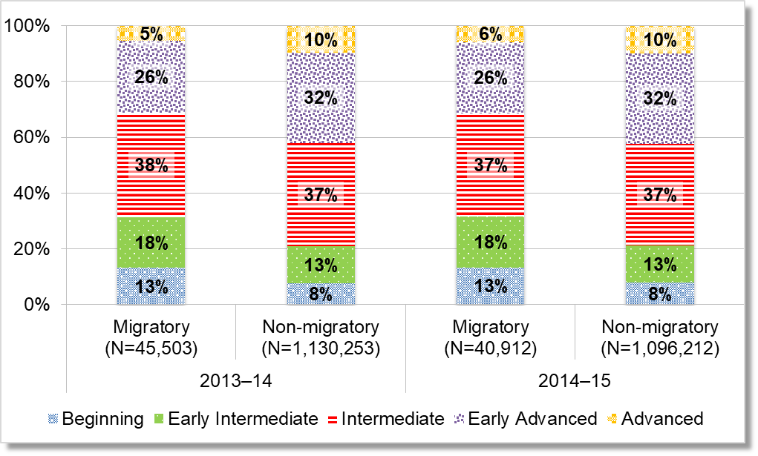
Percent Distribution of 2013–14 and 2014–15 Overall CELDT Scores for Migratory and Non-migratory Students, All Grades. For 2013-14, Advanced Migratory – 5% and Non-migratory – 10%, Early Advanced Migratory – 26% and Non-migratory – 32%, Intermediate Migratory – 38% and Non-migratory – 37%, Early Intermediate Migratory – 18% and Non-migratory – 13%, Beginning Migratory – 13% and Non-migratory – 8%. For 2014-15, Advanced Migratory – 6% and Non-migratory – 10%, Early Advanced Migratory – 26% and Non-migratory – 32%, Intermediate Migratory – 37% and Non-migratory – 37%, Early Intermediate Migratory – 18% and Non-migratory – 13%, Beginning Migratory – 13% and Non-migratory – 8%.
Source: CDE CELDT Data Files, 2013–14 to 2014–15.
Figure 17 shows the percent distribution of Migratory and Non-migratory Students’ overall ELP on the 2014–15 CELDT by grade span.

Figure 17. Percent Distribution of 2014–15 Overall CELDT Scores for Migratory and Non-migratory Students, by Grade Span
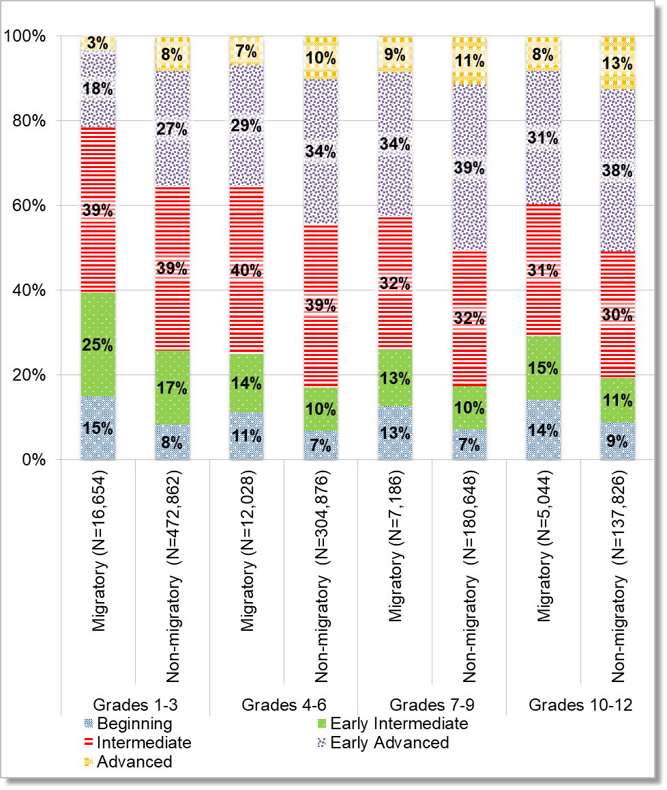
Percent Distribution of 2014–15 Overall CELDT Scores for Migratory and Non-migratory Students, by Grade Span. Grades 1-3, Advanced Migratory – 3% and Non-migratory – 8%, Early Advanced Migratory – 18% and Non-migratory – 27%, Intermediate Migratory – 39% and Non-migratory – 39%, Early Intermediate Migratory – 25% and Non-migratory – 17%, Beginning Migratory – 15% and Non-migratory – 8%. For Grades 4-6, Advanced Migratory – 7% and Non-migratory – 10%, Early Advanced Migratory – 29% and Non-migratory – 34%, Intermediate Migratory – 40% and Non-migratory – 39%, Early Intermediate Migratory – 14% and Non-migratory – 10%, Beginning Migratory – 11% and Non-migratory – 7%. For Grades 7-9, Advanced Migratory – 9% and Non-migratory – 11%, Early Advanced Migratory – 34% and Non-migratory – 39%, Intermediate Migratory – 32% and Non-migratory – 32%, Early Intermediate Migratory – 13% and Non-migratory – 10%, Beginning Migratory – 13% and Non-migratory – 7%. For Grades 10-12, Advanced Migratory – 8% and Non-migratory – 13%, Early Advanced Migratory – 31% and Non-migratory – 38%, Intermediate Migratory – 31% and Non-migratory – 30%, Early Intermediate Migratory – 15% and Non-migratory – 11%, Beginning Migratory – 14% and Non-migratory – 9%.
Source: CDE CELDT Data Files, 2013–14 to 2014–15.
The CDE also explored migratory students’ ELP performance on the individual measures of listening, speaking, reading, and writing, and compared it to those of non-migratory students. For each ELP measure and for each grade span, Migratory Students were less likely than Non-migratory Students to score as Advanced or Early Advanced, and more likely to score as Beginning or Early Intermediate. Across all 2014–15 CELDT measures (overall ELP, listening, speaking, reading, and writing), these gaps are more pronounced for students in grade levels one through three.
Figures 18 through 21 show the distribution of Migratory and Non-migratory Students’ ELP scores for listening, speaking, reading, and writing on the 2014–15 CELDT. For more detailed exploration of Migratory and Non-migratory Students’ performance on these measures by grade, as well as the 2013–14 results, see Appendix D.

Figure 18. Percent Distribution of 2014–15 CELDT Listening Scores for Migratory and Non-migratory Students, by Grade Span
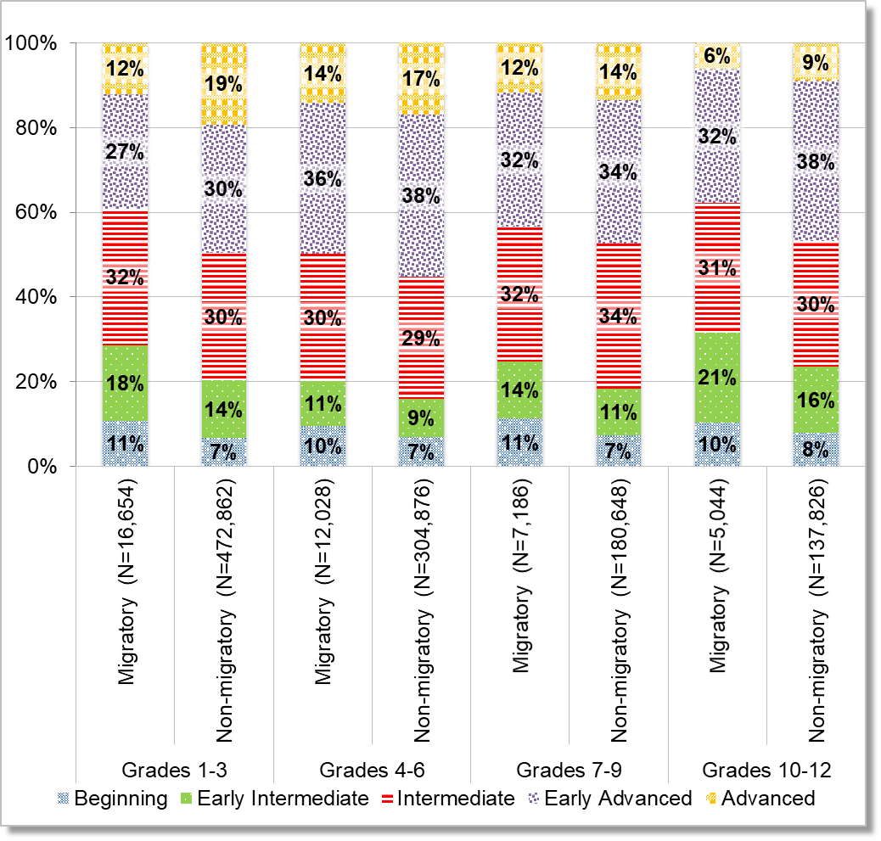
Percent Distribution of 2014–15 CELDT Listening Scores for Migratory and Non-migratory Students, by Grade Span. Grades 1-3, Advanced Migratory – 12% and Non-migratory – 19%, Early Advanced Migratory – 27% and Non-migratory – 30%, Intermediate Migratory – 32% and Non-migratory – 30%, Early Intermediate Migratory – 18% and Non-migratory – 14%, Beginning Migratory – 11% and Non-migratory – 7%. For Grades 4-6, Advanced Migratory – 14% and Non-migratory – 17%, Early Advanced Migratory – 36% and Non-migratory – 38%, Intermediate Migratory – 30% and Non-migratory – 29%, Early Intermediate Migratory – 11% and Non-migratory – 9%, Beginning Migratory – 10% and Non-migratory – 7%. For Grades 7-9, Advanced Migratory – 12% and Non-migratory – 14%, Early Advanced Migratory – 32% and Non-migratory – 34%, Intermediate Migratory – 32% and Non-migratory – 34%, Early Intermediate Migratory – 14% and Non-migratory – 11%, Beginning Migratory – 11% and Non-migratory – 7%. For Grades 10-12, Advanced Migratory – 6% and Non-migratory – 9%, Early Advanced Migratory – 32% and Non-migratory – 38%, Intermediate Migratory – 31% and Non-migratory – 30%, Early Intermediate Migratory – 21% and Non-migratory – 15%, Beginning Migratory – 10% and Non-migratory – 8%.
Source: CDE CELDT Data Files, 2013–14 to 2014–15

Figure 19. Percent Distribution of 2014–15 CELDT Speaking Scores for Migratory and Non-migratory Students, by Grade Span
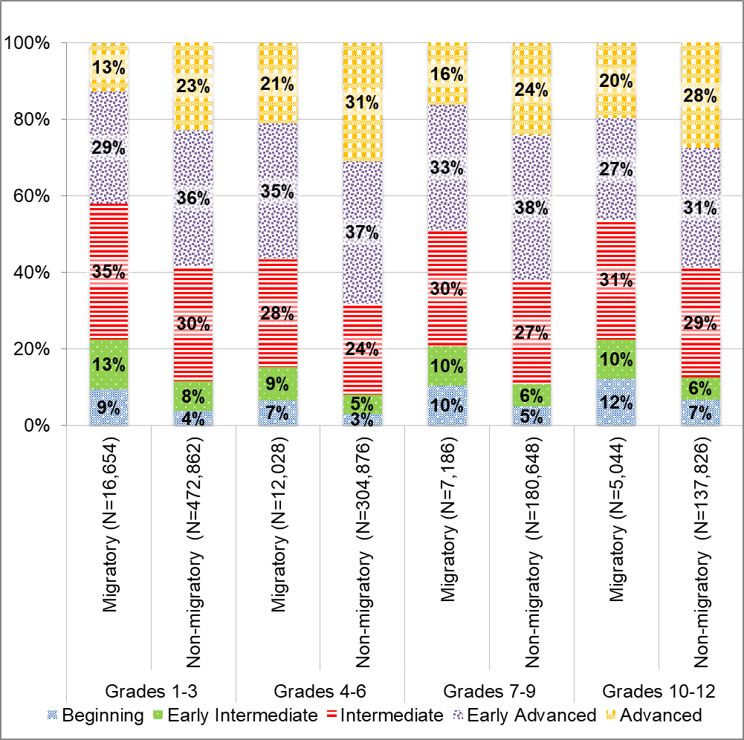
Percent Distribution of 2014–15 CELDT Speaking Scores for Migratory and Non-migratory Students, by Grade Span. Grades 1-3, Advanced Migratory – 13% and Non-migratory – 23%, Early Advanced Migratory – 29% and Non-migratory – 36%, Intermediate Migratory – 35% and Non-migratory – 30%, Early Intermediate Migratory – 13% and Non-migratory – 8%, Beginning Migratory – 9% and Non-migratory – 4%. For Grades 4-6, Advanced Migratory – 21% and Non-migratory – 31%, Early Advanced Migratory – 35% and Non-migratory – 37%, Intermediate Migratory – 28% and Non-migratory – 24%, Early Intermediate Migratory – 9% and Non-migratory – 5%, Beginning Migratory – 7% and Non-migratory – 3%. For Grades 7-9, Advanced Migratory – 16% and Non-migratory – 24%, Early Advanced Migratory – 33% and Non-migratory – 38%, Intermediate Migratory – 30% and Non-migratory – 27%, Early Intermediate Migratory – 10% and Non-migratory – 6%, Beginning Migratory – 10% and Non-migratory – 5%. For Grades 10-12, Advanced Migratory – 20% and Non-migratory – 28%, Early Advanced Migratory – 27% and Non-migratory – 31%, Intermediate Migratory – 31% and Non-migratory – 29%, Early Intermediate Migratory – 10% and Non-migratory – 6%, Beginning Migratory – 12% and Non-migratory – 7%.
Source: CDE CELDT Data Files, 2013–14 to 2014–15.

Figure 20. Percent Distribution of 2014–15 CELDT Reading Scores for Migratory and Non-migratory Students, by Grade Span
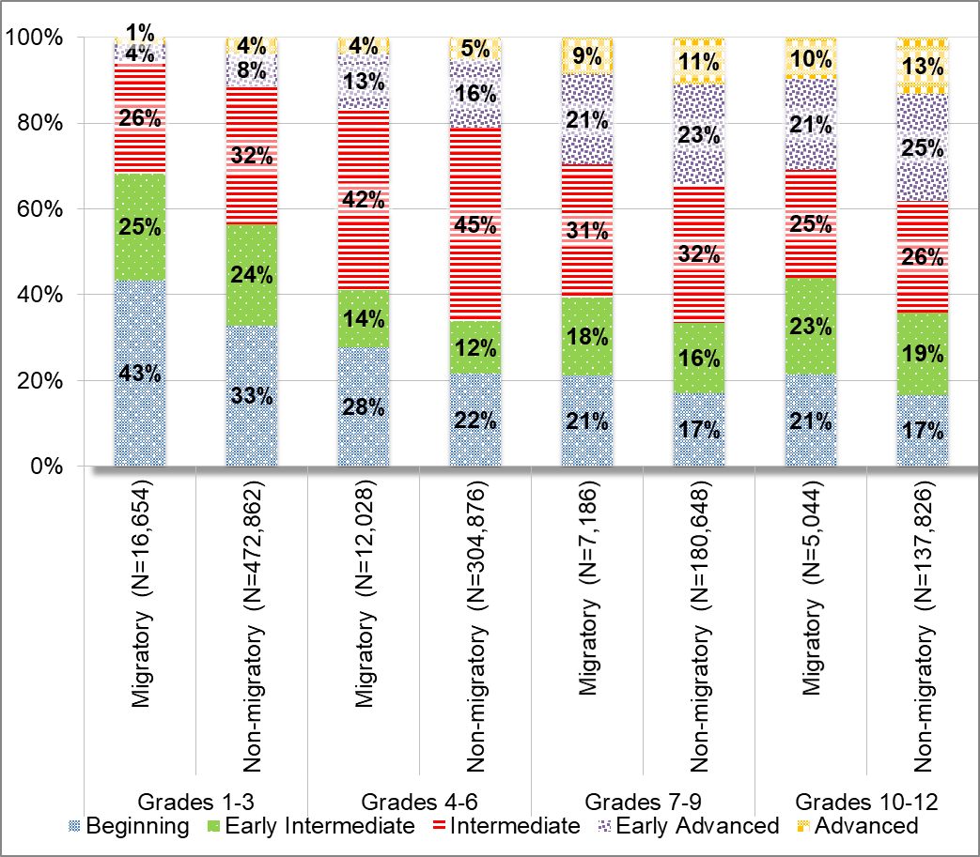
Percent Distribution of 2014–15 CELDT Reading Scores for Migratory and Non-migratory Students, by Grade Span. Grades 1-3, Advanced Migratory – 1% and Non-migratory – 4%, Early Advanced Migratory – 4% and Non-migratory – 8%, Intermediate Migratory – 26% and Non-migratory – 32%, Early Intermediate Migratory – 25% and Non-migratory – 24%, Beginning Migratory – 43% and Non-migratory – 33%. For Grades 4-6, Advanced Migratory – 4% and Non-migratory – 5%, Early Advanced Migratory – 13% and Non-migratory – 16%, Intermediate Migratory – 42% and Non-migratory – 45%, Early Intermediate Migratory – 14% and Non-migratory – 12%, Beginning Migratory – 28% and Non-migratory – 22%. For Grades 7-9, Advanced Migratory – 9% and Non-migratory – 11%, Early Advanced Migratory – 21% and Non-migratory – 23%, Intermediate Migratory – 31% and Non-migratory – 32%, Early Intermediate Migratory – 18% and Non-migratory – 16%, Beginning Migratory – 21% and Non-migratory – 17%. For Grades 10-12, Advanced Migratory – 10% and Non-migratory – 13%, Early Advanced Migratory – 21% and Non-migratory – 25%, Intermediate Migratory – 25% and Non-migratory – 26%, Early Intermediate Migratory – 23% and Non-migratory – 19%, Beginning Migratory – 21% and Non-migratory – 17%.
Source: CDE CELDT Data Files, 2013–14 to 2014–15.

Figure 21. Percent Distribution of 2014–15 CELDT Writing Scores for Migratory and Non-migratory Students, by Grade Span
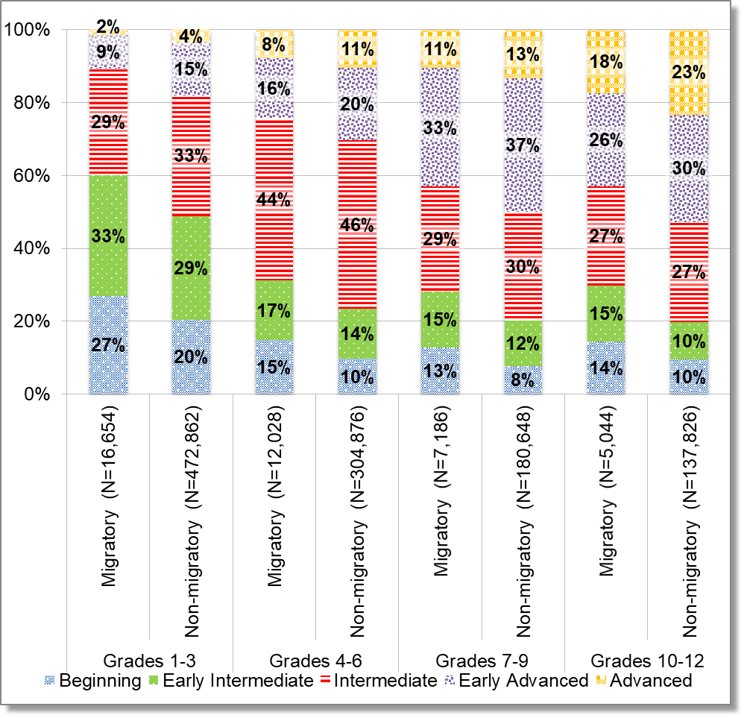
Percent Distribution of 2014–15 CELDT Reading Scores for Migratory and Non-migratory Students, by Grade Span. Grades 1-3, Advanced Migratory – 2% and Non-migratory – 4%, Early Advanced Migratory – 9% and Non-migratory – 15%, Intermediate Migratory – 29% and Non-migratory – 33%, Early Intermediate Migratory – 33% and Non-migratory – 29%, Beginning Migratory – 27% and Non-migratory – 20%. For Grades 4-6, Advanced Migratory – 8% and Non-migratory – 11%, Early Advanced Migratory – 16% and Non-migratory – 20%, Intermediate Migratory – 44% and Non-migratory – 46%, Early Intermediate Migratory – 17% and Non-migratory – 14%, Beginning Migratory – 15% and Non-migratory – 10%. For Grades 7-9, Advanced Migratory – 11% and Non-migratory – 13%, Early Advanced Migratory – 33% and Non-migratory – 37%, Intermediate Migratory – 29% and Non-migratory – 30%, Early Intermediate Migratory – 15% and Non-migratory – 12%, Beginning Migratory – 13% and Non-migratory – 8%. For Grades 10-12, Advanced Migratory – 18% and Non-migratory – 23%, Early Advanced Migratory – 26% and Non-migratory – 30%, Intermediate Migratory – 27% and Non-migratory – 27%, Early Intermediate Migratory – 15% and Non-migratory – 10%, Beginning Migratory – 14% and Non-migratory – 10%.
Source: CDE CELDT Data Files, 2013–14 to 2014–15.

Out-of-School Youth
California’s migratory Out-of-School Youth, or OSY, are youth through age 21 who are currently not enrolled in a K–12 school, and have not graduated from high school, or passed a high school equivalency examination. Migratory OSY may include youth who have dropped out of school, are working on credit recovery outside of a K–12 school, or are here-to-work. Here-to-work OSY are youth who have moved to the United States with the primary purpose of working, many of whom are traveling and working without a guardian.
The CDE examined trends in California’s migratory OSY population size between 2010–11 and 2014–15; and for a sample of OSY from program year 2015–16, explored their home languages, referral needs, access to transportation and here-to-work versus credit recovery status.
The following section details several key findings:
- California’s migratory OSY population has declined by nearly 50 percent over the past five years from 18,302 to 9,293.
- Sixteen percent, or 1,519 of California’s OSY population are under the age of 18 years.
- Among a sample of 100 2015–16 migratory OSY:
  - Spanish is the most common home language, but nearly seven percent, or 7 out of the 100 OSY INAs/MLAPs sampled, speak an indigenous language;
  - Nearly 60 percent are here-to-work, and a quarter have no access to transportation;
  - OSY’s most common need-based referrals are for high school graduation services (62 percent), followed by English as a Second Language services (47 percent), and health services (14 percent).

Population Size and Trends
In 2014–15, California served 9,293 migratory OSY, a decrease of nearly 50 percent compared to the number served in 2010–11. This downward trend is consistent across the OSY population, from ages 15 to 21 years.
The percentage of OSY under the age of 18 years has remained consistent over the five-year period. On average, 16 percent, or 1,519 of California’s migratory OSY are younger than age 18 years. Figure 22 shows the trend in California’s migratory OSY population size between 2010–11 and 2014–15, and Figure 23 illustrates this trend by age. For additional detail on California’s migratory OSY population size, see Appendix E.

Figure 22. Trend in the Number of Migratory OSY in California, 2010–11 to 2014–15
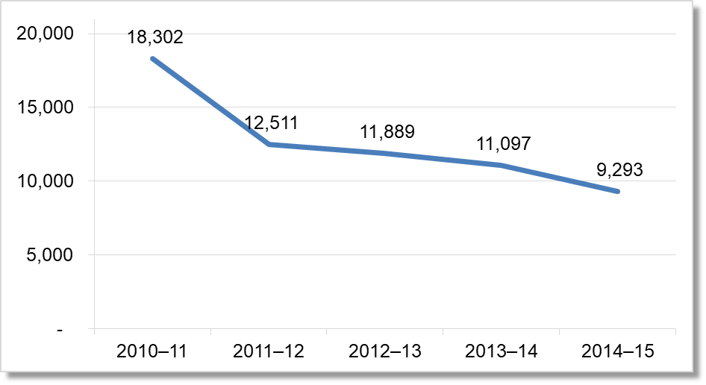
Trend in the Number of Migratory OSY in California, 2010–11 to 2014–15. 2010-11 18,302, 2011-12 12,511, 2012-13 11,889, 2013-14 11,097, 2014-15 9,293.
Source: MSIN Databases for the MEP, 2010–11 to 2014–15.

Figure 23. Trend in the Number of Migratory OSY in California, by Age, 2010–11 to 2014–15
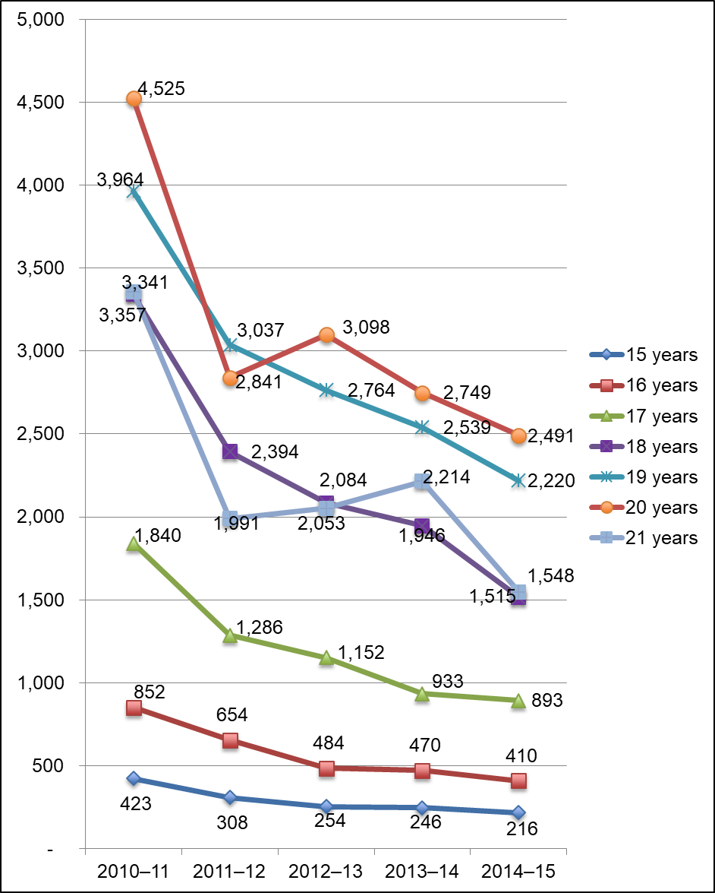
Trend in the Number of Migratory OSY in California, by Age, 2010–11 to 2014–15. For 2010-11, 15 years 423, 16 years 852, 17 years 1,840, 18 years 3,357, 19 years 3,964, 20 years 4,525, 21 years 3,341. For 2011-12, 15 years 308, 16 years 654, 17 years 1,286, 18 years 2,394, 19 years 3,037, 20 years 2,841, 21 years 1,991. For 2012-13, 15 years 254, 16 years 484, 17 years 1,152, 18 years 2,084, 19 years 2,764, 20 years 3,098, 21 years 2,053. For 2013-14, 15 years 246, 16 years 470, 17 years 933, 18 years 1,946, 19 years 2,539, 20 years 2,749, 21 years 2,214. For 2014-15, 15 years 216, 16 years 410, 17 years 893, 18 years 1,515, 19 years 2,220, 20 years 2,491, 21 years 1,548.
Source: MSIN Databases for the MEP, 2010–11 to 2014–15.
To gain a better understanding of California’s migratory OSY population, the CDE collected just over 200 OSY INAs and MLAPs from 11 subgrantees. Due to data limitations, the CDE reviewed a sample of 100 OSY INAs and MLAPs from five of California’s 20 MEP subgrantees for the 2015–16 program year. This review provided a limited view of OSY’s home languages, referral needs, access to transportation, and whether the youth were here-to-work or in credit recovery status. Although this review provides context to the needs of California’s OSY, these findings should not be extrapolated to the overall OSY population in California as the sample size was small and the CDE is not aware of local sampling practices used to select the INAs. Rather, this sample provides the CDE a basis for developing a process of collecting more detailed OSY data from MEP subgrantees.

Sample Out-of-School-Youth Demographics
The students included in the 2015–16 OSY sample were served in five MEP program areas and ranged in age from 13 to 21 years. Nearly 85 percent of the sample was age 18 or over, and 83 percent reported that their home language was Spanish. Seven percent of the OSY sample reported speaking an indigenous language at home, including Mixteco, Triqui, and Chatino Bajo. Tables 3 and 4 detail the demographic characteristics of the OSY sample.

Table 3. Distribution of 2015–16 Migratory OSY Sample, by Age
OSY Age | Frequency | Percent
13 | 1 | 1.0%
14 | 1 | 1.0%
15 | 1 | 1.0%
16 | 1 | 1.0%
17 | 11 | 11.1%
18 | 26 | 26.3%
19 | 21 | 21.2%
20 | 21 | 21.2%
21 | 16 | 16.2%
Total | 99¹ | 100.0%
¹Total sums to less than the original sample size of 100 because one INA/MLAP did not include an entry for this variable.
Source: 2015–16 OSY Initial Needs Assessment Sample.

Table 4. Distribution of 2015–16 Migratory OSY Sample, by Home Language
OSY Home Language | Frequency | Percent
Spanish | 82 | 82.8%
English | 8 | 8.1%
Triqui | 4 | 4.0%
Mixteco | 2 | 2.0%
Spanish and English | 2 | 2.0%
Chatino Bajo | 1 | 1.0%
Total | 99¹ | 100%
¹Total sums to less than the original sample size of 100 because one INA/MLAP did not include an entry for this variable.
Source: 2015–16 OSY Initial Needs Assessment Sample.

Here-to-Work versus Credit Recovery Status
The majority of OSY, 58 percent, included in the 2015–16 sample were here-to-work, while approximately 30 percent were in credit recovery status, and another 12 percent indicated they were both here-to-work and in credit recovery status (see Table 5).

Table 5. 2015–16 Migratory OSY Sample Here-to-Work and Credit Recovery Status
Here-to-Work or Credit Recovery | Frequency | Percent
Here-to-Work | 57 | 58.2%
Credit Recovery | 29 | 29.6%
Both | 12 | 12.2%
Total | 98¹ | 100%
¹Total sums to less than the original sample size of 100 because two INAs/MLAPs did not include entries for this variable.
Source: 2015–16 OSY Initial Needs Assessment Sample.

Access to Transportation
Approximately one-quarter (26 percent) of the sample OSY population lacked access to transportation. This distribution was consistent among both the here-to-work and credit recovery status youth. Figure 24 shows the percent of OSY with and without access to transportation.

Figure 24. 2015–16 OSY Sample Access to Transportation (N=92)
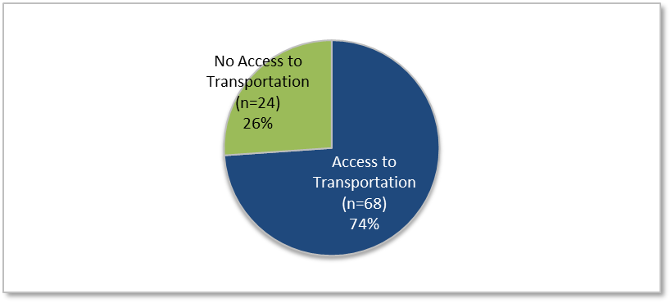
2015-16 OSY Access to Transportation – 74% had access to transportation and 26% did not.
Source: 2015–16 OSY Initial Needs Assessment Sample.

Service Referrals
The number of service referrals per OSY ranged from zero to five, with half the sample receiving one service referral, and 28 percent receiving three or more service referrals. Figure 25 shows the distribution of OSY by the number of service referrals received in 2015–16.

Figure 25. Number of Referrals Received per OSY, 2015–16 Sample (N=100)
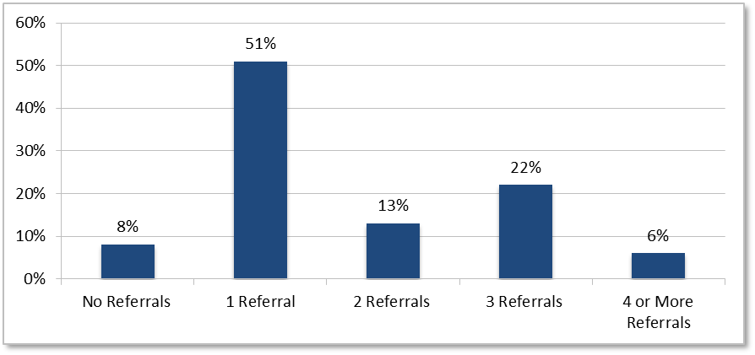
Number of Referrals Received per OSY, 2015–16. 8% no referrals, 51% 1 referral, 13% 2 referrals, 22% 3 referrals, 6% 4 or more referrals.
Source: 2015–16 OSY Initial Needs Assessment Sample.
Approximately 62 percent of OSY referrals were for high school graduation or equivalency services, including General Educational Development (GED) and the High School Equivalency Program (HEP). Nearly 50 percent of referrals were for English as a Second Language (ESL) services, and another 14 percent were for health services. Table 6 details the types of referrals made to OSY in the 2015–16 sample, and Tables 7 and 8 offer additional detail on the high school graduation and health service referrals.

Table 6. Distribution of OSY Referrals, by Service Type, 2015–16 OSY Sample
Service Type (N=100) | Frequency | Percent¹
Any High School Graduation (includes GED/ HEP) | 62 | 62%
ESL | 47 | 47%
Any Health (Medical/Vision/Dental) | 14 | 14%
Transportation | 5 | 5%
Vocational | 5 | 5%
Other | 4 | 4%
1 Percentages sum to greater than 100 because some OSY received more than one type of high school graduation service referral.
Source: 2015–16 OSY Initial Needs Assessment Sample.

Table 7. Breakdown of High School Graduation/GED/ HEP Service Referrals, 2015–16 OSY Sample
High School Graduation Service Referrals (N=62) | Frequency | Percent1
General Educational Development (GED) | 43 | 69%
High School Graduation | 22 | 36%
High School Equivalency Program (HEP) | 15 | 24%
1 Percentages sum to greater than 100 because some OSY received more than one type of high school graduation service referral.
Source: 2015–16 OSY Initial Needs Assessment Sample.

Table 8. Breakdown of Medical/Vision/Dental Service Referrals, 2015–16 OSY Sample
Any Health Service Referrals (N=14) | Frequency | Percent1
Vision | 11 | 79%
Dental | 10 | 71%
Medical | 7 | 50%
1 Percentages sum to greater than 100 because some OSY received more than one type of high school graduation service referral.
Source: 2015–16 OSY Initial Needs Assessment Sample.

School Readiness
The MEP’s first role in school readiness is to ensure that pre-K students are enrolled in a high quality preschool. If, for whatever reason, the child is unable to attend, the MEP provides school readiness services to the migratory children within their program area. California’s MEP provides preschool services to age-eligible migratory children and helps migratory parents develop literacy and parenting skills as well as increase the parent’s involvement in his or her child’s academic success. The services provided in school readiness include a variety of programs with varying delivery methods. For example, the Family Biliteracy Program is delivered once, sometimes twice, per week to both parents and students who engage in, not only, language arts, but explore different areas of Science, Technology, Engineering, and Mathematics education. Other school readiness services are provided one-on-one to the student at home, so there is no one prescriptive school readiness service, but rather a collection of services under the school readiness umbrella.
The CDE is in the process of developing a data collection process to analyze the guiding question for this component for the next cycle of the CNA and SSDP development as current data collection does not distinctly identify whether pre-K students are ready for kindergarten upon entering school. For this Migrant Student Profile we reviewed the following question:
- What are the trends in participation levels for the school readiness services?
To explore migratory students’ school readiness needs, the CDE examined trends in California’s MEP’s school readiness participation levels from all services with available data.

Migrant Education School Readiness Participation
In 2014–15, 2,313 migratory students and 2,032 migratory parents participated in school readiness, a decline of approximately 60 percent compared to the numbers served in 2010–11. This decline is nearly double the decline seen for the state’s population of migratory children age two to five years (refer back to Table 1).
Figure 26 shows the trend in population size for students and parents participating in school readiness services between 2010–11 and 2014–15, and Table 9 shows the percent decline over the same time period.

Figure 26. Trend in the Number of Migratory Students and Parents Served by School Readiness Services, 2010–11 to 2014–15
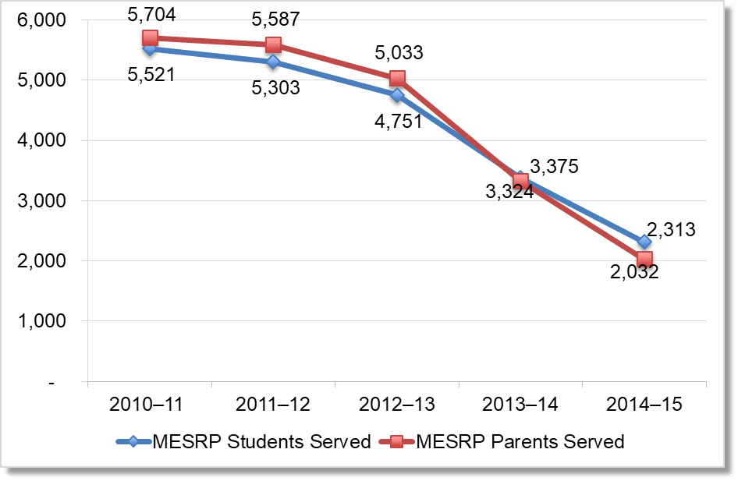
Trend in the Number of Migratory Students and Parents Served by School Readiness Services, 2010–11 to 2014–15. For 2010-11, 5,521 MESRP Students Served and 5,704 MESRP Parents Served. For 2011-12, 5,303 MESRP Students Served and 5,587 MESRP Parents Served. For 2012-13, 4,751 MESRP Students Served and 5,033 MESRP Parents Served. For 2013-14, 3,375 MESRP Students Served and 3,324 MESRP Parents Served. For 2014-15, 2,313 MESRP Students Served and 2,032 MESRP Parents Served.
Source: TROMIK Data Reports, 2010–11 to 2014–15. The complete data table of Figure 26 is located on Table 9.

Table 9. Number of Migrant School Readiness Participants in California and Percent Change over Time, Program Year 2010–11 to 2014–15
Participants | Program Year 2010–11 | Program Year 2011–12 | Program Year 2012–13 | Program Year 2013–14 | Program Year 2014–15 | Percent Change Over 5 Years
Students | 5,521 | 5,303 | 4,751 | 3,375 | 2,313 | -58.1%
Parents | 5,704 | 5,587 | 5,033 | 3,324 | 2,032 | -64.4%
Source: TROMIK Data Reports, 2010–11 to 2014–15.

Parent Involvement
Our guiding question for Parent Involvement could not be properly answered with the data provided to the CDE. The CDE is in the process of developing data collection procedures that will be able to identify parents’ levels of engagement in their students’ education during the next cycle of the CNA and SSDP development. For now, the CDE looked at the following questions using current data to explore parent involvement through school readiness and the State Parent Advisory Council (SPAC) conference participation:
- What percent of students enrolled in California’s MEP have at least one parent who has also participated in school readiness parent training services or activities?
- How many parents have participated in the SPAC Conference over the past five years?
In addition to providing preschool services to age-eligible migratory students, school readiness activities and services assist migratory parents with increasing their ability to support their child’s academic success. The CDE examined migratory students’ parent involvement levels in school readiness services as an indicator for trends in overall migrant parent participation.

Migrant Education School Readiness Students’ Parent Participation
Student’s parent participation in related school readiness programming has declined since 2012–13, when 94 percent of migratory pre-k aged students had at least one parent participating in program activities and services and only 6 percent had no participating parents. Since that time, the percentage of students with at least one participating parent has declined to 78 percent, and the percentage with no participating parents has increased to nearly 22 percent. Figure 27 shows the distribution of migratory students by the number of parents participating in school readiness activities and services.

Figure 27. Number of Migrant School Readiness Participants in California and Percent Change over Time, 2010–11 to 2014–15
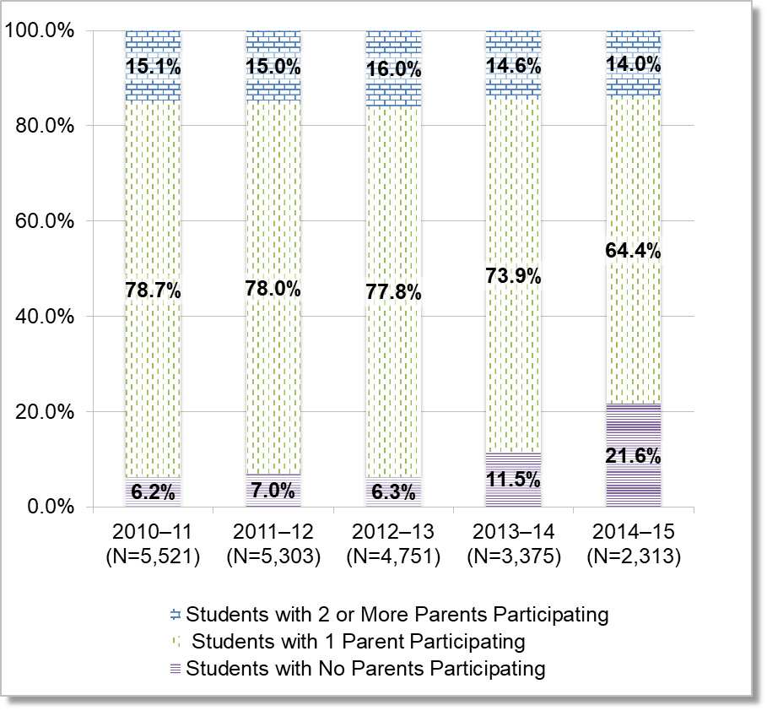
Number of Migrant School Readiness Participants in California and Percent Change over Time, 2010–11 to 2014–15. For 2010-11, 15.1% students with 2 or more parents participating, 78.7% students with 1 parent participating, 6.2% students with no parents participating. For 2011-12, 15.0% students with 2 or more parents participating, 78.0% students with 1 parent participating, 7.0% students with no parents participating. For 2012-13, 16.0% students with 2 or more parents participating, 77.8% students with 1 parent participating, 6.3% students with no parents participating. For 2013-14, 14.6% students with 2 or more parents participating, 73.9% students with 1 parent participating, 11.5% students with no parents participating. For 2014-15, 14.0% students with 2 or more parents participating, 64.4% students with 1 parent participating, 21.6% students with no parents participating.
Source: TROMIK Data Reports, 2010–11 to 2014–15.

State Parent Advisory Council Participation
Another opportunity for parent involvement includes participating on the local Parent Advisory Councils and representing the subgrantees program areas on the SPAC. The SPAC advises the State Superintendent of Public Instruction in the planning, operation, and evaluation of the state MEP. The SPAC includes one parent member from each migrant region and may include up to three community members. The CDE has held an annual SPAC conference where parents come together to foster parent engagement. Future SPAC conferences will take place every other year, while local opportunities to participate will increase. Table 10 identifies the number of parent participants at the annual SPAC conference.

Table 10. Number of Migratory Parents who Participated in the SPAC Conference by Program Year, 2011–12 to 2015–16
2011–12 Participant Numbers | 2012–13 Participant Numbers | 2013–14 Participant Numbers | 2014–15 Participant Numbers | 2015–16 Participant Numbers
672 | 654 | 620 | 662 | 675
Source: Migrant Education Office Attendance Reports, 2011–12 to 2015–16.

Health Needs
The CDE explored the patterns of health services provided to California’s Migrant children as an indicator for their priority health needs. Using an MSIN data file with MEP health service records for a subset of California’s migratory children, the CDE examined the distribution of health services provided each year between 2010–11 and 2014–15, as well as how the types of health services were distributed among different age spans of migratory children. This analysis revealed several key findings:
- The relative frequency of health support services has increased each year, by a total of 16 percentage points between 2010–11 and 2014–15, while the relative frequency of health education has decreased by 11 percentage points and that of referral services by 6 percentage points.
- Among referral services, the frequency of dental referrals/follow-up and medical referrals/follow-up declined by 36 percent and 24 percent, respectively, between 2010–11 and 2014–15. During that same time period, the frequency of vision referrals/follow-up increased by more than 200 percent.
- Among support services, advocacy and coordination activities experienced an 11-fold increase between 2010–11 and 2014–15, while dental and vision screenings each increased more than 200 percent. During that same time period, the frequency of dental treatments declined by 66 percent, and medical screenings and treatments by 48 and 40 percent, respectively.

Health Services and Activities
The CDE categorized MEP health services into four broad service types: 1) referral services, 2) support services, 3) health education, and 4) other instructional services. Each of these service types includes one or more discreet health service activities. Table 11 shows the MEP health service types and activities used to explore the possible health needs of California’s migratory children.

Table 11. MEP Health Service Types and Activities
Service Type | Activities
Referral Services | - Dental Referral and Follow-up  - Hearing Referral and Follow-up  - Medical Referral and Follow-up  - Vision Referral and Follow-up
Support Services | - Advocacy/Coordination of Services  - Dental Screening  - Dental Treatment  - Hearing Screening  - Hearing Treatment  - Medical Screening  - Medical Treatment  - Nutrition  - Vision Screening  - Vision Treatment
Health Education | - Health education
Other Instructional | - Assessment
Source: MSIN Databases for the MEP, 2010–11 to 2014–15.

General Trends
Between 2010–11 and 2014–15, the average number of health services provided per migratory child increased from 1.6 services in 2010–11 to 1.9 services in 2014–15. Over that same time period, the most frequently provided service type was Support Services, comprising 77 percent of all MEP health services in 2014–15. Other Instructional Assessment was the least provided service, with only two instances on record in 2014–15.
The relative frequency of support services has increased each year, by a total of 16 percentage points over the five-year period, while the relative frequency of health education has decreased by 11 percentage points and that of referral services by 6 percentage points.
Table 12 details the average number of health services provided per migratory child each year, and Table 13 details the relative frequency of health service types, along with the percentage point change in those frequencies over the five-year period. Figure 28 shows the frequency distribution of MEP health services across all five years.

Table 12. Frequency of MEP Health Services Provided to Migratory Children, Program Year 2010–11 to 2014–15
Health Services | Program Year 2011–12 | Program Year 2012–13 | Program Year 2013–14 | Program Year 2014–15 | Program Year 2015–16 | Percent Change Over 5 Years
Number of MEP Health Services Provided | 92,168 | 110,172 | 119,076 | 109,183 | 103,459 | -12%
Number of Migratory Children with MEP Health Service Records | 57,032 | 61,009 | 63,095 | 62,837 | 54,827 | -4%
Average Number of Services per Child | 1.6 | 1.8 | 1.9 | 1.7 | 1.9 | 19%
Source: MSIN Databases for the MEP, 2010–11 to 2014–15.

Table 13. Frequency and Percent Distribution of MEP Health Services Provided to Migratory Children, Program Year 2010–11 to 2014–15
Health Service ¹ | Program Year 2011–12 | Program Year 2012–13 | Program Year 2013–14 | Program Year 2014–15 | Program Year 2015–16 | Percentage Point Change Over 5 Years
Referral Service | 15,234  17% | 16,143  15% | 14,485  12% | 13,678  13% | 11,168  11% | -6%
Support Service | 55,928  61% | 77,027  70% | 88,375  74% | 81,745  75% | 79,872  77% | 16%
Health Education | 21,000  23% | 16,943  15% | 16,066  13% | 13,755  13% | 12,417  12% | -11%
Other Instructional Assessment | 6  0.007% | 59  0.05% | 150  0.13% | 5  0.005% | 2  0.002% | -0.005%
All MEP Health Services | 92,168  100% | 110,172  100% | 119,076  100% | 109,183  100% | 103,459  100% | n/a
Source: MSIN Databases for the MEP, 2010–11 to 2014–15.
¹This table includes the health services that were submitted to the MSIN database. Percentages in each row were calculated based on the total number of services in a given year.

Figure 28. Distribution of Health Services Provided, 2010–11 to 2014–15¹
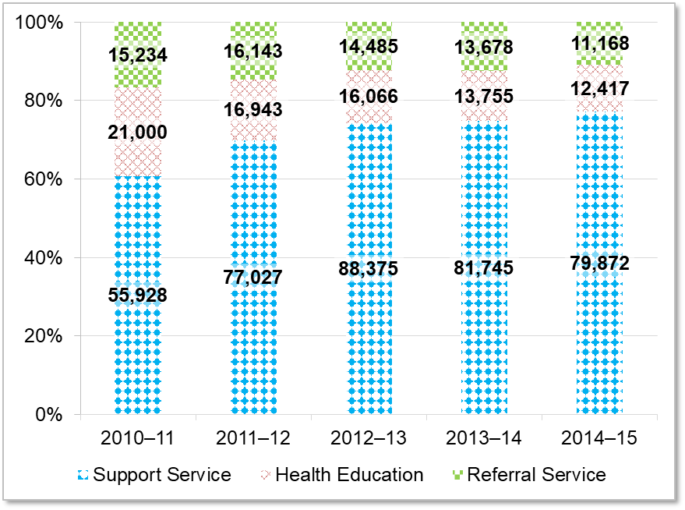
Distribution of Health Services Provided from 2010-11 to 2014-15. For 2010-11, Referral Service – 15,234, Health Education 21,000, Support Services – 55,928. For 2011-12, Referral Service – 16,143, Health Education 16,943, Support Services – 77,027. For 2012-13, Referral Service – 14,485, Health Education 16,066, Support Services – 88,375. For 2013-14, Referral Service – 13,678, Health Education 13,755, Support Services – 81,745. For 2014-15, Referral Service – 11,168, Health Education 12,417, Support Services – 79,872.
¹ The figure does not include Other Instructional Assessments which added a negligible percentage of services (less than 0.2 percent in each program year).
Source: MSIN Databases for the MEP, 2010–11 to 2014–15.

Distribution of Referral and Support Services
To better understand the nature of health services provided by the MEP, the CDE examined the distribution of each service type across its various activities. Among MEP referral services, dental referrals/follow-up was the most frequently provided activity across all five years and made up 60 percent of all services in 2014–15. Figure 29 shows the distribution of referral services by activity type in 2014–15. For referral service distributions in other program years, see Appendix F.

Figure 29. Referral Services by Activity Type, 2014–15
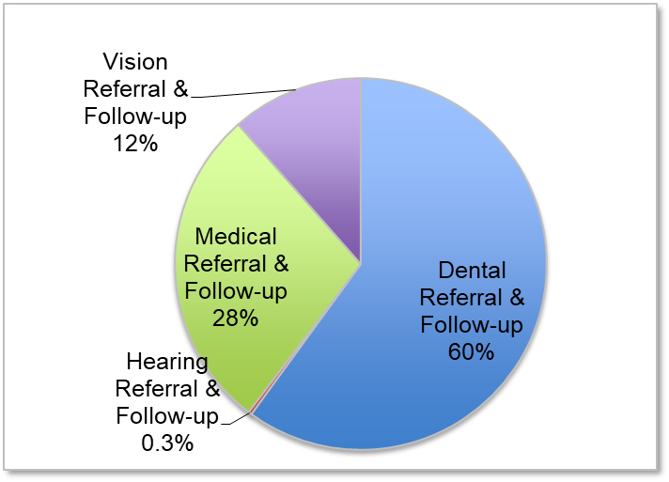
Types of referral services by type for 2014-15. Dental referral and follow-up 60%, Medical referral and follow-up 28%, Vision referral and follow-up 12%, and Hearing referral and follow-up 0.3%.
Source: MSIN Databases for the MEP, 2010–11 to 2014–15.
Among MEP support services, nutrition and advocacy/coordination of services were the most frequently provided activities, making up 35 percent and 34 percent of all support services, respectively, in 2014–15. Nutrition support services include providing snacks and food during MEP services that take place during meal times, and occasionally providing an emergency food supply to families in need by a few MEPs. Advocacy/coordination services include: meeting with local government agencies, community-based organizations, non-profits, etc. to provide services to migratory students; providing support services, such as interpretation or transportation, related to making health referrals; and hiring health educators to provide services to migratory students. Table 14 shows the distribution of support services by activity type in 2014–15. For support service distributions in other program years, see Appendix F.

Table 14. Support Services by Activity Type, 2014–15
Support Activities | Frequency | Percent
Nutrition | 27,877 | 34.9%
Advocacy/Coordination | 26,882 | 33.7%
Dental Screening | 7,978 | 10.0%
Vision Screening | 5,851 | 7.3%
Medical Screening | 3,533 | 4.4%
Medical Treatment | 2,866 | 3.6%
Dental Treatment | 2,187 | 2.7%
Hearing Screening | 1,447 | 1.8%
Vision Treatment | 1,161 | 1.5%
Hearing Treatment | 90 | 0.1%
Total | 79,872 | 100%
Source: MSIN Databases for the MEP, 2010–11 to 2014–15.

Five-Year Trends in Referral and Support Services
To better understand possible trends in the health needs of California’s migratory children, the CDE MEP examined how the frequency of referral and support service activities changed between 2010–11 and 2014–15. Among referral service activities, the frequency of dental referrals/follow-up declined by 36 percent over the five-year period, while the frequency of medical referrals/follow-up declined by 24 percent, and that of vision referrals/follow-up has increased by more than 200 percent. Figure 30 shows the five-year frequency trends among referral service activities.

Figure 30. Trend in the Number of Referral Service Activities, 2010–11 to 2014–15
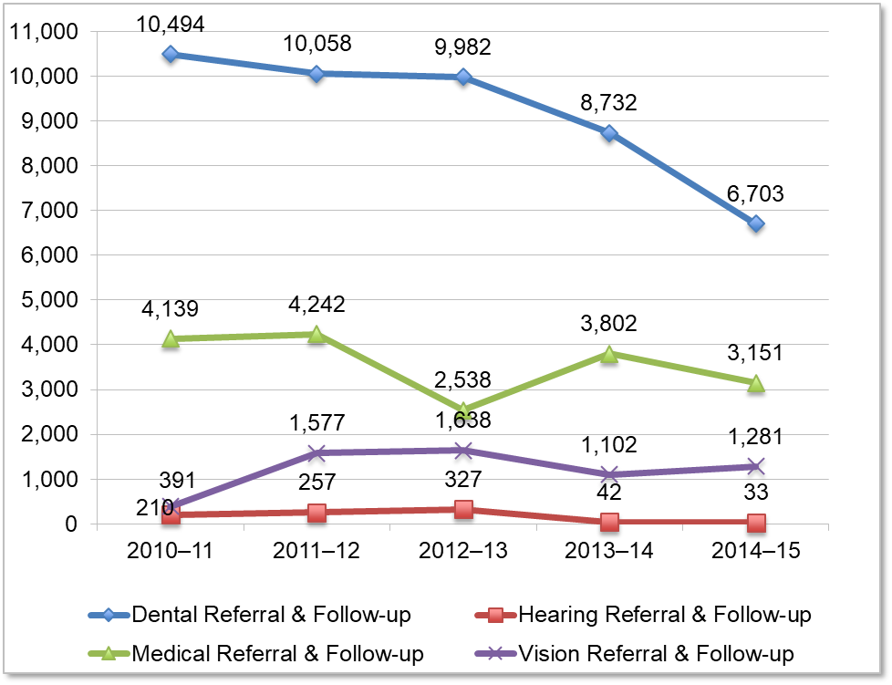
Trend in the number of referral service activities by year for 2010-11 to 2014-15. For 2010-11, 10,494 dental referral and follow-up, 4,139 medical referral and follow-up, 391 vision referral and follow-up, and 210 hearing referral and follow-up. For 2011-12, 10,058 dental referral and follow-up, 4,242 medical referral and follow-up, 1,577 vision referral and follow-up, and 257 hearing referral and follow-up. For 2012-13, 9,982 dental referral and follow-up, 2,538 medical referral and follow-up, 1,638 vision referral and follow-up, and 327 hearing referral and follow-up. For 2013-14, 8,732 dental referral and follow-up, 3,802 medical referral and follow-up, 1,102 vision referral and follow-up, and 42 hearing referral and follow-up. For 2014-15, 6,703 dental referral and follow-up, 3,151 medical referral and follow-up, 1,281 vision referral and follow-up, and 33 hearing referral and follow-up.
Source: MSIN Databases for the MEP, 2010–11 to 2014–15.
Among support service activities, advocacy/coordination activities experienced an
11-fold increase between 2010–11 and 2014–15, while dental and vision screenings each increased more than 200 percent. During that same time period, the frequency of dental treatments declined by 66 percent, and medical screenings and treatments by 48 and 40 percent, respectively. Figure 31 shows the frequency trends for support service activities that have grown during the five-year period, while Figure 32 shows the same for support service activities that have declined during that time period.

Figure 31. Trends in the Number of Growing Support Service Activities,
2010–11 to 2014–15
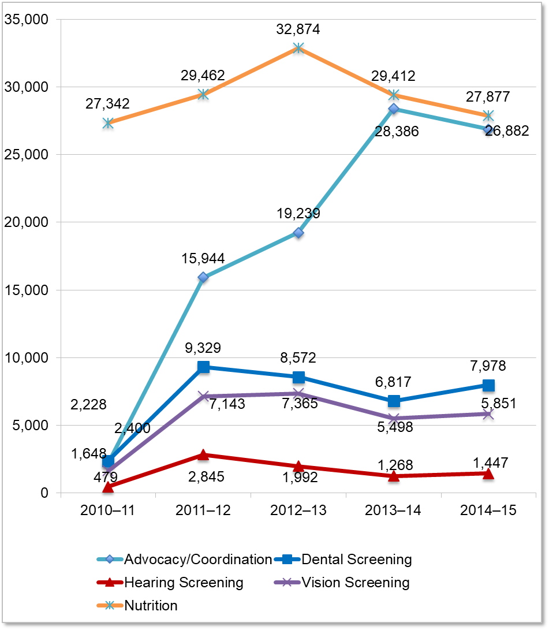
Trends in the number of growing support service activities by year and activity from 2010-11 to 2014-15. For Nutrition, 2010-11 27,342, 2011-12 29,462, 2012-13 32,874, 2013-14 29,412, and 2014-15 27,877. For Advocacy/Coordination, 2010-11 2,228, 2011-12 15,944, 2012-13 19,239, 2013-14 28,386, and 2014-15 26,882. For Dental Screening, 2010-11 2,400, 2011-12 9,329, 2012-13 8,572, 2013-14 6,817, and 2014-15 7,978. For Vision Screening, 2010-11 1,648, 2011-12 7,143, 2012-13 7,365, 2013-14 5,498, and 2014-15 5,851. For Hearing Screening, 2010-11 479, 2011-12 2,845, 2012-13 1,992, 2013-14 1,268, and 2014-15 1,447.
Source: MSIN Databases for the MEP, 2010–11 to 2014–15.

Figure 32. Trends in the Number of Declining Support Service Activities,
2010–11 to 2014–15
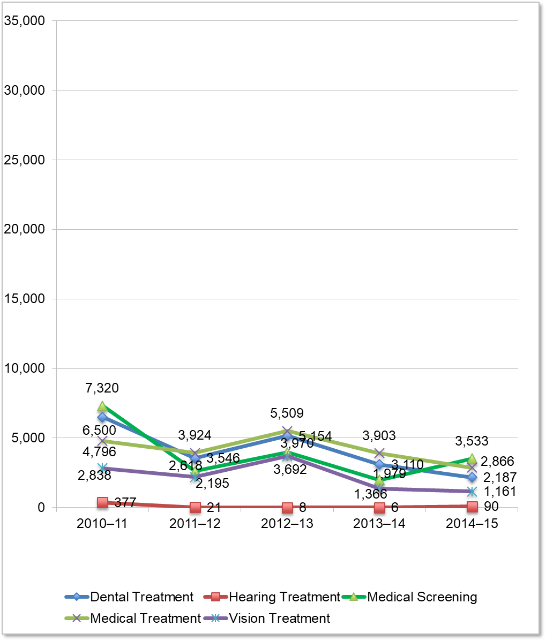
Trends in the number of declining support services activities by year and activity for 2010-11 to 2014-15. For Medical Screening, 2010-11 7,320, 2011-12 2,618, 2012-13 3,970, 2013-14 1,970, and 2014-15 3,533. For Dental Treatment, 2010-11 6,500, 2011-12 3,546, 2012-13 5,154, 2013-14 3,110, and 2014-15 2,187. For Medical Treatment, 2010-11 4,796, 2011-12 3,924, 2012-13 5,509, 2013-14 3,903, and 2014-15 2,866. For Vision Treatment, 2010-11 2,838, 2011-12 2,195, 2012-13 3,692, 2013-14 1,366, and 2014-15 1,161. For Hearing Treatment, 2010-11 377, 2011-12 21, 2012-13 8, 2013-14 6, and 2014-15 90.
Source: MSIN Databases for the MEP, 2010–11 to 2014–15.

Health Services by Age Group
To better understand how migratory children’s health needs may vary by age, the CDE explored the distribution of health services provided to each age group. In 2014–15, the distribution of health services across each age group was similar between support services, referral services, and health education. The one notable, yet small, difference was between referral services and health education. Compared to the age group distributions of health education services, referral services were slightly more likely to be provided to children age 16 to 18 (15 percent vs. 11 percent), and slightly less likely to be provided to children age 5 years and younger (10 percent vs. 16 percent).
Figure 33 shows the distribution of health services provided, by service type and age group, for 2014–15. For detailed information on the distribution of MEP health services by age group for the years 2010–11 through 2013–14, see Appendix F.

Figure 33. Distribution of MEP Health Services by Service Type and Age Group, 2014–15¹
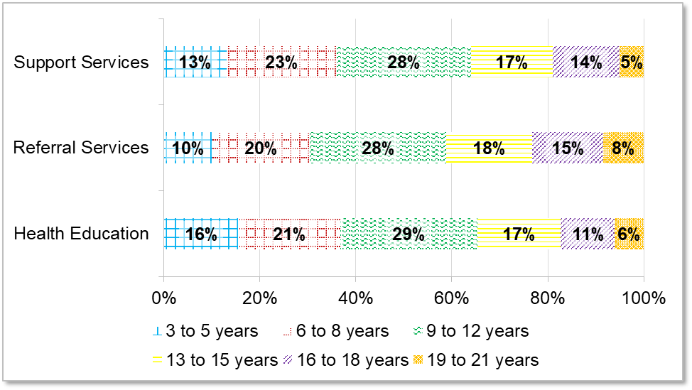
Distribution of MEP health services by service type and age group for 2014-15. For support services, 3-5 years 13%, 6-8 years 23%, 9-12 years 28%, 13-15 years 17%, 16-18 years 14%, and 19-21 years 5%. For referral services, 3-5 years 10%, 6-8 years 20%, 9-12 years 28%, 13-15 years 18%, 16-18 years 15%, and 19-21 years 8%. For health education, 3-5 years 16%, 6-8 years 21%, 9-12 years 29%, 13-15 years 17%, 16-18 years 11%, and 19-21 years 6%.
Source: MSIN Databases for the MEP, 2010–11 to 2014–15.
¹Due to the small number (n=2) of Other Instructional services offered in 2014–15, that service type was not included in this figure.
The CDE will continue to improve its data collection around health needs and related services. For the next cycle of the CNA and SSDP development, the CDE hopes to develop a process for collecting chronic disease prevalence data and will have access to chronic absenteeism data. These data will provide more information on the specific health needs for California’s migratory population.

Student Engagement
The CDE is currently working to develop measures for student engagement for the next cycle of the statewide CNA development. The CDE management team identified the following variables that illustrate student engagement in the school setting:
- High school graduation rates
- High school dropout rates
- Feelings towards school environment, school connectedness, and academic motivation
Although data are not available for this cycle of the statewide CNA, the CDE will include chronic absenteeism and attendance variables in the next iteration of the statewide CNA.

High School Graduation and Dropout Rates
The CDE reviewed the adjusted four-year graduation cohort and dropout data for two focus areas: high school graduation and dropout prevention, both indicators of student engagement. Examining the trends in Migratory and All Students’ graduation and dropout rates revealed one key finding:
- Although California’s migratory student population is less likely than all students to graduate and more likely to drop out of school, Migratory Students appear to be closing these gaps. Between 2013–14 and 2014–15, the graduation rate gap decreased from six percentage points to one percentage point; and between 2012–13 and 2014–15, the dropout rate gap declined from four percent to half a percentage point.
Between 2010–11 and 2014–15, Migratory Students’ high school graduation rates trailed the graduation rates of All Students. During that same time period, Migratory Students were more likely than all students to drop out of school.
Migratory Students appear to be closing these graduation and dropout rate gaps. Migratory Students’ graduation rates increased by eight percentage points over the five-year period (from 73 percent to 81 percent), while the graduation rate for All Students increased by only five percentage points (to 82 percent). Meanwhile, Migratory Students’ dropout rates decreased by six percentage points from 17 percent to 11 percent, while that of All Students dropped by four percentage points. Figure 34 shows the trend in high school graduation and rates for Migratory and All Students between 2010–11 and 2014–15. Figure 35 shows the trends in high school dropout rates during the same time period. For detailed information on Migratory Student and All Student high school graduation and dropout rates, see Appendix G.

Figure 34. Trend in Graduation Rates for Migratory Students and All Students, 2010–11 to 2014–15
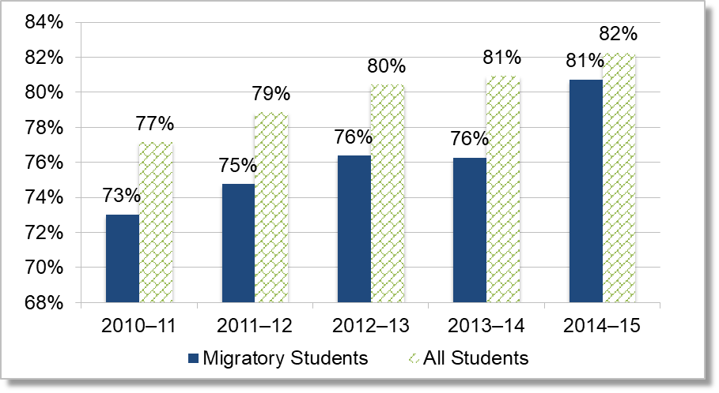
Trend in graduation rates for migratory students and all students by year for 2010-11 to 2014-15. For 2010-11, 73% migratory students and 77% all students. For 2011-12, 75% migratory students and 79% all students. For 2012-13, 76% migratory students and 80% all students. For 2013-14, 76% migratory students and 81% all students. For 2014-15, 81% migratory students and 82% all students.
Source: CDE, DataQuest, http://dq.cde.ca.gov/dataquest/.

Figure 35. Trend in Dropout Rates for Migratory Students and All Students, 2010–11 to 2014–15
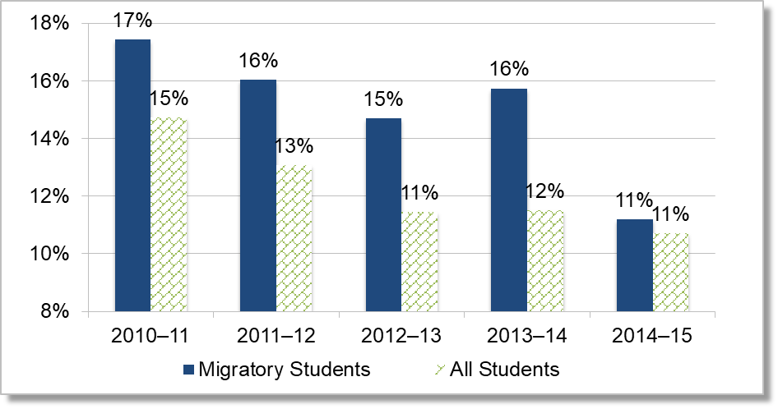
Trend in dropout rates for migratory students and all students by year for 2010-11 to 2014-15. For 2010-11, 17% migratory students and 15% all students. For 2011-12, 16% migratory students and 13% all students. For 2012-13, 15% migratory students and 11% all students. For 2013-14, 16% migratory students and 12% all students. For 2014-15, 11% migratory students and 11% all students. Source: CDE, DataQuest, http://dq.cde.ca.gov/dataquest/

School Environment, School Connectedness, and Academic Motivation
The CDE has funded the California Healthy Kids Survey (CHKS) since 1997 to provide data that would assist schools to: (1) foster positive school climate and engagement in learning; (2) prevent youth health-risk behaviors and other barriers to academic achievement; and (3) promote positive youth development, resilience, and well-being. The CHKS is based on a convenient sample of those districts administering the CHKS in 2015–16 and the results may not be representative.
Tables 15 through 18 show the responses of middle school migratory students, high school migratory students, and their non-migratory peers. School Environmental factors between migratory and non-migratory students in both age groups are similar, with migratory students being more likely to respond with “Low” than their non-migratory peers; furthermore, there is an increase in the percentage of high school migratory students responding with “Low” in all of the factors when comparing middle school migratory students to high school migratory students. Migratory students in both middle and high school are approximately 10 percent less likely to report a “High” feeling of school connectedness than their non-migratory peers. Middle and high school migratory students report a “Low” level of school connectedness than their non-migratory peers at six percent and seven percent respectively.
Tables 15 through also show that the academic motivation of migratory students in the High or Moderate categories are slightly behind that of their non-migratory peers in each age grouping. Additionally, migratory students in high school feel less highly motivated academically than their counterparts at the middle school.

Table 15. Response of Middle School Migratory Students on School Environment, School Connectedness and Academic Motivation
Topics Surveyed | Migratory Students Scoring High | Migratory Students Scoring Moderate | Migratory Students Scoring Low
Total school supports | 39% | 47% | 14%
Caring adults in school | 37% | 49% | 14%
High expectations—adults in school | 53% | 38% | 9%
Meaningful participation at school | 21% | 53% | 26%
School Connectedness | 51% | 35% | 14%
Academic Motivation | 42% | 36% | 22%

Table 16. Response of Middle School Non-migratory Students on School Environment, School Connectedness and Academic Motivation
Topics Surveyed | Non-Migratory Students Scoring High | Non-Migratory Students Scoring Moderate | Non-Migratory Students Scoring Low
Total school supports | 40% | 49% | 11%
Caring adults in school | 39% | 50% | 11%
High expectations—adults in school | 57% | 37% | 6%
Meaningful participation at school | 18% | 53% | 28%
School Connectedness | 61% | 32% | 8%
Academic Motivation | 47% | 39% | 15%

Table 17. Response of High School Migratory Students on School Environment, School Connectedness and Academic Motivation
Topics Surveyed | Migratory Students Scoring High | Migratory Students Scoring Moderate | Migratory Students Scoring Low
Total school supports | 26% | 53% | 21%
Caring adults in school | 27% | 56% | 17%
High expectations—adults in school | 38% | 48% | 14%
Meaningful participation at school | 14% | 49% | 37%
School Connectedness | 39% | 44% | 17%
Academic Motivation | 30% | 42% | 28%

Table 18. Response of High School Non-migratory Students on School Environment, School Connectedness and Academic Motivation
Topics Surveyed | Non-Migratory Students Scoring High | Non-Migratory Students Scoring Moderate | Percent Non-Migratory Students Scoring Low
Total school supports | 30% | 53% | 17%
Caring adults in school | 31% | 54% | 14%
High expectations—adults in school | 43% | 48% | 9%
Meaningful participation at school | 14% | 49% | 37%
School Connectedness | 48% | 42% | 10%
Academic Motivation | 32% | 45% | 23%
Source: California Health Kids Survey, Migrant Education Statewide Report, 2015–16.

Conclusion
This Migratory Student Profile provides a foundation for research and exploration around migratory students’ priority and non-priority needs. Stakeholders will use this information to assist them in developing the statewide CNA which is the groundwork for the SSDP during a series of CNA/SSDP stakeholder meetings.

This student profile refers to MEP-eligible children as students when discussing educational outcomes and demographic characteristics obtained through a child’s enrollment in school, and as children when reporting on a characteristic that is not related to school enrollment.
Due to the implementation of Common Core Standards and the transition to the CAASPP standardized test, the CNA/SSDP Stakeholder Committee chose not to spend a lot of time looking at the CST data.
Regional MEP staff use INAs and MLAPs to document individuals’ needs and actions to address OSY needs as they work with these youths.
Student counts contain some duplicated counts due to variation on reporting specific age groups. Migratory students may have multiple Certificates of Eligibility in which their date of birth, or name, is slightly different for each entry.
Fifty-two percent of ungraded students in 2014–15 were reported to have a disability. Given the small number of ungraded students (N=67), the CDE opted to not include ungraded students in Figure 5.
The number of migratory students with disabilities identified by DataQuest is inconsistent with the total number of migratory students identified in MSIN. The CDE is working to align the migrant-specific MSIN system with data collected by local educational agencies.
Migratory Students includes all students identified as MEP-eligible during the testing year. Migratory PFS Students includes MEP-eligible students who were also identified as Priority for Service during the testing year. All Students includes all students who were not identified as MEP-eligible nor Priority for Service during the testing year. SED Students includes all socio-economically disadvantaged students who were not identified as also being MEP eligible nor Priority for Service during the testing year.
CAASPP: Understanding Your Student Score Report, CDE.
Migratory Students includes all students identified as MEP-eligible during the testing year. Migratory PFS Students includes MEP-eligible students who were also identified as Priority for Service during the testing year. All Students includes all students who were not identified as MEP-eligible nor Priority for Service during the testing year. SED Students includes all socio-economically disadvantaged students who were not identified as also being MEP eligible nor Priority for Service during the testing year.
Migratory Students includes all students identified as MEP-eligible during the testing year. Migratory PFS Students includes MEP-eligible students who were also identified as PFS during the testing year. All Students includes all students who were not identified as MEP-eligible nor PFS during the testing year. SED Students includes all socio-economically disadvantaged students who were not identified as also being MEP eligible nor PFS during the testing year.
The INA is a needs inventory used by the MEP subgrantees to learn about specific individual needs, while the MLAP is a learning action plan that details the services and referrals provided to the OSY.
The CDE/MEO also explored the referral patterns among OSY with only one referral and those with three or more referrals. For both groups, the most common referral was for high school graduation services, followed by ESL services and then health services—a pattern consistent with the overall OSY sample population.
CDE MESRP Web page. http://www.cde.ca.gov/fg/fo/profile.asp?id=2074. 11/2/2016
The health service data file contained data on between 37 percent (2010–11 data) and 55 percent (2013–14 data) of the state’s migratory children population, depending on the program year.
The four-year adjusted cohort forms the basis for calculating graduation rates and dropout rates. http://data1.cde.ca.gov/dataquest/cohortrates/CohortOutcomeDefinitions2016_8_22.pdf.
Students who earn a Special Education Certificate of Completion or a California High School Equivalency Certificate are not counted as receiving a regular high school diploma.
Migratory Student dropout rate for 2014-15 is closer to 11.5 percent, but due to rounding to a full percent, the data label is inconsistent with the visual representation.

