Title: Theory of Action for X

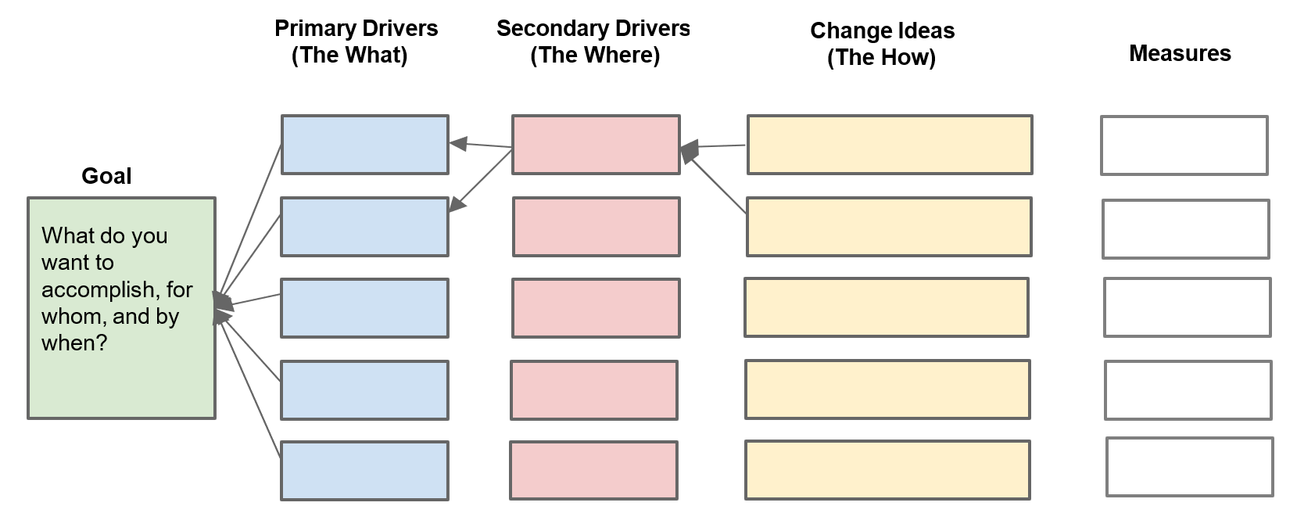
If we want to improve the goal, then we need to focus on primary driver through the secondary driver, and one way to do that is through the change idea.
California Department of Education April 2024

Definitions and Directions
Some helpful definitions:
- Goal = what you want to accomplish, for whom, and by when
- Primary Drivers (the what) = what you need to focus on to achieve your Goal
- Secondary Drivers (the where) = where in your system (the existing
structures/processes) you should focus your energies to effect the Primary Drivers
- Change Ideas (the how) = what you can try and test/refine
Use this to help identify chains of causation: If we want to improve [Goal], then we need to focus on [Primary Drivers], through [Secondary Drivers], and one way to do that is [Change Ideas].

California Department of Education April 2024

