2023–24 Handbook
Connecting CALPADS to the Dashboard
Prepared by the California Department of Education
Available on the CDE Dashboard Resources web page at: https://www.cde.ca.gov/ta/ac/cm/dashboardresources.asp
May 2024

Table of Contents
2023–24 HandbookConnecting CALPADS to the Dashboard 1
Table of Contents 1
Information on the 2024 California School Dashboard 2
Introduction 3
First Step to Success: Having Strong Local Management Data Practices 5
Second Step to Success: Knowing the CALPADS Submission and Certification Deadlines 6
Third Step to Success: Certifying Accurate Data 7
Getting Started 9
Graduation Rate Indicator 11
College/Career Indicator (A Grades 9–12 Indicator) 36
Chronic Absenteeism Rate Indicator (A Grades K–8 Indicator) 46
Suspension Rate Indicator (A Grades K–12 Indicator) 54
District of Residence Rule: Applies to all Dashboard State Indicators 61
Academic Indicators:English Language Arts/Literacy and Math (Indicators for Grades 3–8 and Grade 11) 66
English Learner Progress Indicator (ELPI) (A Grades 1–12 Indicator) 67
Appendix A 68
Appendix B 71

Information on the 2024
California School Dashboard
The release of the 2024 California School Dashboard (Dashboard) this fall signifies a full return of California’s accountability system since 2019. The 2024 Dashboard will report Status (current year data), Change (difference in prior year data), and performance levels (or colors) for all indicators.
With most state indicator data stemming from the California Longitudinal Pupil Achievement Data System (CALPADS), it is critical for local educational agencies (LEAs) to submit CALPADS data that accurately reflects their student population. Therefore, we continue to annually revise this handbook to inform LEAs of CALPADS reports that can be used to validate and confirm submitted data prior to End-of-Year (EOY) certification deadlines and the extraction for Dashboard use. LEAs are also required to self-report their local indicators on the Dashboard. Since local indicators are not reported in CALPADS, they are not covered in this document.
The 2024 Dashboard will be released by December 1, 2024 with the deadlines incrementally getting earlier in future years. To prepare for the Dashboard release, there will be no extensions to the EOY certification deadlines. The 2023−24 End-of-Year certification deadline is July 26, 2024, and the amendment window deadline is August 16, 2024. We urge LEAs to plan accordingly. To view more information about the EOY deadlines for 2023–24, please refer to the CALPADS 2023–24 End-of-year Submissions letter at https://www.cde.ca.gov/ds/sp/cl/eoy2324.asp.
The information covered within this Handbook is as of May 2024.

Introduction
Operational since 2009, CALPADS has been the foundation of California’s K–12 education data system, comprising of student demographic, program participation, grade level, enrollment, course enrollment and completion, discipline, and statewide assessment data. This central, cohesive system maintains quality student-level data and is a vehicle that tracks individual student enrollment history and achievement data which thus provides reliable longitudinal information. The student-level, longitudinal data in CALPADS enables the facilitation of program evaluation, the assessment of student achievement over time, the calculation of more accurate dropout and graduation rates, the efficient creation of reports to meet state and federal reporting requirements, and the ability to create ad hoc reports and responses to relevant questions.
In accordance with student data reporting requirements in state law, the district (or charter school) maintains and submits student data to CALPADS. In return, the system provides LEAs with access to longitudinal data and reports on their own students. It also gives LEAs immediate access to information on new students, enabling LEAs to place students appropriately and to determine whether any assessments are necessary.
It is critical for LEAs to ensure that their CALPADS data are accurate because it is used to meet multiple federal and state data reporting requirements. As noted in the Introduction, one of the uses is to produce the state indicators in the Dashboard.
Regrettably, each year, the CDE is notified by select LEAs – either during the private preview or after the public release of the Dashboard – that there are data submission errors. By this time, it is too late for LEAs to make data corrections. Re-running this complex data set for the entire state after the Dashboard private preview or public release would consume valuable staff resources and potentially impact other district’s state indicator results.
To avoid submitting data errors, the CDE recommends that LEAs view specific CALPADS reports in advance of certifying the data and in advance of the private preview release of the Dashboard to identify and correct these errors. We encourage CALPADS LEA Administrators to collaborate with their LEA Accountability Coordinators to review these reports prior to the close of the EOY certification deadline to ensure that the count of students accurately reflects their LEA’s student population. This handbook has been developed specifically for CALPADS LEA Administrators and LEA Accountability Coordinators to use as they review and finalize their CALPADS data. It is updated to reflect any changes to CALPADS and/or the Dashboard. This handbook also:
- Pinpoints which specific CALPADS reports to view as it relates to the most current year data (Status) reported on the Dashboard,
- Provides a step-by-step process on how to run each relevant CALPADS report, and
- Includes guidance and examples to illustrate areas in which to focus.
Please Note!! In some instances, prior year CALPADS reports were used to produce the print screens illustrated in this handbook. However, LEAs should select the most current academic year for each CALPADS report they generate to review data that will be used to produce the Status or the most current year data reported on the Dashboard.
This handbook does not contain the business rules, calculation formulas, and explanations of the state indicators reported on the Dashboard. To access this information, LEAs should refer to the Dashboard Technical Guide, which is available on the CDE Dashboard Resources web page at https://www.cde.ca.gov/ta/ac/cm/dashboardresources.asp (under the Technical Information tab).
This handbook also does not contain all the rules of using and uploading data into CALPADS. To access this information, LEAs should refer to the latest CALPADS Data Guide and CALPADS communications and trainings, which are posted on the CDE CALPADS web page at https://www.cde.ca.gov/ds/sp/cl/.
For questions about:
- The state indicators reported on the Dashboard, contact the Analysis, Measurement, and Accountability Reporting Division by e-mail at Dashboard@cde.ca.gov.
- The CALPADS Reports, contact the CALPADS Office by e-mail at calpads-support@cde.ca.gov.

First Step to Success: Having Strong Local Management Data Practices
As discussed earlier and illustrated in the steps below, the data submitted in CALPADS are used for many critical purposes, including the Dashboard. Therefore, the first step to data reporting success is to ensure that your LEA has strong local data management practices, which include:
- Inputting and maintaining quality data in the local student information system (SIS),
- Ensuring that relevant staff at the school and district review CALPADS reports before the superintendent (or designee) certifies the data, and
- Comparing local SIS data against CALPADS data to ensure that they match.
Steps to Collect CALPADS Data and the Multiple Ways the Data Are Used
Step 1: LEAs Maintain Data in Local SIS
Step 2: LEAs Extract data from SIS for Upload into CALPADS
Step 3: LEA Superintendent or Designee Certifies CALPADS Data
CALPADS Data Are Used for Multiple Purposes:
- Dashboard
- Determining eligibility for school and LEA support
- DataQuest
- Local Control Funding Formula (LCFF) Supplemental and Concentration Grant Funding, and
- Federal Reporting

Second Step to Success: Knowing the CALPADS Submission and Certification Deadlines
The CALPADS Office annually releases the snapshot collection windows and certification deadlines on the CDE CALPADS Calendar web page (https://www.cde.ca.gov/ds/sp/cl/rptcalendar.asp), which identifies (1) what specific data are collected, (2) when certification deadlines occur, and (3) when the amendment window opens and closes. LEAs are encouraged to review the calendar early in the school year and note when specific data are due. This is crucial because once the EOY certification deadline closes, LEAs are unable to make further corrections and the Dashboard cannot be updated!

The table below is a portion of the 2023–24 CALPADS calendar for EOY as of May 2024. In addition to important EOY dates, note that graduation rate data is always pulled from the CALPADS Operational Data Store (ODS) at the same time the EOY data are extracted, which occurs immediately after the EOY certification (i.e., August 16, 2024, for the 2023–24 school year).
CALPADS Submission | Data to Submit | When Submission Window Opens | Certification Deadline | Amendment Window
EOY 1 | - Course Completion for Grades 7–12  - CTE Participants, Concentrators, Completers  - Work-Based Learning Indicators | May 7, 2024  to  July 26, 2024 | July 26, 2024 | July 27, 2024  to  August 16, 2024
EOY 2 | - Program Eligibility/Participation | May 7, 2024  to  July 26, 2024 | July 26, 2024 | July 27, 2024  to  August 16, 2024
EOY 3 | - Student Incidents  - Cumulative Enrollment  - Student Absence Summary  - One-Year Graduate and Completer Counts  - Count of English Learner (EL) Reclassified during School Year  - Homeless Students | May 7, 2024  to  July 26, 2024 | July 26, 2024 | July 27, 2024  to  August 16, 2024
EOY 4 | - Special Education  - Postsecondary Outcomes for Students with Disabilities (SWD) Prior Year Completers | May 7, 2024  to  July 26, 2024 | July 26, 2024 | July 27, 2024  to  August 16, 2024

Third Step to Success: Certifying Accurate Data
Because most data used to produce the state indicators for the Dashboard are derived from CALPADS, it is important for LEAs to review their CALPADS data for accuracy before the EOY certification deadline ends. As noted earlier, each year, select LEAs have notified the CDE that data submission errors had occurred and therefore their Dashboard data are incorrect. Oftentimes, these errors occur because inaccurate information was certified. Since the certification process is critical in the success of having accurate data reflected on the Dashboard, this section covers the CALPADS submission windows, certification deadlines, the use of data from the ODS, and the role of CALPADS LEA Administrators and Accountability Coordinators.

Submission Windows and Certification Deadlines
The CALPADS Office encourages LEAs to submit data to CALPADS on an ongoing basis. During the fall (fall submissions or “Fall 1” and “Fall 2”) and at the end of the school year (“EOY” submissions 1, 2, 3, and 4), LEAs are required to review certification reports which reflect certain data that have been submitted to CALPADS. LEAs are encouraged to review various state departmental calculation guides in conjunction with the certification reports for data accuracy and quality. Each submission represents specific groups of data. The fall submissions include the certification of data as of Census Day, which is always the first Wednesday in October. The end-of-year submissions include cumulative information from the just-completed school year.
During the submission window, LEAs must review and then certify the certification reports by the specified certification deadline. LEAs may update their data at any point during the submission window and may certify their reports at any point during the submission window. When LEAs are satisfied with the reports, they may certify them, at which point the snapshot of data are “frozen”. While reports that have been certified do not change and remain frozen, during the submission window new revisions continue to be created until the certification deadline. Therefore, during the submission window, even after LEAs certify, they may review revised reports, and if necessary, decertify and then recertify a new report.

Certification
Each LEA has a “Data Collection Certifier” who is responsible for approving the LEA’s Fall 1 and EOY 3 and 4 submissions and certifying the LEA’s Fall 2 and EOY 1 and 2 submissions. Generally, this person is the LEA Superintendent or his/her designee. When certifying a data submission, this designated certifier must check a box next to the following language: “By reviewing these reports and certifying, you are stipulating that the information contained therein is accurate, correct and complete to the best of your knowledge.”
The Fall 1, EOY 3, and EOY 4 submissions include certification reports that reflect data pertaining to students with disabilities (SWD). These reports must also be approved by Special Education Local Plan Areas (SELPAs). Once both LEA and the SELPA approve reports in the submission, the submission is considered certified. Therefore, for these submissions, LEAs must first approve all reports in a submission, and then the SELPA must review and approve the special education reports in the submission, in order for the submission to be certified.
Note that if an LEA decertifies their data and fails to re-certify by the close of the certification deadline, the LEA will have no certified data. There is no opportunity to certify or change certified data following the final certification deadline.

Operational Data Store (ODS)
The Dashboard not only uses certified data, but it also uses data from the ODS. The ODS reflects the most current data in CALPADS and does not necessarily reflect data that have been certified at one point in time by a given LEA. LEAs may update the CALPADS ODS at any time. LEAs can view CALPADS ODS reports for their current data in CALPADS. The reports display the data in the CALPADS ODS for the time period selected by the LEA.
While the ODS data are not certified, the data from the ODS are pulled from CALPADS on the same day as the EOY Final Certification Deadline and used to determine the graduation rate data for comprehensive high schools.

CALPADS LEA Administrators and Accountability Coordinators
As mentioned in the beginning of this section, it is paramount that the CALPADS data are accurate to ensure that correct information is processed for the Dashboard. As a result, we encourage CALPADS LEA Administrators and Accountability Coordinators to work together throughout the data submission and certification process to ensure that their CALPADS data are reflective of their student population.

Resource
To access further information about CALPADS, including the information noted in this section, please see the CALPADS Data Guide posted on the CDE System Documentations web page at https://www.cde.ca.gov/ds/sp/cl/systemdocs.asp.

Getting Started
Each LEA has at least one (but no more than two) CALPADS LEA Administrators who can log onto CALPADS and access the CALPADS Reports discussed in this handbook. Questions regarding the log in process and becoming a CALPADS LEA Administrator should be directed to the CALPADS Service Desk by email at calpads-support@cde.ca.gov.
To access all CALPADS Reports, use the two steps identified below.
Step 1: Use the login address provided to CALPADS LEA Administrators and log on to CALPADS. After typing in your Username and Password in the space provided for each, click the checkbox that confirms your agreement to the terms and conditions. Next, select the LOGIN button. (Figure 1 below only reflects a portion of the login page and does not display the section detailing the terms and conditions.)

Figure 1: CALPADS Login Page (Refer to Appendix B for the descriptive text.)
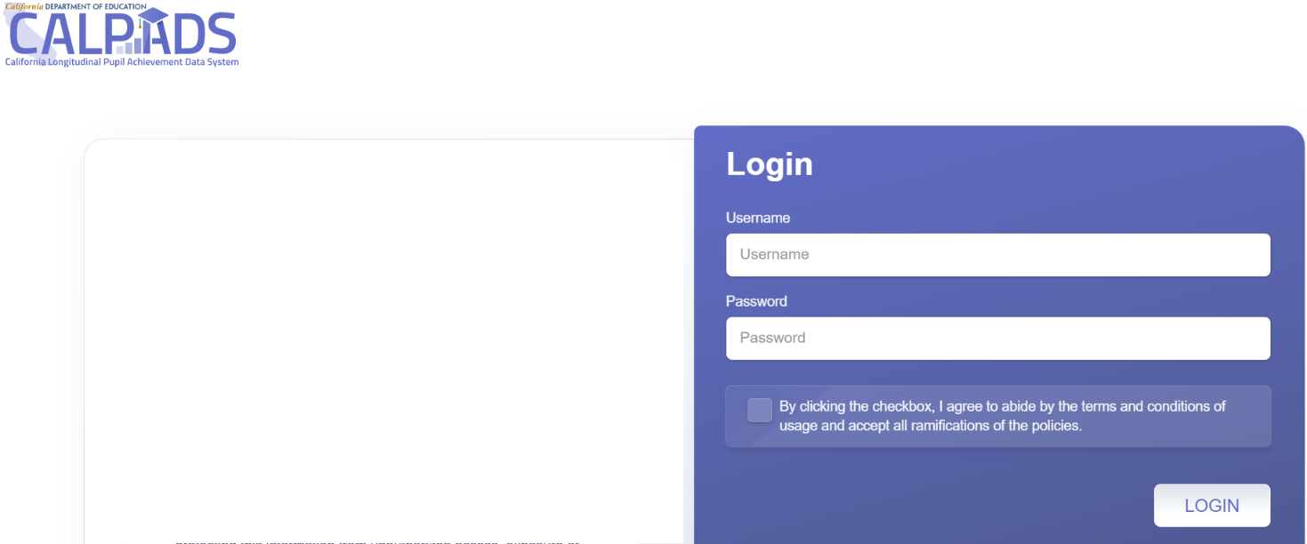

Step 2: Once you have logged on, if you do not see a navigation pane, select the hamburger menu at the top left on the CALPADS Welcome Page. (This is highlighted with a red box in Figure 2 below.) After the menu is selected, the navigation pane will appear to the left, which allows access to various CALPADS features.
To view the specific reports mentioned throughout this handbook, select ‘Reports.’ Next, select ODS Reports, Snapshot Reports, or Accountability/Monitoring Reports depending on the data you would like to access (e.g., suspension rate versus graduation rate). Figure 2 below shows these three types of reports. The sections following this page provide instructions on these reports and what LEAs should review before and after the data is certified.

Figure 2: CALPADS Welcome Page (Refer to Appendix B for the descriptive text.)
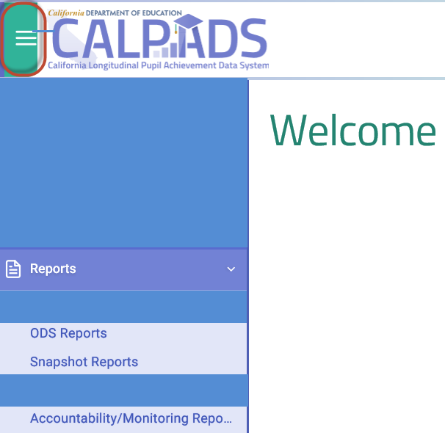
Note that Figure 2 does not fully portray the CALPADS Welcome page and only displays the reports that LEAs should focus on.

Graduation Rate Indicator

(A Grades 9–12 Indicator)

Which CALPADS Report Should you View?
The Graduation Rate Indicator on the Dashboard is a combined four-and five-year graduation rate. The rate consists of high school students who graduate with a regular high school diploma in four or five years.
The following CALPADS reports can be reviewed to verify your LEA/school’s four-year cohort graduation data:
  - CALPADS Report 15.1 Cohort Outcome – Counts and Rates, which reports four-year cohort outcome counts and cohort rates at the LEA, school, and student group levels. The counts also include students who are removed from the cohort calculation.
  - CALPADS Report 15.2 Cohort Outcomes – Student Details, which reports a list of individual student data that supports the aggregate view of Report 15.1.
The following CALPADS reports can also be used to potentially identify your LEA/school’s fifth-year graduates:
  - CALPADS Report 1.23 Graduates and Completers – Student List, which reports a list of individual students.
To access the latest information and business rules on the Graduation Rate Indicator for the Dashboard, please refer to the CDE Graduation Rate Indicator web page at https://www.cde.ca.gov/ta/ac/cm/dashboardgrad.asp.
Beginning with the 2022 Dashboard, the use of modified methods is no longer allowable due to the U.S. Department of Education’s (ED’s) denial of California’s use of a modified graduation rate (i.e., DASS one-year graduation rate) and modified cut scores for the Academic Indicator for accountability. Therefore, beginning with the 2022 Dashboard, DASS schools received the combined four-and five-year graduation rate for the Graduation Rate Indicator (rather than the DASS one-year graduation rate). However, the CDE and SBE are committed to continue reporting out the DASS one-year graduation rate for LEAs to use for local planning purposes and use.
The following CALPADS Reports can be reviewed to compile an estimate of the DASS one-year graduation rate:
  - CALPADS Report 8.1a Student Profile Exits – List, which provides exit information to assist LEAs in the calculation of the DASS one-year graduation rate. LEAs can glean their DASS one-year graduation rate at any time during the school year. However, it does not incorporate the DASS graduation rate business rules.
  - CALPADS Report 1.22 Graduates and Completers – Count also provides LEAs an estimate of their DASS one-year graduation rate. Similar to Report 8.1a, this report (and 1.23 below) does not incorporate the DASS one-year graduation rate business rules.
  - CALPADS Report 1.23 Graduates and Completers – Student List provides a list of individual student data that supports the aggregate view of Report 1.22.
Further information on the use of DASS for accountability can be accessed through the August 2022 SBE Memorandum at https://www.cde.ca.gov/be/pn/im/documents/aug22memogad01.docx and through the September 2022 SBE Agenda Item at https://www.cde.ca.gov/be/ag/ag/yr22/documents/sep22item03.docx.

Reports 15.1 and 15.2: Description
Reports 15.1 and 15.2 are available year-round. LEAs are encouraged to review these reports throughout the year, but specifically throughout the EOY data collection window. The data reflected in these reports are extracted from the ODS. They include:
  - Enrollment and exit data, which are used to calculate the four-year Adjusted Cohort Graduation Rate (ACGR) for state and federal reporting and factored into the calculation of the Graduation Rate Indicator for the Dashboard.
  - Completer indicator data (e.g., UC/CSU entrance requirements, State Seal of Biliteracy, Pre-Apprenticeships, State and Federal Job Program and Transition Work-Based Experience/Transition Classroom-Based Work Exploration), which are used to calculate the College/Career Indicator (CCI).
Once an LEA exits their students with the appropriate completer codes, these reports will allow LEAs to view their four-year cohort graduation data.
Please note that LEAs do not certify their cohort graduation data. After the EOY amendment deadline, which occurs at the end of August, the data used for the ACGR are immediately extracted from the CALPADS ODS. Any further updates made in CALPADS after the extraction will not be reflected in the Dashboard results.

Reports 8.1a, 1.22, and 1.23: Descriptions
Report 8.1a is also available year-round and it contains information for the one-year graduation count. With proper filters applied, viewers can use this report to verify and obtain an estimate number of graduates in the DASS graduation rate.
Reports 1.22 and 1.23 are only available during the EOY submission window (beginning in May) and contain information for any student who exits as a completer between August 16, 2023 through August 15, 2024. This report can be used to verify and obtain an estimate number of any graduates (i.e., fifth-year graduates, sixth-year graduates, etc.). With the proper filters applied, these reports can be used to verify and obtain an estimate number of fifth-year graduates for the combined four-and five-year graduation rate and the DASS one-year graduation rate. See CALPADS user manual for report logic.

How to Run CALPADS Reports 15.1 and 15.2 for the Four-Year Cohort
CALPADS reports 15.1 (Count and Rates) and 15.2 (Student Details) can be found within Cohort Outcome located under Accountability and Monitoring Reports as shown in Figure 3.

Figure 3: Accountability and Monitoring Reports
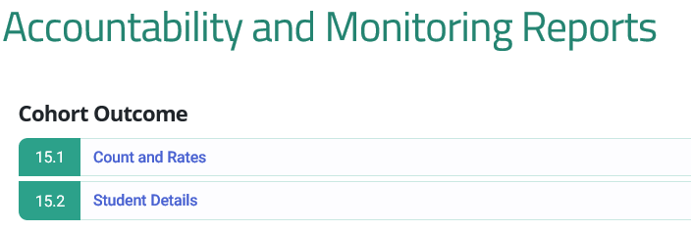
To review your four-year cohort graduation rates, run Report 15.1 by selecting the following filters (as they appear in Figure 4):
- School: Select a specific school of interest; otherwise, keep the default to access LEA-level data.
- Cohort Expected Graduation Year: Select the expected graduation year for the current four-year cohort. (For example, to view the data you are submitting for the 2024 Dashboard, select 2023–2024.)
- Student Groups: To view data for a specific student group, use the following available filters as displayed in Figure 4 from left to right: Ethnicity/Race, Students with Disabilities, Socio-economically Disadvantaged, English Learner, Foster Youth, and Homeless Program Eligible.
- Use the default for the remaining filters not listed above. After selecting all the filters, click on View Report.
The breadcrumbs at the top of Figure 4 identifies that by going through Home, Reports, and Accountability Reports, you can access the 15.1 – Cohort Outcome – Counts and Rates Report.

Figure 4: Report 15.1 – Cohort Outcome – Counts and Rates (Refer to Appendix B for the descriptive text.)
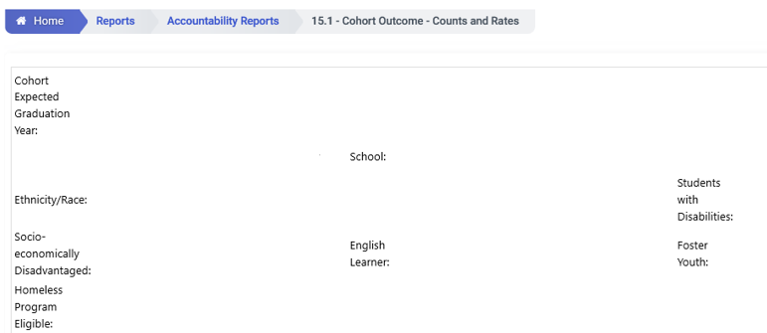
After running 15.1, there are three columns that should be reviewed. These columns are:
- Cohort Students which provides the total number of students in the four-year cohort in each school. For example, in Table 1 on the following page, School ABC has 567 students in the four-year cohort.
- Regular HS Diploma Graduates reflects the count and Regular HS Diploma Graduates Rate reflects the rate of the graduates in each school. As displayed in Table 1 on the following page, 556 students earned a standard diploma and the school’s four-year graduation rate is 98.06 percent. (For the definition of a Graduate, please reference the latest CALPADS Data Guide: A Guide for Program Staff at https://www.cde.ca.gov/ds/sp/cl/systemdocs.asp)

While this school-level report contains many fields, Table 1 on the following page reflects the two columns identified above.

Table 1: Report 15.1: School-Level Results
School Name | Cohort Students | Regular HS Diploma Graduates Count | Regular HS Diploma Graduates Rate
ABC | 567 | 556 | 98.06%
To view student-level information by school, click on the School Name of interest found in the School Name column of the results in 15.1. A student-level report (Report 15.2) will be produced. Table 2 below reflects the specific fields that you can review but note that the table only contains a portion of the actual report. You will also need to remove any students who are not included in the four-year cohort rate, such as those student records reflecting ‘RemovedFromCohort’ in the Cohort Category column. Schools and LEAs can obtain counts and other detailed information of the graduates from this report and compare it to the data in their local SIS.

Table 2: Report 15.2 Results: Student-Level Information by School
SSID | Entry Grade in Cohort | Entry Year in Cohort | Cohort Category
XXXXXXXXXX* | 9th Grade | 2019-2020 | HSDiplomaGraduate
XXXXXXXXXX* | 9th Grade | 2019-2020 | StillEnrolled
XXXXXXXXXX* | 9th Grade | 2019-2020 | RemovedFromCohort
* Note the Xs in the SSID column are used as an example and do not reflect a student’s true SSID.
At the LEA-level, the four-year cohort graduation rate in Report 15.1 is comprised of data for non-charter schools and charter schools. However, for the Dashboard, because charter schools are treated as LEAs under LCFF, refer to Total Selected Non-Charter Schools as shown in Figure 5 below to view an LEA’s four-year cohort graduation data. The Cohort Students column shows 4,785 students in the four-year cohort; the Regular HS Diploma Graduates contains two columns (Count and Rate). The Count column shows 4,311 students earned a standard diploma and the Rate column shows the district’s four-year graduation rate is 90.09 percent.

Figure 5: Report 15.1 LEA-Level Results (This figure only shows a portion of the actual report.)
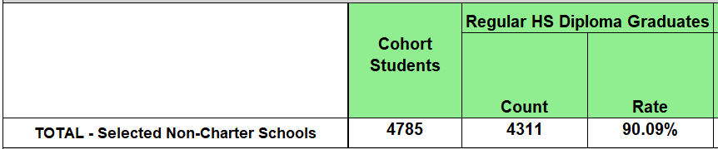
Because the Dashboard graduation rate consists of the four-year cohort graduation rate plus fifth year graduates, you can take the steps identified on the following page to determine the count of fifth-year graduates.

Determining an Estimate Number of Fifth-Year Graduates
First, run Report 15.2 for the prior year cohort (e.g., Class of 2023). Then, run Report 1.23 for the current year (e.g., 2023–24). Next, compare the two lists to determine which of the non-graduates from the prior cohort graduated in the current year. This will result in identifying a count of your fifth-year graduates who have a ‘100’ in the Student Completion Status column. Be sure to also use the cohort entry year information to ensure that the students are fifth-year graduates and not sixth or seventh-year graduates. Table 3 below reflects a portion of the results after running Report 1.23.
Table 3: Use Report 1.23 to Identify Fifth-Year Graduates
SSID | Enrollment Status | Student Exit Reason | Student Completion Status
XXXXXXXXXX* | 10-Primary enrollment | E230 | 100
* Note the Xs in the SSID column are used as an example and do not reflect a student’s true SSID.
Next, combine the students in Report 15.2 along with the fifth-year graduates you determined in Report 1.23. This list will provide you the estimated results for the students in your combined four- and five-year graduates.

DASS One-Year Graduation Rate: Two Methods to Estimate the Number of Graduates
LEAs can use two methods to determine an estimate number of graduates in their DASS one-year graduation rate. The first method is through Report 8.1a (Student Profile Exits), and the second method is through Reports 1.22 and Report 1.23 (Graduates and Completers).
Although there is currently no dedicated CALPADS report for the DASS one-year graduation rate, reports 8.1a, 1.22, and 1.23 include all students who graduated in a given year. However, they do not allow filtering of important business rules, such as the 90-day enrollment requirement, that are used to calculate the DASS graduation rate. To access the details on the DASS one-year graduation rate, please refer to the 2022 Dashboard Technical Guide for DASS, which is posted on the CDE Dashboard Resources web page at https://www.cde.ca.gov/ta/ac/cm/documents/dbguidedass22.docx.
As noted earlier, the core difference between these reports is that:
- Report 8.1 can be run any time during the year and has configurable dates.
- Reports 1.22 and 1.23 can only be run during the EOY submission window (beginning in May) and the dates are pre-configured (i.e., reflects only students who exit as a completer between August 16, 2023 through August 15, 2024).

First Method: Run CALPADS Report 8.1a
CALPADS report 8.1a is located under ODS Reports as shown in Figure 6. Figure 6 identifies the filters to apply and student-level results.
To obtain an estimated count of graduates in the DASS graduation rate, apply the following filters listed below (as shown in Figure 6 on the following page):
- Academic Year: Select the current academic year
- School: Select a DASS school
- Grade: Select 11–Eleventh Grade and 12–Twelfth Grade
- Enrollment Status: Select 10–Primary enrollment and 30–Short term enrollment
- From Date: Select August 16 for the start of each graduation cycle
- Through Date: Select August 15 for the end of the graduation cycle
- Completion Status: select the following filters:
  - 100 – Graduated, standard HS diploma
  - 102 – Pathway Diploma for Students with Disabilities (new for 2024)
  - 120 – Student with Disabilities Certificate of Completion
  - 250 – Adult Ed High School Diploma
  - 320 – Received a High School Equivalency Certificate
  - 330 – Received a CA Certificate of Proficiency (and no standard HS diploma) Use the default for the remaining filters not listed above. After selecting all the filters, click on View Report.

Figure 6: Report 8.1a – Student Profile Exits – List
The breadcrumbs at the top of the figure show that by going through Home, Reports, and ODS Reports, you can access the 8.1a – Student Profile Exits – List.
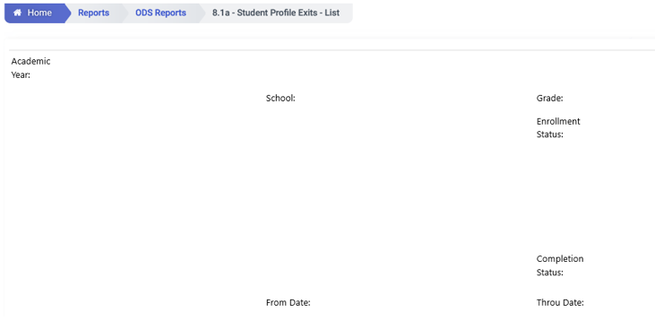

Table 4 below shows a portion of Report 8.1a results.

Table 4: Report 8.1a Student Profile Exits – List
School Name | SSID | Grade | Enrollment Status | Start Date | Exit Date | Completion Status
ABC | XXXXXXXXXX* | 12 | Primary enrollment | 10/14/2021 | 5/29/2022 | Graduated, standard HS diploma
* Note the Xs in the SSID column are used as an example and do not reflect a student’s true SSID.
Further evaluation of the student list can be done by reviewing the student’s enrollment start and exit dates to confirm if a student was enrolled at the DASS school cumulatively for 90 days.

Second Method: Run CALPADS Report 1.22 and 1.23
CALPADS Reports 1.22 and 1.23 can be found within EOY3 (End of Year 3) located under Snapshot Reports. Scroll down to the section on EOY3 to access 1.22 Graduates and Completers – Count and 1.23 Graduates and Completers – Student List. (Figure 7 below shows these reports.)
Graduate and Completers Reports (SN 1.22/SN 1.23/CA1.22) to display completion statuses and to enable LEAs to better check for data quality:
•Graduate with Local Exemption Indicator (filter)
•Alternative Diploma Pathway (School Completion Status = 102)
•Prior Year Academic Year (Informational Only) graduate count to enable LEAs to compare counts to selected academic year

Figure 7: Reports 1.22 and 1.23 in EOY3 Snapshot Reports
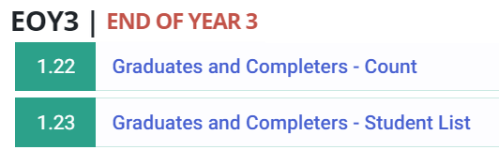
Figure 8 on the following page identifies the filters to apply and the student-level results. The breadcrumbs at the top of Figure 8 show that by going through Home, Reports, and Snapshot Reports, you can access 1.22 – Graduates and Completers – Count.
To obtain an estimated count of graduates in the DASS graduation rate, apply the filters below:
- Academic Year: Select the current academic year.
- Status: Select Revised Uncertified. (Revised-uncertified reflects possible ongoing updates of the data.)
- School: Select the school of your choice. When reviewing the data for all schools within the LEA, deselect all charter schools. (Charter schools are considered LEAs under LCFF and therefore their data are not included in the LEA count.)
- Grade: Select 11–Eleventh Grade and 12–Twelfth Grade.
- Enrollment Status: Select 10–Primary enrollment and 30–Short term enrollment.
- Student Groups: To view data for a specific student group, use the available filters available from left to right in Figure 8: Ethnicity/Race, Students with Disabilities, Socio-economically Disadvantaged, English Language Acquisition Status, and Foster Youth.
- Adult Age Students with Disabilities Transition Status: Students who are marked with the “Y” are removed from the denominator of the DASS graduation rate. (Note that this filter is available in this report but not in Report 8.1a.)
- Use the default for the remaining filters not listed above. After selecting all the filters, click on View Report.
These filters are all reflected in Figure 8 below.

Figure 8: Report 1.22 – Graduates and Completers – Count
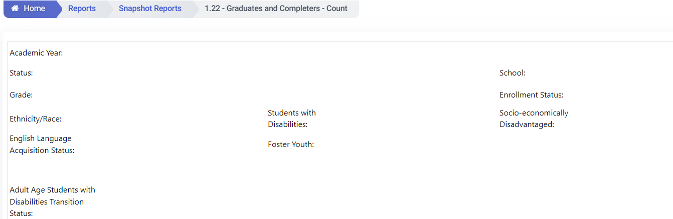
After running Report 1.22, there are several columns that should be reviewed. These columns are:
- Total Graduates and Completers (Unduplicated), which provides the total number of students who graduated with a regular diploma or received a CA Certificate of Proficiency (and no standard HS diploma), an Adult Ed high school diploma, Special Education Certificate of Completion, or a General Educational Development (GED). For example, in Table 5 on the following page, School ABC has 71 total graduates and completers. This total was derived from having 68 students receiving a regular diploma, one student completing the CHSPE, no students earning the Adult Education Diploma, one student earning the Special Education Certificate of Completion, and one student completing the GED.
While Report 1.22 contains many fields, Table 5 only shows the columns described above.

Table 5: Report 1.22 Graduates and Completers – Count Results
School Name | Total Graduates and Completers (Unduplicated) | Regular HS Diploma Graduates | CHSPE Completers | Adult Ed. HS Diploma | Special Ed. Certificate of Completion | GED Completers
ABC | 71 | 68 | 1 | 0 | 1 | 1
To view student-level information by school, click on the School Name of interest found in the School Name column of the results. A student-level report (Report 1.23) will be produced. Table 6 below reflects a portion of this report. Schools and LEAs can obtain counts and other detailed information of the graduates from this report (such as the start date, exit date, exit reason, and completion status) and compare it to the data in their local SIS. Note that Table 6 only contains a portion of the actual report, and the report itself has many fields that the LEA can use to check if the data for each student is accurate.

Table 6: Report 1.23 Results: Student-Level Information by School
SSID | Adult Age Students with Disabilities Transition Status | Student Enrollment Start Date | Student Enrollment Exit Date | Student Exit Reason | Student Completion Status
XXXXXXXXXX* | N | 9/15/2021 | 5/4/2022 | E230 | 100
XXXXXXXXXX* | Y | 1/10/2022 | 5/26/2022 | E230 | 100
* Note the Xs in the SSID column are used as an example and do not reflect a student’s true SSID.

How to Run CALPADS Reports 15.1 and 15.2 for Specific CCI Measures
In addition to providing information on the graduation rate, Reports 15.1 and 15.2 can be used to view student completion of specific CCI measures, which are flagged Y/N upon graduation:
- a-g Completion: Report 15.1 and 15.2
- State Seal of Biliteracy: Report 15.1 and 15.2
- Pre-Apprenticeship Certification Program: Report 15.2
- Pre-Apprenticeship Program (Non-registered): Report 15.2
- State or Federal Job Program: Report 15.2
- Transition Work-Based Experience: Report 15.2
- Transition Classroom-Based Work Exploration: Report 15.2
With the changes to cohort reports this year, there are four new counts and rates displayed, which are attributes of Regular HS Diploma:
- Graduates Meeting UC/CSU requirements
- Graduates earning Seal of Biliteracy
- Graduates earning Golden Seal Merit Diploma
- Graduates with local Exemptions
The UC/CSU counts have been displayed on the one-year graduation reports for a long time, but now LEAs have the opportunity to review them in another report. All four of these counts/rates are under a new heading, “Regular HS Diploma Attributes.”
All the changes apply to reports for 15.1, 15.2, and C/A 15.1

The filters for UC/CSU requirements met (i.e., a-g completion) and State Seal of Biliteracy are available in Report 15.1 and Report 15.2, as shown in Figure 9 on the following page. This figure also identifies the specific filters that you will need to apply.
Please note that when selecting “Y” in the filters for these measures, be sure to select only one measure of interest at a time. In programming terms, the relationship between the filters is AND, meaning that if you select “Y” for multiple measures at the same time, the report will show data that meets “Y” conditions for all the measures selected.
The breadcrumbs at the top of Figure 9 show that by going through Home, Reports, and Accountability Reports, you can access the 15.1 – Cohort Outcome – Counts and Rates Report.

Figure 9: Reports 15.1 and 15.2: a-g Completion and State Seal of Biliteracy
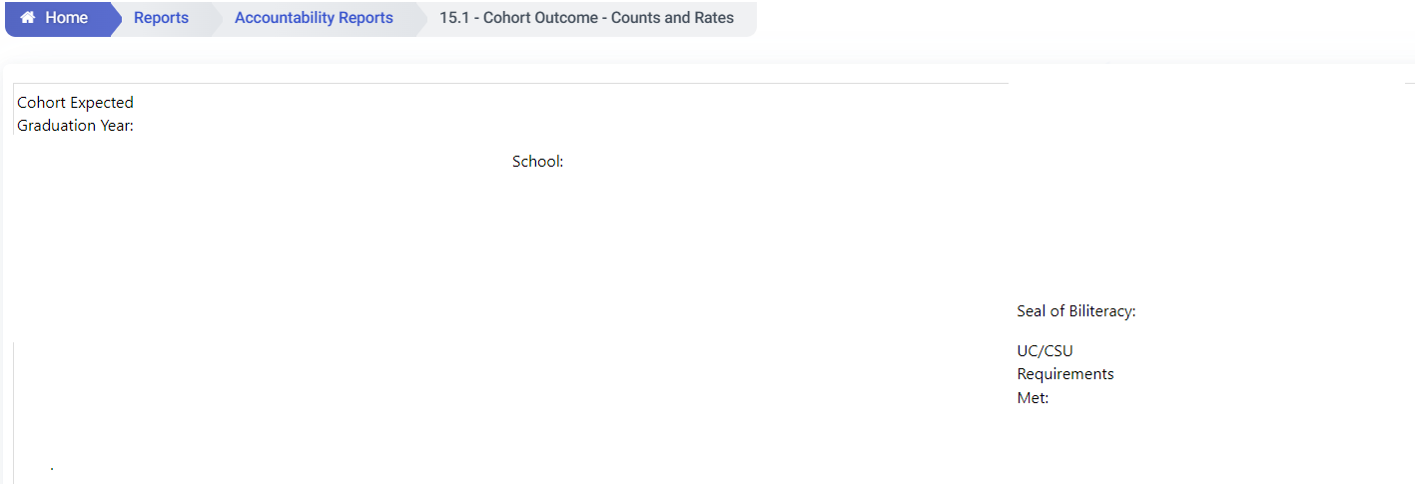

a-g Completion
To obtain a count on the number of students in the four-year cohort who completed a-g requirements, apply the following filters (as shown in Figure 9):
- Cohort Expected Graduation Year: Select the expected graduation year of the four-year cohort.
- School: Select a specific school of interest; otherwise, keep the default to access data for all schools in the LEA.
- UC/CSU Requirements Met: Select Y.
- Use the default for the remaining filters not listed above. After selecting all the filters, click on View Report.
Table 7 on the following page shows a sample report produced for a-g Completion.

Table 7: Count of a-g Completers
School Name | Regular HS Diploma Graduates Count | Regular HS Diploma Graduates Rate
ABC | 150 | 100.00%
XYZ | 170 | 100.00%
TOTAL - Selected Non-Charter Schools | 320 | 100.00%
The column labeled Count under Regular HS Diploma Graduates provides the number of a-g completers in each school. For example, in the table above there are 150 a-g completers in ABC school and 170 a-g completers in XYZ school. For the purposes of reviewing the data at the LEA-level, refer to the total for non-charter schools only. (Charter school data should be excluded because charter schools are considered LEAs under LCFF.) In Table 7, there are 320 a-g completers in the LEA’s four-year cohort.
Note: This report does not provide the actual percentage of students in the four-year cohort who completed a-g requirements. The report will always show a rate of 100 percent because it uses the count of students who completed a-g requirements as the numerator and denominator when the filter is applied.
To view student-level information, click the School Name of interest found in the School Name column of the results. Table 8 displays a portion of the student-level information for the a-g completers.

Table 8: Detailed Information of a-g Completers
SSID | UC/CSU Requirements Met
XXXXXXXXXX* | Yes
* Note the Xs in the SSID column are used as an example and do not reflect a student’s true SSID. The report has many fields. The screenshot above shows the portion that captures the a-g field.

State Seal of Biliteracy
To obtain a count on the number of students in the four-year cohort who earned the State Seal of Biliteracy, apply the following filters to Report 15.1 (as shown in Figure 9 on the prior page):
- Cohort Expected Graduation Year: Select the expected graduation year of the four-year cohort.
- School: Select a specific school of interest; otherwise, keep the default to access data for all schools in the LEA.
- Seal of Biliteracy: Select Y.
- Use the default for the remaining filters not listed above. After selecting all the filters, click on View Report.
Table 9 below shows a portion of the sample report for the State Seal of Biliteracy.

Table 9: Count of Students Who Earned State Seal of Biliteracy
School Name | Regular HS Diploma Graduates Count | Regular HS Diploma Graduates Rate
ABC | 29 | 100.00%
XYZ | 37 | 100.00%
TOTAL - Selected Non-Charter Schools | 66 | 100.00%
The column labeled Count under Regular HS Diploma Graduates provides the total number of graduates, in each of the LEA’s schools, who earned State Seal of Biliteracy. For example, there are 29 graduates in ABC school and 37 graduates in XYZ school who earned State Seal of Biliteracy. For the purpose of reviewing the data at the LEA-level, refer to total non-charter schools only. (Charter school data should be excluded because charter schools are considered LEAs under LCFF.) There are 66 students who earned the seal in the LEA’s four-year cohort.
Note: Similar to the a-g results, this report does not provide the actual percentage of students in the four-year cohort who earned the State Seal of Biliteracy. The report will always show a rate of 100 percent because it uses the count of students who earned the State Seal of Biliteracy as the numerator and denominator when the filter is applied.
To view student-level information, click the School Name of interest found in the School Name column of the results. Table 10 below displays student information for the students who earned the State Seal of Biliteracy.

Table 10: Detailed Information of Students Who Earned State Seal of Biliteracy
SSID | Seal of Biliteracy
XXXXXXXXXX* | Yes
* Note the Xs in the SSID column are used as an example and do not reflect a student’s true SSID. The report has many fields, the table above shows the portion that captures the State Seal of Biliteracy field.

Pre-Apprenticeships, State or Federal Job Programs, and Transition Work-Based Experience/ Transition Classroom-Based Work Exploration
The filters in Report 15.2 allow you to focus on the following CCI measures as shown in Figure 10 from left to right: State or Federal Job Program Completion, Pre-Apprenticeship Certification Program Completion (also known as Registered Pre-Apprenticeship), Pre-Apprenticeship Program (non-registered), Transition Classroom-based Work Exploration, Transition Work-based or Classroom-based Work Experience, and Transition Work-based Experience. The remaining two filters in Figure 10 (i.e., ‘Cohort Expected Graduation Year:’ and ‘Cohort Category’) are explained in detail on the following pages.
The breadcrumbs at the top of Figure 10 show that by going through Home, Reports, and Accountability Reports, you can access the 15.2 – Cohort Outcome – Student Details.
Figure 10: Report 15.2 - Cohort Outcome – Student Details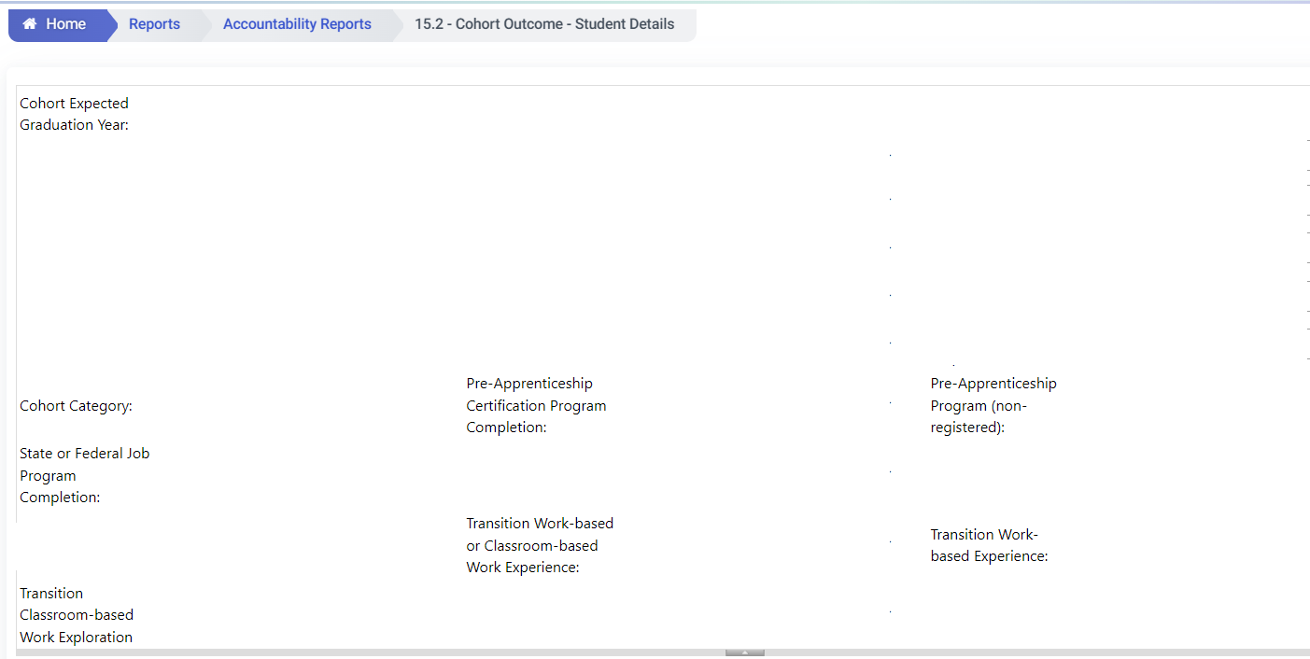
Again, please note that when selecting “Y” in the filters for these measures, be sure to select only one measure of interest at a time. In programming terms, the relationship between the filters is AND, meaning that if you select “Y” for multiple measures at the same time, the report will show data that meets “Y” conditions for all the measures selected. If you keep the cohort category filter as default, you will get a list of both graduates and non-graduates who completed a particular measure. Also note that only graduates who complete specific measure(s) are counted in CCI.

Pre-Apprenticeship Program (Non-Registered)
To obtain a count of students who completed a non-registered Pre-Apprenticeship, apply the following filters that appear in Figure 10:
- Cohort Expected Graduation Year: Select the expected graduation year of the four-year cohort.
- Cohort Category: Select the category of interest.
- School: Select a specific school of interest.
- Pre-Apprenticeship Program (Non-Registered): Select Y.
- Use the default for the remaining filters not listed above. After selecting all the filters, click on View Report.
Table 11 below shows a portion of the sample report for non-registered Pre-Apprenticeship.

Table 11: Report 15.2: Pre-Apprenticeship Program (Non-Registered)
SSID | Pre-Apprenticeship Program (Non-Registered) Completion
XXXXXXXXXX* | Y
* Note the Xs in the SSID column are used as an example and do not reflect a student’s true SSID.

Pre-Apprenticeship Certification Program
Note that the name of the Pre-Apprenticeship Certification Program is also known as the Registered Pre-Apprenticeship Program. To obtain a count of students who completed the Pre-Apprenticeship Certification Program for the four-year cohort, apply the following filters that appear in Figure 10:
- Cohort Expected Graduation Year: Select the expected graduation year of the four-year cohort.
- School: Select a specific school of interest.
- Pre-Apprenticeship Certification Program Completion: Select Y.
- Cohort Category: Select the category of interest.
- Use the default for the remaining filters not listed above. After selecting all the filters, click on View Report.
Table 12 below shows a sample report for certified Pre-Apprenticeship.

Table 12: Report 15.2: Pre-Apprenticeship Certification Program Completion
SSID | Pre-Apprenticeship Certification Program Completions
XXXXXXXXXX* | Y
* Note the Xs in the SSID column are used as an example and do not reflect a student’s true SSID.

State or Federal Job Program Completion
To obtain a count of students who completed a State or Federal Job Program for the four-year cohort, apply the following filters that appear in Figure 10:
- Cohort Expected Graduation Year: Select the expected graduation year of the four-year cohort.
- School: Select a specific school of interest.
- State or Federal Job Program Completion: Select Y.
- Cohort Category: Select the category of interest.
- Use the default for the remaining filters not listed above. After selecting all the filters, click on View Report.
Table 13 below shows a portion of the sample report for this measure.

Table 13: Report 15.2: State or Federal Job Program Completion
SSID | State or Federal Job Program Completion
XXXXXXXXXX* | Y
* Note the Xs in the SSID column are used as an example and do not reflect a student’s true SSID.

Transition Work-Based Experience/Transition Classroom-Based Work Exploration
In prior years, the two transition measures (which apply specifically for Students with Disabilities [SWDs]) were reported together within one field. LEAs could only ascertain the count of students who completed either the Transition Work-based Experience or the Transition Classroom-based Work Exploration but could not determine which measure the students completed. Beginning in 2021–22, these data have been separated to better assist LEAs with reconciling these data against their local SIS. Therefore:
- The Transition Work-based or Classroom-based Work Experience filter in Report 15.2 is still available to use to view data for years prior to 2021–22.
- From 2021–22 on, users are able to see these two measures in separate columns.
Viewers can use the filters below – that appear in Figure 10 – to obtain a count of students who completed either the Transition Work-based Experience or the Transition Classroom-based Work Exploration:
- Cohort Expected Graduation Year: Expected graduation year of the four-year cohort.
- School: Select a specific school of interest.
- Transition Work-based Experience / Classroom-based Work Exploration:
  - To access the list of students who completed the Transition Work-based Experience measure, select “Y” for that measure but keep the other measure (Classroom-based Work Exploration) with the default. Be sure to select only one measure of interest at a time as the relationship between the filters is AND, meaning that if you select “Y” for multiple measures at the same time, the report will show data that meets “Y” conditions for all the measures selected. Note that in order to be Prepared for the CCI, a SWD must complete both Transition Work-based Experience and Classroom-based Work Exploration. Therefore, you may wish to run both filters as “Y” at the same time to get an idea as to how many students could potentially be Prepared.
- Cohort Category: Select the category of interest.
- Use the default for the remaining filters not listed above. After selecting all the filters, click on View Report.
Table 14 below shows a portion of the sample report for this measure.

Table 14: Report 15.2: Transition Work-based Experience/Transition Classroom-based Work Exploration
SSID | Transition Work-based Experience | Transition Classroom-based Work Exploration
XXXXXXXXXX* | N | Y
* Note the Xs in the SSID column are used as an example and do not reflect a student’s true SSID

Some Questions to Consider
While reviewing your data in CALPADS, you may wish to consider a few questions:
- Have I submitted the data within the established time frame?
- Am I referencing the correct reports?
- Am I applying the filters appropriately?
- Does my data look reasonable when compared to prior year data? Are the counts too high? Or too low? Possible causes?
If you find prominent errors/discrepancies, you may want to verify the student-level data provided in CALPADS Report 15.2.

How to Reconcile your CALPADS Data Against Your Local Student Information Data System
To ensure accurate reporting of LEA and school results in the Dashboard, LEAs must submit all graduate data to CALPADS by August 15. These data will be extracted out of CALPADS immediately after the close of the EOY amendment window deadline and used to calculate the Graduation Rate Indicator and the CCI.
In addition, it is advised that LEAs/schools compare their local SIS data to their CALPADS data on a regular basis. LEAs should also keep in mind that the data reflected in Reports 15.1 and 15.2 are based on ODS data and not certified data. When ODS data are extracted for use for the Dashboard, it reflects the latest data in the ODS at the time of the extraction. Therefore, LEAs must confirm the accuracy of their data in ODS at the time they certify their EOY data.

Why Dashboard Data May Not Match Your CALPADS Report
In some cases, the data in the CALPADS Reports may not match the data reported on the Dashboard.
- Both the CCI and the Graduation Rate Indicator are comprised of students from:
- Current-Year Cohort: Students in the most recent four-year cohort who graduate in four years, and
- Prior-Year Cohort: Students from the prior-year cohort who graduated in their fifth year
In contrast, Reports 15.1 and 15.2 reflect only those students in the four-year cohort; viewers should take this into account when making comparisons between CALPADS reports and Dashboard data.
- The Graduation Rate Indicator has been subject to several changes since it was first adopted and reported in 2017. Please refer to the most recent Dashboard Technical Guide noted on the following page for the latest business rules.
- Furthermore, at the LEA-level, charter school data should be excluded because charter schools are considered LEAs under LCFF. Therefore, please refer to the data of the non-charter schools if you are interested in LEA-level data for Dashboard purposes.
- All SWDs are included in their district of residence’s Dashboard report and therefore, this “District of Residence” rule applies at the LEA-level only. Tracking which SWDs are being attributed to your LEA can be difficult and therefore, this may also cause a non-match in counts between the CALPADS Reports, the Dashboard, and your local student information system. The district of residence is recorded as the ‘District of Special Education Accountability’ (field #14.16; file SPED) in CALPADS. Further information about this rule is detailed in the District of Residence section towards the end of this handbook.
The CCI uses multiples years of data to produce the CCI. This section is focused on making sure that the data for the CCI measures submitted for the four-year graduation cohort is submitted accurately.

What if Your Data Is Incorrect on the Dashboard Preview Site?
LEAs will have access to privately preview their Dashboards one week prior to its public release. The preview is only accessible to registered Dashboard Coordinators. The public release of the Dashboard will occur on or before December 1, 2024.
As a reminder, no corrections can be made to the data after the close of EOY. As discussed in the Introduction, the CDE will not extract new data from CALPADS to update the Dashboard after the CALPADS EOY certification deadline. As a result, it is good practice to monitor and review your CALPADS Reports and note the certification deadline. However, the Dashboard Coordinator can make use of the optional narrative section in the Dashboard to share explanations of data errors/discrepancies with Dashboard viewers.

Other Sources
The following resources provide additional information:
- The Graduation Rate Indicator web page (https://www.cde.ca.gov/ta/ac/cm/dashboardgrad.asp) and the College/Career Indicator web page (https://www.cde.ca.gov/ta/ac/cm/dashboardccr.asp) contain general and technical information in regard to each state indicator. These pages also include a link to the Dashboard Technical guide, which details the calculation methodology and rules used to produce these indicators.
- The Graduation Rate Placement Report identifies the performance level that an LEA, school, and student group received on the Dashboard. This report is available on the School Dashboard Additional Reports web page at https://www.cde.ca.gov/ta/ac/cm/dbadditionalrpts.asp.
- The College/Career Measures Additional Report shows the number and percentage of students who completed specific CCI measures. This report is available on the CDE School Dashboard Additional Reports web page at https://www.cde.ca.gov/ta/ac/cm/dbadditionalrpts.asp.
- The CALPADS System Documentation provides detailed information on CALPADS and the steps needed to use the system. This documentation is available on the CDE CALPADS System Documentation web page at https://www.cde.ca.gov/ds/sp/cl/systemdocs.asp.

College/Career Indicator
(A Grades 9–12 Indicator)

Which CALPADS Reports Should You View
The CCI contains multiple measures, many of which are collected from LEAs in CALPADS. This section will help LEA and/or school staff review current year CALPADS data elements used in the CCI to ensure that the data submitted through the EOY submission window is accurate. This section will also only focus on three CCI measures–College Credit, Leadership/Military Science, and CTE Pathway–and the reports specific to these measures.
- For completion of College Credit and Leadership/Military Science, refer to:
- CALPADS Report 3.10 Course Sections Completed - Count and Details for Departmentalized Courses, which reflects aggregate data at the district, school, and student group levels.
- CALPADS Report 3.11 Course Sections Completed - Student List for Departmentalized Courses, which provides course completion data for individual students.
- For completion of the Career Technical Education (CTE) Pathway, refer to:
- CALPADS Report 3.19 Career Technical Education Completers - Count by Pathway, which reflects aggregate data at the district, school, and student group levels.
- CALPADS Report 3.20 Career Technical Education Completers - Student List (New Report), which provides CTE completion data for individual students.
Each of the above reports reflects which courses students completed in a given school year. Because the CCI uses data that a graduate achieved during high school, the last four or five years of data are used for each student depending on if the student graduated in four or five years. Considering this, you will have to access and review the last four or five years of Reports 3.10. 3.11, 3.19, and 3.20 for each student in your Graduation Rate Indicator to match to the CCI.
We encourage LEAs to begin reviewing these reports when the EOY window opens to confirm that the data are accurate and pinpoint possible problems and errors before the closure of the EOY certification deadline.
Other CCI Measures:
Several CCI measures reside in Reports 15.1 (Graduation Count and Rates) and/or 15.2 (Student Details), which are discussed in detail in the Graduation Rate Indicator section of this handbook. These measures include:
- a-g
- State Seal of Biliteracy
- Pre-Apprenticeship Certification Program
- State or Federal Job Program
- Transition Work-based Experience/Transition Classroom-based Work Exploration
The remaining CCI measures are collected outside of CALPADS, from test vendors, and are not covered in this handbook. They are:
- Advanced Placement Exams: collected from The College Board
- International Baccalaureate (IB) Exams: collected from IB
- Smarter Balanced Summative Assessments: collected from the testing vendor, Educational Testing Service

How to Run the CALPADS Report 3.10, 3.11, 3.19 and 3.20
The data submitted for College Credit, Leadership/Military Science, and CTE Pathway can be located under Snapshot Reports. Within EOY1 (End of Year 1), select a report (3.10 - Course Sections Completed - Count and Details for Departmentalized Courses, 3.11- Course Sections Completed - Student List for Departmentalized Courses, 3.19 Career Technical Education Completers - Count by Pathway, or 3.20 Career Technical Education Completers – Student List) as shown in Figure 11.

Figure 11: CALPADS Snapshot Reports Page for EOY 1
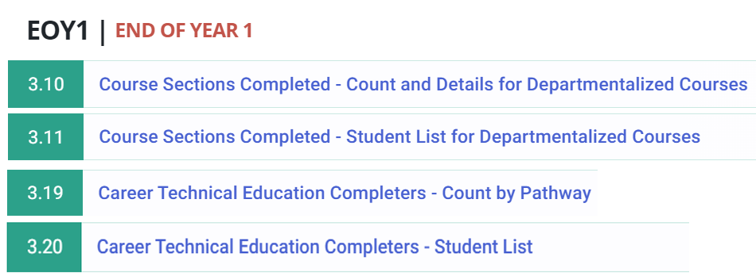

College Credit Courses
This measure includes both College Credit Courses and CTE College Courses. Completion data on both types of courses are reported in Report 3.10.
To get a count of students who completed College Credit courses/CTE College Courses for an academic year, apply the following additional filters in Report 3.10 as shown in Figure 12. The breadcrumbs at the top of Figure 12 identifies that by going through Home, Reports, and Snapshot Reports, you can access the 3.10 – Home - Reports - Snapshot Reports - Course Sections Completed - Count and Details for Departmentalized Courses.

Figure 12: Report 3.10: Apply Filters for College Credit Courses
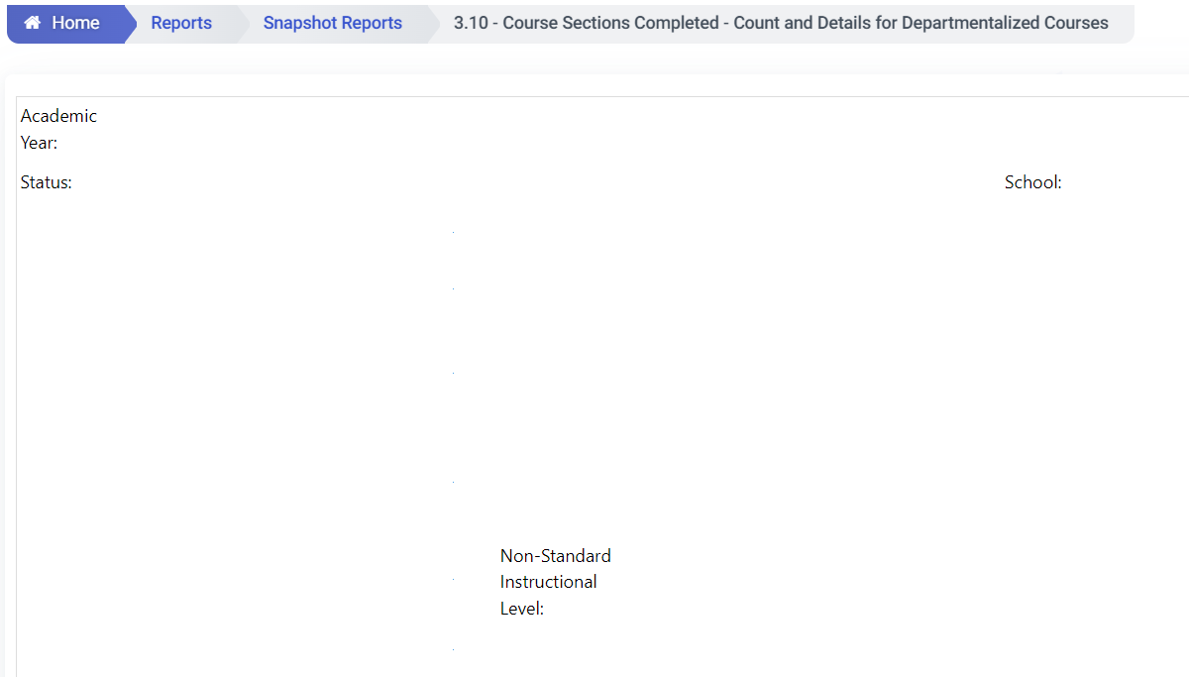
- Academic Year (shown in image above): Select the academic year of your report. (For example, to confirm the data that will be used to generate the 2024 CCI, select 2023–2024.)
- Status (shown in image above): Select LEA Approved. (The Status filter has two options: LEA Approved and Revised-uncertified. Prior to the close of the certification deadline, you should always select the Revised Uncertified status to ensure you’re looking at the most current data in the ODS. Select LEA Approved only after your data have been certified.)
- School (shown in image above): Select your school. (Note that there is no LEA-level report.)
- Non-Standard Instructional Level (shown in image above): Starting in 2019–20, for CTE college credit courses (course code 7000-8999), Non-Standard Instructional Level Code [Field #9.19] of “23-College Credit only” and/or “24 – Dual Credit” must also be selected to be counted as college credit courses for CCI purposes.
  - Note: The filtering for CTE college credit courses has to be completed separately. First, filter for the CTE courses and then filter the Non-Standard Instruction Level Code “23-College Credit only” or “24 – Dual Credit.”
- State Course Code: Select College Credit Courses/CTE College Courses code as appropriate. See Appendix A for course code specifications as codes that were newly established in 2019–20 as well as retired codes (used prior to 2019–20) are all used to determine which graduates completed the College Credit measures.
- Use the default for the remaining filters not listed above. After selecting all the filters, click on View Report.
Viewers can run the reports to view the aggregate counts by school. Table 15 below shows that the total counts of students who earned college credit are further broken down by specific State Course Code and Non-Standard Instructional Level for each school.

Table 15: Report 3.10 on College Credit – Counts Results
School Name | State Course Code | Non-Std Inst Lvl | Total
ABC | 9200-College Credit Course - History/Social Science | 24-Dual Credit | 1
XYZ | 9227-College Credit Course – Visual Arts | 24-Dual Credit | 40
Note: The report has many fields. The table above shows the most relevant information in the report.
Viewers can also select a School Name of interest to view the data by individual students as shown in Table 16 below. Viewers may find it useful to verify data fields such as SSID, Marking Period (used to identify term types) and Final Grade as per the CCI business rules. For more details, please refer to Appendix A on Marking Period and the most recent Dashboard Technical Guide for the grade requirement.

Table 16: Report 3.11 on College Credit - Student List Results
SSID | Marking Period | Final Grade
XXXXXXXXXX* | S2 | A
XXXXXXXXXX* | S1 | B
* Note the Xs in the SSID column are used as an example and do not reflect a student’s true SSID. The report has many fields. The table above shows the most relevant information in the report.

Leadership/Military Science
Over the years, the CALPADS course code for Leadership/Military Science has continued to be updated:
- Code 2505: Leadership/Military Science (prior to July 1, 2019)
- Code 9373: Leadership/Military Science (as of July 1, 2019)
- Code 9374: Junior Reserve Officers Training Corps (JROTC) (starting July 1, 2021)
All three codes are used to determine if graduates completed this measure over the last four or five years. Apply filters in Report 3.10, as shown in Figure 13 on the following page, to generate a report. The breadcrumbs at the top of Figure 13 identifies that by going through Home, Reports, and Snapshot Reports, you can access Report 3.10 – Course Sections Completed - Count and Details for Departmentalized Courses.

Figure 13: Apply Filters for Leadership/Military Science
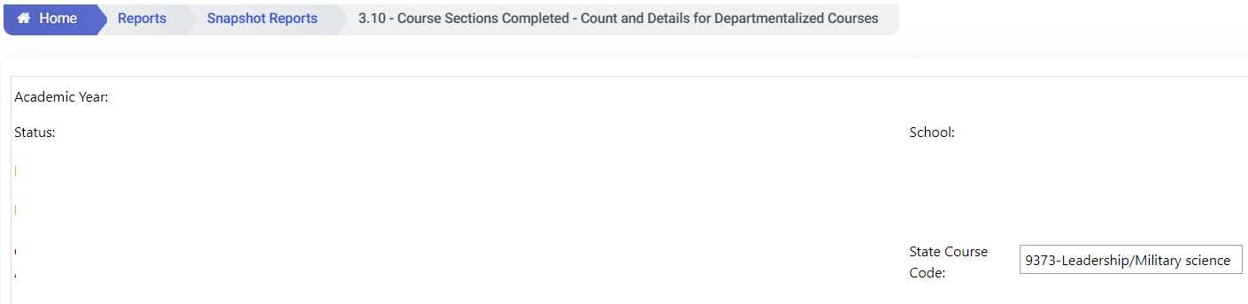
- Academic Year (shown in image above): Select the academic year of your report. (For example, to confirm the data that will be used to generate the 2024 CCI, select 2023–2024.)
- Status (shown in image above): Select LEA Approved. (The Status filter has two options: LEA Approved and Revised-uncertified. Select LEA Approved after your data has been certified. Revised-uncertified reflects possible ongoing updates of the data.)
- School (shown in image above): Select your school. (Note: that there is no LEA-level report.)
- State Course Code (shown in image above): Select “9373 - Leadership/Military science” as referenced in Figure 13. Re-run this report again using “9374 – JROTC” as this course code is also used to determine which students completed the Leadership/Military Science measure for the CCI.
- Use the default for the remaining filters not listed above. After selecting all the filters, click on View Report.
Table 17 below shows data for ABC School. There are two Local Course ID and Course Names under State Course Code 9373 for Leadership/Military Science. Course 07905A-Aerospace I: Aviation has a total number of 26 completers; course 07907A-Aerospace III: Exploration of Space has a total number of 19 completers.

Table 17: Report 3.10 on Leadership/Military Science - Counts Results
School Name | State Course Code | Local Course ID & Course Name | Total
ABC | 9373-Leadership/Military science | 07905A-Aerospace I: Aviation | 26
ABC | 9373-Leadership/Military science | 07907A-Aerospace III: Exploration of Space | 19
Note: The report has many fields. The table above shows the most relevant information in the report.

Table 18 below shows data for ABC School but for JROTC. There is one Local Course ID and Course Names under State Course Code 9374. Course 77325-SFJROTC 2 has a total number of 7 completers.

Table 18: Report 3.10 on Leadership/Military Science - Counts Results
School Name | State Course Code | Local Course ID & Course Name | Total
ABC | 9374-Junior Reserve Officers Training Corps (JROTC) | 77325-SFJROTC 2 | 7
Note: The report has many fields. The table above shows the most relevant information in the report.
Be sure to sum the Total columns in Tables 17 and 18 to ascertain the complete counts for Leadership/Military Science and JROTC for the school in a given academic year.
To view student-level information for students who completed Leadership/Military Science or JROTC, click on the School Name of interest. Viewers can check data fields such as SSID, Marking Period (used to identify term types, for more detail, please refer to Appendix A) and Final Grade against the CCI criteria. Table 19 below reflects these fields and shows an example for Leadership/Military Science.

Table 19: Report 3.11 Report on Leadership/Military Science – Student List Results
SSID | Marking Period | Final Grade
XXXXXXXXXX* | S2 | A
XXXXXXXXXX* | S1 | B
* Note the Xs in the SSID column are used as an example and do not reflect a student’s true SSID. The report has many fields. The table above shows the most relevant information in the report.

CTE Pathway Completion
CTE Pathway Completion data comes from the Student CTE (SCTE) file, which details all CTE pathways a student completed and in which year. Note that only students who meet the requirements to be a CTE Completer should be reported in this file. CTE Non-Completer Participants (i.e., students who just happen to complete a CTE course but are not in any CTE pathway and CTE students completing their concentrator course), should not be reported.
Currently, the CCI only counts CTE completers (CALPADS data field #11.14). To get a count on the number of CTE pathway completers for an academic year, apply proper filters in Report 3.19, as shown in Figure 14. Note that this report may contain non-CTE completers, and Report 3.20 (detailed later) may also identify which students are beginners, concentrators, and completers. Any students identified as beginners or concentrators will need to be filtered out.
The breadcrumbs at the top of Figure 14 show that by going through Home, Reports, and Snapshot Reports, you can access 3.19 – Career Technical Education Completers - Count by Pathway.

Figure 14: Report 3.19: Career Technical Education Completers - Count by Pathway
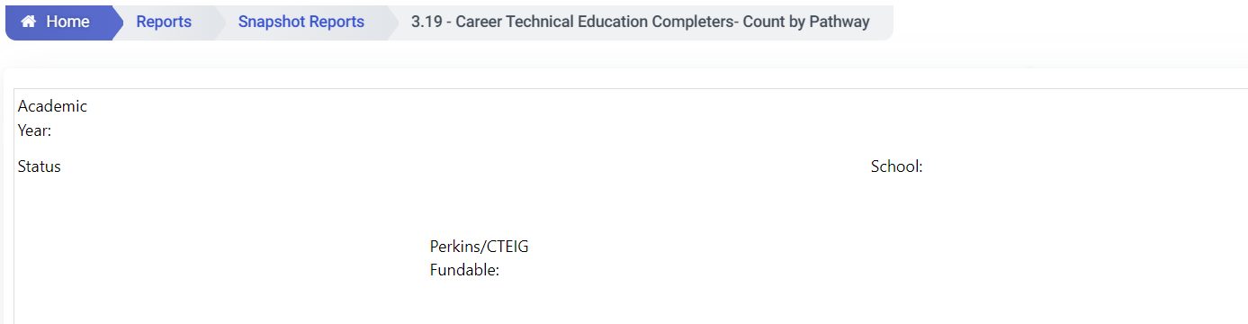
- Academic Year (shown in image above): Select the academic year of your report. (For example, to confirm the data that will be used to generate the 2024 CCI, select 2023–2024.)
- Status (shown in image above): Select LEA Approved. (The Status filter has two options: LEA Approved and Revised-uncertified. Select LEA Approved after your data has been certified. Revised-uncertified reflects possible ongoing updates of the data.)
- School (shown in image above): Select the school of your choice. (Note that there is no LEA-level report.)
- Perkins/CTEIG Fundable (shown in image above): Select the ALL option. Note: All CTE Pathways are used in the calculation of the CCI, including those pathways that are not considered “high quality” (not taught by a CTE credentialed teacher).
- Use the default for the remaining filters not listed above. After selecting all the filters, click on View Report.
Table 20 below shows a portion of the sample report for this measure at the school-level. The # Completers column shows counts of the completers by each CTE Pathway and CTE Industry Sector in a school.

Table 20: Report 3.19 Career Technical Education Completers - Count by Pathway Results
CTE Industry Sector | CTE Pathway | # Completers
Arts, Media, and Entertainment | 111-Design, Visual, and Media Arts | 18
Arts, Media, and Entertainment | 113-Production and Managerial Arts | 8
Engineering and Architecture | 153-Engineering Technology | 17
Note: The report has many fields. The table above shows the most relevant information in the report.
Figure 15 (on the following page) reflects the filters that can be applied to access the student-level data for CTE completers. The breadcrumbs at the top of Figure 15 identifies that by going through Home, Reports, and Snapshot Reports, you can access the 3.20 – Career Technical Education Completers - Student List. The same filters bulleted above for Report 3.19 can also be applied for 3.20. These filters (as referenced in Figure 15) are from left to right: Academic Year, Status, School, and Perkins/CTEIG Fundable.

Figure 15: Report 3.20: Career Technical Education Completers – Student List
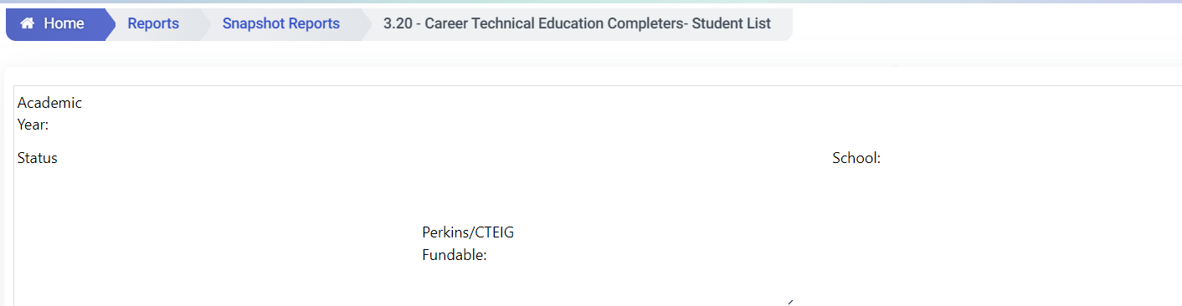
Viewers can use data fields in this report such as SSID and CTE Pathway to verify student-level data in their local SIS. See Table 21 Below.

Table 21: Report 3.20 Career Technical Education Completers – Student Lists Results
SSID | CTEPathWay | StateCourseCode
XXXXXXXXXX* | 174-Software and Systems Development | 8132-Advanced Systems Programming (Capstone)
XXXXXXXXXX* | 244-Marketing | 8311-Advanced Marketing (Capstone)
XXXXXXXXXX* | N/A | 7921-Intermediate Patient Care (Concentrator)
*The Xs in the SSID column are used as an example and do not reflect a student’s true SSID. In addition, the report has many fields and the table above shows the portion that captures the CTE Pathway Completer information.
If Report 3.20 contains students who are non-capstone completers (e.g., Beginners or Concentrators), then these students should be filtered out as the CCI only includes CTE completers.

Some Questions to Consider
If you find prominent errors/discrepancies in your CALPADS reports, running Reports 3.11 and 3.20 will help you further investigate the issue at the student level. For example, for college credit course, Final Grades (CALPADS Data Field #10.18) can only be located in the 3.11 student-level report as shown in Table 22.

Table 22: Student-Level Report
SSID | Marking Period | Final Grade
XXXXXXXXXX* | S2 | A
XXXXXXXXXX* | S1 | B
*Note the Xs in the SSID column are used as an example and do not reflect a student’s true SSID.

How to Reconcile your CALPADS Data Against Your Local Student Information Data System
LEAs can submit and make changes prior to the close of the EOY certification deadline. However, any changes made after the EOY certification deadline will not be used for the Dashboard (or the School Dashboard Additional Reports). Therefore, it is advised that LEAs/schools compare their local SIS data to their CALPADS data on a regular basis. For example, if LEAs/schools find that the CTE Pathway data in the CALPADS report is wrong, they can correct the problem before the EOY certification deadline. LEAs/schools can continue to update their data before the CALPADS certification deadline by taking three steps: 1) de-certify; 2) update the data; 3) re-certify.

Why Dashboard Data May Not Match Your CALPADS Report
In some cases, the data in the CALPADS Reports may not match the data reported on the Dashboard. This is usually due to the following reasons:
- The CCI course data used for Dashboard processing is pulled from the EOY certified snapshot reports. Any new records added after the EOY certification deadline will not be reflected in the CCI or in the College/Career Measures Report. For example, if an LEA certified its data on July 6 and then added new course completion records to the SIS and CALPADS after the certification deadline in August, the data would not be used for the Dashboard.
- The CCI uses multiple years of data to produce the CCI. This handbook is focused on making sure that current year course data is submitted accurately.
- The CCI has evolved over several years, and new measures and changes in methodology continue to be incorporated. In order to correctly compare your counts against the CALPADS report, we advise you to reference the Dashboard Technical Guide (which is noted at the end of this section) for these updates.
- For the purposes of reviewing the data (as it relates to the Dashboard) at the LEA-level, please keep in mind that charter school data should not be included because charter schools are considered LEAs under LCFF.

What if Your Data are Incorrect on the Dashboard Preview Site
LEAs will have access to privately preview their Dashboards one week prior to its public release. The preview is only accessible to Dashboard Coordinators. The public release of the Dashboard will occur on or before December 1, 2024.
As a reminder, no corrections can be made to the data as the close of EOY. As discussed in the Introduction, the CDE will not extract new data from CALPADS to update the Dashboard after the CALPADS EOY certification deadline. However, the Dashboard Coordinator can make use of the optional narrative section in the Dashboard to share explanations of data errors/discrepancies with Dashboard viewers.

Other Sources
Additional information on the CCI is available on the following CDE web pages:
- The College/Career Indicator web page (https://www.cde.ca.gov/ta/ac/cm/dashboardccr.asp) contains general and technical information in regard to the indicator. This page also includes a link to the Dashboard Technical guide, which details the calculation methodology and rules used to produce the CCI.
- The College/Career Measures Report shows the number and percent of students who completed specific CCI measures. This report is available on the CDE School Dashboard Additional Reports and Data web page at https://www6.cde.ca.gov/californiamodel/.
- All SWDs are included in their district of residence’s Dashboard report. This “District of Residence” rule applies at the LEA-level only. The district of residence is recorded as the ‘District of Special Education Accountability’ (field #14.16; file SPED) in CALPADS. Information on which students’ data in your LEA are being attributed to another entity, and which students’ data in another entity are being attributed to your LEA, are detailed in the District of Residence section towards the end of this handbook.
- The CALPADS System Documentation provides detailed information on CALPADS and the steps needed to use the system. This documentation is available on the CDE CALPADS System Documentation web page at https://www.cde.ca.gov/ds/sp/cl/systemdocs.asp.

Chronic Absenteeism Rate Indicator
(A Grades K–8 Indicator)

Which CALPADS Report Should You View?
The following CALPADS reports can be reviewed to verify your LEA/school’s absence data:
- CALPADS Report 14.1 Student Absenteeism – Count, which is a summary report that reflects aggregate absence counts at the LEA, school, and student group levels.
- CALPADS Report 14.2 Student Absences – Student List, which provides absence data for individual students. It can be used to diagnose errors if you determine that the absence counts in 14.1 are not accurate.
These reports are annually available in CALPADS starting in May. We encourage LEAs to review these reports when the EOY window opens and throughout the EOY data collection window to verify the accuracy of your data.

How to Run the CALPADS Report
The chronic absenteeism reports can be found within EOY3 (End of Year 3) located under Snapshot Reports. Scroll down in EOY3 to access 14.1 Student Absenteeism – Count and 14.2 Student Absences – Student List. (Figure 16 below shows these reports.)

Figure 16: CALPADS Snapshot Report Web Page
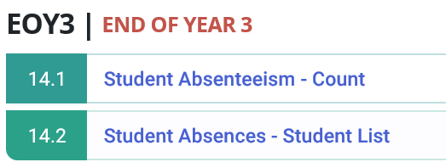
While many filters are available within 14.1 and 14.2, specific filters are relevant to the chronic absenteeism rate reported on the Dashboard. These specific filters are identified in each of the figures displayed throughout this section and a description of these filters has been provided.
Before you run the reports, keep in mind that for the Dashboard, chronic absenteeism applies only to kindergarten through grade eight (K–8) students. However, you can access chronic absenteeism rates for high schools on DataQuest since it reports these rates for all grade levels (K–12).

How to Run CALPADS Report 14.1
To view chronic absence data at the aggregate LEA or school-level, run Report 14.1 by selecting the following filters (which are all reflected in Figure 17) on the following page:
- Academic Year: Select the academic year of your report. (For example, to confirm the data you submitted for the 2024 Dashboard, select 2023–2024.)
- Status: Select Revised Uncertified. (Select Certify if you have certified your absence data and need to confirm the submitted data. Revised-uncertified reflects possible ongoing updates of the data.)
- School: Select the school of your choice. When reviewing the data for all schools within the LEA, deselect all charter schools. (Charter schools are considered LEAs under LCFF and therefore their data are not included in the LEA count.)
  - Grade: Select ‘01–First Grade’ through ‘08 –Eighth Grade’ and ‘KN–Kindergarten’.
  - Enrollment Status: Select 10–Primary enrollment and 30–Short term enrollment.
  - Student Groups: To view data for a specific student group, use the available filters available in Figure 17 starting with Ethnicity/Race, English Language Acquisition Status, Socio-economically Disadvantaged, Students with Disabilities, and Homeless Program Eligible.

  - Expected Attendance Days Indicator: Keep the default of ‘>30’ as for the Dashboard, students are included in the denominator of the Chronic Absenteeism Indicator if they were enrolled for at least 31 instructional days.
- Use the default for the remaining filters not listed above. After selecting all the above filters, click on View Report.

Note that the breadcrumbs at the top of Figure 17 show that by going through Home, Reports, and Snapshot Reports, you can access the 14.1 - Student Absenteeism Count Report.

Figure 17: Report 14.1 – Identifying Filters to Run the Report
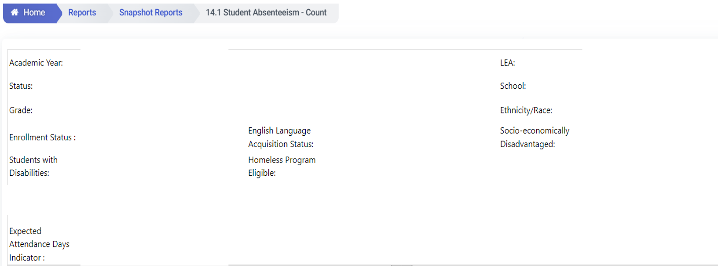
Once you run Report 14.1, you will be able to view absence data by aggregate counts. There are three columns that should be reviewed, which are reflected in Figure 18 on the following page. These columns are:
  - ‘Students Absent >=10 Percent and <20%’ and ‘Students Absent >=20%’: Students are considered ‘chronically absent’ if they are absent 10 percent or more of the instructional days. As a result, the total number of students reflected in columns ‘Students Absent >=10% and <20%’ and ‘Students Absent>=20%’ are included in the numerator of the chronic absenteeism rate. Referencing the print screen below, the total number of students with absences 10 percent or more for all schools in the LEA (displayed in the Total – Selected Schools row) is 1,026 (852 + 174). The total for each school is reported in the row beneath the LEA’s count (e.g., 27 [18 + 9]).

Figure 18: Report 14.1 – Results
School Name | Grade | Student Absence 0% |  | Student Absent >0%-<5%
 |  | Zero Absent Total | Percent | Total | Percent
ABC | Total | 0 |  | 1 | 7%
 | KN | 0 |  | 0 | 0%
 | 01 | 0 |  | 0 | 0%
 | 02 | 0 |  | 1 | 33%
 | 03 | 0 |  | 0 | 0%
*Note: The report has many fields. The table above shows the most relevant information in the report.
The Total Unduplicated column (referenced in Figure 18 above as 24,423 for the LEA [Total – Selected Schools] and as 646 for ABC School), usually matches to the cumulative enrollment data found in Report 1.21. Because cumulative enrollment is used as the denominator of the chronic absenteeism rate for the Dashboard, refer to Report 1.21 to verify this data. However, use 14.1 to confirm the numerator of your chronic absenteeism rate. It is highly unlikely for an LEA or school to have no students who are absent, this may be an error and should be reviewed for any errors.
Keep in mind that when you review the counts in the ‘Total – Selected Schools’ row (which can be found underneath the column headers School Code and School Name as reflected in Figure 18 above), all charter schools should be filtered out as they are considered LEAs under LCFF and are not included in the chronic absenteeism rate at the LEA-level.

How to Run CALPADS Report 14.2
To view absence data at the student-level, run Report 14.2 by selecting the School Name found within Report 14.1 (e.g., ‘ABC School’ in Figure 18). Specific columns in which to focus are identified in Table 23 on the following page. Each field in the table is described and defined below the table on the following page.

Table 23: Report 14.2 – Student-Level Results
SSID | Days Expected  (A) | Days Absent due to Out-of-School Suspensions  (C) | Days Excused Absences  (E) | Days Un-excused Absences  (F) | Non-ADA Generating Independent Study Days  (G) | Days Absent  (C + E + F + G) | % Absence  (((C+E+F+G)/  A)100) | Chronically  Absent (Accountability) (I)
1 | 122 | 0 | 7 | 6 | 0 | 13 | 10.66 | Y
2 | 84 | 2 | 6 | 1 | 0 | 9 | 10.71 | Y
3 | 122 | 0 | 6 | 8 | 0 | 14 | 11.48 | Y
- SSID: This column contains each student’s statewide student identifier. (Note that a true SSID contains 10 digits. This column reflects only one digit due to spacing constraints.)
- Days Expected (A): This column identifies the number of instructional days that a student was enrolled to attend and was expected to attend. This is used as the denominator to calculate a student’s chronic absenteeism rate. (Note: For the Dashboard, a student must be enrolled for at least 31 days to be included in the denominator. Therefore, when you run your counts, exclude all students with less than 31 expected instructional days from the denominator.)
- Days Absent due to Out-of-School Suspensions (C), Days Excused Absences (E), Days Unexcused Absences (F), and Non-ADA Generating Independent Study Days (G) are counted as absences.
- Days Absent (C + E + F + G): This is the sum of all the absences identified in the bullet above. This is used as the numerator to calculate a student’s chronic absenteeism rate.
- % Absence (((C+E+F+G)/A)100): This reflects the calculated chronic absenteeism rate for each student.

- Chronically Absent (Accountability) (I): Students who have a calculated chronic absenteeism rate of ten percent or more will be marked with a ‘Y’ in this column. These students are included in the numerator of the chronic absenteeism rate for the Dashboard.

Some Questions to Consider
After reviewing Report 14.1, here are some questions you may wish to consider:
  - After totaling the number of students who were absent more than 10 percent of the instructional days, does the total look reasonable? Is the total too high? Or extremely low? Having a general understanding of the attendance at your LEA or school site(s) will help you confirm if an error occurred while populating absence data or if the numbers truly reflect what occurred. For instance, if you were informed that more students were absent for longer period of days, then you may expect an increase in the number of students who are chronically absent compared to prior years.
- Do you have zero students who were absent (i.e., 100 percent perfect attendance)? This may be an error. It is highly unlikely for an LEA or school to have no students who are absent.
- Full-day out-of-school suspensions are counted as absences. Did your LEA or school count students as absent if they had an out-of-school suspension?
- You may also need to confirm if the filters are applied appropriately and if the data in the CALPADS report(s) are certified or revised certified.
- For the Dashboard, at the LEA-level, charter school data are not included because charter schools are considered LEAs under LCFF. Therefore, do not include charter schools when you run an LEA-level report.
If the counts do not look accurate after reviewing 14.1, you can review individual student absence data in 14.2 to correct errors – as long as the EOY certification deadline has not closed.

How to Reconcile Your CALPADS Data Against Your Local Student Information System Data
Sometimes, local SIS data are not uploaded correctly into CALPADS. When this occurs, incomplete CALPADS data are used to calculate state indicators for the Dashboard. Therefore, during the EOY3 submission window, LEAs should compare local SIS data against the uploaded CALPADS data, especially before certifying that the data is accurate.
Once the absence data are uploaded, LEAs should review the aggregate counts in CALPADS Reports 14.1. If they do not match your local SIS data, you can: (1) de-certify, (2) update the data, and (3) re-certify – don’t forget this last step!
You can re-certify your CALPADS data as long as the certification deadline has not yet closed. As a reminder, the following CALPADS data file and fields are used to collect student absence data:
Data File: Student Absence Summary (STAS)
Data Fields: While LEA staff should reference the CALPADS File Specifications (available on the CDE CALPADS System Documentation web page at https://www.cde.ca.gov/ds/sp/cl/systemdocs.asp) to access the complete list of data elements and definitions related to the STAS file, some critical fields are:
- Expected Attendance Days (Field 13.15)
- Days Attended (Field 13.16)
- Days Absent Out-of-School Suspension (Field 13.17)
- Days Absent Excused Non-Suspension (Field 13.19)
- Days Absent Unexcused Non-Suspension (Field 13.20)
- Incomplete Independent Study Days (Field 13.21)

Why Dashboard Data May Not Match Your CALPADS Report
At the school-level, the number of chronically absent students in 14.1 usually matches the counts in the Dashboard. However, at the LEA-level, the numbers may not match. Some reasons for this may be:
- While chronic absenteeism data for grades nine through twelve are reported on DataQuest, they are not included in the Dashboard. Grades nine through twelve should be filtered out. For example, if a middle school that typically serves grades seven and eight recorded several grade nine students, while these students may appear in Reports 14.1, 14.2, and 1.21 (cumulative enrollment report), for Dashboard purposes, these grade nine students will be excluded.
- Non-Public Schools (NPS), adult schools, and private schools should also be filtered out.
- All SWDs are included in their district of residence’s Dashboard report and therefore, this “District of Residence” rule applies at the LEA-level only. Tracking which SWDs are being attributed to your LEA can be difficult and therefore, this may also cause a non-match in counts between the CALPADS Reports, the Dashboard, and your local student information system. The district of residence is recorded as the ‘District of Special Education Accountability’ (field #14.16; file SPED) in CALPADS. Further information about this rule is detailed in the District of Residence section towards the end of this handbook.
- Charter schools are not included in the LEA counts because they are treated as LEAs under LCFF. Check to ensure that these schools are filtered out.
Because different rules are used to generate the CALPADS Reports versus the Dashboard reports, the numbers may not always match. However, if the correct filters are applied when running the CALPADS reports, the numbers should be close enough to inform you whether the data are accurate.

What if Your Data is Incorrect on Dashboard Preview Site?
LEAs will have access to privately preview their Dashboards one week prior to its public release. The preview is only accessible to registered Dashboard Coordinators. The public release of the Dashboard will occur on or before December 1, 2024.
As a reminder, no corrections can be made to the data after the close of EOY. As discussed in the Introduction, the CDE will not extract new data from CALPADS to update the Dashboard after the CALPADS EOY certification deadline. As a result, it is good practice to monitor and review your CALPADS Reports and note the certification deadline. However, the Dashboard Coordinator can make use of the optional narrative section in the Dashboard to share explanations of data errors/discrepancies with Dashboard viewers.
Other Sources
Additional information on the chronic absenteeism rate is available at the following CDE web pages:
- The Chronic Absenteeism Indicator web page (https://www.cde.ca.gov/ta/ac/cm/dashboardchronic.asp) contains general and technical information in regard to the indicator. This page also includes a link to the Dashboard Technical guide, which details the calculation methodology and rules used to produce the Chronic Absenteeism Indicator.
- The Chronic Absenteeism Placement Report identifies the performance level that an LEA, school, and student group received on the Dashboard, as well as the chronic absenteeism data used to calculate the indicator. This report is available on the School Dashboard Additional Reports and Data web page at https://www6.cde.ca.gov/californiamodel/.
- The CALPADS System Documentation provides detailed information on CALPADS and the steps needed to use the system. This documentation is available on the CDE CALPADS System Documentation web page at https://www.cde.ca.gov/ds/sp/cl/systemdocs.asp.

Suspension Rate Indicator
(A Grades K–12 Indicator)

Which CALPADS Report Should You View?
The following CALPADS reports can be reviewed to verify your LEA/school’s suspension (or discipline) data:
- CALPADS Report 7.10 Incident Results – Count, which is a summary report that reflects aggregate discipline counts (by each offense type) at the LEA, school, and student group levels.
- CALPADS Report 7.12 Incident Results - Student List, which provides discipline data for individual students. It can be used to diagnose errors if you determine that the discipline counts in 7.10 are not accurate.
These reports are annually available in CALPADS starting in May. We encourage LEAs to review these reports while working toward certification and accuracy of this data.

How to Run the CALPADS Report
The discipline reports can be found within EOY3 (End of Year 3) located under Snapshot Reports. While there are many discipline reports, 7.10 and 7.12 can be used to confirm the data submitted for the Dashboard. Scroll down within EOY3 to select 7.10 Incident – Count and 7.12 Incident Results – Student List. (Figure 19 below references these reports.)

Figure 19: CALPADS Snapshot End of Year 3 Web Page
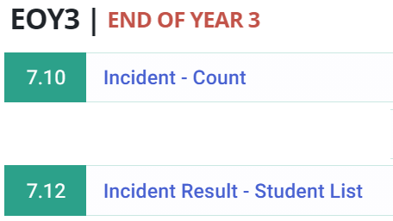
The next section identifies the specific filters that are relevant to confirming your discipline data reported on the Dashboard.

How to Run CALPADS Report 7.10
To view discipline data at the aggregate LEA or school-level, run Report 7.10. Figure 20 below, and the bulleted list following the figure, identifies and describes the specific filters to apply. Note that the breadcrumbs at the top of the figure show that by going through Home, Reports, and Snapshot Reports, you can access the 7.10 – Incident – Count Report.

Figure 20: Report 7.10 – Identifying Filters
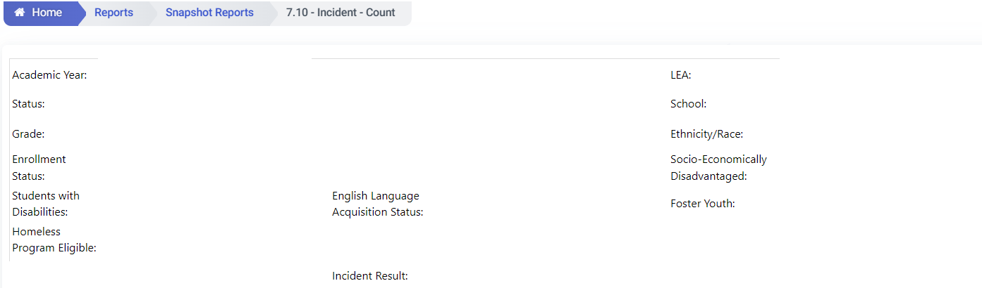
- Academic Year: Select the academic year of your report. (For example, to confirm the data you submitted for the 2024 Dashboard, select 2023–2024.)
- LEA: This filed should automatically reflect the name of your school district or county office of education.
- Status: Select Revised Uncertified. (Select Certify if you have certified your discipline data and need to confirm the submitted data. Revised-uncertified reflects possible ongoing updates of the data.)
- School: Select a school of choice. When reviewing the data for all schools within the LEA, deselect all charter schools. (Charter schools are considered LEAs under LCFF and therefore their data are not included in the LEA count.)
- Grade: Select ‘01–First Grade’ through ‘12 –Twelfth Grade’ and ‘KN–Kindergarten’
- Enrollment Status: Select ‘10–Primary enrollment’ and ‘30–Short term enrollment’
- Student Groups: To view data for a specific student group, use the available filters as shown in Figure 20 from left to right: Students with Disabilities, English Language Acquisition Status, Ethnicity/Race, Socio-Economically Disadvantaged, Homeless Program Eligible, and Foster Youth.
- Incident Result: Select ‘100 – Out-of-School Suspension’ and ‘110 – In-School Suspension’
- Use the default for the remaining filters not listed above. After selecting all the filters, click on View Report.
Figure 21 below is a sample of the results for Report 7.10. Note that this report has many fields, and the figure shows only the most relevant information.

Figure 21: Report 7.10 – Results (Refer to Appendix B for the descriptive text.)
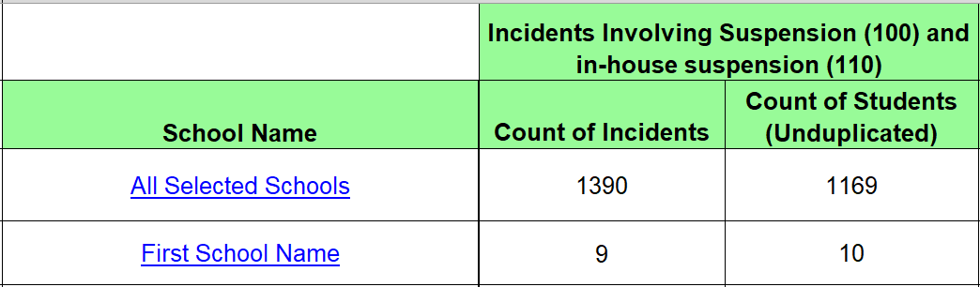
Although multiple disciplinary actions (or incident results) are reported in CALPADS, the suspension data reported on the Dashboard is based on out-of-school and in-school suspensions only. Therefore, you may wish to focus on the total count of incidents under these two suspension categories, such as the column labeled Incidents Involving Suspension (100) and in-house suspension (110) referenced in the figure above. In the figure, for the row labeled ‘All Selected Schools’ (under the column School Name), the total number of incidents at the LEA-level is provided (i.e., 1,390 under the column Count of Incidents). The rows following it reflect the total number of incidents for each school within the LEA. (For example, in the figure above, there are a total of nine incidences in the first school row labeled ‘First School Name.’) Using these results will help you confirm if the number of incidents reflected in Report 7.10 match the number of incidents recorded in your local SIS. The ‘Count of Students (Unduplicated)’ column reflects an unduplicated count of students who were involved in the incidents. If a student was involved in more than one incident, the student would only be included once in this count. For the ‘All Selected Schools’ row, a count of 1,169 unduplicated students for all schools is identified. The rows following it reflect the total unduplicated count of students for each school within the LEA. For instance, there are a total count of ten unduplicated students within the first school row labeled ‘First School Name.’
Typically, the Count of Students column (referenced in Figure 21 above) matches to the cumulative enrollment data found in Report 1.21. Because cumulative enrollment is used as the denominator of the rate for the Dashboard, refer to Report 1.21 to verify this data. However, 7.10 (as well as 7.12 referenced below) should be used to confirm the numerator of the rate.
Keep in mind that when you review the counts in the ‘All Selected Schools’ row, all charter schools should be filtered out as they are considered LEAs under LCFF and are not included in the suspension rate at the LEA-level. To view student-level information by school, click on the School Name of interest. A student-level report will be produced, which is Report 7.12. This report is detailed in the next section.

Reviewing CALPADS Report 7.12
Clicking on the “All Selected Schools” or a specific school name within Report 7.10 will provide you access to Report 7.12. Report 7.12 gives a view of discipline data by individual students as seen in the sample reflected in Table 24 below. Note that this report has many fields and the table below shows only the most relevant information.

Table 24: Report 7.12 – Student-Level Results
School Name | SSID | Student Name | Incident Result Code | Duration Days
School 1 | XXXXXXXXXX* | Student 1 | 100 - Out-of-School Suspension | 2
School 1 | XXXXXXXXXX* | Student 1 | 100 - Out-of-School Suspension | 0.5
School 1 | XXXXXXXXXX* | Student 2 | 100 - Out-of-School Suspension | 0.48
School 1 | XXXXXXXXXX* | Student 3 | 110 - In-School Suspension | 2
* Note the Xs in the SSID column are used as an example and do not reflect a student’s true SSID.
For the Dashboard, students are included in the suspension rate calculation only if they have been suspended within the same LEA (or school) for a cumulative total of one full day within the academic year. Report 7.12 provides the length of time that a student was cumulatively suspended (see column labeled ‘Duration Days’ in the above table). Therefore, you can use the report to help identify the unduplicated students who had a total suspension of one full day or more (i.e., numerator of the suspension rate). However, note that per CALPADS Flash 145, LEAs should report all suspensions, regardless of the length of suspension. This includes any suspension increments of less than one day.
- For example, in the first row, the student had an out-of-school suspension for two full days at one point in time during the school year. The second row reflects the same student having an out-of-school suspension for 0.5 days at another time during the year. Because this student had an aggregated suspension length of at least one full day, the student will be included only once in the numerator of the suspension rate for the Dashboard. Conversely, in the third row, a different student had an out-of-school suspension of 0.48. Because the student did not have at least one full day of suspension at the school during the academic year, the student would NOT be included in the numerator of the suspension rate for the Dashboard.

Some Questions to Consider
After reviewing Report 7.10, here are some questions you may wish to consider:
- Does the suspension count for each offense seem accurate?
- Do the total out-of-school suspensions and in-school suspensions counts seem reasonable?
  - Is the total too high? Or extremely low? Is your site submitting suspensions of any duration for all students?
  - What was the total last year in your local SIS? Comparing to prior years may help determine if the current year total is too high or too low. In most instances, the numbers remain fairly stable from year to year, although a local discipline policy change could cause the numbers to either increase or decrease.
  - If there are significant differences from prior year data, you should investigate the difference to confirm if an error occurred or if the difference truly reflects what occurred at the school site(s).
If the counts do not look accurate after reviewing 7.10, you can review individual student discipline data using 7.12 to correct errors – as long as the EOY certification deadline has not closed.

How to Reconcile Your CALPADS Data Against Your Local Student Information Data
Sometimes, local SIS data are not uploaded correctly into CALPADS. When this occurs, incomplete CALPADS data are used to calculate state indicators for the Dashboard. Therefore, during the EOY3 submission window, LEAs should compare local SIS data against the uploaded CALPADS data, especially before certifying that the data is accurate.
Once the discipline data are uploaded, LEAs should review the aggregate counts in CALPADS Reports 7.10 and 7.12. If they do not match your local SIS data, you can: (1) de-certify, (2) update the data, and (3) re-certify – don’t forget this last step!
You can re-certify your CALPADS data as long as the certification deadline has not yet closed. As a reminder, the following CALPADS data file and fields are used to collect discipline data:
Data File: Beginning in 2019–2020, the following new student incident files were implemented:
- SINC: Student Incident
- SIRS: Student Incident Results
- SOFF: Student Offense
Data Fields: Only two discipline actions are counted in the calculations for the suspension rate for the Dashboard, which are derived from field #19.14 (Incident Result Code) within the SIRS file.

Student Incident Result Code | Suspension Type
110 | In-school suspension
100 | Out-of-school suspension

Why Dashboard Data May Not Match Your CALPADS Report
In some cases, the data in the CALPADS reports may not match the data reported on the Dashboard. This may be due to the following reasons:
- Discipline data used for the Dashboard is pulled from the EOY certified snapshot reports. Therefore, any updates made to the discipline records after the EOY certification deadline will not be reflected in the Dashboard.
- Charter schools are not included in the LEA counts because they are treated as LEAs under LCFF. Check to ensure that these schools are filtered out.
- Non-Public Schools (NPS), adult schools, and private schools are not included in the LEA counts and should be filtered out when running LEA-level reports.
- All SWDs are included in their district of residence’s Dashboard report. This “District of Residence” rule is applied at the LEA-level only. The district of residence is recorded as the ‘District of Special Education Accountability’ (field #14.16; file SPED) in CALPADS. As a result, this may cause differences in the counts at the LEA-level. Information on this rule is detailed in the District of Residence section towards the end of this handbook.
- The Dashboard only includes suspensions that have a cumulative total of one full day within the same LEA or school.
Because different rules are used to generate the CALPADS reports versus the Dashboard reports, the numbers may not match 100 percent. However, if the correct filters are applied when running the CALPADS reports, the numbers should be close enough to inform you if the data looks accurate.

What if Your Data is Incorrect on Dashboard Preview Site?
LEAs will have access to privately preview their Dashboards one week prior to its public release. The preview is only accessible to registered Dashboard Coordinators. The public release of the Dashboard will occur on or before December 1, 2024.
As a reminder, no corrections can be made to the data after the close of EOY. As discussed in the Introduction, the CDE will not extract new data from CALPADS to update the Dashboard after the CALPADS EOY certification deadline. As a result, it is good practice to monitor and review your CALPADS Reports and note the certification deadline. However, the Dashboard Coordinator can make use of the optional narrative section in the Dashboard to share explanations of data errors/discrepancies with Dashboard viewers.

Other Sources
Additional information on the suspension rate is available at the following CDE web pages:
- The Suspension Rate Indicator web page (https://www.cde.ca.gov/ta/ac/cm/dashboardsusp.asp) contains general and technical information in regards to the indicator. This page also includes a link to the Dashboard Technical guide, which details the calculation methodology and rules used to produce the Suspension Rate Indicator.
- The Suspension Rate Placement Report identifies the performance level that an LEA, school, and student group received on the Dashboard. This report is available on the School Dashboard Additional Reports and Data web page at https://www6.cde.ca.gov/californiamodel/.
- The CALPADS System Documentation provides detailed information on CALPADS and the steps needed to use the system. This documentation is available on the CDE CALPADS System Documentation web page at https://www.cde.ca.gov/ds/sp/cl/systemdocs.asp.

District of Residence Rule:
Applies to all Dashboard State Indicators

What is the District Residence Rule?
For most student groups, the LEA in which a student resides will be the same LEA in which the student receives the majority of their instruction. However, students with disabilities (SWDs) often receive services outside their “district of residence.” The district of residence (also known as the “District of Special Education Accountability” [DSEA]) may be unable to provide the full range of special education services that the student requires and will often enter into a Memorandum of Understanding (MOU) with another LEA or county office of education to provide these services. Which entity, then, is held accountable for the outcomes of the student, as reported on the Dashboard?

Which Entity is Accountable for Students with Disabilities?
Beginning with the 2022 Dashboard, the district of residence rule was applied to all state indicators (not just the Academic Indicator, Graduation Rate Indicator, and the College/Career Indicator as in prior years). This means that the state indicator data for all SWDs who receive special education services at another district, county office of education, or non-public school (NPS) are “sent back” to the district of residence (i.e., the DSEA), and included in that LEA’s Dashboard. This ensures that the LEA that receives federal funding—under the Individuals with Disabilities Education Act—for a student will be held accountable for the outcomes of that student. Table 25 below provides a student example.

Table 25: District of Residence Student Example
Student | Galaxy Unified | Moon Unified | Which LEA is Held Accountable?
Sophia is an SWD student who resides in Galaxy Unified. | Because the LEA cannot provide the appropriate special education services to Sophia, Galaxy Unified enters into an MOU with Moon Unified. | Sophia attends Moon Unified. The LEA provides the majority of instruction to her. While attending this LEA, Sophia is suspended for two full days. | Although the suspension occurred at Moon Unified, Galaxy Unified is held accountable because it is Sophia’s district of residence. Galaxy Unified will receive Sophia’s two full suspension days in their suspension rate indicator for the Dashboard.
Please note that, at the school level, the school of attendance (which includes charter schools) will continue to be held accountable for the student’s performance. For full details on the District of Residence rule, please refer to the CDE Changes to District of Residence Rule for Students with Disabilities flyer at https://www.cde.ca.gov/ta/ac/cm/documents/districtresidencerule.pdf.

How Can you Confirm Which Students Your LEA are Accountable for?
The district of residence is recorded as the ‘District of Special Education Accountability’ in CALPADS in the Special Education (SPED) file (field #14.16).
LEAs can confirm which students’ data are being: (1) sent to other entities, and (2) attributed to their LEA by another entity by requesting an extract that identifies students flagged with the “DSEA” field. This extract can be downloaded directly from CALPADS. Figure 22 below and the steps following it identifies the download process.
NOTE that the DSEA extract is based on CALPADS ODS data where the data may continue to fluctuate since ODS reflects data that are continually being updated by LEAs. However, the DSEA data used to process the Dashboard indicators stem from End-of-Year (EOY) and is extracted out of CALPADS as soon as EOY closes. Due to this difference, it may be helpful to run the DSEA extract as soon as EOY closes so that you have a file that may closely match with the information that is used by the CDE for the Dashboard.

Figure 22: District of Special Education Accountability Extract (Refer to Appendix B for the descriptive text)
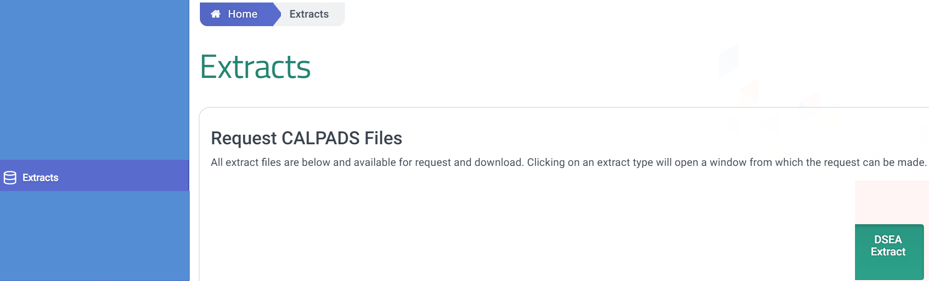
Under the left navigation pane, select “Extracts.” A “Request CALPADS Files” will appear in the middle of your screen and notes all the extract files that are available for request and download. Select the “DSEA Extract” available to the right.
Next, a “Request DSEA Extract” will appear allowing LEAs to submit a request to download the file. There are two versions of this extract – one for accountability and one for informational purposes. For the purposes of validating the District of Special Education Accountability for the Dashboard, LEAs should use the “Accountability – DSEA Extract”. At the “Submitted Extracts” page, select the download button. For complete steps on how to request and download the DSEA file, see the CALPADS User Manual District of Special Education Accountability (DSEA) Extract web page at https://documentation.calpads.org/Extracts/DSEAExtract/#district-of-special-education-accountability-dsea-extract.
Once the file has been downloaded, you can also follow the specific guidance provided in the aforementioned CALPADS User Manual DSEA Extract web page on how to convert the downloaded .txt file to Excel and using their suggested Excel template.
After you open the Excel file, you can use the Record Layout that is also available on the CALPADS User Manual DSEA Extract web page to access the definitions of each field. Of all the fields in the file, the ‘Accountability Attribution Indicator’ and the ‘SPED-District of Special Education Accountability’ will help you determine which SWDs your LEA is held accountable for on the Dashboard. These two fields are outlined in red in Table 26 and further detailed below the table. (Note that this table displays only a portion of all the fields available in the Excel file.)

Table 26: District of Special Education Accountability Extract File Results
Acad-emic Year | Account-  ability  Attribution Indicator | SSID | SENR -Reporting LEA | SENR -School of Attendance | SENR -Grade Level Code | SENR -Enrollment Status Code | SENR -Enrollment Start Date | SENR -Enrollment Exit Date | SENR-Student Exit Reason Code | SENR -School Completion Status | SPED-District of Special Education Account-ability
2021–2022 | Sending | n/a | n/a | n/a | n/a | n/a | n/a | n/a | n/a | n/a | 1212345
- Accountability Attribution Indicator: This field (outlined in red) identifies which LEA the student’s data is being attributed to. It will have:
  - “Sending” if your LEA is not the DSEA. (The LEA that downloaded the DSEA file does not match the county-district code identified in the “SPED-District of Special Education Accountability” field.) This means that your LEA is not accountable for the student on the Dashboard.
  - “Receiving” if your LEA is the DSEA. (The LEA that downloaded the DSEA file matches the county-district code identified in the “SPED-District of Special Education Accountability” field.) This means that your LEA is accountable for the student on the Dashboard.
- SPED – District of Special Education Accountability: This field (outlined in red) identifies the county-district code (or LEA) that is held accountable for the SWD for the Dashboard.

Other Sources
Additional information on the district of residence is available on the following CDE CALPADS Communication web pages:
- CALPADS Flash #161: https://www.cde.ca.gov/ds/sp/cl/calpadsupdflash161.asp
- Reporting Data for Students with Disabilities: https://www.cde.ca.gov/ds/sp/cl/swdreporting.asp. This web page provides the most common scenarios for determining which LEA is responsible for reporting SWD data and which LEA is held accountable on the Dashboard.
- The CALPADS User Manual identifies the steps an LEA can take to extract which students are flagged with the DSEA field from CALPADS. The user manual is available on the CALPADS documentation web page at: https://documentation.calpads.org/Extracts/DSEAExtract/#district-of-special-education-accountability-dsea-extract.
- The Dashboard Technical Guide further defines the district of residence rule as it relates to the Dashboard. The guide is available on the CDE Dashboard Resources web page at https://www.cde.ca.gov/ta/ac/cm/dashboardresources.asp (under the Technical Information tab).

Academic Indicators:
English Language Arts/Literacy and Math
(Indicators for Grades 3–8 and Grade 11)
The Academic Indicators are based on results from the California Assessment of Student Performance and Progress (CAASPP), which include the Smarter Balanced Summative Assessments and California Alternate Assessments (CAAs) for grades three through eight and grade eleven. Because these results are received from the testing vendor, there are no associated CALPADS Reports for this indicator.
However, LEAs are reminded that CALPADS information is used for multiple purposes in the Academic Indicator, including: (1) the demographic data to make student group determinations, (2) the enrollment data to determine testing windows for the participation rate, and (3) the enrollment data to determine continuous enrollment for the calculation of Distance from Standard. Therefore, it is imperative that these data are reviewed for accuracy before they are submitted in CALPADS.
To review more information on the Academic Indicator and the business rules used to produce this indicator, please access the Academic Indicators web page (https://www.cde.ca.gov/ta/ac/cm/dashboardacad.asp).

English Learner Progress Indicator (ELPI)
(A Grades 1–12 Indicator)
The ELPI uses the Summative English Language Proficiency Assessments for California (ELPAC) and Summative Alternate ELPAC results to determine English learner (EL) progress toward English language proficiency. The Summative ELPAC and Summative Alternate ELPAC results are obtained from the testing vendor. There are no associated CALPADS Reports for this indicator.
LEAs are reminded that CALPADS information is used to process the ELPAC participation data used for the ELPI, including: (1) the enrollment data to determine if a student was enrolled during the ELPAC testing window and (2) the English Language Acquisition Status (ELAS) to determine a student’s most current English learner status. Therefore, it is imperative that these data are reviewed for accuracy before they are submitted in CALPADS both before and during the Summative ELPAC and Summative Alternate ELPAC testing window. Any changes made to enrollment data or ELAS in CALPADS following the close of the Summative ELPAC Summative and Summative Alternate ELPAC testing window will not be included in the 2024 Summative ELPAC Summative and Summative Alternate ELPAC results.
To review more information on the ELPI and the business rules used to produce this indicator, please access the English Learner Progress Indicator web page (https://www.cde.ca.gov/ta/ac/cm/dashboardelp.asp).

Appendix A
This appendix provides additional information on some of the topics discussed throughout this handbook.

College/Career Indicator

College Course Measures Codes
CCI Measure | Field Number  in CALPADS | Starting in 2019–2020 | Prior to 2019–2020
College Credit Courses | 9.07 | CALPADS Field #9.07 (CRS-State Course Code) is used CCI College Credit Courses.  Starting in 2019–2020, the following codes are used for Academic College Credit Courses:  • 9020: College Credit Course – Visual Arts  • 9082: College Credit Course – Dance  • 9096: College Credit Course – Theatre  • 9120: College Credit Course – English  • 9154: College Credit Course – World Language  • 9200: College Credit Course – History/Social Science  • 9227: College Credit Course – Other  • 9273: College Credit Course – Mathematics  • 9303: College Credit Course – Music  • 9358: College Credit Course – Science | CALPADS Field #9.07 (CRS-State Course Code) is used CCI College Credit Courses.  Prior to 2019–2020, the following codes were used for Academic College Credit Courses:  • 2190: Dual Enrollment College Course – English Language Arts  • 2290: Dual Enrollment College Course – Foreign Languages  • 2490: Dual Enrollment College Course – Mathematics  • 2690: Dual Enrollment College Course – Science  • 2790: Dual Enrollment College Course – History/Social Science  • 2890: Dual Enrollment College Course – Visual or Performing Arts  • 6090: Dual Enrollment College Course – Other
 |  | • The 7000-8999 codes are used for  CTE College Credit Courses  Course Section Instructional Level Code [Field #9.19] of “23-College and Credit only” and “24 – Dual Credit” must be selected in conjunction with 7000-8999 codes to be counted  CALPADS Data Field #10.18 (Student Course Final Grade):  A+, A, A-, B+, B, B-, C+, C, C-, P (passing) | • The 7000-8999 codes were used for  CTE College Credit Courses  Non-Standard Instructional Level Code [Field #9.19] of “16 – College Credit” must be selected in conjunction with the 7000-8999 codes to be counted  CALPADS Data Field #10.18 (Student Course Final Grade):  A+, A, A-, B+, B, B-, C+, C, C-, P (passing)
Leadership/Military science | 9.07 | For the current year, both of the following course codes are available for use to denote the completion of Leadership/ Military science:  - State Course Code 9373 – Leadership/Military Science (as of July 1, 2019)  - State Course Code 9374 – Junior Reserve Officers Training Corps (JROTC) (starting July 1, 2021) | In prior years, the following course codes were available for use for completion of Leadership/Military science:  - State Course Code 2505 (prior to July 1, 2019)  - State Course Code 9373 (as of July 1, 2019)
CTE Pathway  Completion | 11.14 | CTE Pathway Completion Academic Year ID on the SCTE file | CTE Pathway Completion Academic Year ID on the SCTE file

Marking Periods Used for the College Credit Courses Measure
Marking Period | Term Type
Q1 | First Quarter
Q2 | Second Quarter
Q3 | Third Quarter
Q4 | Fourth Quarter
S1 | First Semester
S2 | Second Semester
T1 | First Trimester
T2 | Second Trimester
T3 | Third Trimester
SS | Summer
FY | Full Year
Note: 1. One full summer session is equivalent to one quarter.
2. One full-year term is equivalent to one semester term
3. The following combination of term types equals one year of course work for college credit:
- 3 quarter term courses
- 3 trimester term courses
- 2 semester term courses

Academic Terms Types Currently Adopted for the Leadership/Military Science Measure
The CCI criteria for leadership/military science is determined by counting the term types. At least two years of leadership/military science is required for a student to be placed in the approaching prepared CCI level. (To be placed in prepared, a student must meet additional criteria).
The following term type combinations equal two years of course work for leadership/military science:
- 2 full-year term courses
- 6 quarter term courses
- 6 trimester term courses
- 4 semester term courses

Appendix B
This section contains long descriptions for some of the images presented throughout this handbook that could not be fully described above or below the image. This section is being included to ensure accessibility to individuals with disabilities as required by Section 508 of the federal Rehabilitation Act of 1973.

Figure 1 Long Description
This image is the Login page. It contains spaces for the user to enter in their Username and Password. It also contains a checkbox so that the user can agree to the following: “By clicking the checkbox, I agree to abide by the terms and conditions of usage and accept all ramifications of the policies.” Once the checkbox is selected, the user can select the Login button. Return to Figure 1.

Figure 2 Long Description
This image reflects the CALPADS Welcome page where an LEA can access the reports mentioned throughout this handbook. There are tabs from top to bottom on the bottom left as follows: Reports, ODS Reports, Snapshot Reports, Accountability/Monitoring Reports. If the navigation pane is not available after logging into CALPADS, the hamburger menu located at the top left should be selected. This will give LEAs access to select ‘Reports.’ Following that, the LEA can select either ODS Reports, Snapshot Reports, or Accountability/Monitoring Reports. Return to Figure 2.

Figure 4 Long Description
This is an image of Report 15.1. The tabs from left to right read as follows: Home, Reports, Accountability Reports, 15.1 Cohort Outcome – Counts and Rates. Below the tabs, the content within the image reads from left to right as follows: Cohort Expected, Graduation Year, Ethnicity/Race, Socio-economically Disadvantaged, Homeless, Program Eligible, School, English Learner, Students with Disabilities, and Foster Youth. Return to Figure 4.

Figure 21 Long Description
This image identifies a portion of the results that are generated after running Report 7.10. The image reflects, under School Name, the ‘All Selected Schools’ and ‘First School Name.’ It also shows that under the column heading ‘Incidents Involving Suspension (100) and In-house suspension (110), you can access the ‘Count of Incidents’ (1,390 and 9) and the ‘Count of Students (Unduplicated)’ (1,169 and 10). Return to Figure 21.

Figure 22 Long Description
This image illustrates how to extract a data file from CALPADS to access which students with disabilities are flagged with the ‘District of Special Education Accountability’ field. Under the navigation pane to the left on the Home page, the user should select Extracts. At this point, a ‘Request CALPADS Files’ section will appear to show which files are available for downloading along with the following information: “All extract files are below and available for request and download. Clicking on an extract type will open a window from which the request can be made.” To extract the District of Special Education Accountability information, the LEA should select the DSEA Extract button that appears to the right. Return to Figure 22.

