# 2024 Dashboard On Demand Session: English Learner Progress Indicator (ELPI)

## **Notetaking Guide**

### Important notes

* Each indicator and a few important additional topics will have videos available on-demand to watch at any time.
* On-Demand videos are available before the Dashboard is published.
* The 2024 ELPI Indicator On-Demand video associated with this Notetaking Guide can be found here: <https://www.cde.ca.gov/ta/ac/cm/dashboardtoolkit.asp>

## California Accountability System Update

### Presenters:

From the Analysis, Measurement and Accountability Reporting Division of the California Department of Education, the presenters are:

* Justin Lane, Educational Programs Consultant
* Irit Winston, Educational Programs Consultant

#### California School Dashboard on Demand

* Short, accessible videos which can be accessed any time
* Covers each of the State Indicators PLUS other important topics

#### Agenda

* Overview of the California School Dashboard (Dashboard)
* The English Learner Progress Indicator (ELPI)
* Frequently Asked Questions​
* General Rules about the Dashboard
* Contacting/Reaching Us​

## Overview of the California School Dashboard (Dashboard)

#### Overview of the Dashboard

The California School Dashboard is an online tool that displays the performance of local educational agencies, or LEAs, schools, and student groups on a set of state and local measures to assist in identifying strengths, challenges, and areas in need of improvement.

The goal of the Dashboard is to help communities across the state access important information about students in kindergarten through grade twelve.

#### Dashboard State Indicators

* Academic Indicator which includes English Language Arts (ELA) and Mathematics Indicators
* English Learner Progress Indicator (ELPI)
* Chronic Absenteeism Indicator
* Graduation Rate Indicator
* Suspension Rate Indicator
* College/Career Readiness Indicator* (CCI)
* Science Indicator

** Note, CCI is back to reporting Status and Change on the 2024 Dashboard

#### Measurement of Performance

* The measurement of performance for LEAs, schools and student groups on the Dashboard is done by looking at two years of data.
  + Current Year Data equals Status.
  + A comparison between the current and prior year's data equals Change.
* It's the combination of status and change that determines color performance on the Dashboard, and is designated by receiving a color, ranging from red at the lowest performance level to blue at the highest performance level.

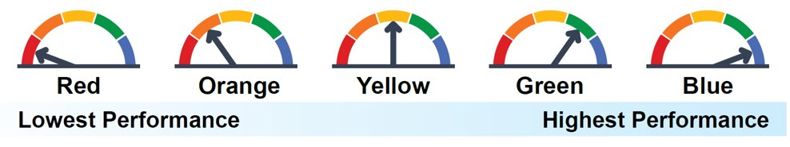

## English Learner Progress Indicator (ELPI)

#### What is the English Learner Progress Indicator?

The English Learner Progress Indicator (ELPI) is a measurement of how well your district or school is at moving current EL students towards English Language Proficiency (ELP).

* Based on performance on the Summative English Language Proficiency Assessments for California (ELPAC) and the Summative Alternate English Language Proficiency Assessments for California (ELPAC).
* ELPI Status measures the percent of EL students progressing towards ELP
* ELPI Change measures the rate of LEA and School improvement of moving their EL students towards ELP.

#### What is New at the ELPI?

The ELPI has many new aspects for the 2023 Dashboard:

* Beginning on the 2024 California School Dashboard (Dashboard), long-term English learners (LTELs) will be added as a student group across all state indicators. EL students who have not been reclassified as fluent-English proficient within seven years will be included in the LTEL student group. Therefore, ELPI, from now on, will include 2 student groups: ELs and LTELs. See the new LTEL flyer at <https://www.cde.ca.gov/ta/ac/cm/documents/ltelstudents.pdf>
* With three years results, the ELPI will incorporate the Summative Alternate ELPAC in Status, Change, and overall performance color for the ELPI.

## The Long-Term English Learner student Group (LTEL)

#### What is the definition of LTEL?

The definition for the LTEL student group will report: “A pupil who has not attained English language proficiency within 7 years of initial classification as an English learner”

All EL students who reach their seventh year as an EL anytime during the academic year will be counted in the LTEL student group. For example, a student enrolls in a California public school in 2018-19 academic year and is determined to be an EL student. This student is still an EL student in the 2023-24 academic year, and, as a result, this student will be included in the LTEL student group.

Please keep in mind, this LTEL definition only applies to the Dashboard and does not apply to other reporting, such as DataQuest, which still uses the definition outlined in Education Code section 313.1

#### The LTEL in the ELPI

The number of LTEL students, or N-size, required to receive an ELPI Status, Change, and overall performance level:

Districts/COEs – 15 or more LTEL students with current year and prior year Summative or Summative Alternate ELPAC results

Schools – 30 or more LTEL students with current and prior year Summative and Summative Alternate ELPAC results.

#### LTEL Participation Rate?

The LTEL n-size required for ELPAC participation rate is 15 for districts/COEs and 30 for schools.

## Summative English Language Proficiency Assessments for California (ELPAC)

#### ELPI Levels Based on the Summative ELPAC Results

Each student receives one of four ELPAC performance levels. The four ELPAC performance levels are then divided into six ELPI levels to allow students enough time to make progress toward English language proficiency in the ELPI.

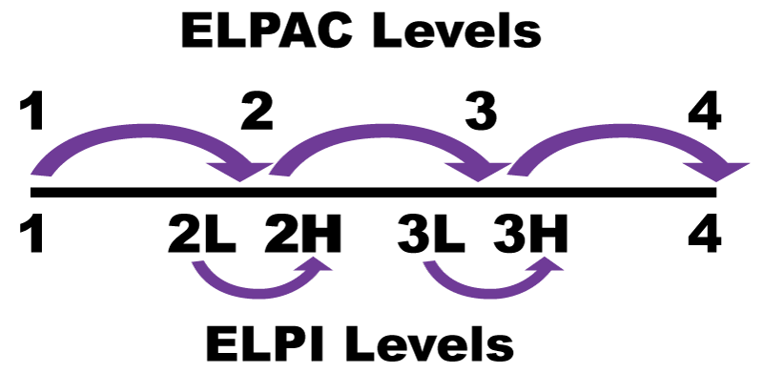

#### Determining Progress on the ELPI (Traditional ELPAC)

To show progress toward English language proficiency, EL students must increase at least one ELPI level from the previous year or maintain a Level 4 from one year to the next.

2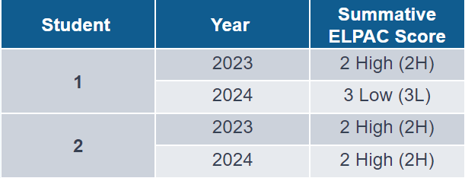

* Example 1: A student in 2023 scored a Level 2 High (2H). In 2024, the same student scored a Level 3 Low (3L). This student **advanced** one ELPI level.
* Example 2: A student in 2023 scored a Level 2 High (2H). In 2024, the same student scored a Level 2 High (2H). This student **did not** advance one ELPI level.

## Summative Alternate ELPAC

#### Update for Summative Alt ELPAC Results in the ELPI

* With the 2024 Alternative ELPAC results, the CDE has three years of Alternative ELPAC results to incorporate into the ELPI.
* Beginning on the 2024 California School Dashboard (Dashboard), the results of the Summative Alternate ELPAC will be incorporated into the English Learner Progress Indicator (ELPI) for current year Status, Change which is the progress or lack of progress from the previous year, and overall performance color.

#### ELPI Levels Based on the Summative Alternate ELPAC Results

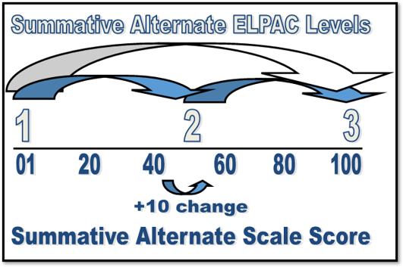

The Summative Alternate ELPAC has three Performance Levels that are used to determine progress on the ELPI:

• Level 1—Novice

• Level 2—Intermediate

• Level 3—Fluent English Proficient

EL students taking the Summative Alternate ELPAC have three paths to demonstrate progress towards ELP:

* Increasing at least one performance level on the Summative Alternate ELPAC;

**or**

* Maintaining Level 3 on the Summative Alternate ELPAC;

**or**

* Scale score change of 10 or more points from the prior year test administration;

EL students meeting at least one of the above criteria will be counted as progressing in the ELPI.

#### Example for Progress on the ELPI (Alternate ELPAC)

To calculate the scale score change, the first digit of the scale score is removed.

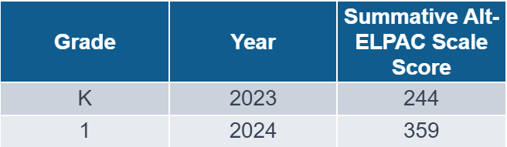

* **Example:** In 2023, an EL student taking the Summative Alternate ELPAC had a scale score of 244 in kindergarten. In 2024, this EL student had a scale score of 359 in grade 1.
* Due to the difference between scale score range by grade level, the scale score of 244 in 2023 gets converted to 44 and the scale score of 359 in 2024 gets converted to 59. The difference between 59 and 44 is 15, a scale score change of +15.

**As a result, this EL student would be counted as making progress towards English language proficiency.**

#### ELPI Status

* ELPI Status measures the rate at which LEAs and schools are moving their EL students towards English language proficiency (ELP).
* ELPI Status requires two years of assessment results.
* For example, Kotel High School has an ELPI Status rate of 66.7%, this means that 66.7% of the EL students enrolled at Kotel High during the ELPAC testing window made progress towards ELP.

#### ELPI Status Cut Scores

ELPI has five Status levels. The cut scores for the Status levels are as follows:

**Very Low:** Less than 35%

**Low:** 35% to less than 45%

**Medium:** 45% to less than 55%

**High:** 55% to less than 65%

**Very High:** 65% or greater

#### ELPI Status Rate Formula

Number of EL students who made progress between 2023 and 2024*

***Plus***

Number of EL students who maintained the highest Level from the prior year

***Divided by***

Total number of EL students with prior and current year Summative ELPAC and Summative Alt ELPAC results

***Equals***

ELPI Status

*For EL students taking the Summative ELPAC, advancing at least one ELPI level. For EL students taking the Summative Alternate ELPAC, advancing at least one level on the Summative Alternate ELPAC or a scale score change of at least 10+.

#### ELPI Change

* ELPI Change measures the year-to-year rate of change (e.g., measures LEAs’ ability to move their EL students towards ELP)
* Requires three years of assessment results.
* For example, Eastern Parkway Elementary had a prior year ELPI status of 59.0 percent. In the current year, this school has an ELPI status of 62.3 percent. The difference between the current year status and prior year status equals ELPI Change. In this example, the ELPI Change is +3.3 percentage points for Eastern Parkway Elementary.

#### ELPI Change Cut Scores

The ELPI has five Change levels. The cut scores for the Change levels are as follows:

**Decreased Significantly:** Declined more than 10 percentage points

**Decreased:** Declined by 2 to 10 percentage points

**Maintained:** Declined or increased by less than 2 percentage points

**Increased:** Increased by 2 to 10 percentage points

**Increased Significantly:** Increased more than 10 percentage points

#### ELPI Change Rate Formula

Current Year ELPI Status rate

***Minus***

Prior Year ELPI Status rate ​

***Equals***

ELPI Change

#### ELPI Participation Rate

Every spring, English learner (EL) students are required to take the Summative English Language Proficiency Assessments for California (ELPAC) or the Summative Alternate ELPAC. The purpose of the Summative ELPAC and the Summative Alternate ELPAC is to measure an EL student’s progress in learning English and to identify the EL student’s level of English language proficiency.

To ensure districts and schools are testing all of their current EL students, the California Department of Education (CDE) requires that they meet or exceed a participation rate of 95 percent on the Summative ELPAC and the Summative Alt ELPAC.

Districts and schools that **do not** meet the 95 percent participation rate on the Summative ELPAC or the Summative Alternate ELPAC and have at least 30 EL students enrolled, will be incorporated into the ELPI calculation as not making progress. The resulting number of the English Learner Progress Indicator (ELPI) will be reported on the 2024 California School Dashboard (Dashboard).

#### Who is Counted as Participating in the Summative ELPAC and the Summative Alternate ELPAC?

EL students who log on to at least one domain (i.e., Listening, Speaking, Reading, or Writing) in each composite are counted as participating in the Summative ELPAC.

* Oral Language Composite:
  + Listening
  + Speaking
* Written Language Composite:
  + Reading
  + Writing

Similarly, for the Summative Alt ELPAC, EL student must be administered at minimum

* one receptive item which includes:
  + listening
  + Speaking
* one expressive item which includes:
  + Reading
  + Writing

Please note, that a mark of “no response” is also considered a valid response.

#### Summative ELPAC and Summative Alt ELPAC Participation Rate Formula

Number of EL students who were tested on the 2024 Summative ELPAC and the Summative Alt ELPAC

***Divided by***

Total number of ​EL students enrolled during the testing window

***Equals***

ELPAC Participation Rate

More information about Summative ELPAC: <https://www.elpac.org/about/summative-elpac/>

​

## Frequently Asked Questions (FAQs)

#### What grades are included in the ELPI?

Grades 1 – 12.

#### Are reclassified fluent English proficient (RFEP) students included in the ELPI?

No. Students who are reclassified anytime before May 31st are not included in the ELPI because they are no longer current EL students and do not take the Summative ELPAC.

#### Who is counted as participating in the Summative ELPAC and the Summative Alt ELPAC?

EL students who log on to at least one domain (i.e., Listening, Speaking, Reading, or Writing) in each composite are counted as participating in the Summative ELPAC. for the Summative Alt ELPAC, EL student must be administered at minimum one receptive item which include: listening and Speaking and one expressive item which include Reading and Writing. Please note, that a mark of “no response” is also considered a valid response.

#### Do RFEP students count in the Participation Rate?

Yes, if the student was reclassified after the student took the 2024 ELPAC Summative.

#### Need Additional Help with the ELPI?

**Extra resources Include:**

* ELPI web page: <https://www.cde.ca.gov/ta/ac/cm/dashboardelp.asp>
  + The California School Dashboard Technical Guide has been divided into mini-guides. The ELPI mini-guide can be found here: <https://www.cde.ca.gov/ta/ac/cm/dashboardguide24.asp>
* CDE School Dashboard Additional Reports web page at <https://www6.cde.ca.gov/californiamodel/>
  + The suspension rate data includes:
    - Number of students counted as suspended
    - Percent of students counted as suspended
    - Number of students included in denominator (cumulative enrollment)
  + School or student group comparison through the tables provided

## General Rules About the Dashboard

#### District of Special Education Accountability (DSEA)

The District of Special Education Accountability (DSEA) rule is applied to all available state indicators for Students with Disabilities (SWDs) who receive special education services at another district or county office of education. These students will be “sent back” to the district of residence or DSEA and included in the DSEA’s Dashboard.

For example, the district where the student geographically resides is held accountable for the student’s graduation outcomes and that data is included in the district of residence’s Graduation Rate Indicator.

Please note that this rule applies to LEAs only. All schools, including charter schools, are held accountable for all SWDs.

#### A Rule About Charter Schools

Since charter schools are treated as local educational agencies, or LEAs, under the Local Control Funding Formula, or LCFF, their data are not included in their authorizer’s Dashboard report. This includes both direct and locally funded charters.

DataQuest reports have the toggle option to either include or exclude charters from the District reports.

#### Reporting for At Least 30 Students

* Performance Level (Color) gauge graphic is displayed
* Status & Change Levels are reported
* Held accountable for support determinations

#### Reporting for 11-29 Students

* Performance Level (Color) graphic is greyed out
* Status Level and Change Level is reported
* Not held accountable for support determinations

#### Reporting for Fewer than 11 Students

* Performance Level (Color) graphic is greyed out
* Status Level and Change Level is not reported
* Not held accountable for support determinations

## Contacting/Reaching Us

* [Dashboard@cde.ca.gov](mailto:Dashboard@cde.ca.gov)
* Follow us on Twitter: [@CDEDashboard](https://twitter.com/cdedashboard)