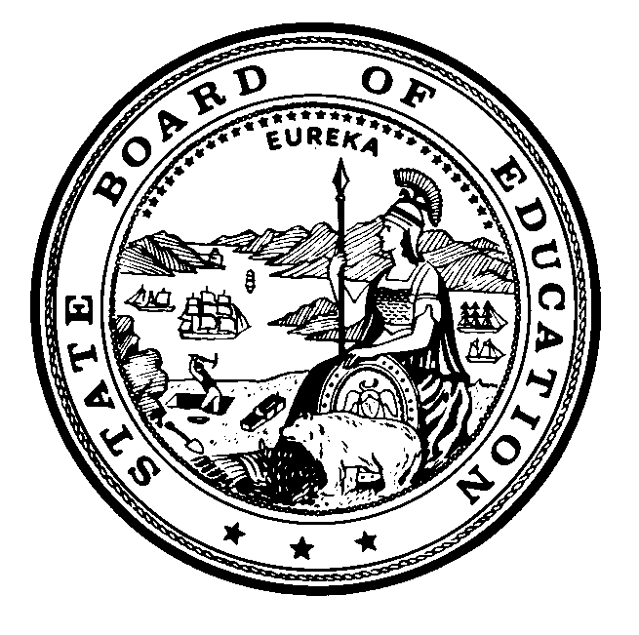

**Instructional Quality Commission**

*An Advisory Body to the California State Board of Education*

# Instructional Quality Commission Meeting Dates

Commission will consider for approval on January 30, 2025

## 2026 Dates

Wednesday–Thursday, January 28–29, 2026

Wednesday–Thursday, March 18–19, 2026

Wednesday–Thursday, May 20–21, 2026

Wednesday–Thursday, July 15–16, 2026

Wednesday–Thursday, September 23–24, 2026

Wednesday–Thursday, November 18–19, 2026

All meetings, unless otherwise indicated, will be held at the

California Department of Education Building

1430 N Street

Sacramento, CA 95814

California Department of Education, January 2025.