Draft for Review

RDRSSP Application Evaluation Protocol
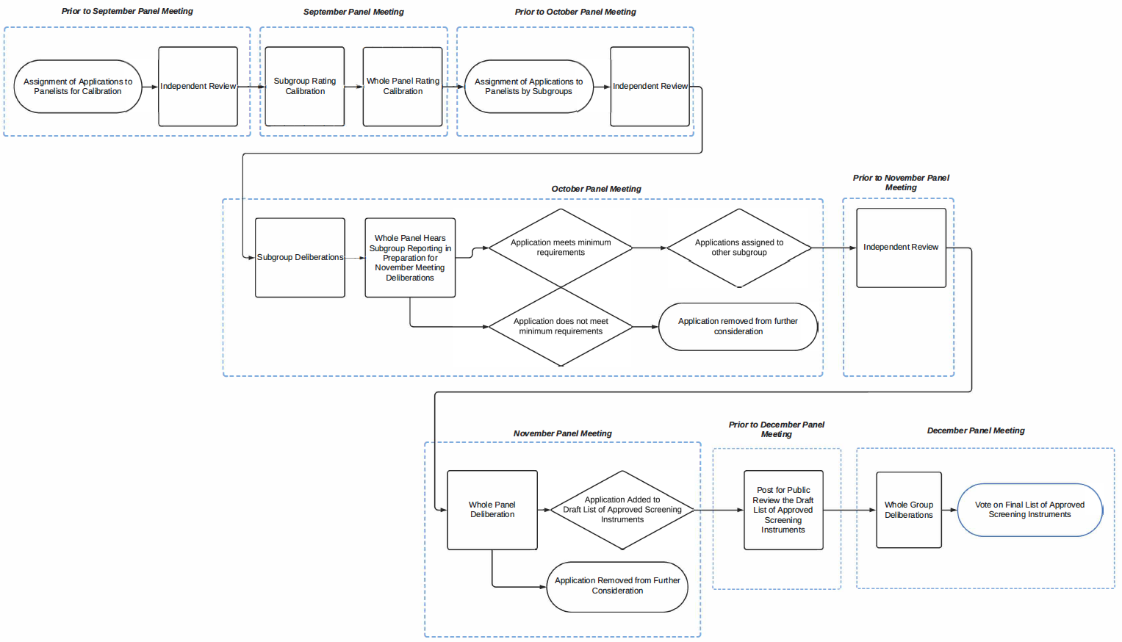
Step | Timing
- Assignment of applications to panelists, with focus on calibration of 2–3 applications  - Panelists independently review assigned applications | Prior to September Meeting
- Calibration of rubric ratings in subgroups  - Calibration of rubric ratings with whole panel | September 20 RDRSSP Meeting
- Assignment of applications to panelists by subgroup  - Panelists independently review assigned applications | Between September and October Meetings
- Subgroup deliberations: Discussion of rubric ratings for each assigned application:  - Subgroups identify applications that advance for further deliberation by the whole panel (i.e., Step 10)  - Subgroups identify applications that do not meet the minimum requirements, as determined by unanimous agreement in the subgroup and approval of the Panel Chair, and remove from further consideration.  - Among the whole panel, subgroups report the highlights of their findings and deliberations, including applications that do not meet minimum requirements | October 18 RDRSSP Meeting
- Panelists independently review applications  - Panelists have the ability to focus in more detail on originally assigned applications, addressing aspects that arose during previous deliberations.  - Panelists in each subgroup review the applications that were assigned to the other subgroup. | Between October and November Meetings
- Whole panel deliberations: Subgroups will present findings and deliberations to the whole panel, including a full debrief from each subgroup regarding their review of each application, culminating in a draft list of instruments recommended for approval and applications removed from further consideration. | November 18 RDRSSP Meeting
- Post for public review the Draft List of Approved Screening Instruments | Between November and December Meetings
- Whole panel deliberations  - Vote on final list of approved screening instruments | December 16 RDRSSP Meetings
Note: A Panelist may ask for reconsideration of an application any time prior to the final vote.
California Department of Education, August 2024

