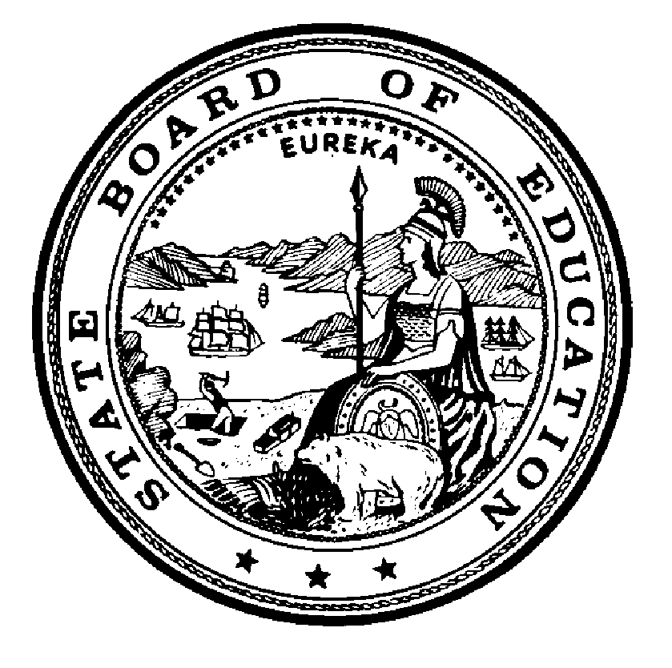

California State Board of Education
Final Minutes
May 7, 2019

Members Present
- Linda Darling-Hammond, President
- Ilene W. Straus, Vice President
- Sue Burr
- Matt Navo
- Feliza I. Ortiz-Licon
- Kim Pattillo Brownson
- Patricia A. Rucker
- Ting L. Sun
- Gema Q. Cardenas, Student Member

Member Absent
- Niki Sandoval
- Tony Thurmond, State Superintendent of Public Instruction (SSPI), Secretary and Executive Officer

Principal Staff
- Karen Stapf Walters, Executive Director, State Board of Education (SBE)
- Judy Cias, Chief Counsel, SBE
- Patricia de Cos, Deputy Executive Director, SBE
- David Sapp, Deputy Policy Director and Assistant Legal Counsel, SBE
- Janet Weeks, Director of Communications, SBE
- Carolyn Pfister, Education Administrator I, SBE
- Laila Fahimuddin, Policy Consultant, SBE
- Sara Pietrowski, Policy Consultant, SBE
- Amy Bubbico, Staff Services Manager I, SBE
- Lupita Cortez-Alcalá, Chief Deputy Superintendent, California Department of Education (CDE)
- Tom Adams, Deputy Superintendent, CDE
- Amy Bisson Holloway, Chief Counsel II, CDE
- Catalina Cifuentes, Deputy Superintendent, CDE
- Stephanie Papas, Education Policy Administrator I, CDE
Please note that the complete proceedings of the May 7, 2019 State Board of Education Study Session meeting, including closed-captioning, are available online at: http://www.cde.ca.gov/be/ag/ag/sbewebcastarchive.asp

California State Board of Education
Study Session ONLY
Public Session May 7, 2019
Tuesday – May 7, 2019, 1:00 p.m. Pacific Time ±
California Department of Education
1430 N Street, Room 1101
Sacramento, California 95814
- Call to Order
- Salute to the Flag
- Communications
- Announcements
- Report of the State Superintendent of Public Instruction
- Special Presentations
  - Public notice is hereby given that special presentations for informational purposes may take place during this session.
- Agenda Items
- Continuance
President Darling-Hammond called the meeting to order at approximately 1:00 p.m.
President Darling-Hammond administered the oath of office to board members Matt Navo and Kim Pattillo Brownson.

AGENDA ITEMS DAY 1

Item 01
Subject: Update on the Implementation of the Integrated Local, State, and Federal Accountability and Continuous Improvement System: Study Session on the College/Career Indicator including the Development History, Implementation, and the Purpose of Indicator in the Accountability System.
Type of Action: Information
Recommendation: No specific action is recommended at this time.
ACTION: No Action Taken.

Item 02
Subject: GENERAL PUBLIC COMMENT.
Public Comment is invited on any matter not included on the printed agenda. Depending on the number of individuals wishing to address the State Board, the presiding officer may establish specific time limits on presentations.
Type of Action: Information
ACTION: No Action Taken.

ADJOURNMENT OF MEETING
President Darling-Hammond adjourned the meeting at approximately 4:08 p.m.

