California Department of Education
Executive Office
SBE-002 (REV. 11/2017)
memo-itb-amard-feb22item01

MEMORANDUM
DATE: February 11, 2022
TO: MEMBERS, State Board of Education
FROM: TONY THURMOND, State Superintendent of Public Instruction
SUBJECT: Exploration into Reporting Academic Student Growth by English Language Proficiency Assessments for California Achievement Level.

Summary of Key Issues
This Memorandum is a follow up to the October 2021 Information Memorandum to State Board of Education (SBE), “Update on the Implementation of the Integrated Local, State, and Federal Accountability and Continuous Improvement System: Progress Report on Ongoing Work on the Student-Growth Model” (https://www.cde.ca.gov/be/pn/im/documents/oct21memoamard01.docx). The Memorandum provides an overview of research conducted by the California Department of Education (CDE) on the development of a data report or display to combine English Language Proficiency Assessment for California (ELPAC) levels with academic growth scores. Attachment 1 describes the research and work conducted to support such data reporting and options for the future.

Attachment(s)
Attachment 1: Support for Reporting Academic Student Growth by English Language Proficiency Assessments for California Achievement Level (3 pages)

Attachment 1

Support for Reporting Academic Student Growth by English Learner Proficiency Assessments for California Achievement Level

Background
The State Board of Education (SBE) adopted a methodology for a student growth model in May 2021. During the board discussion, and in response to educational partner feedback, the SBE requested that the California Department of Education (CDE) review the feasibility of developing a report to display growth scores by English Language Proficiency Assessments for California (ELPAC) performance level. The CDE continues to review options for graphical displays of the growth data at the local educational agency (LEA), school, and student group levels to accompany the next release of growth data in 2024. This attachment provides an overview of the work CDE conducted in 2021 to combine ELPAC and growth data and the feedback received by educational partners related to this proposal.

Understanding the Parameters of Displaying Academic Student Growth by ELPAC Achievement Level
In 2021, pursuant to a request from the SBE, the CDE explored the option of displaying academic student growth by ELPAC achievement level. A display of this nature requires combining two sets of data: (1) individual student growth, and (2) ELPAC scores. Individual student growth scores for English language arts/ literacy (ELA) and mathematics are available for students in grades four through eight with two consecutive years of Smarter Balanced Summative Assessment scores. ELPAC scores are available for all students who are currently designated as English Learners, and there are four attainable achievement levels.
Using growth and ELPAC data from 2019, the CDE conducted data analysis and modeling to evaluate what information would be available for students that have both an individual growth score and an ELPAC score.

FIGURE 1. Venn diagram showing the number of students with growth scores, ELPAC scores and the combination of both.
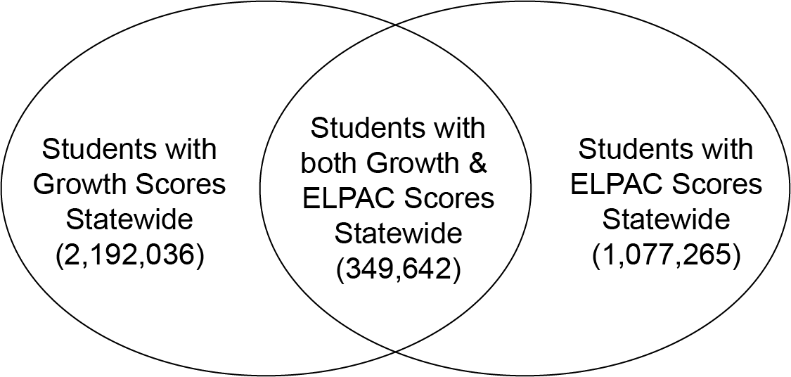
The information in Figure 1 shows that in 2019, there were 2,192,036 students with growth scores in either English Language Arts (ELA) or Mathematics, and 1,077,265 current English Learner students with ELPAC scores. However, the number of students with both an academic growth score and an ELPAC score totaled 349,642 students. This is the student population which the CDE could display a report at the statewide level that shows the intersection of the growth score and ELPAC scores.
FIGURE 2. Graph showing the reporting categories for which growth scores can be reported for all ELPAC Levels.

As shown in Figure 2, the research conducted by the CDE found a significant difference in the amount of data available to report growth scores by ELPAC level at the district or school level. In 2019, only 30.7 percent of LEAs/Districts and 5.4 percent of schools had more than 29 students with growth scores for all four ELPAC Levels. Since the accountability system requires an n size of 30 students to report performance color by group, we applied this same metric to this data analysis. In addition, if the analysis was limited to elementary and middle schools, the percentage of schools with 30 or more students with growth scores for all four ELPAC levels increases to 6.7 percent. This small cross-section of students with both growth scores and ELPAC results means that the CDE would only be able to report this data for a small number of schools and LEAs.
In practice, CDE publishes data at the LEA/district and school levels only when there is data available for all LEAs/districts. If the state were to proceed with producing this data set, we would not be able to provide reports for the vast majority of LEAs/districts and schools. This would leave the LEAs/districts that have these reports in an inequitable position in comparison to those without data and cause confusion for parents and other educational partners.

Meeting to Explore Options with Educational Partners
In August 2021, CDE brought together educational partners to discuss the research and the possibilities available to report Growth Scores disaggregated by ELPAC achievement level. The educational partners present were representatives of the Technical Design Group and the English Learner Progress Indicator Work Group, as well as staff from multiple divisions within the CDE. There was lengthy discussion around the limitations of the data, particularly what value the data had if it was not available at the state, and every LEA, and school level.
Some educational partners provided feedback that data at the state level alone may be interesting, but it would not elicit functional change if information could not be disaggregated to the local levels. Other partners felt that such reporting might conflict with the English Learner Progress Indicator on the Dashboard, as it is often referred to as a growth measure for English Learners by the nature of it requiring two years of ELPAC data to calculate Status for a single year. Additional technical considerations were raised about how to appropriately interpret the combination of such data at any level, and providing necessary guidance to assist the public with any conclusions that could be made. There was no unanimous agreement on how or if to create such a report, but the group generally saw a state level report disaggregated by grade level as the preferred option for further exploration.

Future Work on Reporting
CDE plans to share the research and results of the meeting with the California Practitioners Advisory Group in February 2022 and at the SBE meeting in March 2022. The CDE is proposing to conduct additional technical analysis to evaluate whether the sample of students and their results are technically valid and reliable for a statewide report.

