Professional Learning Needs Assessment Survey for
World Languages Educators
Summary Report

Introduction
On January 22, 2020, the California Department of Education (CDE) launched the first needs assessment specifically addressing the professional learning priorities of world languages (WL) educators. The survey was publicized and the link to the online survey instrument was distributed through CDE listservs and notifications sent to CDE’s WL partners—the California World Language Project (CWLP), the California Global Education Project (CGEP), the California Language Teachers’ Association (CLTA), and the California Association for Bilingual Education (CABE). Within the CDE, information on the survey, as well as the survey link, was widely shared across divisions. The intention was to reach all public, private, and charter schools with programs in WL. Follow-up communications and reminders were sent weekly throughout the survey window to encourage participation.
The online survey was accessible to the field through March 6, 2020. Within that time, 867 completed surveys were submitted. This report summarizes the data from the completed surveys in order to inform our internal and external partners in providing professional learning support. The CDE will move forward in collaboration with these partners to craft recommendations for state-level actions based upon careful and comprehensive review.
The survey was completed prior to the inception of the CDE’s Coronavirus response and the imposition of conditions that have impacted California schools, educators, and families in extraordinary and unanticipated ways. When making the recommendations based on the data provided by the survey, these continuing circumstances will be considered.
The report is intended for distribution to a broad audience, including interested divisions and offices within the CDE, the CDE’s external partners in providing professional learning and support for WL educators, and for the field at large.

Survey Content
Answers to the survey questions provide a description of California’s administrators and teachers of WL—where they work and the years of experience they bring to the job. Responses also describe the types of programs available to students and the broad array of languages offered.
The World Languages Standards for California Public Schools, Kindergarten Through Grade Twelve (WL Standards) were updated in 2018 and adopted by the State Board of Education (SBE) in January 2019. The survey provided the opportunity to determine how awareness and implementation of the WL Standards is proceeding in WL programs across the state.
The survey also provided a chance to assess participation in two significant state-level initiatives targeting student achievement of bilingualism and multilingualism: The State Seal of Biliteracy (SSB), effective since 2012, and the Global California 2030 initiative (Global 2030), launched in 2018. In addition to information about their participation, both teachers and administrators were asked for examples of actions they have taken locally to support the SSB and Global 2030.
Following the overwhelming approval of Proposition 58 by voters, the California Education for a Global Economy Initiative (CA Ed.G.E.) was fully enacted in July of 2017. The legislation requires that, if more than 20 parents or guardians from any one grade level or 30 parents or guardians from an entire school make a collective request for a dual language or bilingual program, the school site is required to, at minimum, explore the possibility of creating one. To assess the impact of the legislation, the survey asked administrators about plans or actions undertaken for expansion of their WL programs.
Both administrators and teachers were invited to identify the principal challenges they encounter in their positions, and to tell us what they need to support their WL programs and to build their own capacity.

Survey Organization: Separating the Answers of Administrators and Teachers
The survey used the following question to separate respondents by job function, so that classroom teachers received one set of questions and administrators another. The question sets were very similar, but customized to the duties and responsibilities of each group.
Select the job classification/title that most closely captures your primary role as a world languages educator:
- Administrator
- Program Lead or Coordinator
- Program Specialist or Teacher on Special Assignment (TOSA)
- Classroom Teacher

Survey Respondents: Where Respondents Work and the Jobs They Do
The vast majority (90 percent) of survey respondents work at school sites. Eight (1 percent) reported that they work at county offices of education and 58 (7 percent) work at school district offices. Post-secondary educational institutions, private consultancies, nonprofit educational foundations, and CWLP sites were listed among the workplaces (2 percent) specified as “Other.”
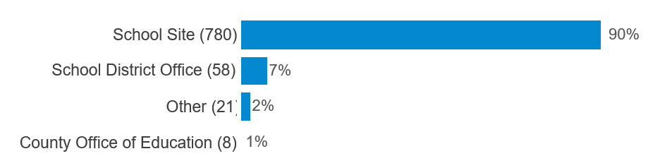
Classroom teachers comprised 87 percent of survey respondents, a robust sample of 755. The remaining categories, representing 13 percent of respondents in total (112), were grouped together as serving in administrative roles, with 66 (8 percent) identifying as administrators, 25 (3 percent) identifying as program specialists or TOSAs, and 21 (2 percent) identifying as program leads or coordinators.
Respondents were given the opportunity to submit narrative responses to certain survey questions. Representative comments expressing their observations and perspectives have been included where appropriate. All respondents’ comments included in this report are reproduced as received, without edits.
Within this report, responses from administrators are presented first, followed by responses received from teachers. Comparisons between teachers’ and administrators’ responses are drawn where similarities or differences of note help to illuminate the topic or suggest an action.

Administrators: Experience
Experience, as measured in terms of years served as an administrator, was distributed across the range of responses. Close to equal numbers of respondents self-identify as either new administrators with two or fewer years of experience (29) or veteran administrators with more than 10 years of experience (27), and a slightly larger group (31) stated they had 3–5 years of experience. The smallest number of respondents (11) affirmed 6–10 years of experience. Fourteen respondents, though they were grouped by self-selected job title with administrators, stated that they do not currently administer a WL Program. The chart below provides a visual representation of the responses received.
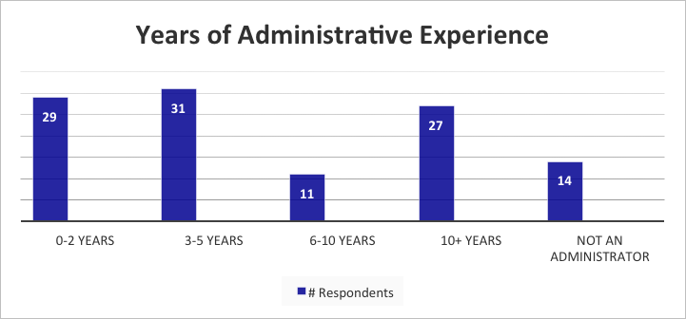

Administrators: Languages Taught, Language Program Types, Grade Levels, Plans for Expansion
Administrators’ responses indicate that Spanish, cited by 97 administrators, is taught in a far greater number of programs than any other world language. In order of their prevalence, the 10 most commonly taught languages, according to our survey respondents, are:
- Spanish (97)
- French (33)
- Chinese (Mandarin) (24)
- German (15)
- American Sign Language (ASL) (15)
- Korean (11)
- Italian (8)
- Latin (7)
- Arabic (6)
- Japanese (6)
Less commonly taught languages cited in administrators’ responses are listed below, in alphabetical order:
- Armenian
- Chinese (Cantonese)
- Hebrew
- Hindi
- Hmong
- Khmer
- Persian
- Portuguese
- Russian
- Tagalog
- Vietnamese
When asked about plans to offer additional languages within their programs, 43 percent of respondents indicated that they had no plans to add any WL to their current offerings. Spanish was the most frequently mentioned language (15 percent) that administrators did plan to add, followed by American Sign Language (ASL) at 11 percent and Mandarin Chinese at 8 percent.
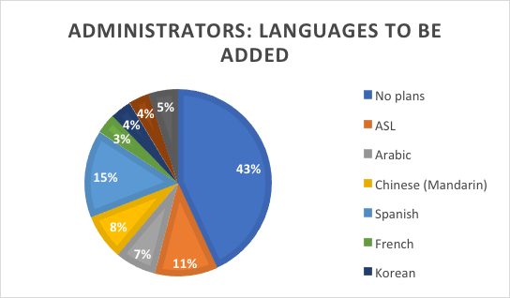
Administrators also provided information about the different types of programs offered at their school sites. The largest percentage of administrators responding to this question (45 percent) reported that they operated traditional four-year high school WL programs. Another 22 percent cited high school Advanced Placement programs. Programs for heritage speakers were noted by 12 percent of administrators, and International Baccalaureate programs in WL were mentioned by 12 percent of administrators. Fewer than 5 percent of administrators cited any of the following program types: Foreign Language Exploratory programs (FLEX), Foreign Language in the Elementary School programs (FLES), Bilingual, and National Examinations in World Languages (NEWL). Answers specified under “Other” all cited higher education programs or programs for adult learners.
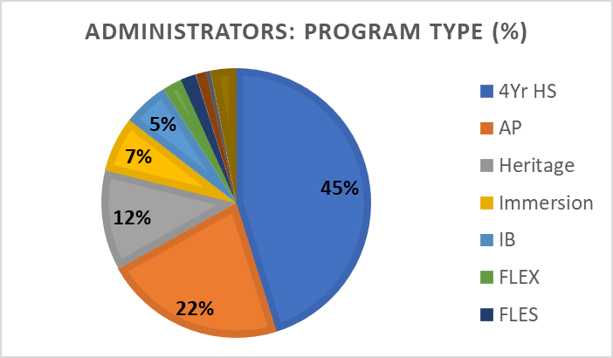
As more programs open in the wake of the enactment of CA Ed.G.E and in response to local demand, and as more students develop proficiency in earlier grades, relative numbers of dual immersion programs, heritage learner programs, and traditional high school programs may shift.
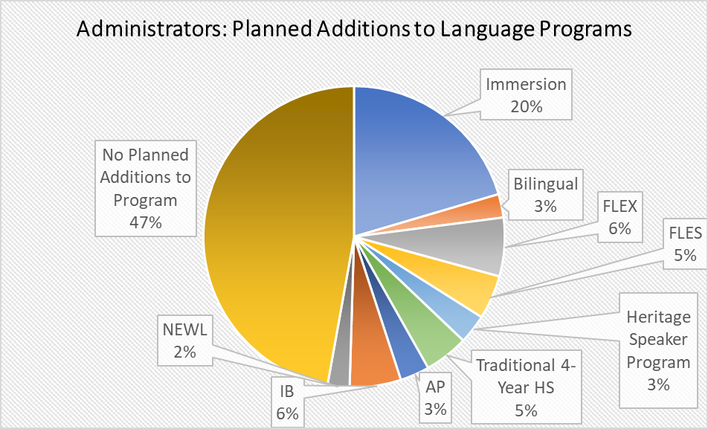
When asked about possible expansion of their WL programs, almost half of respondents (47 percent) indicated that they had no plans to expand their offerings within the next two years. Immersion programs were the most frequently cited program type (20 percent) among administrators who do plan to add to their programs.

Administrators: The 2019 World Languages Standards: Awareness, Familiarity, and Implementation
The SBE adopted the revised WL Standards in January of 2019. This needs assessment survey was launched a year later, on January 22, 2020.
The survey asked administrators to gauge their familiarity with the WL Standards, their engagement, including participation in professional learning, and the progress toward implementation of the WL Standards in their programs.
Familiarity with the WL Standards varied among administrators responding to the survey. However, the total assessing themselves as very familiar with the current standards (20 percent) was eclipsed by the equal percentages who judged themselves either only somewhat familiar (36 percent) or aware but not familiar (36 percent). The remaining 9 percent of respondents stated that they were not aware of the newly revised WL Standards.
Similarly, the majority of respondents (66 percent) indicated little if any involvement with the 2019 WL Standards in terms of professional learning or exposure. Administrators who attended one or more presentations (13 percent) or professional learning events (13 percent) related to the standards comprised a total of 26 percent of respondents. A smaller number (6 percent) indicated participation in the public comment period for the WL Standards, which took place August–September 2018.
Most administrators also indicated that implementation of the WL Standards in their programs and classrooms either had not yet begun (35 percent) or was in the early planning stages (27 percent). Smaller numbers of respondents identify WL Standards implementation as in progress (10 percent) or nearing full implementation (5 percent).
The three succeeding charts provide a visual representation of administrators’ responses regarding their familiarity, engagement and participation with, and implementation of the WL Standards.
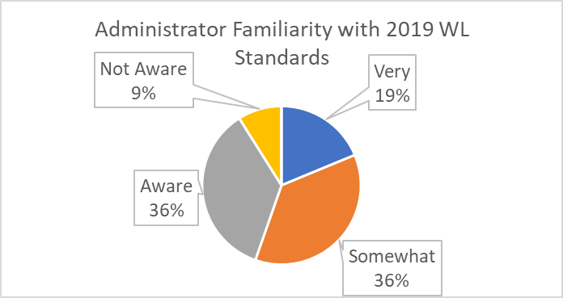
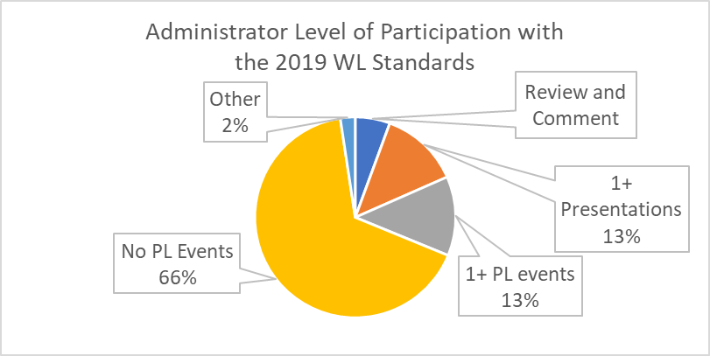
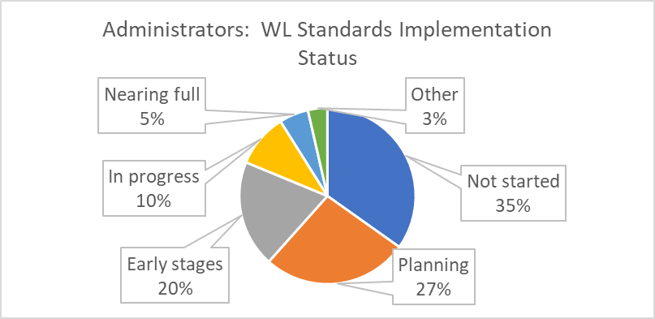

Administrators: State Programs, Policies, and Initiatives for World Languages
Questions in this section of the survey focused on two state-level programs promoting biliteracy and multiliteracy: The SSB and the Global 2030 initiative. The SSB, recognizes high school graduates who have attained a high level of proficiency in speaking, reading, and writing one or more languages in addition to English.
Global 2030 was launched in 2018, with the intention to vastly expand the teaching and learning of WL and the number of students proficient in more than one language over the following 12 years. Four principal goals were articulated:
- By 2030, half of all kindergarten through twelfth grade (K–12) students participate in programs leading to proficiency in two or more languages, either through a class, a program, or an experience.
- The number of students who receive the SSB, which is nationally recognized for college admissions and career opportunities, more than triples from 46,952 in 2017 to more than 150,000 in 2030. By 2040, three out of four graduating seniors will earn the SSB.
- The number of dual immersion programs that teach languages besides English quadruples from about 400 in 2017 to 1,600 in 2030.
- The number of new bilingual teachers authorized in WL classes more than doubles from 2017 to 2030.
The SSB has been awarded to qualifying high school graduates in California since 2012. The number of awardees has increased year by year. When administrators responding to the survey were asked to characterize their participation in the SSB Program, 55 percent indicated that their schools or districts took part in the program, while 45 percent answered that they did not participate in awarding the SSB, as shown in the chart below. Please be aware that, because the SSB is only available to graduating high school seniors, and responses to this question were not restricted to administrators of high school programs, the data gathered in answer to this question may include responses from administrators of K—8 world languages programs, and therefore the results may not accurately reflect current statewide participation in the SSB for grades 9—12.
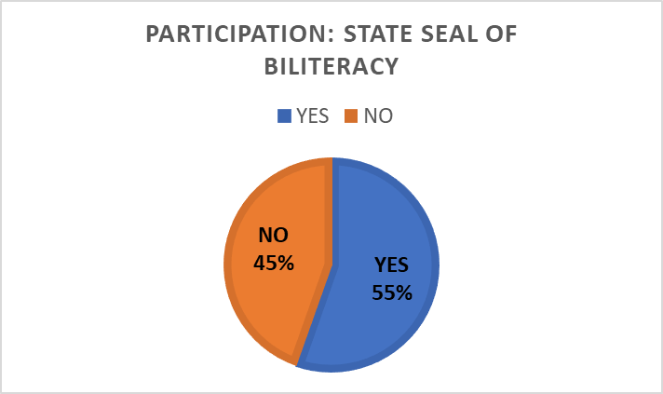
Administrators were also asked: Have you set WL program goals that align with the Global 2030 initiative? Thirty percent of respondents replied in the affirmative.
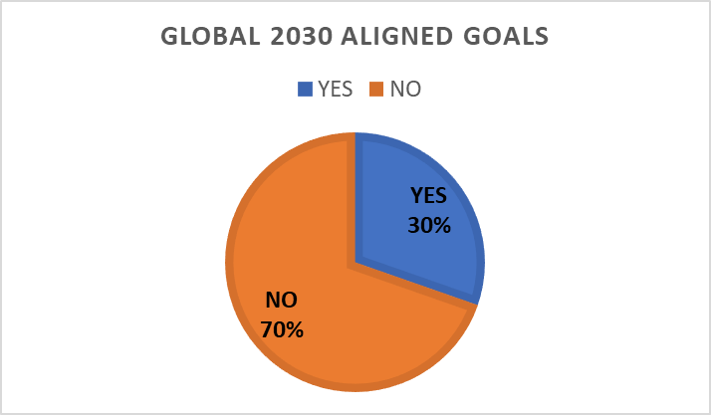
In addition to weighing in on the two state-level initiatives, administrators were asked to indicate linkages in their Local Control and Accountability Plan (LCAP) between objectives established for their WL programs and the Local Control Funding Formula (LCFF) priorities, listed below:
LCFF Priority 1: Basic Services
LCFF Priority 2: Implementation of State Standards
LCFF Priority 3: Parent Involvement
LCFF Priority 4: Student Achievement
LCFF Priority 5: Student Engagement
LCFF Priority 6: School Climate
LCFF Priority 7: Course Access
LCFF Priority 8: Student Outcomes
As seen in the following chart, some percentage of respondents noted a link with each of the eight state priorities. The greatest percentage of responses (19 percent) linked WL Program goals with LCFF Priority 4: Student Achievement. Close to an equivalent percentage of respondents (17 percent) indicated that goals established for their WL programs were not linked to any of the LCFF priorities in their LCAP.
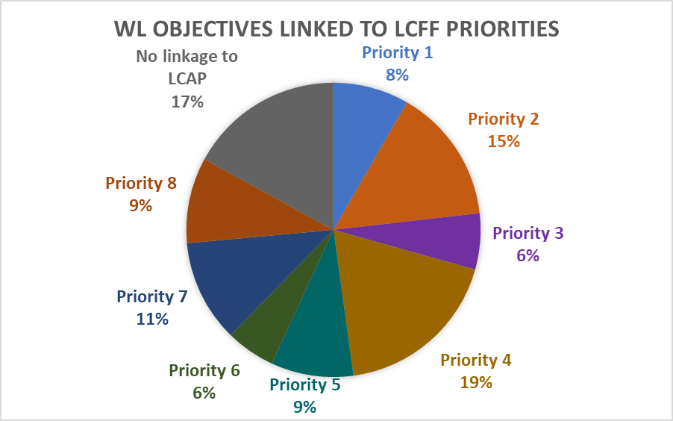

Professional Learning Priorities for World Languages Program Administrators
Administrators responding to the survey identified their own top professional learning priorities as well as their professional learning priorities for WL teachers. The WL Standards are the learning priority for themselves that WL program administrators cited most often, followed closely by professional learning focused on creating, growing, and sustaining WL programs. Teacher recruitment and retention was the third most frequently cited professional learning topic. The chart below shows the relative frequency with which the top professional learning topics for WL program administrators were cited.
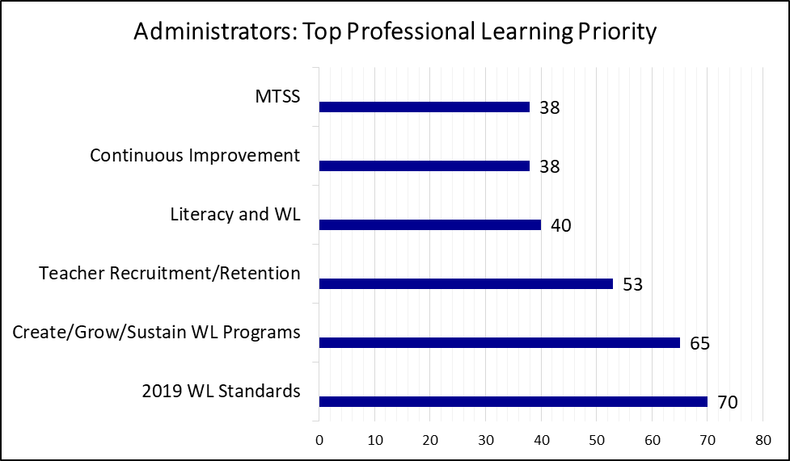

Administrators: Professional Learning Priorities for World Languages Program Teachers
When asked to name the top priority professional learning topics for WL teachers, administrators focused on the classroom rather than the program level. While the WL Standards were the most frequently cited professional development topic for teachers as well as administrators, the other topics cited most frequently were pedagogy, especially second language acquisition theory and methodology, meeting the needs of English learners, and assessment, as indicated in the chart that follows.
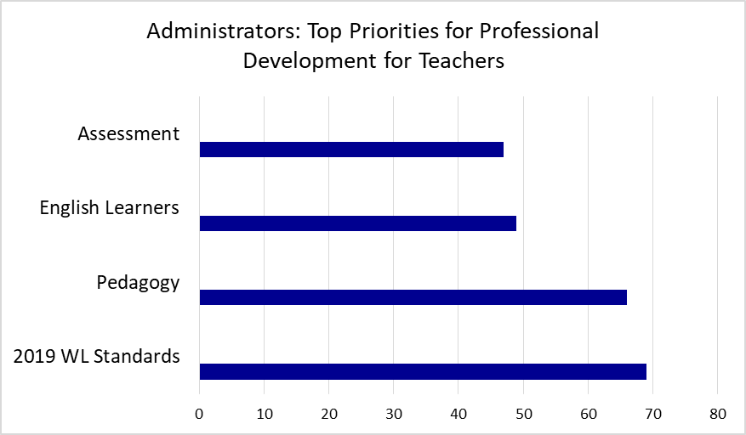

Administrators: Principal Challenge
Administrators provided 112 narrative responses to the question: Briefly describe the principal challenge you face as an administrator of WL programs. Responses were limited to 500 words. These narrative responses were reviewed and grouped by category, resulting in six collections of closely related comments. Challenges cited infrequently or singly were grouped under “Other.” The following chart represents the relative percentages of administrators responding to the survey who cited each of the most frequently mentioned challenges.
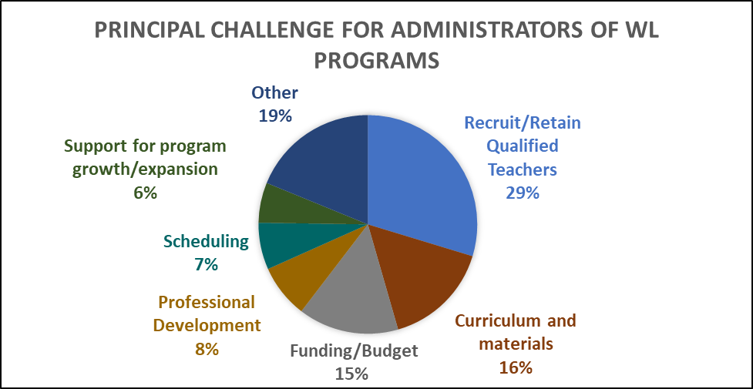
The greatest percentage (21 percent) of administrators responding to this question cited staffing, particularly the recruitment and retention of qualified teachers, as their principal challenge. The following responses represent administrators’ concerns regarding teacher recruitment and retention in their own words:
“Staffing is our main challenge—having enough students to adequately fill five levels of four languages, and having enough staff who can teach them. This is especially a concern for smaller programs where one teacher may have five preps—one for each level. Sometimes the numbers just don't work out and we have mixed class sections (e.g., two different levels in one period, taught by the same teacher), which is an incredible challenge to teach and not an optimal learning experience for students.”
“I think finding teachers is our greatest challenge. We often need to take people who do not have enough training, and then our task is really difficult.”
“We are a very small district and cannot offer competitive salaries. It took us three years to find one language teacher for one school—we still have two schools with no language program.”
Curriculum and materials (16 percent), particularly the prevalence of outdated textbooks and the lack of standards-based curriculum, and issues related to funding/budget (15 percent), noting that language programs are perceived as less important than core curriculum, were the second and third most frequently cited challenges.
Groups of administrators also commented on the need for affordable and accessible professional development options for teachers and for themselves, especially in regard to the 2019 WL Standards (8 percent), the difficulty of managing student schedules with so many competing requirements and elective options (7 percent), and a lack of financial support sufficient for program growth (6 percent).

Administrators: Principal Channel of Information from the California Department of Education
Administrators were asked to indicate which of the many channels of communication that the CDE employs they most often rely on. Almost half (48 percent) selected the CDE website as their principal information source, closely followed by a group (43 percent) citing one or more CDE listservs. Few administrators indicated that they keep up to date by connecting with the CDE through social media platforms.
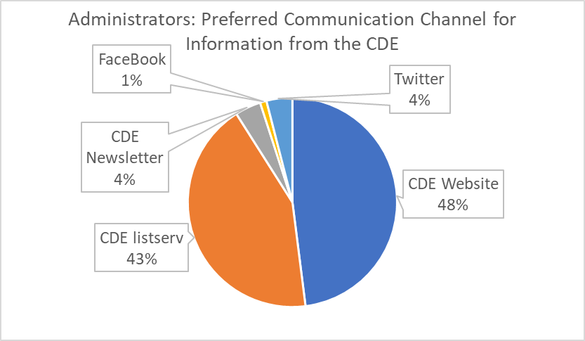

Administrators: Additional Support from the California Department of Education
Finally, administrators were asked how else the CDE can best support them. Echoing themes that emerged as their principal challenges, most responses focused on these areas in combination: increased professional development opportunities, teacher recruitment, and funding. Several private school administrators requested support for the implementation of new credentialing and professional fitness requirements for educators employed at charter schools, as a result of the passage of Assembly Bill 1505. A selection of representative responses from administrators appears below:
“Provide free or low-cost training for WL teachers, and incentives for individuals to become WL teachers. Effective, qualified teachers are hard to find in general, and WL teachers are almost impossible to find and retain.”
“Provide professional learning that we can replicate focusing on the standards, pedagogical practices, and the upcoming Framework.”
“I would love to see CDE offering professional development for WL administrators or a platform for sharing challenges or questions or success stories.”
“Schools need immediate help with the new credentialing requirement (AB 1505) for WL teachers. This is dire.”

Teachers: Experience
The survey asked teachers to report their experience, measured by number of years teaching. The responses to this question highlight the fact that we have a mostly veteran workforce instructing our WL students. Of the 755 responses received, 472 (65 percent) reported having over 10 years of classroom teaching experience. Much smaller numbers of teachers were grouped across the remaining range, with 55 (7 percent) who identified as new teachers with experience of two years or less. Ninety-five (12 percent) reported having 3–5 years of teaching experience, and 131 (17 percent) claimed 6–10 years of experience in the classroom. The chart below provides a visual representation of the responses received.
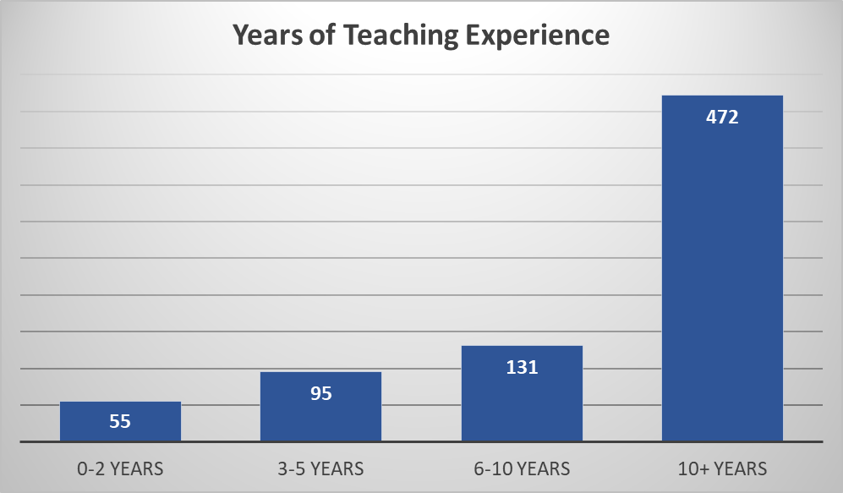

Teachers: Languages and Language Program Types
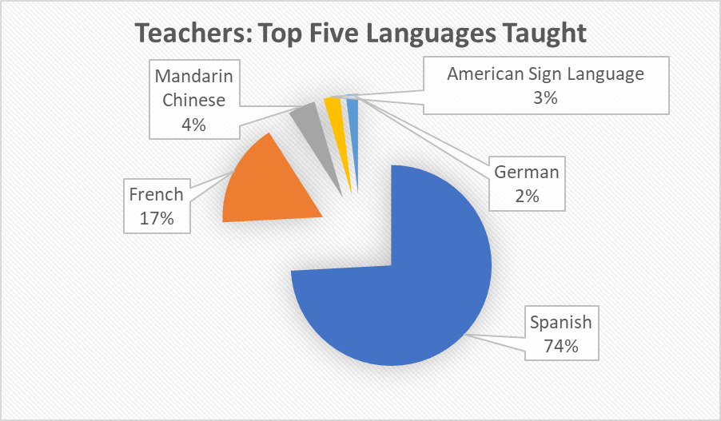
We asked teachers to indicate the language(s) they currently teach. The chart above illustrates the percentages of teachers for the five languages most frequently cited in answer to this question. In descending order, they are Spanish (74 percent), French (17 percent), Mandarin Chinese (4 percent), American Sign Language (ASL) (3 percent), and German (2 percent). An additional 39 languages not included in this chart were cited by fewer than 2 percent of respondents.
When asked to identify the type(s) of language program(s) in which they teach, 91 percent of respondents named one of five program types. The top three program types were cited by 79 percent of respondents. The greatest number of teachers responding to the survey (45 percent) cited a traditional four-year high school sequence as the type of program in which they taught. In descending order, the other most frequently identified program types were Advanced Placement Program (22 percent), Heritage Speaker Program (12 percent), Immersion Program (7 percent), and International Baccalaureate Program (5 percent).
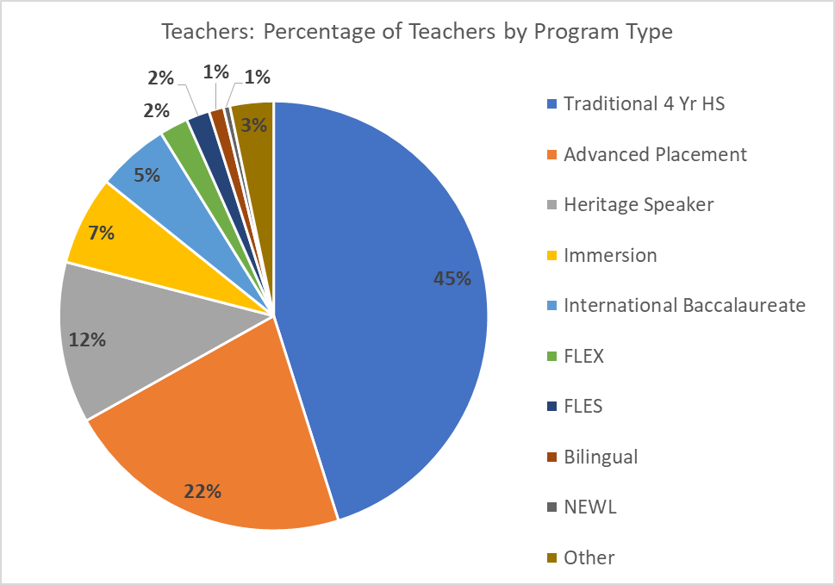
Teachers: The 2019 World Languages Standards: Awareness, Familiarity, and Implementation
As with administrators, the survey prompted teachers to gauge their familiarity with the WL Standards, their engagement, including participation in professional learning, and the progress toward implementation of the WL Standards in their programs.
According to their self-assessment, familiarity with the WL Standards is somewhat greater among teachers than administrators. Almost half of teachers responding to this question (49 percent) assessed themselves as somewhat familiar with the current standards, as opposed to 36 percent of administrators. Close to a quarter of teachers who responded (23 percent) stated that they were very familiar with the WL Standards, whereas among administrators, 19 percent claimed this greater familiarity. The remaining 6 percent of teacher respondents stated that they were not aware of the newly revised WL Standards, in comparison with 9 percent of administrators.
Similarly, slightly greater percentages of teachers than administrators reported some level of engagement with the WL Standards, although over half (55 percent) reported no exposure to informational conference presentations or professional learning events. A total of 38 percent of teacher respondents reported attending one or more WL Standards presentations (17 percent) or professional learning events (21 percent). An equal percentage to that of administrators (6 percent) noted their participation in the WL Standards public review and comment period.
Teachers responding to the survey gauge WL Standards implementation as having progressed a bit farther than do administrators responding to the same question. Over a quarter of respondents (26 percent) reported their programs having reached the early stages of implementation, and another 19 percent rated the implementation at their site as in progress. Eighteen percent rated implementation as still in the planning stages, while 5 percent, the same percentage of administrators who concurred with them, rated their local progress as nearing full implementation.
The three succeeding charts provide a visual representation of teachers’ responses regarding their familiarity, engagement with, and implementation of the WL Standards.
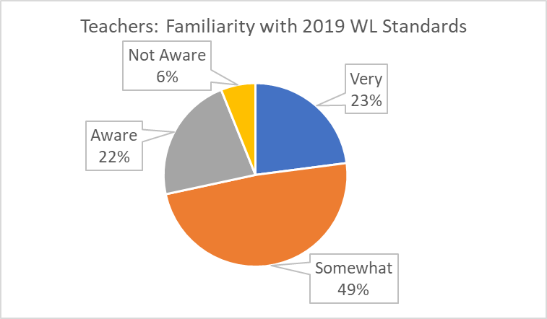
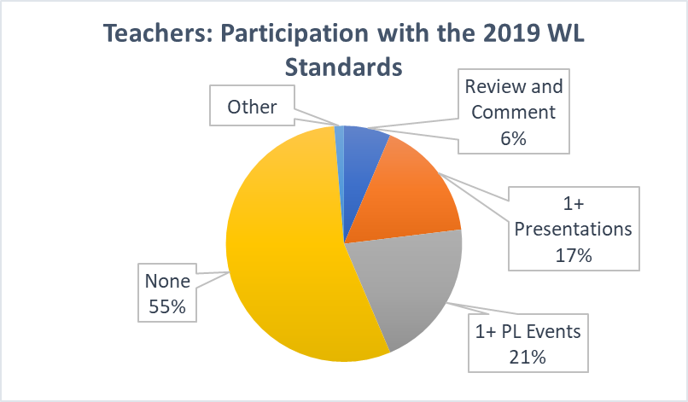
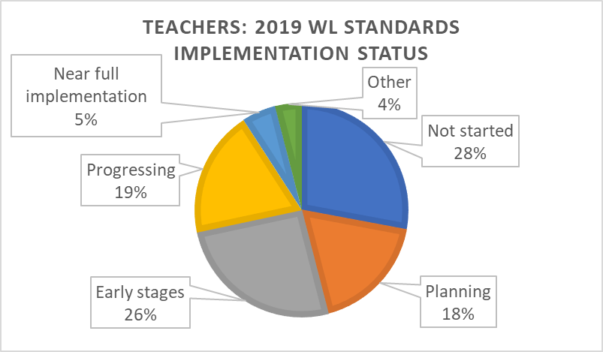

Professional Learning Priorities for World Languages Classroom Teachers
The responses of WL teachers were widely and comparably distributed across professional learning topics. Close to equivalent percentages of respondents cited the WL Standards (13 percent), pedagogy (15 percent) and assessment (15 percent) among their priorities for professional learning. In addition, slightly smaller percentages of respondents selected continuous improvement practices (11 percent) and cultural awareness (12 percent) among their professional learning priorities. The following chart visually captures this information.
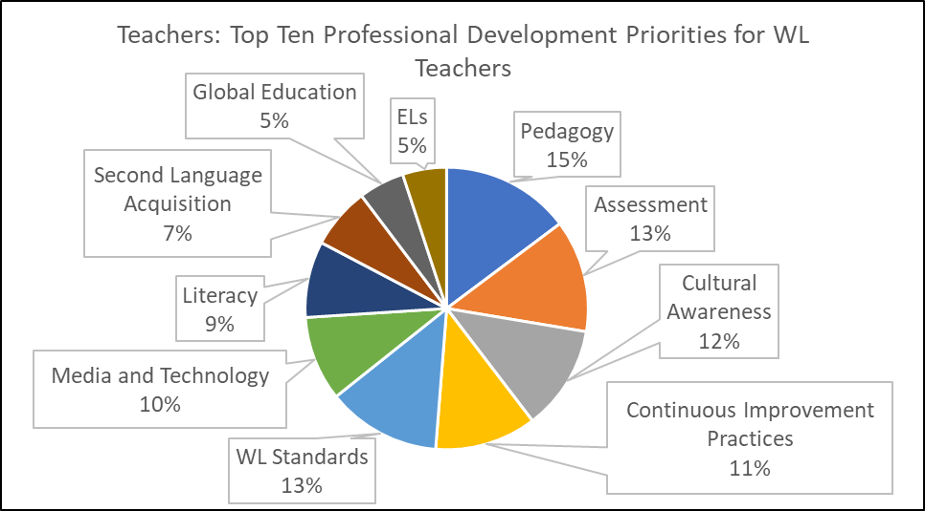
Between 5 and 10 percent of teachers selected each of a number of other professional learning topics listed in the survey. These next five most frequently cited topics were:
- Incorporating media and technology in the WL classroom (10 percent)
- Literacy and WL (9 percent)
- Second Language Acquisition theory (7 percent)
- Addressing Global Education in the WL classroom (5 percent)
- Supporting English Learners in the WL classroom (5 percent)

Teachers: Professional Learning Topics Helpful for Administrators
Teachers were also asked to select the professional learning topics they felt would be most helpful for administrators of WL programs. The top five professional learning topics they prioritized (with the number of respondents selecting each topic displayed in parentheses) were:
- Planning, developing, growing, and sustaining WL programs (507)
- The 2019 WL Standards (389)
- Basics of Second Language Acquisition theory and methodology (275)
- Cultural awareness (268)
- Teacher recruitment, development, and retention (268)
This information is depicted in the chart below. See p.13 of this report for administrators’ selection of their top professional learning priorities.
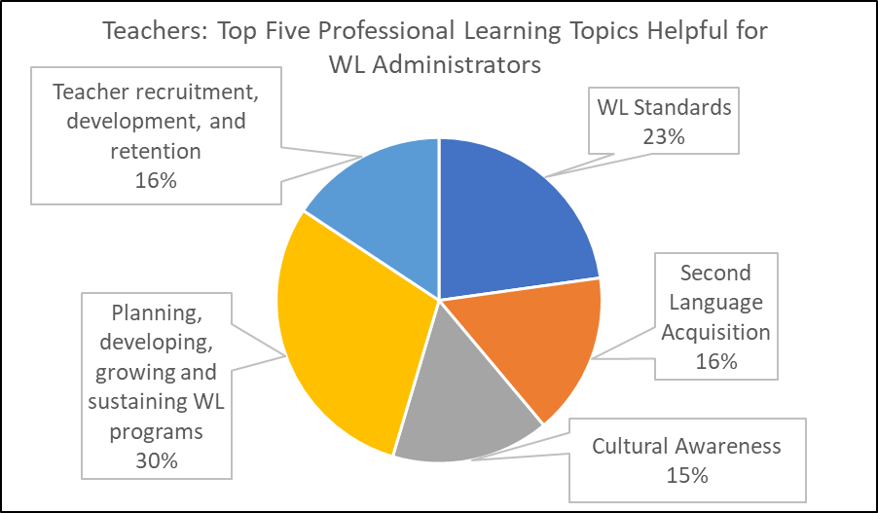
Notably, significant percentages of teachers indicate that administrators would benefit from professional learning in the areas of Second Language Acquisition and Cultural Awareness, fundamental components of the change in pedagogic approach and methodology embodied in the 2019 WL Standards.

Teachers: Principal Challenge
Teachers provided narrative responses to the question: Briefly describe the principal challenge you face as a teacher of WL. Responses were limited to 500 words, and 755 responses were submitted. These narrative responses were reviewed and grouped by category, resulting in seven collections of closely related responses. Challenges cited by only one or two individuals were grouped as “Other.”
The chart below represents the relative percentages of respondents citing each of the most frequently mentioned challenges.
Among the 755 responses received to this question, the two most frequently cited challenges were curriculum and materials (21 percent) and student motivation (23 percent). A closer look at the narrative responses in these areas reveals several distinct themes.
The greatest percentage of teachers responding to the survey identified student motivation as their principal challenge. Several contributing factors impacting student motivation emerged in teachers’ explanations of their perspectives on this issue. Most frequently mentioned was the fact that WL is not a core subject, and so students perceive these programs as less important or valuable. Learning another language is presented to them as just one alternative that they weigh against multiple options competing for space in their packed schedules. The following comments are representative of teachers’ observations:
“Many students who are undecided on attending college or university choose to take Career Technical Education/Regional Occupational Program classes to fulfill their graduation requirements rather than continue in WL.”
“I feel that students are not fully aware of the importance of being bilingual in this global world. As English speakers, they do not see the need of knowing a foreign language. Also, since California universities and colleges are requiring foreign language as one of their requisites, students just take the WL class to get the grade/grade point average they need, not because they do want to be able to communicate in another language.”
“WL classes are seen as electives. Our students often choose to leave the program after meeting the minimum college entrance requirements, because their schedules are too full with Advanced Placement core classes, which are viewed as "more valuable" for college entrance.”
Almost every teacher addressing curriculum and materials cited the outdated textbooks and resources still used in their schools and districts, which neither capture the interest of students nor align with current methodology and best practice in second language instruction. Teachers also pointed out the difficulty and labor-intensiveness of locating appropriate and high-quality authentic materials in the target language, and several teachers of less commonly taught languages, such as Vietnamese and Tagalog, related the scarcity of both curriculum and assessment resources for their students.
The following comments help to illuminate this perspective:
“Lack of current resources. We are using textbooks that are older than our students.”
“Curriculum and assessment requirements set by district administration more than 20 years ago and which do not correlate to current best practices and research.”
As a result of these circumstances, in addition to lesson planning, California’s WL teachers report spending many hours outside the classroom engaged in adapting and developing curriculum; researching, identifying, and acquiring resources such as authentic materials in the target language; and locating, acquiring, adapting, or crafting appropriate assessments. Many of the responses (9 percent) citing time as a principal challenge also refer to the hours required for teachers to develop these materials.
Administrative support was respondents’ third most frequently cited challenge. Issues grouped under this theme include budgetary support for program staffing, maintenance, and expansion and a perception that administrators view WL as less important a content area than core subjects. The following representative comments communicate these concerns:
“Lack of support or acknowledgement from school or district because we are not a core subject.”
“I would say the biggest challenge is growing the program and getting support from the school and district to develop a full, K–12 program. Another major challenge is getting adequate resources for our teachers.”
“Also the fact that foreign languages are considered an elective gives the impression that they are not a priority to students as much as core classes.”
“The principal challenge centers on administrators who don't understand the importance of learning one or more languages, specifically using the 21st Century instructional approach.”
As mentioned previously, the teachers who identified time as a principal challenge (9 percent) often referred to the labor intensiveness of developing curriculum and assessments. Others mentioned scheduling issues that result in fewer class periods for students, sometimes only one or two days per week. Several respondents cited the scarcity or absence of time reserved for their professional development.
Respondents (7 percent) also raised issues of equity and access in WL classes, and the challenge of meeting the needs of specific student groups. The two underserved groups specifically mentioned were special education students and English learners, and in particular among English learners, heritage speakers.
A number of respondents (6 percent) raised the issue of class size. The shortage of qualified teachers presumably contributes to the need to increase the number of students per class, and at times to necessitate combining students at multiple levels within a single large class.
The enactment of Proposition 58 removed prior barriers to the development of bilingual and dual immersion WL programs, and the number of such programs in the state has begun to increase. In their responses, some WL teachers (5 percent) take note of resulting program alignment challenges in these early stages of program growth. Clear and sequential pathways for the development of bilingual and multilingual proficiency do not yet exist in much of the state, resulting in barriers to continuous study and skill development throughout grade levels. In addition, teachers pointed out the disconnect created by the university admissions requirement of two years of language study. They see students remain in their classes just long enough to meet the minimum requirement before dropping language study in favor of alternatives they feel are more necessary or relevant to their college and career goals.
The graph below summarizes the principal challenges most frequently cited by teachers responding to the survey.
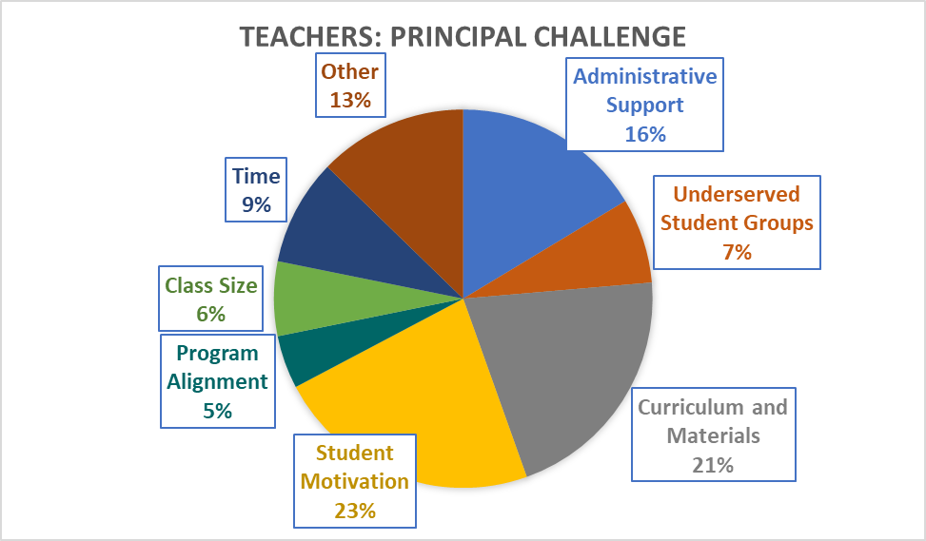

Teachers: Principal Channel of Information from the California Department of Education
Teachers were asked to indicate which of the many channels of communication that the CDE employs they most often rely on. The majority (62 percent) selected the CDE website as their principal information source. Under “Other,” respondent answers were largely divided between noting that they either receive information from the CDE through the district rather than directly, or that they do not access or receive any information by any means from the CDE (none). Listservs and newsletters were cited by much lower percentages of teachers, and very small percentages (3 percent or under) selected any of the three named social media platforms as their principal source of information.
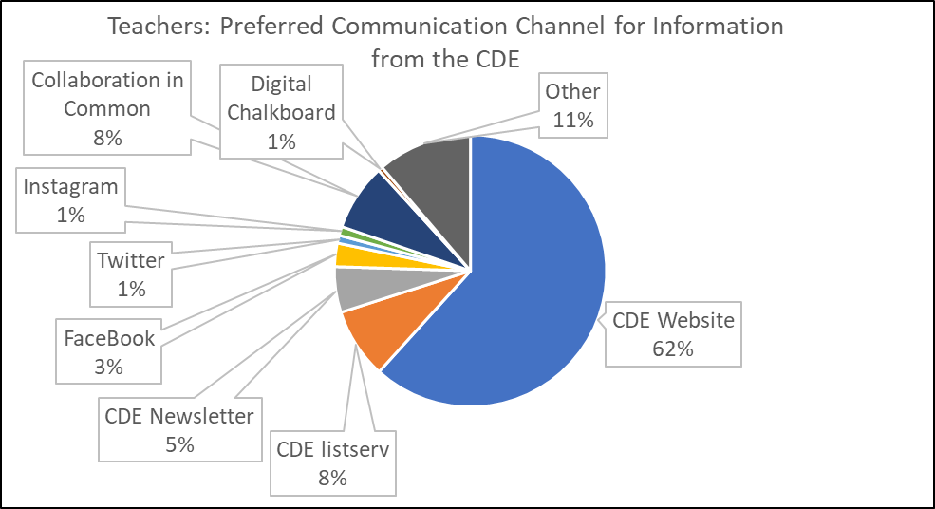

Conclusion
The WL Standards provide the infrastructure to update language teaching strategies and to welcome all students to the WL classroom. The WL Framework provides deeper explanation, examples, and explicit guidance for the evidence-based methodologies that fully implement the WL Standards in WL instruction. It also incorporates the policies and practices critical to access and equity for all student groups across all content areas.
Analysis of the robust response of the WL education community to the survey will assist the CDE, working with its internal and external partners, to identify significant opportunities to support the effectiveness of California’s existing WL programs, as well as to guide their expansion.
Use of the data in this report to plan actions and program support will enable California educators to reflect and collaborate, generating and continuously improving WL programs that leverage the assets of diversity, lived experience, and language skills of California students, and enable them to attain the linguistic and cultural competence so necessary to their leadership as global citizens.

Appendix: Long Descriptions

Administrator Level of Participation with the 2019 WL Standards
Pie chart depicting the level of participation of WL program administrators in professional learning and other events regarding the 2019 WL Standards: No participation: 66 percent; 1 or more professional learning events: 13 percent; 1 or more presentations: 13 percent; participated in public comment: 6 percent; Other (unspecified): 2 percent.

Administrators: WL Standards Implementation Status
Pie chart depicting the level of implementation of the 2019 WL Standards in their WL classrooms, as assessed by WL program administrators: Nearing full implementation: 5 percent; In progress: 10%; Early stages: 20 percent; In planning: 27 percent; not started: 35 percent; other (unspecified): 3 percent.

Teachers: Participation with the 2019 WL Standards
Pie chart depicting the level of participation of WL teachers in professional learning and other events regarding the 2019 WL Standards: No participation: 55 percent; 1 or more professional learning events: 21 percent; 1 or more presentations: 17 percent; participated in public comment: 6 percent; Other (unspecified): <2 percent.

Teachers: 2019 WL Standards Implementation Status
Pie chart depicting the level of implementation of the 2019 WL Standards in their WL classrooms, as assessed by WL teachers: Nearing full implementation: 5 percent; In progress: 19 percent; Early stages: 26 percent; In planning: 18 percent; not started: 28 percent; other (unspecified): 4 percent.
California Department of Education 27
November 2020

https://www.cde.ca.gov/sp/el/er/caedge.asp
http://leginfo.legislature.ca.gov/faces/billNavClient.xhtml?bill_id=201920200AB1505

