USER GUIDE
CDE’s COMBINED DAILY PARTICIPATION AND
WEEKLY ENGAGEMENT TEMPLATE
2020–21 School Year

California Department of Education
School Fiscal Services Division
October 2020
www.cde.ca.gov
For questions and assistance regarding the requirements of the CDE Template or an LEA alternative, email attendanceaccounting@cde.ca.gov.

Table of Contents
INTRODUCTION 3
SUMMARY OF REQUIREMENTS 4
CDE TEMPLATE INSTRUCTIONS 6
Weekly Assignments Completed Samples 9
General Information 11
Daily Participation and Verification Key Terms 13
Daily Participation and Verification Completed Sample 14
Section D: Certification 14
General Information 14
RESOURCES 15

INTRODUCTION
For the 2020-21 school year, local educational agencies (LEA) (https://www.cde.ca.gov/ci/cr/dl/distlearningfaqs.asp) providing instruction through distance learning in whole or part are subject to the provisions of the distance learning statutes (Education Code (EC) Section 43500, et. seq). Included within those provisions of law are requirements that the LEA document student attendance, daily participation, and weekly engagement, as well as certifying to the instructional time being assigned to students. As distance learning instruction is only applicable to the 2020-21 school year, the implementing statutes become inoperative on June 30, 2021. The California Department of Education (CDE) recognizes that implementing significant changes to the delivery of instruction to students along with additional recordkeeping requirements in a short span of time is tremendously challenging.
A LEA’s wealth of experience with documenting student attendance and maintaining student records will assist with transitioning to these new requirements. Daily participation is akin to taking attendance and the weekly engagement record reflects most of the information already found in a teacher’s lesson plan and/or grade book. Much of the information needed for these records already exists, and for the 2020-21 school year may need to be captured and maintained a little differently than in prior school years.
To assist LEAs with understanding these statutory requirements and avoid fiscal consequences, the CDE created the following resources:
- Technical frequently asked questions, https://www.cde.ca.gov/fg/it/pafaqs.asp
- An optional Combined Daily Participation and Weekly Engagement Tracking Template, (CDE Template) that meets the all statutory requirements, https://www.cde.ca.gov/fg/it/documents/template.pdf
- An LEA Alternatives for Tracking Daily Participation and Weekly Engagement for Distance Learning guide (LEA Alternatives), https://www.cde.ca.gov/fg/it/documents/leaoptuserguide.docx.
This user guide intends to further assist LEAs gain a better understanding of how to complete the optional CDE Template. An LEA that elects to modify their local student information system (SIS), learning management system or create an alternative template should review the LEA Alternatives guide for ideas on how LEAs can integrate these requirements into existing local systems in lieu of the CDE Template. In addition to the options in the LEA Alternatives guide, an LEA could decide to use select sections of the CDE Template in combination with its local SIS to meet the distance learning documentation requirements. This guidance does not constitute legal advice or a legal service.
The CDE recognizes LEAs will work in partnership with their employees to ensure the process being used at the local level to capture this information is as efficient as possible, clearly understood, uses sound recordkeeping practices, and meets the requirements of the law. Following these guidelines will help ensure LEAs are successful during their annual external audit of these requirements and avoid any fiscal consequence to the LEA.
At the close of this document, there is a list of additional distance learning resources available on the CDE’s website.

SUMMARY OF REQUIREMENTS
LEAs have instructional time requirements that create a structure within which the annual school day, month, and year are created. In most years, these requirements also have a significant impact on the claiming of attendance for funding purposes. Historically, instructional time has been calculated based on time spent under the immediate supervision of a certificated employee in a classroom.

Instructional Time
For the 2020-21 school year, instructional time requirements continue to create a structure within which the school day and year are created. These requirements have been expanded by statute to accommodate the need for distance learning. LEAs continue to have statutory instructional year and day requirements this year. In 2020-21, instruction can be offered through in-person instruction under the immediate physical supervision of a certificated employee or through distance learning under the general supervision of a certificated employee. In-person instructional time continues to be calculated based on time scheduled for instruction under a certificated employee’s physical supervision. Distance learning instructional time is calculated based on the time value of assignments, including assigned instruction made by and certified to by a certificated employee. The length in instructional minutes of the minimum instructional day is the same by grade level for each setting in which instruction is delivered whether it be in-person or distance learning.

Attendance Record Keeping
While attendance is not claimed for funding in 2020-21, pursuant to statute, attendance and participation in distance learning must be documented and verified. Similar to the principle that in an in-person environment, student attendance is based on being scheduled for and attending school while engaging in educational activities for some part of that school day, attendance in distance learning is based on a student being scheduled for and participating in at least some part of the assignments that constitute that student’s school day. In distance learning, the assignments that constitute a school day may include assigned instruction such as participating in a synchronous online lecture with the teacher, class discussion, assigned school work, and student assessments.

Distance Learning Documentation Requirements
As mentioned above, an LEA is required by law to document student attendance, daily participation, and weekly engagement, and certify to the instructional time being assigned to students when delivering instruction to students through distance learning. The table below summarizes these requirements.
Distance Learning Requirement | Statutory Reference | Summary of Requirement | Where Requirement is Met on CDE Template?
- Instructional Assignment/ Delivery Method | 43504(e) | Documents synchronous or asynchronous instruction for each whole or partial day of distance learning, as part of the weekly engagement record. | Section B, Weekly Engagement
- Assignment Tracking | 43504(e) | Documents assigned instruction, school work, and assessments assigned to meet each whole or partial day of distance learning instruction, as part of the weekly engagement record. | Section B, Weekly Engagement
- Attendance/ Absence Documentation | 43504  (d)(1) and (f)(1) | Attendance and absences must be documented to facilitate reporting chronic absenteeism and meet compulsory education requirements. | Section C, Daily Participation
- Daily Participation Documentation and Verification | 43504(d)(2), (e) | Daily participation may include, but is not limited to, evidence of participation in online activities, completion of assignments/assessments, contact with student, parents/guardians. Verifying participation is a requirement of the weekly engagement record. | Section C, Daily Participation
- Instructional Time Certification | 43502(e)  43504(c) | Certification by LEA certificated staff to time value of assignments so that minimum instructional day and annual school year length requirements can be met. | Section D, Certification
The above distance learning requirements, in addition to the LEA’s tiered reengagement strategies for students absent from distance learning, will be checked during the annual audit and have a fiscal consequence if not met. EC Section 43504(f)(2) requires an LEA to develop written procedures for tiered reengagement strategies for students that are absent from distance learning for more than three schooldays or 60 percent of the instructional days in a school week.
These requirements apply whether distance learning is provided in whole or for part of an instructional day and result in auditable records. Auditable records for distance learning are maintained at the local level and not submitted to the CDE. It is important for LEAs to have a plan in place to collect and manage information from employees, including teachers that are documenting and maintaining these records, so that the information is available and easily attainable at the time of the annual audit.

CDE TEMPLATE INSTRUCTIONS
Section A: LEA/Class General Information
Section A of the CDE Template captures LEA and class information as follows:
LEA/Class General Information Instructions
- LEA: Enter the LEA name.
- Month of: Enter the first date of the school month for which the CDE Template is being completed. A school month is a school month for the purpose of attendance accounting and is not the same as a calendar month.
- Certificated Employee: Enter the name of the certificated employee/teacher.
- School Site: Enter the school site name.
- Week of: Enter the weekly date range for which assignments are made and participation was verified.
- Grade Level/Class: Enter the grade level, period or class title.
Section B: Weekly Assignments
General Information
Although daily participation verification is a required element of the weekly engagement record, in the interest of documenting the other required elements of the weekly engagement record at a class level, daily participation verification is included with other student level requirements in Section C of the CDE Template.
- Section B of the CDE Template substantiates that the LEA is meeting the instructional time requirement for a school day by:
  - Documenting synchronous or asynchronous instruction for each whole or partial day, and tracking assignments.
  - Facilitates an opportunity for certificated staff to certify to time value of assignments in Section D to meet the minimum instructional day and annual school year length requirements.
- Tracking is done at the class level and is similar to a teacher’s lesson plan and/or grade book.
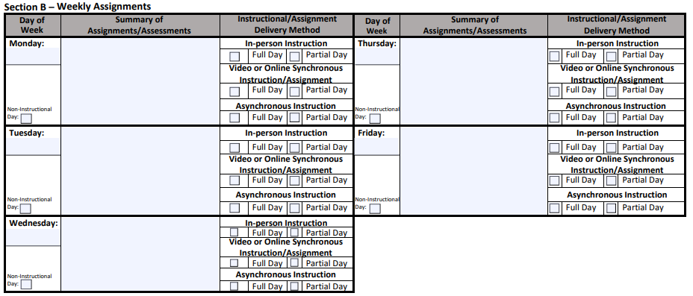
Weekly Assignments Instructions
In Section B enter the following weekly assignment information:
- Day of Week: Enter the date within the weekly date range. If no instruction was provided, select the box next to Non-Instructional Day.
- Summary of Assignments/Assessments: List student assignments/assessments for each instructional day, as indicated below. Only work assigned to meet the distance learning portion of the “school day” is required to be tracked. Classes of students scheduled for a full school day of distance learning will have distance learning assignments listed for that full instructional day.
  - LEAs have options on how to provide student assignments/assessments for each instructional day. For example, a certificated employee could indicate the following as shown in the Completed Sample screen shots below:
    - See lesson plan and/or grade book; or,
    - Provide a summary of class assignments/assessments.
    - Provide a detailed list of class assignment/assessments.
  - Classes of students scheduled for an instructional day that is made up of in-person instruction and distance learning will have distance learning assignments listed for the distance learning portion of the school day. It is not necessary to list assignments that are included in the in-person portion of the instructional day in the weekly engagement record.
  - The assignments section should be left blank or in-person instruction should be written in the “Summary of Assignment/Assessments” box for classes of students scheduled for in-person instruction for the full day. Assignments do not need to be listed for instruction delivered under the immediate physical supervision of a certificated employee and accounted for as in-person instruction.
- Instructional/Assignment Delivery Method: Indicate if the instruction or assignments were delivered in-person, video or online synchronous, or asynchronous and if full or partial day.
  - If full day is selected for any delivery method of the instruction or assignment (full or partial day/period and in-person, synchronous, or asynchronous), no other delivery method would be checked for that day.
  - If partial day is marked, more than one instructional/assignment delivery method may be selected.
  - If maintaining class level records in a departmentalized setting, multiple records will need to be combined across departmentalized subjects to show a full school day for a specific student.
- Sample work product is not required to be included in the weekly engagement record.
Weekly Assignments Key Terms
- Assignment: The instructional day for each student participating in distance learning is based on synchronous and/or asynchronous assignments, including assigned instruction (e.g. participating in a synchronous online lecture with the teacher, watching an asynchronous lecture, etc.), class discussion, school work, and assessments to meet the instructional day or portion of instructional day made by and certified to by a certificated employee of the LEA.
- Assignment Tracking: Documents assigned instruction, school work, and assessments assigned to meet each whole or partial day of distance learning instruction, as part of the weekly engagement record. If completing assignment tracking at a class level and a teacher is differentiating instruction for groups of students within the class by making separate assignments for each group, the assignment for each group should be indicated.
- In-Person: In-person instruction is instruction delivered under the immediate physical supervision of a certificated employee of the LEA in which a student is enrolled.
- Synchronous: Synchronous assignments and assigned instruction in distance learning takes place in real-time, with delivery of instruction and/or interaction with participants such as a live whole-class, small group, or individual meeting via an online platform.
- Asynchronous: Asynchronous assignments and instruction occurs without direct, simultaneous interaction of participants.
Full or Partial Day: A full instructional day is the length of the school day established by the local governing board, which is no less than the minimum number of instructional minutes for each grade level. Any amount of time that is less than the full instructional day is a partial day of instruction. A class period in a departmentalized setting may need to be treated as a day for the purpose of indicating the instructional delivery method. This does not mean that a period is the equivalent of a day for instructional time purposes. All students still need to be scheduled for the instructional minutes that apply to their grade span each day in order for a LEA to meet instructional time requirements.

Weekly Assignments Completed Samples

Single Teacher All Subjects
- Most likely in an elementary setting.
- Either of the first two examples would meet the requirements of statute. Additionally, the third example shows how to complete if in-person instruction for full day. This option would be chosen if a student is scheduled for full days of in-person instruction on some days of a school week and distance learning instruction on other days of a school week.

Examples 1 and 2
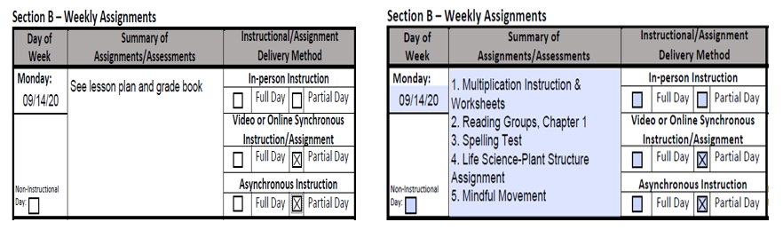
Example 3
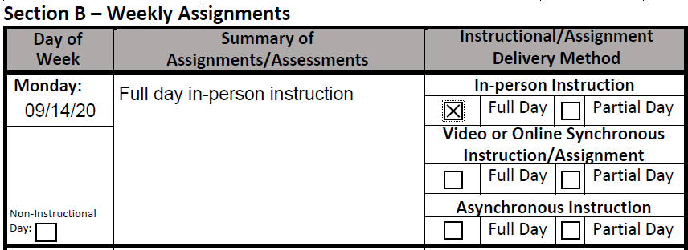

Departmentalized Setting/Multiple Teachers
- Most likely in a secondary setting.
- LEAs will need to substantiate for auditors that a student met the number of instructional minutes of the minimum instructional day for each class or period, which will require gathering weekly engagement records from all classes for that student. LEAs should plan now to create processes that would allow the retrieval of weekly engagement records for multiple courses for audit purposes.
  - The samples below reflect weekly engagement records that would be combined for auditing purposes.

Government
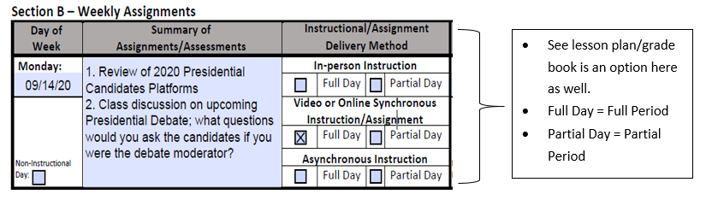
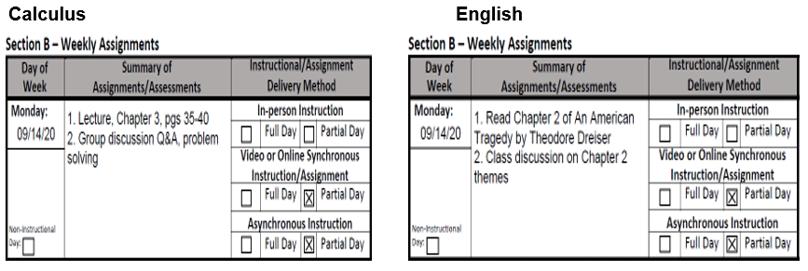
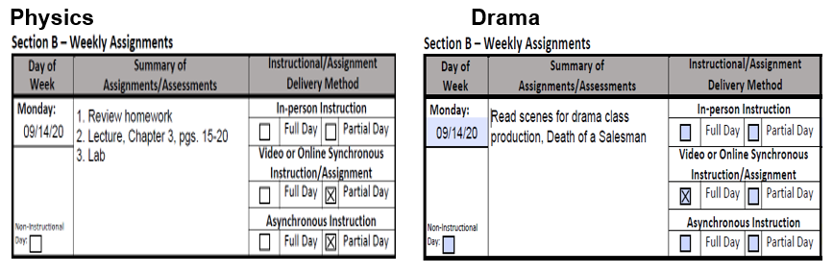Section C: Daily Participation and Verification Tracking

General Information
- Section C of the CDE Template tracks and documents student attendance and participation as follows:
  - Identifies daily participation which may include, but is not limited to, evidence of participation in online activities, completion of assignments/assessments, contact with student, parents/guardians.
  - Documents daily participation which can facilitate reporting attendance and absences for chronic absenteeism and compulsory education.
  - Indicates the method used when verifying and documenting participation in order to meet the verification requirement for the Weekly Engagement Record, Section B. By collecting this information as part of attendance verification at the student level it allows Section B to be documented at a class level.
- This is done at the student level and is akin to and substantiates taking daily attendance.
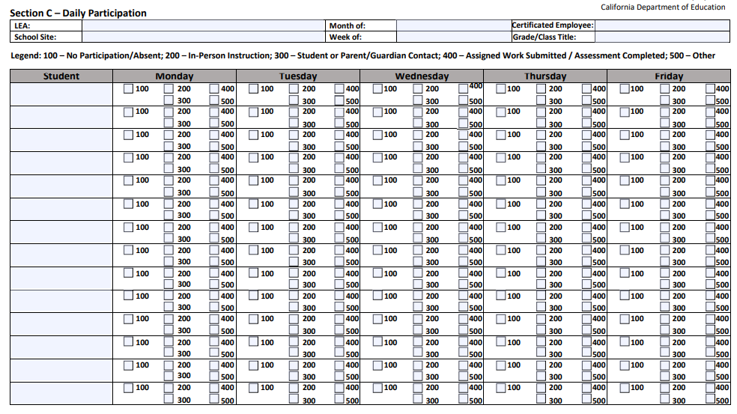
Daily Participation and Verification Instructions
In Section C enter the following student daily participation information:
- Student: List the names of each student in the class.
- Daily Participation: For each student for each instructional day, identify if the student participated or did not participate in the assigned instruction/assignments/assessments for that instructional day by selecting the appropriate code. These CDE defined codes are unique to the CDE Template and have no connection to CALPADS coding.
  - If the student participated, indicate how student participation was measured by checking the appropriate box(es).
  - If no participation is verified, the student is absent for the day. If the code 100 box is checked, no other participation boxes would be checked for that instructional day.
  - If any of the boxes other than the “No Participation/Absent” (code 100) box is checked, that indicates that the student is in attendance for that day. It is possible, although not necessary, for more than one box to be checked.

Daily Participation and Verification Key Terms
- Participation: Students that participate in any part of the instructional day are considered to be in attendance for that day. In distance learning, the instructional day is based on assignments, including assigned instruction made by and certified to by a certificated employee. Statute does not indicate a specific level of participation or amount of time students must be engaged in order to generate a day of attendance; that determination is at an LEA’s discretion. Since the distance learning instructional day is based on assignments, including assigned instruction, that are the equivalent of a school day, participation in any part of those assignments can result in attendance. Statute requires that participation be verified by an LEA and lists example means of participation such as evidence of participation in online activities, completion of assignments/assessments, and contact with student, parents/guardian. Statute does not limit the means of participation to those listed.
- No Participation/Absent (Code 100): The teacher or LEA employee is unable to verify that a student participated in at least some part of the assignments or assigned instruction that is included in the student’s school day. In a distance learning setting, if a student does not participate in at least some part of the assignments or assigned instruction that constitute their school day, that student would generate an absence for that day.
- In-Person Instruction (Code 200): In-person instruction is instruction delivered under the immediate physical supervision of a certificated employee of the LEA in which a student is enrolled.
- Student or Parent/Guardian Contact (Code 300): A teacher or LEA employee is able to verify through contact with a student or parent/guardian that the student participated in at least some part of the assignments or assigned instruction that is included in the student’s distance learning school day or distance learning portion of the school day.
- Assigned Work/Assessment Completed (Code 400): A student turns in any of their assigned work or completes an assessment that is included in the assigned day of distance learning or part of a day of distance learning, whether or not the student participates in any synchronous portion of the day. This would not include a homework assignment that is in addition to the synchronous and/or asynchronous assignments that constitute the instructional day for distance learning.
- Other (Code 500): Any other means an LEA has than those listed whereby a teacher or other LEA employee verifies student participation in their assigned distance learning school day or part of the distance learning school day.

Daily Participation and Verification Completed Sample
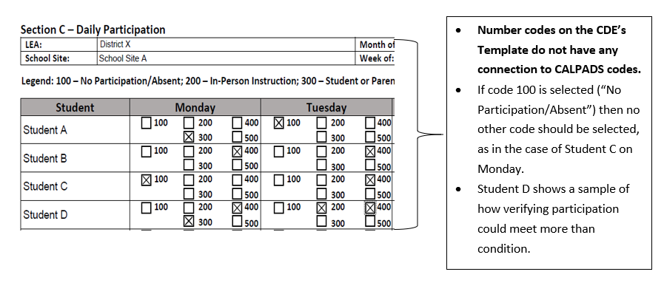

Section D: Certification

General Information
- Section D of the CDE Template certifies to attendance/participation and instructional time.
- The CDE Template combines the daily participation, weekly engagement, and instructional time requirements. As such, there is one certification line that certifies to both student participation and time value of assignments and/or assigned instruction and must be signed by a certificated employee of the LEA.
- In a departmentalized instructional setting where students are participating in multiple classes to make up a day of instruction, it is permissible for a supervising certificated employee to make this determination and sign the certification.
- For additional information on frequency of signatures and the ability to sign electronically, refer to question 18 under the Attendance Accounting and Reporting header of CDE’s FAQ (https://www.cde.ca.gov/fg/it/pafaqs.asp).
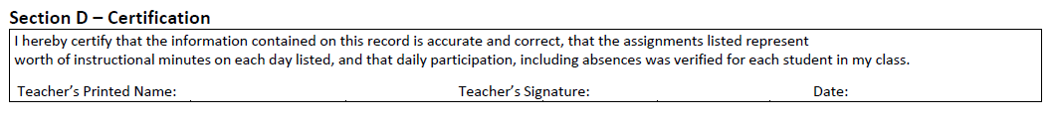Certification Instructions
In Section D enter the following certification information:
- Certification: Add in the time value of assignments to those the certificated employee is certifying. If the certificated employee is certifying to a full instructional day or period then input “a full day/period” into the fillable section. If the certificated employee is certifying to a specific time value in hours or minutes then input the specific number of minutes or hours being certified to into the fillable section.
- Teacher's Printed Name: Print the name of the certificated employee certifying the record.
- Teacher's Signature: The certificated employee certifying the daily participation and weekly engagement records must sign this section.
- Date: Enter the date that the record is signed.

RESOURCES
- 2020–21 Funding and Instructional Time FAQs
https://www.cde.ca.gov/fg/it/pafaqs.asp
- LEA Alternatives for Tracking Daily Participation and Weekly Engagement for Distance Learning
https://www.cde.ca.gov/fg/it/documents/leaoptuserguide.docx
- Distance Learning Frequently Asked Questions
https://www.cde.ca.gov/ci/cr/dl/distlearningfaqs.asp
- Distance Learning Instruction Planning Guidance
http://staging.cde.ca.gov/ls/he/hn/guidanceplanning.asp
- CDE’s COVID-19 Web Page
https://www.cde.ca.gov/ls/he/hn/coronavirus.asp

