Summer Food Service Dollars Go Further with USDA Foods
  - 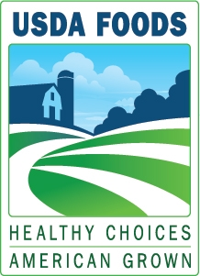
  - 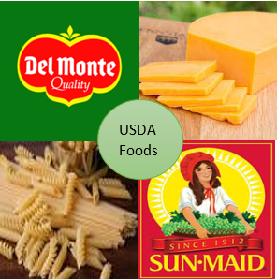
All Summer Food Service Program sponsors receive a minimum of $1,000 in USDA Foods!

USDA Foods Available Include:
- Assorted beans
- Cheese
- Deli Style Meats
- Pasta
- Salsa
- Raisins
- Peanut butter
- Frozen potato products
- Canned and frozen fruits and vegetables
- Ready to use chicken and beef products
All USDA Foods are 100 percent American-grown agricultural commodities and products, comply with the Buy American requirements, and they support the Dietary Guidelines for Americans.
For inspiration, view the Kooking 4 Kids Commodity Program video on the Youth Sports Films YouTube Channel at https://www.youtube.com/watch?v=V3dJRRlZY6E&t=212s to find out what one SFSP sponsor has to say about USDA Foods.

Next Steps
View the USDA Foods and the SFSP training video on the CDE Nutrition YouTube Channel at https://www.youtube.com/watch?v=rK6uw-2SOvc&feature=youtu.be.
For questions or to sign up, please contact Amy Bell, Child Nutrition Consultant, Food Distribution Program by phone at 916-322-5051 or by e-mail at abell@cde.ca.gov.
Posted May 2018
California Department of Education, Nutrition Services Division, Food Distribution Program
This institution is an equal opportunity provider.

