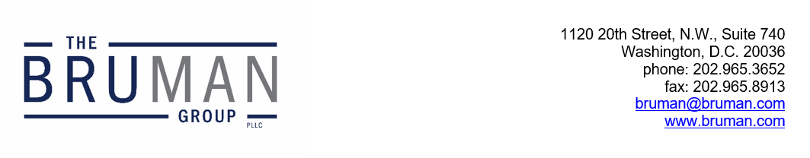

The Federal Update for January 3, 2025

From: Michael Brustein, Julia Martin, Steven Spillan, Kelly Christiansen
Re: Federal Update
Date: January 3, 2025
Legislation and Guidance 1
119th Congress Begins 1
ED Issues Final Rules on Return to Title IV, Distance Education 2
OESE Publishes New Title I, Part D Guidance 2
School Improvement Guidance Finalized 3

Legislation and Guidance

119th Congress Begins
The new session of Congress begins today with the swearing-in of new members of the House and Senate. The processes that occur today will be generally organizational and ceremonial, with little substantive policy discussion expected. However, it will mark the beginning of Republican control in the Senate, and turnover in House Committees. The first official duties of the House begin Friday, when the process of electing a Speaker kicks off. Though Representative Mike Johnson (R-LA) served as Speaker in the last session of the House, that position is not guaranteed in the new year, and it is likely that lawmakers will use this selection process as a means of securing agreements on Committee assignments, legislative schedules, House rules, and other priorities. Still, others have voiced discontent with Johnson’s leadership, suggesting another difficult election for the slim Republican majority in the House.
Other action continues Monday as the House certifies the results of the Presidential election.
Author: JCM

ED Issues Final Rules on Return to Title IV, Distance Education
The U.S. Department of Education (ED) has issued final rules, published today, on portions of Title IV of the Higher Education Act (HEA) governing distance education and Return to Title IV. The rules finalized provisions first proposed in July of 2024.
The regulations on returning funds to Title IV (known as R2T4), ED says, will “increase the accuracy and simplicity” of calculating return amounts, “address unique circumstances,” and “codify longstanding policies into regulation.” The “unique circumstances” where an institution will not have to calculate and perform R2T4 include situations where a student is treated as never having begun attendance, where all HEA assistance disbursed has already been returned, where the institution refunds all institutional charges to that student, and the institution writes off or cancels any enrollment balance due to prior return of funds. The notice says that institutions will have only one way to calculate the percentage of payment period the student completed, versus the two currently allowed.
Additionally, ED will codify longstanding guidance that an institution that is required to take attendance must document the date of the institution’s determination that the student withdrew no later than 14 days after the student’s last date of attendance.
Portions on distance education will be amended to create a definition of a distance education course, and enrollment in those courses would be reported to ED through a process to be determined by the agency.
The regulations are effective starting July 1, 2026. ED has also noted it will not be issuing final TRIO regulations – a draft version would have opened eligibility to include any high school students in the United States or U.S. territories, effectively extending access to undocumented students. That portion may have been removed because it would be controversial and could be rescinded under the Congressional Review Act (CRA), which would mean that the agency would be prohibited from ever issuing “substantially similar” regulations on the same legislative text. Nevertheless, ED also asserts in the notice that this rulemaking is not subject to the CRA because it is not a “major rule” under the definitions of the act.
Author: JCM

OESE Publishes New Title I, Part D Guidance
At the end of last year, the U.S. Department of Education’s (ED’s) Office of Elementary and Secondary Education issued final guidance on Title I, Part D of the Elementary and Secondary Education Act (ESEA), the Prevention and Intervention Programs for Children and Youth Who Are Neglected, Delinquent, or At-Risk. ED released a draft form of the guidance in August 2024 for stakeholder feedback, resulting in 13 entities submitting comments.
The final guidance replaces the last guidance on the program, released in 2006. The 2006 guidance was issued before ESEA was amended by the Every Student Succeeds Act (ESSA) in 2015. ESSA broadened the scope of the program to include youth in Tribal institutions and allows local educational agencies to use funds to support Indian youth who are considered “at risk.” It also clarified that State agencies can use funds for transition services to move youth between schools and institutions.
ED’s new guidance includes a list of frequently asked questions about the program and is divided by the three subsections of the legislation. The first subpart of Title I-D provides funding for State agencies to support youth who live in or attend institutions designed for neglected and delinquent youth. The second subpart allows local educational agencies to use funds to serve students in local correctional facilities or other local programs for neglected and delinquent youth and assist in their transition back to the classroom. The final subpart addresses required evaluation measures of the programs by State agencies and local educational agencies.
In the guidance, ED also provides a list of resources that States and subgrantees can use to improve Title I-D programs.
The new guidance is available here.
Author: BTW

School Improvement Guidance Finalized
The U.S. Department of Education released final guidance Friday on school improvement requirements under Title I, Part A of the Elementary and Secondary Education Act. A draft version of the guidance was issued for public feedback in September last year. Overall, the guidance addresses the range of requirements involved in the identification of schools for improvement status, including timelines, categories of improvement, school improvement plans, evidence-based interventions, identifying and addressing resource inequities, and other provisions.
As part of the final guidance release, ED also issued a document outlining the changes that were made in response to public feedback. In response to the 17 comments received from stakeholders on the draft guidance, ED expanded the guidance, providing more clarity and information on areas where States have discretion; continuous improvement, review, and monitoring of school improvement plans; available federal technical assistance related to school improvement; exit criteria for targeted support and improvement schools; and timelines and sustainability, as well as other issues, under Section 1003 grants.
The final guidance is available here and the summary of changes is here.
Author: KSC
The Federal Update has been prepared to inform The Bruman Group, PLLC’s legislative clients of recent events in federal education legislation and/or administrative law. It is not intended as legal advice, should not serve as the basis for decision-making in specific situations, and does not create an attorney-client relationship between The Bruman Group, PLLC and the reader.
© The Bruman Group, PLLC 2025
Contributors: Julia Martin, Kelly Christiansen, Brandi Tennant Wills
Posted by the California Department of Education, January 2025

