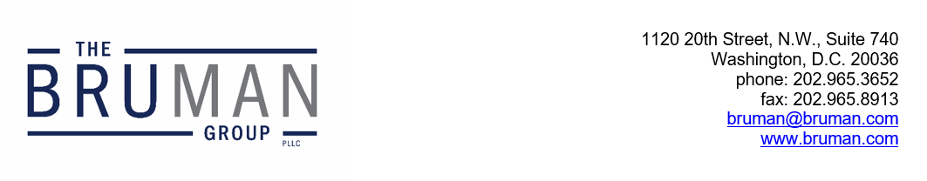

The Federal Update for January 10, 2025

From: Michael Brustein, Julia Martin, Steven Spillan, Kelly Christiansen
Re: Federal Update
Date: January 10, 2025
Legislation and Guidance 1
Committees Announce Membership for 119th Congress 1
Cardona Sends Letter on Restraint and Seclusion Practices 2
News 2
Federal Judge Strikes Down Title IX Rule Nationwide 2

Legislation and Guidance

Committees Announce Membership for 119th Congress
The House and Senate Congressional Committees with jurisdiction over education have announced their membership for the 119th Congress, which began last week.
In the now-renamed House Committee on Education and Workforce (the new Congressional rules removed “the” before “workforce”), headed by new Chair Tim Walberg (R-MI), new members on the majority side include Bob Onder (R-MO), Ryan Mackenzie (R-PA), Michael Baumgartner (R-WA), Mark Harris (R-NC), and Mark Messmer (R-IN). Former chair Virginia Foxx (R-NC) will remain on the Committee despite no longer being chair. Representative Elise Stefanik (R-NY), who has been nominated to be Ambassador to the United Nations, will serve on the Committee until confirmed, and then will be replaced by House leadership. The Democratic delegation to the Committee has not yet been formally announced, but will be led by Representative Bobby Scott (D-VA).
In the Senate, new members of the Committee on Health, Education, Labor, and Pensions include Tim Scott (R-SC), Josh Hawley (R-MO), Jim Banks (R-IN), Mike Crapo (R-ID), and Marsha Blackburn (R-TN). New Senators Andy Kim (D-NJ) and Angela Alsobrooks (D-MD) will round out the minority.
Among the first orders of business for new Committee members will be organization meetings and – for the Senate – confirmation hearings for the President-elect’s nominees.
Author: JCM

Cardona Sends Letter on Restraint and Seclusion Practices
Secretary of Education Miguel Cardona sent a letter to education leaders this week on the use of restraint and seclusion in schools. Cardona encouraged leaders to consider previous guidance released by the U.S. Department of Education (ED) on these practices and to prohibit restraint and seclusion.
Restraint, restricting a student’s movement, and seclusion, confining a student to a solitary space, are harmful to students and not in line with ensuring students are treated with dignity, the letter says. Cardona references a previous report from the General Accountability Office (GAO) which found that there have been multiple instances of abuse and even death related to the use of restraint and seclusion in classrooms.
Despite these results, data show that over 50,000 students were restrained or secluded in schools during the 2020-2021 school year. However, the GAO has found that schools often underreport these numbers and has encouraged ED to implement quality controls to ensure misreporting is addressed going forward. More recent data is not yet available to the public.
There are no federal laws that prohibit restraint and seclusion. Even so, ED has released guidance in recent years on using evidence-based approaches to discipline instead of relying on restraint and seclusion practices. A 2022 guidance document provides resources to aid schools in applying alternative approaches to support students with disabilities and 2023 guidance addresses applying evidence-based approaches to discipline for all students in schools.
Cardona encourages schools to use “multi-tier systems of supports with individualized, targeted, and effective interventions for high-need students.” The letter also advises State leaders to invest in teaching educators these evidence-based alternatives and provides an overview of the federal funding opportunities States can use to address this.
The letter is available here.
Author: BTW

News

Federal Judge Strikes Down Title IX Rule Nationwide
A federal judge for the Eastern District of Kentucky struck down regulations on Title IX of the Education Amendments of 1972 on Thursday, determining that the regulations are unlawful. The Title IX regulations were issued in final form by the U.S. Department of Education (ED) early last year and went into effect for conduct occurring on or after August 1st. But after several lawsuits were filed against the rule, implementation was halted in 26 States and in hundreds of schools around the country while those lawsuits proceeded. The final ruling handed down Thursday, however, applies nationwide.
The regulations issued by the Biden administration were considered controversial as they expanded protections under Title IX, which prohibits discrimination based on sex in educational programs or activities run by institutions receiving federal funding, to include discrimination based on sexual orientation and gender identity. In addition, the requirements under the federal regulations were contrary to some State and school district laws and policies across the country.
In his decision, the judge writes that the regulations are “arbitrary and capricious,” and that ED exceeded its authority in expanding the application of Title IX. Further, the judge determines that the regulations violated First Amendment free speech rights by requiring educators and other staff to use pronouns for students that do not align with students’ biological sex. Republican lawmakers praised the ruling, including the new chairs of the House and Senate education committees.
ED did not comment on the ruling Thursday but will likely leave the handling of the decision’s aftermath to the incoming Trump administration. The Trump administration planned to withdraw and possibly issue new regulations on Title IX as part of its education agenda. It is unclear if President-elect Trump’s ED will re-issue the 2020 regulations that were promulgated during the administration’s prior term in office or write new regulations, and what requirements recipients will be held to in the interim.
Resources:
Bianca Quilantan, “Federal judge vacates Biden’s Title IX rule,” Politico, January 9, 2025.
Collin Binkley, “Judge scraps Biden’s Title IX rules, reversing expansion of protections for LGBTQ+ students,” Associated Press, January 9, 2025.
Author: KSC
The Federal Update has been prepared to inform The Bruman Group, PLLC’s legislative clients of recent events in federal education legislation and/or administrative law. It is not intended as legal advice, should not serve as the basis for decision-making in specific situations, and does not create an attorney-client relationship between The Bruman Group, PLLC and the reader.
© The Bruman Group, PLLC 2025
Contributors: Julia Martin, Kelly Christiansen, Brandi Tennant Wills
Posted by the California Department of Education, January 2025

