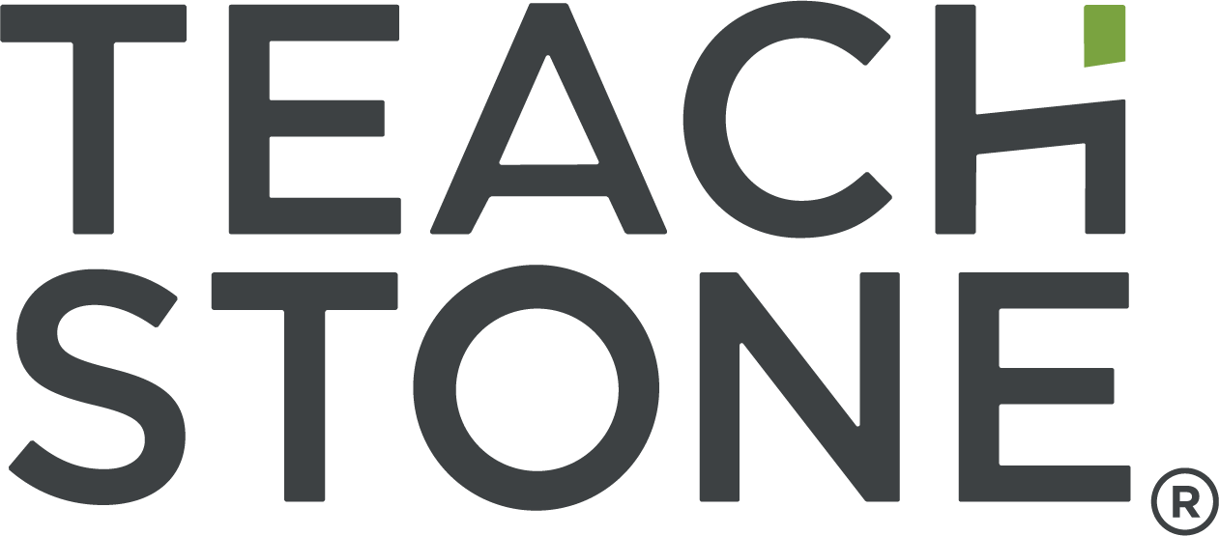

myTeachstone® System
User Navigation Resource
March 2025
California Department of Education

Introduction 3
User Accounts within myTeachstone 4
Accessing myTeachstone 5
My Teachstone Dashboard 7
User Settings 10
Administrator Level Users 11
Creating New Accounts Linked to Agency or Contractor 12
Managing Program Hierarchy 12
Adding Sites within your Program 13
Managing Site Classroom Hierarchy 14
Adding or Editing Classrooms within a Site 15
Adding New Members or Users to the Site 18
Transferring Users between Sites or Programs 21
Adding Observers to an Organization 21
Tracking and Accessing Observation Level Data 22
Searching and Filtering Observations 24
Creating and Accessing CLASS Data Reports 25
Downloading Reports 28
Accessing Individual Observation Reports 29
Creating Comparison Reports 30
CSPP Observers and CLASS Data Entry Users (i.e., Observers and Support Team Members). 34
Accessing CLASS Data Collection (Admin, Observer, Data Entry roles) 34
Preparing for Data Entry 37
Entering CLASS Observation Data 38
Entering CLASS Environment Scores 45
Entering Cycle Data 47
Entering Evidence for the Observation 50
Uploading Attachments 51
When CLASS and CLASS Observation Records are Complete 53
Tracking Data Entry 53
CSPP Educator/Classroom Level User 56
Accessing CLASS Scores for the Classroom 57
CLASS Learning Community 59
Learning Resources 61

Introduction
This resource is designed to support user navigation of the myTeachstone platform for successful implementation of data collection for the Classroom Assessment Scoring System (CLASS) and CLASS Environment for California State Preschool Programs (CSPPs).
The myTeachstone platform will be a centralized location for all CSPP CLASS and CLASS Environment data to support accessibility and reporting to the California Department of Education (CDE). Access to myTeachstone is available for a variety of user types, based on a hierarchy and associated permissions. The diagram below shows a hierarchy with CDE at the top. Below is the CSPP program, divided into four ASPIRE regions: A, B, C, and D. Within each ASPIRE region, contractors within the region are separated out. Then each contractor is divided into all the CSPP sites that the contractor operates. All of the sites are then separated into each of the CSPP classrooms that make up the site, and finally all classrooms include all of the educators that support the classroom.
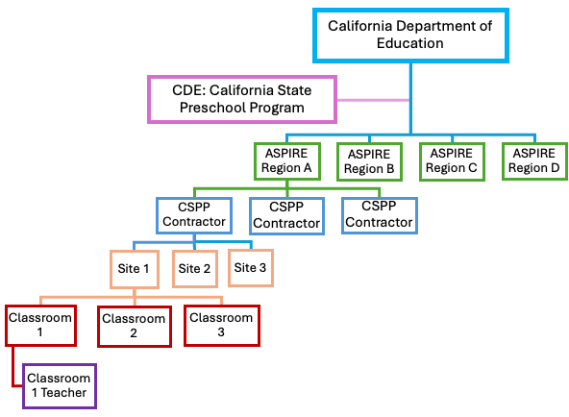
Through myTeachstone, users will be able to track their progress toward completing observations and obtain reports at the classroom, site, and agency level. To further support user knowledge of CLASS and effective interactions support can be accessed within the platform and are aligned to CLASS indicators.

User Accounts within myTeachstone
There are several user types within the myTeachstone platform for CSPP. An overview of the user roles and responsibilities is provided below. Contractors are responsible for creating profiles for their agency and site staff, including assigning accounts for site supervisors, educators, other classroom teaching staff, and adding sites and classrooms. Contractors are also able to add additional administrative user accounts as needed. Contractors will determine how many users within their organization need administrative access to myTeachstone. The total number of users and the number of users assigned to each user type is anticipated to vary across contractors. Contractors may assign staff more than one user type as needed.
Table 1. Alignment between CSPP role, myTeachstone permission levels, and functionality within myTeachstone.
User Account Type/Role | CSPP Contractor/ Site Roles | User Account Role and Responsibilities
Administrator  (program level) | CSPP Contractor, Executive Director, or Program Director | - Maintain hierarchy of all sites operated by the agency (add/edit/delete sites, classrooms, Administrators, Educators, and Observer users or change user access as needed)  - Access observation data  - Generate Contractor level summary reports
Administrator  (site level) | CSPP Site Supervisor | - Maintain hierarchy of classrooms and educators at the site (add/edit/delete classrooms, Site Supervisors, Educators, and Observer users or change user access as needed)  - Enter observation data (if the user has an active CLASS Certification)  - Access observation data  - Generate site level summary reports
Educator (view-only accounts) | CSPP Teacher | - Access to view their classroom observation data and feedback
Independent Observers should not be assigned a role within an organization | CLASS Observers (external to your organization) | - Enter their own observation into the myTeachstone system
(These accounts are created by Teachstone at Contractor’s request) | Data Entry Users | - Enter observation data on behalf of an Observer

Accessing myTeachstone
All CSPPs will be added to a Statewide CSPP myTeachstone account. Upon obtaining user account information from Teachstone, the CSPP Contractor and site staff may access the myTeachstone system by following the steps below:
- Navigate to the Teachstone Login Dashboard located at https://dashboard.teachstone.com/users/login
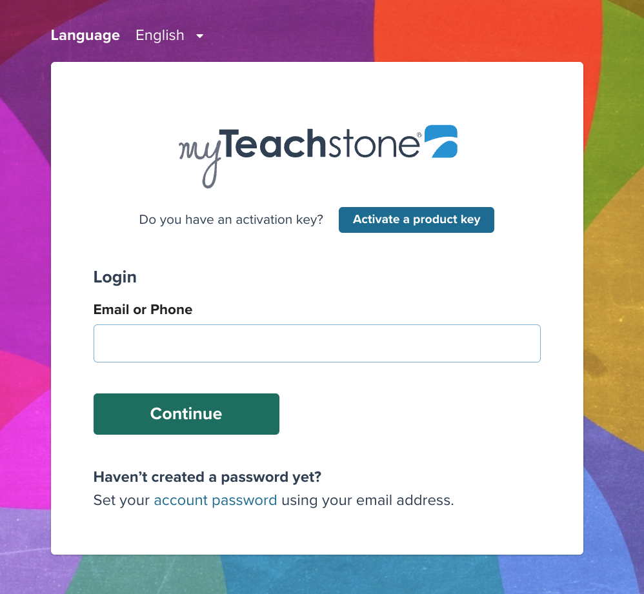
- Login using the email and password credentials provided via email communication from Teachstone.
Note: Users can change the display language to English, Spanish, or French, as desired. Users may also use the “Chat with Support” button on the bottom right side of the display to obtain technical support.
User Assurances and Consent
When first logging on to myTeachstone, users are provided with a copy of Teachstone’s Privacy Policy outlining how Teachstone collects, uses, and shares user personal information. Users are urged to read the policy and direct questions or concerns about their privacy while using myTeachstone to supportca@teachstone.com.
Although all CSPPs will be added to the Statewide CSPP account, all users will only have access to the specific CSPP agency information and data they are associated with within myTeachstone.

myTeachstone Dashboard
Upon successful login, users will be taken to the myTeachstone Dashboard:
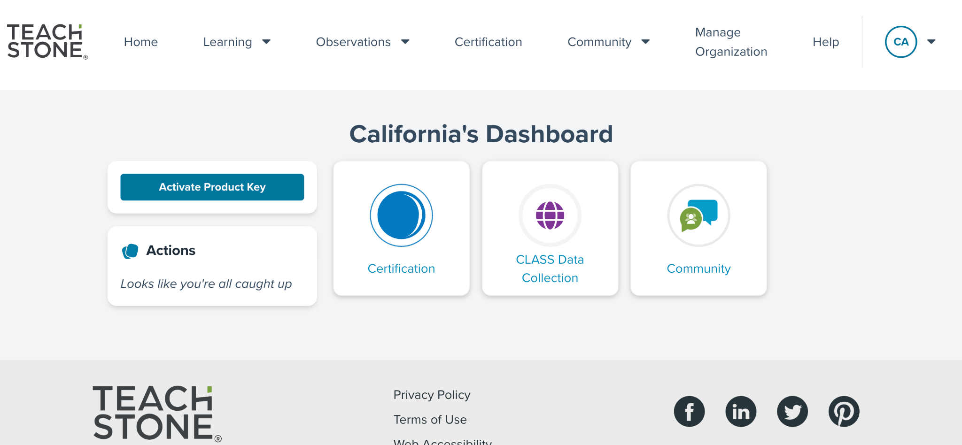
User dashboards will vary based on myTeachstone user role and the user's position within their organization.
Once users have logged into the myTeachstone system, the ‘Home’ page will appear. The ‘Home’ page will be the navigation center with tiles representing different tasks. A menu of navigation tabs or options will also be displayed across the top of the screen.
Toward the middle of the page, users will find hyperlink tiles that allow users to navigate to commonly used functions quickly. Other tiles will appear based on myTeachstone user role and the user’s position within their organization. For example, users with CLASS and CLASS Environment data entry permissions, or whose primary function is to review data or obtain data summary reports, will have a “CLASS Data Collection” tile.
Overview of Dashboard Tiles
- Certification: This tile takes users to the Organization’s Certification dashboard and allows users to view a dashboard of Certifications held by their organization's members or their personal Certifications.
- CLASS Data Collection: This tile takes users to the organization’s observations (both in-process and completed observations). This supports the user’s ability to track the number of observations that are ‘in progress’ and those that have been ‘completed.’ It also allows access to CLASS reports at the classroom, site, and program levels.
- Community: This tile provides access to the CLASS Learning Community. Users will be asked to review and agree to a Community Expectations and Privacy Agreement before having full access. The CLASS Learning Community offers a place to ask questions, share resources, and connect with others using CLASS.
Overview of Dashboard Navigation tabs:
- Home: Returns you to the main menu and allows you to navigate to other areas of the site.
- Learning: Provides access to Teachstone training and tracks your completed training history.
- Observations: Allows users to be taken to the CLASS Data Collection dashboard or CLASS Data Reports.
- Certifications: Allows users to view a dashboard of Certifications held by their organization's members or their personal Certifications.
- Community: Allows users to navigate to the CLASS Learning Community, the Teachstone Blog, or to be taken to a page with upcoming Teachstone events.
- Manage Organization: Allows users to build out their program’s hierarchy by adding user accounts at the program, site, Observer, and classroom levels.
As users navigate through myTeachstone, the navigation menu will remain constant at the top of the page. The ‘Home’ option takes users back to the main page. Different levels of users will see different tiles on their ‘Home’ page depending upon their level of access and assigned responsibilities.
To log out of myTeachstone, users may click on their profile button at the upper right corner of any page within the platform. If the user shares their computer with others, they should be careful to log out each time they leave the site.
If a user has a pre-existing myTeachstone account using their current work email address, this user’s information including current CLASS Certifications and their training history will be populated when they log into the CSPP account. If, however, their existing account uses another email address (such as a personal email address or the email address of a previous employer), their training information and Certifications will not populate in the new CSPP associated account.
TIP: To help facilitate a smooth transition for existing myTeachstone users, it is recommended that anyone with a pre-existing myTeachstone account log into the pre-existing account and update their email address with their current work email address to ensure their myTeachstone account within the Statewide CSPP account is complete and accurate.
Once the Statewide CSPP myTeachstone account goes ‘live,’ the Program Director or Executive Director of the CSPP will receive notification that they have been added to the Statewide CSPP account.
As others are added to organizations, they will either:
- If they already have an existing myTeachstone account: receive an email indicating that they have been added to the CSPP account with the permissions specified by their role and position within their organization’s hierarchy; or
- If they do not have a pre-existing account with their current work email address: will be sent an invitation to join myTeachstone. For more information about the invitation, please refer to the Accessing CLASS Data Collection section of this resource.
Users with pre-existing myTeachstone accounts who were successfully added to the Statewide CSPP account will have access to both accounts with a single login.
Users with two linked accounts will be asked to indicate which account within myTeachstone they want to access. They can then select the account in the dropdown box on the upper right side of the screen to select the appropriate account.
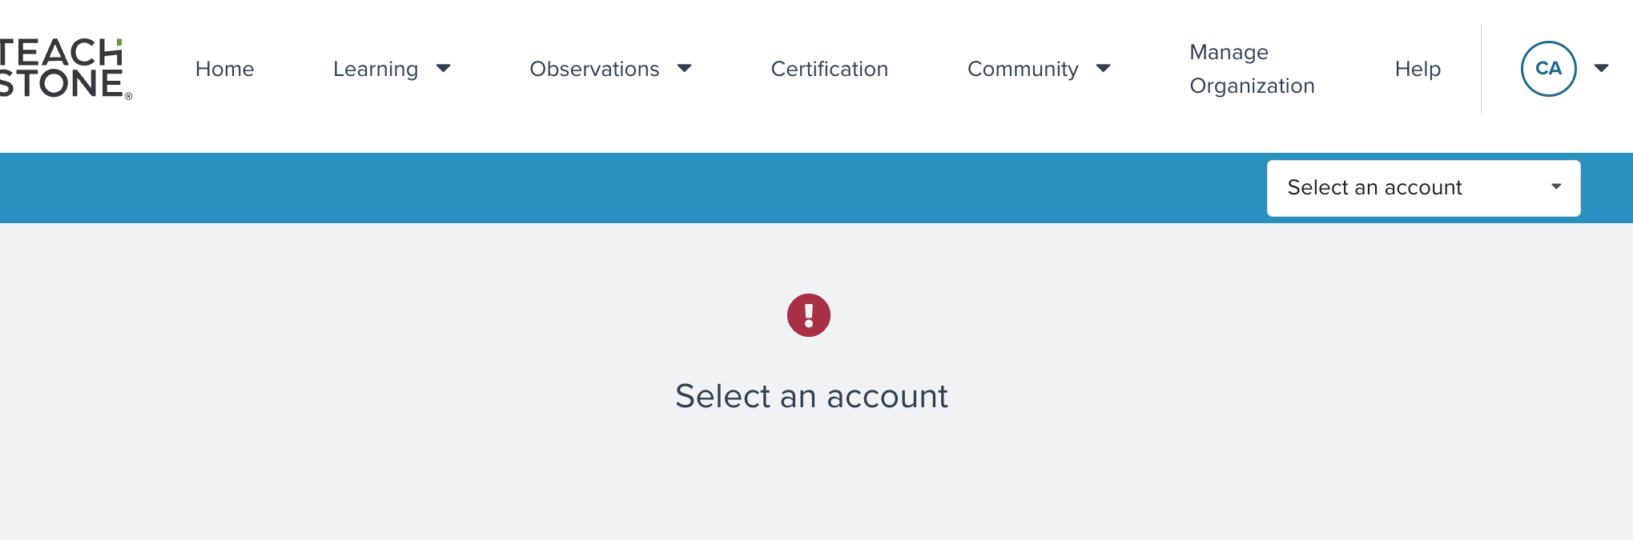
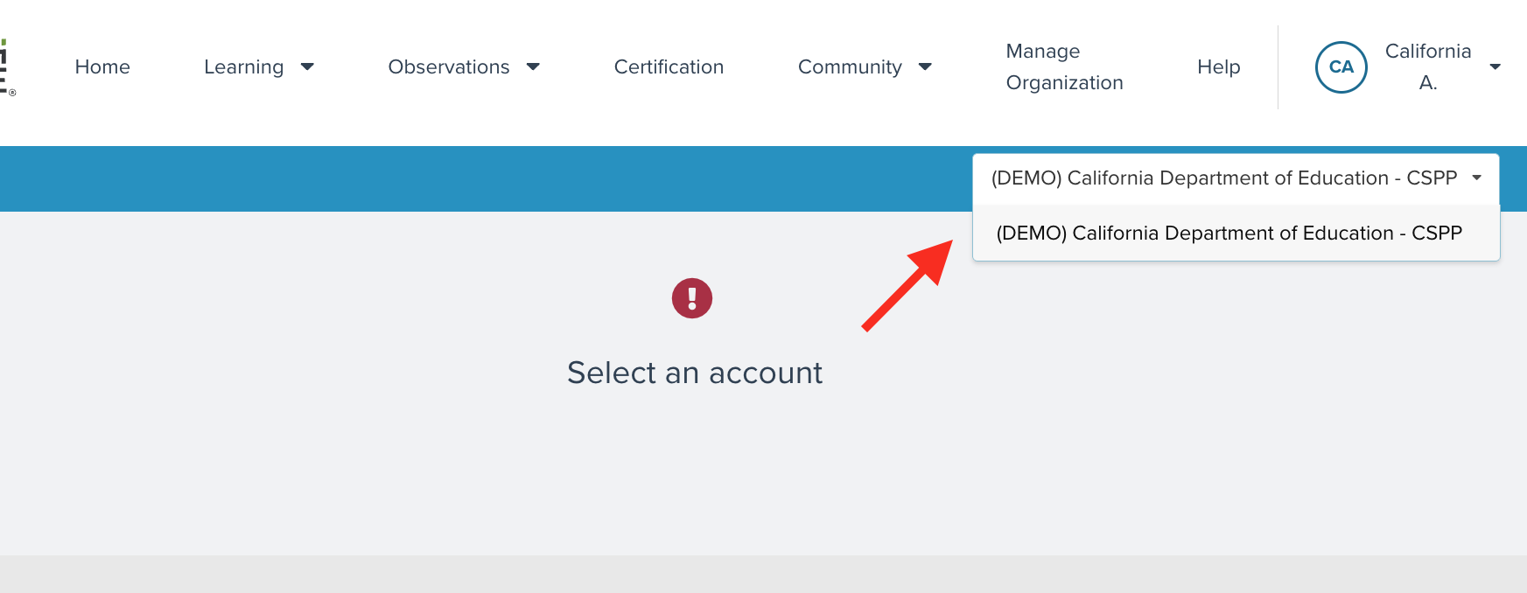
Users with multiple linked accounts may have different dashboards and access to information in myTeachstone in their different linked accounts. Access is based on the user role within each myTeachstone account, but certain information like CLASS Certifications will be visible in all of the user’s accounts because that information is tied to the user, rather than a specific organization or account.
TIP: myTeachstone account usernames are based on emails. If you already have an account in myTeachstone, review the email on your account; you may want to update it to reflect your work email. By taking this step, your existing Certifications will be merged into your agency CSPP account. This must be done before a new user account is created within the CSPP hierarchy. Once two accounts have been created, they cannot be merged.
TIP: If you have a current CLASS certification, but it is not listed on your dashboard after clicking on the Observations tile, contact supportca@teachstone.com. A customer service representative can manually link your current certifications to your CSPP myTeachstone account.

User Settings
Once logged into the system, users can view their home screen and update their user information. It is recommended that users double-check their user information for accuracy the first time they log in. This will ensure they receive emails at their preferred email and support completing program, site, and classroom information.
User information is accessed by clicking on the username in the top right-hand corner of the screen and selecting ’User Settings’. This will take the user to a screen with fields asking for name, email, address, and communication preferences. Users are required to fill out the information and select ‘Save Changes.’
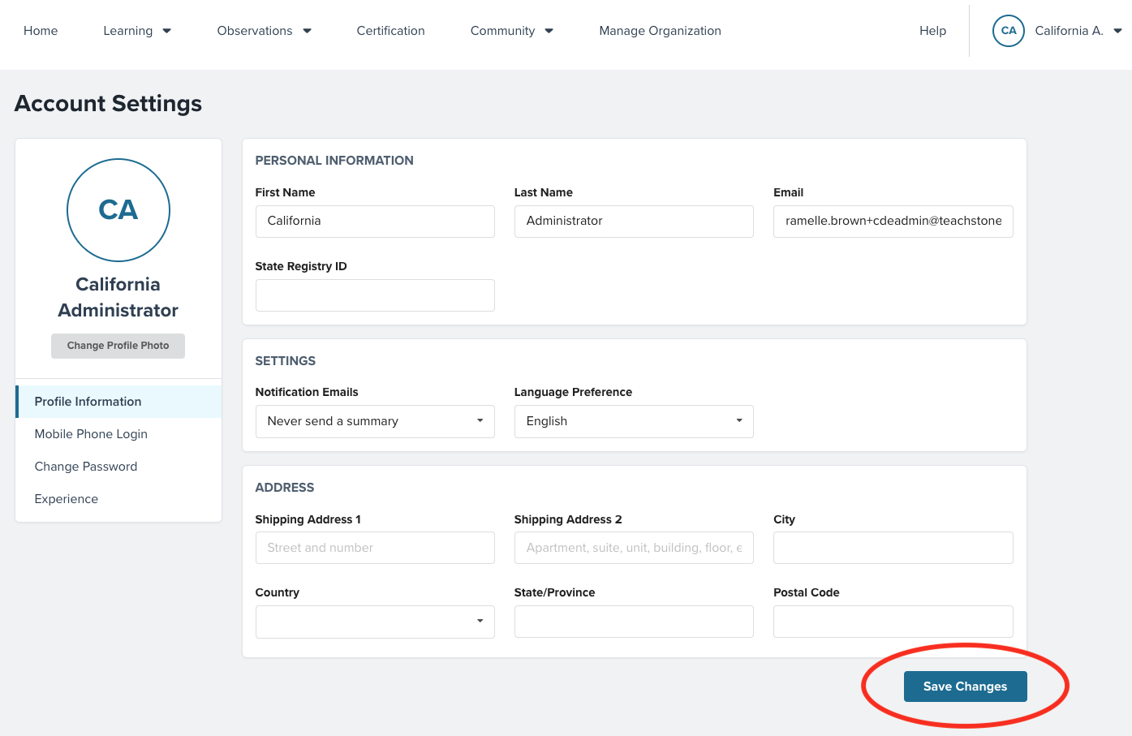
Please note that the email notifications are a required field and determine the frequency of emails the system will automatically send from Teachstone’s CLASS Community. For example, if a user selects ‘Send a Summary Daily’ the user will receive daily emails summarizing the activity within the CLASS Community. Users can also select to never receive emails or send a summary weekly or monthly. Users can also select the language of the emails; English, Spanish, or French. After selecting ‘Save Changes,’ a pop-up box will appear verifying that changes have been successfully saved. After saving updates, select the ‘Home’ option from the top navigation bar to return to the Home page.

Administrator Level Users
Accounts will be set up for all Executive Directors and Program Directors for the CSPP contract. These users will serve as Administrators for the program and be responsible for designating other users and managing the hierarchy for their sites and classrooms. Users at this level will have access to program, site, and classroom level user data, as well as CLASS and CLASS Environment observation data.
Executive Directors or Program Directors with current CLASS Certifications can also enter Observation data. To view Certifications, users should click on the Certifications tile on the dashboard and select My Certifications. If all Certifications aren’t listed, users can reach out to supportca@teachstone.com. They will assist with linking Certifications with the user’s CSPP myTeachstone account.
Administrators level users can also access and create site and agency level reports based upon the CLASS and CLASS Environment data entered for their agency.
TIP: While Program Directors have the ability and responsibility to manage their organization’s hierarchy, Site Supervisors can also add and manage classrooms and users within their individual sites.

Creating New Accounts Linked to Agency or Contractor
After logging in, one of the first action steps for a Contractor is managing the organizational structure for the agency’s CSPP myTeachstone account. Contractors must determine who should have Administrator access at each hierarchy level. Administrator access allows these users to manage the portion of the hierarchy they are associated with. For example, Site Supervisors who have an Administrator role within the system can add and edit classrooms and users, and view data within their site, but cannot manage, edit, or view data from other sites within their organization.
In addition to identifying users who should have Administrator access in myTeachstone, Executive Directors or Program Directors may also want to identify and add Data Entry Users, Educators, and Observers to their organization. Please refer to Table 1 for the roles and responsibilities of each user to help guide the creation of initial accounts for the program.

Site Supervisor Administrator Level
Users assigned as Site Supervisor Administrators have limited access to the CSPP agency’s hierarchy. This administrative access enables them to manage the specific site, including creating and updating the users and classrooms associated with the site. Site Supervisors who have Administrator access to the site can also create and view site level reports.

Managing Program Hierarchy
Managing hierarchy and adding members can be done by clicking on the ‘Manage Organization’ tab on the navigation menu at the top of the screen. Once selected, users will be taken to a screen to manage the hierarchy or the members (users).
Users can toggle between managing users and managing hierarchy by clicking on the appropriate tab under the ‘Manage Organization’ heading on the screen.
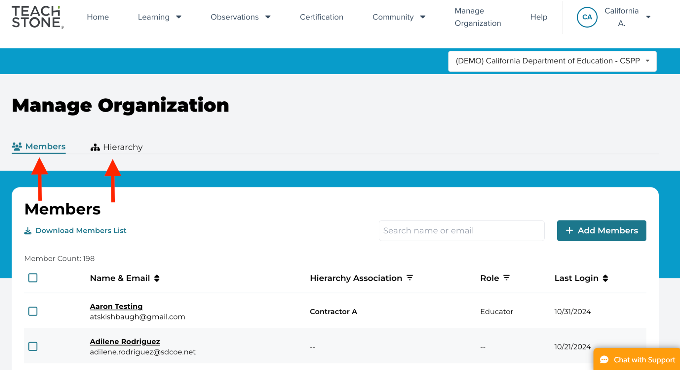
It is recommended that users start by navigating to the ‘Hierarchy’ tab first. This will allow users to set up the program’s sites (for example, centers and/or family childcare homes) first to link with Educators and other staff as they are added.
Currently, all CSPPs fall at the third hierarchy level under the California Department of Education, California State Preschool Program, identified as “California Department of Education: CSPP”. Contractors will expand the hierarchy detail to add and review the names of associated sites. Contractors have the ability to add classrooms; however, Site Supervisors also have access to add or revise classrooms within their specific site hierarchy, so contractors may choose to have Site Supervisors update site specific data and add or remove educators as necessary.

Adding Sites within your Program
Select the ‘Hierarchy’ tab from the ‘Manage Organization’ screen. On the left side of the screen, users will see the name of their organization. To the right of the organization’s name will be a down arrow. Click on the arrow to expand the list of sites within the program. Note that for CSPP purposes, the field labeled as “Center” may include both centers and family childcare homes.
From this screen, users can view all sites currently associated with the CSPP Contracting Agency. Should any of the information displayed on the Hierarchy screen need to be edited, or if an additional site needs to be added, click on the ‘Edit Hierarchy’ button on the right side of the screen. This will open a new screen to add a new site or edit existing sites.
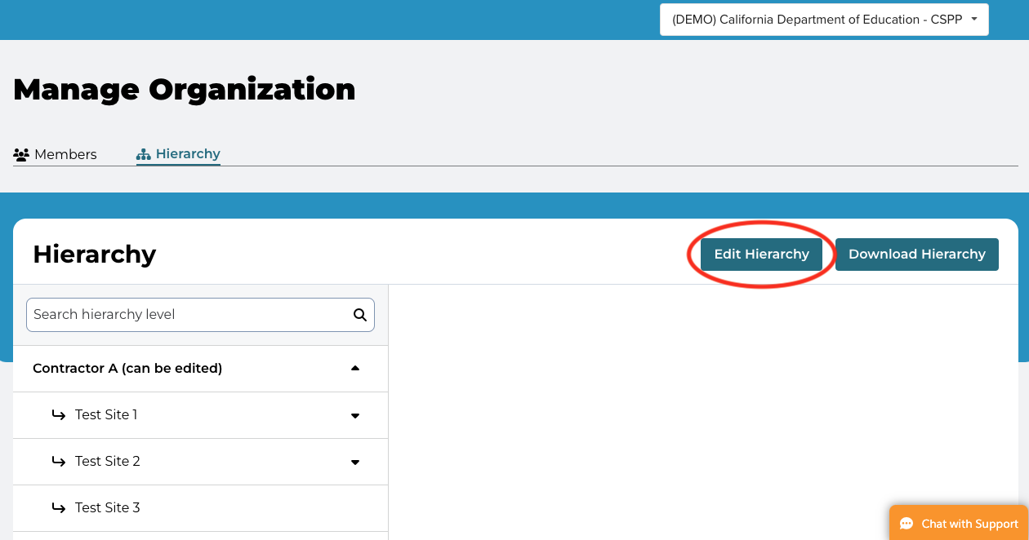
On the ‘Edit Hierarchy’ screen the agency name will be listed. When the cursor hovers over the name of the organization three options will appear, a pencil icon, a plus sign, and a down arrow.
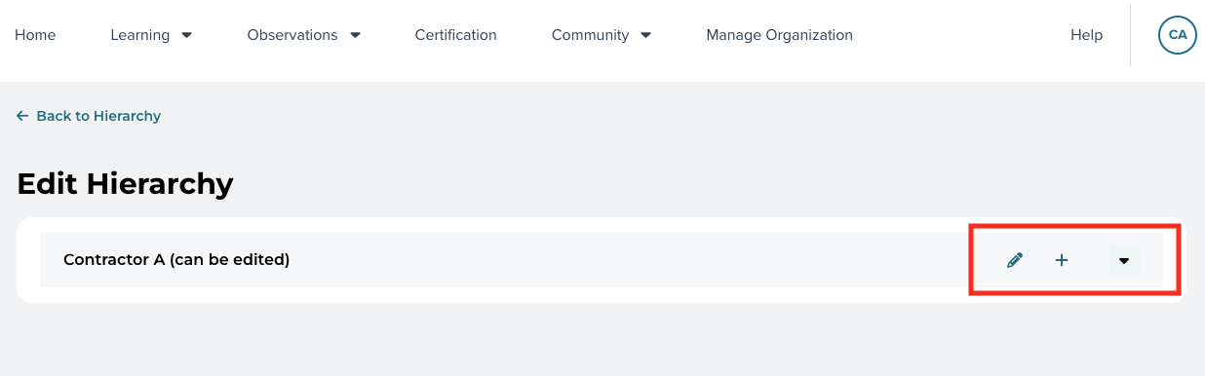
To add a site, select the plus sign and a new screen will open to enter the name of the additional site. Make sure to save the addition and the new site will appear within the hierarchy.

Managing Site Classroom Hierarchy
Site Supervisor Administrators can manage their site’s hierarchy, including creating additional classrooms, adding new users to their site, and assigning Educators to classrooms. To manage the site's hierarchy, select the ‘Manage Organization’ tab on the navigation menu on the top of the screen. Once on the ‘Manage Organization’ screen, users can select ‘Members’ or ‘Hierarchy’ on the upper left side of the page. It is recommended that Site Supervisors first create classrooms before adding members or users (such as Data Entry or Educator). Entering all classrooms first allows new users to be linked to a classroom as the user account is added rather than having to go back and edit new users created before their classroom was in the system.

Adding or Editing Classrooms within a Site
To add or edit classrooms within a site, select ‘Hierarchy’ and click on the down arrow next to their organization’s name to reveal all of the sites within the organization. To add a classroom, select ‘Edit Hierarchy’ on the upper right side of the screen.
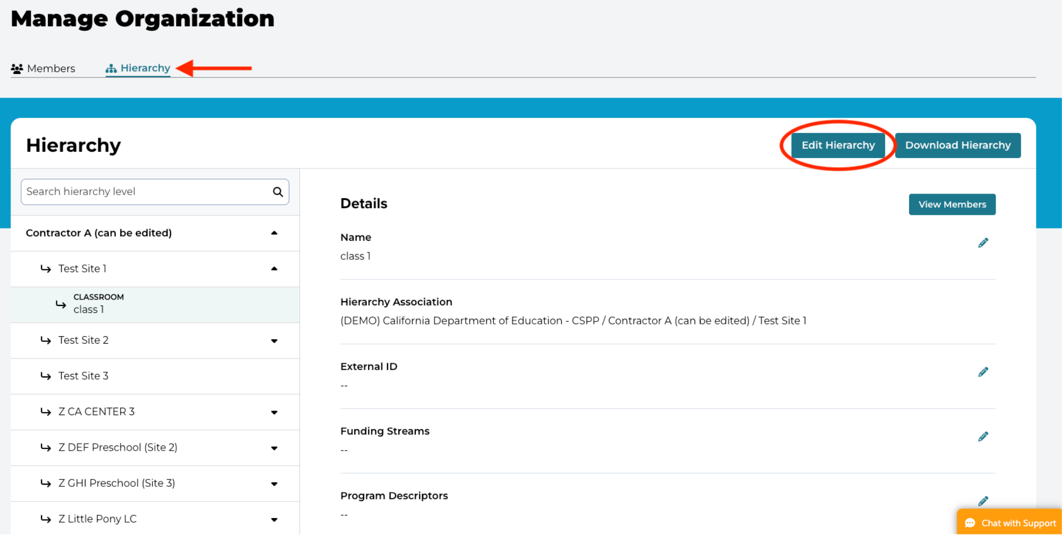
Move the cursor over the site name, and the pencil, plus sign, and down arrow will appear. Click on the plus sign and enter the classroom name.
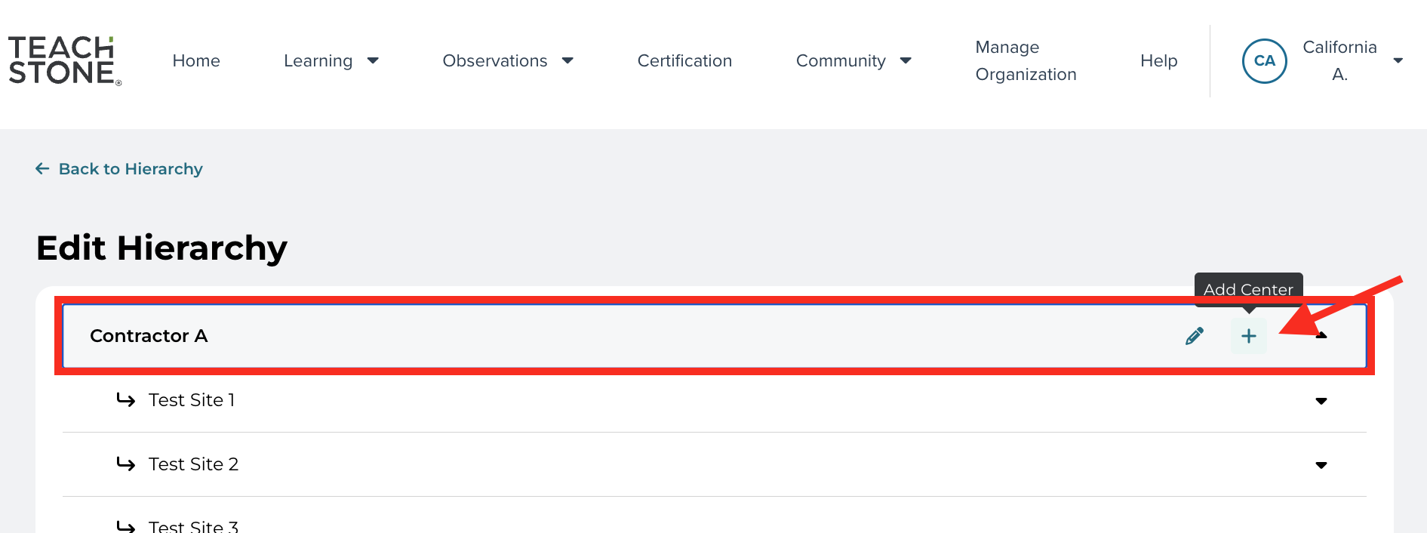
Clicking on the plus sign will open a dialogue box to enter the classroom name. Once entered, the user must save the new classroom.
Please note: If a classroom has two different sessions in the same room (such as an AM and a PM session), each session is entered as a separate classroom. If the contractor is reporting in the California Preschool Data Collection (CAPSDAC) system, then use the same classroom names or identifiers as reported in CAPSDAC; if the contractor does not report in CAPSDAC, use the following naming convention when entering each classroom: [classroom name] AM for the first classroom and [classroom name] PM for the second classroom.
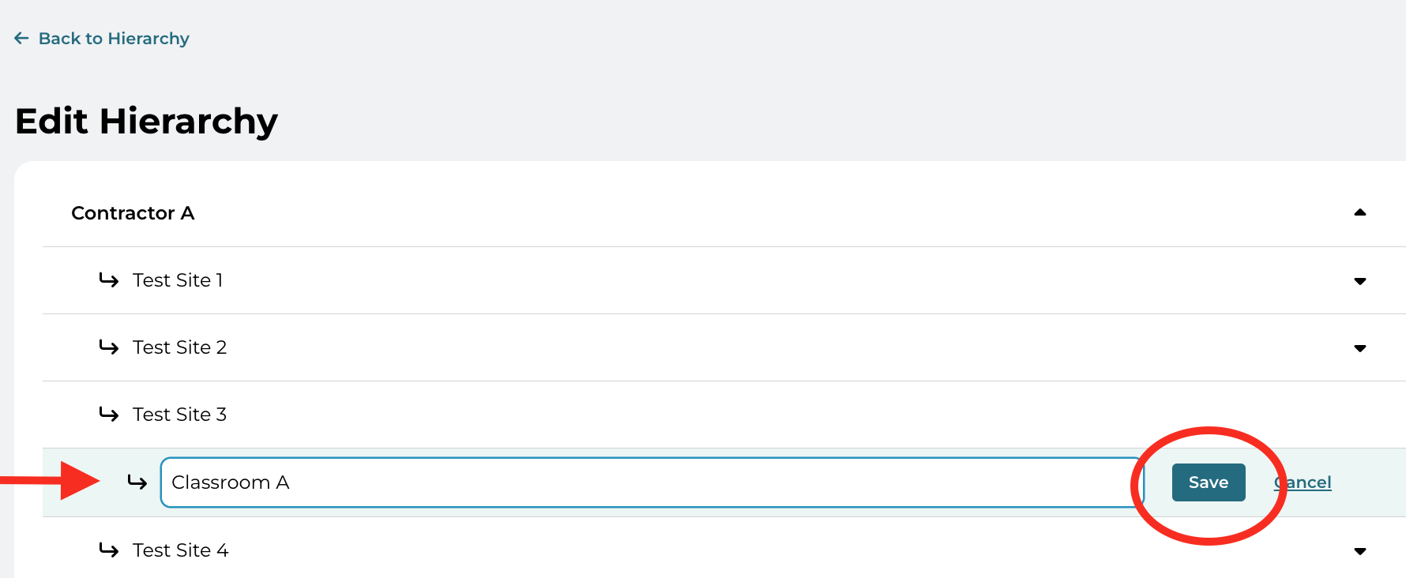
If the classroom is already listed within the hierarchy, the classroom will not be able to be added again. If the classroom is saved and added, the system will display a green box in the upper right corner of the screen indicating that the classroom was successfully created.
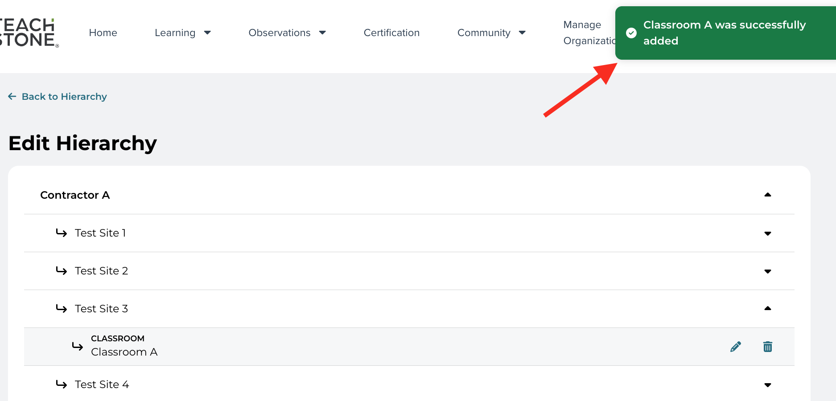

Adding New Members or Users to the Site
(NOTE: Members and users are synonymous with one another and may be used interchangeably within this document)
After all classrooms have been created, Administrators at the contract or site level can add new members/users to respective sites and associate them with a role within their organization.
Administrators will select the ‘Manage Organization’ tab from the navigation menu at the top of the screen to add members. Select 'Members' on the upper left side of the ‘Manage Organization’ screen. This screen will display all users associated with the site.
To add members, Administrators will select ‘Add Members’ on the far-right side of the screen. From the ‘Add Members’ screen, Administrators will be asked to provide the new member’s email address, first and last names, their role within the program, and select which layer of the hierarchy (for example., “classrooms” level for users in an Educator role or “site” for users in an Administrator or Data Entry role) the member is associated with.
To select a specific classroom or site within the hierarchy, click on the level and select the specific site(s) or classroom(s) the new member should be associated with. Clicking on each level of the hierarchy will drill down deeper into the hierarchy. Once the correct hierarchy layer is displayed, Administrators will mark the check box for the site(s) or classroom(s) the new member will be associated with. Once the appropriate box or boxes are checked, select ‘Continue’.
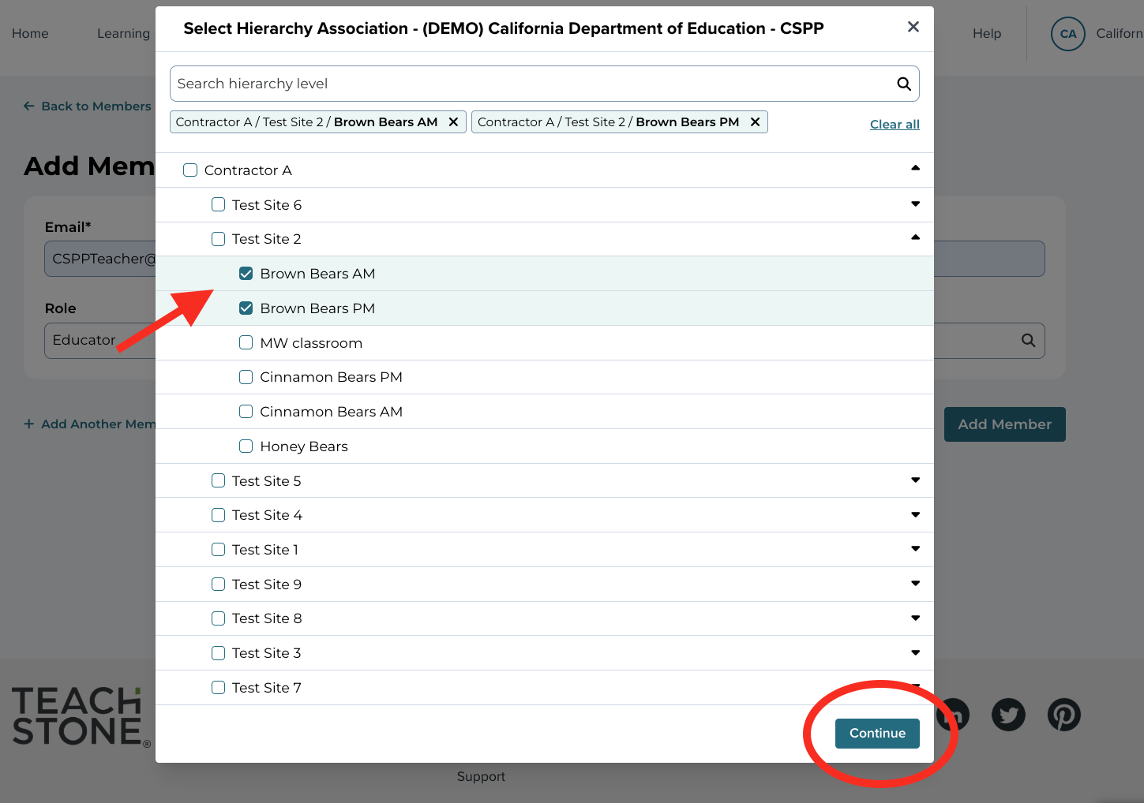
After selecting continue, the add member screen will appear. Confirm that the correct hierarchy was added to the member’s profile and select ‘Add Member' at the bottom of the screen.
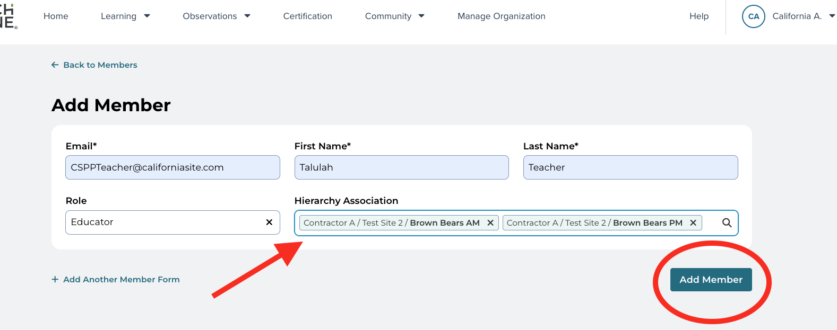
If correctly added, the user will be returned to the ‘Members’ screen, and a brief popup window will appear in the top right section of the screen confirming that the member has been added.
TIP: If adding a member with an Administrator role within myTeachstone, it is essential that the Administrator member is associated with the correct hierarchy level. For example, if they are associated with a higher level within the organization (at the contractor or program level rather than the site level) they can access all of the observation data from the entire organization rather than certain sites or classrooms. Contractors must determine which level of the hierarchy staff need and have access to.
It is recommended that all Site Supervisors be provided access to at least all classrooms within their site. Once they are linked with the site in the hierarchy, all of the classrooms in the site will automatically be associated with their account. Data Entry Users will also need to be associated with specific sites to enter data for any classroom within the site or at the program level to enter data across the program.
The added members will now appear on the list of the organization’s members. The member will be associated with the correct site or classroom and will have access to all data they are associated with. Additionally, myTeachstone will generate an email welcoming them to the CLASS Community, with information and support getting started on the platform.
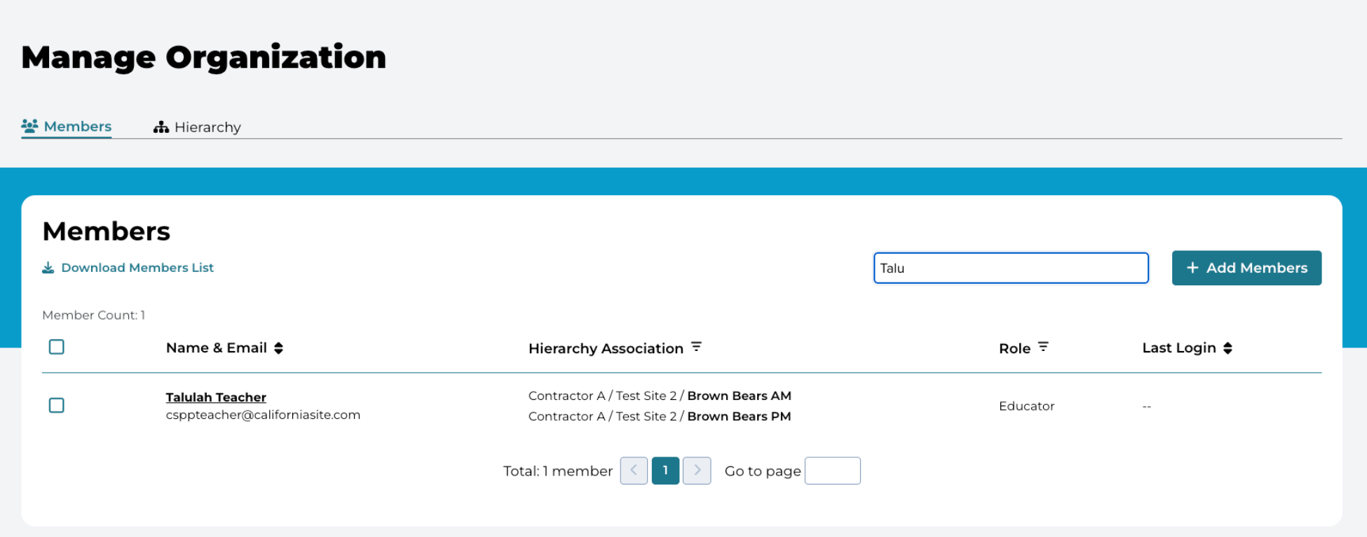
TIP: Once any new member is added or assigned to a new organization regardless of their role, the platform will send an automated email informing them that they have been added to the system and inviting them to log in and set up their accounts. New members should be informed that they will receive this email before adding them to the system to reduce the likelihood that they will miss, ignore, or delete this critical email.

Transferring Users between Sites or Programs
As Educators transition across classrooms, sites, and/or agencies, their myTeachstone account will remain active. When staff or providers with access to myTeachstone are no longer employed or associated with the CSPP agency, the contractor is responsible for deleting the user’s Hierarchy Association with their site. This is done by editing the user in the ‘Manage Organization’ section of myTeachstone and deleting the user’s hierarchy association with your site. Please delete this field only. Do not attempt to delete or archive the user.
Once the user’s place in the hierarchy is deleted, the contractor can simply add them and associate the staff member with their new site and classroom. Users who have observation data associated with their accounts will continue to have access to all of their previous observation data.
While the educator will be able to view previous observations, the new contractor will only be able to view observations that have taken place in their new program.

Adding Observers to an Organization
If an organization has users with current CLASS Certifications linked to their work email address, they can conduct observations and do not need to be added as an observer. Users who believe they have a current CLASS certification that is not listed in the ‘My Certifications’ section should contact supportca@teachstone.com. The customer service team at Teachstone can manually link a current certification with your CSPP account. Once completed, the user will be able to use one login to access all assigned functions within myTeachstone.
Administrators using independent California-based CLASS observers must verify that the observer has the necessary qualifications to conduct CLASS observations for CSPP programs. Once verified, an administrator level user must add the observer to their organization. Once added, the system automatically generates an email to the observer inviting them to join the organization as an observer. Users whose only role is to conduct observations can only enter their observations. They cannot pull reports, nor will they be able to view any other organization-specific aspects of myTeachstone.
To successfully add an independent CLASS observer to an organization, it is essential that the email associated with the observer’s CLASS certification is used. CLASS certification status is linked to each user’s email address. If the incorrect email address is used when trying to add them as an observer, the system will not recognize them as a certified observer and will not add them.

Tracking and Accessing Observation Level Data
Contract or program level Administrators can access all observation data for their hierarchy, including CLASS and CLASS Environment data. These users can access this data by clicking on their dashboard's CLASS Data Collection tile or selecting the Observations tab on the navigation menu at the top of their screen and selecting Class Data Collection.
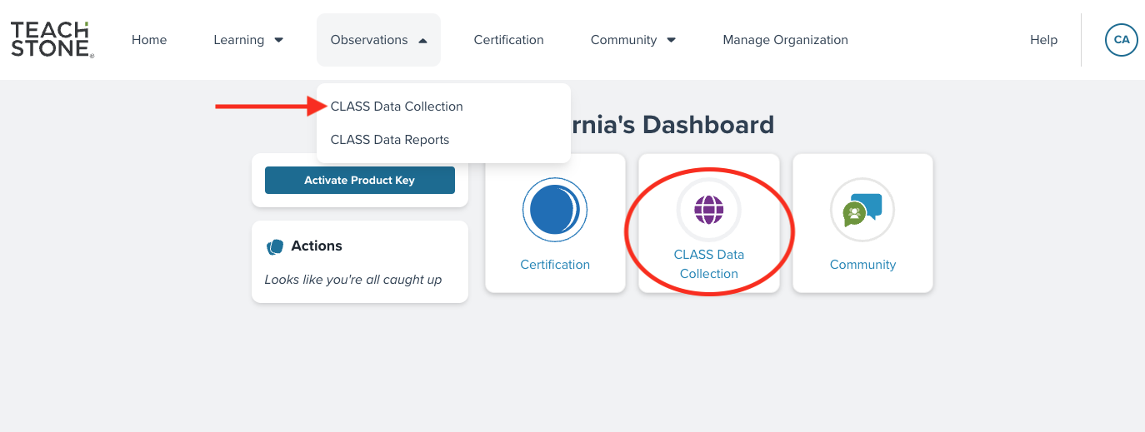

On the CLASS Data Collection screen, Contractor-level Administrators can view their program’s observations based on the status of the observation. Observations entered in the system are classified as either ‘In-Progress’ or ‘Completed.’ This classification system is used to designate an observation’s status within the platform and helps Administrators monitor the progress of data reporting. Table 2 outlines how an observation’s status affects its ability to be edited, viewed, or included in reports.
Table 2. Observation Status and its Impact on Observation Data
Observation Status | What determines the status? | Who can view the observation? | Is the observation included in reports?
In-Progress | These observations have not been submitted. They may be missing data or are in the process of being entered. | Only the Observer or Data Entry User can view or modify In-Progress observations. | Because these observations have yet to be submitted, they will not be included in reports.
Completed | The Observer or Data Entry User has entered all of the information required for the observation and has submitted the observation. | Anyone in the hierarchy who is associated at the site or contractor level.  Any Educators who were observed. | Completed observations are included in reports.

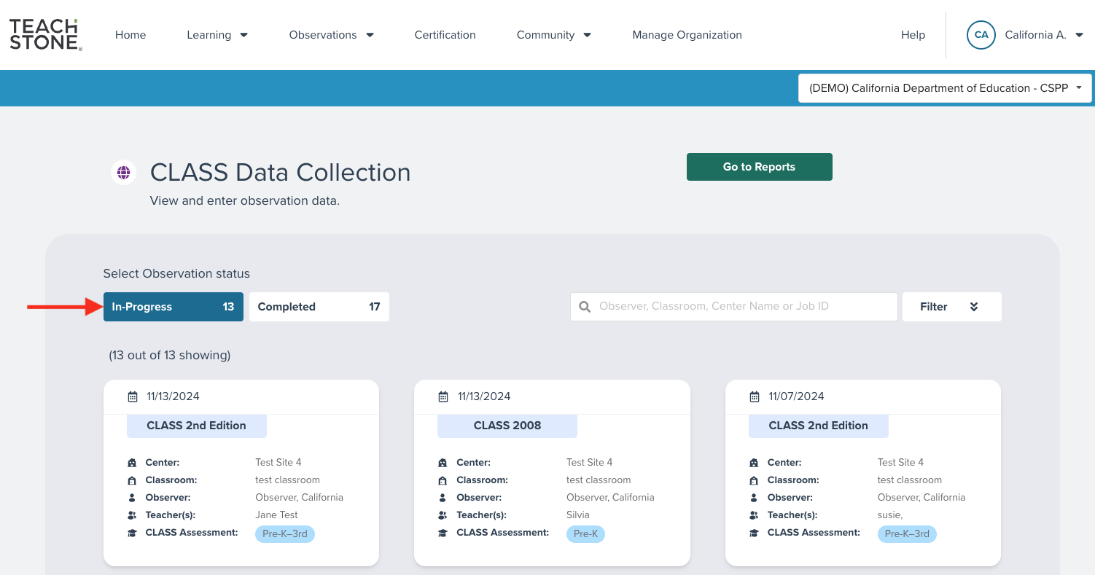
Administrators can access and view completed observations and run reports using the data from completed observations.
Note that the user’s hierarchy association limits their access to observation data. Site Supervisors assigned an Administrator role within myTeachstone can only view data and create reports for the site(s) they are associated with in myTeachstone.
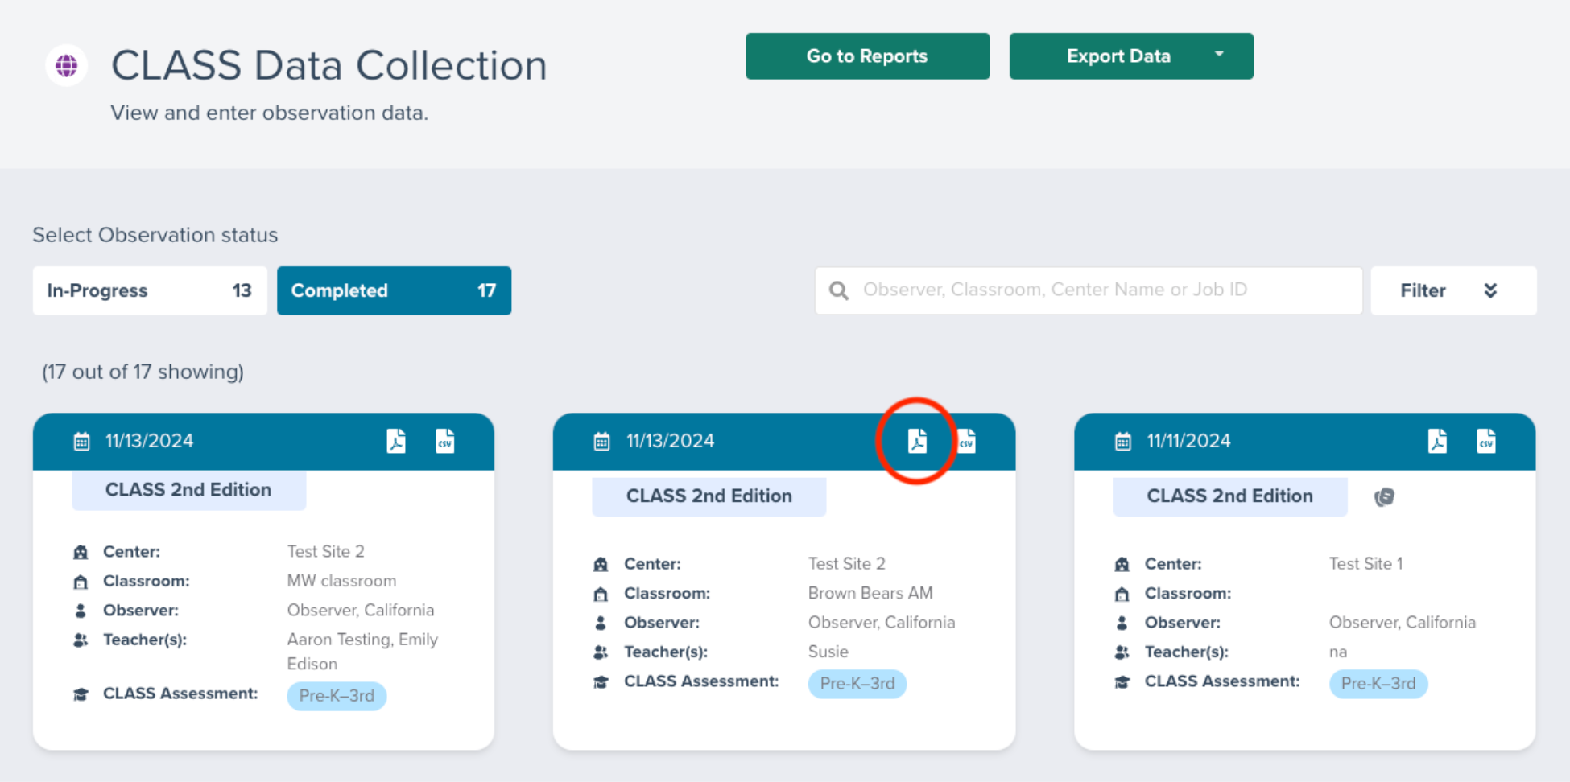

Searching and Filtering Observations
In addition to viewing observations by status, Administrators can search for observations by Observer, classroom name, or program by entering their search parameters in the search bar to the right of the program status buttons.
Observations can also be filtered by multiple criteria by clicking the filter button to the right of the search bar. Clicking on ‘Filter’ will reveal a drop-down menu of criteria that can be used to filter observations. These filters include observation tool, age level, hierarchy, Observer, and date range.
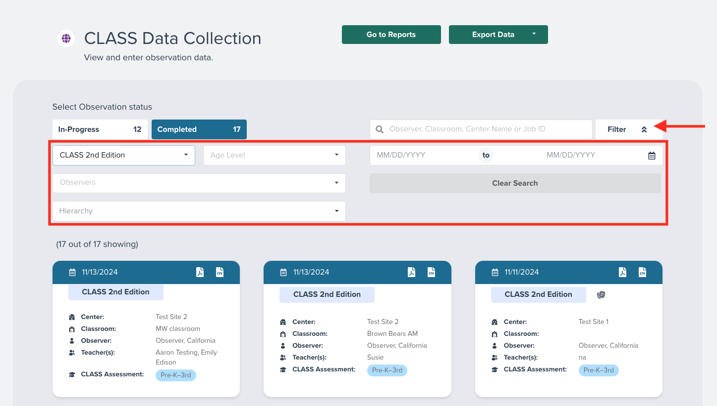
Once users enter criteria in the fields, the observations meeting those criteria will be displayed on the page. Please note that the applicable observations may be displayed across multiple pages. Multiple pages of observations can be navigated by clicking the page number forward or backward buttons on the bottom left side of each screen.

Creating and Accessing CLASS Data Reports
Administrators can view and create custom reports within the system. Their ability to access and run reports depends on the hierarchy level they are assigned within the system. For example, Program Directors or Executive Directors can view the data and run reports for all of the sites and classrooms within their organization. However, they cannot view data from other programs within the Statewide CSPP account because they are not part of that organization’s hierarchy.
Reports can be viewed and created easily within myTeachstone. To create a report, users can either click on the CLASS Data Collection tile on their dashboard or by selecting the Observation tab in the navigation menu at the top of the screen.
From the dropdown menu, click on CLASS Data Reports.
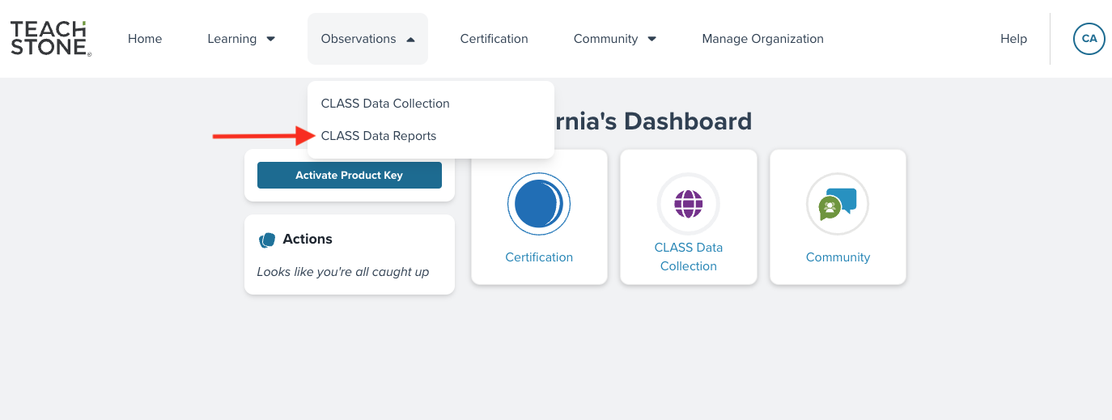
Once on the CLASS Data Reports screen, users can view previously created reports and create new reports. To create a new report, select ‘Create New Report’ on the upper right side of the screen.
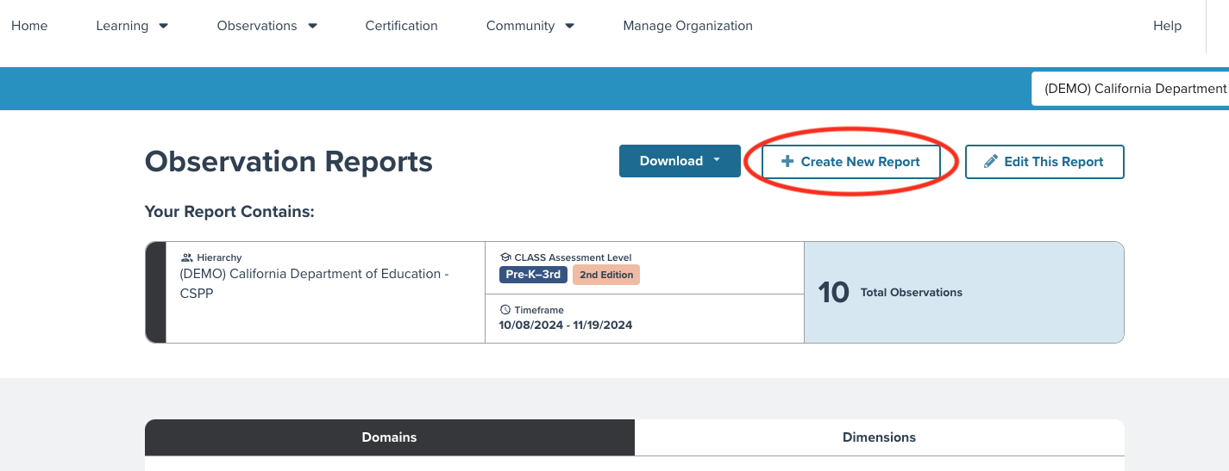
Once selected, the user will be taken to a new screen to specify the data to be included in the new report.
To create a report, the user must indicate which observations to include in the report.
- Enter the date range for the observations to be included in the report.
- Then, select which observation tool was used from the drop-down menu and select the tool’s age range.
- Finally, select which level of the hierarchy should be included in the report.
Once the user has specified which observations should be included in the report, select ‘Generate Report’ at the bottom of the screen.
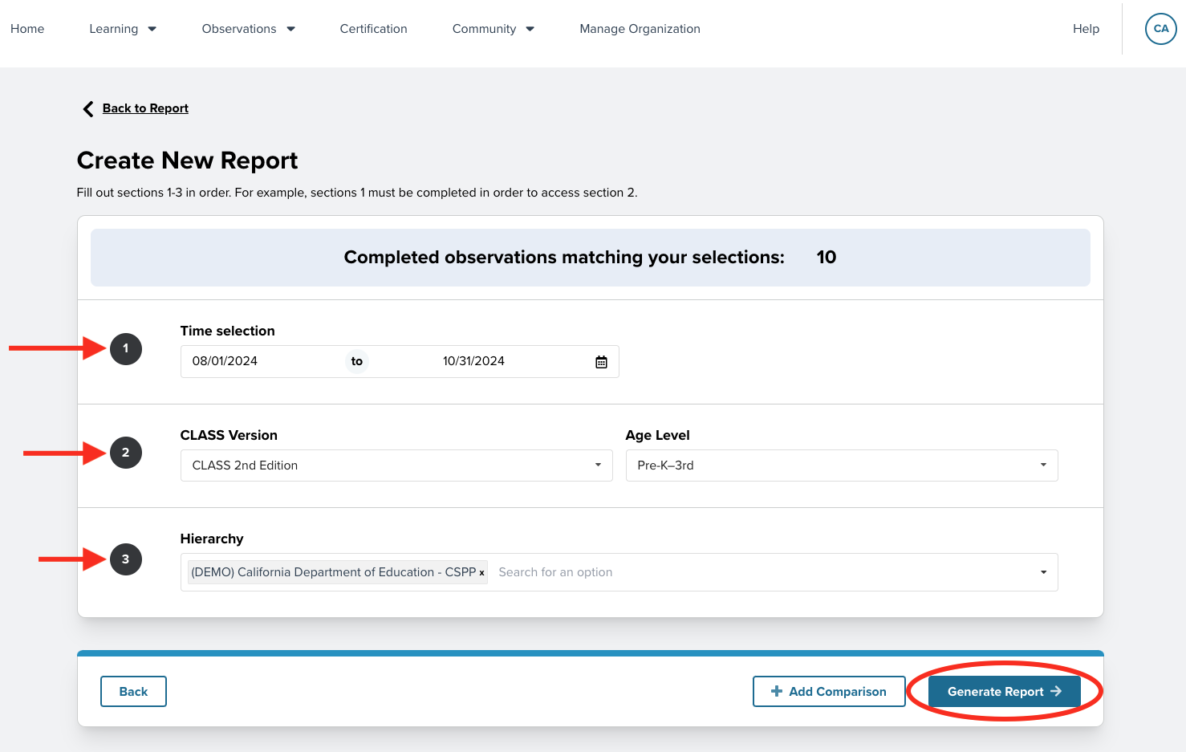
This generates the report and displays it online on your screen. Users can toggle between domain level and dimension level report data by clicking on these tabs above the column table.
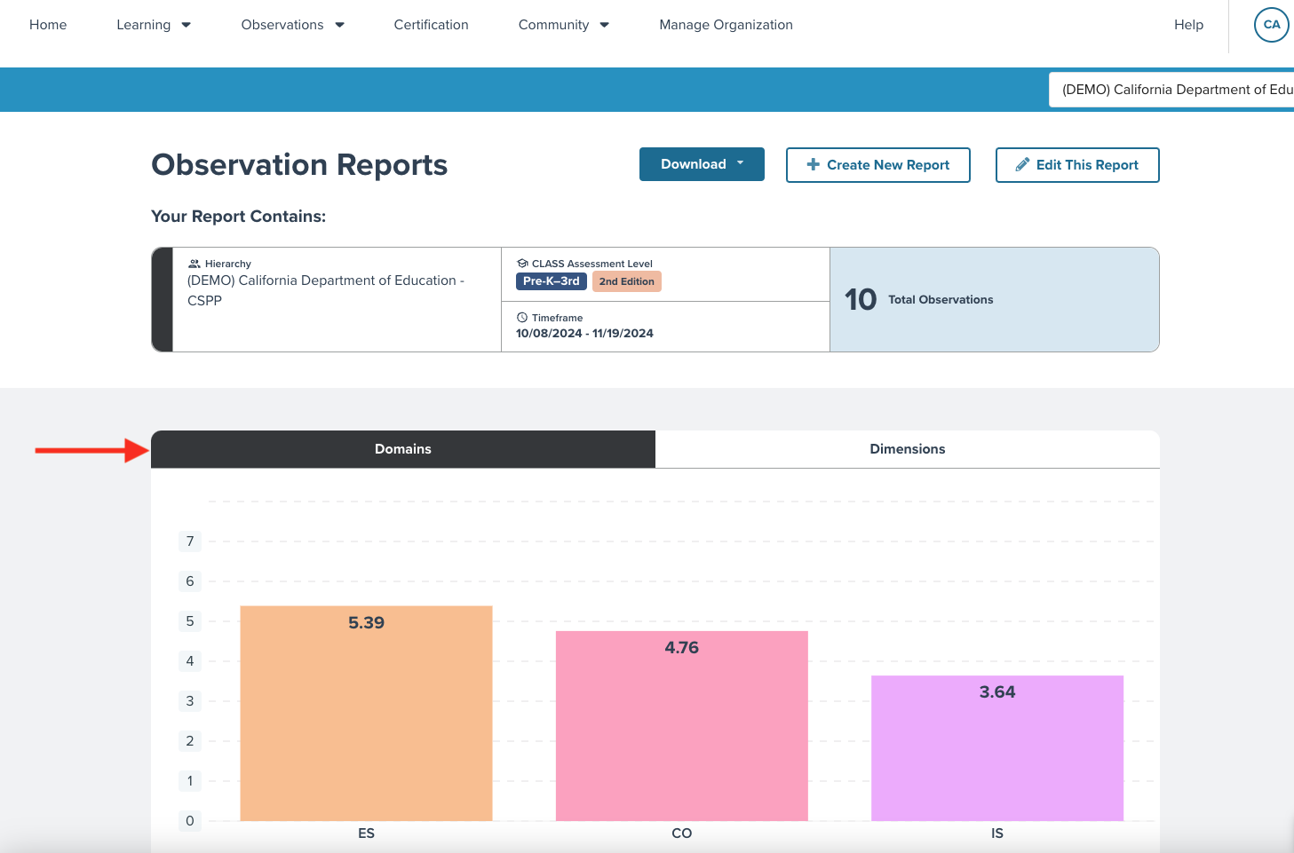
TIP: Reviewing the ‘Your Report Contains’ section above the column graph is always good practice. This ensures the report contains the intended data. Remember, only observations with the ‘Completed’ status will be included in the reports.
If, upon review, the parameters are not correct, the user can edit the report by clicking ‘Edit the Report’ above the report on the far-right side of the screen. This will take the user back to the ‘Create New Report Screen’ where the parameters can be edited.

Downloading Reports
To generate a Portable Document File (PDF) version of the report, users will click the blue ‘Download’ button toward the top of the screen. Once downloaded, the user can view, save, or share the report.
The report's title page will list which observation data is included but will not break out the data by classroom.
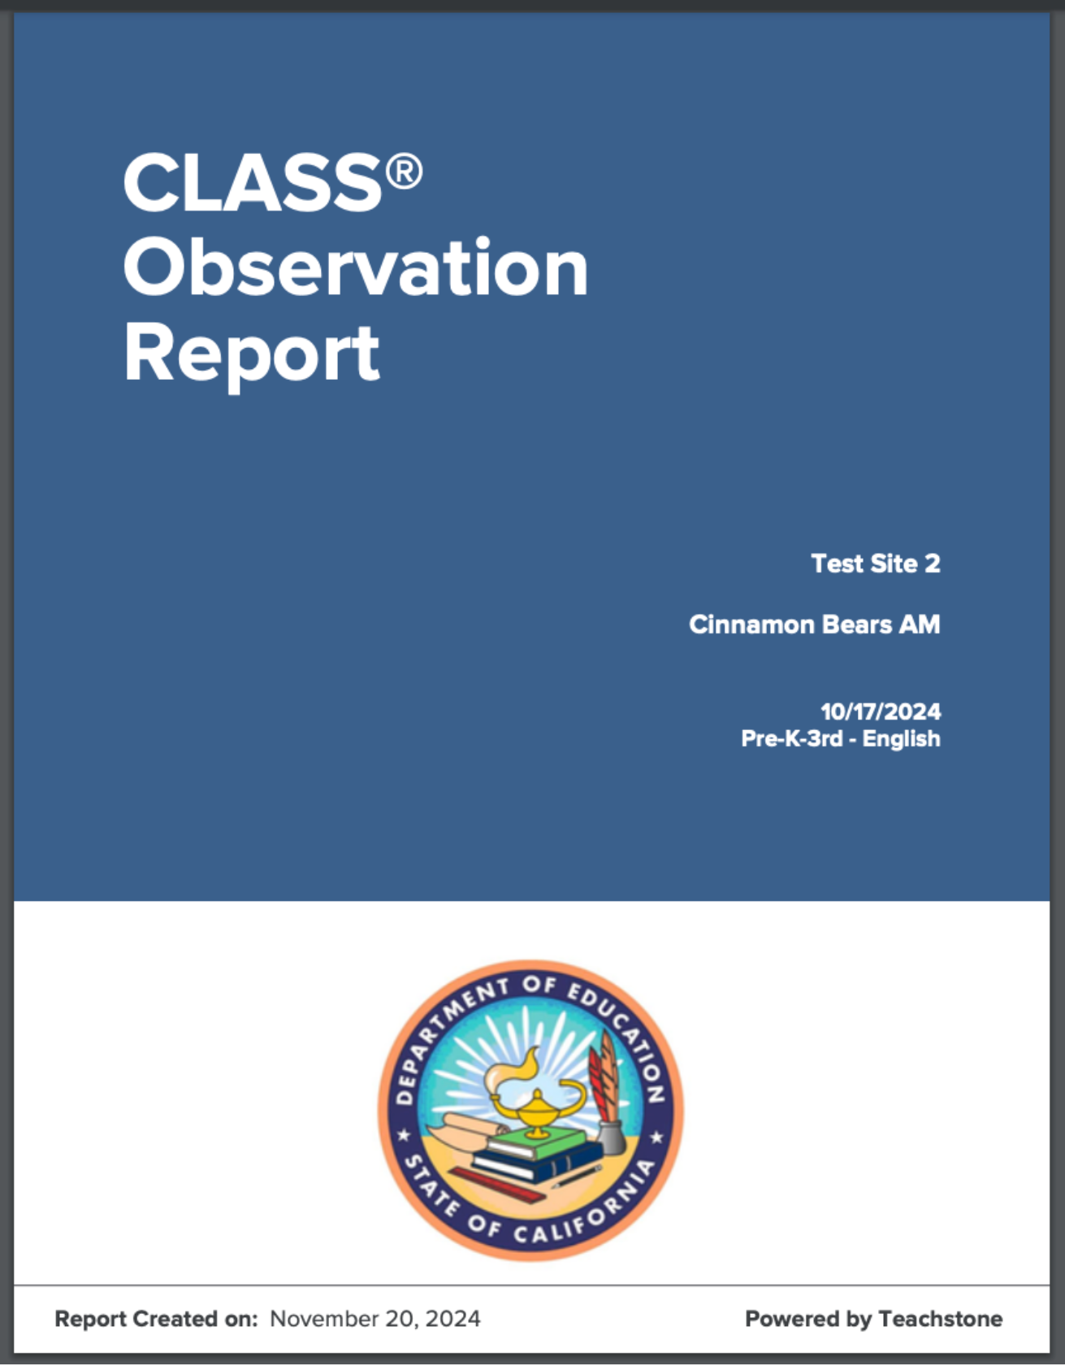

Accessing Individual Observation Reports
Users associated with a specific classroom can also download an individual observation report by clicking on the observation tile on their dashboard. This will take the user to all of their observations. If only one observation has been completed, they will be taken directly to the single observation and can download the individual report.
Educators can access their observation data by clicking on the Observations navigation tab at the top of their myTeachstone dashboard and then selecting CLASS Data Reports. Once selected, educators will view a summary of their CLASS scores. This is an interactive report and users can toggle between domain and dimension scores. Users can also download a PDF summary of the interactive report by clicking Download on the upper part of the screen and selecting PDF Program Report.
By default, the report automatically generated includes all of the users’ observations. Users may want to isolate the report to a single observation or a single classroom. To do this, educators can click on Create a New Report or Edit Report. This will allow the user to adjust the parameters so that only observations conducted this year are included in the report, or the report only includes observations from an AM or PM classroom. Once the report is generated it can be downloaded or saved by selecting Download and then PDF report.
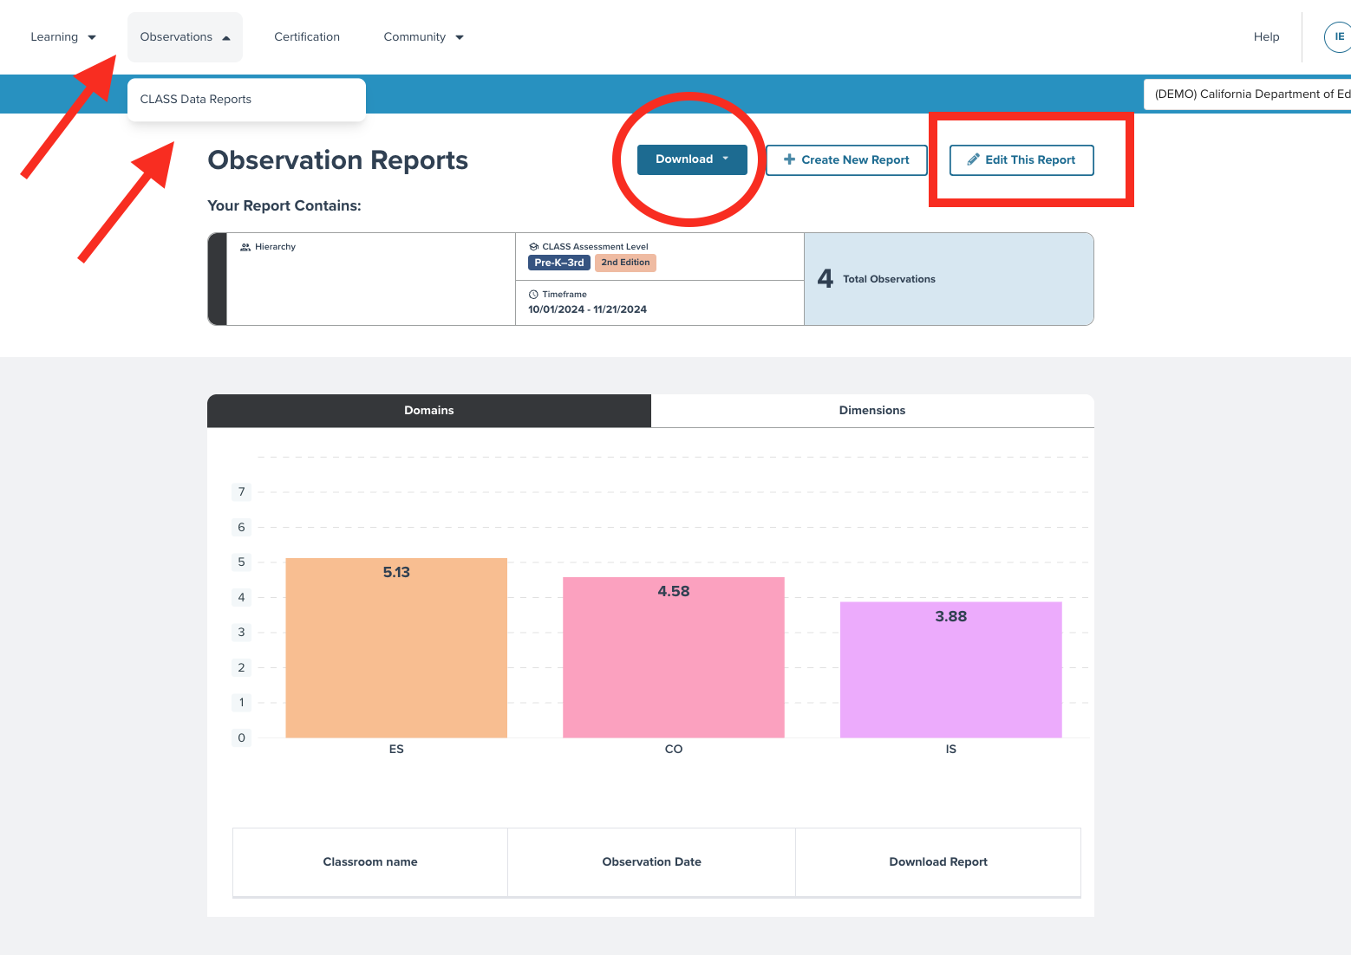

Creating Comparison Reports
Users wishing to compare two sets of observation data (for example, comparing observations from two time periods) can create a comparison report.
From the ‘Create New Report’ screen, select ‘Add Comparison’ at the bottom right side of the screen. This will open a second area to specify which data to include as the comparison group.
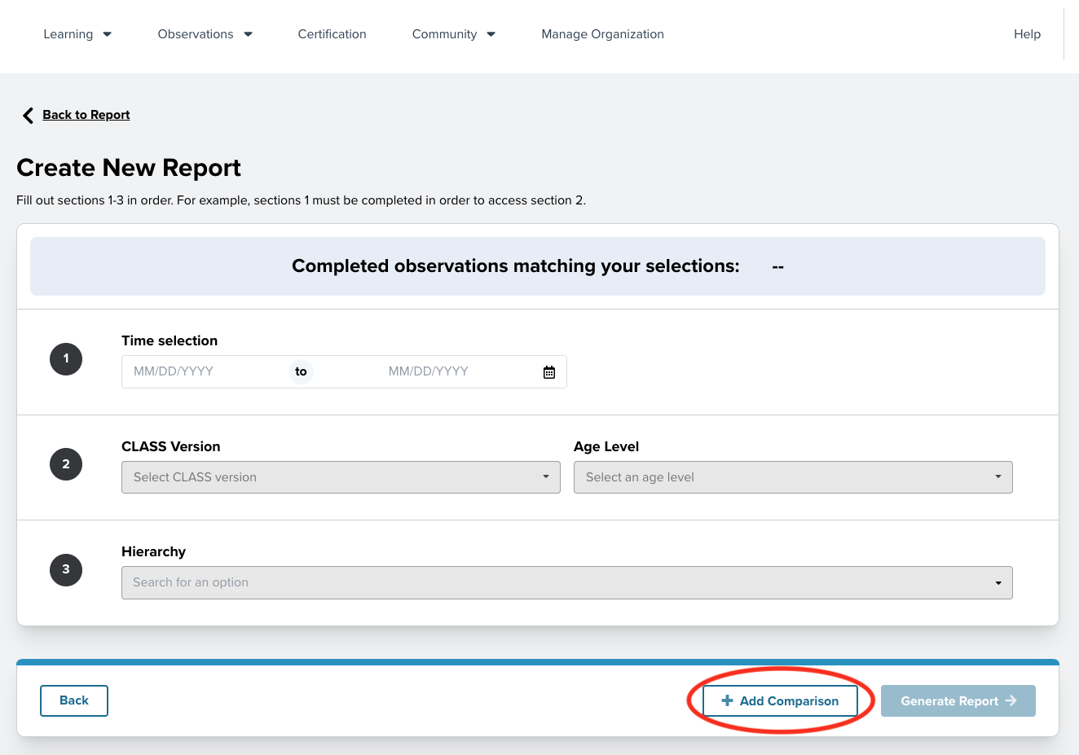
Once the parameters are entered for both groups, select ‘Generate Report’ on the bottom right side of the screen.
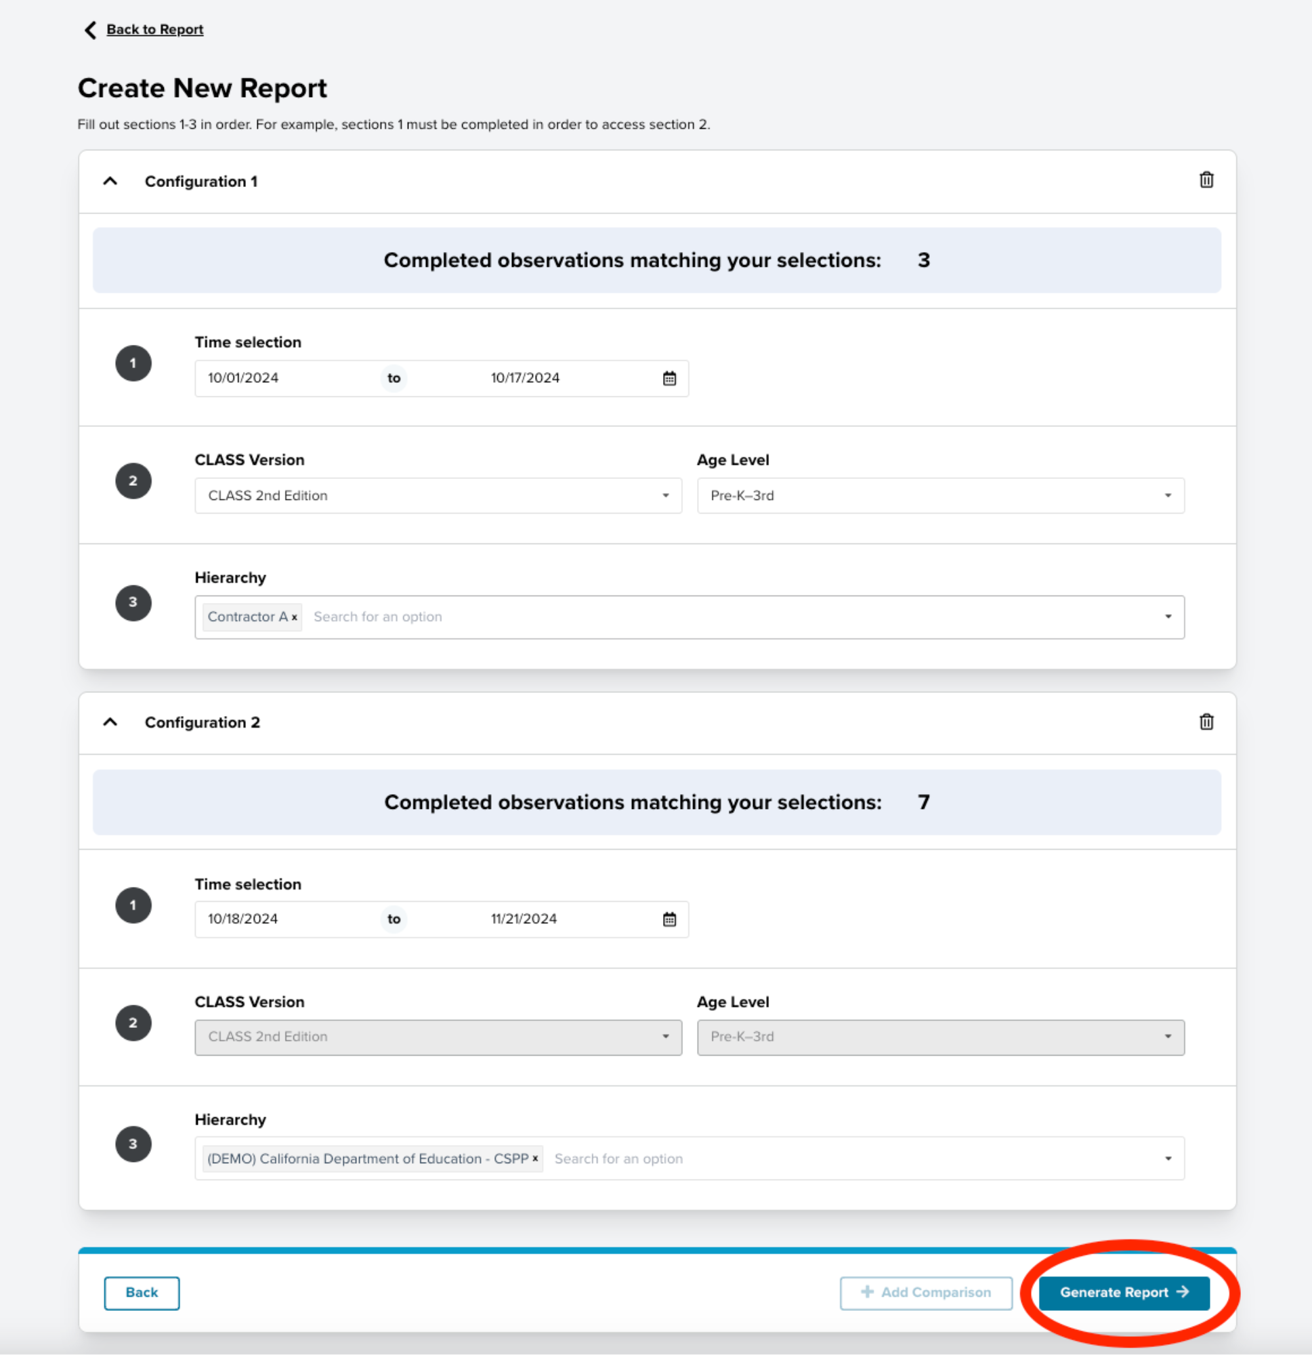
Once selected, the comparison report will be displayed. Please note that at this time, comparison reports can only be viewed in the system. Users cannot download comparison reports.
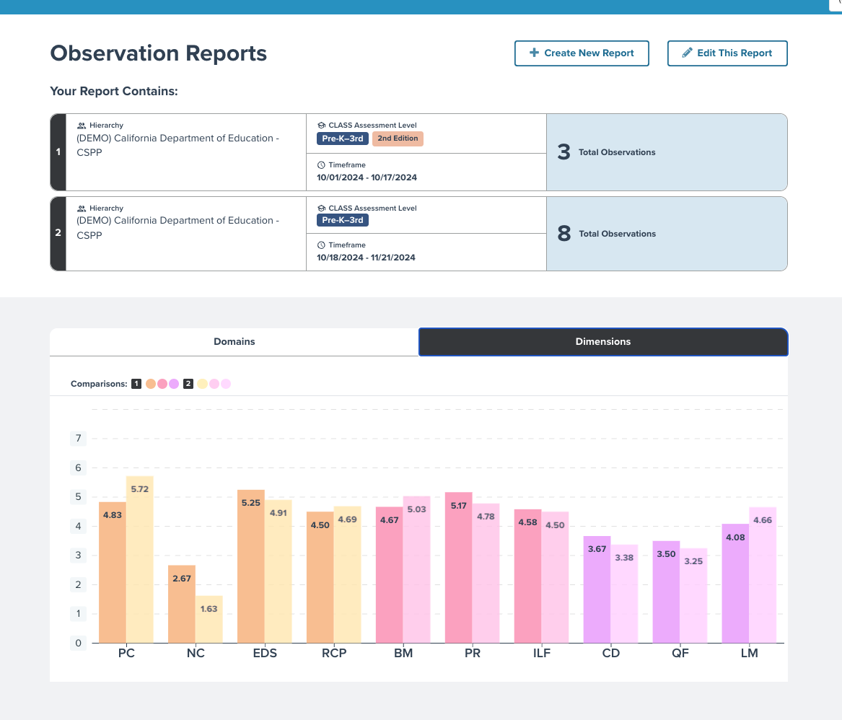
As with all reports, users can toggle between Domain and Dimension level comparisons to compare different units of analysis and better understand their data.

CSPP Observers and CLASS Data Entry Users (i.e., Observers and Support Team Members).
All CLASS observations will be entered into myTeachstone to support the CSPP. It is recommended that the CLASS Observer enter their scores for both the CLASS Environment and CLASS observation as soon as possible. While it is best practice for observers to enter their own observations, this may not always be possible. For this reason, the system will have data entry users.

Accessing CLASS Data Collection (Admin, Observer, Data Entry roles)
Contractors, or their designee, are responsible for creating accounts for those entering CLASS and CLASS Environment data. Once an account has been created, the user will receive an invitation from Teachstone via email. An activation link of ‘Accept Invitation’ will be embedded in the email. Users will be prompted to ‘Accept Invitation’ for the CLASS Data collection module.
The invitation email will be sent from Teachstone Training with the email address of notifications@teachstone.com. Since many organizations have spam filters, it is important to add notifications@teachstone.com to any ‘Safe Senders’ lists you have within your email system or add this email address to your email contacts. Likewise, if a user does not see their invitation, they should also check any spam folders.
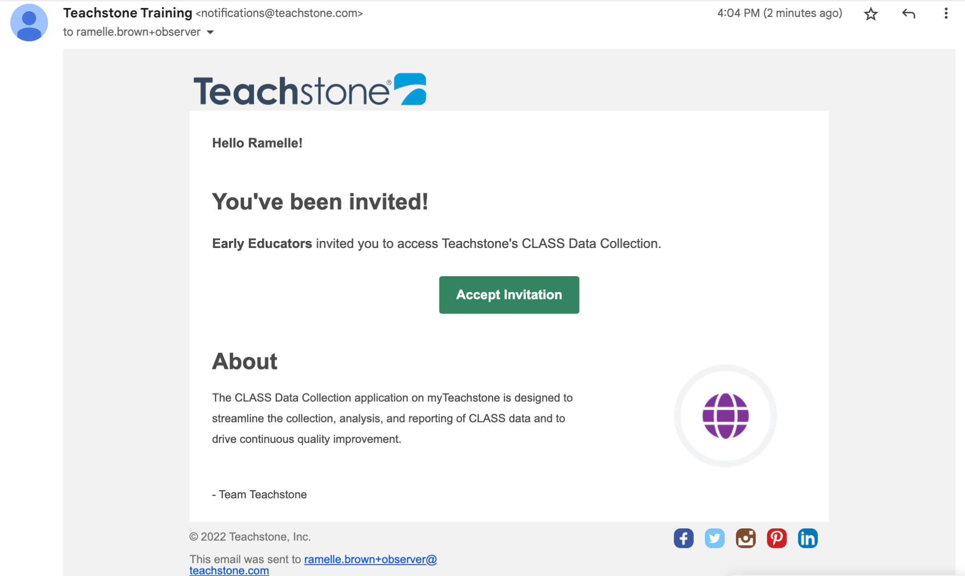
When the user selects ‘Accept Invitation’, they are then taken to a confirmation page. From the confirmation page, users will need to click on ‘Accept Invitation’ for the final time. The final acceptance will ensure the CLASS Data Collection tile is added to the user’s dashboard and allows them to begin entering CLASS and CLASS Environment data.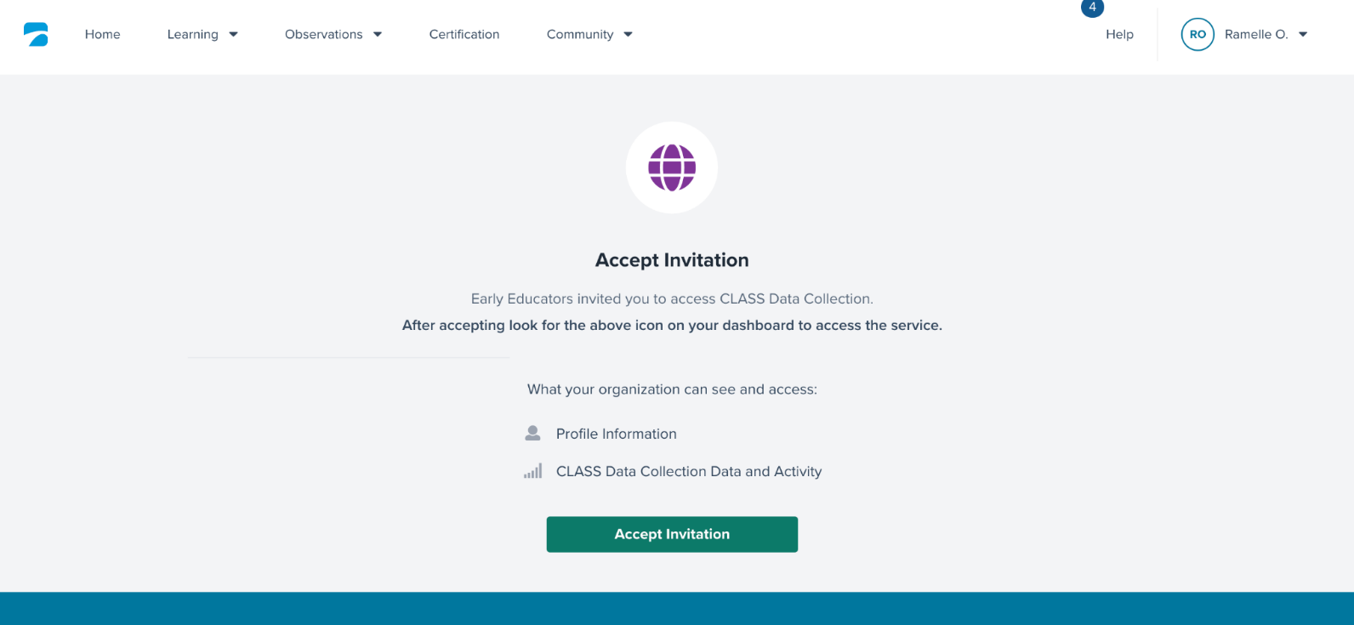
Once the invitation is accepted, users will see the main myTeachstone dashboard (or ‘Home’ page). Users may also access this page using the purple icon at any time. All users should note that ‘CLASS Data Collection’ appears as an option in the drop-down menu under the ‘Observations’ Tab in the navigation menu at the top of the screen. When the CLASS Data Collection tile is visible as an option on the dashboard, users may enter CLASS and CLASS Environment Observation data.
Users will be asked to indicate which account within myTeachstone they want to access. Even users with only one myTeachstone account will be asked to identify an account. Clicking on the “Select an Account” field reveals a drop-down menu of accounts the user can select from.
Once the appropriate account is selected, the user will be taken to their dashboard for that account.
Users with multiple accounts may have different dashboards and access to information in myTeachstone depending on their roles within their different accounts. Certain information like CLASS certifications will be visible in all of the user’s accounts since that information is tied to the user rather than a specific organization or account.
TIP: myTeachstone account usernames are based on emails. If you already have an account in myTeachstone, review the email on your account; you may want to update it to reflect your work email. By taking this step, your existing Certifications will be merged into your agency CSPP account. This must be done before creating a new user account within the CSPP hierarchy. Once two accounts have been created, they cannot be merged. If users find that their CLASS certification is not reflected in their CSPP account, they can contact supportca@teachstone.com to request the certification be transferred to their CSPP account.

Preparing for Data Entry
Prior to entering data, Observation Data Entry users should review the CLASS and CLASS Environment score sheets or summaries. This review will help ensure data entry is accurate. This review should check for the following:
- CLASS scoring sheets or summaries with notes
  - Ensure Observer name, Educator(s) name(s), classroom name, date, and languages spoken are identified.
  - Check that the classroom descriptives are provided for each cycle. For example, are cycle start and end times provided? Are the number of adults and children in the classroom entered?
  - Double check to ensure all scores are clearly marked, including indicator level scores at the cycle level.
  - Ensure the Activity Setting section is complete for each cycle.
- CLASS Environment scoring sheets or summaries with notes
  - Be sure that the Observer has scored each item.
  - Ensure that all scores are clearly marked, including items scored as N/A.
Additional Information Related to the Evidence Section of the Observation
Two additional data fields not included in the CLASS scoring sheet are required for data entry. The two questions for these data fields are:
- What is the Observer’s affiliation with the organization? Please indicate the Observer’s affiliation with the organization using the following two-letter codes: IT (Internal team member). IO (Independent Observer) or AU (Affiliation unknown).
- What format was used to conduct the observation? Please indicate the format of the observation using the following two-letter codes: RE (Recorded), IP (In-person), LR (Live-remote), or UN (Unknown).
For Data Entry users who did not complete the observation: If this information is not provided by the Observer on the scoring sheet, please follow up with them.

Entering CLASS Observation Data
TIP: It is recommended that all data for an observation be completed in one sitting. It is possible to split data entry into multiple sessions; however, that increases the likelihood of data entry errors.
After entering all observation data, double check your work. This will ensure accurate scores in the myTeachstone platform and increase the overall quality of the observation data.
CLASS Data Collection entry screens can be accessed in two ways: Either by choosing the ‘CLASS Data Collection’ option found under the ‘Observation’ tab along the top of the page, or by choosing the purple ‘CLASS Data Collection’ tile on the dashboard. Either method will bring the user to the ‘CLASS Data Collection’ screen. Here, users will be able to view and/or select classrooms that have been assigned for CLASS data entry.
When scoring sheet information is verified as complete, users may proceed to enter data from the ‘CLASS Data Collection’ page. To begin, select “California Department of Education: CSPP” from the account/agency drop-down selection in the top right-hand corner of the CLASS data Collection screen.
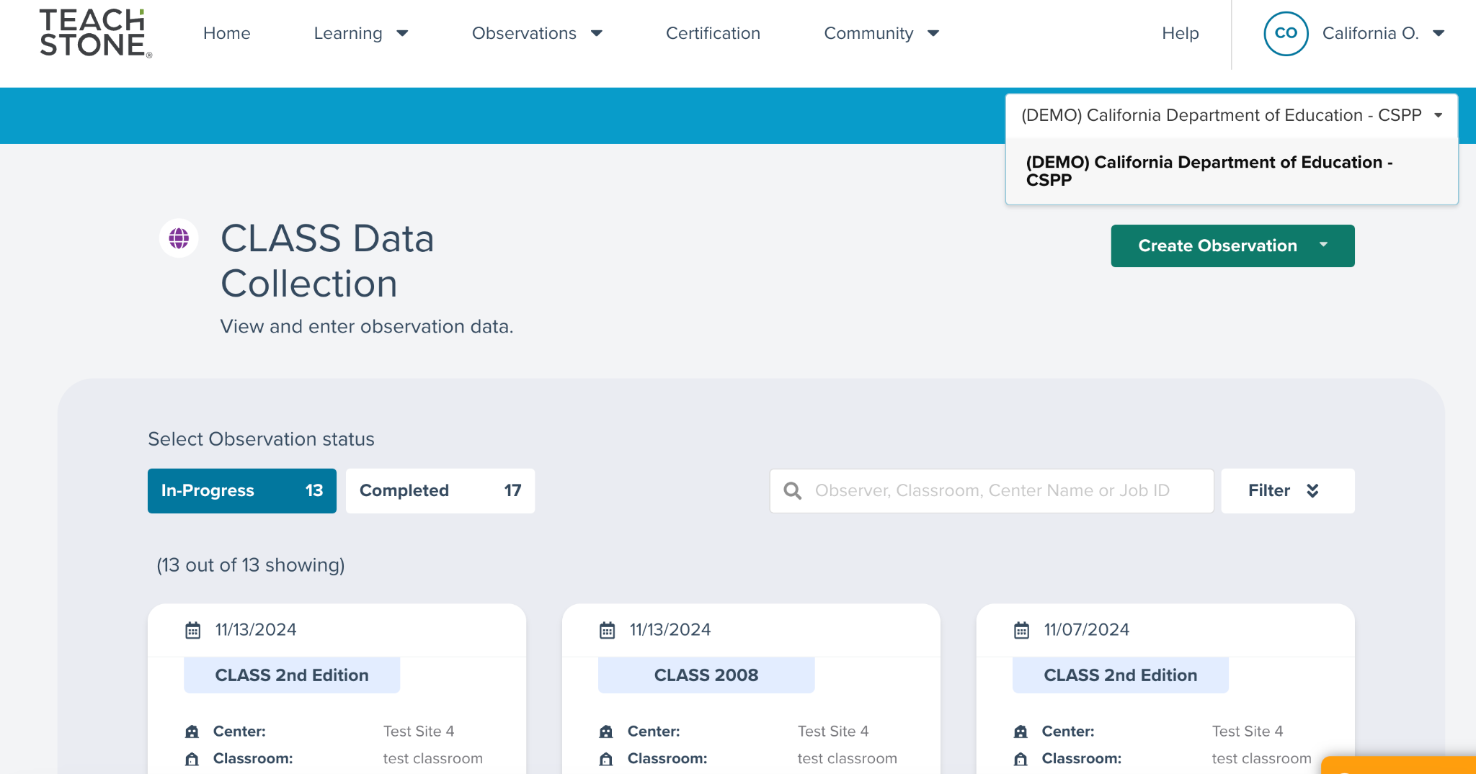
TIP: Users might need to select an account to ensure they are in the right spot for data entry. A drop-down menu can be found at the top right-hand corner of the page. Click on the down arrow and your assigned accounts will appear. The CSPP account will be listed as California Department of Education CSPP.
The next step is to create an observation. Users will select the green button in the top right-hand corner titled ‘Create Observation’.
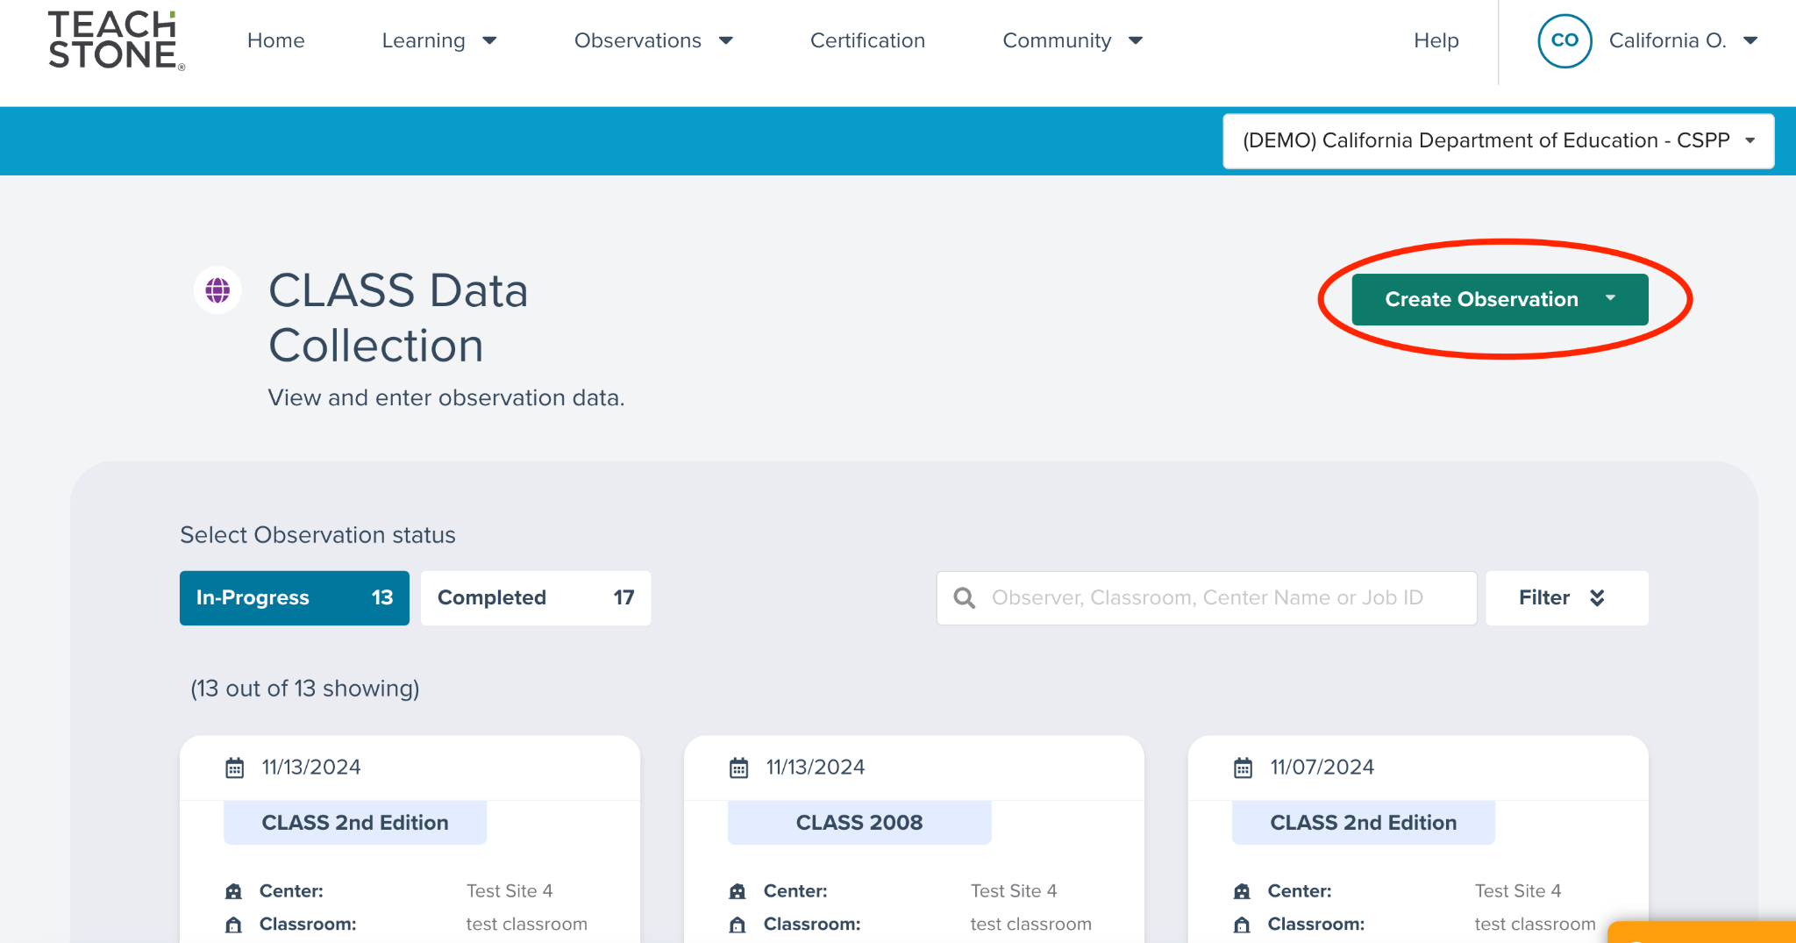
Once the icon is clicked, a drop-down menu will appear to select the version of CLASS you are entering. Note that CSPPs are required to follow the requirements of MB 23-10 when determining which version of the CLASS tool to use for observations.
After selecting the CLASS version being used, users will be taken to the ‘Create Observation’ page and asked to enter the following observation details in the table below. Definitions have also been provided to help guide a response.
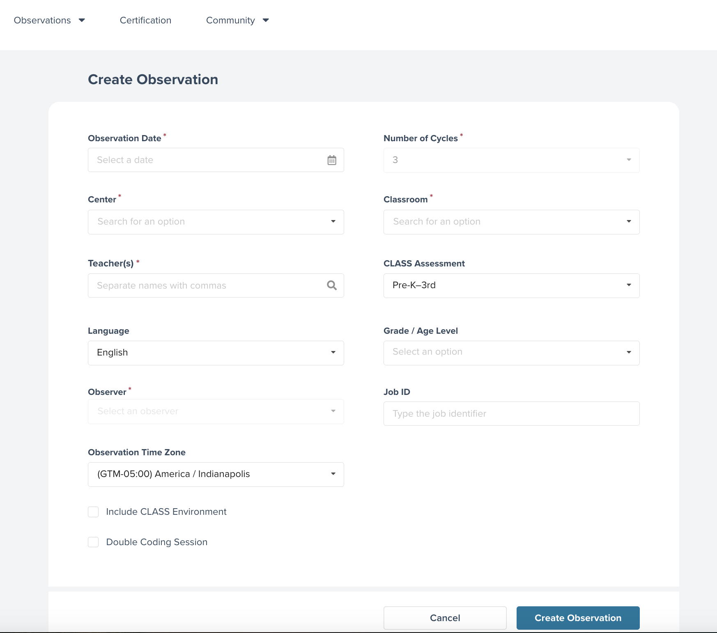
All of the information requested can be found on the CLASS or CLASS Environment score sheet.
Table 3. Observation Details Entered into myTeachstone
Information Needed | Format | Definition
Observation Date | Calendar provided to select date | Date the CLASS and CLASS Environment observation took place.
Number of Cycles | Dropdown Menu | Represents the number of cycles that occurred during the observation.
Center | Dropdown menu | Name of the site where observation took place.  Note that for CSPP purposes, this field may include both centers and family childcare homes.
Classroom | Dropdown menu | Name of the classroom observed. The list of classrooms will populate once a site has been chosen.
Teacher(s) | Open fill and searchable | The name of the Lead Teacher on the day the observation took place.
CLASS Assessment | Drop down menu | The version of the CLASS that is used for the observation.
Language | Drop down menu | The primary language of instruction during observation, set to English by default. The drop-down menu allows changes, for example, if English is used more than Spanish.
Grade/Age Level | Drop down menu | Represents the age of the children in the classroom. Allows users to select multiple age groups (i.e., Pre-K 3-year-olds and Pre-K 4-year-olds).
Job ID | Open fill | Optional field. Sites or contractors can choose to use this field as they wish. *
Observation Time Zone | Drop down menu | Represents the time zone in which the observed classroom is located.
Include CLASS Environment | Check box | Allow Observers to add CLASS Environment observation data.
Double coding session | Check box | Indicates the observation is entered by a second observer for reliability. Double coding scores are not used in reports or included in site/agency aggregated scores.
* For example, a contractor or site may choose to use this field to manage their data collection process, or perhaps to include session information to facilitate data matching to QRIS data systems. The decision to use this field is optional.
TIP: Only check the Double Coding Session box for ‘Observation Details’ if you were a second Observer in the classroom for reliability purposes. Scores entered for Double Coding are not used to generate reports nor are they included in site and/or agency aggregated scores.
Once the observation details have been entered, users will be moved to the next page to begin entering CLASS and CLASS Environment scores. Users will be invited to enter data for cycle details, CLASS domains, dimensions, and indicators for each observation cycle. The navigation bar on the left side of the page allows users to select the cycle for which they want to enter data. Users can also select ‘CLASS Environment’ from the navigation menu to enter that data. As users move through data entry, details about the observation will be at the top. For example, regardless of the cycle being entered users will always see the observation date, site name, classroom name, and CLASS Assessment.
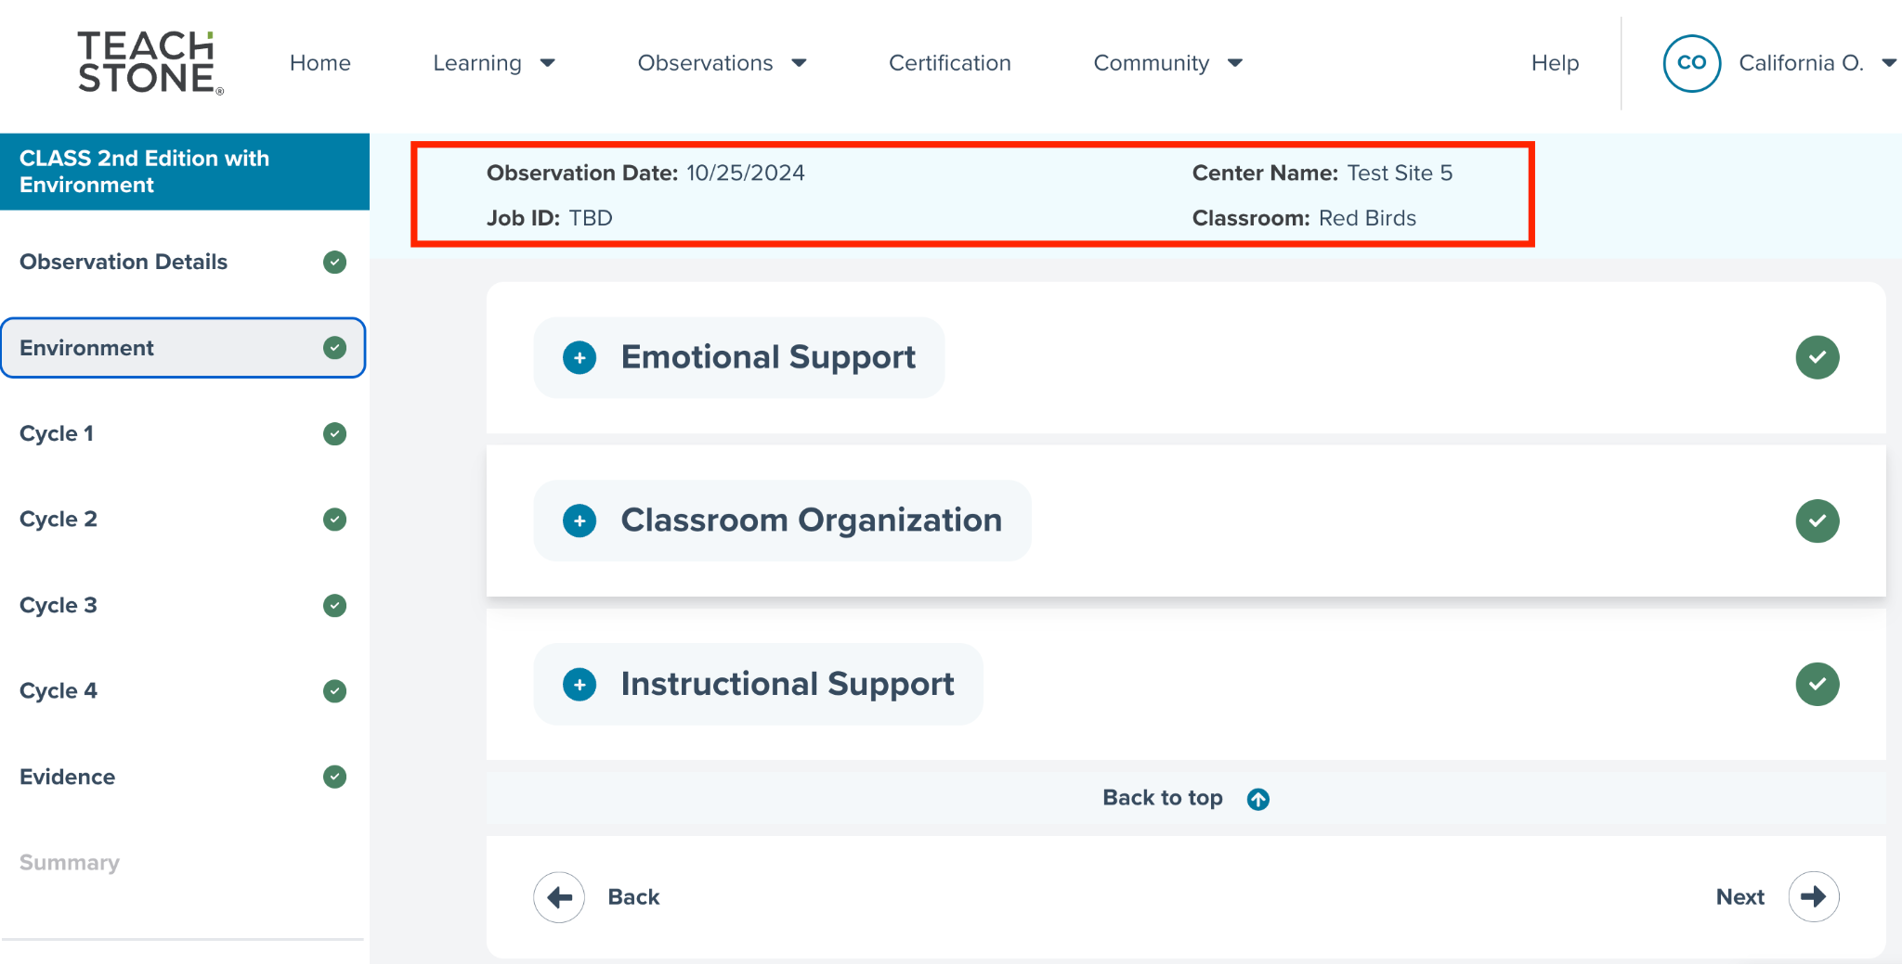
Please note: The myTeachstone platform has some automated data verification popups that appear when the user enters a score outside the typical range for the dimension. This is designed to help prevent data entry errors and is not intended to question or challenge the observer’s score. The system will accept a score even if it is outside the typical range.
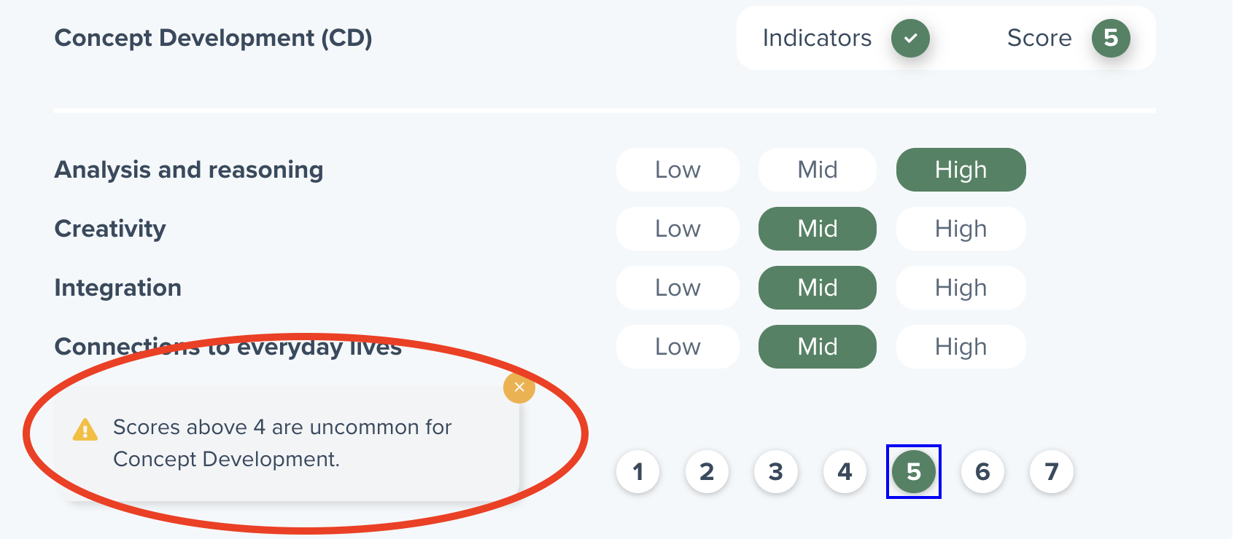
TIP: If a user’s navigation pane does not list CLASS Environment as a data entry option, they should click on the drop-down menu for ‘Observation Details’ and ensure the CLASS Environment box is checked. Once the box is checked the option for data entry should appear active for them.
Users can expand and collapse each section by clicking the +/- button next to the domain name. Additionally, the arrows at the bottom of the page (Back’ and ‘Next’) will move them through the cycles and elements of their observation.
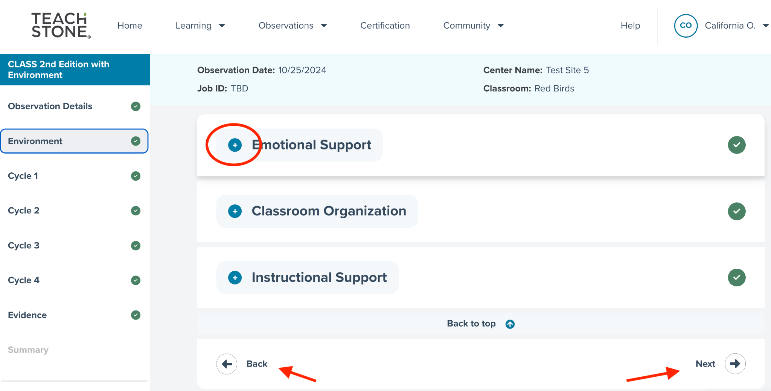

By default, the system will take the user through data entry in the order of the navigation pane. If the user has selected CLASS Environment from the ‘Observation Details’ page, they will automatically be prompted to begin entering CLASS Environment scores for each domain. Users can also confirm what data they enter by referencing the navigation pane to see which option is highlighted in gray.

Entering CLASS Environment Scores
When users are ready to enter CLASS Environment scores, they should navigate to ‘Environment’ on the left-hand side and/or use the ‘Back’/Next’ buttons on the navigation pane at the bottom of the screen to highlight it. Users should then select the ‘+’ button next to each domain to expand the window to support item level data entry. Items appear in the same order as they are on the score sheet. Most of the items are scored as 1, 2, or 3. In a few instances, items may be scored as N/A if use of the material, display, or arrangement did not occur during the observation. Users need to click on the appropriate circle for each item. Once selected, a green circle will appear.
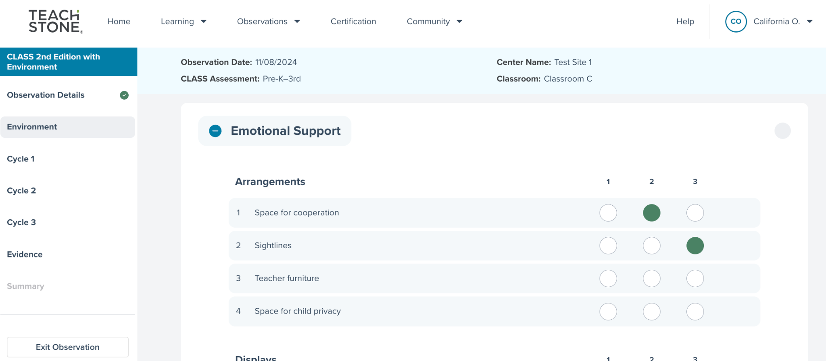
TIP: As CLASS Environment data is entered, double check scoring sheets to confirm that the correct scores are recorded in myTeachstone. During the data entry process, it can be easy to miss an item during entry and/or enter the wrong score for an item.
To move to the next domain, click on the ‘-’ button next to the domain name to collapse that section and find the next domain for entry. Before collapsing a domain, double check data entry to ensure scores have been entered correctly for all items. Users can then move through entering data for the remaining domain(s) in the same manner.
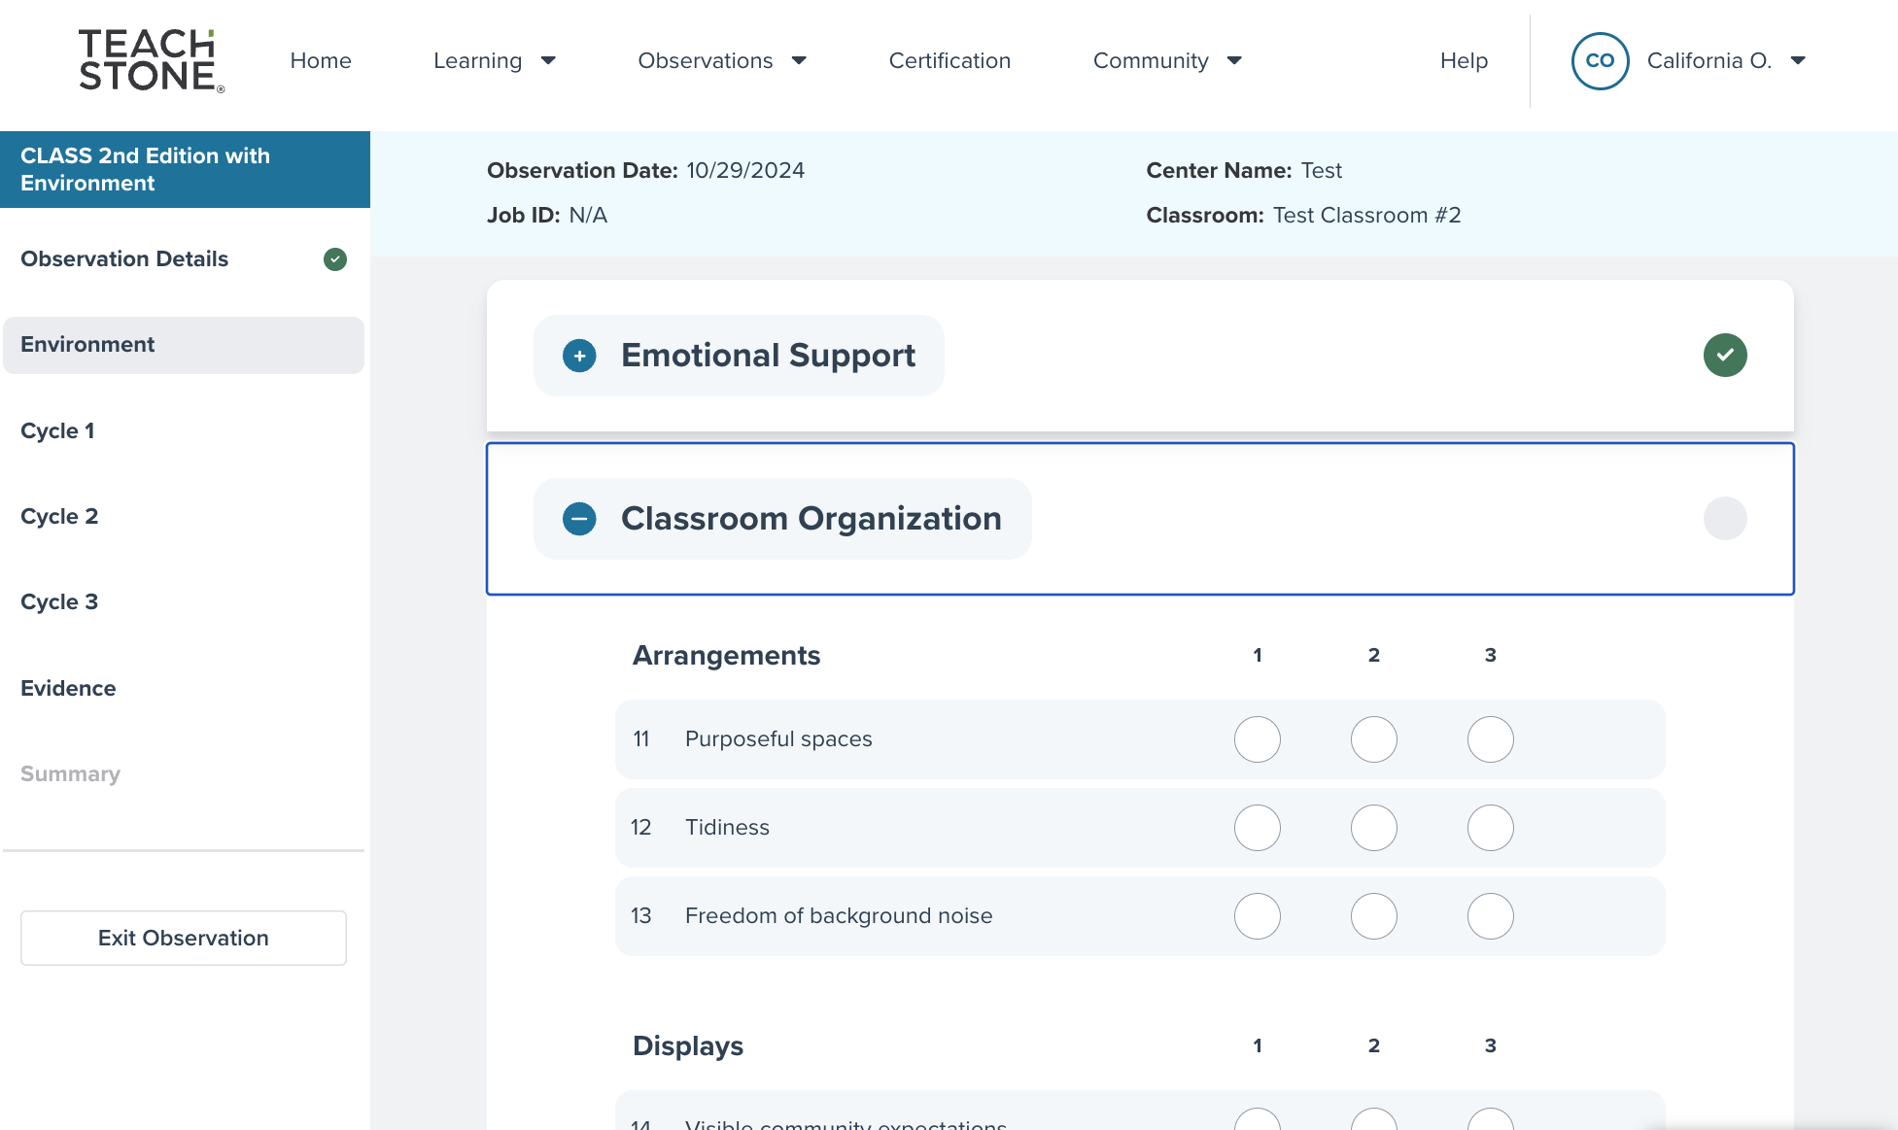
TIP: Use the green check marks to guide data entry progress. If a domain or cycle doesn’t have a green check mark, that indicates missing data.
Select ' Next ' after entering CLASS Environment data to begin entering cycle level data. For each cycle, users will enter the following data:
- Cycle Details: This includes cycle begin/end times, number of adults and children present, as well as the activity setting data
- Enter Scores: CLASS version indicator, dimension, and domain level scores
The order of data entry is aligned with the score sheet. All data fields are required and must be completed in myTeachstone. If scores are missing, the Observer must provide the missing information before moving forward with data entry.
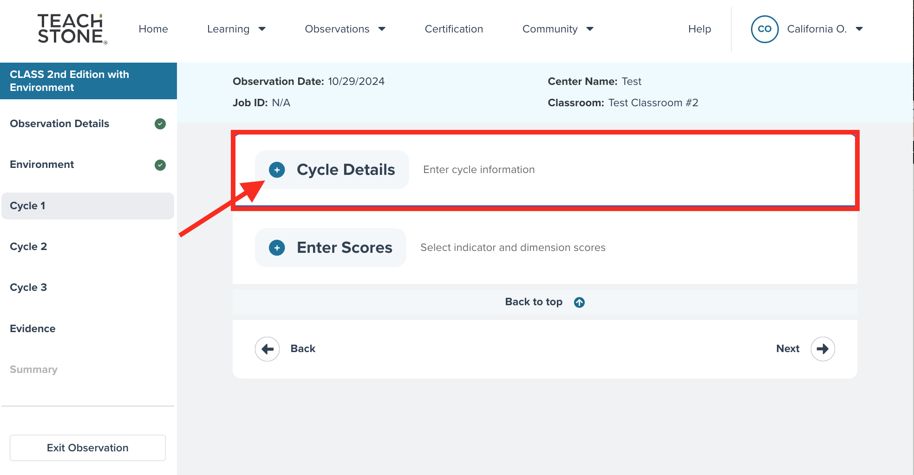
To enter ‘Cycle Details, select the ‘+’ to expand the screen section. The user will need to complete information at the top of the screen - cycle time, number of adults, and number of children.

Entering Cycle Data
Consistent with the process described for entering Environment data, users will enter dimension and domain scoring data by cycle, as reflected on the scoring sheet.
For each cycle, users will first navigate through the ‘Cycle Details’ screen, entering scoring information for content covered during the observation, with format identifiers.
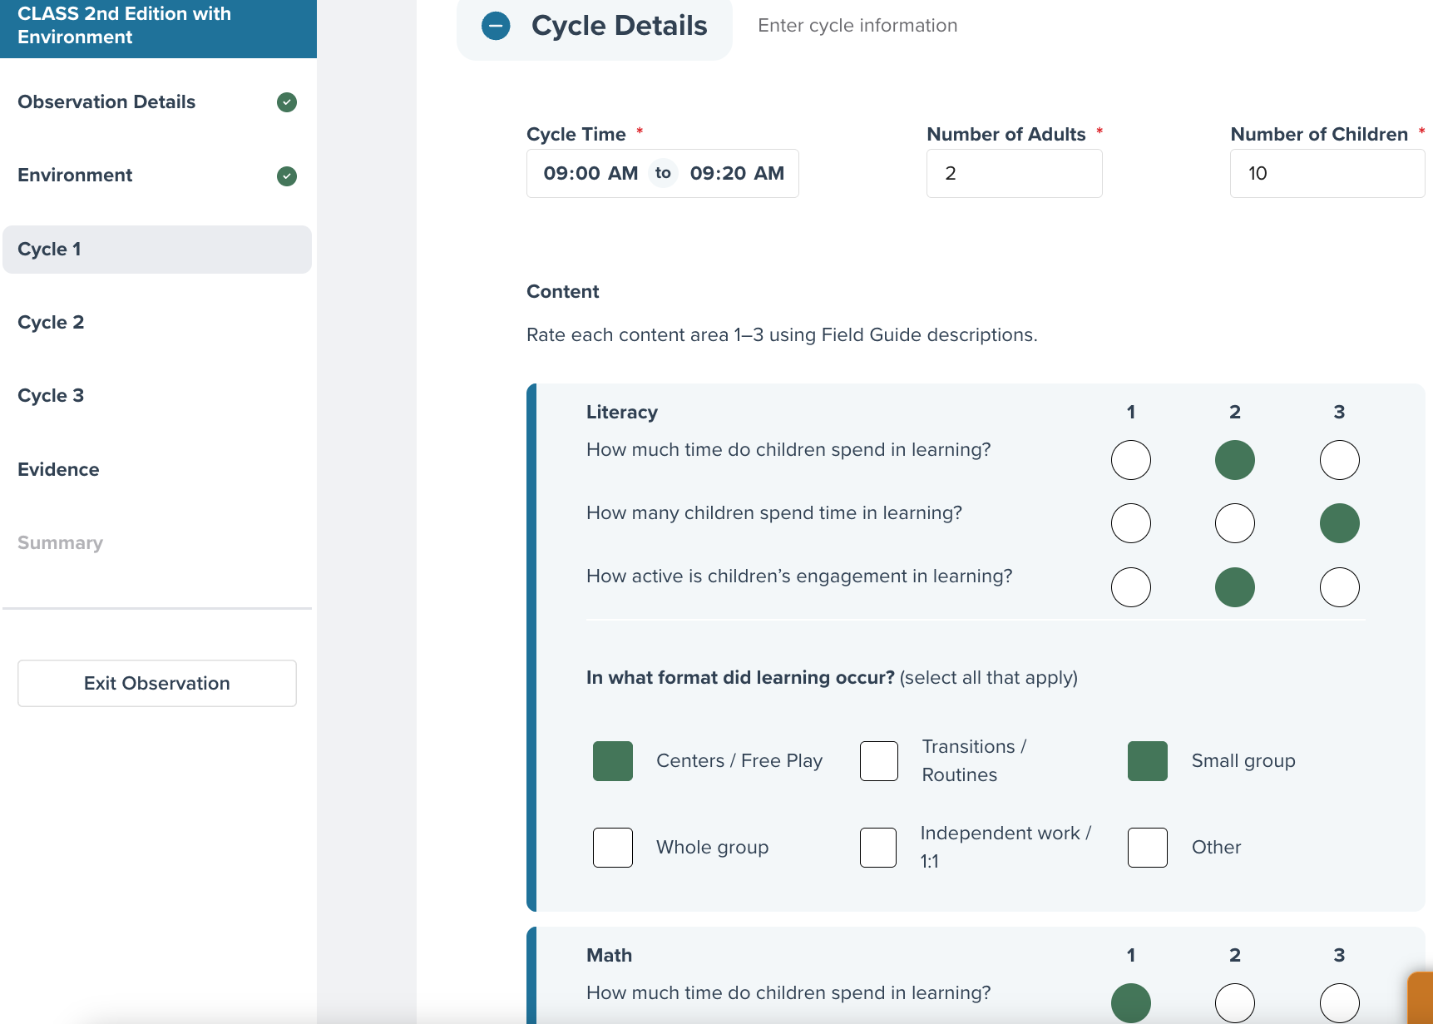
When ‘Cycle Details’ are complete, proceed (using navigation tabs to the left side of the screen, or using the ‘Back’ or ‘Next’ buttons at the bottom) to enter indicator and dimension scores for each cycle performed, consistent with scoring sheet information. Cycles to complete are based on the number of cycles identified in the ‘Observation Details’ section.
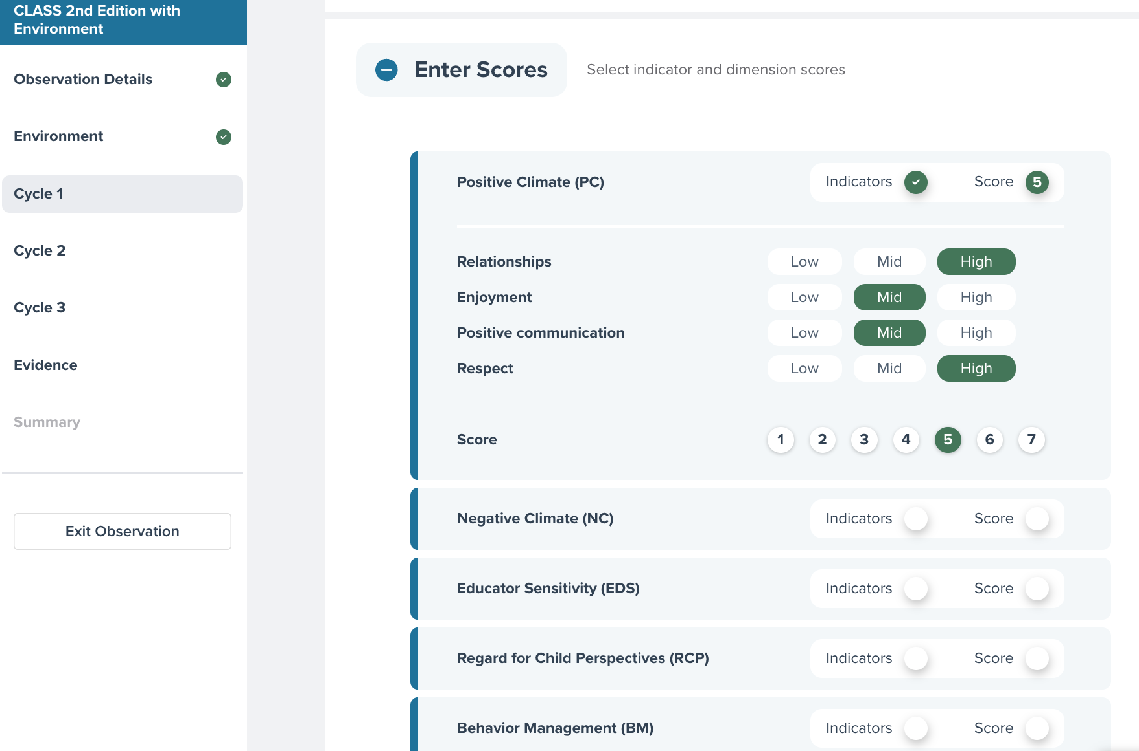
Note that as each dimension’s scores are completed, along the header row, an ‘Indicators’ button will turn green and the ‘Score’ button will reflect a number. This lets the user know that the dimension scoring data is complete.
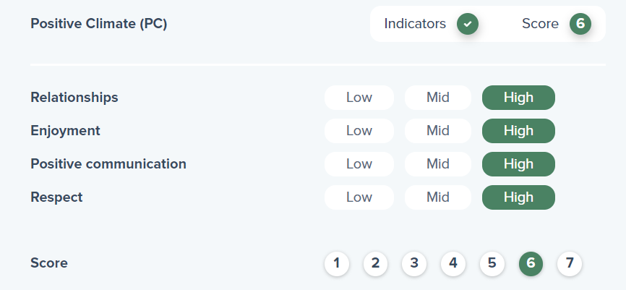

Entering Evidence for the Observation
To complete the observation record, navigate to the ‘Evidence’ section to answer two questions related to the observation and format. The additional questions provide information requested by CDE about the observation and are required.
Two additional data fields not included in the CLASS scoresheet are required for data entry. The two questions for these data fields are:
- What is the Observer’s affiliation with the organization? Please indicate the Observer’s affiliation with the organization using the following two-letter codes: IT (Internal team member). IO (Independent Observer) or AU (Affiliation unknown).
- What format was used to conduct the observation? Please indicate the format of the observation using the following two-letter codes: RE (Recorded), IP (In-person), LR (Live-remote), or UN (Unknown).
If this information was not provided by the Observer, please follow up with them.
To answer each evidence question, click on the question and a text box will open, allowing the user to enter their responses.
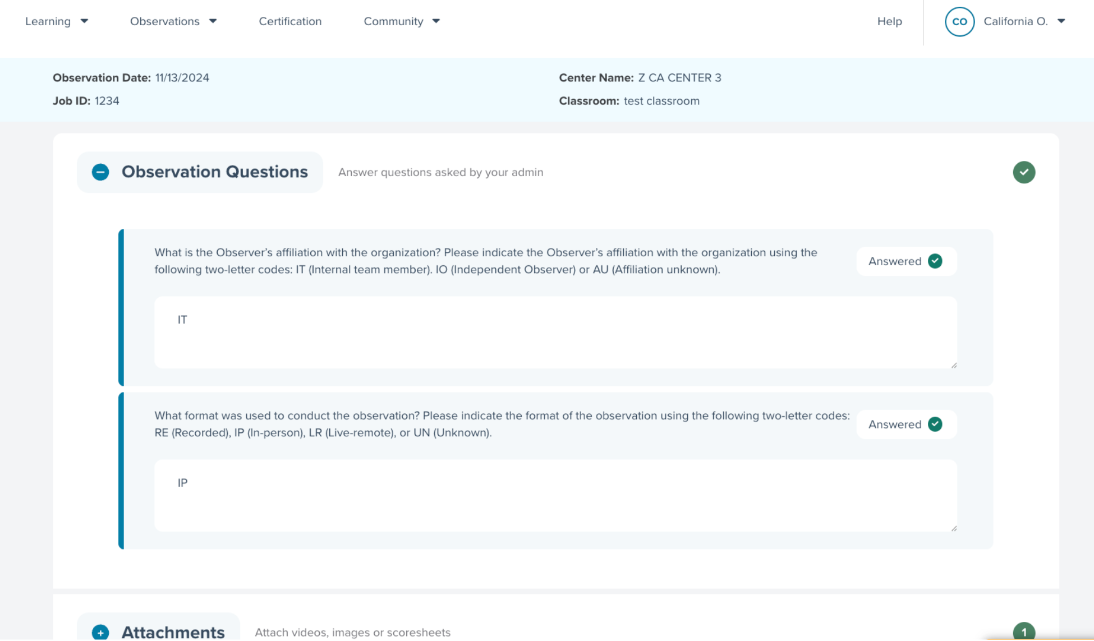
Each question is open-ended, and guidance is provided on how best to format the response you enter. Please adhere to the guidance provided for each question. Depending on your role, you may need to reach out to the Observer to gather additional information. If the Observer did not gather information, please indicate ‘Missing’ or N/A as the response.
TIP: Be sure to check that the Observer has provided the information for the ‘Evidence’ section on their scoresheet prior to starting data collection. If the information is missing, check with the Observer as soon as possible.
After responding to each evidence question, upload an image of the completed score sheet.

Uploading Attachments
Users will also use the ‘Attachments’ section of the ‘Evidence’ tab to upload a copy of the original completed CLASS observation scoring sheets. Accepted file types include .jpeg, .png, .tiff, .pdf, .heic, .avi, .mkv, .mov, and .mp4. There is a maximum upload size of 50 MB for files and no maximum upload size for videos.
Images can be created on a phone or with the use of a scanner. Prior to uploading the image, please ensure that the notes/evidence can be clearly read. Additionally, all scores should be visible across all cycles and at the indicator and dimension levels. It is recommended that all scoring sheet pages/images be uploaded into a single PDF file to make them accessible across operating systems and browsers.
In addition to scanning, saving, and uploading a scanned image of score sheets, there are phone apps that can be used to take photographs, and save them as PDFs which can then be uploaded to the observation. Some resources can be found here:
Apple users
Android users
When ready to upload, select the ‘Upload Document’ button. From there, find the file name for the image you would like to upload and double click on it. The file will begin the upload process. Once complete, an attachment will appear at the bottom of the page. Click the ‘Save’ button before navigating to another page.
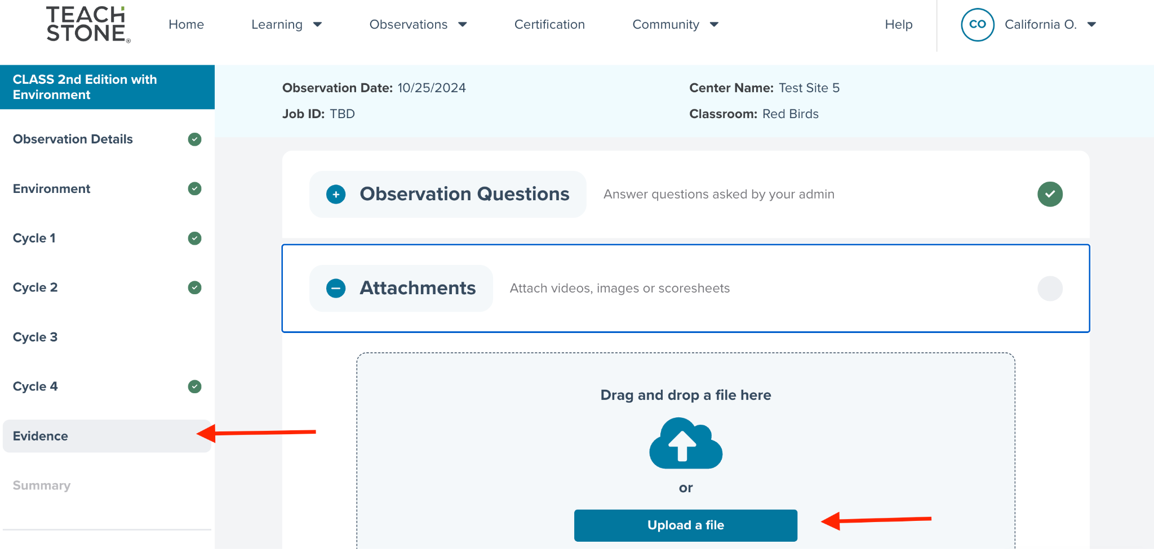
TIP: After uploading the score sheets, double click on the PDF icon to ensure you attached the correct file. If the wrong file was uploaded, users have the option to remove it.
While it is preferred that the images of your score sheet be merged into one file, it is also an option to upload multiple documents and/or images.
Once all fields in the navigation pane have green checkmarks next to them, the ‘Submit’ button can be selected to submit the observation to the system
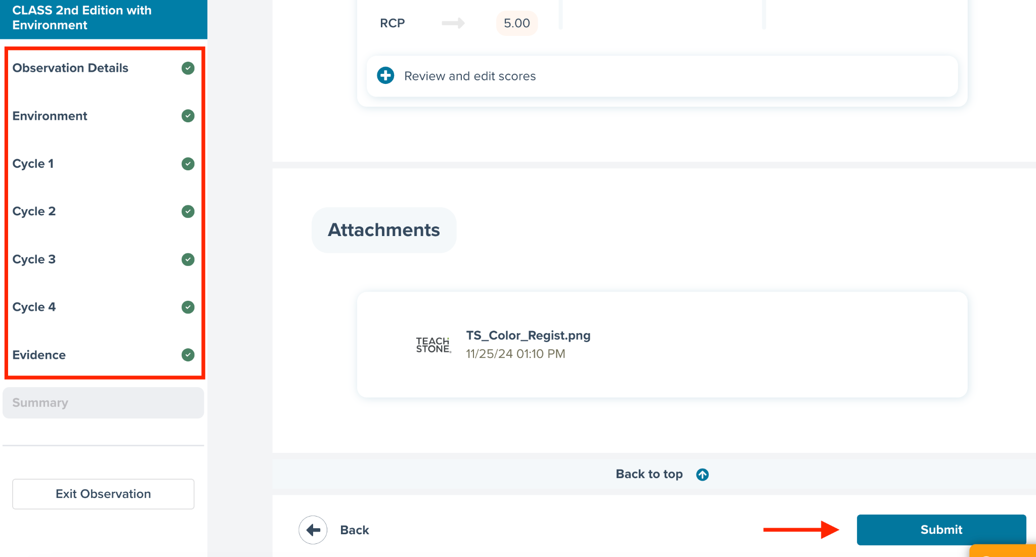
Once the observation is complete, click ‘Submit.’
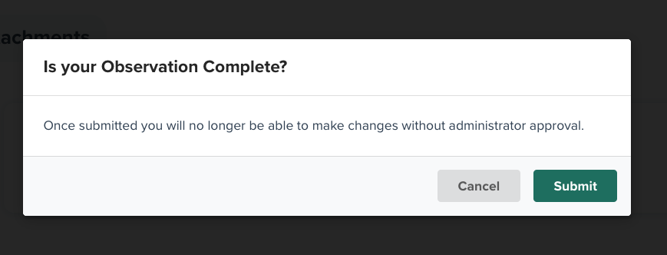

When CLASS and CLASS Observation Records are Complete
When all data is complete for the observation record, users will be taken back to the observation page. From here, users can select any of the observations to view the data and track your progress with data entry. This page will also allow users to start data entry for a new observation by selecting ‘Create New Observation’ in the top right-hand corner.

Tracking Data Entry
To locate a classroom for which data has already been entered, users can use the search bar near the top right of the page to search observations. Search criteria can include Observer name and/or classroom name to find specific observations.
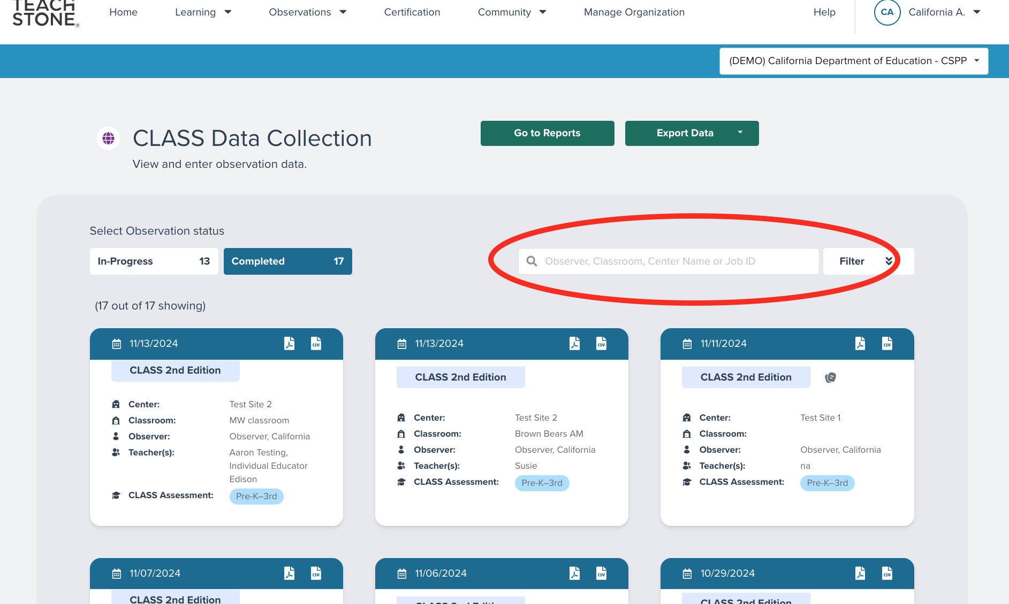
Users can conduct an advanced search by using the filter feature next to the search box. Filter options include type of observation (i.e., CLASS or CLASS Environment), a specific date range, or by site.
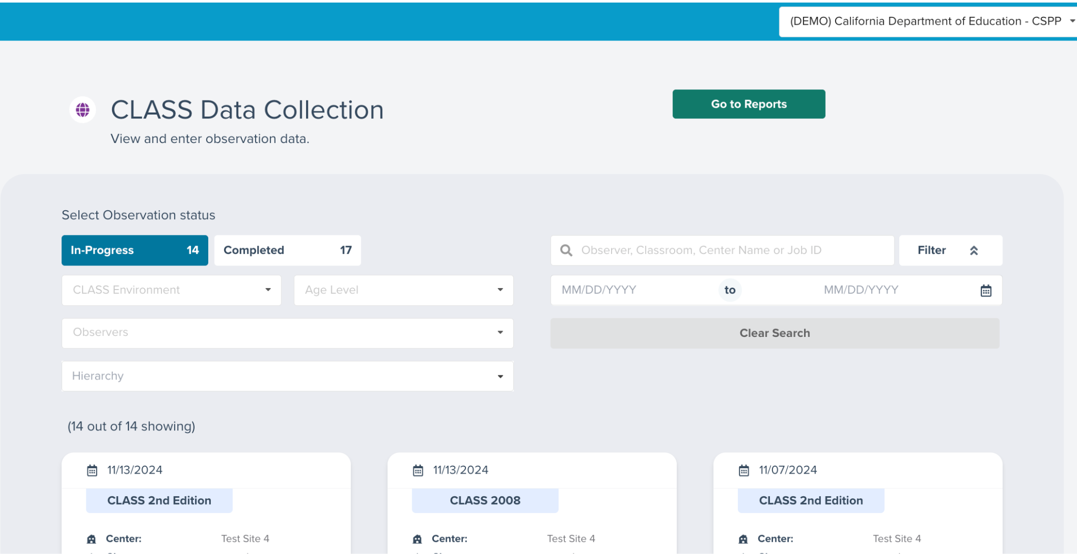
Once the user has identified search parameters, classroom tiles will appear to review, by clicking on the tile to access the data. It is important to note that while all users will see all of the observation tiles for the classrooms assigned to them, only Administrators and/or Observers who conducted the observation can access the scores themselves.
Observations ‘In-Progress’ can only be viewed by the Observer or Data Entry User linked to the observation. Administrators cannot view the observation until the Observer submits the observation.
TIP: If you cannot locate the classroom for data entry, be sure to reach out to the site leader to ensure you have the correct classroom name.
In the myTeachstone system, observations are tracked as being ‘In-Progress’ and ‘Completed’ The ‘In-Progress’ tab identifies the number of classrooms assigned to an Observer and/or where data entry has been started but not completed. Observations with incomplete data cannot be used to generate reports, nor the entered data used to calculate classroom, site, or Contractor level CLASS scores. The final category of ‘Completed’ represents that an observation has complete data entered and the scores are being included in reporting and aggregated calculations.
TIP: If you notice classrooms are in progress, consider reaching out to your Observers and/or Data Entry team to ensure they have what is needed to finish data entry.

CSPP Educator/Classroom Level User
Accounts for Educators can be created by Administrators. CSPP Educators with the agency CSPP myTeachstone accounts will be able to access CLASS scores and classroom level reports for their assigned classroom only. Educator roles alone are not able to enter data nor view scores for other classrooms at their site or in their agency.
TIP: Educators cannot see scores or reports for classrooms unless they are assigned additional access by the Administrator. Administrators will need to re-assign classrooms as Educators shift classrooms, sites, and/or programs.
If an Educator moves to another CSPP, the Educator will be able to view previous observations from other programs; however, their new Site Supervisor will only be able to view observations that have taken place at their new site.
Upon logging into the system, the Educator will arrive at the ’Home’ page. The ‘Home’ page will allow the user to navigate to features within myTeachstone that supports the Educator account. User settings can be adjusted, and account preferences can be updated by clicking on the name in the top right-hand corner and selecting ‘User Settings.’ For example, the user can change the email associated with the account and select the frequency of emails from the CLASS Learning Community.
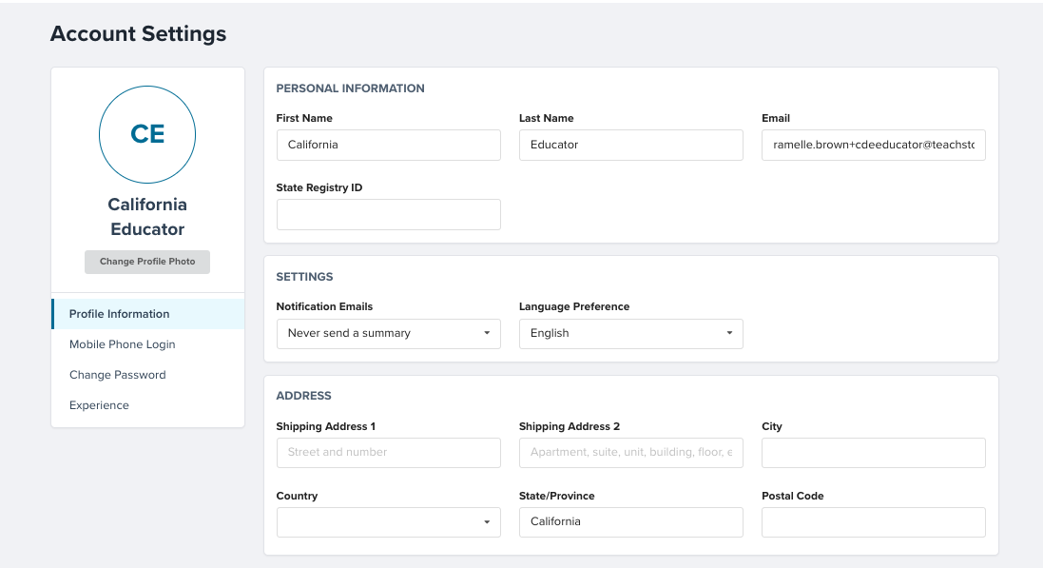
Users with a California Early Care and Education Workforce Registry number are asked to enter this number in the State Registry ID field on this screen. See California Early Care and Education Workforce Registry for more information.
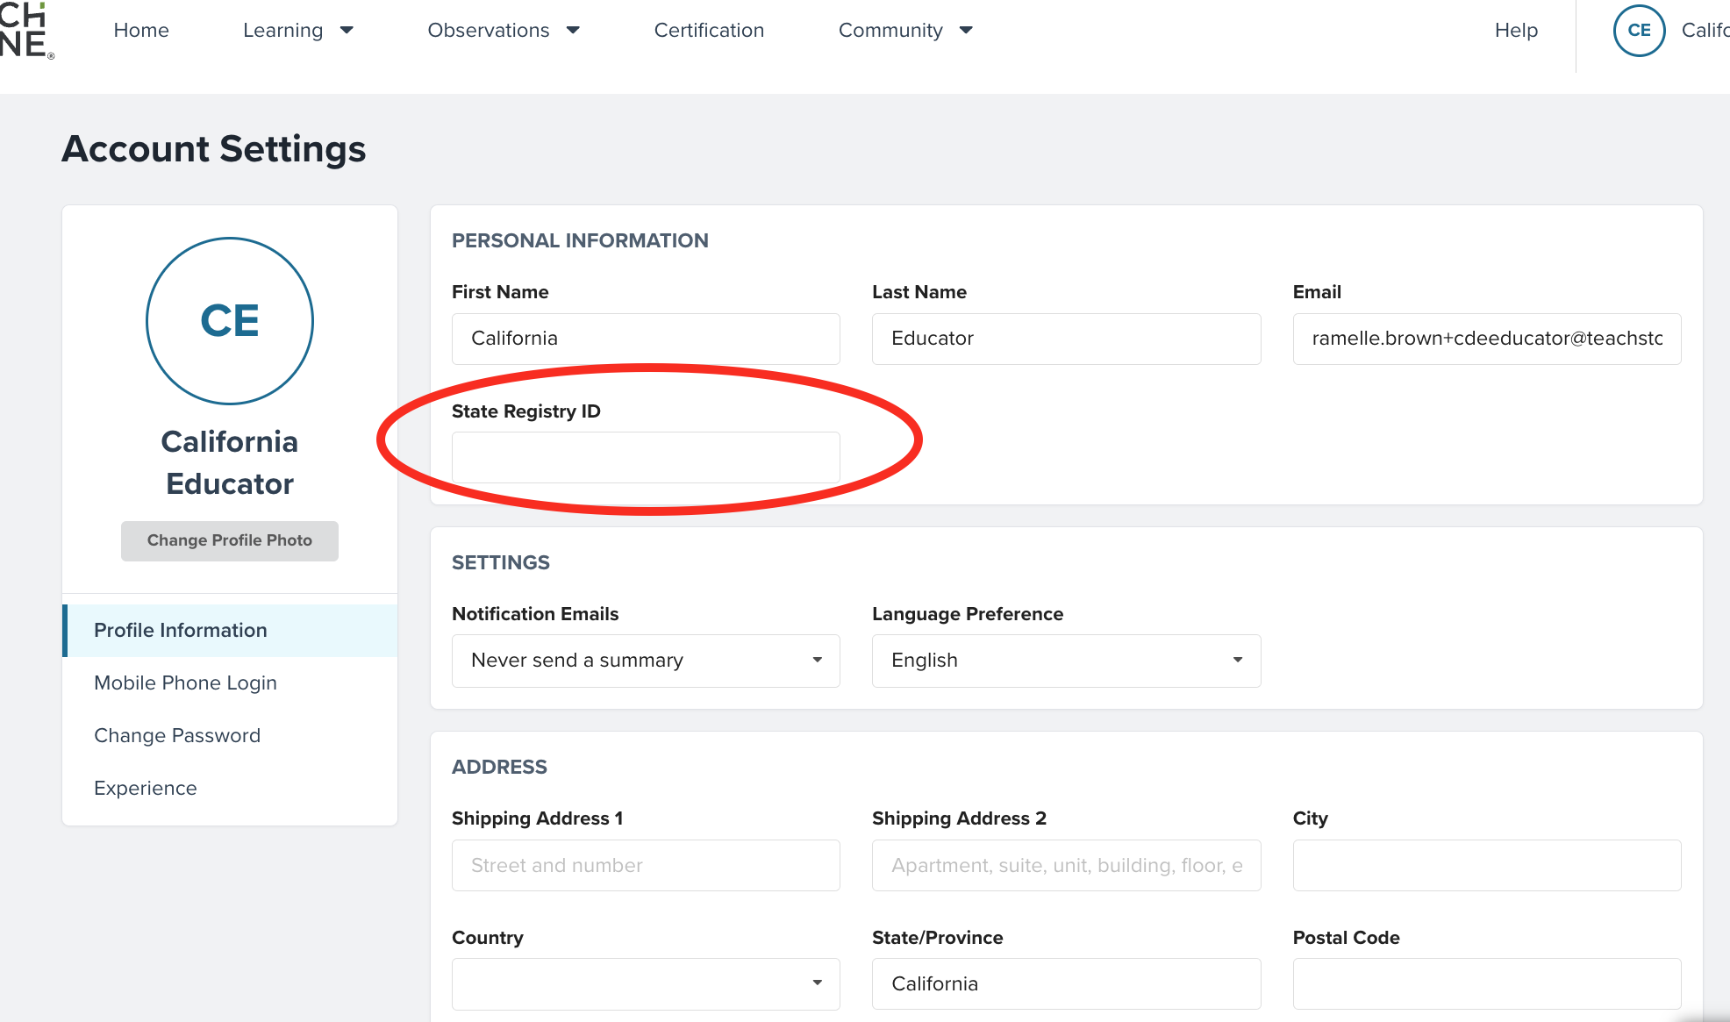

Accessing CLASS Scores for the Classroom
Ideally, Educators will receive feedback from their Administrator prior to gaining access to their CLASS scores. However, this may not be possible and may vary depending on a program’s size, location, and staffing. To support Educators, Teachstone has developed a detailed classroom level report that helps support Teachers in understanding their CLASS scores.
To obtain the CLASS report from an associated observation, select ‘CLASS Data Reports’ from the ‘Observations’ drop-down tab along the top navigation menu.
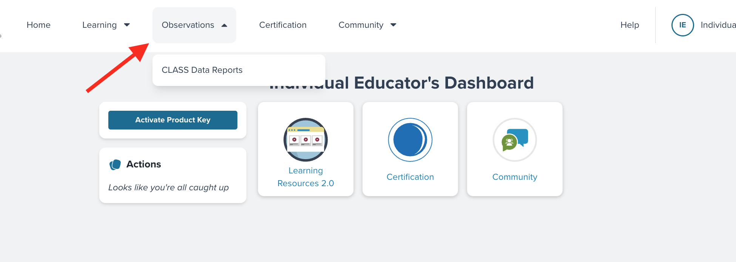
This will take the user to the next page to create or view the report. Educators with only one observation will automatically view their observation. If the Educator has multiple observations, they can create a new report by selecting ‘Create New Report’ from the top right hand side of the screen.
Educators’ reports appear on screen and users can toggle between domain and dimension level analysis. To download a PDF with additional guidance on what CLASS measures and how to interpret the data, select ‘Download’ on the upper right side of the screen displaying the report, or scroll to the bottom right side of the screen and click on the Download report icon. Once downloaded, the user can view, save, or share the report.
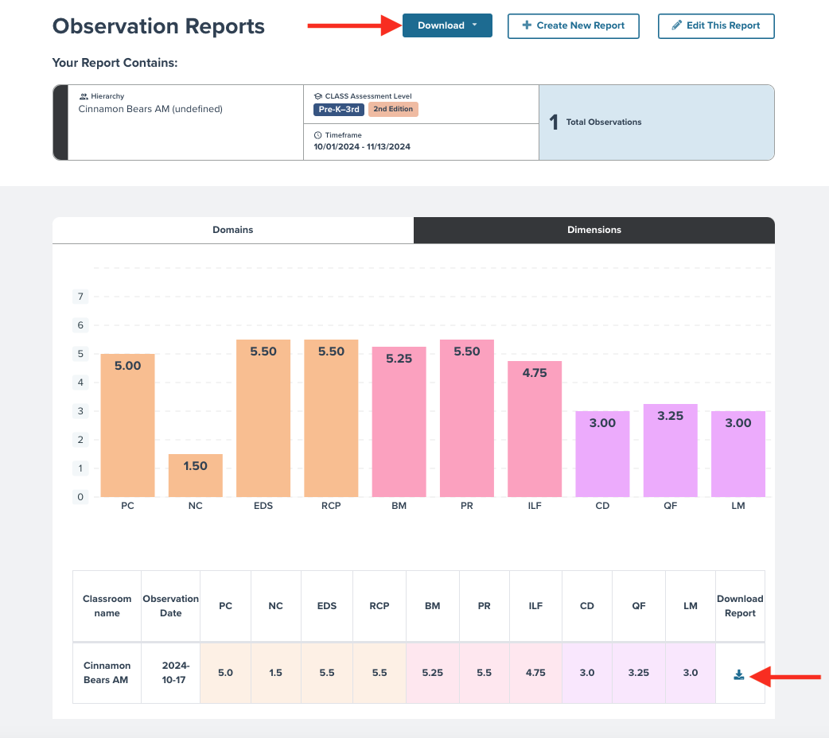
TIP: myTeachstone may take a few minutes to create your report. Please do not refresh the page while waiting since this will reset the system and will be required to start over.

CLASS Learning Community
Educators will also have access to the CLASS Learning Community. This resource provides the opportunity for Educators to connect with other Educators, ask questions about CLASS, and learn more about CLASS and effective interactions. Educators can access the CLASS Learning Community from the tile on their ‘Home’ page.
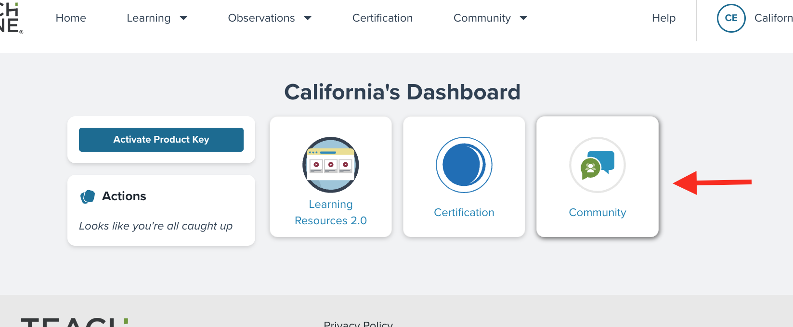
Upon the first login, the user will be invited to agree to the CLASS Learning Community Expectations and Privacy Policy. Be sure to read through all of the guidelines and information provided.
Users will need to scroll to the bottom of the page to indicate ‘Agree’ or ‘Do Not Agree’ to the expectations and privacy policy.
Once the user has agreed to the community expectations and privacy policy, they will be navigated to the main page for the community. There are daily threads of communication organized by topic and a banner across the top highlighting CLASS Resources.
TIP: Users can control how frequently they receive daily summaries from the CLASS Learning Community by visiting the user settings.
First time users can click anywhere, and an invitation for a tour will appear. The tour will highlight the features of the community as well as guide users to the different resources. Users are encouraged to select ‘Take a tour.’
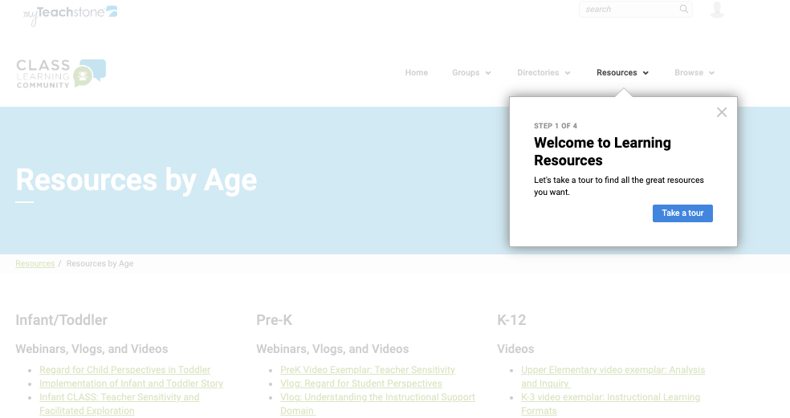
A variety of resources can be found within the community. Educators can join groups and become part of the discussion boards and find a variety of resources focused on CLASS.
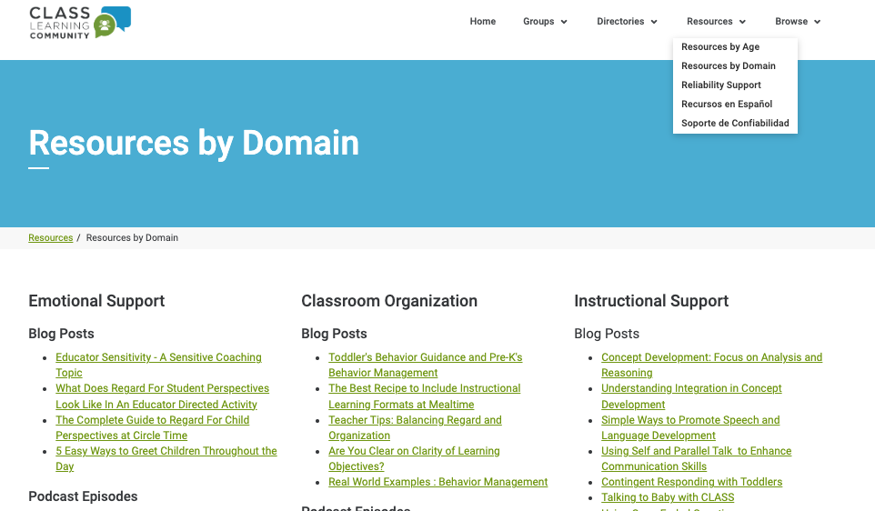
TIP: The ‘Home’ tab at the top of the CLASS Learning Community will take Educators to their Community home page. To return to myTeachstone, select the myTeachstone logo in the top left corner.
Educators are encouraged to make the most of this resource. Educators are invited to ask questions about CLASS scores, other Educators’ experiences during CLASS observations, and so much more! The CLASS Community is monitored by members of the Teachstone team to ensure questions are answered and/or additional resources are provided to support Educators on their CLASS journey.
