# 2024 Dashboard On-Demand Session: College/Career Indicator Notetaking Guide

California Department of Education | November 2024

Welcome

**Presenters**: Kathryn Morrissey, Education Research and Evaluation Consultant and Michael Ishimoto, Education Research and Evaluation Consultant in the Analysis, Measurement and Accountability Reporting Division of the California Department of Education.

## Agenda

* Overview of the California School Dashboard (Dashboard)
* College/Career Indicator
* Frequently Asked Questions
* General Rules About the Dashboard
* Contact Us

## Overview of the Dashboard

### California School Dashboard

The Dashboard is an online tool designed to help communities across the state access important information about transitional kindergarten through grade twelve. The Dashboard reports how districts and schools are performing on multiple state and local measures that make up California’s accountability system.

### Dashboard State Indicators

* Academic Indicators
  + English language arts/literacy (ELA)
  + Mathematics
* English Learner Progress Indicator (ELPI)
* Chronic Absenteeism Indicator
* Graduation Rate Indicator
* Suspension Rate Indicator
* College/Career Indicator (CCI)
* Science Indicator*

*The Science Indicator will be for informational purposes only on the 2024 Dashboard.

### Measurement of Performance

For all state indicators, the measurement of performance for local educational agencies (LEAs), schools and student groups on the Dashboard is done by looking at two years of data:

* Current year data equals Status.
* A comparison between the current and prior year's data equals Change.

It is the combination of Status and Change that determines color performance on the Dashboard, and is designated by receiving a color, ranging from red at the lowest performance level to blue at the highest performance level. The Performance Levels in order from highest to lowest are Blue, Green, Yellow, Orange, and Red.

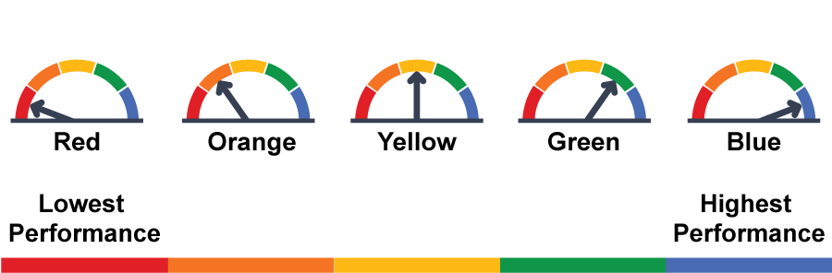

### The CCI is Back

Last year the CCI was in status only with no performance color. For the 2024 Dashboard, as we now have two years of data, performance levels or colors will be displayed this year.

Much like the other indicators, the baseball card with color is returning for the CCI. This means it will have the colored banner across the top of the card as well as the Performance Level or color in the form of the gauge and the color explicitly written out.

Additionally, we will determine the current year Status and whether the Status has changed from the year prior.

The equity report shows the number of student groups in each of the Performance Levels or colors for that particular school or LEA. This top-level report can assist schools and LEAs in looking at student group inequities that may be occurring.

At the very bottom of the baseball cards, there is a link to view more details which provides more specific student group information and trends in data over time, when available.

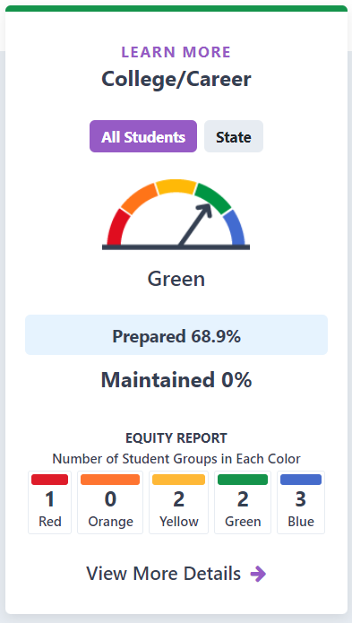

## College/Career Indicator

### What is the CCI?

The CCI measures how well districts and schools are preparing its graduates for college/career. Specifically, the CCI measures the percent of graduates who are deemed “Prepared” for college and career.

### Career Measures

The career measures approved by the State Board of Education are:

* Registered Pre-Apprenticeships
* State and Federal Job Programs (DASS Only)
* Transition Classroom and Work-Based Learning Experiences (Students with an Individualized Education Program (IEP) and earn a Special Education Certificate of Completion are included)
* Career Technical Education Pathway Completion
* Leadership/Military Science

View the preparedness criteria approved by the State Board of Education on the CDE website:

* Measure of Career Readiness (PDF) at <https://www.cde.ca.gov/ta/ac/cm/documents/ccicareer.pdf>

### College Measures

The college measures approved by the State Board of Education are:

* Smarter Balanced Summative Assessments in English Language Arts/Literacy and mathematics (Grade 11)
* Advanced Placement Exams
* University of California/California State University Requirements (formerly called A-G requirement)
* International Baccalaureate Exams
* State Seal of Biliteracy
* College Credit Course (formerly called Dual Enrollment)

View the preparedness criteria approved by the State Board of Education on the CDE website:

* Measures of College Readiness (PDF) at <https://www.cde.ca.gov/ta/ac/cm/documents/ccicollege.pdf>

### CCI Levels

Students are placed in three levels:

* Prepared
* Approaching Prepared
* Not Prepared

### Students Included in the CCI?

Students included in the CCI are derived from students in the Graduation Rate Indicator.

This means these are the students included in the combined four- and five-year graduation rate (those who graduated in four years [as part of most current graduating class] and students that graduated in five years [as part of the prior year graduating class]).

### CCI Calculation

| **Performance Level** | **Declined Significantly**  **from Prior Year (by 9.1% or more)** | **Declined**  **from Prior Year (by 2.0% to 9.0%)** | **Maintained**  **from Prior Year (declined or increased by 1.9% or less)** | **Increased**  **from Prior Year (by 2.0% to 8.9%)** | **Increased Significantly**  **from Prior Year (by 9.0% or more)** |
| --- | --- | --- | --- | --- | --- |
| **Very High**  70.0% or greater in Current Year | **Yellow** | **Green** | **Blue** | **Blue** | **Blue** |
| **High**  55.0% to 69.9% in Current Year | **Orange** | **Yellow** | **Green** | **Green** | **Blue** |
| **Medium**  35.0% to 54.9% in Current Year | **Orange** | **Orange** | **Yellow** | **Green** | **Green** |
| **Low**  10.0% to 34.9% in Current Year | **Red** | **Orange** | **Orange** | **Yellow** | **Yellow** |
| **Very Low**  9.9% or less in Current Year | **Red** | **Red** | **Red** | **Orange** | **Yellow** |

To calculate CCI Status for the 2024 Dashboard, a rate is determined using a numerator and denominator:

* The numerator is the Number of Students Who Graduated “Prepared” or the total number of students in the **Class of 2024** who graduated in four years and met the “Prepared” criteria; plus;total number of students in the **Class of 2023** who graduated in five years and met the “Prepared” criteria
* The denominator is the total number of students in the 2023–24 four-year graduation rate and “Prepared” students in the five-year graduation rate

### Five-by-Five Table

To determine a performance level or color for CCI, and all other indicators on the Dashboard, a five-by-five table is used. Below is the five-by-five table used for determining performance for the CCI:

**Five-By-Five Colored Tables**

### Three-by-Five Table

To limit large swings in the Change data that can be triggered by just a few students, the State Board of Education approved the application of a three-by-five colored table when the student population size is less than 150. Below is the three-by-five table used for determining performance for the CCI:

**Three-By-Five Colored Tables**

| **Performance Level** | **Declined**  **from Prior Year (by 2.0% or more)** | **Maintained**  **from Prior Year (declined or increased by 1.9% or less)** | **Increased**  **from Prior Year (by 2.0% or more)** |
| --- | --- | --- | --- |
| **Very High**  70.0% or greater in Current Year | **Green** | **Blue** | **Blue** |
| **High**  55.0% to 69.9% in Current Year | **Yellow** | **Green** | **Green** |
| **Medium**  35.0% to 54.9% in Current Year | **Orange** | **Yellow** | **Green** |
| **Low**  10.0% to 34.9% in Current Year | **Orange** | **Orange** | **Yellow** |
| **Very Low**  9.9% or less in Current Year | **Red** | **Red** | **Orange** |

### Verify Your CCI Data?

LEAs can validate the CCI data that are submitted prior to the close of the California Longitudinal Pupil Achievement Data System (CALPADS) certification window by reviewing:

* + *CALPADS Reports 3.19 and 3.20 for Career Technical Education (or CTE) Pathway completers*
  + *CALPADS Reports 3.10 and 3.11 for College Credit and Leadership/Military Science*
  + *And finally, Reports 15.1 and 15.2 for the following measures:* 
    - Met UC/CSU Requirements
    - State Seal of Biliteracy
    - Pre-Apprenticeships
    - State or Federal Job Program and
    - Transition Work-based Experience/Transition Classroom-based Work Exploration

Connecting CALPADS to the Dashboard is available at <https://www.cde.ca.gov/ta/ac/cm/documents/caldashhandbook24.docx>

Keep in mind that the remaining CCI measures are collected outside of CALPADS, from test vendors. They are:

* Advanced Placement Exams: collected from The College Board
* IB Exams: collected from IB
* Smarter Balanced Summative Assessments: collected from the testing vendor, ETS

### Where Can You Find the Additional Report for Your School?

The CCI measures will be reported in Additional Reports as it has in past years.

* This report will be coming in Spring 2025!
* College/Career Additional Report is available on CDE School Dashboard Additional Reports web page at <https://www.cde.ca.gov/ta/ac/cm/dbadditionalrpts.asp>.

## Frequently Asked Questions

### What Years of Data are Used for the CCI?

Up to five years of data are used. Therefore, if a student graduated in four years, then we use the last four years of data to identify what a student accomplished. If the student graduated in five years, then the last five years of data are used.

### Do Dashboard Alternative School Status (DASS) have a separate One-Year Graduation Rates

Due to the US Department of Education’s denial of California’s waiver to continue using modified methods for accountability, the DASS one-year graduation rate can no longer be used.

Beginning with the 2022 Dashboard, the combined four-and five-year graduation rate is now used for the Graduation Rate Indicator and therefore, this is also used as the denominator for the CCI for all schools, including DASS.

### How is College Credit counted in the CCI?

If the college course is offered within your course catalog then that would be included in CCI but if a student takes a college course independently that is not included in your course catalog, that would not count as college credit for the CCI.

### Can we double count CTE pathway and college credit courses?

Any CTE college courses used to meet CTE pathway criteria do not also count for the college credit criteria of the CCI. CDE does not allow LEAs and schools to double count students in two CCI measures.

### Can the DASS One-Year Graduation Rate be used to calculate the CCI?

Due to the US Department of Education’s denial of California’s waiver to continue using modified methods for accountability, the DASS one-year graduation rate can no longer be used.

### How is College Credit counted in the CCI?

If the college course is offered within your course catalog, and entered into CALPADS as a College Credit Course, then that would be included in CCI. If a student takes a college course independently and on their own, and it is a course that is not included in your course catalog or CALPADS, that would not count as college credit for the CCI.

### Can CTE Pathways that simultaneously offer college credit be used for the CCI?

In order to be prepared on the CCI through the completion of a CTE Pathway, an LEA/school must show that a student has completed both a pathway, as well as meet Smarter Balanced assessment criteria or take an additional college credit course.

CTE college courses used to meet CTE pathway criteria cannot also count for the college credit criteria of the CCI.

### Additional Help with the CCI?

* The CDE College/Career Indicator web page: <https://www.cde.ca.gov/ta/ac/cm/dashboardccr.asp>
* CA School Dashboard Technical Guide:  
  <https://www.cde.ca.gov/ta/ac/cm/dashboardguide24.asp>
* The CDE School Dashboard Additional Reports web page: <https://www6.cde.ca.gov/californiamodel/>

## General Rules About the Dashboard

### A Rule About Charter Schools

Because charter schools are treated as LEAs under the Local Control Funding Formula (LCFF), their data are not included in their authorizer’s Dashboard report.

### Dashboard for 30 or More Students

* Performance Level (color) gauge graphic displayed
* Status and Change reported
* Held accountable for support determinations

### Dashboard for 11 to 29 Students

* Performance Level (color) graphic greyed out
* Status and Change reported
* Not held accountable for support determinations

### Dashboard for Fewer than 11 Students

* Performance Level (color) graphic greyed out
* Status and Change not reported
* Not held accountable for support determinations

### N-Size Exceptions

The N-Size Exception applies to **Foster Youth, Homeless, and Long-Term English Learner (LTEL) student groups**. Foster Youth and Homeless student group N-size thresholds are different at LEA and school levels.

* LEA-level: N-size must be 15 or more students in the denominator to be reported on the Dashboard and held accountable.
* School-level: N-size must be 30 or more students in the denominator to be reported on the Dashboard and held accountable.

For this exception, **charter schools** are treated as schools (not LEAs). Therefore, charter schools will need 30 or more students in the denominator for Foster Youth, Homeless and LTEL student groups to be held accountable.

### District of Special Education Accountability (DSEA)

The District of Special Education Accountability (DSEA) rule is applied to all available state indicators for Students with Disabilities (SWDs) who receive special education services at another district or county office of education. These students will be “sent back” to the district of residence or DSEA and included in the DSEA’s Dashboard.

For example, the district where the student geographically resides is held accountable for the student’s graduation outcomes and that data is included in the district of residence’s Graduation Rate Indicator.

Please note that this rule applies to LEAs only. All schools, including charter schools, are held accountable for all SWDs.

For further information on the DSEA rule, refer to District of Special Education Accountability Rule for Students with Disabilities Flyer on the CDE website at <https://www.cde.ca.gov/ta/ac/cm/documents/districtresidencerule24.pdf>

### Contacting Us

Email the Analysis, Measurement, and Accountability Reporting Division at [dashboard@cde.ca.gov](mailto:dashboard@cde.ca.gov).

Follow us on X (formerly Twitter): [@CDEDashboard](https://twitter.com/cdedashboard)