# 2024 Dashboard On-Demand Session: Science Indicator Notetaking Guide

California Department of Education | November 2024

## Welcome

### Agenda

* Overview of the California School Dashboard (Dashboard)
* Science Indicator
* Participation Rate
* Frequently Asked Questions (FAQs)
* General Rules About the Dashboard
* Contact Us

## Overview of the Dashboard

### Dashboard

The Dashboard is an online tool designed to help communities across the state access important information about students in transitional kindergarten through grade twelve. The Dashboard reports how districts and schools are performing on multiple state and local measures that make up California’s accountability system.

#### What Can I Expect from the 2024 Dashboard?

The Dashboard will still report local indicators and state indicators. Science will be available on the Dashboard for the first time this year.

## Dashboard State Measures

* Academic Indicators
  + English language arts/literacy (ELA)
  + Mathematics
* English Learner Progress Indicator (ELPI)
* Chronic Absenteeism Indicator
* Graduation Rate Indicator
* Suspension Rate Indicator
* College/Career Indicator (CCI)
* Science Indicator

## Science Indicator

### What is the Science Indicator?

The science indicator is based on the student performance on the California Science Test or CAST and the California Alternate Assessment, or CAA for Science.

These are the summative assessments that are administered in grades 5, 8, and once in high school or grades 10, 11, or 12. These assessments show how well students are meeting next generation science standards.

Test scores are only included in the indicator if the student is continuously enrolled.

#### What Is Continuous Enrollment?

Continuous enrollment is defined as enrollment from Fall Census Day (the first Wednesday in October) to testing without a gap in enrollment of more than 30 consecutive calendar days.

### Where Do the Data Come From?

* The California Science Test and CAA for Science results are received from the testing vendor.
* California Longitudinal Pupil Achievement Data Systems (CALPADS) data—specifically
  + demographic data (to make student group determinations);
  + enrollment data (to determine which students are included in the participation rate); and
  + enrollment data (to determine continuous enrollment to calculate the Distance from Standard [DFS]).

### Science Indicators on the Dashboard

A baseball card will be the first level of information available to schools and LEAs related to the Science Indicators. It shows Performance Levels (colors), Status, Change, and the equity report.

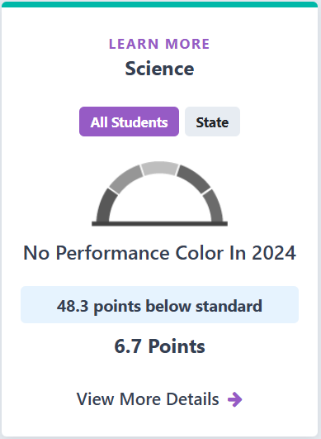

#### Description of the Science Baseball Cards

At the top of the card will be a **Learn More Button** to view information on what the Science Indicator is.​

​Below that you will find two buttons. First an all students button, which will display results for that LEA or school. Next to that you will find a state button. When selected, the card will display results for the state.​

​Below those buttons will be a greyed out gauge. When it is full of color, it shows five different performance levels on the baseball card: red, orange, yellow, green, and blue. The gauge is greyed out because, as it states on the card below the gauge, there is ‘**No Performance Color in 2024**’ for any LEA, school, or student group. This text and a grey color gage will be displayed on every science card.​

​Below that will be information displaying the status results for Science in points as well as change from the prior year. ​

​In this example, the entity's status shows a "Distance from Standard" ***in the current year that was 48.3 points below standard. It shows the change from the prior year as an increase of 6.7 points.***​

Finally, there is a link to view more details, which provides more specific student group information.

### Additional Student Group Reports

The Science Indicator on the 2024 Dashboard provides DFS and change overall as well as for each of the 14 student groups when the school or district has met the minimum N-size to show results.

DFS and Change are provided on the Dashboard for additional student groups for informational purposes only. No Performance Levels or colors are shown for these groups.

These student groups include the following groups:

* Current English Learners
* Recently Reclassified English Learners
* English Only

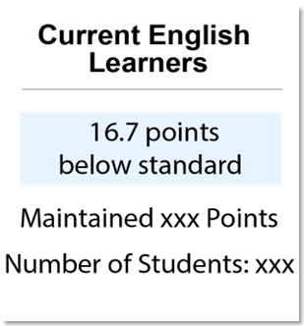 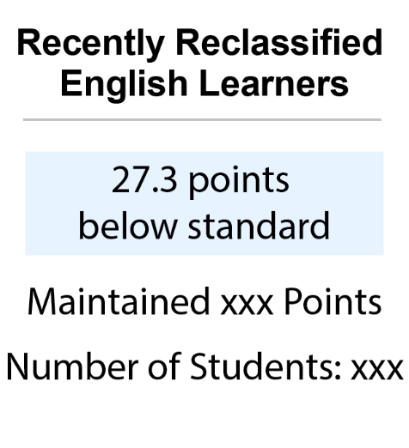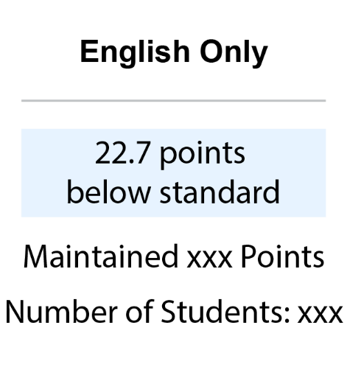

### What Is the DFS?

The DFS is used to determine the Status for science.

​It is the distance between a student’s score on the California Science Test (CAST) and the thereshold for the Standard Met Achievement Level. In other words, it is the distance between the student’s score and the lowest threshold scale score for Level 3. ​

The scale score ranges for the CAST vary by grade level. The scale score levels and ranges for each grade can be found on the CAASPP website  
<https://caaspp-elpac.ets.org/caaspp/ScaleScoreRangesCAST>.

#### Calculating the CAST DFS

1. Calculate the DFS for each student.
2. Calculate the Average DFS for a school or district using all students’ DFS values. The Average DFS will be used to determine the Status level if a school, district, or student group meets the minimum N-size.
3. Calculate change based on the difference in DFS from the year prior.

### CAA for Science DFS

For the CAA scores, a crosswalk was created to convert levels of the CAAs to correspond with levels on the CAST using a "Top of the Scale Range" Approach.

#### Top of the Scale Range

For levels one to three on the CAA, a student's CAA score would be substituted with the top score point of the same CAST achievement level. All CAA assessment results will be converted to one of three scale scores in each content area. For example, grade five CAA scores will be converted to the following CAST scores:

Table . Scale Score Ranges for the CAA

| Science |
| --- |
| Level one is converted to 178 |
| Level two is converted to 213 |
| Level three is converted to 230 |

Scale score ranges for the CAA can be found on the CAASPP CAA for Science Scale Score Ranges web page at [https://caaspp-elpac.ets.org/caaspp/ScaleScoreRangesCAAS.](https://caaspp-elpac.ets.org/caaspp/ScaleScoreRangesCAA)

This newly converted CAST Assessments score will be used to calculate the DFS for those students taking the CAA.

## Participation Rate

For the academic indicators English language arts and mathematics, the Every Student Succeeds Act (ESSA) requires that at least 95% of students participate in the assessment or a penalty will be applied. However, the science indicator is not included in this requirement for the 2024 Dashboard. Even though, the participation rate requirement is not a part of the 2024 Dashboard the CDE does encourage LEAs and students to assess all their students. And starting with the 2025 Dashboard, a penalty rule will be applied if less than 95 percent of students do not participate similar to the academic indicators.

For more information about the participation rate, refer to the Changes to Academic Indicator Participation Rate Calculation for the Dashboard on the CDE Dashboard Flyers web page at <https://www.cde.ca.gov/ta/ac/cm/dashboardflyers.asp>.

### Participation Rate Formula

#### 5th and 8th Grade Participation Rate

**Numerator**: Number of tested students

**Denominator**: Number of students enrolled during the Accountability testing window

**Numerator Tested**: For student to count as "tested,” the following must be true:

* Must log on to the single domain of the CAST or all four domains of the CAA for Science
  + Does not need to complete the entire assessment, however, their score will be included in the average DFS calculations

**Denominator Enrolled:** Many rules are applied to determine if the student is enrolled at the school or LEA.

* Few exemptions for special cases (medical emergency)
* Grace periods for students entering or exiting the school during the testing window.

#### High School Participation Rate

**Numerator**: Number of 10th, 11th, and 12th grade tested students

**Denominator**: Number of tested 10th and 11th grade students and the number of 12th grade students enrolled during the Accountability testing window

**Numerator Tested**: For student to count as "tested,” the following must be true:

* Must log on to the single domain of the CAST or all four domains of the CAA for Science
  + Does not need to complete the entire assessment, however, their score will be included in the average DFS calculations

**Denominator Enrolled:** Many rules are applied to determine if the student is enrolled at the school or LEA.

* Few exemptions for special cases (medical emergency)
* Grace periods for students entering or exiting the school during the testing window.

#### Exemptions for Participation Rate

There are a few students who are excluded from the participation rate. These students are not expected to take the test and are not included in either the numerator or the denominator of the participation rate.

Students excluded from Participation Rate

* Medical Exemption Flag

There are other students who did not take the test for a variety of possible reasons who are not excluded from the participation rate. These students are still expected to take the test and are included in the denominator of the participation rate. If they did not test, they will not be included as testing in the numerator.

Students **not** excluded from Participation Rate for the Science Indicator:

* Parent opt-outs
* Chronically Absent
* Sick without medical emergency exemption
* EL students enrolled in a US school for less than one year

### Completion Status Reports Versus Participation Rate

* The Test Operations Management System (TOMS) completion reports are **not** the same as the participation rate.
* TOMS reports can provide insight in "real-time."
  + Dashboard does not use the same inclusion/exclusion rules.
  + CDE does not receive testing data until the Fall.
  + May not reflect the final Dashboard participation rate.

### Testing Windows and Grace Periods

#### Testing Windows

Determining a school’s accountability testing window is one of the first steps to finalize the participation rate denominator.

Although LEAs set their own testing window for the CAST and CAA for Science in the TOMS Test Administration Setup module, for Dashboard accountability purposes, CDE determines what is called an Accountability testing window for each school and LEA.

The Accountability testing window for the Dashboard starts when the first student at the school takes the test. Depending on the length of the LEA-selected testing window, grace periods may be applied as well.

#### Grace Period Defined

* Developed for students who transfer in or out during a school's determined testing window
* Apply only to certain students who transfer in and/or out within the testing start and end dates (not the entire testing window)
* Hold schools harmless when there is inadequate time to administer the assessments

#### Grace Period Applied

If the LEA selected testing window is:

* 14 days or less
  + No grace periods applied
* Between 15–30 days
  + One grace period applied at the end of the window
    - For students entering the school at the end of the testing window
* 31 or more days
  + One grace period applied at the beginning of the window
    - For students exiting the school at the beginning of the testing window
  + One grace period applied at the end of the window
    - For students entering the school at the end of the testing window

#### Participation Rate Simplified

Students who transfer in or out of a school are expected to test if they are enrolled for at least one day during the Accountability testing window.

## FAQs

#### What are the performance levels for Science?

Science on the Dashboard will be its own indicator on the 2024 Dashboard. Also, there will be no performance levels on the 2024 Dashboard for science. Therefore, results shown on the Dashboard will be for informational purposes only and will not be used for school or district accountability determinations in 2024.

#### Why do the CAASPP reports not match the results of the Dashboard?

The CAASPP reporting web page and the Dashboard are reporting results from the Spring Summative CAASPP testing, however, they do have a number of differences and will often not match. Table 3 simplifies these differences below.

Table 3. Dashboard and CAASPP Results

| CAASPP Results | Dashboard Results |
| --- | --- |
| Most student demographics based on data at the close of testing | Student demographics based on CALPADS EOY submissions |
| Results based on achievement levels and included all tested students | Results based on a combination of participation rate and DFS |
| Reports Alternative tests separate from CAST | Reports Alternative tests together with CAST through DFS |
| Reports the total number of students tested | Student scores are included only for continuously enrolled |
| No District of Residence rules applied | District of Residence rules applied |

#### A student left my school before the testing window opened but they are still showing up in TOMS—will this affect my participation rate?

TOMS is a great tool for looking at real-time testing rates within a school or LEA. Completion rates, however, are a similar but different metric than the participation rate. Additionally, students remain in TOMS at their last known CALPADS school. Therefore, if a student never enrolled in another California school, they would appear as needing to test in TOMS. Since these students left before the testing window opened, they will not be included in the numerator or the denominator of the participation rate.

#### A student left in the middle of testing but did not start any of the assessments. Will I be held accountable for their test?

If the student is expected to test and did not test the school and LEA will be held accountable for their student not testing. If the student falls under any of the exemptions including grace periods and is not expected to test, the school and LEA will not be held accountable for the student not testing.

#### A student left my school during the LEA-selected testing window but before we tested any students. Will they affect my participation rate?

No. Students who exit the school before testing has begun are not expected to test and will not be included in either the numerator or the denominator of the participation rate.

#### Does Science have a participation rate minimum like ELA and Math?

There will be no participation rate requirement for the Science Indicator on the 2024 Dashboard, therefore Science will not have a penalty if LEAs, schools, or student groups do not meet the 95 percent participation rate. Starting with the 2025 Dashboard, LEAs, schools, and student groups will be required to test at least 95 percent of students at each level.

#### My school did not reach 95 percent participation in the CAST. What will happen?

At this time, the Science test is not included as a measure on the Academic Indicators. While we encourage participation in the test, reaching less than 95 percent for the Science test has no impact on Accountability.

## General Rules About the Dashboard

### Additional 2024 Science Indicator Resources

* CDE Science Indicator web page:   
  <https://www.cde.ca.gov/ta/ac/cm/dashboardscience.asp>
* CDE Science Indicator Mini-Guide web page: <https://www.cde.ca.gov/ta/ac/cm/dashboardguide24.asp>
* CDE School Dashboard Additional Reports web page: <https://www6.cde.ca.gov/californiamodel/>

### Reporting for At Least 30 Students

* Performance Level (color) gauge graphic greyed out
* Status and Change reported

### Reporting for 11 to 29 Students

* Performance Level (color) gauge graphic greyed out
* Status and Change reported

### Reporting for Fewer than 11 Students

* Performance Level (color) gauge graphic greyed out
* Status and Change not reported

### Reporting for At Least 30 Students: Exception

LEAs with at least 15 students in the current and prior year will receive a Performance Level (color) for Homeless, Foster Youth, and Long-Term English Learners only.

Charter schools are treated as schools and still require the 30 students to receive a Performance Level (color).

### DSEA

The DSEA rule is applied to all available state indicators for students with disabilities who receive special education services at another district or county office of education. These students will be “sent back” to the district of residence or DSEA and included in the DSEA’s Dashboard.

For example, the district where the student geographically resides is held accountable for the student’s graduation outcomes, and that data is included in the district of residence’s Graduation Rate Indicator.

Please note that this rule applies to LEAs only. All schools, including charter schools, are held accountable for all students with disabilities. Also, students are expected to take the test at the school they are attending.

For more information about DSEA rules, refer to the DSEA flyer under the Additional Flyers and Information section on the CDE Dashboard Communications Toolkit web page at <https://www.cde.ca.gov/ta/ac/cm/dashboardtoolkit.asp>.

### A Rule About Charter Schools

Since charter schools are treated as LEAs under the Local Control Funding Formula, or LCFF, their data are not included in their authorizer’s Dashboard report. This includes both direct and locally funded charters.

DataQuest reports have the toggle option to either include or exclude charters from the district reports.

## Contact Us

* Email: [Dashboard@cde.ca.gov](mailto:Dashboard@cde.ca.gov)
* Follow us on X (formerly Twitter): [@cdedashboard](https://twitter.com/cdedashboard)